MY AWS S3 LAB LOG
From Empty Console to a Stored File
A step-by-step record of creating the bucket "ak-092" and uploading my first file to Amazon S3
Date: 21 September 2026 Session: 09:31 to 10:06 (IST) Region: us-east-1

Quick Overview
In this session I worked entirely inside the AWS Console. I opened S3, filled in the Create bucket form, kept the safe default protections, created a bucket named ak-092, uploaded a Word report into it, and then opened the object to check its details. The sections below follow the exact order of my screenshots, each with a heading, a short explanation and the screen itself.

Configuration at a Glance
Setting | Value I used
Region | US East (N. Virginia), us-east-1
Bucket name | ak-092
Bucket type | General purpose
Namespace | Global namespace
Object Ownership | Bucket owner enforced (ACLs disabled)
Block Public Access | All four settings on
Versioning | Disabled
Tags | None
Default encryption | SSE-S3, Bucket Key enabled
File uploaded | AWS_EC2_EBS_Infrastructure_Report (1).docx, 549.7 KB

Step 1: Landing on the Amazon S3 Home Page
Time on screen: 09:31
I began the session in the AWS Management Console, signed in to the US East (N. Virginia) region, and opened the Amazon S3 service. The welcome page explains that S3 is object storage and that every object lives inside a bucket. Since I had nothing stored yet, the "Create bucket" button in the top-right card was my starting point. I also noticed the pricing panel, which reminds me that S3 has no minimum fee and billing depends on usage and region.
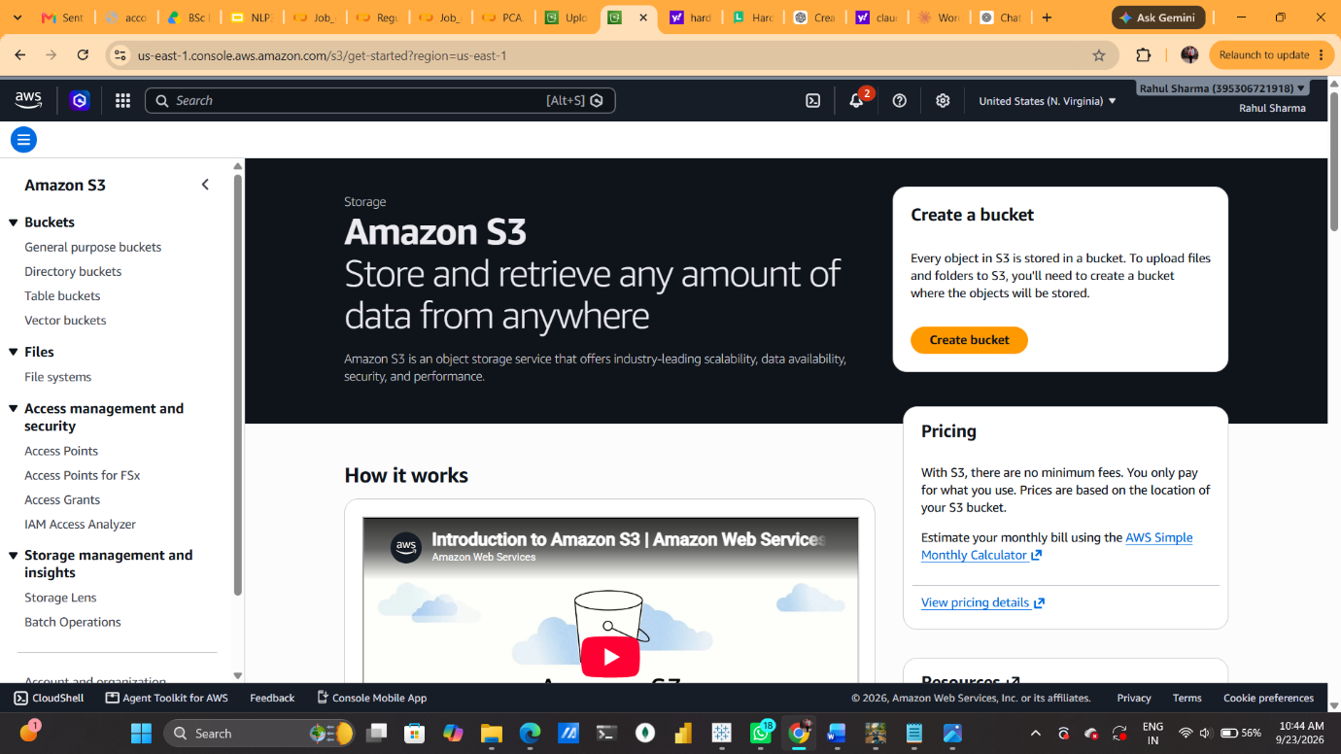

Step 2: Opening the Create Bucket Form and Choosing the Bucket Type
Time on screen: 09:33
Clicking "Create bucket" opened the configuration form. The region was already fixed to us-east-1. Under Bucket type I kept "General purpose", which is the standard choice for most projects and spreads objects across multiple Availability Zones. The other choice, "Directory", is meant for very low-latency work inside a single zone, which I did not need for a simple storage exercise.

Step 3: Typing the Bucket Name: ak-092
Time on screen: 09:45
Here I filled in the Bucket name field with ak-092. It is short, lowercase, uses a hyphen and ends with a digit, so it satisfies every naming rule shown beneath the field. Everything else in General configuration stayed unchanged: General purpose type and Global namespace.
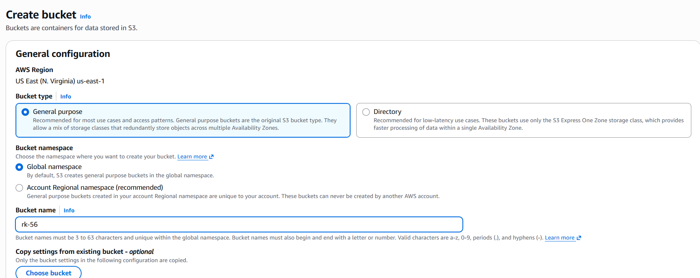

Step 4: Checking Object Ownership and Block Public Access
Time on screen: 09:53
Further down, Object Ownership showed "Bucket owner enforced", so access control lists are disabled and the bucket owner owns every uploaded object. In Block Public Access, the "Block all public access" checkbox was ticked, which automatically turns on all four sub-settings covering new and any ACLs, plus new and any public bucket policies. I deliberately left this protection on so nothing inside the bucket could be exposed to the internet by accident.
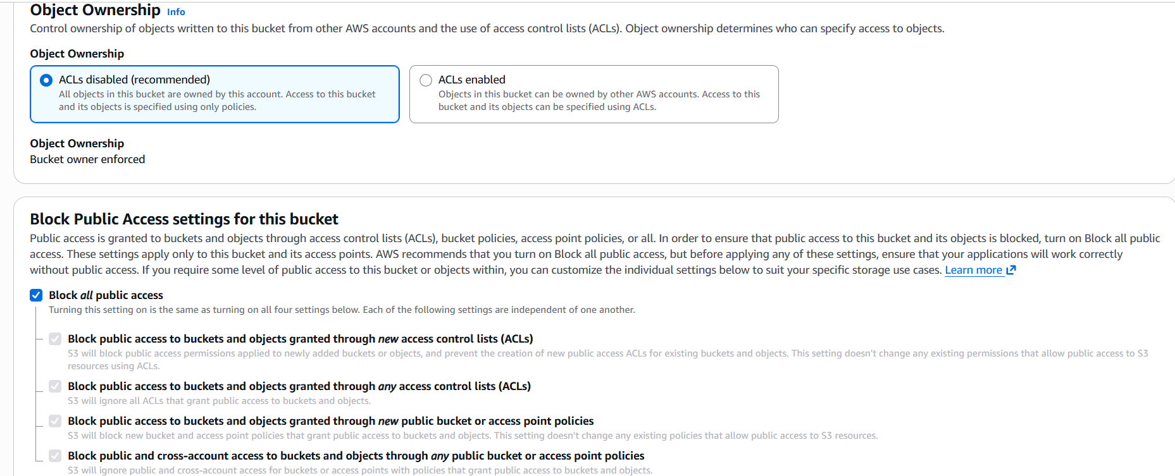

Step 5: Bucket Versioning and Tags
Time on screen: 09:53
The next block was Bucket Versioning, which I left on "Disable". That means S3 will not keep older copies of an object when it is overwritten or deleted. Below it, the optional Tags section said no tags were attached, and I did not add any. Tags are useful for cost tracking and organizing resources, but this bucket was only for a quick practice upload.
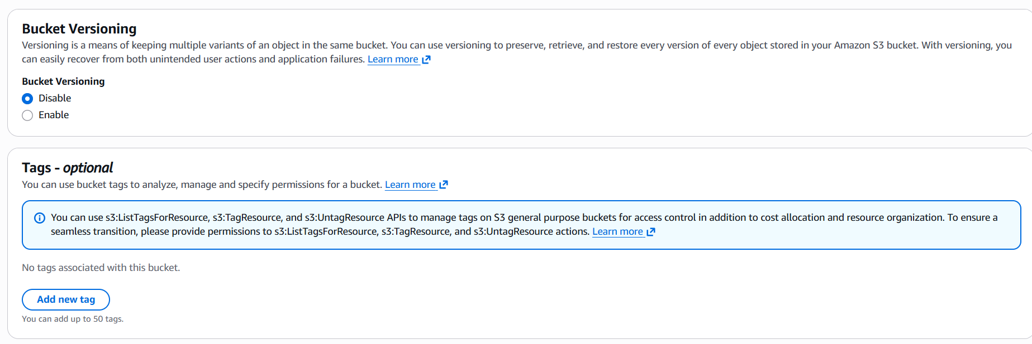

Step 6: Default Encryption and Creating the Bucket
Time on screen: 09:53
At the bottom of the form, Default encryption was set to "Server-side encryption with Amazon S3 managed keys (SSE-S3)", so every new object is encrypted automatically without any key management on my side. The Bucket Key option was shown as Enabled. I did not open Advanced settings. After a last look at the notice that files can be uploaded once the bucket exists, I clicked the orange "Create bucket" button.
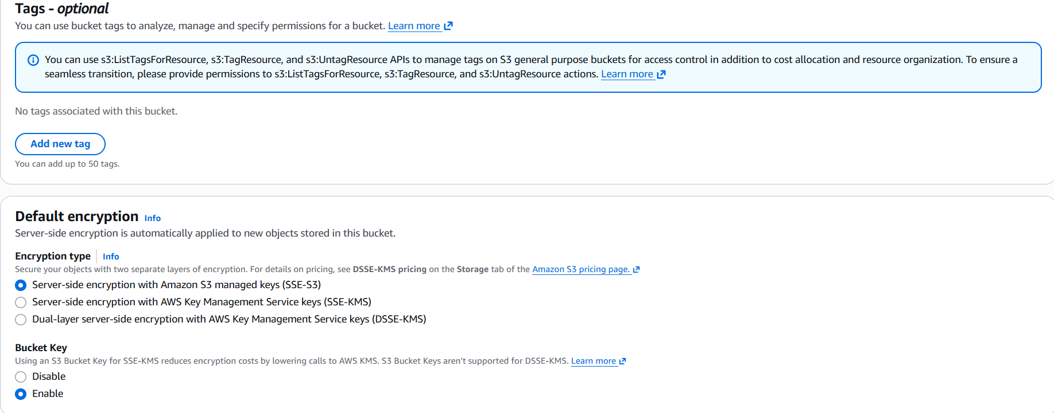

Step 7: Bucket Created Successfully
S3 responded with a green banner: Successfully created bucket "ak-092". The bucket page opened on the Objects tab, which showed Objects (0) and the message that the bucket was empty. The other tabs here (Metadata, Properties, Permissions, Metrics, Management, File systems and Access Points) are where I could later change settings, but for now the next action was simply to upload something.
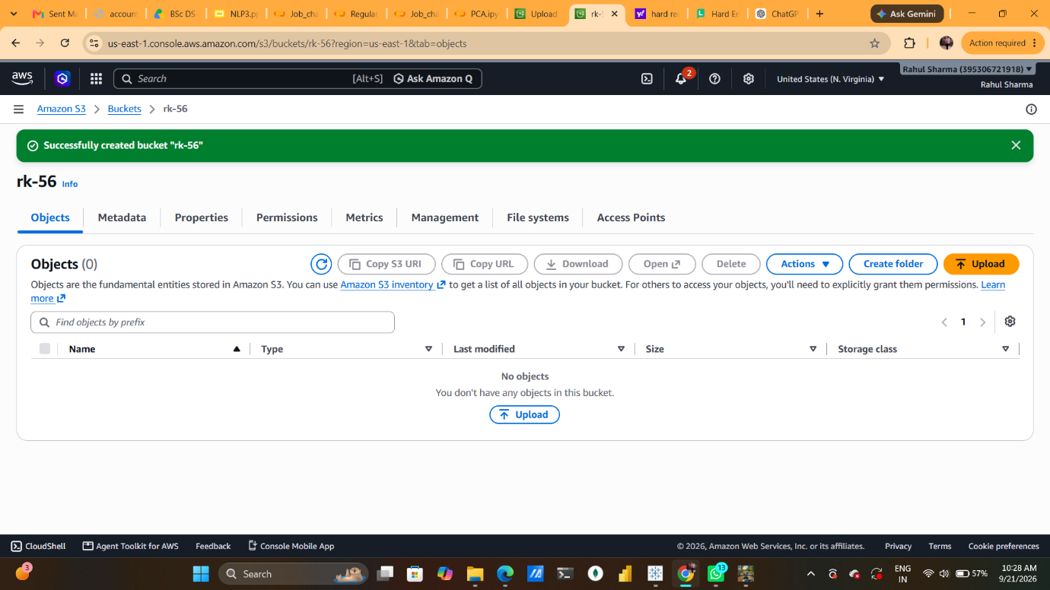

Step 8: Selecting a File on the Upload Page
Time on screen: 10:05
I clicked Upload and landed on the upload screen. Using "Add files", I picked a Word document named AWS_EC2_EBS_Infrastructure_Report (1).docx, size 549.7 KB. The Destination panel confirmed the target was s3://ak-092. I left the Destination details and the Permissions and Properties sections at their defaults and confirmed the upload.
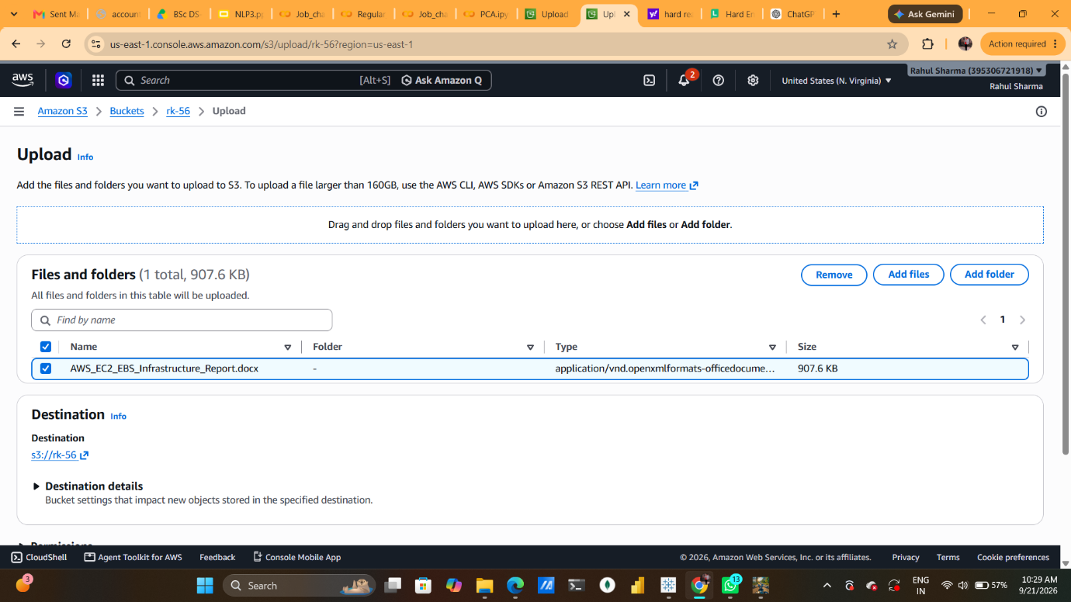

Step 9: Upload Status: Succeeded
Time on screen: 10:06
The Upload: status page reported "Upload succeeded". The summary showed one file of 549.7 KB transferred at 100 percent with zero failures, and the file row carried a green Succeeded status with an empty Error column. This screen disappears once you navigate away, so it was worth capturing.
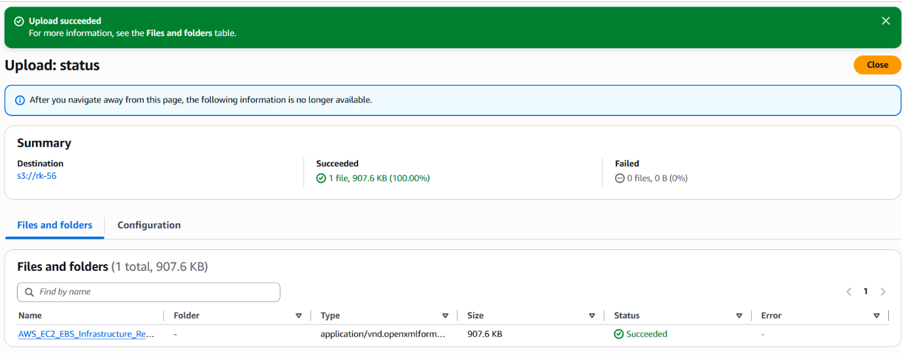

My Full Summary of the Session
My goal in this session was simple: create a storage bucket on Amazon S3 and put one file inside it. I started from the S3 home page in the us-east-1 region and clicked Create bucket. On the form I chose the General purpose bucket type, kept the Global namespace, and typed the name ak-092 after checking it against the naming rules (3 to 63 characters, lowercase letters, numbers, periods and hyphens, starting and ending with a letter or number).
The remaining options I handled with a safety-first mindset. Object Ownership stayed on Bucket owner enforced, so ACLs are off and I own everything uploaded. Block all public access remained ticked, which shuts the door on any accidental public sharing through ACLs or bucket policies. Versioning was left disabled and I attached no tags, since this was a small practice bucket. For encryption I stayed with SSE-S3, so S3 encrypts every new object with keys it manages for me. After that, one click on Create bucket produced the green success message.
With the bucket ready, I opened the upload page, added the file AWS_EC2_EBS_Infrastructure_Report (1).docx (549.7 KB) and sent it to s3://ak-092. The status page confirmed one file succeeded and none failed. I then opened the object to inspect its properties: the region, timestamp of 10:06:26, size, key, S3 URI, ARN, ETag and Object URL were all present. Because public access is blocked, that URL is not publicly readable, which is exactly what I wanted for a private report.
What I take away from this exercise is the full life cycle of a basic S3 task: choose a unique name, decide on protection settings, create the bucket, upload an object and verify it. If I continue from here, sensible next steps would be turning on versioning for important files, adding tags for cost tracking, and writing a narrowly scoped IAM policy or bucket policy when someone else needs access. Since S3 bills on what is stored and transferred, I should also delete the file and the bucket when I no longer need them.

