Amazon SNS Practical Report
Topic Creation, Email Subscription, Message Publishing and Unsubscription

1. Overview
This report summarizes the practical steps performed in Amazon Simple Notification Service (Amazon SNS). The workflow covers creating a Standard SNS topic, adding an email subscription, confirming the subscription through Gmail, publishing a test message, verifying delivery, and finally removing the subscription.

2. Practical Objective
- Create an Amazon SNS topic.
- Configure an email subscription for the topic.
- Confirm the subscription through the recipient's email.
- Publish a test notification to the topic.
- Verify that the notification is delivered by email.
- Unsubscribe the email endpoint from the SNS topic.

3. Step-by-Step Summary

Step 1: Opening Amazon SNS
The Amazon SNS dashboard is opened in the AWS Management Console. The page introduces Amazon Simple Notification Service as a managed publish/subscribe messaging service. A new topic can be created from the Create topic section.
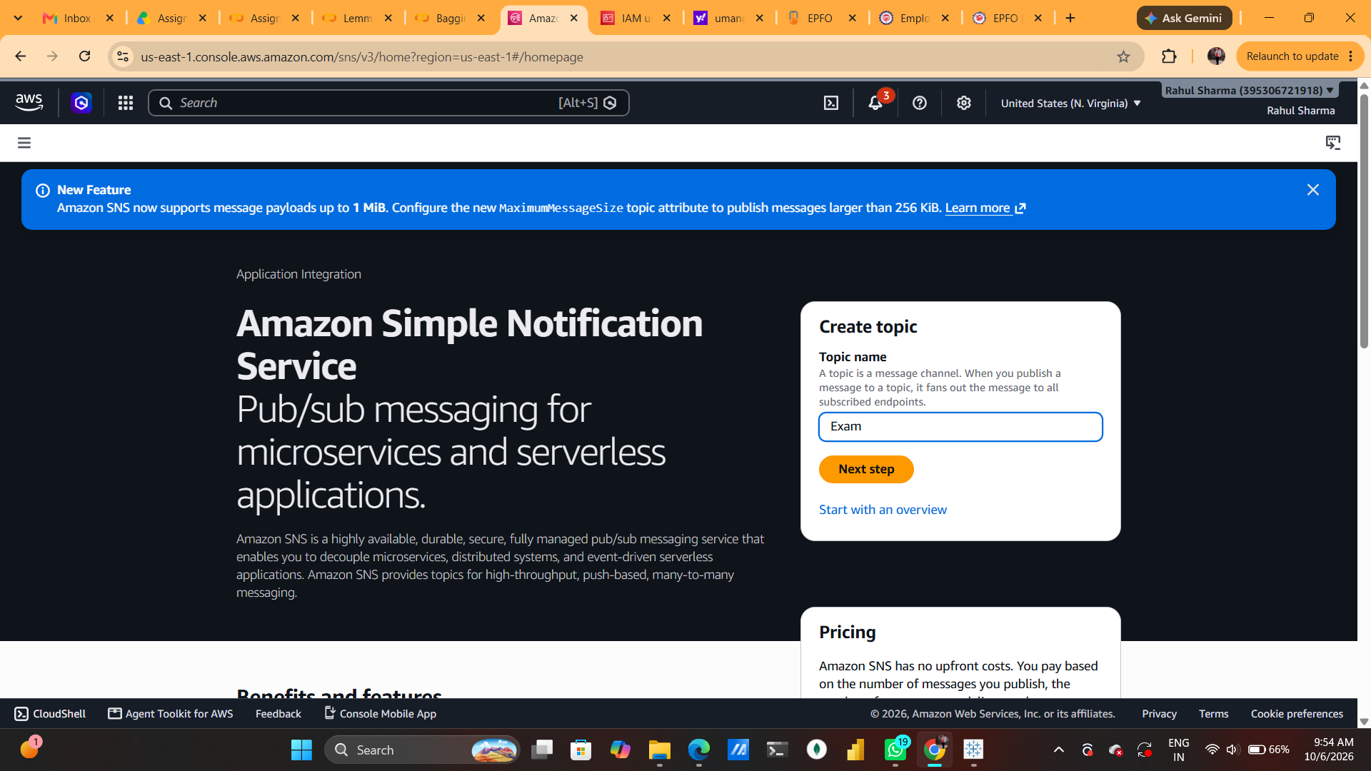

Figure 1: Opening Amazon SNS

Step 2: Create Topic – Type and Basic Details
The Create topic page is opened. Standard topic type is selected, and the topic name is entered as “Example”. Standard SNS topics provide best-effort ordering and at-least-once message delivery and support common subscription protocols such as Email, SQS, Lambda, HTTP/S and SMS.
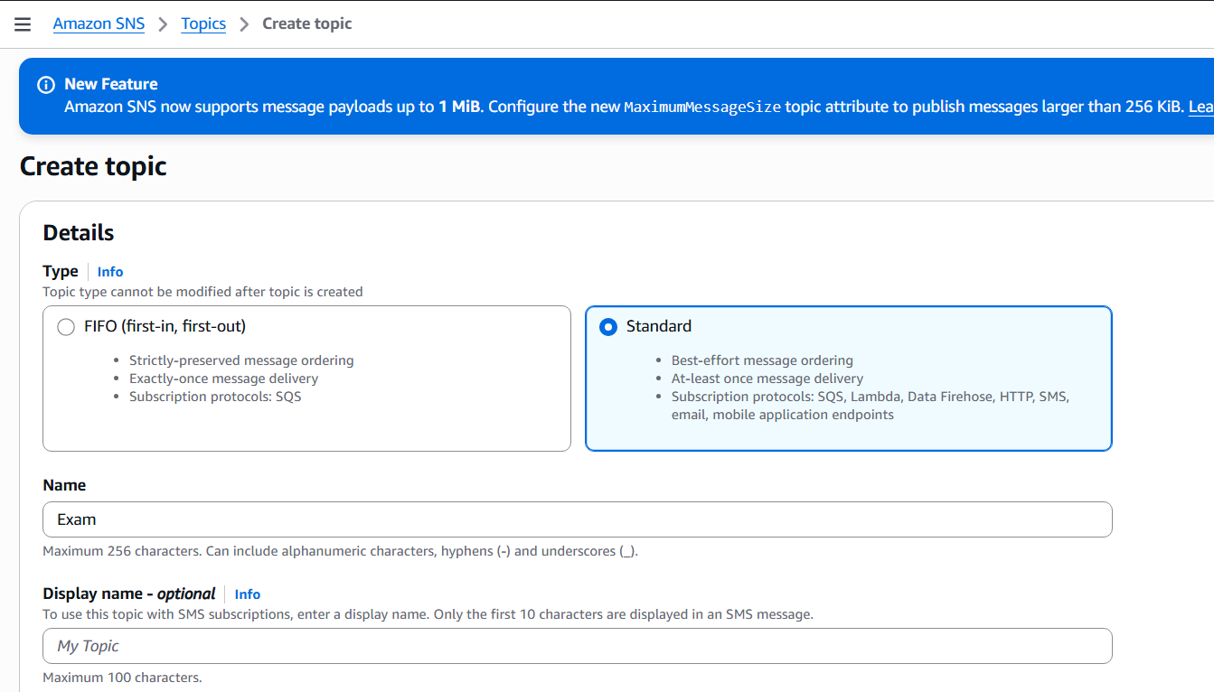

Figure 2: Create Topic – Type and Basic Details

Step 3: Create Topic – Optional Settings
The remaining topic configuration options are reviewed. Encryption, access policy, HTTP/S delivery policy, message delivery status logging, tags and other optional settings can be configured. For a basic practical, the default settings can be kept and the topic can be created.
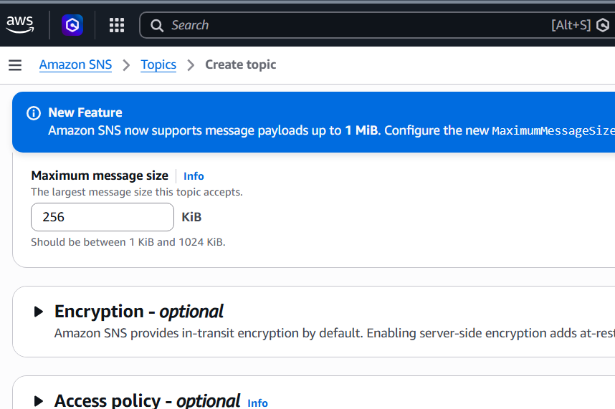

Figure 3: Create Topic – Optional Settings

Step 4: Topic Created Successfully
The topic named “Example” is successfully created. The topic details show its ARN, Standard type, owner and maximum message size. At this stage, no subscriptions are attached to the topic.
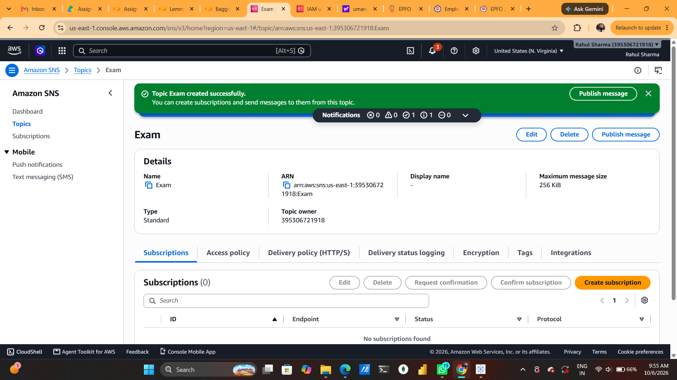

Figure 4: Topic Created Successfully

Step 5: Create Email Subscription
A subscription is created for the Example topic. The protocol is set to Email and an email endpoint is entered. Amazon SNS requires the recipient to confirm the subscription before notifications can be delivered.
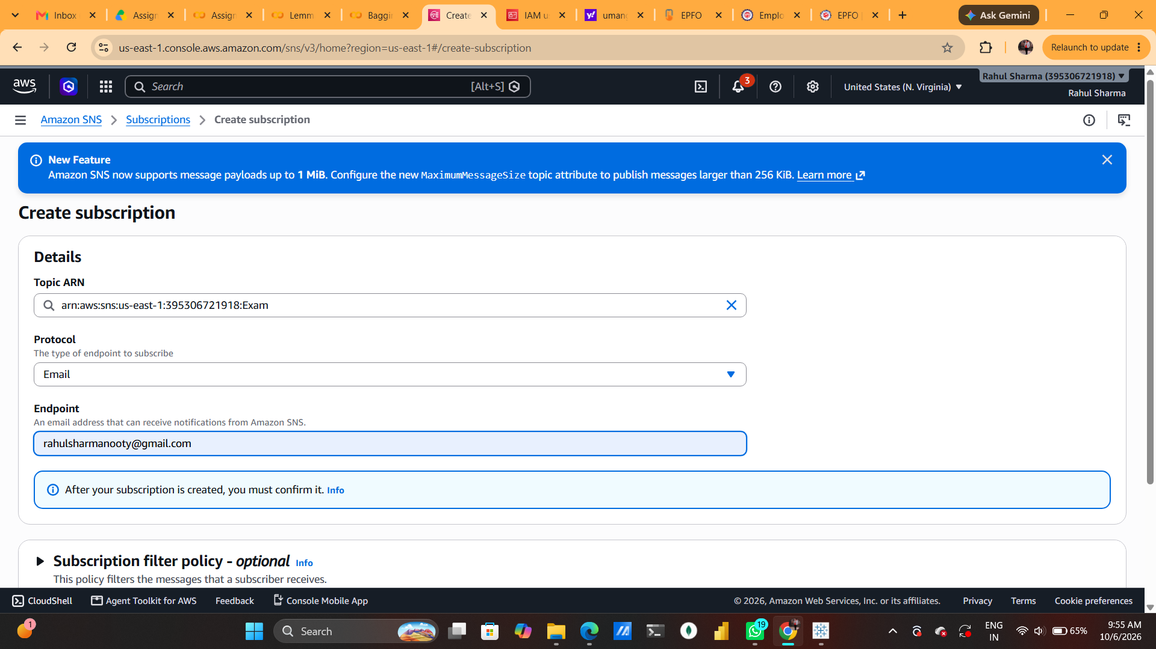

Figure 5: Create Email Subscription

Step 6: Subscription Confirmation Email
An AWS Notification email is received in Gmail. The email contains a Confirm subscription link, which is required to activate the SNS email subscription.
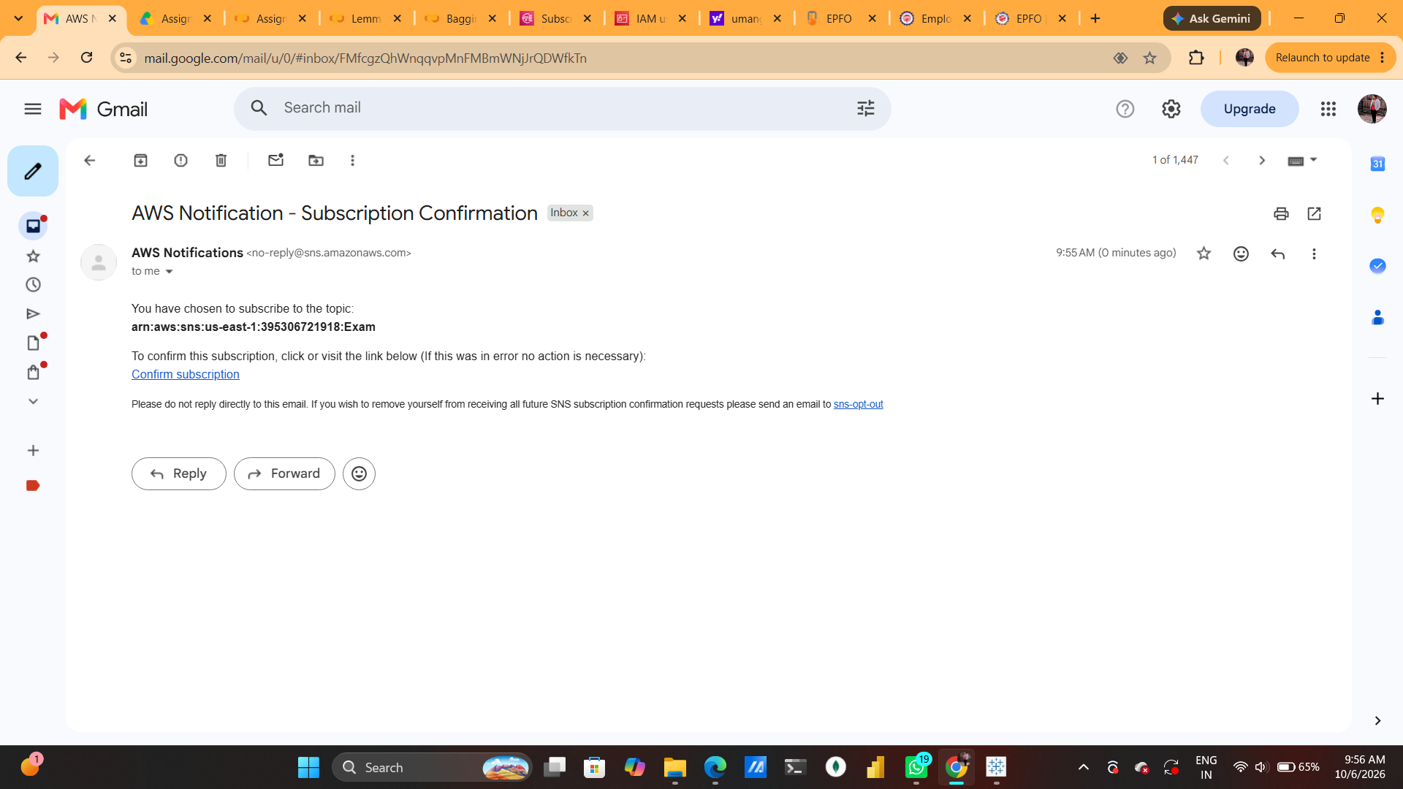

Figure 6: Subscription Confirmation Email

Step 7: Subscription Confirmed
The confirmation link is opened and AWS displays “Subscription confirmed!”. This verifies that the email endpoint has successfully subscribed to the SNS topic.
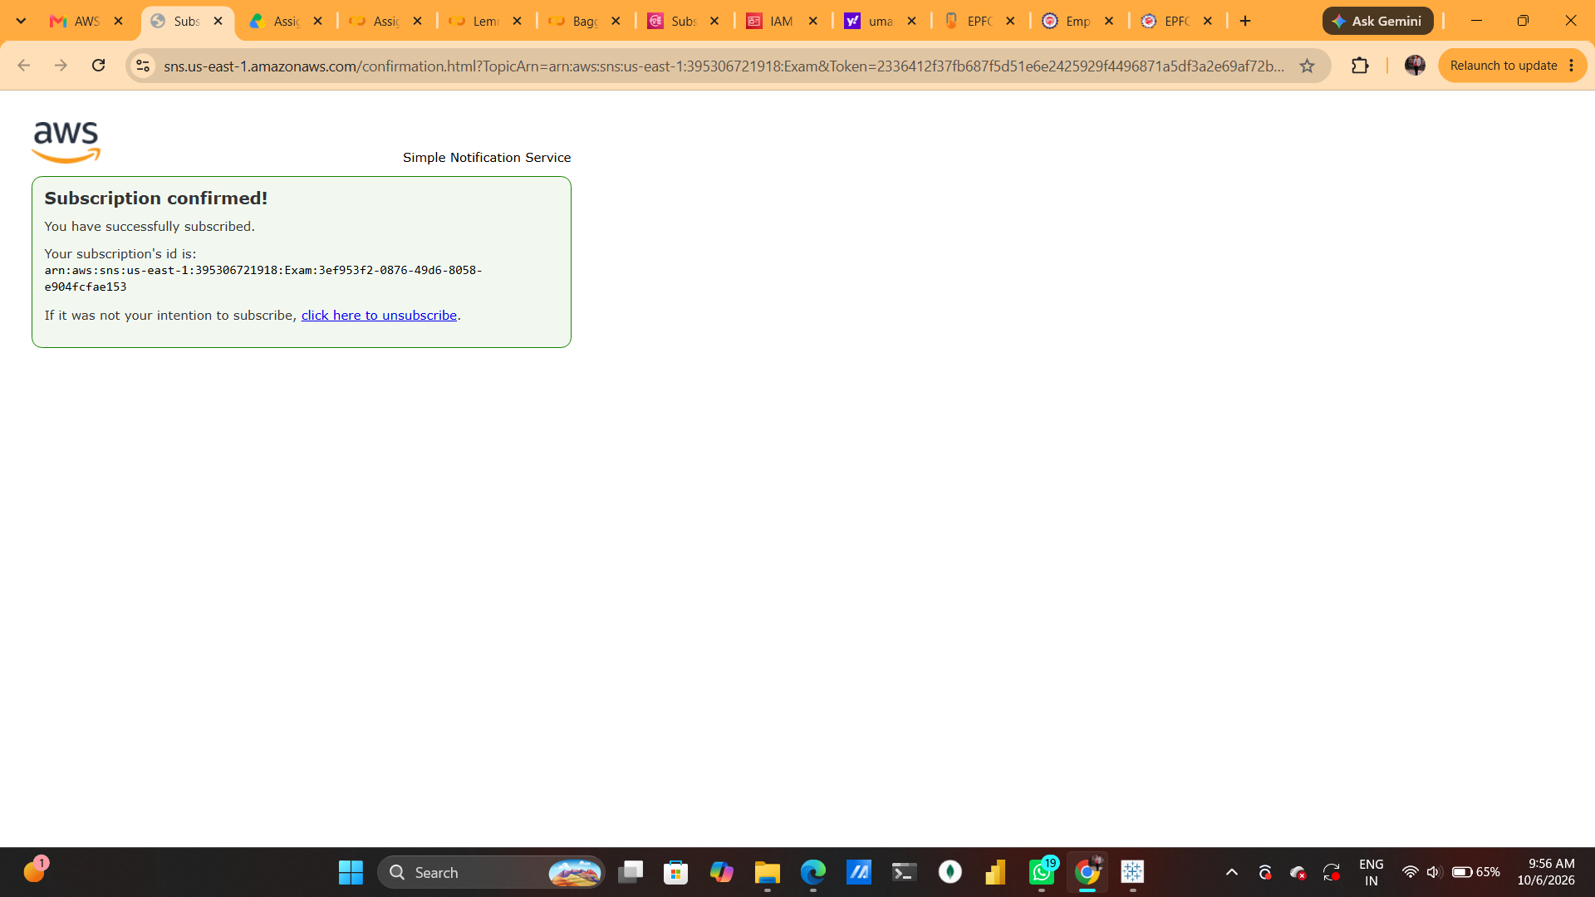

Figure 7: Subscription Confirmed

Step 8: Confirmed Subscription in SNS
Back in the SNS topic page, the subscription list shows the email endpoint with status “Confirmed” and protocol “EMAIL”. The topic is now ready to deliver published messages to the subscriber.
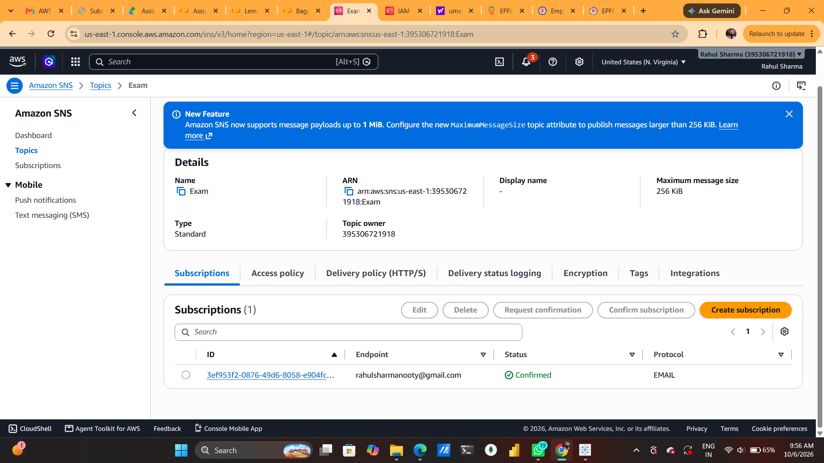

Figure 8: Confirmed Subscription in SNS

Step 9: Topics List
The Amazon SNS Topics page shows the Example topic in the account. The topic is listed as a Standard topic with its Amazon Resource Name (ARN).
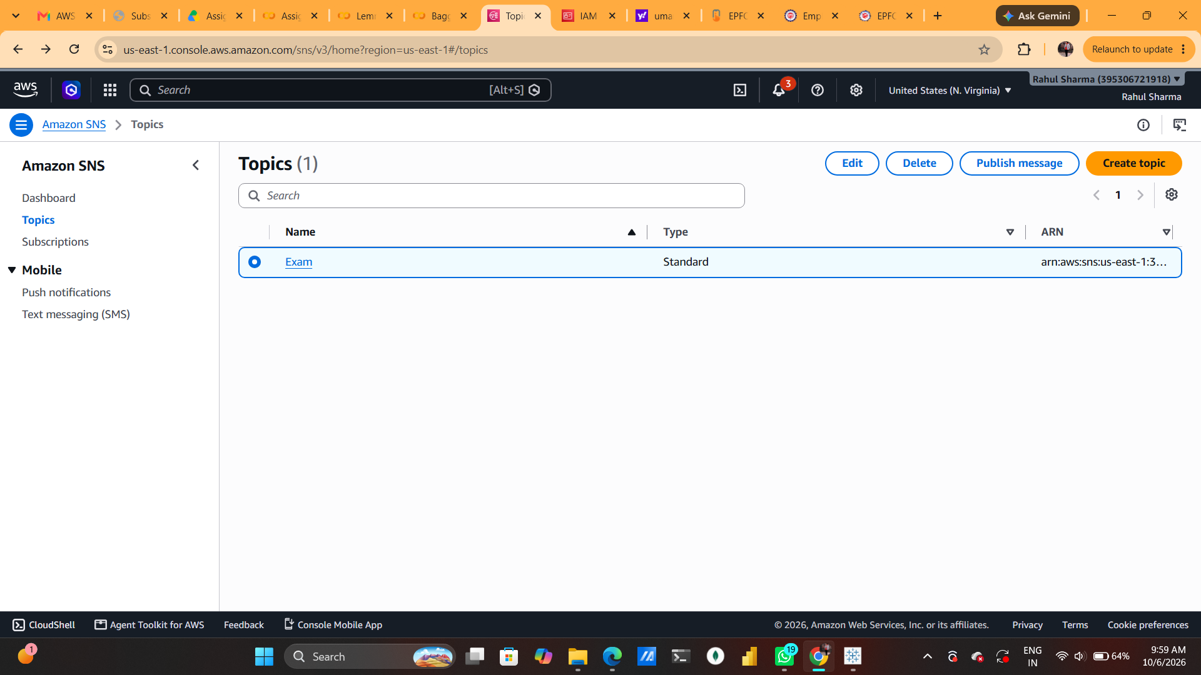

Figure 9: Topics List

Step 10: Publish a Message – Details
The Publish message page is opened for the Example topic. A subject is entered and the message publishing form is prepared. SNS allows a message to be sent to all confirmed subscribers of the topic.
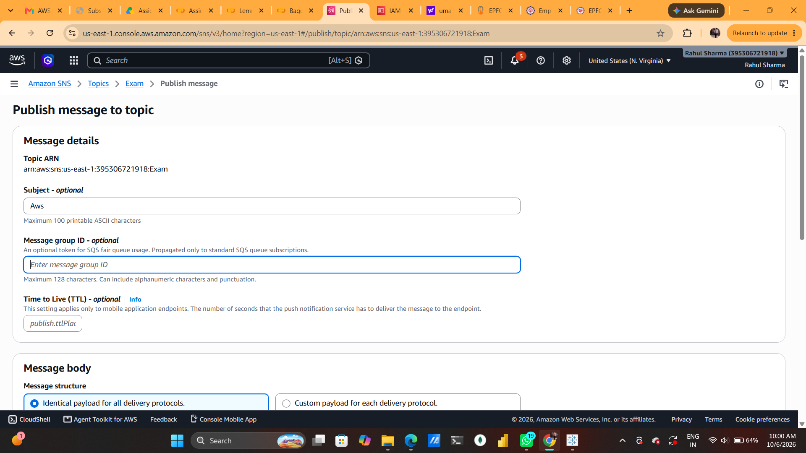

Figure 10: Publish a Message – Details

Step 11: Publish a Message – Message Body
The message structure is kept as an identical payload for all delivery protocols. The message body contains a sample text such as “hwllo! how are you”. Message attributes are optional and can be used to provide structured metadata.
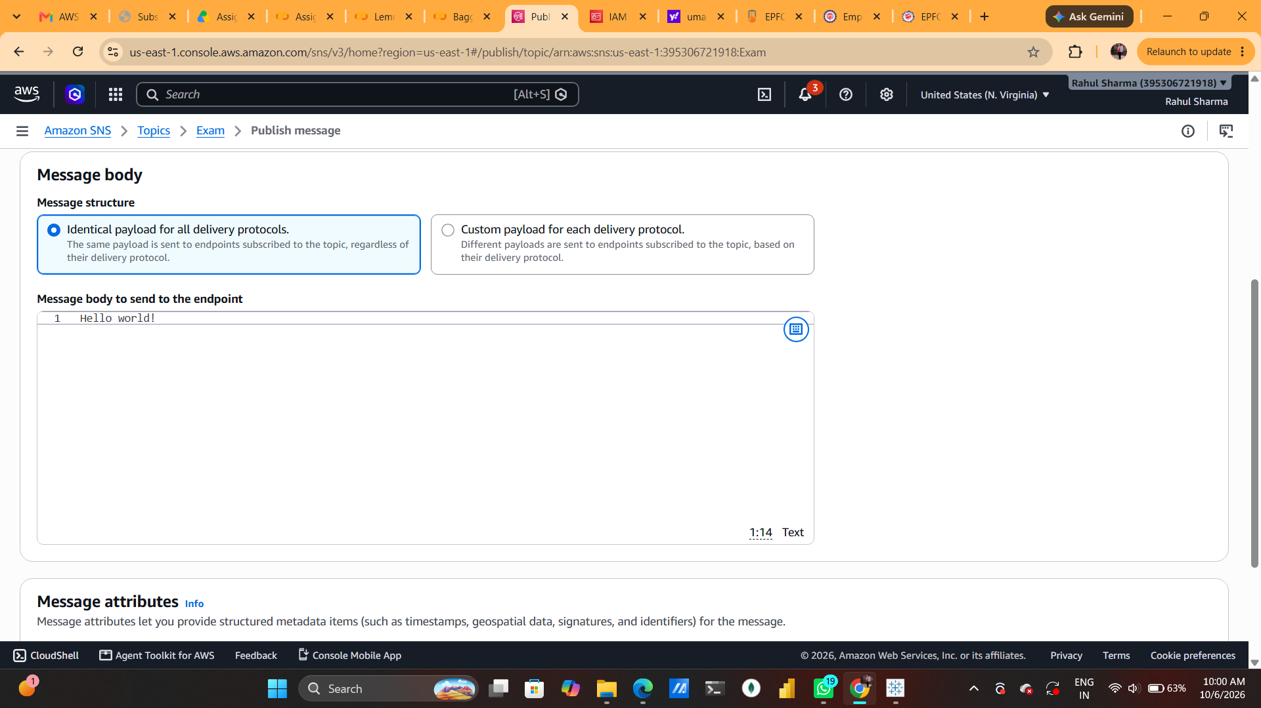

Figure 11: Publish a Message – Message Body

Step 12: Message Published Successfully
Amazon SNS confirms that the message was published successfully. A message ID and request ID are displayed, indicating that SNS accepted the message for delivery.
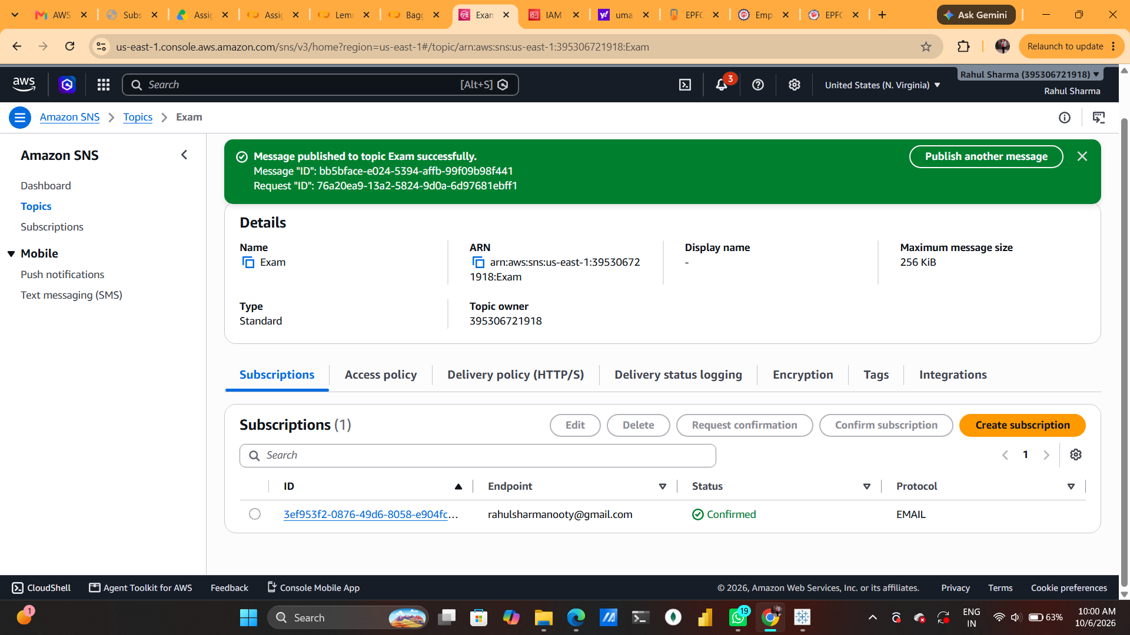

Figure 12: Message Published Successfully

Step 13: Message Received in Gmail
The published SNS message is received in Gmail. The email contains the message body along with SNS unsubscribe information and AWS support information. This confirms end-to-end message delivery.
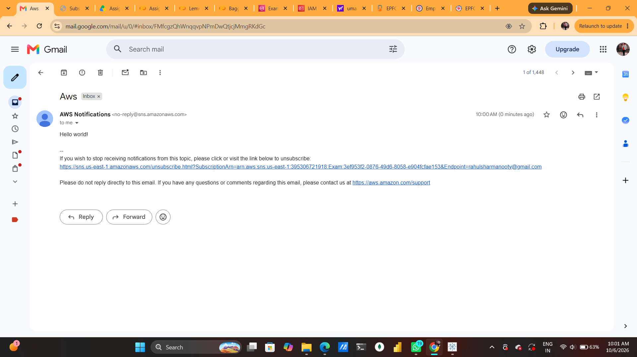

Figure 13: Message Received in Gmail

Step 14: Unsubscribe / Subscription Removed
The unsubscribe link is opened from the SNS notification email. AWS displays “Subscription removed!”, confirming that the email subscription has been deleted and future notifications from this topic will no longer be sent to that endpoint.
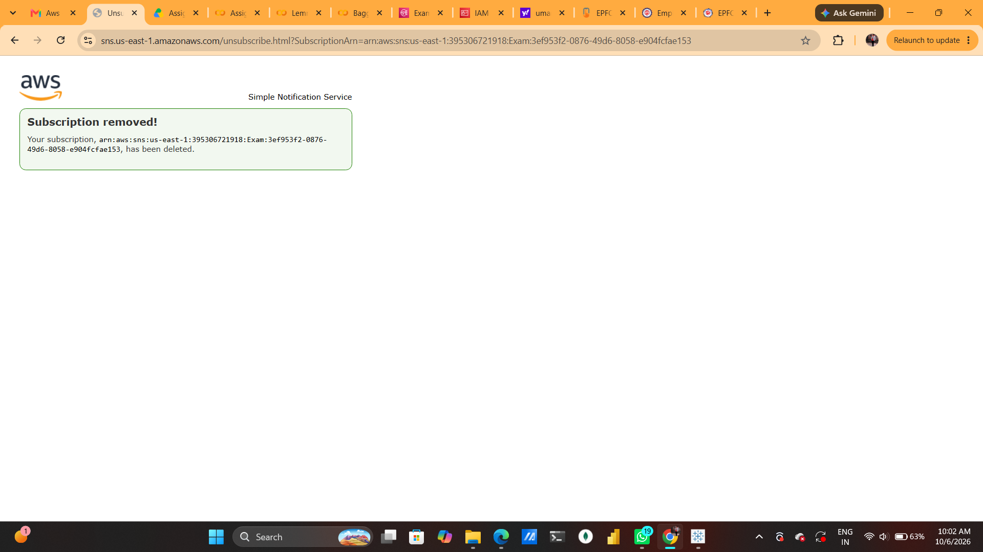

Figure 14: Unsubscribe / Subscription Removed

4. Final Result
The practical successfully demonstrated the complete Amazon SNS publish/subscribe workflow. A Standard topic named “Example” was created, an email endpoint was subscribed and confirmed, a test notification was published and received in Gmail, and the subscription was subsequently removed.

5. Conclusion
Amazon SNS provides a simple way to distribute notifications from a publisher to multiple subscribers. In this practical, the email protocol was used to demonstrate the process. The exercise shows how SNS topics, subscriptions, confirmation, message publishing, delivery verification and unsubscription work together in a real AWS environment.

