MongoDB Assignment A

Q-1 Create a new database called student_management ?
Soln : 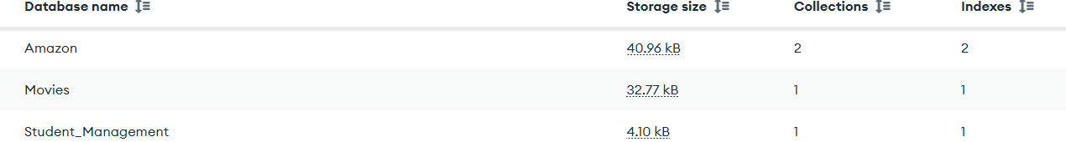
Q-2 Create a collection called students in the student_management database.
Soln :
Q-3 Insert at least five student records into the students collection. Each record should have the following fields:
Soln :
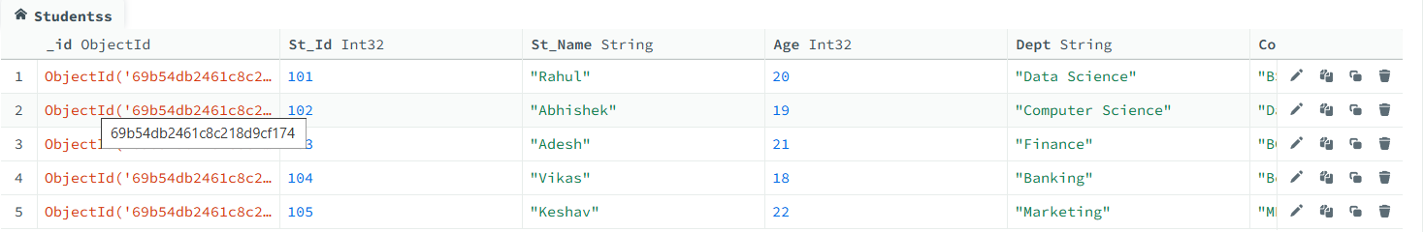
Q-4 Query the Collection:
Write queries to perform the following tasks:
- Retrieve all students who are in the "Computer Science" department.
- Retrieve students who have an age greater than 21.
- Retrieve students who are taking the "Database Systems" course.
- Retrieve students with a grade of "A".
Soln :
- 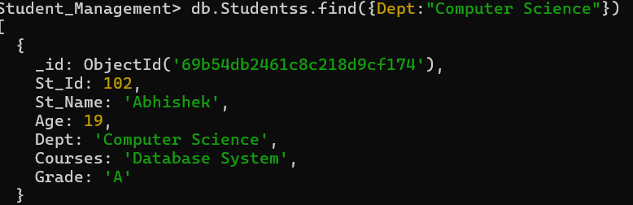

- 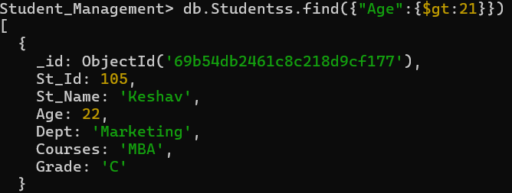

- 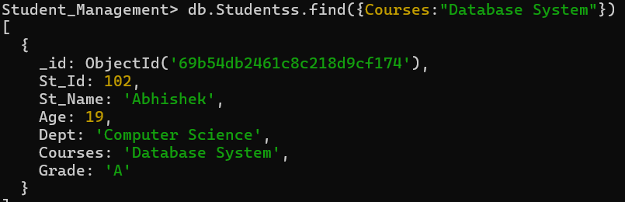

- 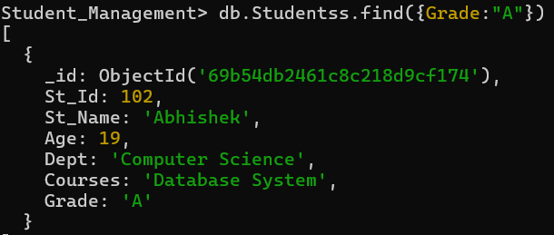

Q-5 Update Documents:
- Update the age of a student with student_id 101 to 21.
- Add a new course, "Machine Learning", to the courses array for students in the "Computer Science" department.
Soln :
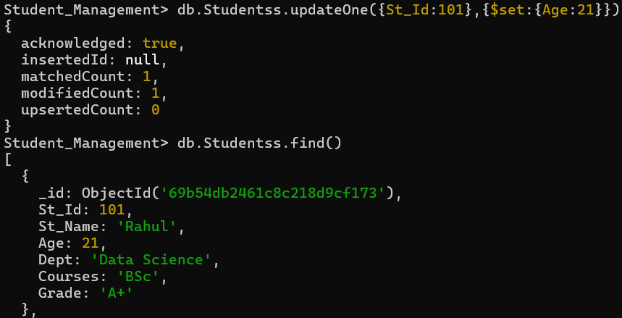

Q-6 Delete Documents:
- Delete a student record with student id 105.
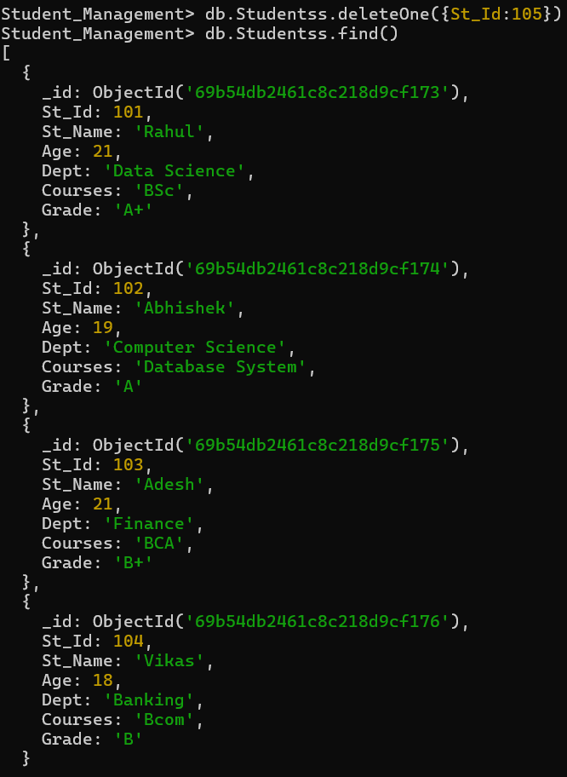

- Delete all students who have a grade lower than "C"

