Mongo db Assignment B
Q.1 Create a database named university and a collection named students. Insert multiple student document with field: name, age, department, and grades.
Soln: 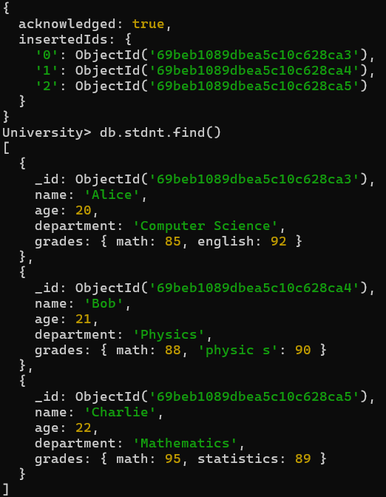

Q.2 Write a query to display all students who are in the Computer Science department.
Soln: 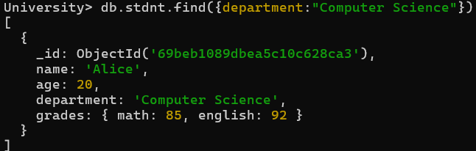
Q-3 Write a query to update the grades of a student named Alice by adding a new subject programming with a grade of 93.
Soln: 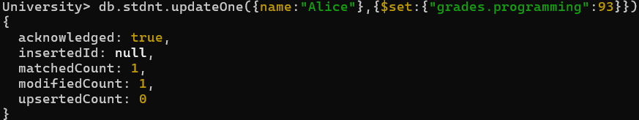
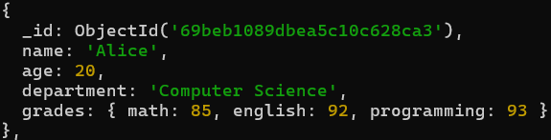
Q-4 Write a query to increment the age of all students by 1.
Soln: 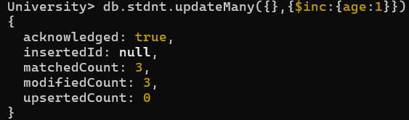
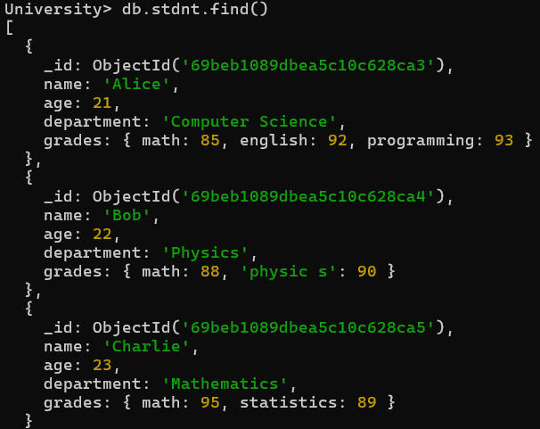
Q.5 Write a query to delete all students who are 23 years old ?
Soln:
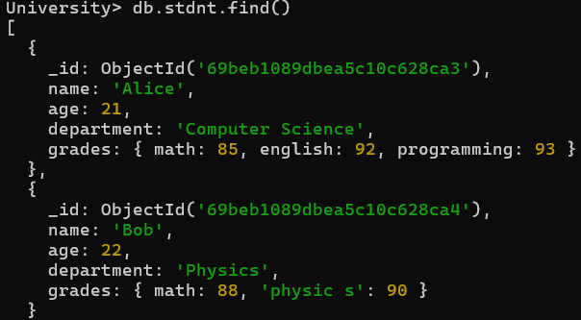
Q.6 Write a query to create an index on the name field of the students collection ?
Soln:
Q.7 Write an aggregation query to group students by their department and calculate the average age in each department ?
Soln:
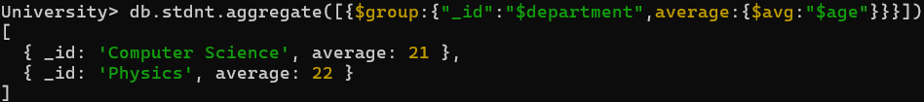
Q.8 Write a query to find all students who have scored more than 90 in any subject ?
Soln:
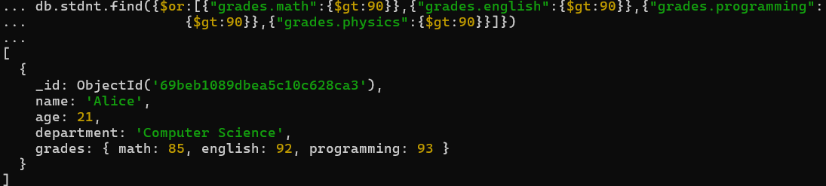
Q.9 Write a query to add a new field graduated set to false for all students who are in the Mathematics department ?
Soln:
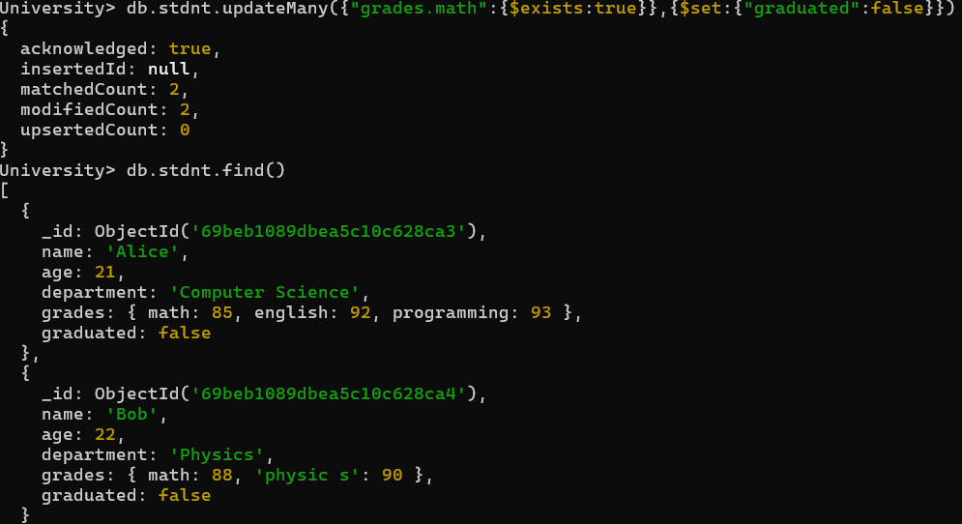
Q.10 How can you retrieve only the name and department fields for all students, excluding the _id field ?
Soln:
