Assignment D MongoDB

Q-1: Display all employees who have MongoDB skill ?
Soln:
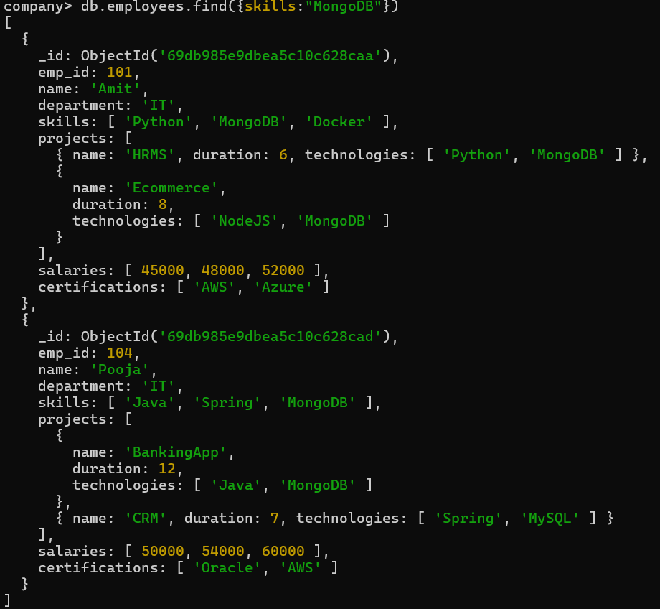
Q-2 Find employees having both Python and MongoDB skills ?
Soln:
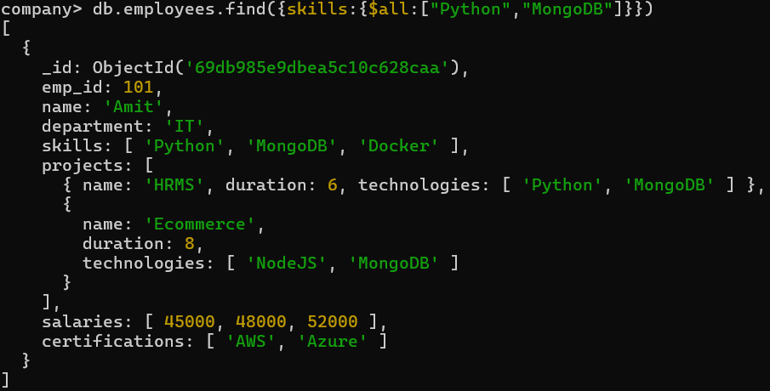
Q-3 Display employees with more than 2 skills ?
Soln:
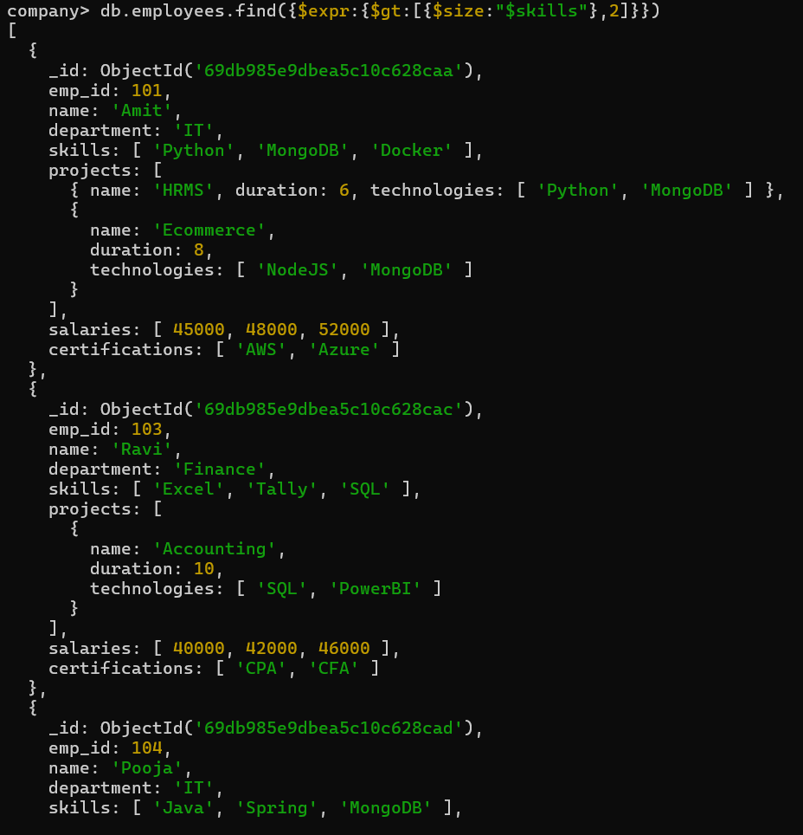
Q-4 Add a new skill "Kubernetes" to Amit ?
Soln:
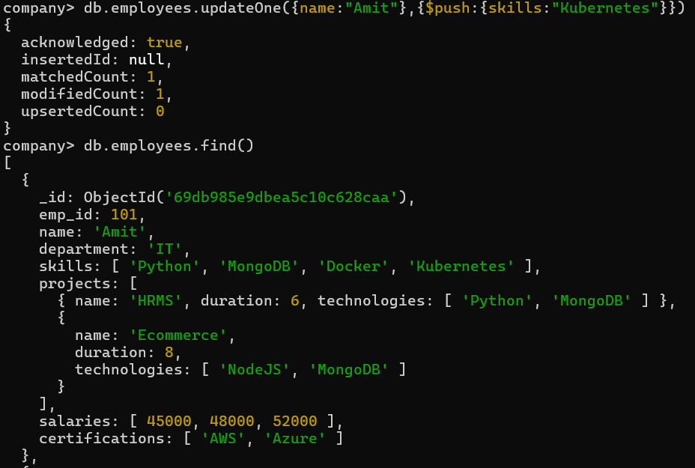
Q-5 Add multiple skills to Pooja ?
Soln:
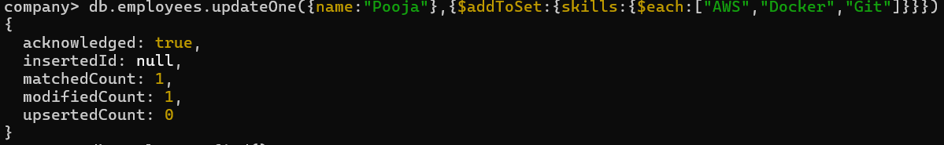
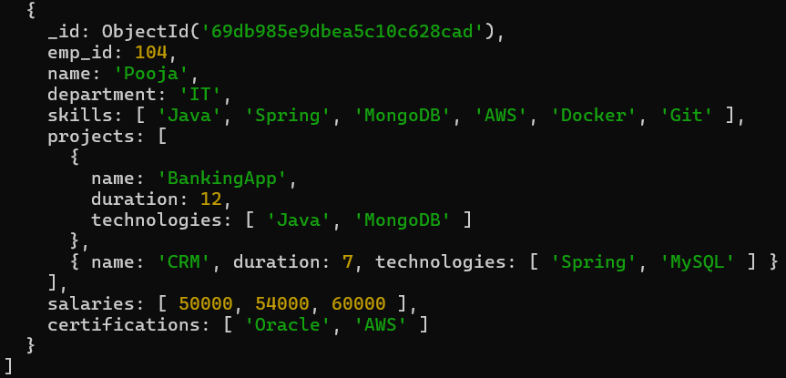
Q-6 Add a certification only if not already present ?
Soln:
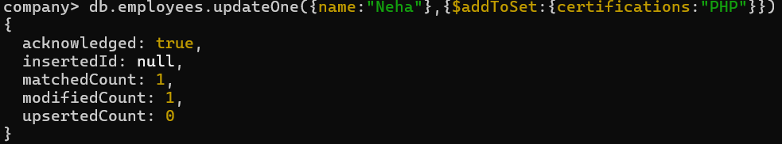
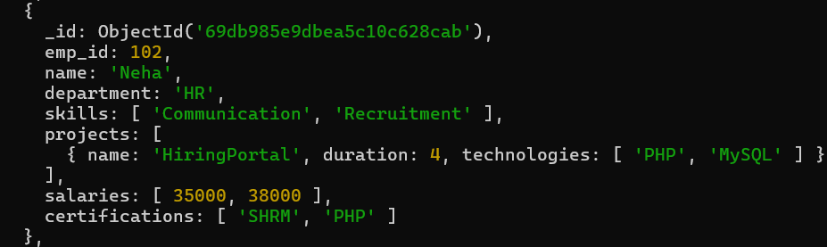
Q-7 Remove "Docker" skill from Amit ?
Soln:
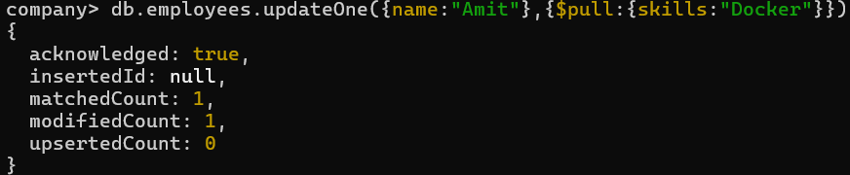
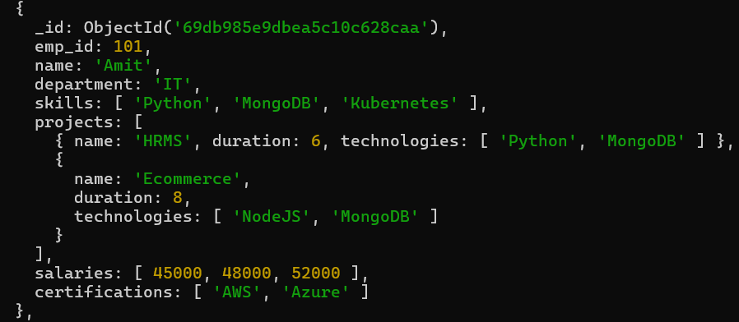
Q-8 Remove multiple salaries less than 45000 ?
Soln:
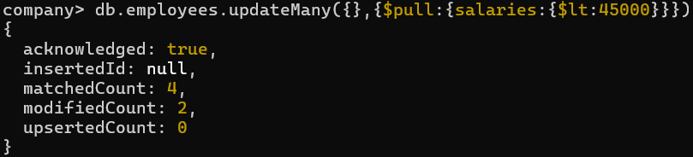
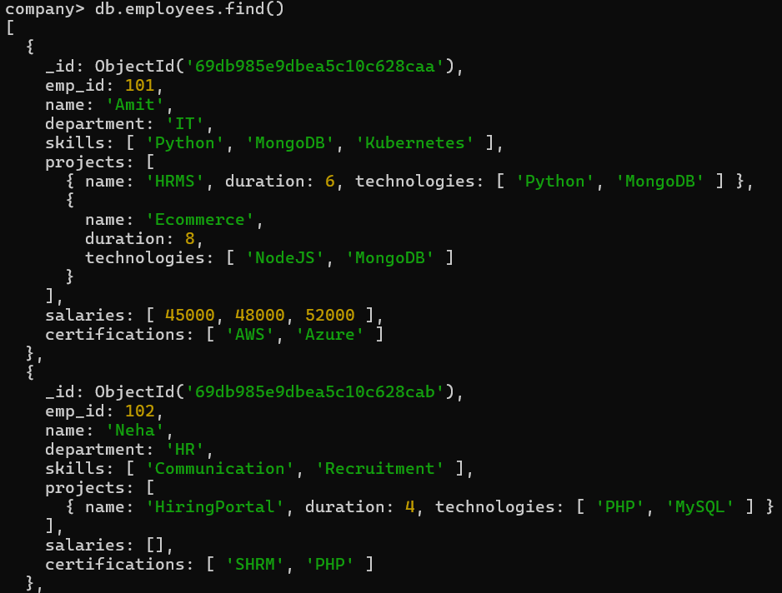
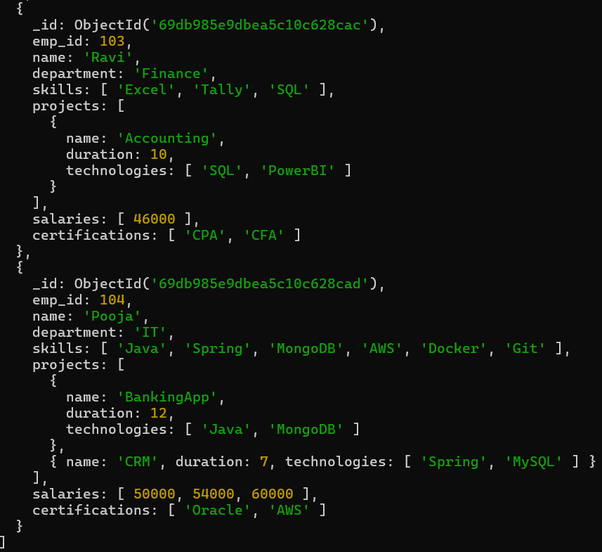
Q-9 Find employees who worked on MongoDB projects ?
Soln:
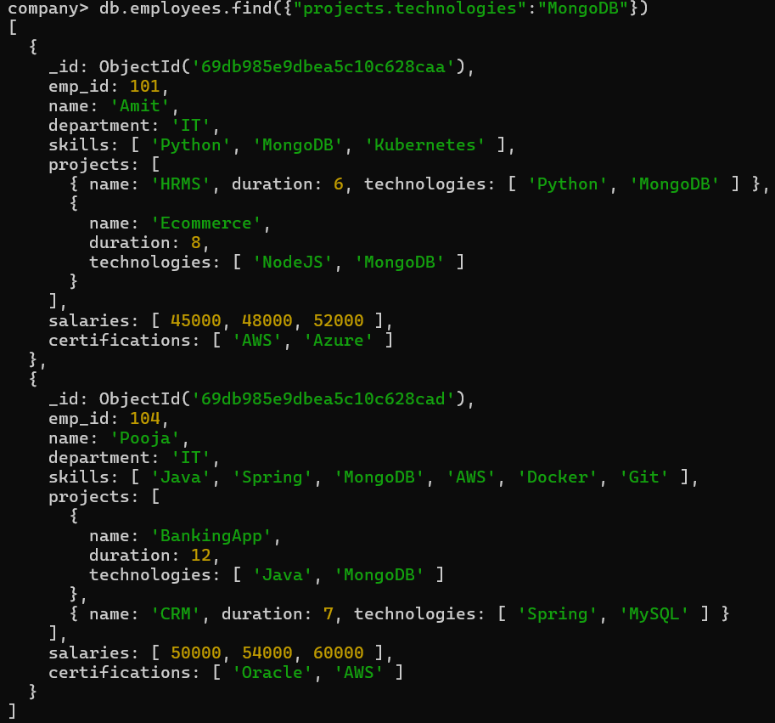
Q-10 Use $elemMatch to find project duration > 6 using MongoDB ?
Soln:
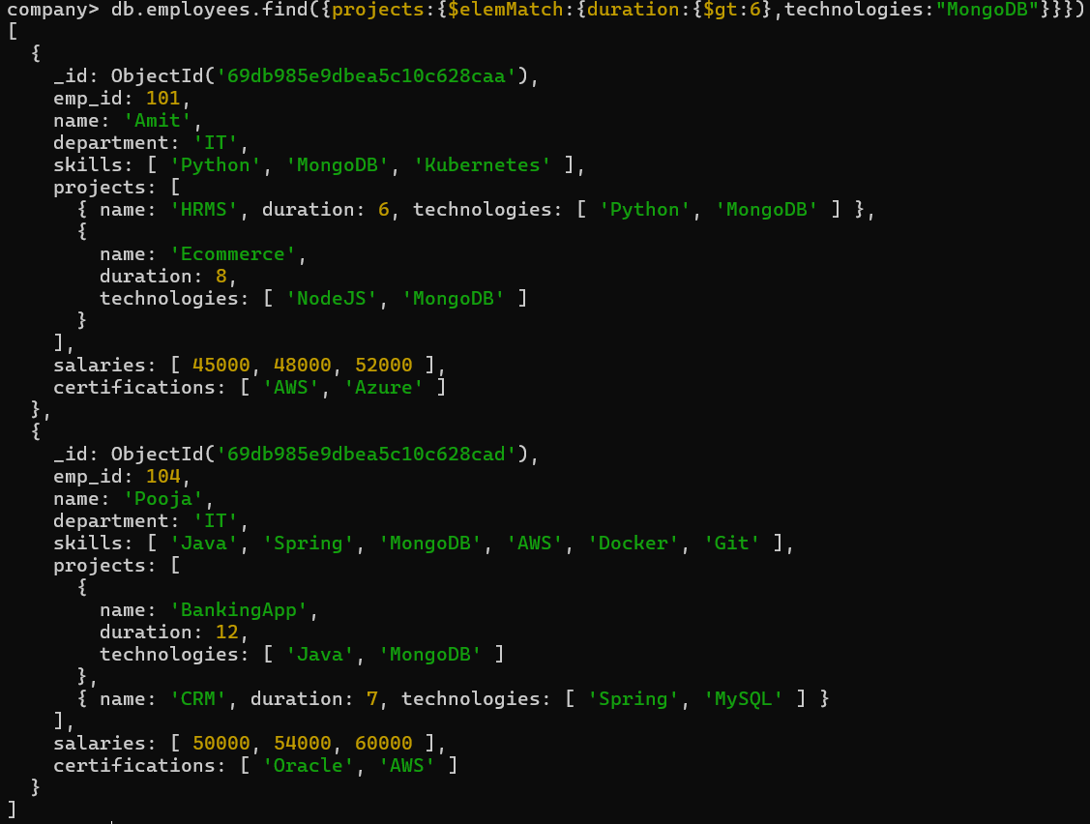
Q-11Count number of projects for each employee ?
Soln:
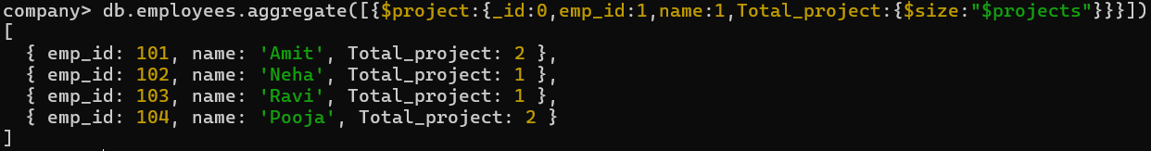
Q-12 Unwind skills array ?
Soln:
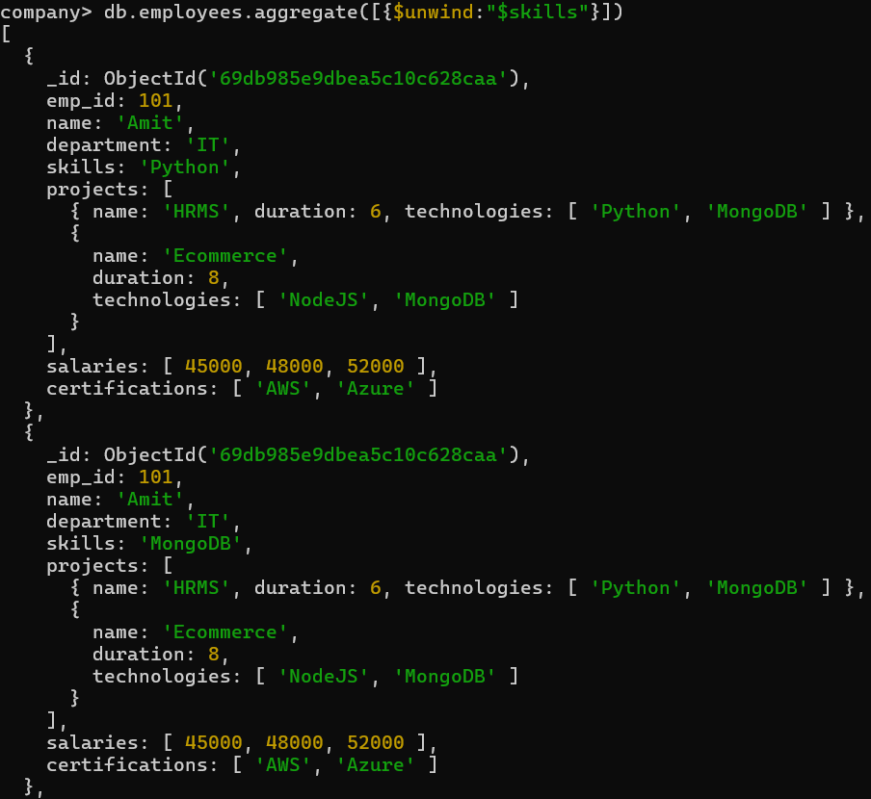
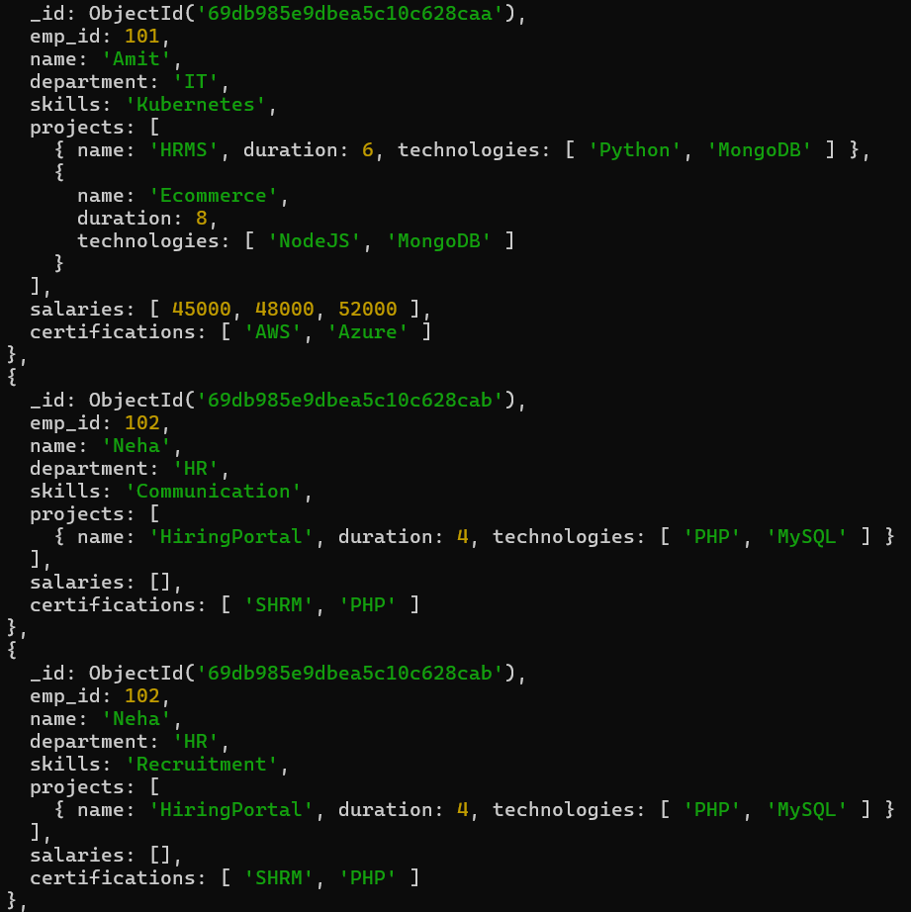
Q-13 List unique skills across company ?
Soln:
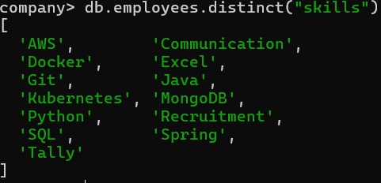
Q-14 Find employees with salary greater than 50000 ?
Soln:
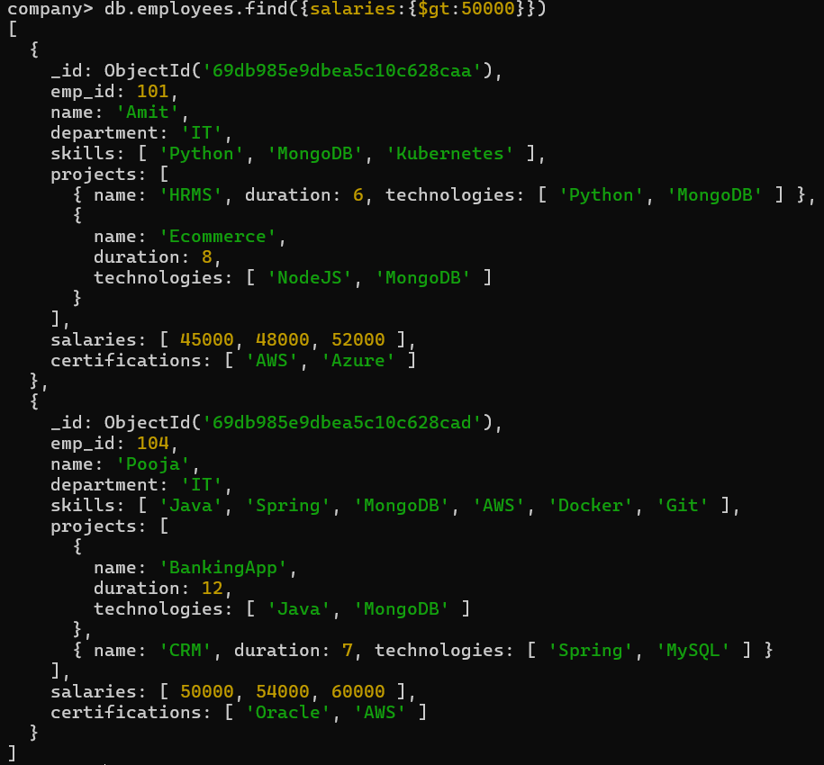
Q-15 Find employees with exactly 2 certifications ?
Soln:
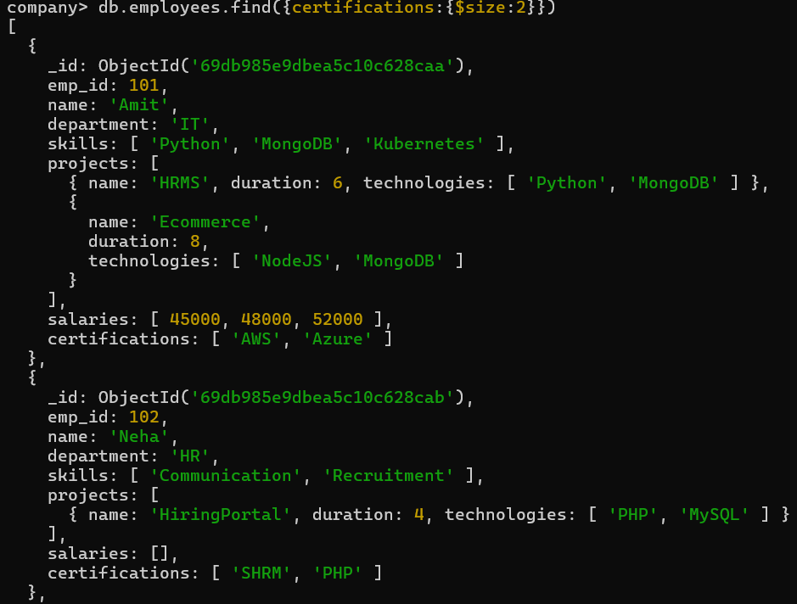
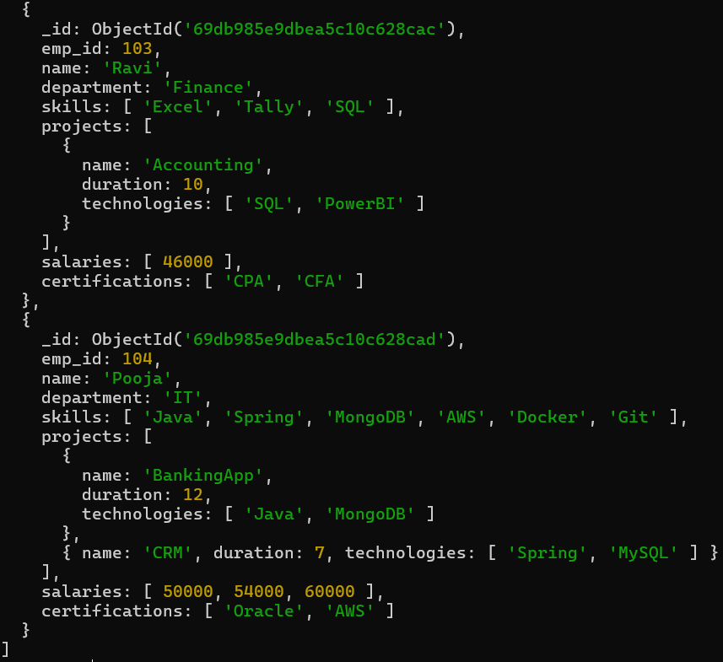
Q-16 Add new project to Ravi ?
Soln:
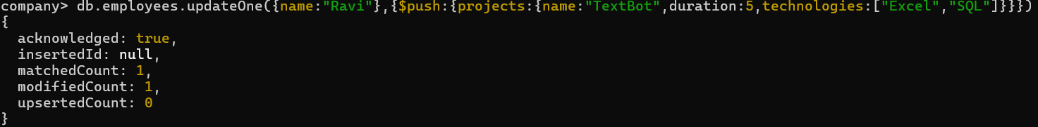
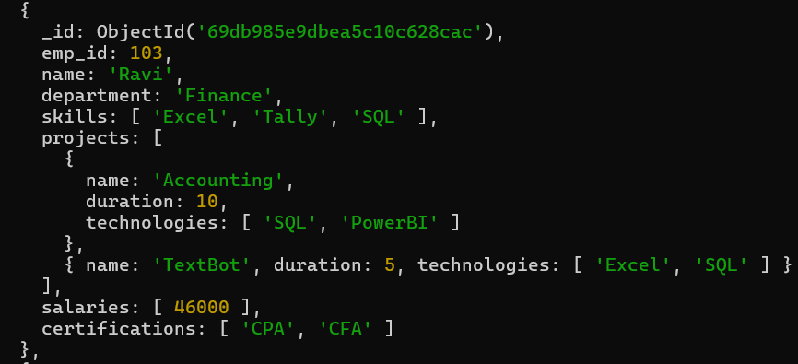
Q-17 Increase all salaries by 10% (array update) ?
Soln:
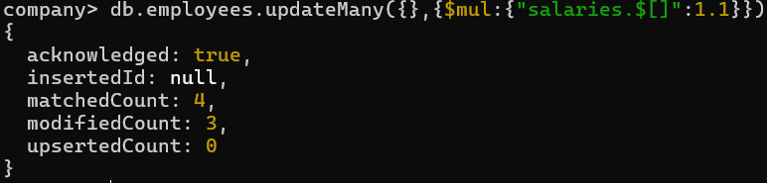
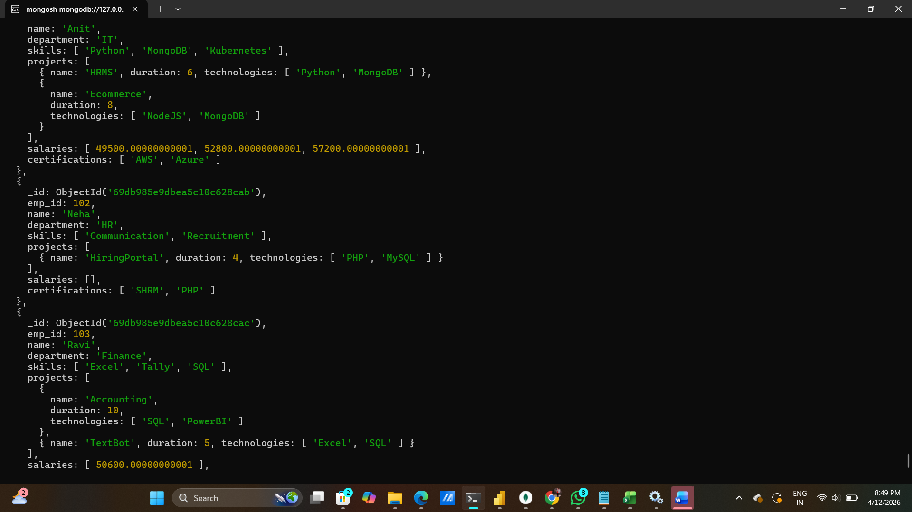
Q-18 Find highest salary of each employee ?
Soln:
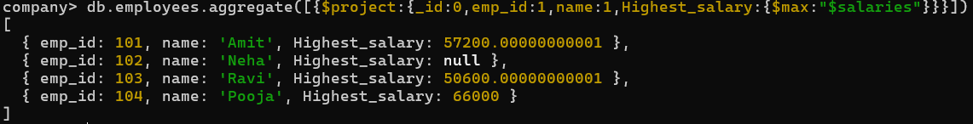
Q-19 Find average salary of employees ?
Soln:
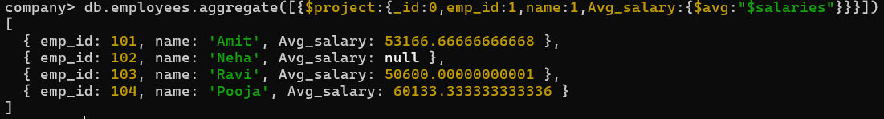
Q-20 Filter projects longer than 6 months ?
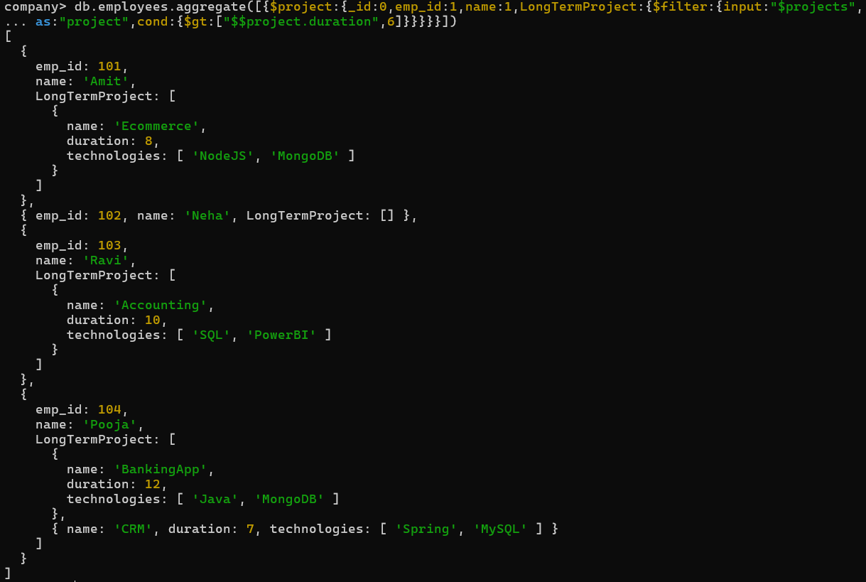
Q-21 Find employees who have any of these skills: Java or Python ?
Soln:
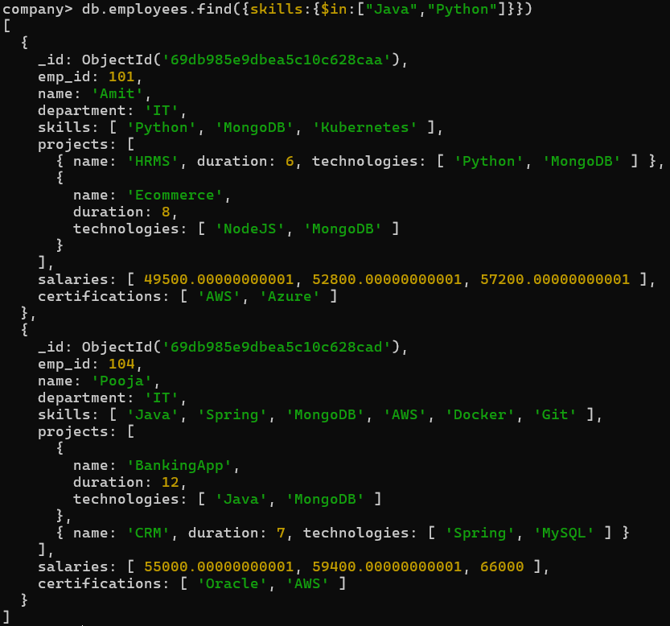
Q-22 Remove last salary entry ?
Soln:
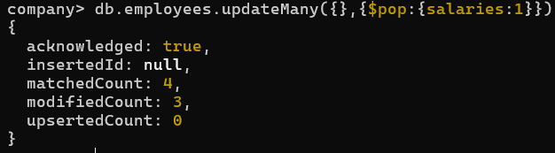
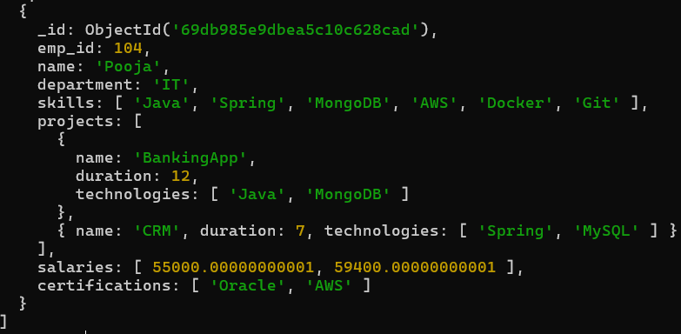
Q-23 Remove first salary entry ?
Soln:
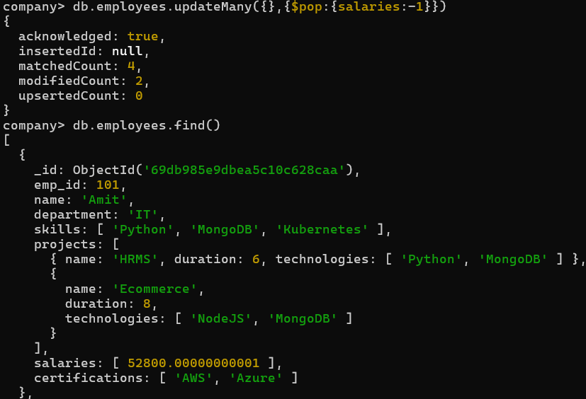
Q-24 Sort salaries array ?
Soln:
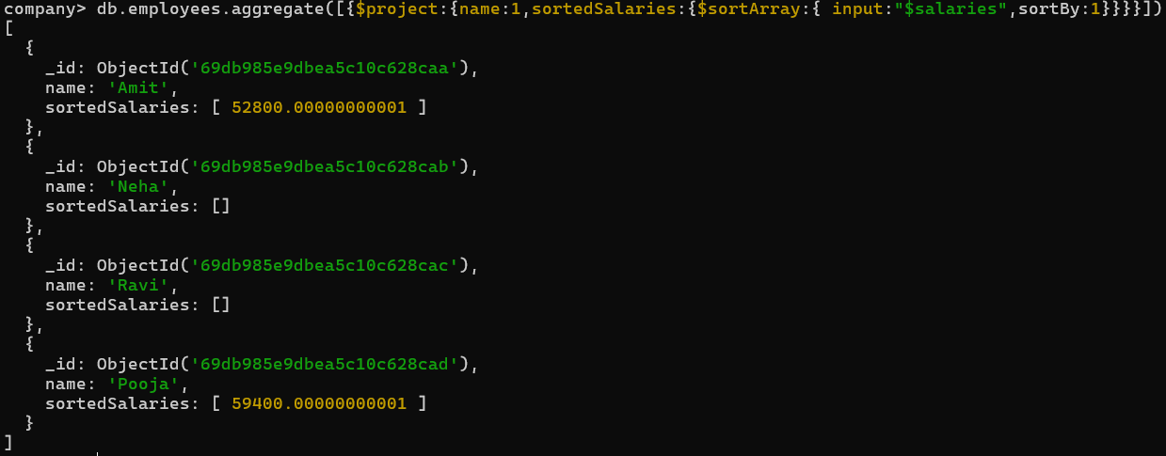
Q-25 Limit salaries array to last 2 entries ?
Soln:
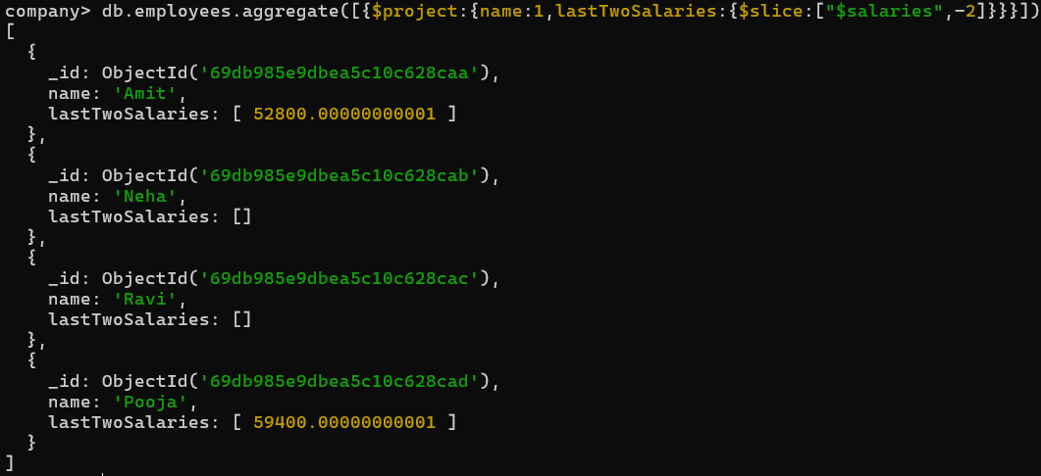
Q-26 Find total salary paid to each employee ?
Soln:
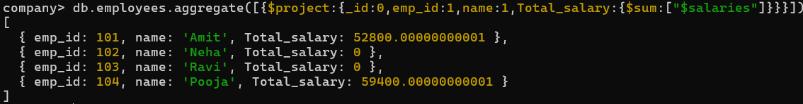
Q-27 Convert skills to uppercase ?
Soln:
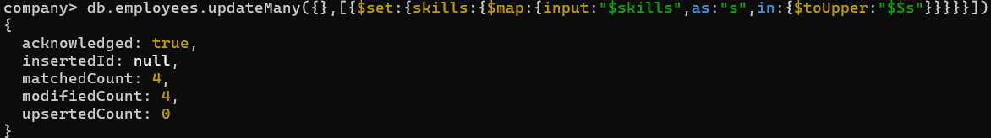
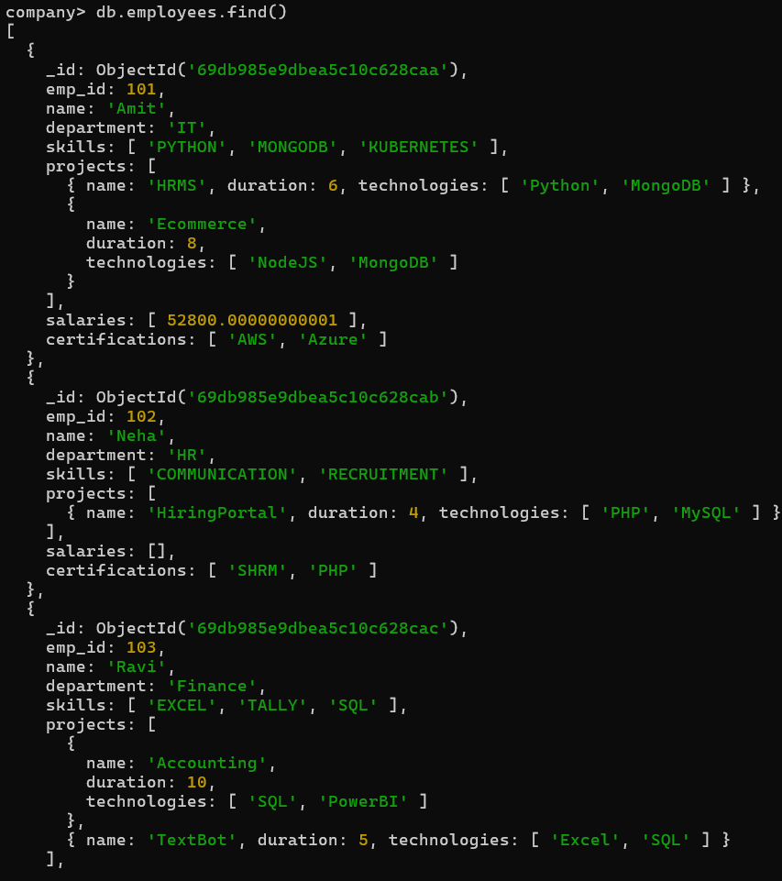
Q-28 Find employees with more than one project ?
Soln:
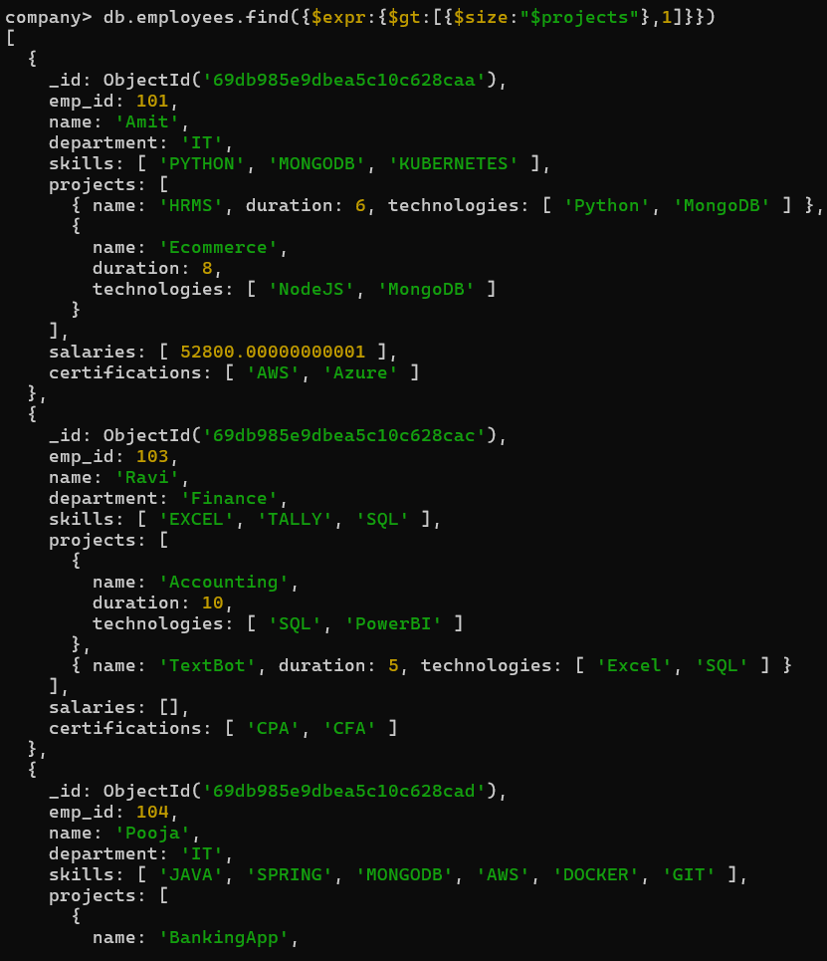
Q-29 Count employees per skill ?
Soln:
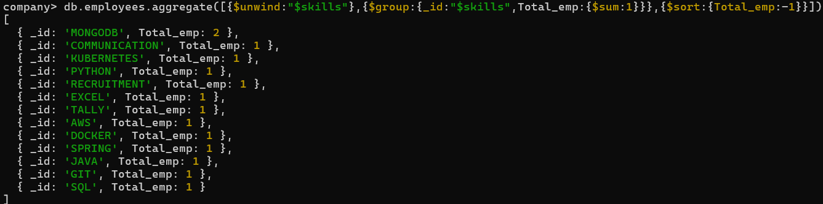
Q-30 Find employees whose all projects use MongoDB ?
Soln:
