Make the Img file

Folder Direction

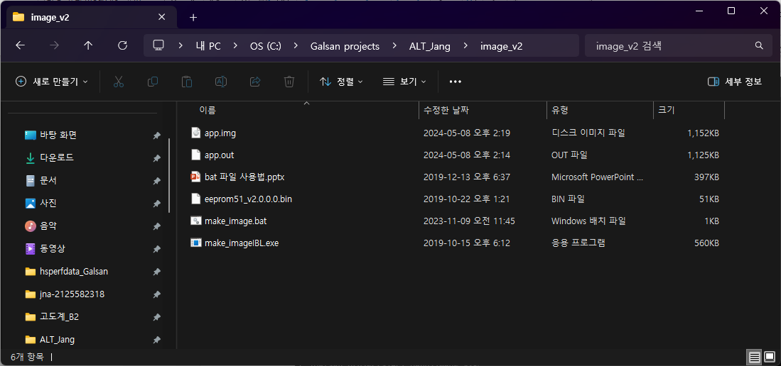

CMD window

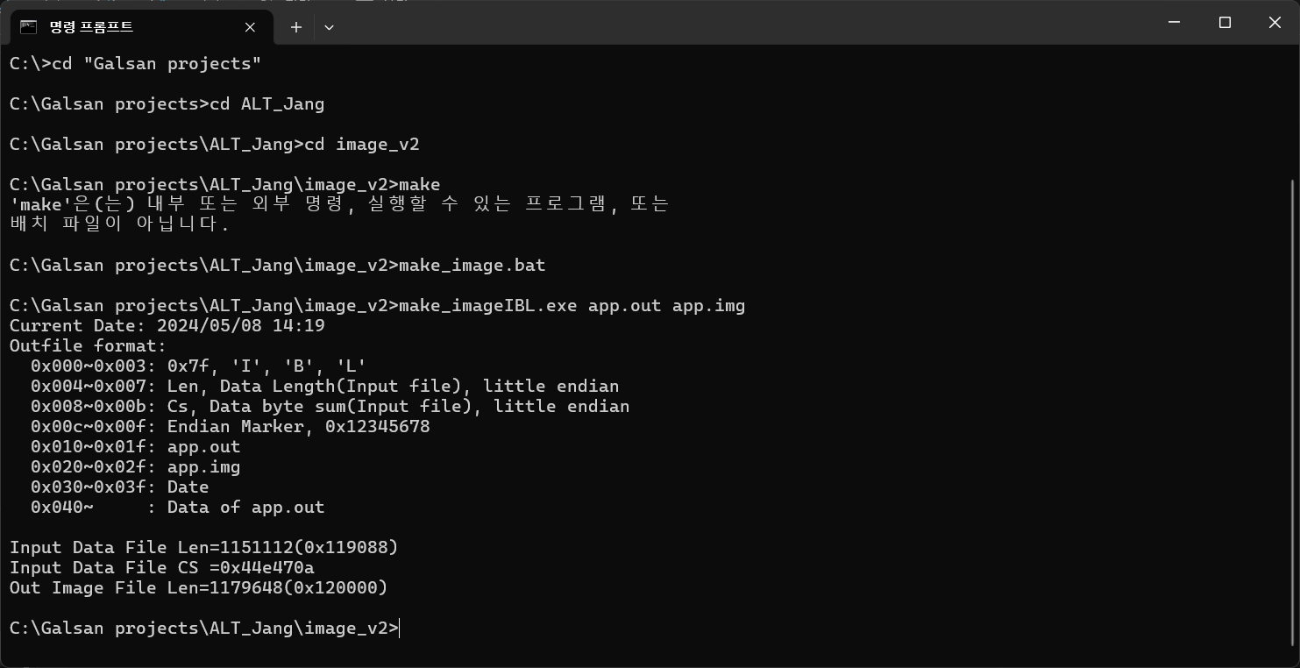

Change it to .img to bin

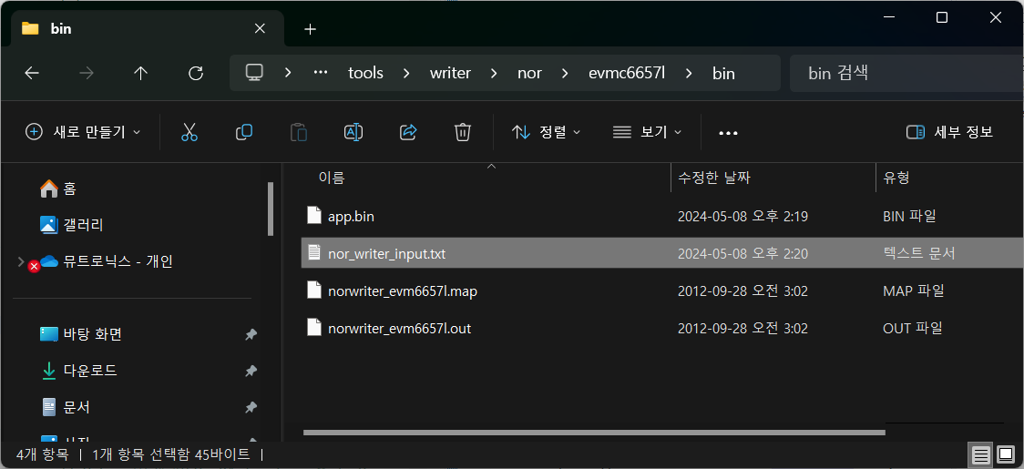

Copy to bin file

C:\ti\mcsdk_2_01_01_04\tools\writer\nor\evmc6657l\bin

nor_writer_input.txt

file_name = app.bin

start_addr = 2097152

Run->Load

C:\ti\mcsdk_2_01_01_04\tools\writer\nor\evmc6657l\bin-> norwriter_evm6657l.out file

View->Memory Browser->

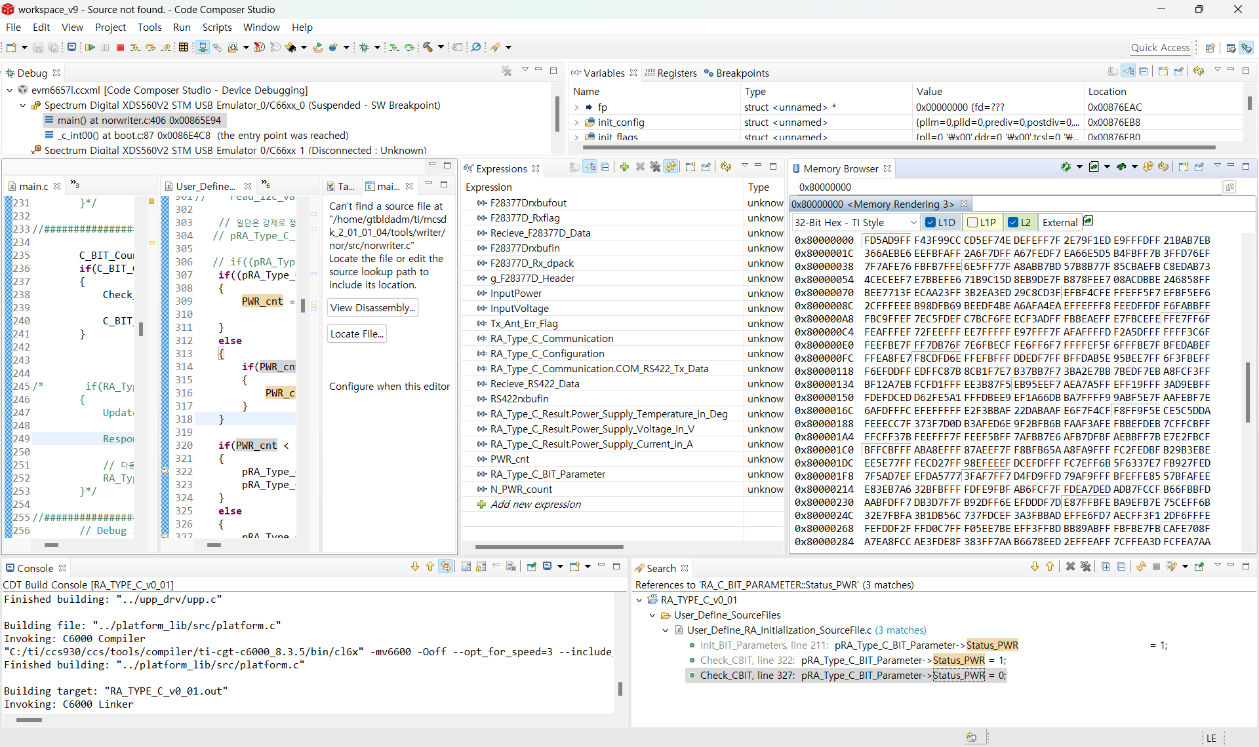ㅋStart address: 0x80000000

Mouse right ->Load Memory

C:\ti\mcsdk_2_01_01_04\tools\writer\nor\evmc6657l\bin

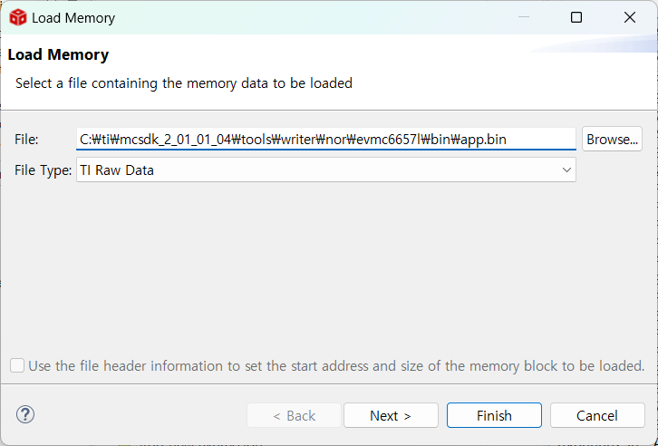

Next

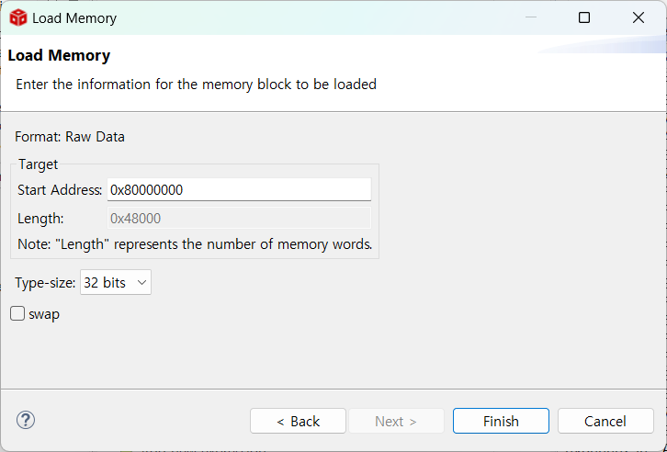

Finish

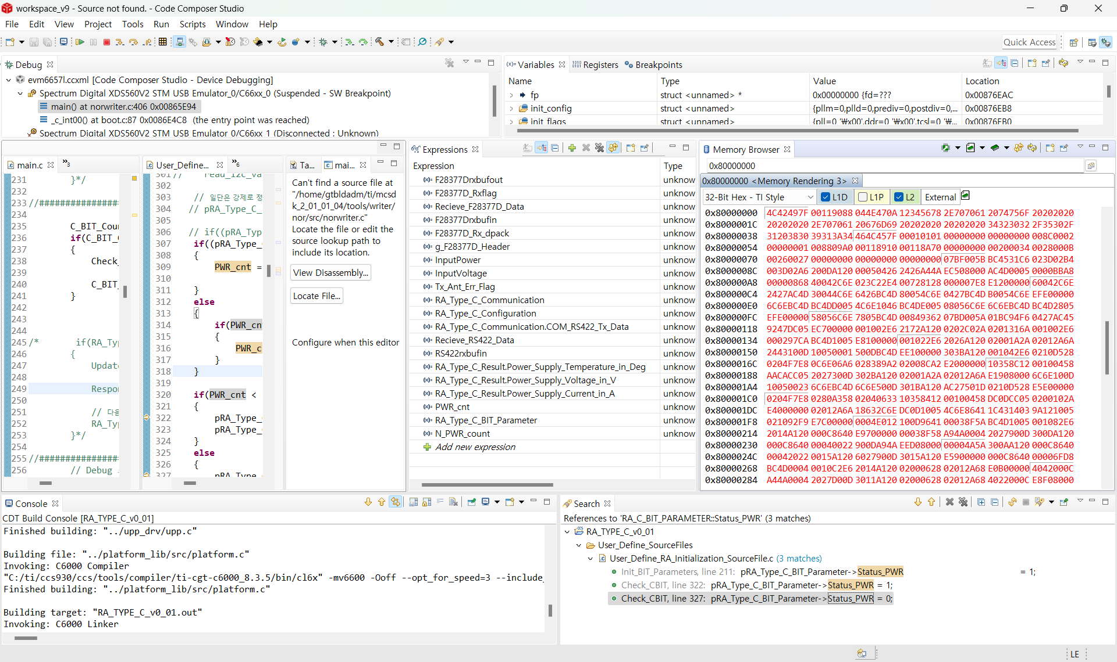

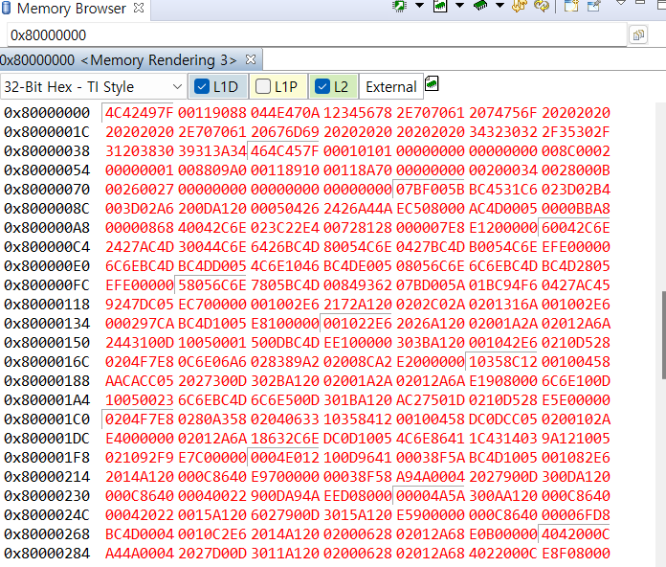

Run

You see below on the Console

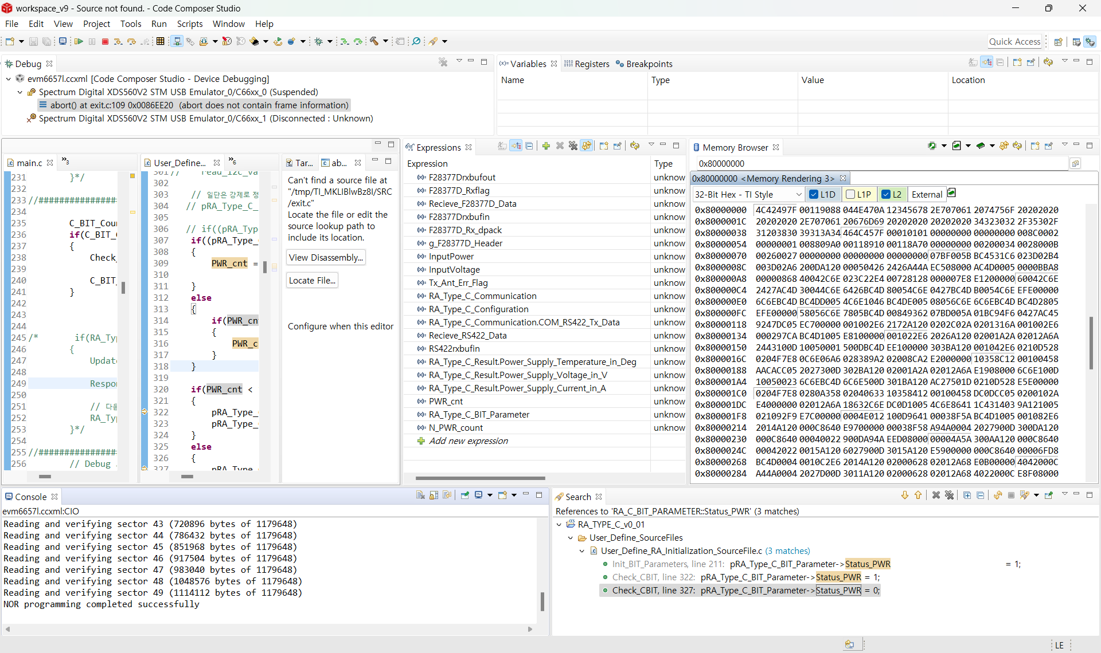

You can show after nor programming completed successfully.