Task 6: Power BI Dashboard
E-Commerce Sales & Customer Performance Dashboard
September 2026

1. Overview
This document presents an interactive Power BI dashboard design built on the cleaned E-Commerce Sales dataset (1,996 orders, Jan 2023 – Dec 2024). Section 2 shows the dashboard design — a full-resolution mockup rendered directly from the project's real, cleaned data so every number matches the analysis in Tasks 3–5. Section 3 provides the exact step-by-step build guide (data model, DAX measures, visual types, filters, and layout) needed to recreate this as a live, interactive .pbix file in Power BI Desktop, using the accompanying data file ecommerce_sales_for_powerbi.xlsx.
Note: Power BI Desktop is a Windows application and is not available to run directly in this environment, so the dashboard below was designed and laid out here, then rendered as an image for documentation. It reflects exactly what the finished .pbix dashboard will show once the build steps in Section 3 are followed against the provided data file — a matter of minutes in Power BI Desktop.

2. Dashboard Design
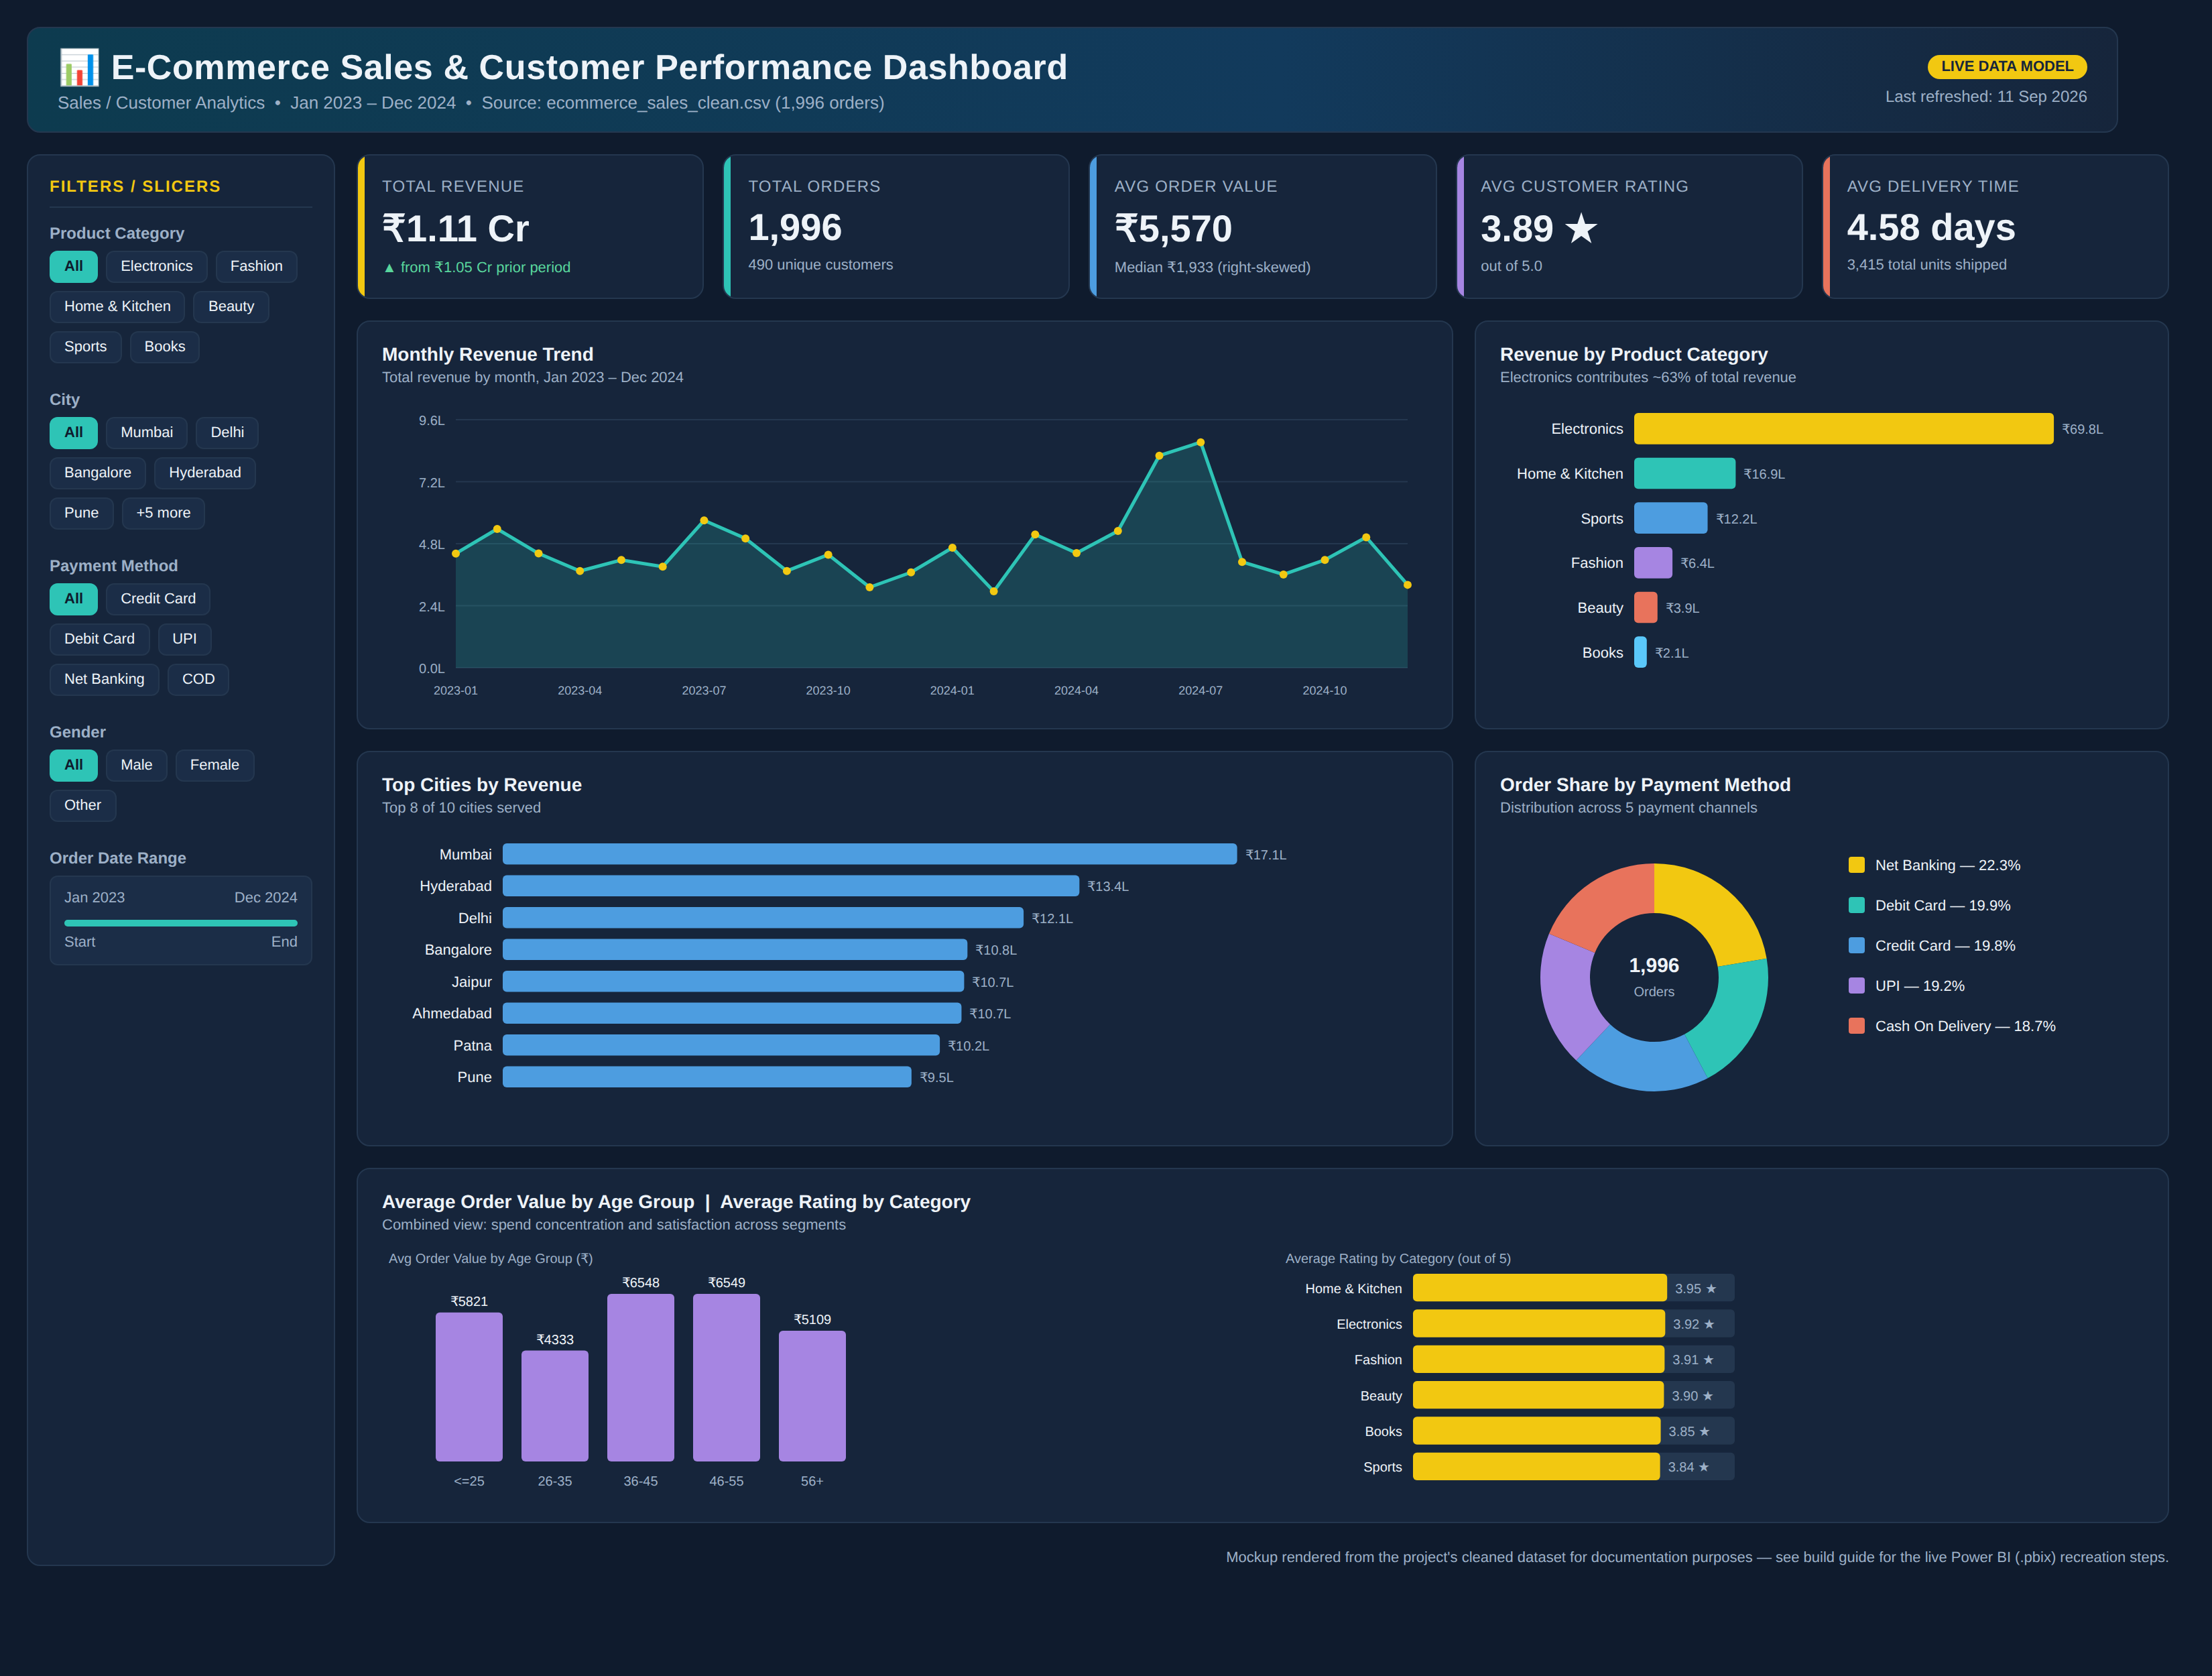
E-Commerce Sales & Customer Performance Dashboard — full design, rendered from the actual cleaned dataset.

2.1 Dashboard Components
Component | Count | Details
KPI Cards | 5 | Total Revenue, Total Orders, Avg Order Value, Avg Customer Rating, Avg Delivery Time
Visualizations | 5 | Line chart, category bar chart, city bar chart, donut chart, dual bar chart (age group + rating)
Slicers / Filters | 5 | Product Category, City, Payment Method, Gender, Order Date Range
Dashboard Title | 1 | "E-Commerce Sales & Customer Performance Dashboard" with domain, date range, and data source subtitle

2.2 KPI Cards — Business Metrics
KPI | Value | Why it matters
Total Revenue | ₹1.11 Cr | Top-line business performance across the full period
Total Orders | 1,996 | Order volume; denominator for all rate-based metrics
Avg Order Value (AOV) | ₹5,570 | Revenue efficiency per transaction; median (₹1,933) shown alongside to flag the right-skew
Avg Customer Rating | 3.89 / 5 | Overall customer satisfaction signal
Avg Delivery Time | 4.58 days | Operational/fulfilment performance

2.3 Visualizations and What They Communicate
- Monthly Revenue Trend (line chart): reveals the mid-2024 revenue spike identified in the EDA and overall month-to-month volatility.
- Revenue by Product Category (bar chart): shows Electronics contributing ~63% of total revenue despite similar order counts to other categories.
- Top Cities by Revenue (horizontal bar chart): shows a geographically diversified base, with Mumbai, Hyderabad, and Delhi leading.
- Order Share by Payment Method (donut chart): confirms no single payment channel dominates (18–22% each).
- Avg Order Value by Age Group / Avg Rating by Category (combined panel): surfaces the 36–55 age band as the highest-value segment, and shows ratings are consistently strong (3.84–3.95) across all categories.

3. Power BI Build Guide (Recreate as a Live .pbix)
Follow these steps in Power BI Desktop to recreate the dashboard above as a fully interactive report, using the supplied ecommerce_sales_for_powerbi.xlsx data file.

3.1 Load and Prepare Data
- Open Power BI Desktop → Get Data → Excel workbook → select ecommerce_sales_for_powerbi.xlsx → load the SalesData sheet.
- In Power Query Editor, confirm data types: OrderDate as Date, Price/TotalAmount/ShippingCost as Decimal Number, Quantity/DeliveryDays/OrderYear as Whole Number, Rating as Decimal Number, and all remaining text columns as Text.
- Create a dedicated Date table for time intelligence: Modeling → New Table, then use the DAX formula below, and mark it as a Date Table (Mark as Date Table → OrderDate).
DateTable = CALENDAR(MIN(SalesData[OrderDate]), MAX(SalesData[OrderDate]))
- Relate DateTable[Date] (1) to SalesData[OrderDate] (many) in the Model view.

3.2 Create DAX Measures (for KPI Cards)
Create the following measures in a new table (e.g., _Measures) via Modeling → New Measure:
Total Revenue = SUM(SalesData[TotalAmount])
Total Orders = DISTINCTCOUNT(SalesData[OrderID])
Avg Order Value = DIVIDE([Total Revenue], [Total Orders])
Median Order Value = MEDIAN(SalesData[TotalAmount])
Avg Rating = AVERAGE(SalesData[Rating])
Avg Delivery Days = AVERAGE(SalesData[DeliveryDays])
Total Units Sold = SUM(SalesData[Quantity])
Unique Customers = DISTINCTCOUNT(SalesData[CustomerID])
Revenue Prior Period = CALCULATE([Total Revenue], DATEADD(DateTable[Date], -1, YEAR))
Revenue Growth % = DIVIDE([Total Revenue] - [Revenue Prior Period], [Revenue Prior Period])
Format 'Total Revenue' and 'Revenue Prior Period' with a currency (₹) format and use thousands/lakh display units; format 'Revenue Growth %' as a percentage.

3.3 Build the KPI Cards
- Insert → Card (New Card visual, recommended for Power BI's modern card style) for each of: Total Revenue, Total Orders, Avg Order Value, Avg Rating, Avg Delivery Days.
- Set each card's data label to the corresponding measure; add a small callout/comparison value (e.g., Revenue Growth %) as the card's secondary field where supported.
- Arrange the 5 cards in a single horizontal row at the top of the canvas, directly below the title.

3.4 Build the Visualizations
Visual | Type | Fields | Notes
Monthly Revenue Trend | Line chart | Axis: DateTable[Date] (Month); Values: [Total Revenue] | Enable 'Show data labels' off; add trend line if desired
Revenue by Product Category | Clustered bar chart | Axis: ProductCategory; Values: [Total Revenue] | Sort descending by revenue
Top Cities by Revenue | Clustered bar chart | Axis: City; Values: [Total Revenue] | Sort descending; use Top N filter (8) if needed
Order Share by Payment Method | Donut chart | Legend: PaymentMethod; Values: [Total Orders] | Enable data labels as percentage of total
Avg Order Value by Age Group | Column chart | Axis: AgeGroup; Values: [Avg Order Value] | Sort axis in natural age order (<=25, 26-35, ...56+)
Avg Rating by Category | Bar chart | Axis: ProductCategory; Values: [Avg Rating] | Set axis min=0, max=5 for consistent scale
- Arrange the six visuals in a 2-column grid below the KPI row: Monthly Trend and Category Revenue on row 1; City Revenue and Payment Donut on row 2; Age Group AOV and Category Rating side-by-side on row 3.

3.5 Add Slicers / Filters
- Insert a Slicer visual for ProductCategory — set to 'Tile' layout for the chip-style look.
- Insert a Slicer visual for City — 'Tile' or 'Dropdown' layout (dropdown recommended given 10 values).
- Insert a Slicer visual for PaymentMethod — 'Tile' layout.
- Insert a Slicer visual for Gender — 'Tile' layout.
- Insert a Slicer visual for DateTable[Date] — set to 'Between' style for a range slider.
- Place all five slicers in a vertical panel on the left side of the canvas, and sync them across report pages if additional pages are added (View → Sync Slicers).

3.6 Layout and Formatting
- Add a Text Box at the top spanning the full canvas width titled "E-Commerce Sales & Customer Performance Dashboard" with a subtitle noting the domain and date range — this is the Dashboard Title requirement.
- Use a consistent theme: apply a custom Power BI theme (View → Themes → Browse for themes) with a dark navy background and gold/teal/blue accent colors to match the design shown in Section 2.
- Keep consistent card and visual padding, align all visual edges to the grid (View → Gridlines and Snap to Grid), and group the 5 KPI cards as a single object for easy repositioning.
- Add a footer text box with the data source and last-refreshed date.
- Publish to the Power BI Service (Home → Publish) if a shareable, browser-based interactive version is needed.

3.7 Interactivity Checklist
- Confirm that clicking any bar/segment cross-filters the other visuals and KPI cards (default Power BI behavior — verify under Format → Edit Interactions).
- Test each slicer independently and in combination (e.g., City = Mumbai + Category = Electronics) to confirm KPI cards and charts update correctly.
- Verify the Date Range slicer correctly filters the Monthly Revenue Trend line chart via the DateTable relationship.

4. Files Provided
File | Purpose
ecommerce_sales_for_powerbi.xlsx | Cleaned, analysis-ready dataset formatted for direct import into Power BI
dashboard_mockup.png | Full-resolution dashboard design (also embedded in Section 2 above)
Ecommerce_Analytics_Project_Report.docx / Task3–5 reports | Supporting analysis that the dashboard's KPIs and charts are derived from
Together, these allow the dashboard to be reproduced exactly as designed in a live Power BI Desktop session, fully interactive with working slicers, cross-filtering, and drill-down.

