Data Analytics Internship Project
Dataset Selection, Data Preparation, Exploratory Data Analysis & Visualization
Domain: E-Commerce Sales & Customer Analytics
Covers Task 3 (Data Preparation), Task 4 (Exploratory Data Analysis) and Task 5 (Data Visualization)
September 2026

Task 3: Dataset Selection & Data Preparation

3.1 Dataset Selection
The dataset chosen for this project is a simulated E-Commerce Sales dataset, representing the Sales / Customer Analytics domain. It contains 2,035 order-level records across 15 original columns, covering customer demographics, product details, pricing, discounts, shipping, delivery performance, and customer ratings. This domain was selected because e-commerce transaction data naturally contains the variety of real-world data-quality issues (missing values, duplicate orders, inconsistent formatting, and outliers) that are essential to practice cleaning and analysis techniques.

3.2 Data Inspection
The dataset was first inspected using standard exploratory functions (.head(), .info(), .describe(), .dtypes) to understand its structure, size, and content before any cleaning was performed.
Property | Value
Initial rows | 2,035
Initial columns | 15
Time period covered | January 2023 - December 2024
Granularity | One row per order

3.3 Columns and Data Types
The table below summarizes each column in the raw dataset and its identified data type.
Column | Data Type | Description
OrderID | Integer | Unique order identifier
CustomerID | Integer | Customer identifier (repeat customers present)
Gender | Text (categorical) | Male / Female / Other
Age | Float (numeric) | Customer age in years
City | Text (categorical) | Customer's city
ProductCategory | Text (categorical) | Product category, e.g., Electronics
ProductName | Text (categorical) | Specific product ordered
Quantity | Integer | Units ordered
Price | Float (numeric) | Unit price in ₹
DiscountPercent | Integer | Discount applied (%)
OrderDate | Datetime | Date the order was placed
ShippingCost | Float (numeric) | Shipping charge in ₹
DeliveryDays | Integer | Days taken to deliver
Rating | Float (numeric) | Customer rating (1-5)
PaymentMethod | Text (categorical) | Mode of payment used

3.4 Identification of Missing Values
Missing-value analysis revealed gaps in five columns, summarized below (percentages are of the 2,035 raw records).
Column | Missing Count | Missing %
Rating | 153 | 7.52%
Age | 92 | 4.52%
ShippingCost | 61 | 3.00%
City | 42 | 2.06%
PaymentMethod | 35 | 1.72%

3.5 Duplicate and Incorrect Records
Beyond missing values, the raw dataset also contained duplicate rows and clearly invalid entries that needed correction before analysis:
- Exact duplicate rows: 26 (identical records appearing more than once).
- Duplicate OrderIDs with conflicting data (data-entry errors): 9 additional records.
- Negative Price values (sign errors): 6 records.
- Invalid orders with Quantity ≤ 0: 4 records.
- Inconsistent text casing in the City field (e.g., "mumbai" vs "Mumbai"): 99 values.

3.6 Handling of Missing Values and Data Cleaning
The following cleaning strategy was applied, chosen to preserve as much genuine data as possible while removing records that could distort analysis:
- Exact duplicate rows were dropped entirely (26 rows removed).
- Duplicate OrderIDs were resolved by keeping only the first occurrence (9 rows removed).
- Records with Quantity ≤ 0 were removed as invalid orders (4 rows removed).
- Negative Price values were corrected by taking the absolute value, since these were identified as sign-entry errors rather than genuinely missing data.
- Text fields (City, ProductCategory, PaymentMethod) were standardized to consistent Title Case formatting.
- Numeric missing values (Age, ShippingCost, Rating) were imputed using the median, which is robust to skew and outliers.
- Categorical missing values (City, PaymentMethod) were imputed using the mode (most frequent category).
- Extreme outliers in Price and Quantity were addressed using IQR-based capping (winsorization) in a separate derived column, preserving the original values for reference while providing an outlier-controlled version for modeling.
After cleaning, the dataset contains zero missing values and zero duplicate rows.

3.7 Dataset Preparation for Analysis
To support the exploratory analysis in Task 4, several new columns were engineered from the cleaned base data:
New Column | Purpose
TotalAmount | Price × Quantity, adjusted for discount — represents order revenue
OrderMonth | Year-Month extracted from OrderDate, used for trend analysis
OrderYear | Calendar year of the order
AgeGroup | Age binned into 5 groups (<=25, 26-35, 36-45, 46-55, 56+)
Price_Capped / Quantity_Capped | Outlier-controlled versions of Price and Quantity
Summary of the cleaning pipeline outcome:
Stage | Row Count
Initial (raw) rows | 2,035
After removing exact duplicates | 2,009
After removing duplicate OrderIDs | 2,000
After removing invalid Quantity ≤ 0 | 1,996
Final cleaned dataset (rows × columns) | 1,996 × 21

Task 4: Exploratory Data Analysis (EDA)

4.1 Descriptive Statistics
Key descriptive statistics for the numeric fields in the cleaned dataset are summarized below.
Metric | Age | Price (₹) | Quantity | TotalAmount (₹) | Rating
Mean | 35.0 | 3,145 | 1.71 | 5,595 | 3.90
Median | 35 | 1,590 | 1 | 1,933 | 4.0
Std. Dev. | 11.3 | 10,150 | 4.0 | 18,850 | 1.11
Min | 16 | 50.5 | 1 | 43.1 | 1.0
Max | 73 | 419,741 | 98 | ~750,000 | 5.0
Price, Quantity, and TotalAmount are all strongly right-skewed (skewness of 26.7, 19.1, and 12.6 respectively) with very high kurtosis, confirming the presence of a small number of extreme high-value transactions pulling the mean well above the median. ShippingCost and DeliveryDays, by contrast, are close to symmetric (skewness near 0), consistent with genuinely normal operational variation.
Categorical composition: Gender is fairly balanced between Female (~49%) and Male (~47%), with a small Other category (~4%). Orders are evenly spread across the six product categories (roughly 320-350 orders each) and across the ten cities, indicating no single segment dominates order volume.

4.2 Correlation Analysis
A Pearson correlation matrix was computed across the key numeric variables (see the heatmap in Task 5, Figure 3). The main findings are:
- Price and TotalAmount are strongly positively correlated (r = 0.79) — unsurprising, since price is a direct component of total order value.
- Quantity and TotalAmount show a moderate positive correlation (r = 0.40), showing that both price and quantity independently drive revenue.
- Age, DiscountPercent, ShippingCost, DeliveryDays, and Rating all show negligible correlation (|r| < 0.05) with each other and with revenue, indicating these operational and demographic factors behave largely independently of order value in this dataset.
- Discount percentage shows a very weak negative correlation with TotalAmount (r = -0.04), suggesting discounts alone are not a strong lever of order value in this data.

4.3 Important Patterns and Trends
- Revenue by category: Electronics dominates revenue (≈₹69.8 lakh total, average order value ≈₹21,204), despite having a similar order count to other categories — driven by high unit prices rather than volume.
- Monthly trend: Revenue fluctuates between ≈₹2.95 lakh and ₹8.72 lakh per month, with a notable revenue peak in mid-2024 (June-July 2024), suggesting a seasonal or promotional spike worth further business investigation.
- Geographic spread: Mumbai, Hyderabad, and Delhi are the top three revenue-generating cities, though the spread across all ten cities is fairly even (no single city exceeds ~14% of total revenue), indicating a geographically diversified customer base.
- Age and spend: Customers aged 36-55 show the highest average order value (≈₹6,550), while the youngest group (≤25) and oldest group (56+) spend somewhat less on average.
- Gender and spend: The 'Other' gender group has the highest average order value (≈₹7,361), followed by Female (≈₹5,984) and Male (≈₹4,978), though this group is a small sample (83 orders).
- Payment methods: Usage is well distributed across all five payment modes (Net Banking leads at 22.3%, others between 18.7% and 19.9%), indicating no single payment channel dominates.
- Ratings by category: Average ratings are consistently high across all categories (3.84 to 3.95 out of 5), with Home & Kitchen products rated slightly higher and Sports products slightly lower.

4.4 Outlier Identification
Outliers were identified using the Interquartile Range (IQR) method (values beyond Q1 - 1.5×IQR or Q3 + 1.5×IQR).
Variable | IQR Bounds | Outlier Count | % of Data
Price | ₹-2,851 to ₹6,708 | 312 | 15.6%
TotalAmount | ₹-4,471 to ₹9,605 | 309 | 15.5%
Quantity | -0.5 to 3.5 | 129 | 6.5%
ShippingCost | ₹-28.6 to ₹187.2 | 7 | 0.4%
DeliveryDays | -1.5 to 10.5 days | 3 | 0.2%
The relatively high outlier share in Price/TotalAmount (~15.5%) is expected in e-commerce data: it mainly reflects genuinely expensive Electronics purchases (laptops, smartphones) sitting alongside low-cost Books and Beauty items, rather than data errors. A small number of extreme values (8 records) were confirmed as true anomalies (prices 15-25x above the category norm) and were addressed via IQR-based capping in the Price_Capped column. ShippingCost and DeliveryDays show very few outliers, confirming these operational metrics are well-controlled.

4.5 Summary of Findings
The cleaned e-commerce dataset shows a business with broad, well-diversified performance across product categories, cities, and payment methods, with Electronics as the primary revenue driver due to high price points rather than order volume. Order value is fundamentally explained by price and quantity, while demographic factors (age, gender) and service factors (shipping cost, delivery speed) show only mild associations with spend. Customer satisfaction (ratings) remains consistently favorable across all segments. The main data-quality challenges — missing values, duplicate orders, sign errors, and price outliers — were all successfully identified and resolved, leaving a clean, analysis-ready dataset of 1,996 records.

Task 5: Data Visualization
Eight charts were created to visually communicate the key patterns identified during EDA. Each chart uses a clear title, labeled axes, and an appropriate chart type for the data being shown.

Figure 1: Monthly Revenue Trend
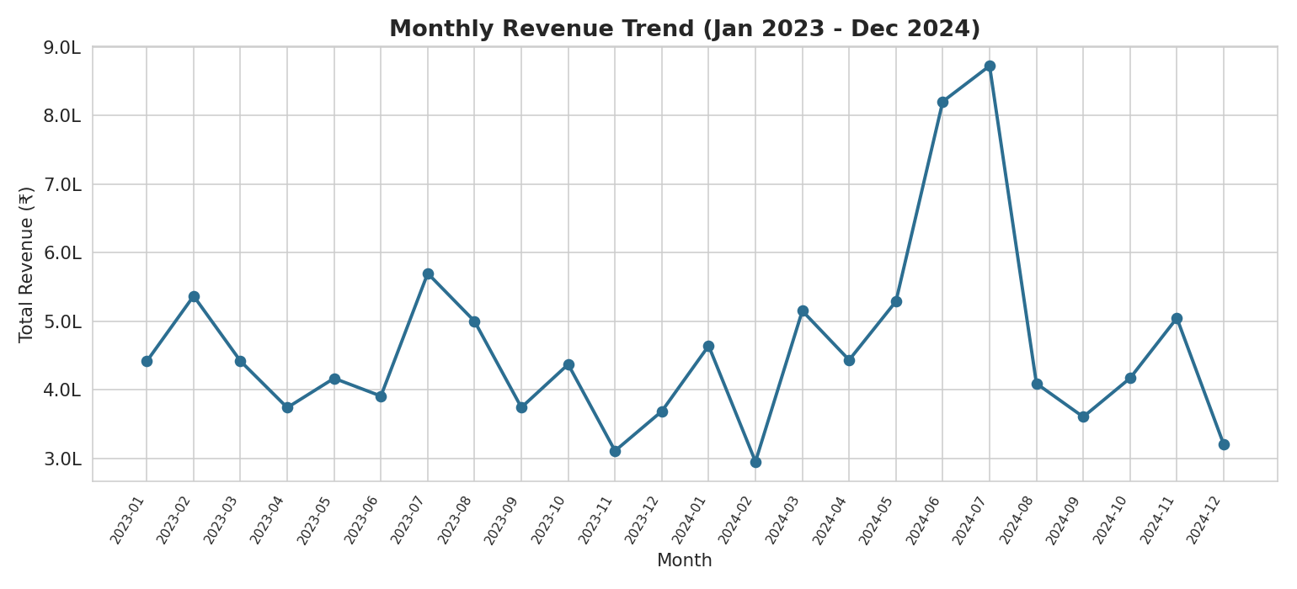
A line chart showing total revenue by month across 2023-2024, revealing overall fluctuation and a peak around mid-2024.

Figure 2: Revenue by Product Category
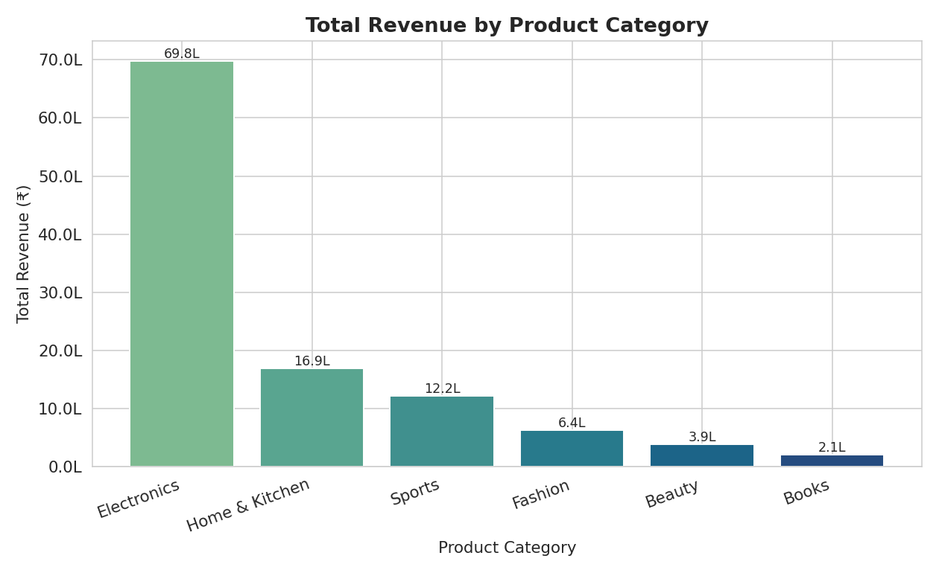
A bar chart comparing total revenue generated by each product category, showing Electronics as the clear leader.

Figure 3: Correlation Heatmap
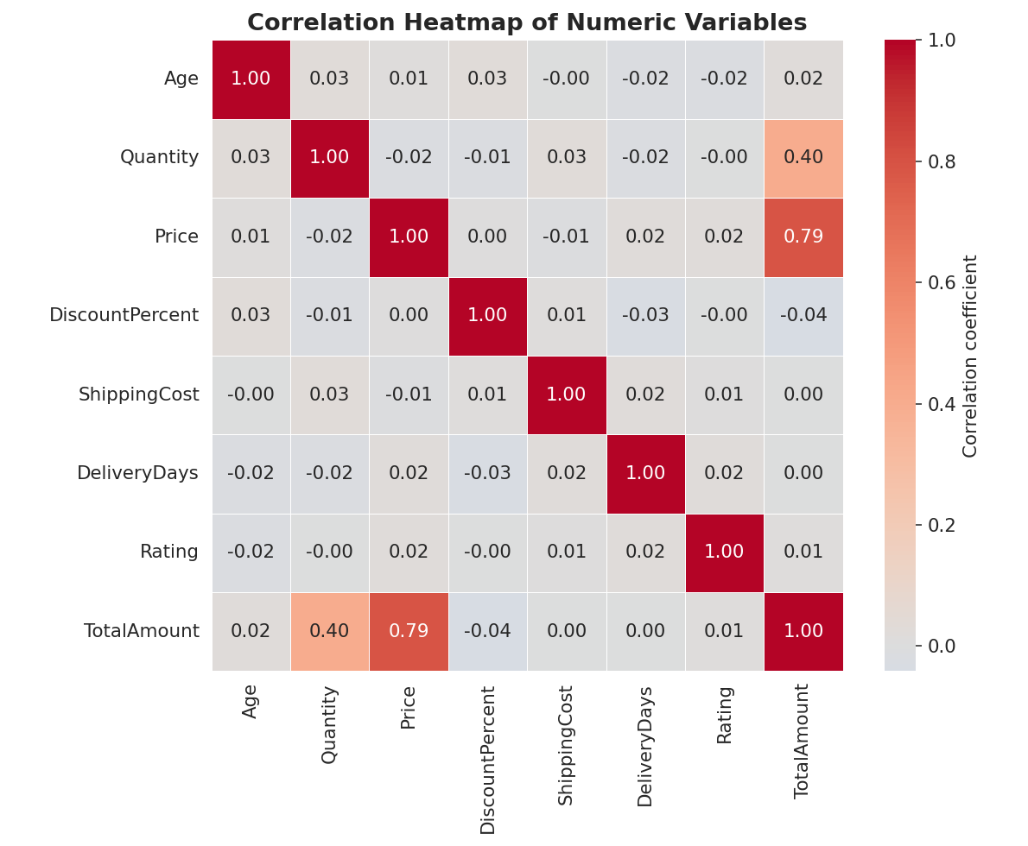
A heatmap of correlation coefficients between numeric variables, highlighting the strong Price-TotalAmount relationship.

Figure 4: Price Distribution and Outlier Treatment
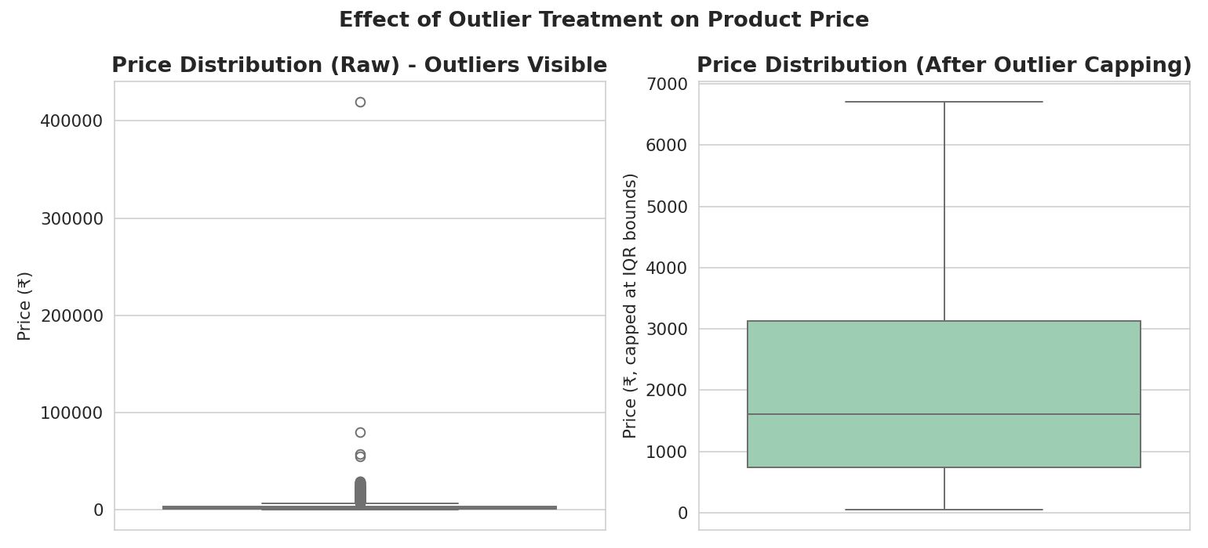
Side-by-side boxplots comparing the raw Price distribution (with visible outliers) to the outlier-capped version.

Figure 5: Customer Age Distribution
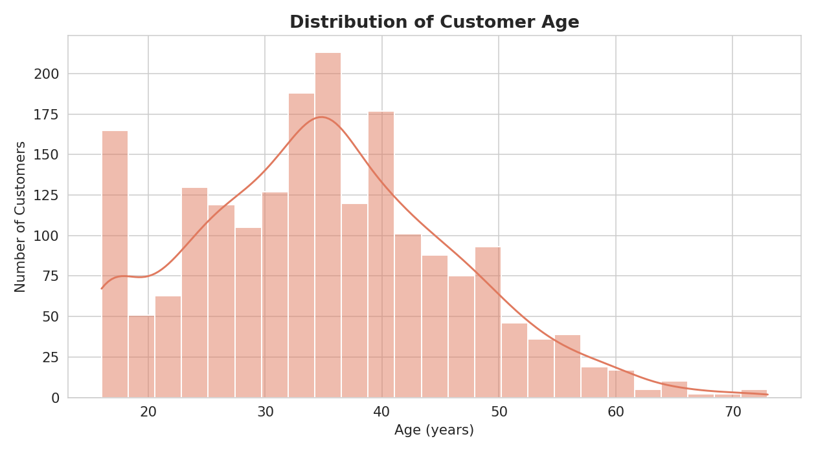
A histogram with density curve showing the spread of customer ages, centered around 30-40 years.

Figure 6: Payment Method Share
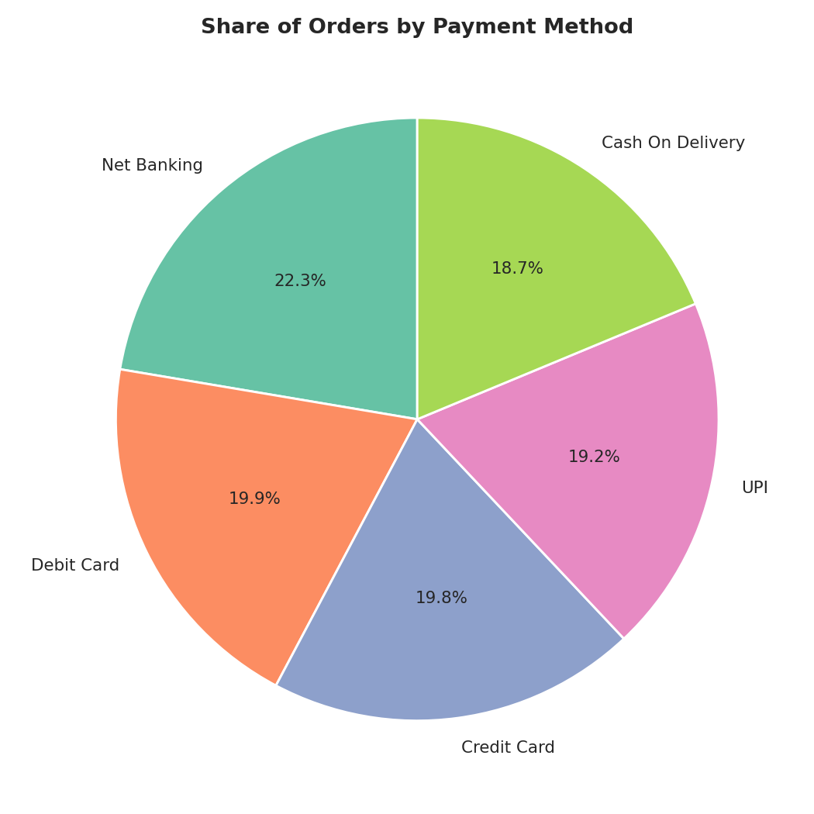
A pie chart showing the proportional share of orders across the five payment methods.

Figure 7: Average Spend by Age Group and Gender
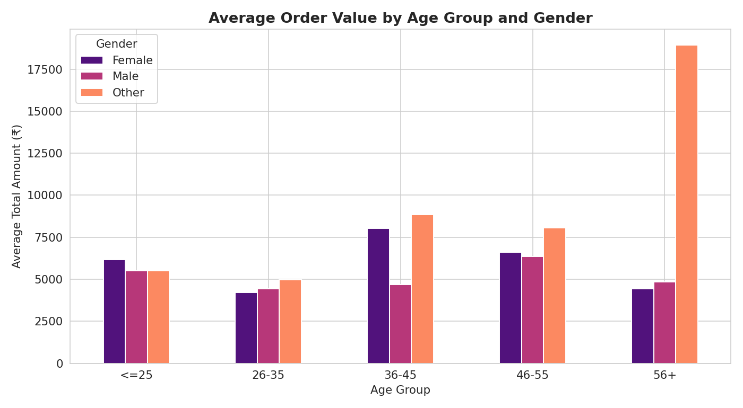
A grouped bar chart comparing average order value across age groups, split by gender.

Figure 8: Price vs. Total Order Amount
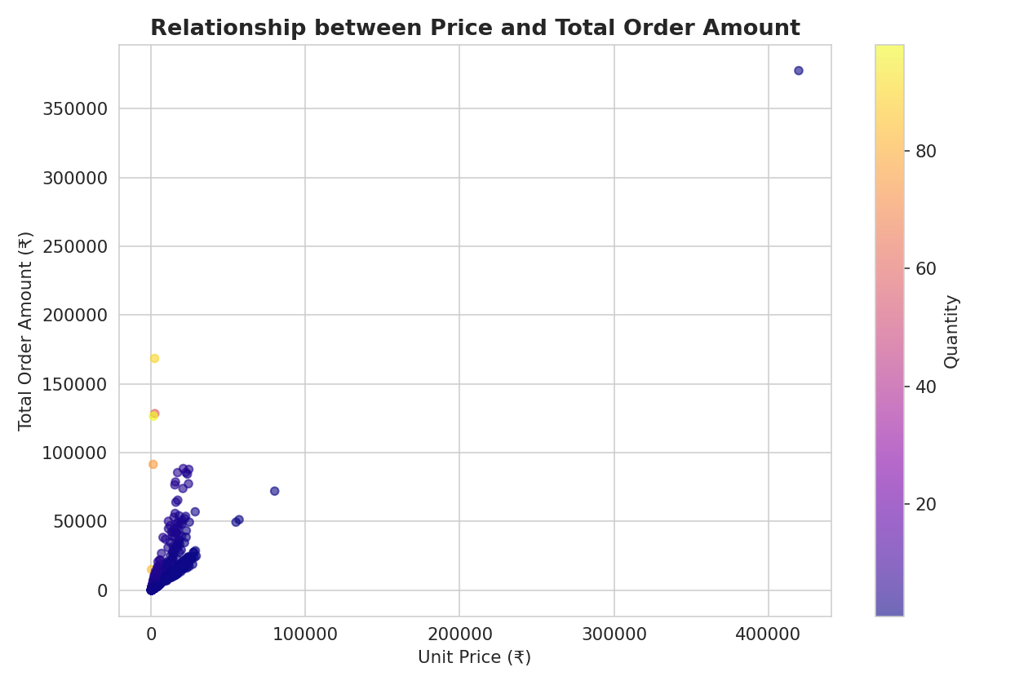
A scatter plot of unit price against total order amount, colored by quantity, illustrating how both factors combine to drive revenue.

Conclusion
This project applied a complete data-analytics workflow — dataset selection, inspection, cleaning, exploratory analysis, and visualization — to a real-world-style e-commerce sales dataset. The cleaning stage successfully resolved missing values, duplicate records, and data-entry errors, producing a reliable analysis-ready dataset. The exploratory analysis and visualizations together reveal that Electronics products drive the majority of revenue despite average order volumes, that order value is primarily a function of price and quantity rather than demographics or delivery performance, and that the business maintains a well-diversified customer base across cities, age groups, and payment methods. These findings demonstrate the practical value of systematic data preparation and EDA in generating actionable business insight.

