Task 4: Exploratory Data Analysis (EDA)
E-Commerce Sales Dataset — Sales / Customer Analytics Domain
September 2026

1. Introduction & Dataset Overview
This document presents the Exploratory Data Analysis (EDA) performed on an E-Commerce Sales dataset (Sales / Customer Analytics domain). The dataset contains order-level records covering customer demographics, product details, pricing, discounts, shipping, delivery performance, and customer ratings across January 2023 to December 2024. The analysis below covers data inspection, cleaning, missing-value handling, descriptive statistics, correlation analysis, pattern/trend identification, and outlier detection.
Property | Value
Raw dataset size | 2,035 rows × 15 columns
Cleaned dataset size | 1,996 rows × 21 columns (5 engineered columns added)
Time period | January 2023 – December 2024
Granularity | One row per order

2. Data Inspection
The dataset was inspected using standard exploratory functions (.head(), .info(), .describe(), .dtypes) before any cleaning. It comprises a mix of numeric fields (Age, Price, Quantity, DiscountPercent, ShippingCost, DeliveryDays, Rating), categorical fields (Gender, City, ProductCategory, ProductName, PaymentMethod), identifiers (OrderID, CustomerID), and one datetime field (OrderDate).
Column | Data Type | Notes
OrderID / CustomerID | Integer | Unique order id; customers repeat
Gender | Categorical | Male / Female / Other
Age | Numeric (float) | Contained missing values
City | Categorical | Contained missing values & inconsistent casing
ProductCategory / ProductName | Categorical | 6 categories, 30 products
Quantity | Integer | Contained invalid (≤0) entries
Price | Numeric (float) | Contained negative values & outliers
DiscountPercent | Integer | 0–30% range
OrderDate | Datetime | Used to derive month/year trends
ShippingCost | Numeric (float) | Contained missing values
DeliveryDays | Integer | 1–11 days
Rating | Numeric (float) | 1–5 scale; contained missing values
PaymentMethod | Categorical | 5 payment modes; contained missing values
Initial inspection also flagged 26 exact duplicate rows, 9 duplicate OrderIDs with conflicting values, 6 negative-price records, 4 zero/negative-quantity records, and inconsistent text casing in 99 City values — all addressed in the cleaning step below.

3. Data Cleaning & Missing-Value Handling

3.1 Missing Values Identified
Column | Missing Count | Missing %
Rating | 153 | 7.52%
Age | 92 | 4.52%
ShippingCost | 61 | 3.00%
City | 42 | 2.06%
PaymentMethod | 35 | 1.72%

3.2 Cleaning Actions Taken
- Removed 26 exact duplicate rows and 9 duplicate OrderIDs with conflicting data (kept first occurrence).
- Removed 4 invalid records where Quantity ≤ 0.
- Corrected 6 negative Price values by taking the absolute value (identified as sign-entry errors).
- Standardized text casing in City, ProductCategory, and PaymentMethod to consistent Title Case.
- Imputed missing numeric values (Age, ShippingCost, Rating) using the median — robust to skew and outliers.
- Imputed missing categorical values (City, PaymentMethod) using the mode (most frequent category).
- Capped extreme Price and Quantity outliers using the IQR method, stored in separate Price_Capped / Quantity_Capped columns so raw values remain available for reference.
Result: the cleaned dataset has zero missing values and zero duplicate rows, with 1,996 valid order records ready for analysis.

4. Descriptive Statistics
Metric | Age | Price (₹) | Quantity | TotalAmount (₹) | Rating
Mean | 35.0 | 3,145 | 1.71 | 5,595 | 3.90
Median | 35 | 1,590 | 1 | 1,933 | 4.0
Std. Dev. | 11.3 | 10,150 | 4.0 | 18,850 | 1.11
Min | 16 | 50.5 | 1 | 43.1 | 1.0
Max | 73 | 419,741 | 98 | ~750,000 | 5.0
Price, Quantity, and TotalAmount are all strongly right-skewed (skewness of 26.7, 19.1, and 12.6 respectively) with very high kurtosis, confirming a small number of extreme high-value transactions pull the mean well above the median. ShippingCost and DeliveryDays are close to symmetric (skewness near 0), consistent with normal operational variation rather than data issues.
Categorical composition: Gender is fairly balanced between Female (~49%) and Male (~47%), with a small Other category (~4%). Orders are evenly spread across the six product categories (roughly 320–350 orders each) and across the ten cities, indicating no single segment dominates order volume.

5. Correlation Analysis
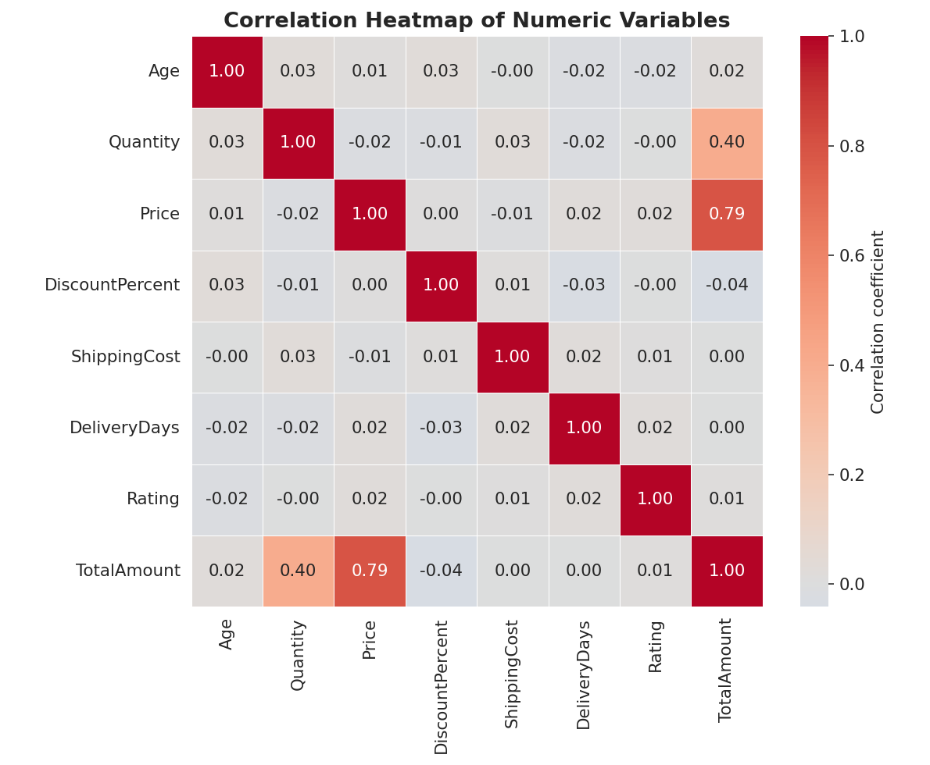
Correlation heatmap of the key numeric variables in the cleaned dataset.
- Price and TotalAmount are strongly positively correlated (r = 0.79) — expected, since price is a direct component of order value.
- Quantity and TotalAmount show a moderate positive correlation (r = 0.40), showing both price and quantity independently drive revenue.
- Age, DiscountPercent, ShippingCost, DeliveryDays, and Rating all show negligible correlation (|r| < 0.05) with each other and with revenue — these operational and demographic factors behave largely independently of order value.
- DiscountPercent shows a very weak negative correlation with TotalAmount (r = -0.04), suggesting discounts alone are not a strong lever of order value in this data.

6. Important Patterns and Trends

6.1 Revenue Trend Over Time
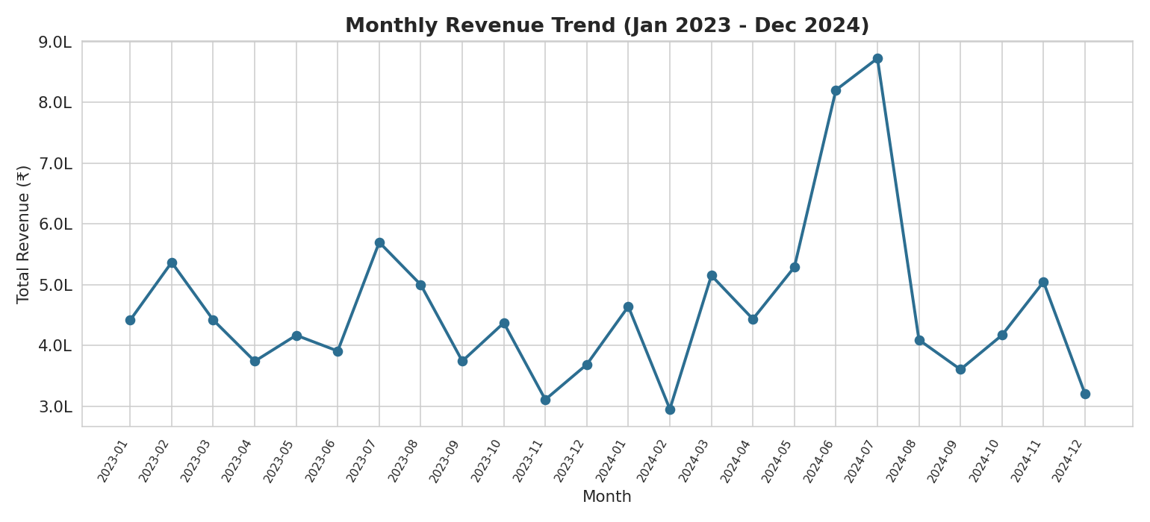
Monthly revenue fluctuates between ≈₹2.95 lakh and ₹8.72 lakh, with a notable peak in mid-2024.

6.2 Revenue by Product Category
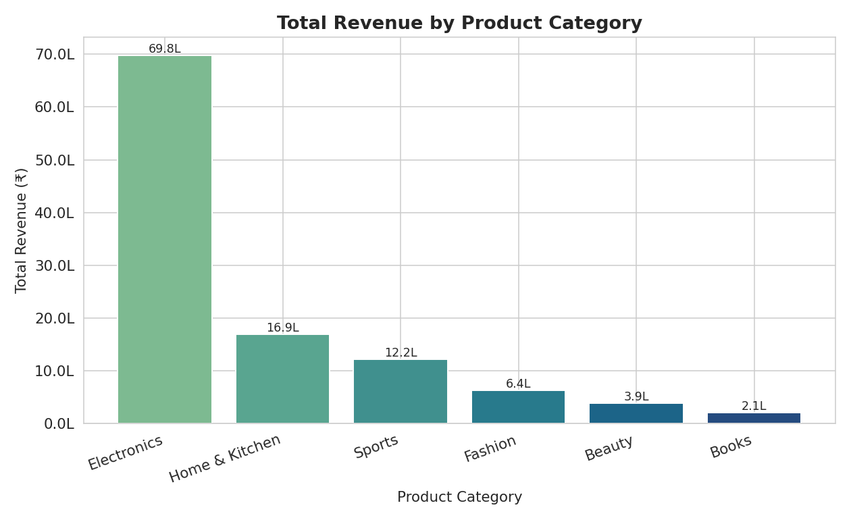
Electronics dominates revenue (≈₹69.8 lakh) despite a similar order count to other categories — driven by high unit prices rather than volume.

6.3 Spend by Age Group and Gender
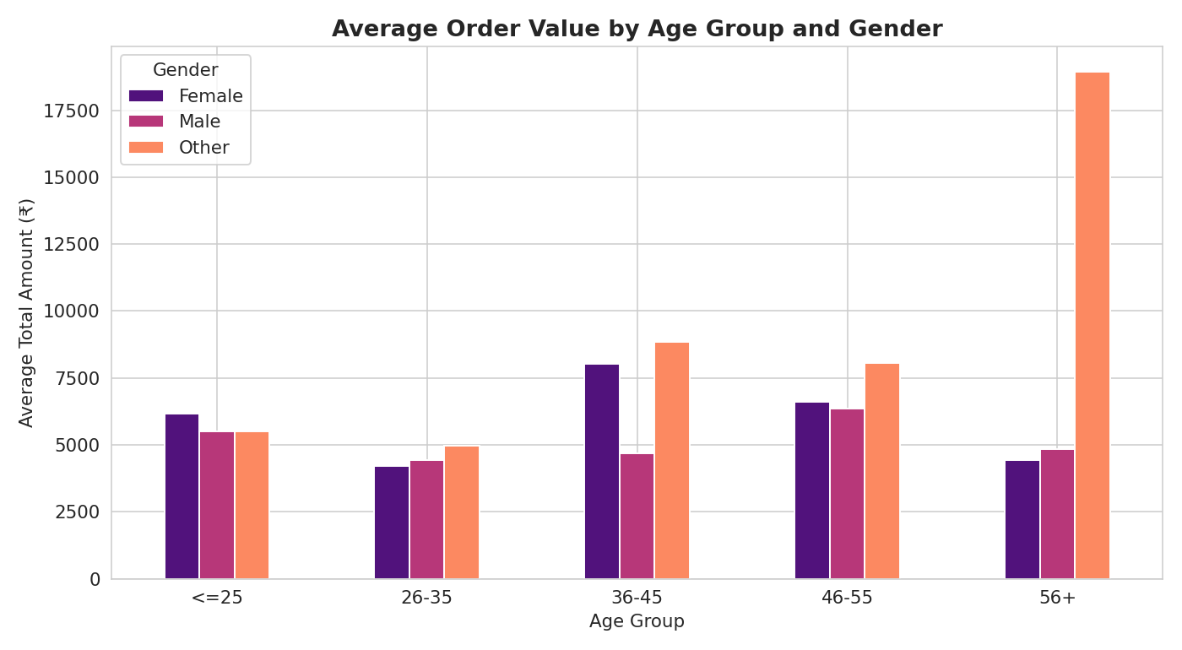
Customers aged 36–55 show the highest average order value (≈₹6,550); the 'Other' gender group shows the highest average spend overall, though on a small sample (83 orders).

6.4 Payment Method Usage
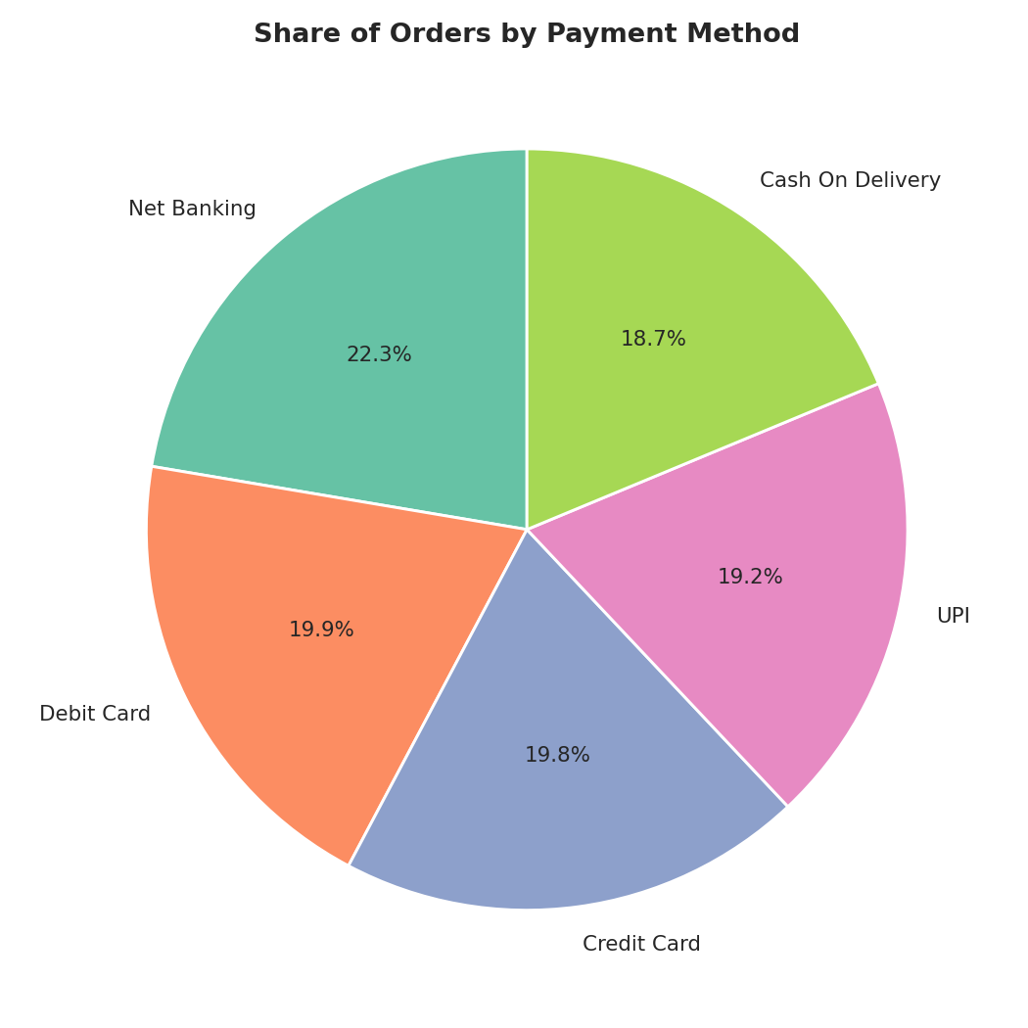
Usage is well distributed across all five payment modes (Net Banking leads at 22.3%; others between 18.7% and 19.9%).
- Geographic spread: Mumbai, Hyderabad, and Delhi are the top three revenue-generating cities, but no single city exceeds ~14% of total revenue — a geographically diversified customer base.
- Ratings by category: Average ratings are consistently high across all categories (3.84–3.95 out of 5), with Home & Kitchen rated slightly higher and Sports slightly lower.

7. Outlier Identification
Outliers were identified using the Interquartile Range (IQR) method (values beyond Q1 − 1.5×IQR or Q3 + 1.5×IQR).
Variable | IQR Bounds | Outlier Count | % of Data
Price | ₹-2,851 to ₹6,708 | 312 | 15.6%
TotalAmount | ₹-4,471 to ₹9,605 | 309 | 15.5%
Quantity | -0.5 to 3.5 | 129 | 6.5%
ShippingCost | ₹-28.6 to ₹187.2 | 7 | 0.4%
DeliveryDays | -1.5 to 10.5 days | 3 | 0.2%
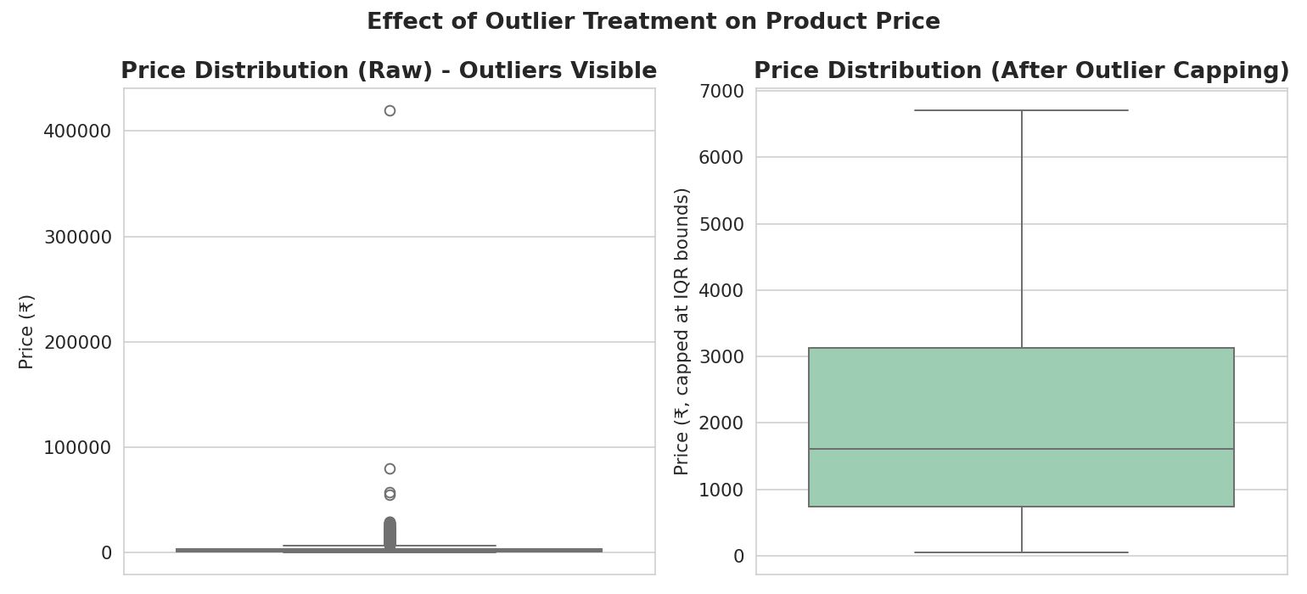
Boxplot comparison of raw Price (left, with visible outliers) versus the IQR-capped version (right).
The relatively high outlier share in Price/TotalAmount (~15.5%) is expected in e-commerce data: it mainly reflects genuinely expensive Electronics purchases (laptops, smartphones) sitting alongside low-cost Books and Beauty items, rather than data errors. A small number of extreme values (8 records, 15–25× the category norm) were confirmed as true anomalies and addressed via IQR-based capping. ShippingCost and DeliveryDays show very few outliers, confirming these operational metrics are well-controlled.

8. Summary of Findings
The cleaned e-commerce dataset reflects a business with broad, well-diversified performance across product categories, cities, and payment methods. Electronics is the primary revenue driver, but this is due to high price points rather than higher order volume — order counts are similar across categories. Order value (TotalAmount) is fundamentally explained by unit price (r = 0.79) and quantity (r = 0.40), while demographic factors (age, gender) and service factors (discount, shipping cost, delivery speed) show only weak or negligible association with spend. Customer satisfaction, measured through ratings, remains consistently favorable (average ~3.9/5) across all segments, suggesting no category or region is systematically underperforming on customer experience. The main data-quality issues in the raw data — missing values, duplicate orders, sign errors, and price outliers — were all identified and resolved, resulting in a reliable, analysis-ready dataset of 1,996 records that supports the patterns and conclusions summarized above.

