Task 5: Data Visualization
E-Commerce Sales Dataset — Sales / Customer Analytics Domain
September 2026

Introduction
This document presents eight visualizations built from the cleaned E-Commerce Sales dataset (1,996 records), created using Python (Matplotlib and Seaborn). Each chart was chosen to communicate a specific, important finding from the exploratory analysis — a trend over time, a comparison across categories, a relationship between variables, or a distribution shape. Every chart carries a meaningful title, labeled axes, and is discussed below in terms of what it reveals and why it matters for the business.

Figure 1: Monthly Revenue Trend
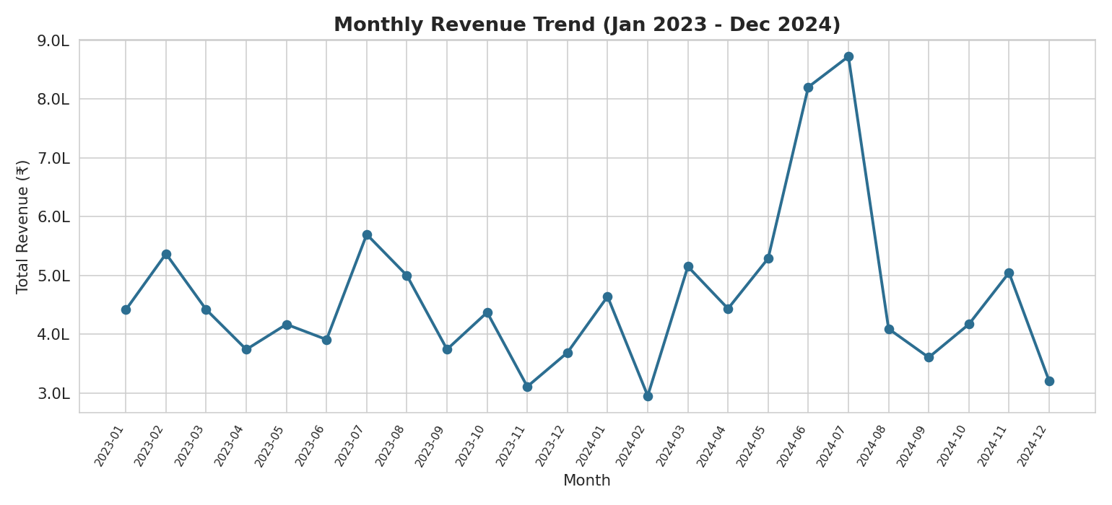
Line chart of total monthly revenue, January 2023 – December 2024.
Chart type: Line chart — the natural choice for showing change over a continuous time axis.
What it shows: Revenue fluctuates month to month between roughly ₹2.95 lakh and ₹8.72 lakh, with a sharp, sustained spike in June–July 2024 reaching the highest levels in the two-year window. This kind of spike is worth investigating operationally — it likely corresponds to a seasonal event or promotional campaign and represents a repeatable opportunity if the business can identify and recreate its cause.

Figure 2: Revenue by Product Category
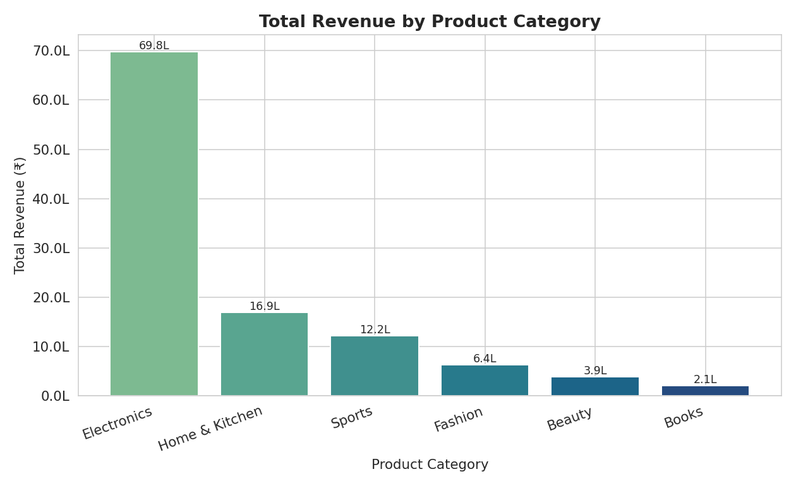
Bar chart comparing total revenue across the six product categories, with value labels.
Chart type: Bar chart — best for comparing a metric across discrete categories.
What it shows: Electronics alone generates ≈₹69.8 lakh, more than four times the next-highest category (Home & Kitchen, ≈₹16.9 lakh). Since order counts are broadly similar across categories, this gap is driven by price per unit rather than popularity — meaning Electronics carries the business's revenue disproportionately and deserves priority in inventory, marketing spend, and stock-out prevention.

Figure 3: Correlation Heatmap
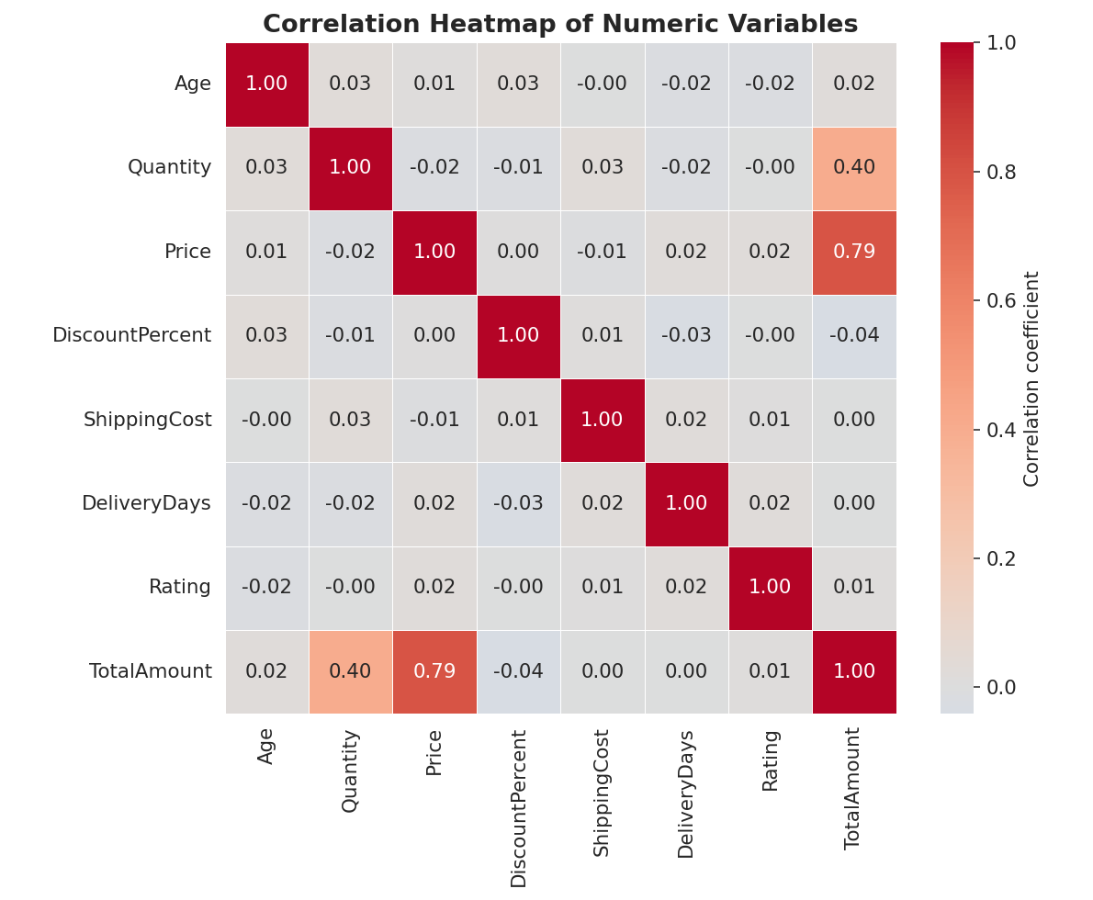
Heatmap of Pearson correlation coefficients across all key numeric variables.
Chart type: Heatmap — the standard way to compactly display many pairwise relationships at once.
What it shows: TotalAmount is strongly related to Price (r = 0.79) and moderately related to Quantity (r = 0.40), confirming these are the two real levers of order value. Every other variable — Age, DiscountPercent, ShippingCost, DeliveryDays, Rating — shows almost no relationship (|r| < 0.05) with revenue or with each other, telling the business that demographic targeting or faster shipping is unlikely, on its own, to move average order value.

Figure 4: Price Distribution and Outlier Treatment
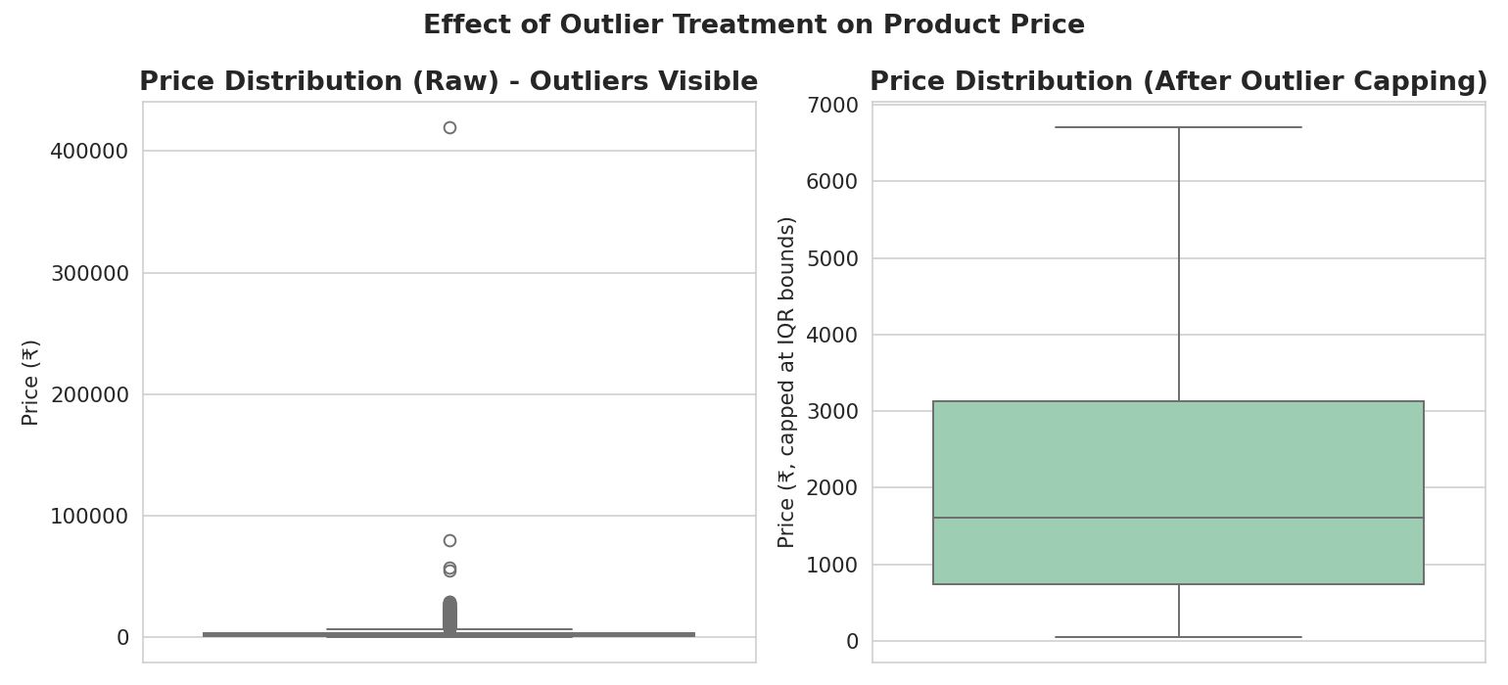
Side-by-side boxplots: raw Price (left) versus IQR-capped Price (right).
Chart type: Boxplot — ideal for showing spread, median, and outliers simultaneously.
What it shows: The raw Price data (left) contains a long tail of high-value outliers, some products priced far above the typical range. After IQR-based capping (right), the distribution is far more compact and interpretable. This comparison justifies why outlier treatment was necessary before deeper statistical analysis — without it, a handful of extreme prices would distort averages and correlations.

Figure 5: Customer Age Distribution
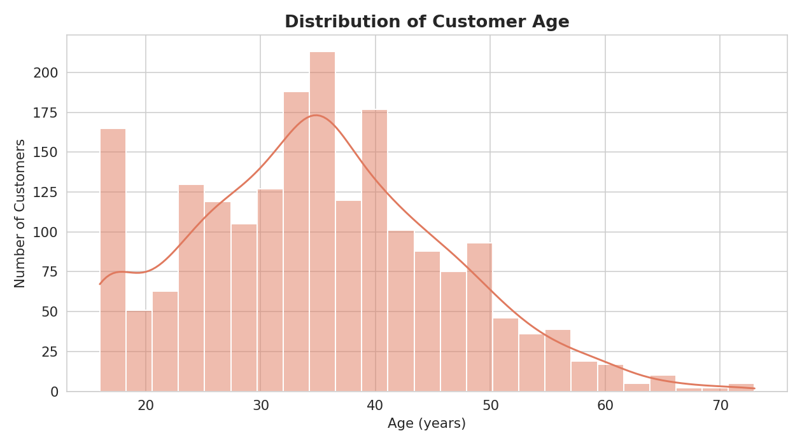
Histogram with density curve showing the spread of customer ages.
Chart type: Histogram with KDE overlay — appropriate for visualizing the shape of a continuous distribution.
What it shows: The customer base is concentrated in the 28–45 age range, with a peak around the early-to-mid 30s, and a long tail extending toward the 60s and 70s. This tells the business its core demographic is young-to-mid-career adults, which should inform product selection and marketing tone.

Figure 6: Payment Method Share
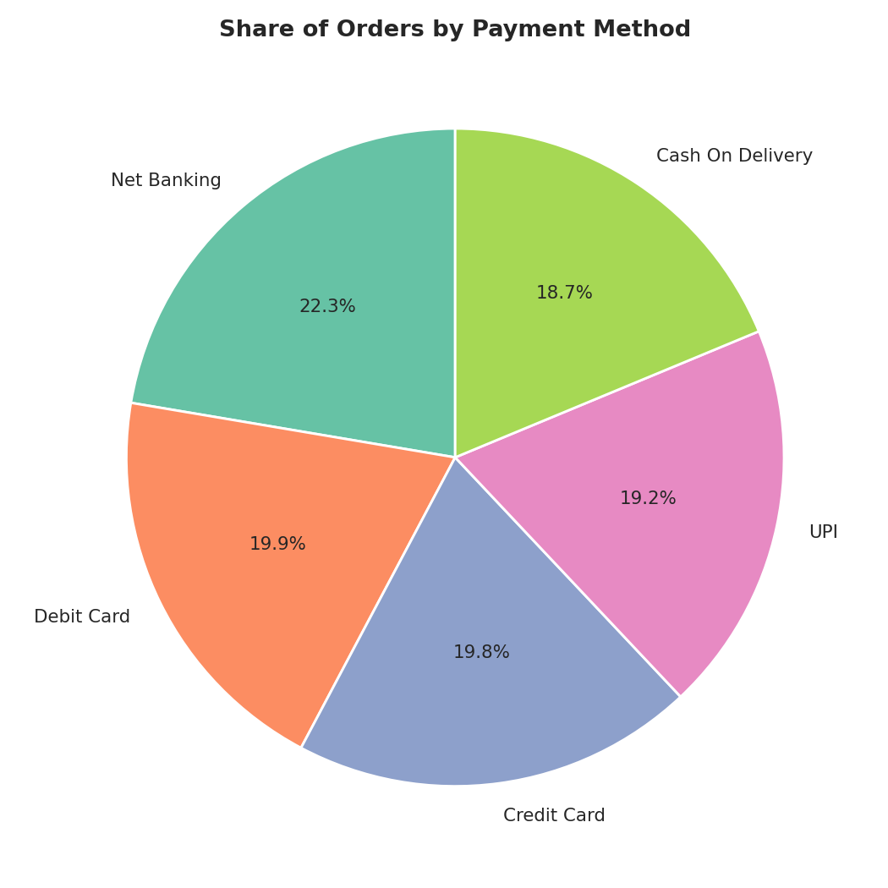
Pie chart showing the proportional share of orders by payment method.
Chart type: Pie chart — suitable for showing parts of a whole when there are few categories (5 here).
What it shows: No payment method dominates — Net Banking leads narrowly at 22.3%, with Debit Card, Credit Card, UPI, and Cash on Delivery all in the 18–20% range. This even spread means the business should continue supporting all five channels rather than over-investing in any single payment gateway.

Figure 7: Average Spend by Age Group and Gender
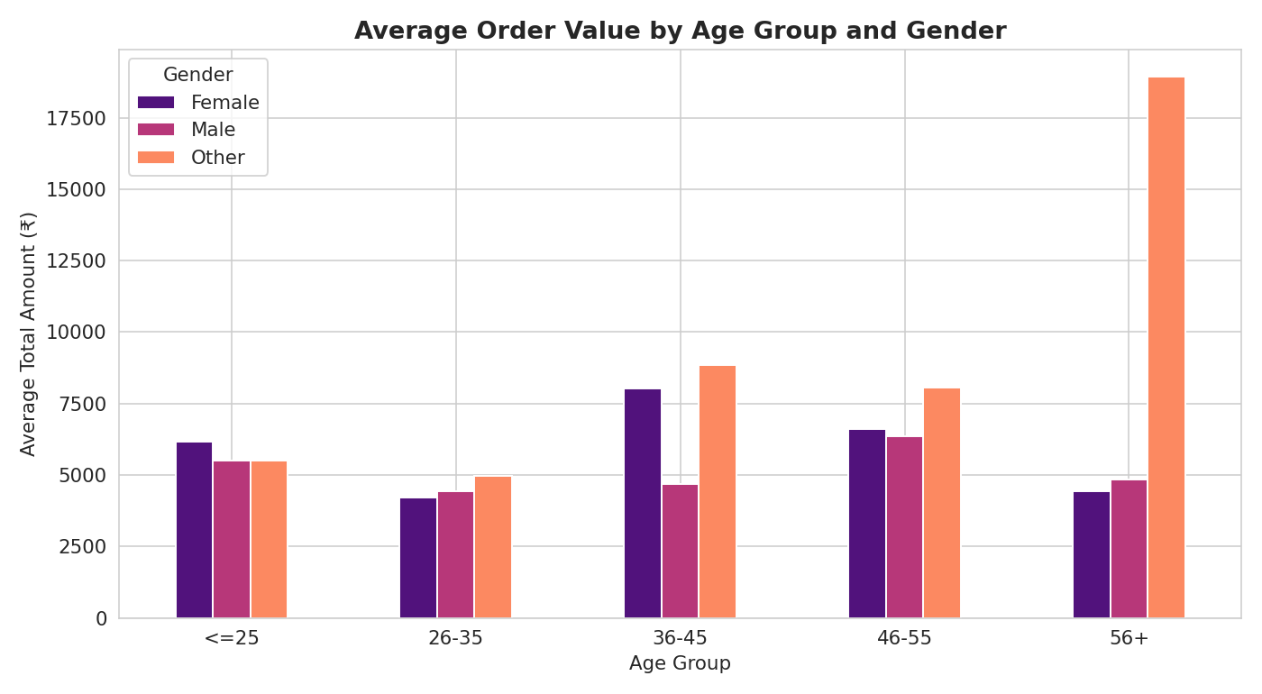
Grouped bar chart comparing average order value across age groups, split by gender.
Chart type: Grouped bar chart — allows two categorical dimensions (age group and gender) to be compared side by side against a shared metric.
What it shows: Average order value rises through the 26–35 and 36–45 age bands before tapering off in the 56+ group, a pattern that holds broadly across genders. This helps the business identify its highest-value age segment (36–55) for targeted campaigns.

Figure 8: Price vs. Total Order Amount
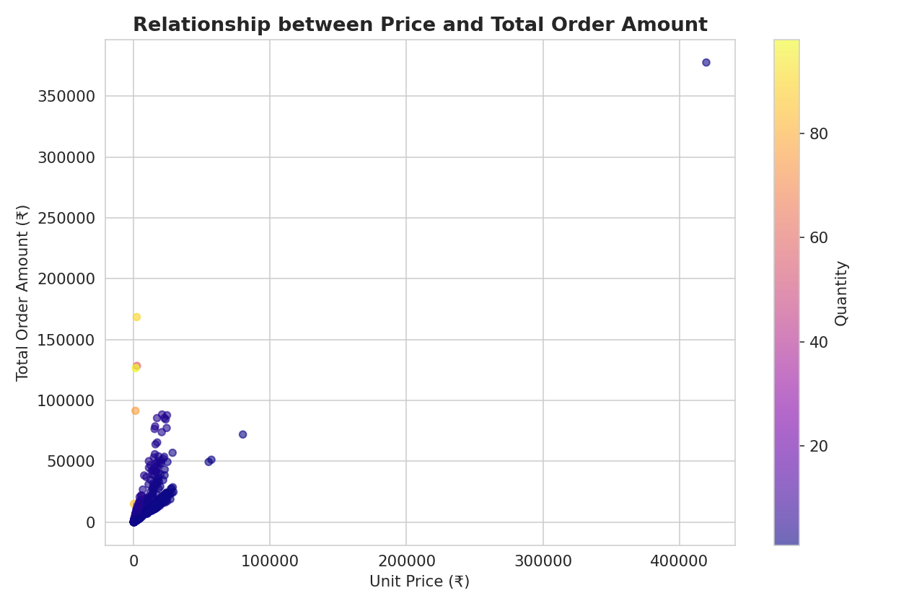
Scatter plot of unit price against total order amount, colored by quantity ordered.
Chart type: Scatter plot with color encoding — the right choice for showing the relationship between two continuous variables plus a third dimension (quantity).
What it shows: Total order amount rises with price, as expected, but the color gradient reveals that orders with higher quantity (brighter points) can reach high total amounts even at moderate unit prices. This visually confirms the correlation finding that both price and quantity independently contribute to revenue.

Summary
Together, these eight visualizations tell a consistent story: Electronics drives outsized revenue through high price points, order value is fundamentally a function of price and quantity rather than demographics or service metrics, the customer base skews toward young-to-mid-career adults with peak spend in the 36–55 range, and the business is well-diversified across payment channels and cities. Each visualization was matched to the shape of the underlying data — trends as line charts, category comparisons as bar charts, relationships as heatmaps and scatter plots, and distributions as histograms and boxplots — to ensure the intended finding is communicated as clearly as possible.

Chart Type Reference
Figure | Chart Type | Purpose
1 | Line chart | Trend over time (monthly revenue)
2 | Bar chart | Comparison across categories (revenue by category)
3 | Heatmap | Relationships among multiple numeric variables
4 | Boxplot (paired) | Distribution spread and outlier detection
5 | Histogram + KDE | Shape of a single continuous distribution (age)
6 | Pie chart | Proportional share of a whole (payment methods)
7 | Grouped bar chart | Two-dimensional categorical comparison (age × gender)
8 | Scatter plot (color-encoded) | Relationship between two continuous variables plus a third dimension

