INTEGRAL UNIVERSITY, LUCKNOW
Bachelor of Technology
Computer Science & Engineering

Explainable AI Based Machine Learning Framework for Clinical Decision Support Systems
PROJECT REPORT
Submitted under the supervision of
Dr. S. H. Abbas Rizvi
Submitted by
Zaid Hasan Khan | 2300101438
Raza Khan | 2300104164
Soyab Khan | 2300101263
Academic Year 2026–2027

ACADEMIC DEMONSTRATION ONLY This prototype is not clinically validated and must not be used for diagnosis, screening, treatment, or patient care. Do not enter real patient information.

Abstract
This project implements an educational prototype that compares four classical machine-learning classifiers on the public UCI Heart Disease dataset and presents model outputs with feature-level explanations. A stratified, fixed-seed train/test split and cross-validation on the training partition are used to compare Logistic Regression, Decision Tree, Random Forest, and Gradient Boosting. Random Forest ranked first by mean training-partition cross-validation ROC-AUC in the recorded run. The Streamlit interface displays held-out metrics and can calculate a local Kernel SHAP explanation for an entered structured record. These results illustrate model inspection only; they do not establish clinical validity or an individual’s medical status.

1. Introduction
Clinical decision-support software can organize information and present model outputs, but a predicted label alone does not show how the model arrived at that output. This project demonstrates a bounded workflow that places an explainability layer beside a classifier and exposes a model comparison, evaluation results, and local feature contributions in one interface.

1.1 Problem statement
Many machine-learning classifiers provide a label or probability without a clear account of which input features influenced it. The project addresses that interpretability gap for an academic binary-classification example using structured, public data.

1.2 Objectives
- Prepare a reproducible and leakage-aware data-processing pipeline.
- Compare four classification models using cross-validation and held-out evaluation metrics.
- Display accuracy, precision, recall, F1-score, ROC-AUC, confusion matrix, and ROC curve.
- Provide local Kernel SHAP contributions and global permutation feature importance.
- Present the output and its limitations in a simple Streamlit interface.

2. Dataset and Target
The experiment uses UCI Machine Learning Repository dataset 45, the Cleveland Heart Disease subset. The fetched dataset contained 303 records and 13 selected predictors. The original outcome `num` was mapped to a binary project target: 0 remains class 0, and values 1–4 are grouped into class 1. Records with missing target labels are excluded. Missing predictor values are imputed inside each model pipeline; categorical codes are one-hot encoded, and continuous predictors are standardized for Logistic Regression.
The grouping is a dataset transformation for this project, not a clinical definition. The dataset is shared under Creative Commons Attribution 4.0; the data folder includes the attribution and DOI. The dataset is small and historical, and it should not be treated as a representative population or used to estimate anyone’s health status.

3. System Design and Method
Workflow: UCI dataset → target validation → stratified train/test split → model-specific preprocessing pipeline → candidate models → stratified cross-validation on training data → select by mean CV ROC-AUC → held-out evaluation → SHAP and permutation explanations → Streamlit dashboard.
Each preprocessing transformation is fitted within the scikit-learn pipeline, including during cross-validation, to prevent test-fold information from leaking into training. The held-out partition is reserved for final metrics. Random Forest was selected using the training-partition cross-validation result, not by selecting the highest test score. The fixed random seed is 42.

4. Experimental Results
The following table contains results from the project training run on 8 November 2026. The split held out 61 of 303 records; five-fold cross-validation was run on the remaining training partition. Scores are rounded to three decimals.
Model | CV ROC-AUC  mean ± std | Accuracy | Precision | Recall | F1-score | Test ROC-AUC
Random Forest | 0.897 ± 0.045 | 0.869 | 0.812 | 0.929 | 0.867 | 0.960
Logistic Regression | 0.893 ± 0.044 | 0.869 | 0.812 | 0.929 | 0.867 | 0.966
Gradient Boosting | 0.883 ± 0.052 | 0.902 | 0.867 | 0.929 | 0.897 | 0.957
Decision Tree | 0.816 ± 0.024 | 0.770 | 0.719 | 0.821 | 0.767 | 0.877
Random Forest ranked first by mean cross-validation ROC-AUC (0.897 ± 0.045) and was selected for the prototype. Gradient Boosting had the highest held-out accuracy and F1-score in this particular split. The close scores and small sample mean no model should be considered generally superior based on this one experiment.

4.1 Confusion matrix and error analysis
For the selected Random Forest model, the held-out confusion matrix (rows = actual class; columns = predicted class) was [[27, 6], [2, 26]]. This corresponds to 27 true negatives, 6 false positives, 2 false negatives, and 26 true positives. There were 33 actual class-0 records and 28 actual class-1 records in the test set. These counts refer only to the dataset target grouping.
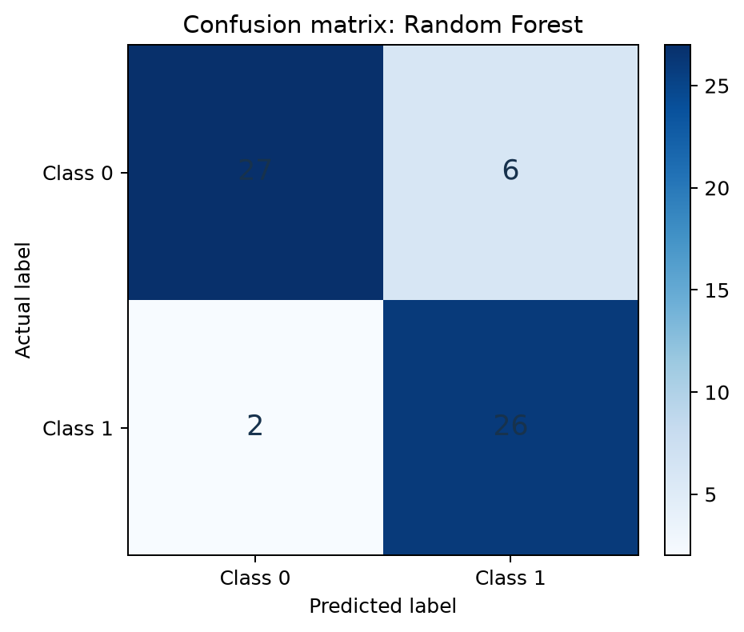

4.2 ROC curve
The selected model achieved a held-out ROC-AUC of 0.960. The curve below summarizes ranking performance for this test split. It does not establish calibration, clinical usefulness, or performance in a different population.
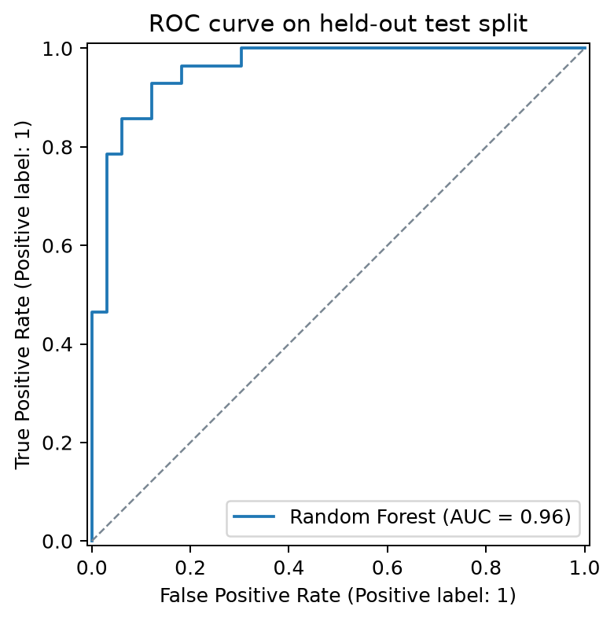

5. Explainability Results

5.1 Global permutation importance
Permutation importance was calculated on held-out data as the decrease in ROC-AUC after shuffling an input feature. The leading features for this fitted model were cp, ca, thal, exang, and oldpeak. Importance is a model diagnostic and does not imply that a feature causes an outcome.
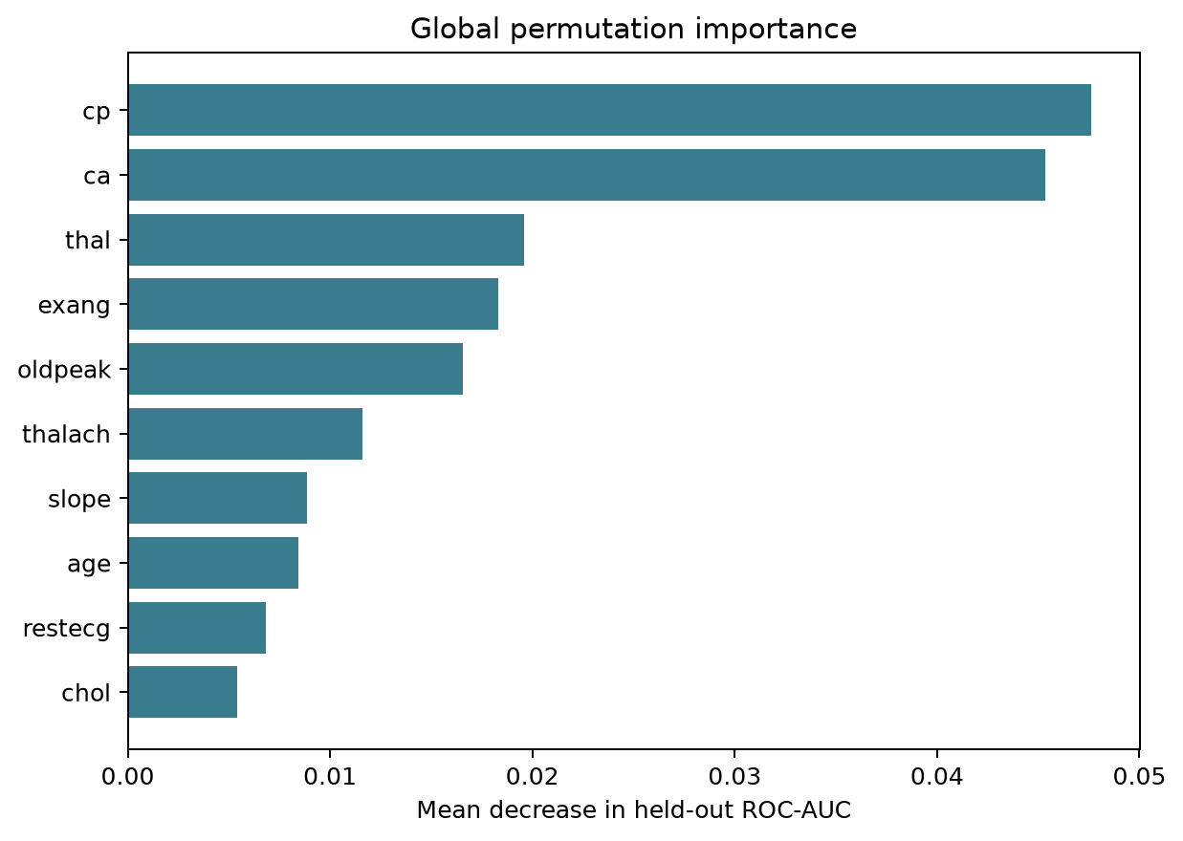

5.2 Local SHAP explanation
Kernel SHAP was calculated for held-out record index 219. The model predicted class 0 with probability 0.3086 for class 1. The chart shows the largest signed feature contributions: positive values move the model output toward class 1 and negative values toward class 0. This explanation describes the model’s behavior around one record; it is not a reason for clinical action.
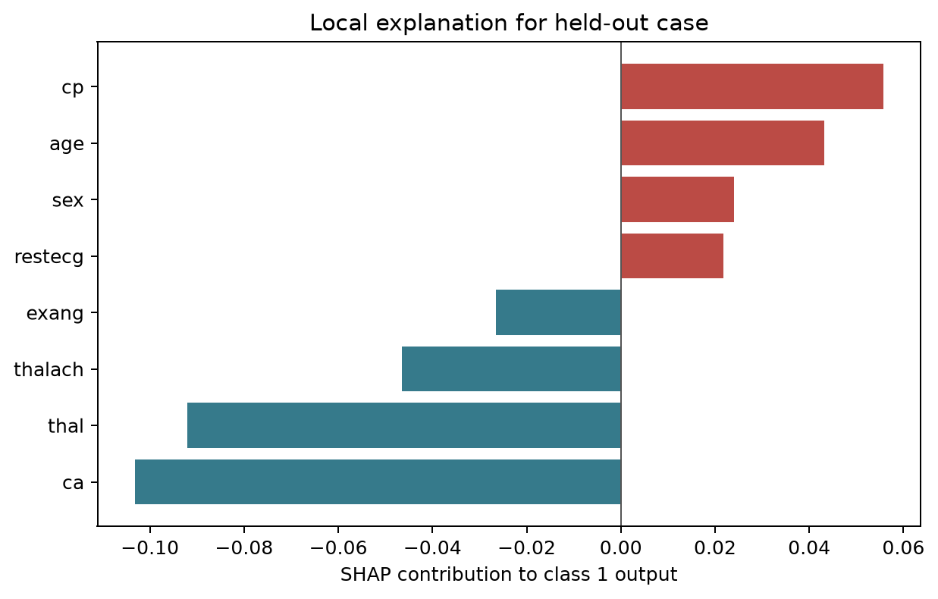

6. Prototype Implementation
- src/data.py downloads and caches the public dataset, validates the outcome, and prepares predictors and target.
- src/modeling.py defines preprocessing, candidate models, cross-validation, held-out metrics, SHAP, and permutation importance.
- src/train.py runs the experiment and saves the model, comparison CSV, run summary, and figures in the reports folder.
- app.py contains the Streamlit dashboard with model overview, case input, probability display, local explanation, and limitations.
- The fitted model artifact is saved as artifacts/heart_disease_model.joblib.

7. Testing and Verification
All three automated checks passed with python -m unittest discover -s tests -v. They verify the 303 × 13 data schema and binary labels, the trained model’s held-out probability output, and finite per-feature SHAP values. The Streamlit browser flow was exercised: model comparison rendered, a default demonstration input produced class 0 with a 25.3% model output for class 1, local SHAP contributions rendered, global permutation importance rendered, and the method and limitations tab displayed. The browser example used only the form defaults, not a real patient record.

8. Limitations and Responsible Use
- The source data contains only 303 Cleveland records and is historical; it is not a representative or prospective clinical cohort.
- A single random split can yield variable metrics on a small sample. Scores should not be generalized to other populations.
- The outcome grouping is a project-specific transformation, not a diagnosis.
- Model probabilities are not presented as calibrated personal risk estimates.
- SHAP and permutation importance describe associations learned by this model; neither establishes causation, fairness, safety, or correctness.
- The prototype has no external validation, clinical workflow integration, regulatory review, or clinician oversight.
- Use only the public de-identified dataset. Do not enter real patient information.

9. Reproduction
Use Python 3.12, the version used to generate and verify these artifacts. Install dependencies with python -m pip install -r requirements.txt. Run streamlit run app.py to open the interface, or run python -m src.train to reproduce training outputs. Run python -m unittest discover -s tests -v for the automated checks. The attributed dataset is bundled, so the demo and training run offline. The experiment uses random seed 42. Outputs include the saved model, model comparison, run summary, confusion matrix, ROC curve, permutation importance, and local SHAP explanation.

References
- S. M. Lundberg and S.-I. Lee, “A Unified Approach to Interpreting Model Predictions,” Advances in Neural Information Processing Systems, vol. 30, 2017.
- M. T. Ribeiro, S. Singh, and C. Guestrin, “Why Should I Trust You?: Explaining the Predictions of Any Classifier,” Proceedings of the 22nd ACM SIGKDD International Conference on Knowledge Discovery and Data Mining, pp. 1135–1144, 2016.
- T. Chen and C. Guestrin, “XGBoost: A Scalable Tree Boosting System,” Proceedings of the 22nd ACM SIGKDD International Conference on Knowledge Discovery and Data Mining, pp. 785–794, 2016.
- A. Janosi, W. Steinbrunn, M. Pfisterer, and R. Detrano, “Heart Disease [Dataset],” UCI Machine Learning Repository, 1989. DOI: 10.24432/C52P4X.
- R. Detrano et al., “International Application of a New Probability Algorithm for the Diagnosis of Coronary Artery Disease,” The American Journal of Cardiology, 1989.

