A Project Report on

DESIGN OF OBSTACLE DETECTION AND COLLISION AVOIDANCE MODEL USING RASPBERRY PI

Submitted to the Department of Information Technology

**For the partial fulfilment of the degree of B.E. in Information Technology**

By

#### ADITYA BOSE RAJAT KUMAR AGARWAL

**VIVEK KUMAR**

Roll number(s): 111308036, 111308038, 111308051

Registration number(s): 110813037, 110813039, 111308054

Of, 2013-17

B.E., 4th year

Under the supervision of

#### DR. PRASUN GHOSAL



Department of Information Technology

INDIAN INSTITUTE OF ENGINEERING SCIENCE AND TECHNOLOGY, SHIBPUR



#### Department of Information Technology

**Indian Institute of Engineering Science and Technology, Shibpur**

**CERTIFICATE**

This is to certify that the work presented in this report entitled “DESIGN OF OBSTACLE DETECTION AND COLLISION AVOIDANCE MODEL USING RASPBERRY PI”,

submitted by Aditya Bose, Rajat Kumar Agarwal and Vivek Kumar, having the examination roll number 111308036, 111308038 and 111308051 has been carried out under my supervision for the partial fulfilment of the degree of Bachelor of Engineering in Information Technology during the session 2013-17 in the Department of Information Technology, Indian Institute of Engineering Science and Technology, Shibpur.

—————————————– —————————————– DR. PRASUN GHOSAL DR. ARINDAM BISWAS

Assistant Professor Head of the Department

Department of Information Technology Department of Information Technology Indian Institute of Engineering Science Indian Institute of Engineering Science and Technology, Shibpur and Technology, Shibpur

Date: 8 May, 2017

# Acknowledgements

We are thankful to Dr. Prasun Ghosal, Assistant Professor, IIEST Shibpur for his constant guidance and supervision as well as for providing the necessary information required for making the project “DESIGN OF OBSTACLE DETECTION AND COLLISION AVOIDANCE MODEL USING RASPBERRY PI”.

Date: 8 May, 2017 —————————————

ADITYA BOSE

—————————————– RAJAT KUMAR AGARWAL

—————————————–

VIVEK KUMAR

Department of Information Technology Indian Institute of Engineering Science

and Technology, Shibpur

|  |  |  |
| --- | --- | --- |
|  | **Contents** |  |
| **1** | **INTRODUCTION** | **6** |
| **2** | **RELATED WORKS** | **7** |
| **3** | **PRELIMINARIES AND DEFINITIONS**   * 1. INFRARED SENSOR   2. RASPBERRY PI   3. MOTOR DRIVER MODULE | **8** |
| **4** | **PROBLEM DEFINITION** | **12** |
| **5** | **PROPOSED APPROACH** | **13** |
| **6** | **WORKING MODEL** | **14** |

##### 7 CIRCUIT DIAGRAM 15

**8 CONCLUSIONS**

**9 REFERENCE**

1. **WORKING OF MODEL**

With the reliability and high level of performance of robotic vehicles nowadays, it is a great way to demonstrate the application of collision detection and obstacle avoidance in real lives. In this project, we have designed an autonomous robotic vehicle which is used to detect obstacles and avoid collision. This robot consists of two infrared sensors – one on the left of the front face and one the right of the front face.

On running the program written for functioning of the robot, the robot gets the information about the obstacles from the surrounding area through the two infrared sensors in front of the robot. Whenever the robot is travelling on the desired path (on without obstacles), the infrared waves are transmitted by the head of infrared sensors. Whenever an obstacle comes in front of it, the infrared waves are reflected back from that obstacle and that information is passed to the motor driver module.

The motor driver then controls the movement of the two DC motors mounted on the left and right of the motor based on the infrared signals. For example, if the obstacle is detected by the right infrared sensor then the movement of the vehicle in its reverse direction is initiated by the motors. The left motor turns anticlockwise and the right motor turns clockwise. Then the vehicle turns left with both the motors moving in the clockwise direction. This movement helps avoid the obstacle and travel without collision. The speed of each motor pulse in controlled by pulse width modulation (PWM).

1. **CIRCUIT DIAGRAM**

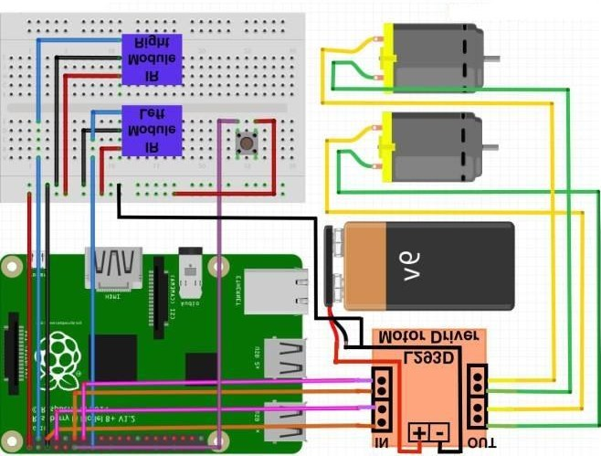

Figure 7.1 CIRCUIT DIAGRAM

Code 3.

The code of the moving Robot that Detect and avoid the collision.

Code:

import RPi.GPIO as GPIO import time GPIO.setwarnings(False) GPIO.setmode(GPIO.BOARD)

GPIO.setup(3, GPIO.IN) #Right IR sensor module

GPIO.setup(12, GPIO.IN, pull_up_down=GPIO.PUD_DOWN) #Activation button

GPIO.setup(16, GPIO.IN, pull_up_down=GPIO.PUD_UP) #Left IR sensor module

GPIO.setup(5,GPIO.OUT) #Left motor control GPIO.setup(7,GPIO.OUT) #Left motor control GPIO.setup(11,GPIO.OUT) #Right motor control GPIO.setup(13,GPIO.OUT) #Right motor control

#Motor stop/brake GPIO.output(5,0) GPIO.output(7,0) GPIO.output(11,0) GPIO.output(13,0)

flag=0 while True:

j=GPIO.input(12)

if j==1: #Robot is activated when button is pressed flag=1

print "Robot Activated",j

while flag==1:

i=GPIO.input(3) #Listening for output from right IR

sensor sensor

k=GPIO.input(16) #Listening for output from left IR if i==0: #Obstacle detected on right IR sensor

print "Obstacle detected on Right",i

#Move in reverse direction

GPIO.output(5,1) #Left motor turns anticlockwise GPIO.output(7,0)

GPIO.output(11,1) #Right motor turns clockwise GPIO.output(13,0)

time.sleep(1)

#Turn robot left

GPIO.output(5,0) #Left motor turns clockwise GPIO.output(7,1)

GPIO.output(11,1) #Right motor turns clockwise GPIO.output(13,0)

time.sleep(2)

if k==0: #Obstacle detected on left IR sensor print "Obstacle detected on Left",k

GPIO.output(5,1) GPIO.output(7,0) GPIO.output(11,1) GPIO.output(13,0) time.sleep(1)

GPIO.output(5,1) GPIO.output(7,0) GPIO.output(11,0) GPIO.output(13,1) time.sleep(2)

elif i==0 and k==0:

print "Obstacles on both sides" GPIO.output(5,1) GPIO.output(7,0) GPIO.output(11,1) GPIO.output(13,0)

time.sleep(2)

GPIO.output(5,1) GPIO.output(7,0) GPIO.output(11,0) GPIO.output(13,1) time.sleep(4)

elif i==1 and k==1: #No obstacles, robot moves forward print "No obstacles",i

#Robot moves forward GPIO.output(5,0) GPIO.output(7,1) GPIO.output(11,0) GPIO.output(13,1) time.sleep(0.5)

j=GPIO.input(12)

if j==1: #De activate robot on pushin the button flag=0

print "Robot De-Activated",j GPIO.output(5,0) GPIO.output(7,0) GPIO.output(11,0) GPIO.output(13,0) time.sleep(1)