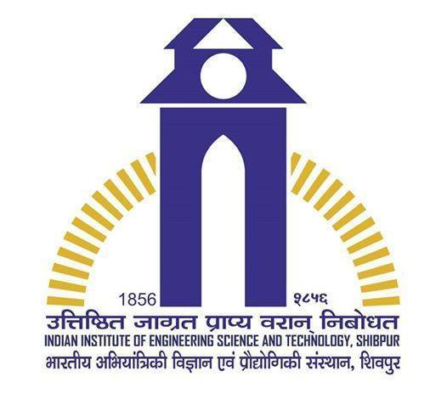**RAJAT KUMAR AGARWAL**

B.E. 3rd year,

|  |
| --- |
| Information Technology |

iiests.ac.in

**EDUCATIONAL QUALIFICATIONS**

|  |  |  |  |  |
| --- | --- | --- | --- | --- |
| **Year** | **Qualification** | **Institute / Organization** | **Board / University** | **%age / CGPA** |
| 2017* | B. Tech | Indian Institute of Engineering Science and Technology, Shibpur. | IIEST,SHIBPUR | 8.03 |
| 2012 | 12th | Chinmaya Vidhayalaya, Bokaro | CBSE | 92.0 |
| 2010 | 10th | D.A.V Public School , Dhanbad | CBSE | 95.0 |

*Currently in 6th Sem. Expected year of graduation 2017.

**TECHNICAL SKILLS**

* Programming Languages : C, C++,CORE JAVA,PHP,HTML5, MYSQL,ORACLE
* Platforms : Linux (Ubuntu, Kali, Red hat) and Windows7,8,10
* Software : WAMP, XAMP, Xilinx, Open GL.

**PROJECT / INTERNSHIP**

* **“Library Management System Database Project” *(Oct ‘15 – feb ‘16)***

Developed a web application of library management system (HMS)

Studied DBMS, SQL in general and PHP, HTML5 (using Wamp and Xamp) underguidance of **Dr. S. Roy.**

* **“Digital Dictionary using Core Java” *(may ‘15 – june ‘15)***

Developed the front end of Dictionary using core java.

Studied Core Java(Applet, Encapsulation, Inheritance).

* **“Lexical Analyzer of our own Language” (**mar’16-april’16)

Developed a basic Lexical Analyzer using C Language

studying basic Compiler Design (automata theory).

* “**Statistical Analysis of what we Write and what we Spoke” (**jan’16-april’16)

Analyze the differences between the Theory Paper, Slide and video Lecture

studying Natural Language Processing (NLP) basic under guidance of Prof M. Bhattacharyya.

**TRAINING AND COURSES**

* 1 month course in **JAVA (Core)** from MTA at Kolkata in summer may, 2015..
* 1 month course in **Database Fundamentals** from MTA at Kolkata in summer June, 2015.
* 1 month course in “**Professional English Language Course**” from British Council at IIEST,SHIBPUR

**WORKSHOP**

* Attended Workshop on "**ETHICAL HACKING**" conducted by TECH DEFENCE.
* Attended Workshop on “**Cloud Computing**” organised by ‘IIT Kharaghpur'.
* Attended Workshop on “**GLOBAL ENTERPRENEURSHIP SUMMIT**” organised by ‘IIT Kharaghpur'.

**POSITIONS OF RESPONSIBILITY**

|  |
| --- |
| * **Webcasting-** Live streaming of events   Live streaming and recording of Events of Alumni Day 2015 directly on YouTube channel  YouTube channel link: <https://www.youtube.com/channel/UCgqWjIJ0LK-YAv_aPsd1_IQ/feed>   * **INSTRUO 2015 *–*** Largest Tech fest of Kolkata   Event co-ordinator of the special event War of Titans on INSTRUO 2015     * **INSTRUO 2016 *–*** Largest Tech fest of Kolkata   Event co-ordinator of the special event MatheMania on INSTRUO 2016 |

.

**ACHIVEMENTS AND EXTRA ACTIVITIES**

* Congratulation letter from HRM Minister, Government of India, **Kapil Sibal.**
* Recieved **Merit Scholarship** of Rs12,000 from GAABESU consecutive two year.
* Recieved **Merit cum Means Scholarship** from IIEST UNIVERSITY of Rs 14,400.
* City topper, **AIR-261**, Merit Certificate ,National Cyber Olympiad.

3rd Year, Info. Tech. (B.E.), IIEST, Shibpur **Email:** agarwalrajat72@gmail.com | **Phone:** +91 –7209286765,9163333954