Assignment 02
Software Project Management

Course Instructor
Ma’am Uzma Mahar

Section
E

Submitted By

Roll No
I221507 (Rabail)
I228777 (Amna Asif)
I222667 (Azghan Ahmed)

Date: 11th October 2025

Fall2025

Department of Computing - Software Engineering
FAST – National University of Computer & Emerging Sciences
Islamabad Campus

1. Project Scope Statement 3
1.1 Project Justification 3
1.2 Product Characteristics and Description 3
1.3 Project Deliverables 4
1.4 Assumptions 5
1.5 Constraints 6
1.6 Agent Description 7
1.6.1 Agent Purpose: 7
1.6.2 Functional Overview: 7
1.6.3 Integration Details (JSON Schema) 7
1.6.4 Communication Protocol: 9
1.6.5 Output Integration: 9
2. Work Breakdown Structure (WBS) 9
2.1 Hierarchical (Graphical) WBS 10
2.2 Tabular WBS 12
3. Scope Management Plan 13
3.1 Scope Definition Process 13
3.1.1 In Scope: 13
3.1.2 Out of Scope: 13
3.2 Scope Validation Approach 14
3.3 Scope Control Strategy 14
3.4 Managing Scope Changes and Preventing Scope Creep 15
3.5 Stakeholder Alignment Strategy 16
4. Gantt Chart (Project Schedule) 17
4.1 Gantt Chart Overview 17
4.2 Critical Path Activities: 17
4.3 Key Dependencies: 17
4.4 Resource Allocation: 18
5. Scope Verification and Validation Report 18
5.1 Scope Management Processes 18
20
5.2 Steps for Scope Verification and Validation 20
5.3 Tools & Techniques for Validation 21
5.4 Acceptance Criteria 22
5.5 Scope Verification Strategy 24
5.6 Tools for Traceability 25
5.7 Outcome & Benefits 27
6. Team Task Assignment and Monitoring 27
6.1 Task Assignment Board / Table 27
6.2 Progress Status and Tracking 28
6.3 Screenshots of Project Management Software 28

Project Scope Statement

1.1 Project Justification
An AI-powered software project called The Nutrition Coach Agent was created to help consumers maintain a balanced diet. It makes recommendations for individualized diet regimens after analyzing user data, including food intake, calorie count, and exercise objectives. Due to hectic schedules and a lack of precise instruction, many people find it difficult to maintain a balanced diet, which makes our initiative justifiable.
By encouraging nutritional awareness and adaptable recommendations, the agent promotes long-term health. It functions as a "Personal Nutrition Advisor" within the university's section-wide multi-agent system, enhancing the system's overall capacity for health awareness.

1.2 Product Characteristics and Description

Category | Characteristics
Functional Features | • Collects user dietary inputs (meals, calories, macronutrients)  • Analyzes eating patterns and nutritional balance  • Calculates personalized diet recommendations based on health goals  • Tracks daily/weekly nutrition progress  • Provides REST API endpoints for integration with other wellness agents  • Generates meal suggestions aligned with user preferences and restrictions
Non-Functional Features | • Responsive web-based interface for easy data entry  • Fast processing (<2 seconds for recommendations)  • Privacy-preserving: uses synthetic data for testing  • Scalable architecture supporting multiple concurrent users  • Cross-platform compatibility (desktop and mobile browsers)
Technologies / Stack | Flask (Python) backend, HTML/CSS/JavaScript frontend, JSON-based REST API, synthetic nutrition dataset, SQLite database for data persistence
User Interface | Clean, intuitive dashboard with:  • Food logging forms  • Visual nutrition breakdown (charts/graphs)  • Goal tracking indicators  • Personalized meal recommendations display
Interoperability | Exposes /api/nutrition/analyze and /api/nutrition/recommendations endpoints for Section E Supervisor Agent integration

1.3 Project Deliverables

Deliverable | Description | Expected Completion
1. Project Management Artifacts | Project Charter, Lifecycle Mapping, SWOT Analysis, Scope Statement, WBS, Gantt Chart, Progress Reports | Throughout Semester
2. Design Artifacts | UI/UX wireframes, database schema, API specifications, system architecture documentation | October 2025
3. Synthetic Dataset | Comprehensive nutrition database with food items, calories, macronutrients, and sample user logs | October 2025
4. Prototype Implementation | Functional Nutrition Coach Agent (frontend + backend + recommendation engine) | November 2025
5. Integration Build | Successfully integrated with Section E multi-agent application via REST API | November 2025
6. Testing Reports | Unit test results, integration test cases, user acceptance testing documentation, bug tracking logs | November–December 2025
7. Final Deliverables | Working demonstration, final presentation, comprehensive documentation, user manual, lessons learned report | December 2025

1.4 Assumptions
- Real-world eating situations will be sufficiently simulated by synthetic nutrition datasets.
- Every team member stays available and dedicated to the planned deliverables and milestones.
- Throughout the project, internet access and the necessary programming tools (Flask, Python, GitHub, and project management software) are available.

- Instructor approvals and comments will be given on schedule.
- The university won't need to make any significant adjustments to its technical infrastructure.
- Student licenses and free-tier cloud services will be adequate for testing and development.

1.5 Constraints
Time Restrictions:
- Timeline for a fixed semester (September 14–December 12, 2025)
- No extensions past the week of the final exam
- Conflicting academic obligations from additional classes
Team Limitations:
- A three-person group with different levels of technical expertise
- Restricted accessibility during the periods of midterm and final exams
- Coordination between several schedules is required.
Technical Limitations:
- Only rule-based recommendation engines are included (machine learning will be delayed until later revisions).
- Integration is limited to the ecology of Section.
- Must use synthetic data only (no genuine personal health information)
- limited computing power (free cloud tiers and student hardware)
Limitations on Resources:
- No funding for commercial equipment or services
- Dependency on free development platforms and open-source frameworks
- Professional nutrition databases are inaccessible; synthetic data must be created instead.
Limitations on Scope:
- Pay attention to basic nutrition tracking and advice.
- The scope does not include advanced capabilities like grocery lists, recipe databases, or meal delivery integration.
- Absence of interaction with third-party health apps or external fitness trackers

1.6 Agent Description
Using a rule-based AI system, the Nutrition Coach Agent creates meal recommendations and serves as a personalized diet coach. It interacts with a Supervisor Agent, who oversees the coordination of all section agents (e.g., menu planner, fitness coach).
Intake logs are analyzed, user goals (weight loss, gain, or maintenance) are gathered, and adaptive recommendations are generated. This makes it possible for the supervisor agent to keep track of each user's complete health profile.

Agent Name: Nutrition Coach Agent

1.6.1 Agent Purpose:
Analyze user dietary patterns, track nutritional intake, and generate personalized meal recommendations aligned with individual health goals (weight loss, muscle gain, or balanced nutrition).

1.6.2 Functional Overview:
- Data Collection: Accepts user food logs including meal types, calories, protein, carbohydrates, and fats
- Pattern Analysis: Evaluates daily/weekly nutritional balance against health goals
- Recommendation Generation: Provides personalized diet suggestions using rule-based heuristics
- Goal Adaptation: Adjusts recommendations based on:
  - Weight loss: 15-20% calorie deficit, high protein
  - Muscle gain: 10-15% calorie surplus, 1.6-2.2g protein/kg body weight
  - Balanced diet: Macro ratio of 40% carbs, 30% protein, 30% fats
- Progress Tracking: Logs historical data for trend analysis

1.6.3 Integration Details (JSON Schema)
Endpoint: POST /api/nutrition/analyze
Request:
json
{
"user_id": "string",
"date": "2025-10-15",
"meals": [
{
"meal_type": "breakfast",
"food_items": ["oatmeal", "banana", "almonds"],
"calories": 450,
"protein_g": 12,
"carbs_g": 65,
"fats_g": 15
}
],
"health_goal": "weight_loss",
"body_weight_kg": 75,
"activity_level": "moderate"
}
Response:
json
{
"analysis": {
"total_calories": 450,
"macro_breakdown": {
"protein_percent": 21,
"carbs_percent": 58,
"fats_percent": 21
},
"goal_alignment": "Good - within target range"
},
"recommendations": [
"Increase protein intake by 20g for optimal muscle preservation",
"Consider adding vegetables for micronutrient diversity",
"Stay hydrated - aim for 2.5L water daily"
],
"next_meal_suggestions": [
"Grilled chicken salad (350 cal, 35g protein)",
"Quinoa bowl with vegetables (380 cal, 15g protein)"
],
"timestamp": "2025-10-15T14:30:00Z"
}
Endpoint: POST /api/nutrition/recommendations
Request:
json
{
"user_id": "string",
"health_goal": "muscle_gain",
"dietary_restrictions": ["vegetarian"],
"meal_time": "lunch"
}
Response:
json
{
"recommended_meals": [
{
"meal_name": "Lentil and Chickpea Curry",
"calories": 520,
"protein_g": 28,
"carbs_g": 65,
"fats_g": 14,
"prep_time_min": 30
}
],
"nutritional_tips": [
"Add Greek yogurt for extra protein",
"Include iron-rich foods with vitamin C for better absorption"
]
}

1.6.4 Communication Protocol:
- API Type: REST API (JSON over HTTP)
- Authentication: Bearer token (shared secret with Supervisor Agent)
- Update Frequency: Real-time on user submission, daily summary reports
- Error Handling: Standard HTTP status codes with descriptive error messages

1.6.5 Output Integration:
The Supervisor Agent aggregates nutrition data to provide holistic wellness insights, combining dietary patterns with sleep, exercise, and stress metrics from other Section E agents.

2. Work Breakdown Structure (WBS)
A Work Breakdown Structure (WBS) systematically decomposes the project's total scope into smaller, manageable deliverables organized hierarchically. This structure clarifies responsibilities, improves resource allocation, and ensures comprehensive coverage of all project activities.

2.1 Hierarchical (Graphical) WBS
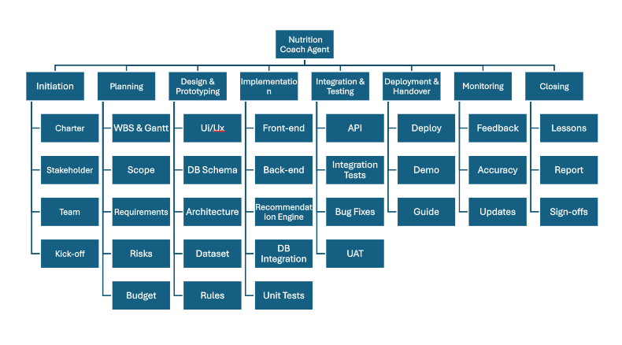

2.2 Tabular WBS
Nutrition Coach Agent Project (0)
├── 1. Initiation Phase
│ ├── 1.1 Project Charter
│ ├── 1.2 Stakeholder ID
│ ├── 1.3 Team Setup
│ └── 1.4 Kick-off
├── 2. Planning Phase
│ ├── 2.1 WBS & Gantt
│ ├── 2.2 Scope Statement
│ ├── 2.3 Requirements
│ ├── 2.4 Risk Plans
│ └── 2.5 Budget Plan
├── 3. Design & Prototyping
│ ├── 3.1 UI/UX Design
│ ├── 3.2 DB Schema
│ ├── 3.3 Architecture
│ ├── 3.4 Dataset
│ └── 3.5 Rules Engine
├── 4. Implementation Phase
│ ├── 4.1 Backend Dev
│ ├── 4.2 Recommendation Engine
│ ├── 4.3 Frontend Dev
│ ├── 4.4 DB Integration
│ └── 4.5 Unit Testing
├── 5. Integration & Testing
│ ├── 5.1 API Integration
│ ├── 5.2 Integration Tests
│ ├── 5.3 Bug Fixes
│ └── 5.4 User Acceptance Testing (UAT)
├── 6. Deployment & Handover
│ ├── 6.1 Build Deploy
│ ├── 6.2 Upload Demo
│ ├── 6.3 User Guide
│ └── 6.4 Demo
├── 7. Monitoring Phase
│ ├── 7.1 Feedback
│ ├── 7.2 Accuracy Review
│ └── 7.3 Minor Updates
└── 8. Closing Phase
├── 8.1 Lessons Learned
├── 8.2 Final Report
├── 8.3 Sign-offs
└── 8.4 Archive

3. Scope Management Plan

3.1 Scope Definition Process
The Scope Management Plan establishes how the project scope will be defined, validated, controlled, and formally accepted throughout the Nutrition Coach Agent project lifecycle. This plan ensures all work aligns with agreed objectives while preventing uncontrolled scope expansion.

3.1.1 In Scope:
- Collection and logging of user dietary intake (meals, calories, macronutrients)
- Analysis of eating patterns against health goals (weight loss, muscle gain, balanced diet)
- Generation of personalized nutrition recommendations using rule-based algorithms
- Development of responsive web-based user interface for data entry and visualization
- Creation of synthetic nutrition datasets for testing and validation
- Implementation of JSON-based REST API endpoints for Section E integration
- Production of comprehensive project management artifacts (charter, WBS, Gantt, reports)
- Unit, integration, and user acceptance testing
- Deployment of working prototype and handover documentation
- Post-deployment monitoring and feedback collection

3.1.2 Out of Scope:
- Machine learning-based predictive modeling (postponed for future iterations)
- Integration with external fitness trackers or third-party health apps
- Collection or processing of real personal health data (synthetic data only)
- Recipe database with cooking instructions
- Grocery shopping lists or meal delivery integration
- Mobile native application development (web-based only)
- Multi-language support (English only)
- Advanced features like barcode scanning or photo-based food recognition
- Integration beyond Section E ecosystem

3.2 Scope Validation Approach
Scope validation ensures project deliverables meet defined requirements and stakeholder expectations through formal inspection and acceptance.

Validation Process:
- Milestone Reviews: Each major deliverable undergoes formal review at phase completion:
  - Post-Design Phase: UI/UX mockups, system architecture, database schema
  - Post-Implementation Phase: Working prototype with core functionality
  - Post-Integration Phase: Fully integrated agent within Section E application
- Validation Criteria:
  - Functionality: Nutrition recommendations align with health goals and dietary inputs
  - Integration: Successful API communication with Supervisor Agent
  - Usability: User interface is intuitive and responsive
  - Accuracy: Recommendation engine produces appropriate suggestions based on rules
  - Documentation: All artifacts are complete, clear, and professionally formatted
- Stakeholder Review Sessions:
  - Weekly progress meetings with instructor for feedback and guidance
  - Mid-semester demonstration of prototype to Section E integration coordinator
  - Final presentation and demo to all stakeholders
- Formal Acceptance:
  - Instructor sign-off required for each major deliverable
  - Written acceptance criteria documented for each WBS work package
  - Defects or gaps must be resolved before acceptance

3.3 Scope Control Strategy
Scope control prevents unplanned changes and manages approved modifications systematically.
Change Control Process:
- Change Request Submission:
  - Any scope change must be formally documented using Change Request Form
  - Submitted to Project Manager (Azghan Ahmad) for initial review
  - Must include: description, justification, impact analysis, priority level
- Impact Assessment:
  - Project Manager evaluates impact on:
    - Schedule: Will this delay milestones?
    - Resources: Does this require additional effort or skills?
    - Quality: How does this affect deliverable standards?
    - Dependencies: What other components are affected?
- Approval Authority:
  - Minor changes (< 4 hours effort, no deadline impact): Project Manager approval
  - Moderate changes (4-16 hours, potential deadline shift): Team consensus + instructor notification
  - Major changes (> 16 hours, significant scope expansion): Instructor approval required
- Implementation:
  - Approved changes documented in Scope Change Log
  - WBS and Gantt chart updated to reflect changes
  - Team members notified of modifications
  - Revised baseline communicated to all stakeholders
- Baseline Management:
  - Original scope baseline preserved for comparison
  - Current approved scope clearly documented
  - Version control maintained for all project documents

3.4 Managing Scope Changes and Preventing Scope Creep
Preventive Measures:
- Clear Requirements: Detailed functional and non-functional requirements documented upfront
- Defined Boundaries: Explicit "Out-of-Scope" section in scope statement
- Stakeholder Agreement: Written acceptance of scope statement by instructor
- Regular Communication: Weekly status meetings to address concerns early
- Prioritization Framework: MoSCoW method applied to feature requests:
  - Must Have: Core nutrition analysis and recommendations
  - Should Have: Visual nutrition charts, goal tracking
  - Could Have: Enhanced UI animations, additional dietary preferences
  - Won't Have (this iteration): ML models, external integrations
- Time-Boxing: Fixed deadlines for each phase prevent endless refinement
- Feature Freeze Date: November 20, 2025 - no new features after this date
- Documentation Discipline: All decisions and changes formally recorded

3.5 Stakeholder Alignment Strategy
Stakeholder Engagement:
- Early Involvement:
  - Instructor consulted during scope definition phase
  - Section E integration coordinator involved in API planning
  - Team members participate in all major decisions
- Transparent Reporting:
  - Weekly progress updates submitted via project management software
  - Milestone presentations with live demonstrations
  - Open communication channels for questions and concerns
- Expectation Management:
  - Realistic timelines communicated upfront
  - Limitations of rule-based approach clearly explained
  - Synthetic data usage justified and accepted
- Feedback Integration:
  - Instructor feedback incorporated within 48 hours
  - User acceptance testing results drive final refinements
  - Lessons learned documented for continuous improvement
- Regular Checkpoints:
  - Week 4: Scope and planning review
  - Week 8: Design and prototype demonstration
  - Week 11: Integration testing review
  - Week 13: Final acceptance and handover

4. Gantt Chart (Project Schedule)
The Gantt chart provides a visual timeline of the project schedule, showing task durations, dependencies, milestones, and the critical path. This chart was developed using project management software with the following conventions:
Legend:
- 🟣 Milestone - Key project checkpoints
- 🔴 Critical Path - Tasks that directly impact project completion date
- 🟢 Completed - Finished tasks
- 🔵 Normal Task - Standard project activities

4.1 Gantt Chart Overview
Project Timeline: September 14, 2025 - December 12, 2025 (14 weeks)
Major Milestones:
- Project Charter Approved (Sep 25, 2025)
- WBS and Scope Statement Complete (Oct 10, 2025)
- Design Phase Complete (Oct 31, 2025)
- Prototype Development Complete (Nov 20, 2025)
- Integration Testing Complete (Dec 5, 2025)
- Final Presentation and Handover (Dec 12, 2025)

4.2 Critical Path Activities:
The critical path represents the sequence of tasks that determine the minimum project duration. Any delay in critical path activities will delay the entire project.
Critical Path Sequence:
- Draft Project Charter (Sep 14-20)
- Stakeholder Identification (Sep 20-22)
- Define Scope Statement (Oct 1-3)
- System Architecture Design (Oct 18-22)
- Synthetic Dataset Creation (Oct 20-27)
- Backend Development (Nov 1-8)
- Recommendation Engine (Nov 8-12)
- Integration Testing (Nov 24-28)
- Final Report Compilation (Dec 11)
- Project Sign-offs (Dec 12)

4.3 Key Dependencies:
- Database schema must be complete before backend development starts
- Synthetic dataset required before recommendation engine testing
- Backend and frontend must be complete before integration testing
- All testing must pass before deployment
- Documentation must be finalized before final presentation

4.4 Resource Allocation:
- Azghan Ahmad: Project management activities, documentation, coordination
- Amna Asif: Frontend development, UI/UX design, API integration
- Rabail: Backend development, AI/ML components, database design
(Note: Actual Gantt chart screenshots from project management software should be inserted here showing weekly timeline with colored bars representing different task statuses and dependencies)

5. Scope Verification and Validation Report
The process for formally verifying that all project deliverables satisfy specified requirements, acceptance criteria, and stakeholder expectations is established in the Scope Verification and Validation Report. This guarantees that all supporting artifacts and the Nutrition Coach Agent prototype are finished and prepared for approval.

5.1 Scope Management Processes
The verification and validation process directly aligns with the five standard Project Scope Management processes:

Scope Management Process | Application to Nutrition Coach Agent
1. Plan Scope Management | Define how project scope will be measured, verified, and controlled. Establish acceptance criteria for each deliverable including:  • Functional nutrition recommendation engine  • Accurate macro/micronutrient calculations  • Responsive web interface  • Successful API integration  • Response time < 2 seconds  • Comprehensive documentation
2. Collect Requirements | Gather detailed functional and non-functional requirements from:  • Instructor expectations for project deliverables  • Section E integration coordinator for API standards  • Team analysis of user needs  Documented requirements include: dietary input formats, goal types, recommendation accuracy, usability standards
3. Define Scope | Break down deliverables into clear components using WBS:  • Backend Module (Flask application, business logic)  • Frontend Module (HTML/CSS/JS interface)  • Recommendation Engine (rule-based heuristics)  • API Integration (REST endpoints)  • Synthetic Dataset (nutrition database)  • Testing Reports (unit, integration, UAT)  • Documentation (technical and user guides)
4. Create WBS | Map all deliverables to specific WBS items ensuring traceability from requirements to work packages. Each WBS element has:  • Clear ownership  • Measurable acceptance criteria  • Start and finish dates  • Dependencies identified  This supports verification that every task contributes to final scope.
5. Validate Scope | Formally review deliverables with stakeholders at key milestones:  • Design review (UI mockups, architecture)  • Prototype demonstration (core functionality with synthetic data)  • Integration testing (API communication with Supervisor Agent)  • Final acceptance (complete working system)  Any non-conformance triggers corrective action and re-validation
6. Control Scope | Monitor scope baseline and assess any proposed changes. Ensure only approved changes are implemented, preventing scope creep. Process includes:  • Change request evaluation  • Impact assessment (schedule, resources, quality)  • Formal approval before implementation  • Documentation updates  • Stakeholder communication

5.2 Steps for Scope Verification and Validation

Step 1: Define Acceptance Criteria
- Establish clear, measurable criteria for each deliverable during planning phase
- Document criteria in WBS and shared with all stakeholders
- Criteria cover functionality, performance, usability, and documentation standards
Step 2: Conduct Milestone Reviews
- Schedule formal review sessions at end of each major phase:
  - Design Phase Review (Oct 31, 2025)
  - Implementation Phase Review (Nov 20, 2025)
  - Integration Phase Review (Dec 5, 2025)
- Present deliverables to instructor and Section E stakeholders
- Demonstrate functionality with live examples using synthetic data
Step 3: Perform Inspection
- Systematic examination of deliverables against acceptance criteria
- Technical inspection: code reviews, architecture validation, API testing
- Documentation inspection: completeness, clarity, professional formatting
- Use checklists to ensure all requirements addressed
Step 4: Execute Testing
- Unit Testing: Verify individual components (recommendation engine, data parsers)
- Integration Testing: Validate API communication with Supervisor Agent
- System Testing: Test complete end-to-end workflows
- User Acceptance Testing: Stakeholder validation of usability and functionality
- All test results documented with pass/fail status
Step 5: Collect Stakeholder Feedback
- Formal feedback sessions after each demonstration
- Document comments, suggestions, and concerns
- Prioritize feedback into: critical fixes, enhancements, future improvements
- Address critical issues before proceeding to next phase
Step 6: Obtain Formal Acceptance
- Present final deliverables with supporting documentation
- Conduct live demonstration of complete Nutrition Coach Agent
- Provide evidence of testing completion and quality assurance
- Obtain written sign-off from instructor
- Archive approval documentation
Step 7: Document Verification Results
- Create comprehensive verification report including:
  - List of all deliverables reviewed
  - Acceptance criteria met for each deliverable
  - Test results and metrics
  - Stakeholder feedback incorporated
  - Outstanding issues and resolutions
  - Lessons learned

5.3 Tools & Techniques for Validation
1. Inspection and Peer Review
- Code reviews conducted by team members
- Documentation peer review for clarity and completeness
- Cross-validation of calculations and recommendation logic
2. Demonstrations and Walkthroughs
- Live demonstrations with synthetic user scenarios:
  - Weight loss goal: Show calorie deficit recommendations
  - Muscle gain goal: Display protein-rich meal suggestions
  - Balanced diet: Demonstrate macro ratio maintenance
- Interactive walkthroughs showing all system features
- Screen recordings for documentation purposes
3. Testing and Validation Tools
- Unit Testing Framework: Python unittest or pytest for backend validation
- API Testing: Postman or curl for REST endpoint verification
- Browser Testing: Chrome DevTools for frontend validation
- Performance Testing: Response time measurement tools
- JSON Validators: Ensure API responses meet schema specifications
4. Checklists and Matrices
- Requirements Traceability Matrix (RTM): Maps requirements to deliverables
- Acceptance Criteria Checklist: Verify all criteria met before approval
- Test Case Checklists: Track completion of all testing activities
- Documentation Review Checklist: Ensure all required documents present
5. Measurement and Metrics
- Quantitative metrics tracked:
  - Recommendation accuracy rate (target: >90%)
  - System response time (target: <2 seconds)
  - API uptime during testing (target: 99%)
  - Test case pass rate (target: 100%)
  - Code coverage (target: >80%)
6. Stakeholder Reviews
- Weekly progress meetings with instructor
- Mid-semester formal presentation
- Final demonstration and Q&A session
- Written feedback forms for structured input

5.4 Acceptance Criteria
To guarantee quality and completeness, each deliverable is evaluated in relation to particular, quantifiable standards.

Deliverable | Acceptance Criteria
Backend Module | • All API endpoints functional and return correct responses  • Recommendation engine calculates accurately based on rules  • Data validation prevents invalid inputs  • Error handling implemented for edge cases  • Unit tests achieve >80% code coverage  • Documentation includes API specifications
Frontend Module | • All input forms functional and user-friendly  • Nutrition data displays accurately with visual charts  • Responsive design works on desktop and mobile browsers  • Navigation is intuitive without training  • No critical UI bugs or broken links  • Positive feedback from usability testing
Recommendation Engine | • Accurate calculations for all three goal types (weight loss, muscle gain, balanced)  • Recommendations align with nutritional science principles  • Edge cases handled appropriately (allergies, restrictions)  • Performance meets <2 second response time  • Logic documented and peer-reviewed
API Integration | • REST endpoints respond with correct HTTP status codes  • JSON schema validated and matches specification  • Successful communication with Supervisor Agent  • Authentication mechanism functional  • Error responses clear and actionable  • Integration tests pass 100%
Synthetic Dataset | • Comprehensive coverage of common foods (minimum 200 items)  • Accurate nutritional information (calories, macros)  • Diverse meal types and dietary preferences  • Sample user logs for testing scenarios  • Data format compatible with backend  • Documentation explains dataset structure
UX/UI Design | • Clear visual hierarchy and layout  • Consistent styling and branding  • Accessibility standards met (contrast, fonts)  • Positive stakeholder feedback  • Design mockups match implementation
Project Management Artifacts | • Charter approved and signed by instructor  • WBS complete with all work packages  • Gantt chart shows dependencies and milestones  • Scope statement detailed and approved  • All reports professional and well-formatted
Testing Documentation | • All test cases documented with expected results  • Test execution logs show pass/fail status  • Bug tracking log maintains issue history  • UAT results include stakeholder feedback  • Test coverage report shows adequacy
Final Prototype | • Complete functionality demonstrated live  • Integration with Section E application confirmed  • No critical bugs or errors during demo  • Performance meets all specified requirements  • Instructor provides formal approval
User Documentation | • Installation and setup instructions clear  • User guide covers all features  • API documentation complete for developers  • Troubleshooting section addresses common issues  • Professional formatting and language

5.5 Scope Verification Strategy
Phase-Based Verification Approach:
Phase 1: Design Verification (End of October)
- Verify UI/UX mockups match requirements
- Validate system architecture against functional needs
- Confirm database schema supports all data operations
- Review API specifications for completeness
- Ensure synthetic dataset design is comprehensive
Phase 2: Implementation Verification (Mid-November)
- Conduct code reviews for backend and frontend modules
- Execute unit tests for all components
- Verify recommendation engine accuracy with test cases
- Confirm database integration works correctly
- Review code documentation and comments
Phase 3: Integration Verification (Early December)
- Test API communication with Supervisor Agent
- Validate end-to-end system workflows
- Execute integration test suite
- Verify data flow between components
- Confirm error handling across integrated system
Phase 4: Final Verification (Mid-December)
- Conduct user acceptance testing with stakeholders
- Perform final demonstration with multiple scenarios
- Verify all documentation is complete and accurate
- Confirm all acceptance criteria met
- Obtain formal sign-offs
Continuous Verification Activities:
- Weekly progress reviews against WBS
- Daily code commits reviewed by peers
- Ongoing documentation updates
- Regular stakeholder communication
- Risk monitoring and mitigation tracking

5.6 Tools for Traceability

1. Requirements Traceability Matrix (RTM)
- Maps each requirement to corresponding WBS deliverables
- Tracks requirement status (planned, in-progress, complete, verified)
- Links requirements to test cases for validation
- Ensures no requirements are overlooked or forgotten
Example RTM Structure:
Req ID | Requirement | WBS Item | Test Case | Status | Verified By
FR-001 | Log daily meals | 4.3 | TC-001 | Complete | Amna
FR-002 | Calculate macros | 4.1 | TC-002 | Complete | Rabail

2. Test Case Logs
- Comprehensive log of all testing activities
- Includes: test case ID, description, expected result, actual result, pass/fail, tester
- Tracks defects found and resolution status
- Maintains test execution history for audit trail
3. Change Request Log
- Documents all scope change requests
- Tracks: request date, description, justification, impact, approval status, implementation
- Links changes to affected WBS items and updated schedules
- Provides historical record of scope evolution
4. Version Control System
- GitHub repository tracks all code changes
- Commit messages link to specific requirements or tasks
- Branch naming convention indicates feature or fix being implemented
- Pull requests require review before merging
5. Project Management Software
- Notion workspace maintains up-to-date task status
- Links tasks to WBS codes for traceability
- Tracks progress, dependencies, and blockers
- Provides dashboard view of project health
6. Documentation Repository
- Centralized storage for all project documents
- Version control for documents shows change history
- Clear naming convention indicates document type and version
- Index document maps deliverables to file locations

5.7 Outcome & Benefits
Expected Outcomes:
- All deliverables meet pre-defined functional and non-functional requirements
- Stakeholder expectations formally addressed and validated
- Scope creep minimized through systematic traceability and control
- High-quality prototype ready for deployment and integration
- Comprehensive documentation supports future maintenance and enhancement
- Team demonstrates professional project management competency
Benefits of Verification Process:
- Quality Assurance: Systematic validation ensures high-quality deliverables
- Risk Mitigation: Early detection of issues prevents major problems
- Stakeholder Confidence: Formal reviews build trust and alignment
- Clear Acceptance: Defined criteria eliminate ambiguity about completion
- Audit Trail: Documentation provides evidence of due diligence
- Knowledge Transfer: Verification process captures lessons learned

6. Team Task Assignment and Monitoring

6.1 Task Assignment Board / Table
The team used Trello as a project management tool to assign and monitor tasks.
Each task corresponds to a specific WBS item and includes the responsible team member, start and finish dates, and current progress status.
The following table summarizes the task allocation:

WBS | Task Name | Owner | Start | Finish | Status | Description
1.1 | Project Charter | Azghan | 14-Sep | 20-Sep | ✅ Completed | Prepare the official Project Charter document outlining objectives, scope, stakeholders, and approval by the instructor.
1.2 | Stakeholder Identification | Azghan | 20-Sep | 22-Sep | ✅ Completed | Identify and document all stakeholders (team members, instructor, integration coordinator) with their roles and interests.
1.3 | Team Formation | Azghan | 22-Sep | 23-Sep | ✅ Completed | Define team structure, assign key roles (leader, backend, frontend), and confirm responsibilities.
2.2 | Define Scope Statement | Azghan | 01-Oct | 03-Oct | ✅ Completed | Develop a comprehensive scope statement including project justification, deliverables, assumptions, and constraints.
2.3 | Requirements Collection | Rabail | 02-Oct | 04-Oct | ✅ Completed | Gather functional and non-functional requirements for Nutrition Coach Agent through discussions and documentation.
3.1 | UI/UX Design | Amna | 11-Oct | 15-Oct | 🟡In Progress | Design interactive wireframes and page layouts for the Nutrition Coach interface, ensuring responsive and user-friendly visuals.
3.2 | Database Schema Design | Rabail | 15-Oct | 18-Oct | 🔵Not Started | Design SQLite database schema defining tables for meals, nutrients, and user profiles to support backend operations.
3.3 | System Architecture | Rabail | 18-Oct | 22-Oct | 🔵Not Started | Create architectural diagrams showing backend, frontend, and REST API communication layers.
3.4 | Synthetic Dataset | Rabail | 20-Oct | 27-Oct | 🔵Not Started | Build a dataset containing synthetic nutrition records (food items, calories, macros) for testing and analysis.
4.1 | Backend Development | Rabail | 01-Nov | 08-Nov | 🔵Not Started | Implement backend logic using Flask; develop endpoints for data analysis, meal recommendations, and user data management.
4.2 | Recommendation Engine | Rabail | 08-Nov | 12-Nov | 🔵Not Started | Code the rule-based recommendation system for diet suggestions according to user health goals.
4.3 | Frontend Development | Amna | 05-Nov | 15-Nov | 🔵Not Started | Build a responsive HTML/CSS/JS frontend for logging meals, visualizing data, and viewing meal recommendations.
4.4 | Database Integration | Rabail | 12-Nov | 14-Nov | 🔵Not Started | Connect backend modules with SQLite database ensuring CRUD operations and persistent data storage.
4.5 | Unit Testing | All | 16-Nov | 18-Nov | 🔵Not Started | Write and execute test cases for each module to validate correctness and performance of backend and frontend.
5.1 | API Integration | Amna | 21-Nov | 24-Nov | 🔵Not Started | Connect the Nutrition Coach API with the Section E Supervisor Agent via REST endpoints and validate data flow.
5.2 | Integration Testing | All | 24-Nov | 28-Nov | 🔵Not Started | Test the full system integration, ensuring proper interaction between backend, frontend, and Supervisor Agent.
5.3 | Bug Fixes & Refinement | Rabail | 28-Nov | 02-Dec | 🔵Not Started | Resolve defects identified during integration tests, improve stability and performance before user testing.
5.4 | User Acceptance Testing (UAT) | Azghan | 02-Dec | 04-Dec | 🔵Not Started | Conduct UAT sessions with instructor and team; gather feedback and document acceptance results.
6.1 | Deployment Build | Rabail | 06-Dec | 06-Dec | 🔵Not Started | Package final build for deployment, ensuring that the Flask server and frontend are properly configured.
6.2 | Upload to Demo Environment | Amna | 06-Dec | 07-Dec | 🔵Not Started | Upload the deployed prototype to the live environment or cloud platform for demonstration.
6.3 | User Guide & Documentation | Azghan | 07-Dec | 08-Dec | 🔵Not Started | Prepare the user manual, setup instructions, and system documentation for handover.
6.4 | Handover Demo | All | 08-Dec | 08-Dec | 🔵Not Started | Deliver final project demo to instructor and Section E integration coordinator, showcasing all features.
7.1 | Feedback Collection | Azghan | 09-Dec | 09-Dec | 🔵Not Started | Collect post-deployment feedback from users and instructor to identify strengths and improvement areas.
7.2 | Recommendation Accuracy Review | Rabail | 09-Dec | 10-Dec | 🔵Not Started | Review and analyze accuracy of generated recommendations based on sample user inputs.
7.3 | Minor Updates | Amna | 10-Dec | 10-Dec | 🔵Not Started | Apply minor improvements based on feedback without altering the main project scope.
8.1 | Lessons Learned | All | 10-Dec | 11-Dec | 🔵Not Started | Document key takeaways and challenges faced during the project for future improvements.
8.2 | Final Report Compilation | Azghan | 11-Dec | 11-Dec | 🔵Not Started | Compile final project report with all documents, results, and screenshots for submission.
8.3 | Sign-offs | Azghan | 12-Dec | 12-Dec | 🔵Not Started | Obtain instructor’s formal sign-off confirming project completion and acceptance.
8.4 | Archive Project Artifacts | Azghan | 12-Dec | 12-Dec | 🔵Not Started | Organize and upload all project documents, datasets, and reports to a shared repository for record keeping.

6.2 Progress Status and Tracking
To ensure transparency and effective coordination, the Nutrition Coach Agent Project Board was created on Trello.
Each card represents a deliverable or work package derived from the WBS.
Team members were assigned to their respective tasks, with clear start and due dates.
The board was divided into lists — To Do, In Progress, and Completed — to visually track progress.
Weekly progress meetings were conducted, and the status of each task was updated accordingly.
This setup provided real-time visibility, improved accountability, and reduced delays through collaborative updates.

6.3 Screenshots of Project Management Software

Trello Board: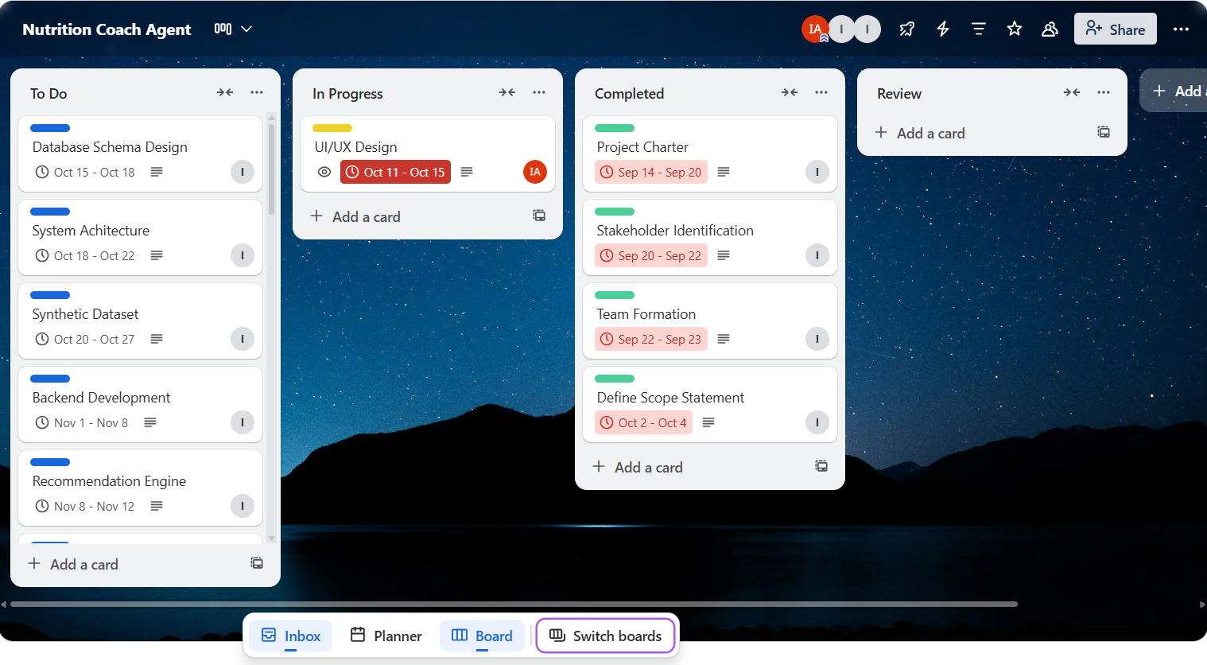
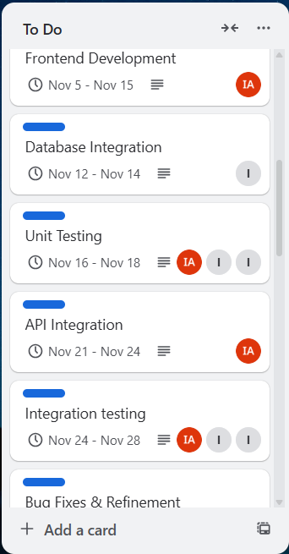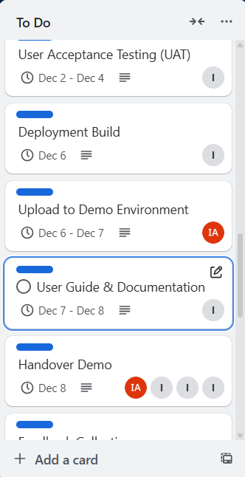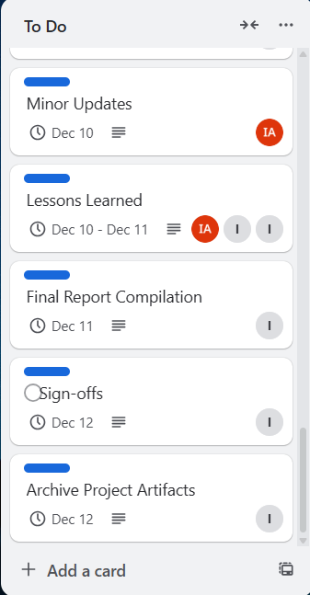

Sample task card

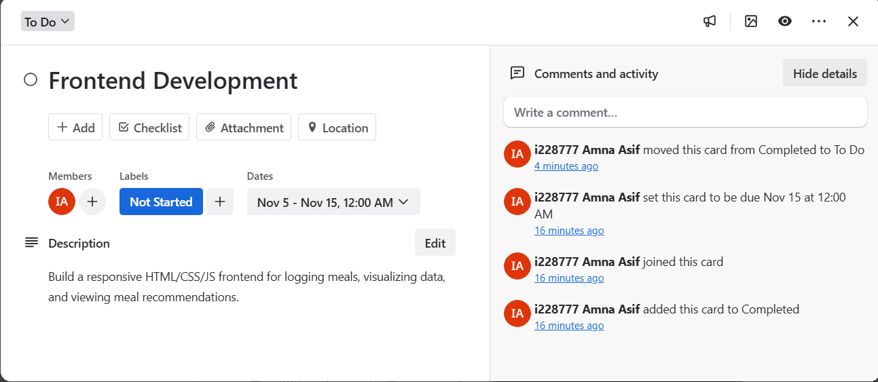

Calendar view illustrating overall project timeline and dependencies.

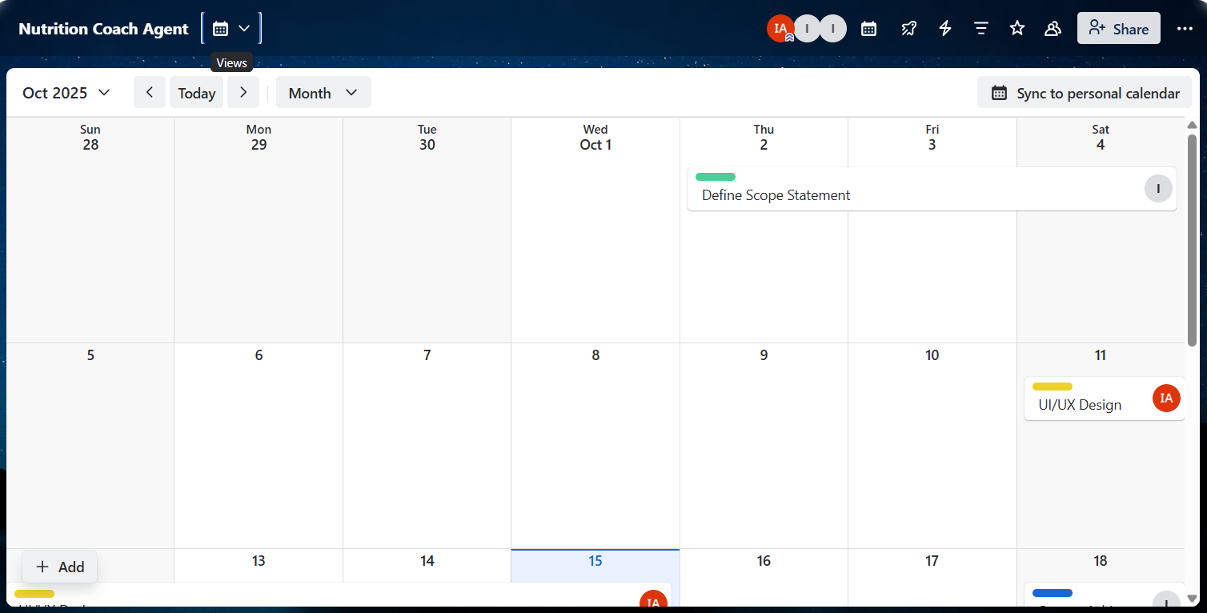

Timeline View:
