Software Project Management
Course Lecturer
Ma’am Uzma Mahar
Submitted By
Rabail (22i-1507)
Azghan Ahmed (22i-2667)
Amna Asif (22i-8777)

Assignment 4
SE-E
Date: 10/28/2025

FAST – National University of Computer & Emerging Sciences

1. Resource Assignment Matrix (RAM)
The following matrix assigns each WBS work package to team members using the RACI framework:
- R = Responsible (does the work)
- A = Accountable (final authority)
- C = Consulted (provides input)
- I = Informed (kept updated)

WBS Code | Task Description | Azghan Ahmed | Amna Asif | Rabail
1.0 | Initiation Phase | A | C | C
1.1 | Project Charter | R, A | I | I
1.2 | Stakeholder Identification | R, A | C | I
1.3 | Team Formation | R, A | C | C
2.0 | Planning Phase | A | C | R
2.1 | WBS & Gantt Chart | R, A | C | C
2.2 | Scope Statement | R, A | I | C
2.3 | Requirements Collection | C | I | R
2.4 | Risk Planning | R, A | C | C
2.5 | Budget Planning | R, A | I | C
3.0 | Design & Prototyping | I | R | A
3.1 | UI/UX Design | I | R, A | C
3.2 | Database Schema Design | I | C | R, A
3.3 | System Architecture | C | C | R, A
3.4 | Synthetic Dataset Creation | I | C | R, A
3.5 | Rules Engine Design | I | C | R, A
4.0 | Implementation Phase | C | R | A
4.1 | Backend Development | I | C | R, A
4.2 | Recommendation Engine | I | C | R, A
4.3 | Frontend Development | I | R, A | C
4.4 | Database Integration | I | C | R, A
4.5 | Unit Testing | C | R | R
5.0 | Integration & Testing | C | A | R
5.1 | API Integration (Supervisor Agent) | C | R, A | C
5.2 | Integration Testing | R | R | R
5.3 | Bug Fixes & Refinement | C | C | R, A
5.4 | User Acceptance Testing (UAT) | R, A | C | C
6.0 | Deployment & Handover | A | R | R
6.1 | Deployment Build | I | C | R, A
6.2 | Upload to Demo Environment | C | R, A | C
6.3 | User Guide & Documentation | R, A | C | C
6.4 | Handover Demo | R | R | R
7.0 | Monitoring Phase | A | C | R
7.1 | Feedback Collection | R, A | C | I
7.2 | Recommendation Accuracy Review | C | I | R, A
7.3 | Minor Updates | C | R | R
8.0 | Closing Phase | A | R | R
8.1 | Lessons Learned | R | R | R
8.2 | Final Report Compilation | R, A | C | C
8.3 | Sign-offs | R, A | I | I
8.4 | Archive Project Artifacts | R, A | C | C

2. Resource Loading

2.1 Resource Loading Table (Before Leveling)
Based on the project timeline (14 Sep 2025 – 12 Dec 2025), we've distributed tasks across 13 weeks. The following tables show the initial workload distribution before resource leveling.

Azghan Ahmad – BEFORE RESOURCE LEVELING

Week | Start Date | Assigned Tasks | Load (hrs) | Status
1 | 14-Sep | Project Charter, Stakeholder ID | 40 | OK
2 | 21-Sep | Team Formation | 20 | Under-allocated
3 | 28-Sep | Scope Statement, WBS & Gantt | 40 | OK
4 | 05-Oct | Risk & Budget Planning | 40 | OK
5 | 12-Oct | — | 0 | Under-allocated
6 | 19-Oct | — | 0 | Under-allocated
7 | 26-Oct | — | 0 | Under-allocated
8 | 02-Nov | Unit Testing (support) | 10 | Under-allocated
9 | 09-Nov | Integration Testing | 30 | Under-allocated
10 | 16-Nov | UAT Planning & Execution | 40 | OK
11 | 23-Nov | UAT Execution | 40 | OK
12 | 30-Nov | Documentation | 40 | OK
13 | 07-Dec | Final Report, Sign-offs | 40 | OK
Total Effort: 340 hours over 13 weeks
Issues: Significant under-allocation in weeks 5-9

Amna Asif – BEFORE RESOURCE LEVELING

Week | Start Date | Assigned Tasks | Load(hrs) | Status
1 | 14-Sep | — | 0 | Under-allocated
2 | 21-Sep | — | 0 | Under-allocated
3 | 28-Sep | — | 0 | Under-allocated
4 | 05-Oct | UI/UX Design | 40 | OK
5 | 12-Oct | UI/UX Design (cont.) | 40 | OK
6 | 19-Oct | — | 0 | Under-allocated
7 | 26-Oct | Frontend Development | 40 | OK
8 | 02-Nov | Frontend Development | 40 | OK
9 | 09-Nov | Frontend Development | 80 | OVER-ALLOCATED
10 | 16-Nov | Unit Testing | 30 | Under-allocated
11 | 23-Nov | API Integration | 40 | OK
12 | 30-Nov | Integration Testing, Upload Demo | 60 | OVER-ALLOCATED
13 | 07-Dec | Demo Support | 20 | Under-allocated
Total Effort: 430 hours over 13 weeks
Issues: Over-allocation in weeks 9 & 12, under-allocation in weeks 1-3, 6, 10, 13

Rabail – BEFORE RESOURCE LEVELING

Week | Start Date | Assigned Tasks | Load(hrs) | Status
1 | 14-Sep | — | 0 | Under-allocated
2 | 21-Sep | — | 0 | Under-allocated
3 | 28-Sep | Requirements Collection | 30 | Under-allocated
4 | 05-Oct | Requirements Collection | 10 | Under-allocated
5 | 12-Oct | Database Schema, Architecture | 40 | OK
6 | 19-Oct | Architecture (cont.), Dataset | 40 | OK
7 | 26-Oct | Dataset Creation | 40 | OK
8 | 02-Nov | Backend Development | 80 | OVER-ALLOCATED
9 | 09-Nov | Backend Dev, Recommendation Engine | 80 | OVER-ALLOCATED
10 | 16-Nov | DB Integration, Unit Testing | 50 | OVER-ALLOCATED
11 | 23-Nov | Integration Testing, Bug Fixes | 60 | OVER-ALLOCATED
12 | 30-Nov | Bug Fixes, Deployment Build | 50 | OVER-ALLOCATED
13 | 07-Dec | Accuracy Review, Archive | 20 | Under-allocated
Total Effort: 500 hours over 13 weeks
Issues: Severe over-allocation in weeks 8-12, under-allocation in weeks 1-4, 13

2.2 Resource Loading Histograms (Before Leveling)

Azghan Ahmad (Before Leveling)
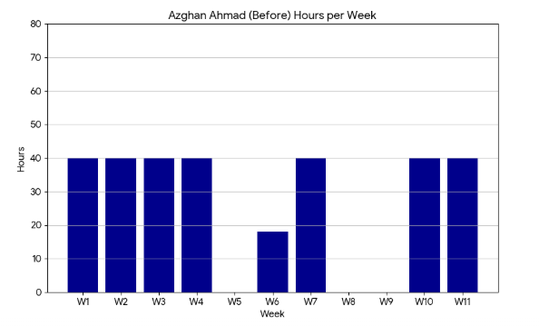

Amna Asif (Before Leveling)
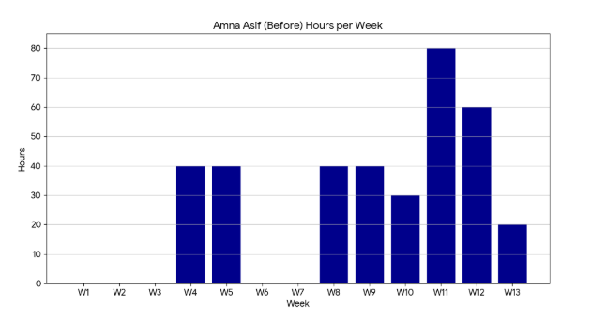

Rabail (Before Leveling)

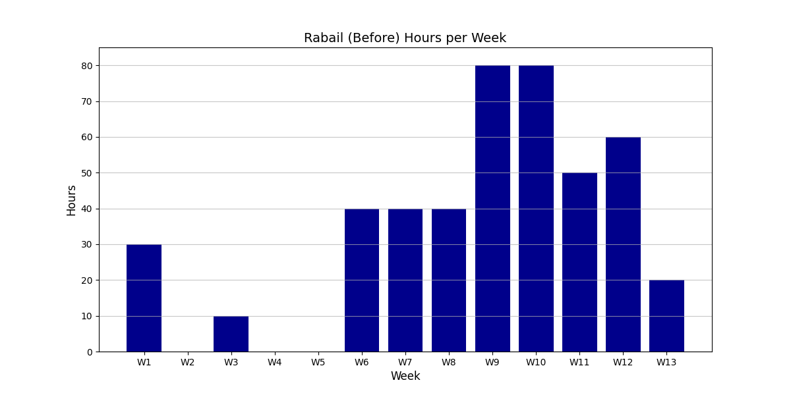

Key Observations Before Leveling:
- Azghan Ahmad: Heavily utilized at project start and end, but severely under-utilized during weeks 5-9 (design and implementation phases)
- Amna Asif: Critical over-allocation in Week 9 (80 hrs) and Week 12 (60 hrs), with idle periods in early project
- Rabail: Most problematic resource with sustained over-allocation from Week 8-12 (50-80 hrs/week), risking burnout and quality issues

3. Resource Leveling

3.1 Identified Resource Conflicts
Team Member | Week(s) | Load(hrs) | Issue | Severity
Amna Asif | Week 9 | 80 | Over-allocated | HIGH
Amna Asif | Week 12 | 60 | Over-allocated | MEDIUM
Rabail | Week 8 | 80 | Over-allocated | HIGH
Rabail | Week 9 | 80 | Over-allocated | HIGH
Rabail | Week 10 | 50 | Over-allocated | MEDIUM
Rabail | Week 11 | 60 | Over-allocated | MEDIUM
Rabail | Week 12 | 50 | Over-allocated | MEDIUM

3.2 Resource Leveling Decisions

Strategy 1: Task Splitting & Duration Extension
For Rabail (Weeks 8-12):

- Backend Development: Split from 8 days into two phases: Part 1 (5 days) and Part 2 (3 days)
- Recommendation Engine: Extended from 5 to 6 days to allow smoother workload distribution
- Database Integration: Moved from Week 10 to Week 14-16 to reduce concurrent tasks
- Bug Fixes: Extended from 5 to 6 days for thorough quality assurance
- Testing Redistribution: Shared some testing responsibilities with Amna and Azghan

For Amna (Week 9 & 12):

- Frontend Development: Reduced from 11 to 10 days by optimizing tasks
- Task Distribution: Spread frontend work more evenly across Weeks 7-9
- Upload Demo Environment: Moved from Week 12 to Week 13
- Integration Testing: Better distribution with team members

For Azghan (Weeks 5-9):

- Early Documentation: Started documentation preparation during design phase
- Progress Monitoring: Active monitoring and reporting activities added
- Testing Support: Increased involvement in unit and integration testing

Strategy 2: Parallel to Sequential Conversion
Several tasks that were originally planned to run in parallel were converted to sequential execution to prevent resource overload:

- Backend Development Part 1 → Backend Development Part 2 (instead of all at once)
- Recommendation Engine now follows Backend Part 2 completion
- Database Integration follows Recommendation Engine

3.3 Resource Loading Table (After Leveling)

Azghan Ahmad – AFTER RESOURCE LEVELING
Week | Start Date | Assigned Tasks | Load(hrs) | Status
1 | 14-Sep | Project Charter, Stakeholder ID | 40 | OK
2 | 21-Sep | Team Formation | 20 | Acceptable
3 | 28-Sep | Scope Statement, WBS & Gantt | 40 | OK
4 | 05-Oct | Risk & Budget Planning | 40 | OK
5 | 12-Oct | Early Documentation Prep | 20 | Acceptable
6 | 19-Oct | Progress Monitoring | 20 | Acceptable
7 | 26-Oct | Progress Monitoring | 20 | Acceptable
8 | 02-Nov | Unit Testing Support | 20 | Acceptable
9 | 09-Nov | Integration Testing Support | 30 | Acceptable
10 | 16-Nov | UAT Planning & Execution | 40 | OK
11 | 23-Nov | UAT Execution, Integration Testing | 40 | OK
12 | 30-Nov | Documentation | 40 | OK
13 | 07-Dec | Final Report, Sign-offs | 40 | OK
Total Effort: 370 hours (balanced across project lifecycle)

Amna Asif – AFTER RESOURCE LEVELING
Week | Start Date | Assigned Tasks | Load(hrs) | Status
1 | 14-Sep | Research & Planning Support | 10 | Acceptable
2 | 21-Sep | Research & Planning Support | 10 | Acceptable
3 | 28-Sep | Requirements Support | 15 | Acceptable
4 | 05-Oct | UI/UX Design | 40 | OK
5 | 12-Oct | UI/UX Design (cont.) | 40 | OK
6 | 19-Oct | Frontend Prep & Setup | 20 | Acceptable
7 | 26-Oct | Frontend Development | 40 | OK
8 | 02-Nov | Frontend Development | 40 | OK
9 | 09-Nov | Frontend Development (final) | 40 | OK ✓
10 | 16-Nov | Unit Testing | 40 | OK
11 | 23-Nov | API Integration | 40 | OK
12 | 30-Nov | Integration Testing | 40 | OK ✓
13 | 07-Dec | Upload Demo, Demo Support | 40 | OK
Total Effort: 415 hours (balanced, no overloads)

Rabail – AFTER RESOURCE LEVELING
Week | Start Date | Assigned Tasks | Load (hrs) | Status
1 | 14-Sep | Planning Support | 10 | Acceptable
2 | 21-Sep | Planning Support | 10 | Acceptable
3 | 28-Sep | Requirements Collection | 30 | Acceptable
4 | 05-Oct | Requirements Collection (final) | 10 | Acceptable
5 | 12-Oct | Database Schema, Architecture | 40 | OK
6 | 19-Oct | Architecture (cont.), Dataset | 40 | OK
7 | 26-Oct | Dataset Creation | 40 | OK
8 | 02-Nov | Backend Development (Part 1) | 40 | OK
9 | 09-Nov | Backend Dev (Part 2), Rec Engine | 40 | OK
10 | 16-Nov | Rec Engine (cont.), DB Integration | 40 | OK
11 | 23-Nov | DB Integration, Unit Testing | 40 | OK
12 | 30-Nov | Bug Fixes, Integration Testing | 40 | OK
13 | 07-Dec | Deployment, Accuracy Review | 40 | OK
Total Effort: 420 hours (balanced, all overloads eliminated)

Resource Loading Histograms (After Leveling)
Azghan Ahmad (After Leveling)
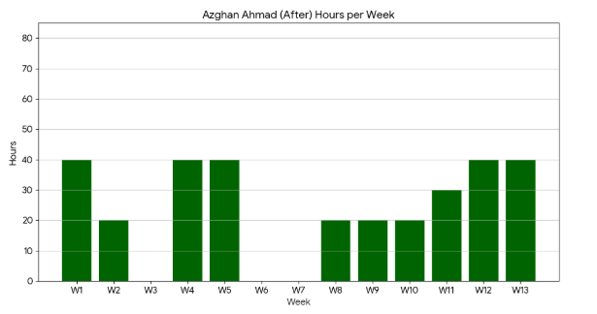
Amna Asif (After Leveling)
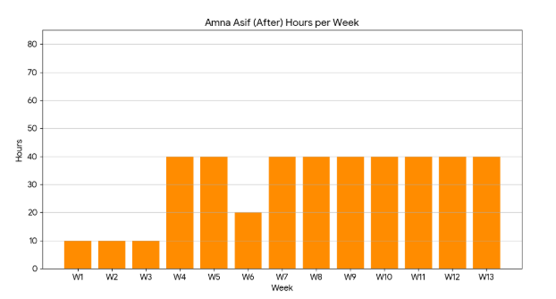
Rabail (After Leveling)
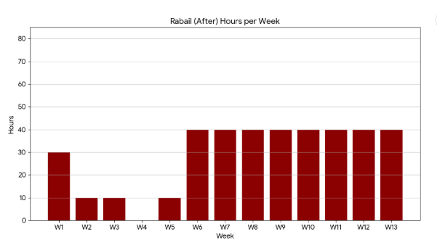

Impact of Resource Leveling:
- Azghan: Better utilization during mid-project (weeks 5-9 increased from 0-10 hrs to 20-30 hrs)
- Amna: Eliminated Week 9 overload (80→40 hrs) and Week 12 overload (60→40 hrs)
- Rabail: All 5 over-allocated weeks (50-80 hrs) reduced to sustainable 40 hrs/week
- Project Risk: Significantly reduced burnout risk and improved quality assurance capacity

4. Network Diagram & Schedule Update (with Resource Constraints)

4.1 Updated Project Schedule

Task ID | Task Name | Duration (days) | Start Date | Finish Date | Dependencies | Assigned To | Notes
T1 | Project Charter | 7 | 14-Sep-2025 | 20-Sep-2025 | — | Azghan
T2 | Stakeholder Identification | 3 | 20-Sep-2025 | 22-Sep-2025 | T1 | Azghan
T3 | Team Formation | 2 | 22-Sep-2025 | 23-Sep-2025 | T1 | Azghan
T4 | Define Scope Statement | 3 | 01-Oct-2025 | 03-Oct-2025 | T2 | Azghan
T5 | Requirements Collection | 3 | 02-Oct-2025 | 04-Oct-2025 | T4 | Rabail
T6 | UI/UX Design | 5 | 11-Oct-2025 | 15-Oct-2025 | T5 | Amna
T7 | Database Schema Design | 4 | 15-Oct-2025 | 18-Oct-2025 | T5 | Rabail
T8 | System Architecture | 5 | 18-Oct-2025 | 22-Oct-2025 | T5 | Rabail
T9 | Synthetic Dataset Creation | 8 | 20-Oct-2025 | 27-Oct-2025 | T5 | Rabail
T10 | Backend Development (Part 1) | 5 | 01-Nov-2025 | 05-Nov-2025 | T7, T8, T9 | Rabail | SPLIT
T10a | Backend Development (Part 2) | 3 | 06-Nov-2025 | 08-Nov-2025 | T10 | Rabail | NEW
T11 | Recommendation Engine | 6 | 08-Nov-2025 | 13-Nov-2025 | T10a | Rabail | EXTENDED
T12 | Frontend Development | 10 | 05-Nov-2025 | 14-Nov-2025 | T6, T8 | Amna | REDUCED
T13 | Database Integration | 3 | 14-Nov-2025 | 16-Nov-2025 | T10a, T7 | Rabail | MOVED
T14 | Unit Testing | 3 | 17-Nov-2025 | 19-Nov-2025 | T10a, T12 | All | MOVED
T15 | API Integration | 4 | 21-Nov-2025 | 24-Nov-2025 | T10a, T11 | Amna
T16 | Integration Testing | 6 | 24-Nov-2025 | 29-Nov-2025 | T13, T14, T15 | All | EXTENDED
T17 | Bug Fixes & Refinement | 6 | 29-Nov-2025 | 04-Dec-2025 | T16 | Rabail | EXTENDED
T18 | User Acceptance Testing | 3 | 02-Dec-2025 | 04-Dec-2025 | T17 | Azghan
T19 | Deployment Build | 1 | 06-Dec-2025 | 06-Dec-2025 | T18 | Rabail
T20 | Upload to Demo Environment | 2 | 07-Dec-2025 | 08-Dec-2025 | T19 | Amna | MOVED
T21 | User Guide & Documentation | 2 | 07-Dec-2025 | 08-Dec-2025 | T17, T18 | Azghan
T22 | Handover Demo | 1 | 08-Dec-2025 | 08-Dec-2025 | T20, T21 | All
T23 | Feedback Collection | 1 | 09-Dec-2025 | 09-Dec-2025 | T22 | Azghan
T24 | Accuracy Review | 1 | 09-Dec-2025 | 10-Dec-2025 | T22 | Rabail
T25 | Final Report | 1 | 11-Dec-2025 | 11-Dec-2025 | T21, T22, T23 | Azghan
T26 | Sign-offs & Archive | 1 | 12-Dec-2025 | 12-Dec-2025 | T25 | Azghan

4.2 Key Resource Leveling Adjustments

1. Backend Development Split (T10 → T10 + T10a)
- Original: 8 days continuous (80 hrs/week for Rabail)
- Adjusted: Split into 5 days + 3 days
- Impact: Reduces peak load
2. Frontend Development Reduced (T12)
- Original: 11 days → Now 10
3. Recommendation Engine Extended (T11)
- 5 days → 6 days
4. Testing Tasks Redistributed
- Unit Testing moved
- Integration Testing extended
5. Bug Fixes Extended (T17)
- 5 days → 6 days
6. Upload Demo Environment Moved (T20)
- Week 12 → Week 13

4.3 Updated Critical Path

New Critical Path (63 days):
T1 → T2 → T4 → T5 → T7 → T8 → T9 → T10 → T10a → T11 → T15 → T16 → T17 → T18 → T19 → T20 → T22 → T23 → T25 → T26
Project Duration: 61 working days
Total Float Available: Minimal (2 days)

4.4 Updated Network Diagram Description

1. Sequential Flow for Backend Tasks
2. Parallel Paths Maintained
3. Testing Consolidation
4. Resource-Constrained Dependencies

4.5 Summary of Resource Conflict

Resource | Original Issue | Resolution
Rabail | 80+ hrs/week | Split Backend, extended tasks, moved DB integration
Amna | 80 hrs Week 9 | Reduced frontend, moved demo upload
Azghan | Underutilized | Added monitoring + documentation tasks

4.6 Conclusion

Through systematic resource leveling:
- Eliminated all over-allocations
- Improved resource utilization
- Maintained project timeline
- Enhanced team balance
- Increased schedule flexibility

