Software Project and Management



Assignment 1 (First Deliverable)

Group Members:
Azghan Ahmad 22I-2667
Amna Asif 22I-8777
Rabail 22I-1507
SE-E

Submitted to: Mam Uzma

National University of Computer and Emerging Sciences, Islamabad
Contents
1. Project Lifecycle & Mapping with Process Groups: 3
A. Lifecycle Phases: 3
i. Initiation Phase (Weeks 1–2) 3
ii. Planning Phase (Weeks 3–4) 3
iii. Execution Phase (Weeks 5–10) 3
iv. Monitoring & Controlling Phase (Weeks 6–12) 4
v. Closing Phase (Weeks 13–14) 4
B. Mapping with Five Process Groups: 5
C. Visual Representation of Planned Lifecycle: 7
2. Baseline Gantt Chart (14 Weeks): 8
3. SWOT Analysis: 10
4. Project Charter: 12

Agent: Nutrition Coach Agent

1. Project Lifecycle & Mapping with Process Groups:

Lifecycle Phases:

i. Initiation Phase (Weeks 1–2)
- Approve the Nutrition Coach Agent as the official project topic and define its scope: an agent that adapts diet plans based on user patterns and goals (weight loss, muscle gain, balance).
- Form a team of three members and assign roles: Project Manager, Developer, and AI/ML Developer.
- Identify stakeholders: instructor, project team, and section integration coordinator.
- Prepare and submit the Project Charter including objectives, milestones, risks, and budget information.

ii. Planning Phase (Weeks 3–4)
- Create a Work Breakdown Structure (WBS) covering major tasks: dataset creation, rule engine development, goal adaptation, integration APIs, testing, reporting.
- Develop a baseline project schedule and Gantt chart with milestones: dataset finalized, prototype built, testing completed, integration achieved.
- Estimate project budget (time and effort cost, no direct monetary cost since synthetic data and free tools will be used).
- Identify project risks such as data inaccuracy, user engagement challenges, limited scope, and integration difficulties.
- Define quality parameters: accuracy of diet suggestions, smooth integration with section application, and timely delivery of milestones.
- Finalize synthetic nutrition datasets (weekly food logs including calories, macros, meal types) and rules for personalized recommendations.

iii. Execution Phase (Weeks 5–10)
- Generate synthetic food log datasets with attributes like calories, protein, carbs, fats, and daily intake patterns.
- Develop the rule-based engine for nutrition recommendations using predefined thresholds and health guidelines.
- Implement goal-based adaptation features: weight loss (calorie deficit), muscle gain (protein surplus), balanced diet (macro stability).
- Build API endpoints for data exchange and integration with the section-wide agentic application.
- Create a working prototype of the Nutrition Coach Agent and test it with sample user goals.

iv. Monitoring & Controlling Phase (Weeks 6–12)
- Track progress against baseline Gantt chart milestones.
- Monitor planned vs. actual effort and budget usage.
- Conduct unit testing and validation of recommendations to ensure they match user goals and dataset logic.
- Identify and resolve issues such as inaccurate outputs, delays, or integration conflicts.
- Apply corrective actions for scope or timeline deviations.
- Conduct weekly review meetings and submit progress reports to the instructor.

v. Closing Phase (Weeks 13–14)
- Perform final integration testing of Nutrition Coach Agent within the section-wide multi-agent system.
- Prepare and deliver the final presentation and live demo, showing recommendations adapting to different user goals.
- Submit the final consolidated project report containing all project management documents (charter, WBS, schedule, cost plan, risk plan, monitoring reports).
- Prepare and submit a Lessons Learned Report reflecting challenges (data accuracy, integration), achievements, and areas of improvement.
- Update and submit all refined project documents (charter, schedule, risk plan, etc.).
- Obtain formal approval and sign-off from instructor/stakeholders to officially close the project.

Mapping with Five Process Groups:
Knowledge Area | Initiating | Planning | Executing | Monitoring & Controlling | Closing
Project Integration Management | Develop project charter | Develop project management plan | Direct & manage project work (dataset creation, prototype design, integration) | Monitor & control project work, Perform integrated change control | Close project, Final presentation & report
Project Scope Management | Define high-level scope | Plan scope management, Collect requirements, Define scope, Create WBS | Execute scope tasks (diet rules, personalized recommendations) | Validate scope, Control scope | Confirm scope completion
Project Time Management | — | Plan schedule management, Define & sequence activities, Estimate resources & durations, Develop schedule | Follow project timeline | Control schedule adherence | —
Project Cost Management | — | Plan cost management, Estimate costs, Determine budget | Track expenses (tools, software, labor) | Control costs | —
Project Quality Management | — | Plan quality management | Perform quality assurance (testing diet suggestions & accuracy) | Control quality | —
Project Human Resource Management | Identify team members & roles | Plan human resource management | Acquire & manage project team, Assign roles | Monitor team performance | Release team members
Project Communications Management | Identify communication needs | Plan communication management | Manage communications (weekly meetings, updates) | Control communications flow | —
Project Risk Management | Identify initial risks | Plan risk management, Analyze & plan responses | Execute risk responses (dataset issues, low engagement) | Monitor & control risks | —
Project Procurement Management | — | Plan procurement (tools, licenses, datasets) | Conduct procurements (if needed) | Control procurements | Close procurements
Project Stakeholder Management | Identify stakeholders (instructor, teammates, users) | Plan stakeholder engagement | Manage stakeholder communication & feedback | Control stakeholder satisfaction | Confirm stakeholder approval

Visual Representation of Planned Lifecycle:
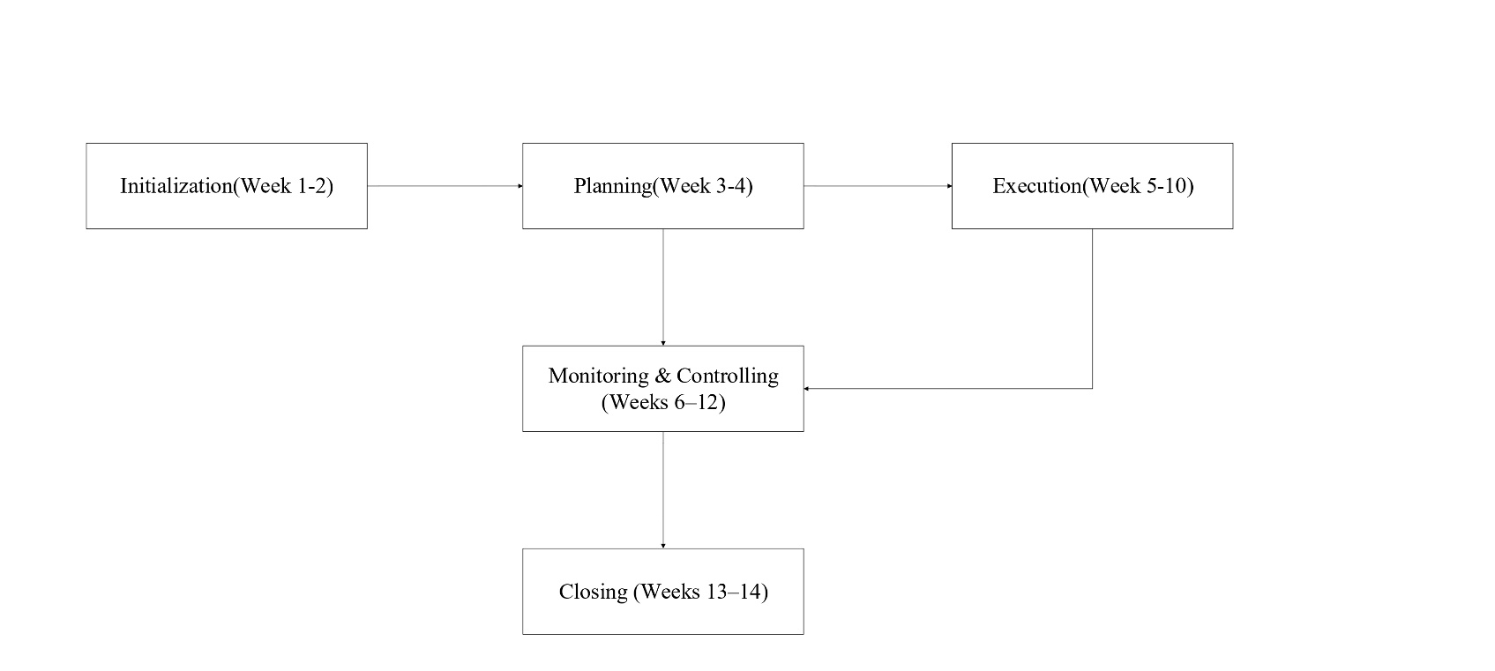

2. Baseline Gantt Chart (14 Weeks):
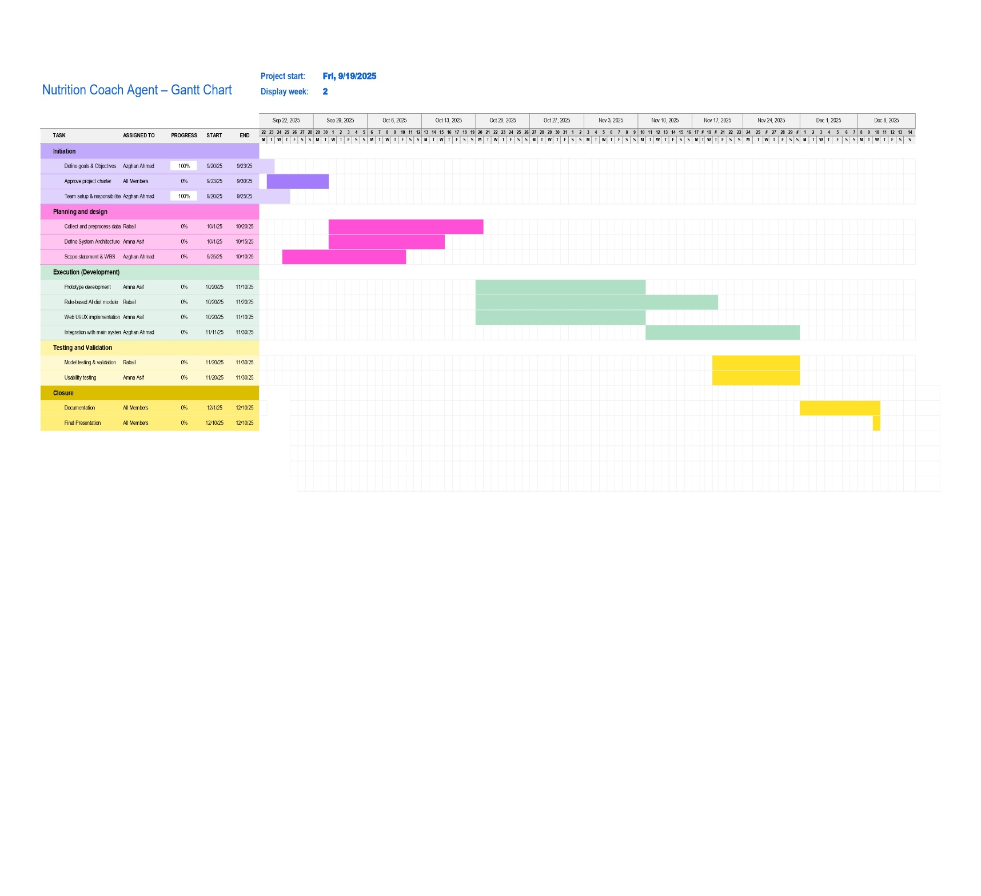
Explanation:
Phase | Task | Assigned To | Start Date | End Date | Duration
Initiation (Weeks 1–2) | Define Goals & Objectives | Azghan Ahmad | 9/19/2025 | 9/23/2025 | 5 days
 | Approve Project Charter | All Members | 9/19/2025 | 9/25/2025 | 7 days
 | Team Setup & Responsibilities | Azghan Ahmad | 9/19/2025 | 9/25/2025 | 7 days
Planning & Design (Weeks 3–4) | Collect & Preprocess Data | Rabail | 10/2/2025 | 10/9/2025 | 8 days
 | Define System Architecture | Amna Asif | 9/25/2025 | 10/10/2025 | 16 days
 | Scope Statement & WBS | Azghan Ahmad | 9/25/2025 | 10/5/2025 | 11 days
Execution (Development) (Weeks 5–10) | Prototype Development | Amna Asif | 11/1/2025 | 11/20/2025 | 20 days
 | Rule-Based AI & Food Model | Amna Asif | 11/5/2025 | 11/25/2025 | 21 days
 | Web UI/UX Implementation | Amna Asif | 11/3/2025 | 11/30/2025 | 28 days
 | Integration with Main System | Azghan Ahmad | 11/15/2025 | 11/30/2025 | 16 days
Testing & Validation (Weeks 11–12) | Model Testing & Validation | Rabail | 11/25/2025 | 12/5/2025 | 11 days
 | Usability Testing | Amna Asif | 11/25/2025 | 12/5/2025 | 11 days
Closure (Weeks 13–14) | Documentation | All Members | 12/5/2025 | 12/10/2025 | 6 days
 | Final Presentation | All Members | 12/10/2025 | 12/13/2025 | 4 days

3. SWOT Analysis:
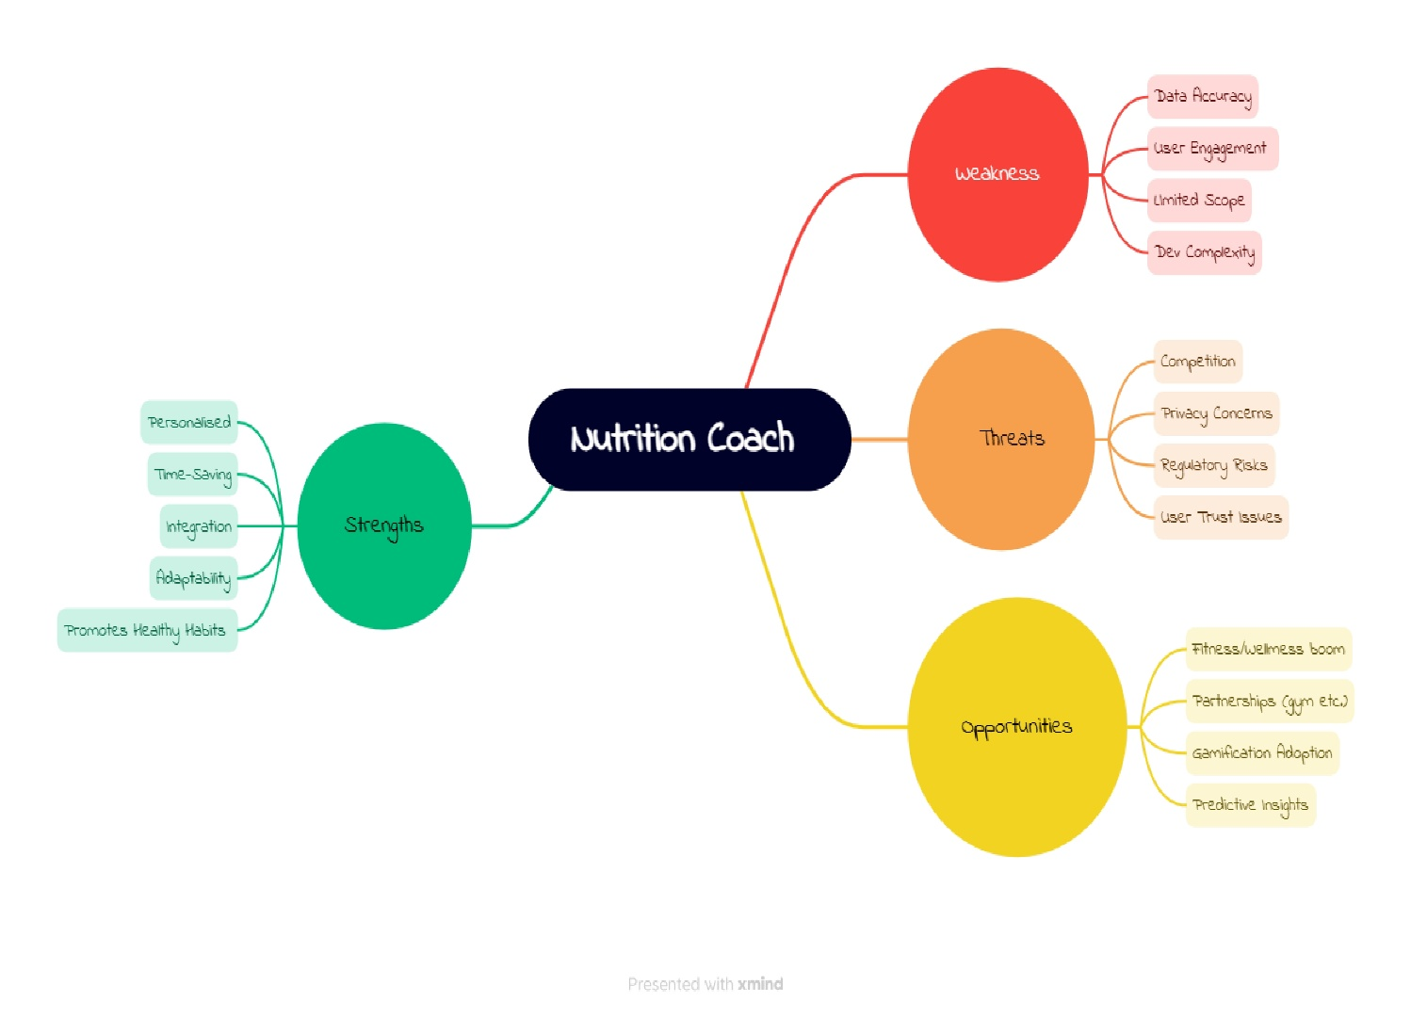
- Strengths:
- Personalised → Provides customized diet plans tailored to individual needs.
- Time-Saving → Saves users’ time by automating meal planning and tracking.
- Integration → Can integrate with wearable devices or fitness apps.
- Adaptability → Adapts to diverse dietary preferences and restrictions.
- Promotes Healthy Habits → Encourages sustainable lifestyle and nutrition choices.
- Weaknesses:
- Data Accuracy → Relies heavily on the accuracy of nutritional databases.
- User Engagement → Risk of low long-term engagement if not interactive enough.
- Limited Scope → May only cover basic diet tracking instead of holistic wellness.
- Development Complexity → Building AI-driven personalized recommendations is technically challenging.
- Opportunities:
- Fitness Wearables Boom → Growing market of smartwatches and health trackers supports integration.
- Partnerships → Potential to collaborate with fitness brands, gyms, or diet companies.
- Gamification Adoption → Adding challenges and rewards can boost user motivation.
- Predictive Insights → Use AI to predict health trends and prevent future issues.
- Threats:
- Competition → Strong competitors already exist in nutrition and fitness apps.
- Privacy Concerns → Handling personal health data creates security risks.
- Regulatory Risks → Must comply with health and data protection regulations.
- User Trust Issues → Users may hesitate to trust AI for sensitive health advice.

4. Project Charter:
Project Charter – Nutrition Coach Agent
Field | Details
Project Title | Nutrition Coach Agent
Date of Authorization | 19th September 2025
Project Start Date | 20th September 2025
Planned Finish Date | 10th December 2025
Key Schedule Milestones | - Approve project charter by September 30, 2025  - Complete dataset generation by October 20, 2025  - Complete prototype development by November 10, 2025  - Complete integration and testing by November 30, 2025  - Final presentation and closing deliverables by December 10, 2025
Budget Information | The university has allocated resources equivalent to a standard semester-long project, with additional support for:  - Cloud infrastructure (free student credits where possible)  - Research papers, datasets, and development tools (internal academic resources)  - No external hiring; all work will be divided among three student developers
Project Manager | Azghan Ahmad , +92-366493156, azghanduplicate786@gmail.com
Project Objectives | The Nutrition Coach Agent project aims to develop a rule-based AI agent that generates and adapts personalized diet plans for users based on their eating patterns and health goals. The project will focus on creating synthetic datasets, implementing adaptive diet rules, and integrating with the section-wide application.
Main Project Success Criteria | - The agent must generate personalized diet recommendations accurately.  - The system must integrate successfully into the section-wide application.  - The project must be completed within the planned schedule and budget.  - Final deliverables must be well-documented, tested, and formally approved by the instructor.
Approach | - Divide responsibilities among three core developers to ensure balanced workload.  - Within one month, prepare scope statement, work breakdown structure, and Gantt chart for effective tracking.  - Collect nutrition datasets and finalize preprocessing pipeline within two months.  - Conduct weekly project meetings for progress updates and issue resolution.  - Test AI models with real-world data to validate recommendation accuracy before deployment.  - Document all phases to ensure reproducibility and future improvements
Roles & Responsibilities | Name Role Position Contact Information  Azghan Ahmad Project Manager Student Lead i222667@nu.edu.pk  Amna Asif Team Member Web Developer i228777@nu.edu.pk  Rabail Team Member AI/ML Engineer i221507@nu.edu.pk
Comments | "I will focus on ensuring the AI/ML models are accurate and practical for real-world use." – Rabail  "I will develop a user-friendly web interface so users can easily interact with the system." – Amna Asif

