ClassWork Activity 2
User Experience Engineering

Course Lecturer
Ma’am Behjat Zuhaira
Submitted By
Rabail Kaghzi
Section
A

Roll No
i221507(Rabail)

Date: 07th April 2026

Spring 2026


Department of Computing - Software Engineering
FAST – National University of Computer & Emerging Sciences
Islamabad Campus

Evaluating I228753 Class Activity 1:

Prompts Used:
Scenario: Prepare a luggage checklist for a 10-day trip in the mountains.

Prompt1: “Prepare a luggage checklist for a 10-day trip in the mountains.”

Prompt 2: “Prepare a comprehensive luggage checklist for a 10-day trip in the mountains. The
checklist should cover clothing, footwear, outdoor gear, personal items, health and safety
essentials, and optional extras. Assume the trip involves hiking, camping, and variable weather
conditions (cold nights, possible rain). Organize the checklist into categories for easy readability.”

Prompt 3: “Prepare a checklist for luggage to be taken on a 10-day-long trip to the mountains.
Organize the checklist into the following categories:
Clothing: Consider layers, weather-appropriate items, and quantity.
Footwear: Include options for hiking and casual wear.
Toiletries: List essential personal hygiene items.
Health & First Aid: Include any necessary medications and basic first aid supplies.
Gear & Equipment: List items specific to mountain activities.
Documents & Essentials: Include identification, money, and travel-related items.
Miscellaneous: Any other useful items.
Output Format
Provide the output as a markdown list. A checkbox should precede each item `[ ]`.
Notes
Assume the trip is during a temperate season (spring/fall) with potential for varying weather
conditions.
Consider the need for items that can be layered.
Emphasize durable and quick-drying materials for clothing where necessary.”

AI Tools Used:
- Chatgpt
- Gemini

Prompting the Same Scenario and Regenerating Responses:
Chatgpt:
Prompt 1: Prepare a luggage checklist for a 10-day trip in the mountains.
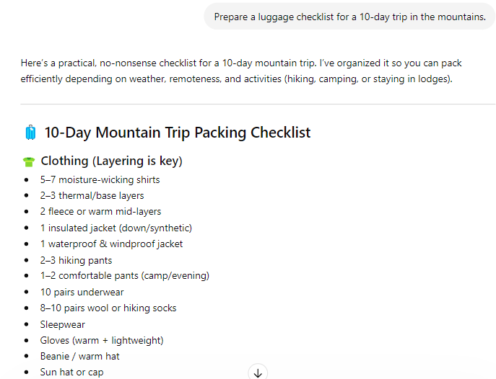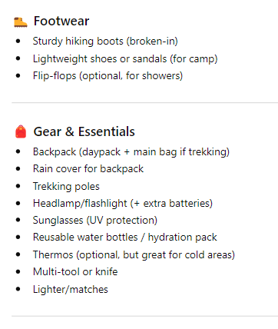
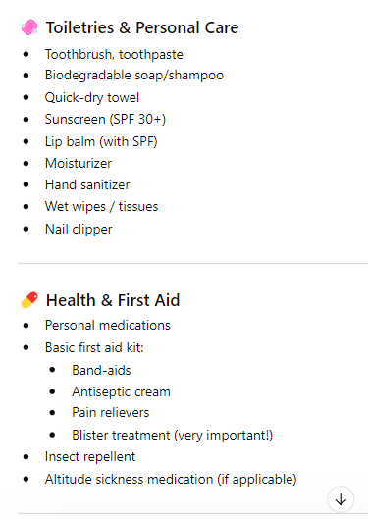
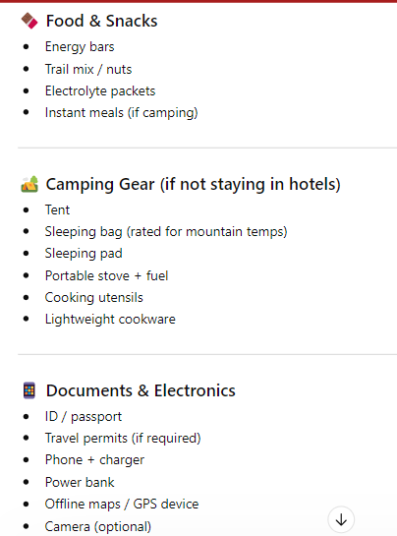
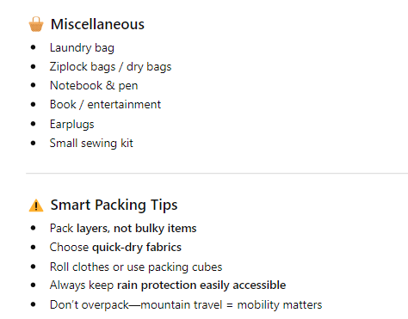

Prompt 2: “Prepare a comprehensive luggage checklist for a 10-day trip in the mountains. The
checklist should cover clothing, footwear, outdoor gear, personal items, health and safety
essentials, and optional extras. Assume the trip involves hiking, camping, and variable weather
conditions (cold nights, possible rain). Organize the checklist into categories for easy readability.”

Response:
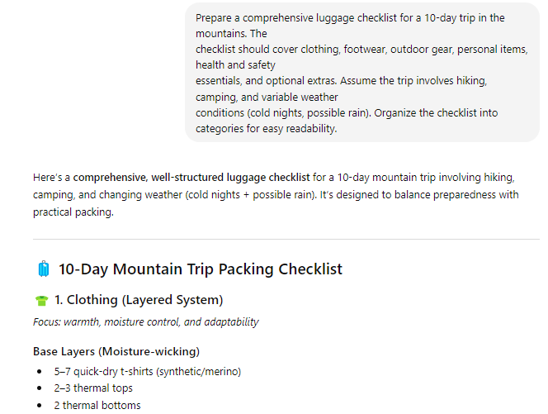

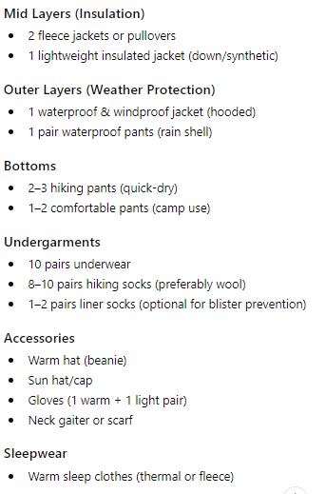
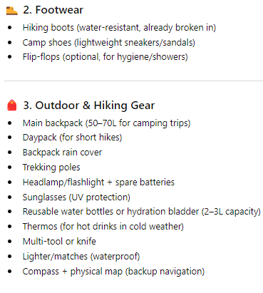
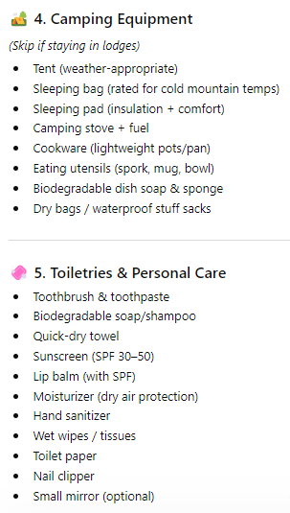
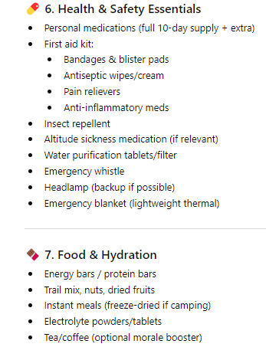
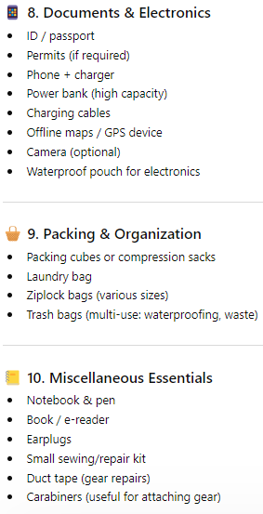
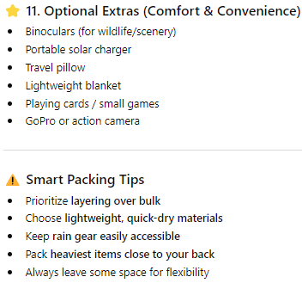

Prompt 3: “Prepare a checklist for luggage to be taken on a 10-day-long trip to the mountains.
Organize the checklist into the following categories:
Clothing: Consider layers, weather-appropriate items, and quantity.
Footwear: Include options for hiking and casual wear.
Toiletries: List essential personal hygiene items.
Health & First Aid: Include any necessary medications and basic first aid supplies.
Gear & Equipment: List items specific to mountain activities.
Documents & Essentials: Include identification, money, and travel-related items.
Miscellaneous: Any other useful items.
Output Format
Provide the output as a markdown list. A checkbox should precede each item `[ ]`.
Notes
Assume the trip is during a temperate season (spring/fall) with potential for varying weather
conditions.
Consider the need for items that can be layered.
Emphasize durable and quick-drying materials for clothing where necessary.”

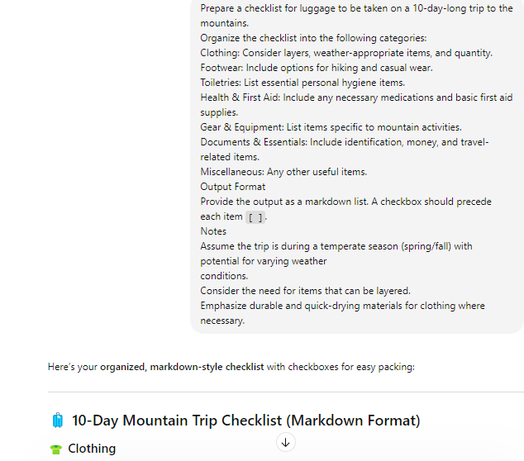
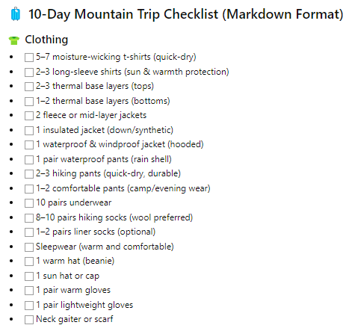
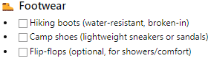
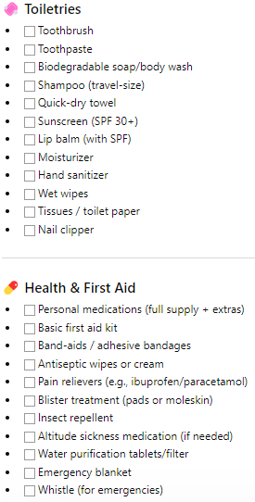
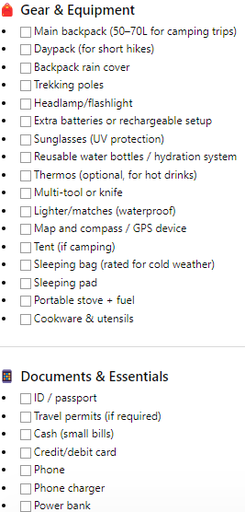
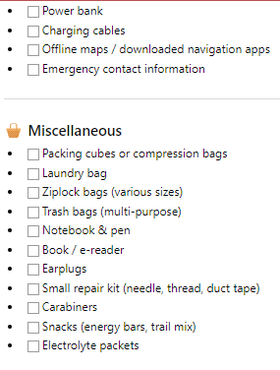
Gemini:
Prompt 1: “Prepare a luggage checklist for a 10-day trip in the mountains.”

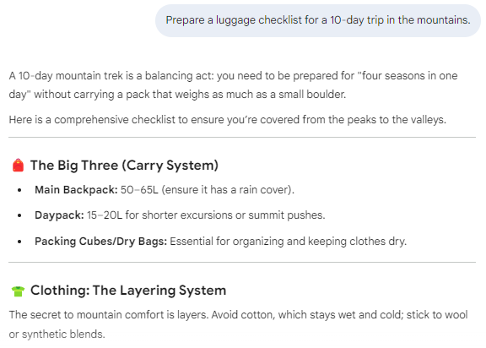
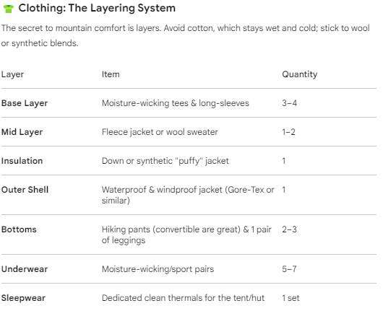
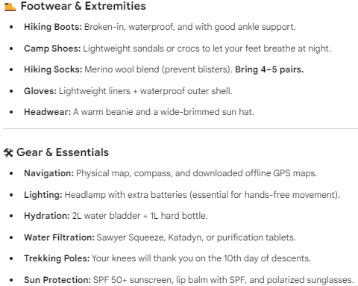
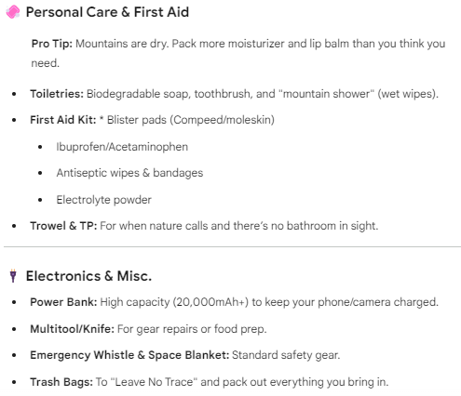

Prompt 2:
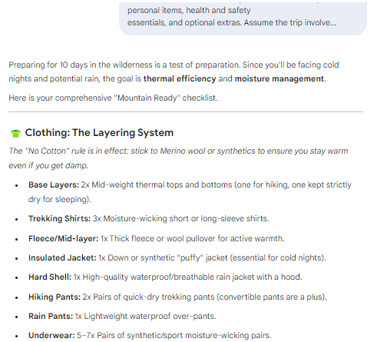
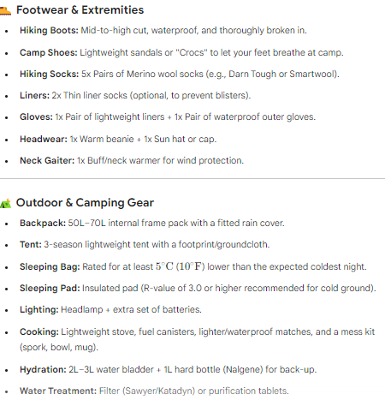
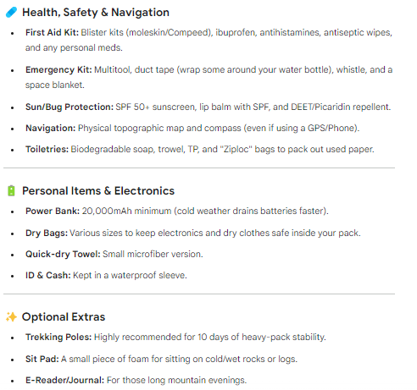

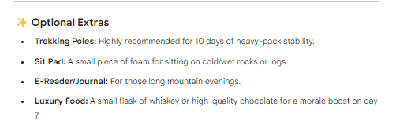

Prompt 3: “Prepare a checklist for luggage to be taken on a 10-day-long trip to the mountains.
Organize the checklist into the following categories:
Clothing: Consider layers, weather-appropriate items, and quantity.
Footwear: Include options for hiking and casual wear.
Toiletries: List essential personal hygiene items.
Health & First Aid: Include any necessary medications and basic first aid supplies.
Gear & Equipment: List items specific to mountain activities.
Documents & Essentials: Include identification, money, and travel-related items.
Miscellaneous: Any other useful items.
Output Format
Provide the output as a markdown list. A checkbox should precede each item `[ ]`.
Notes
Assume the trip is during a temperate season (spring/fall) with potential for varying weather
conditions.
Consider the need for items that can be layered.
Emphasize durable and quick-drying materials for clothing where necessary.”

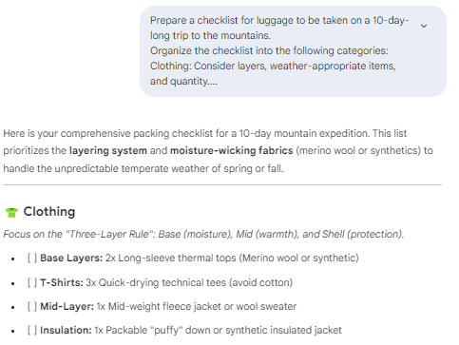
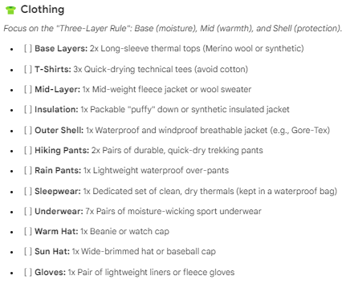
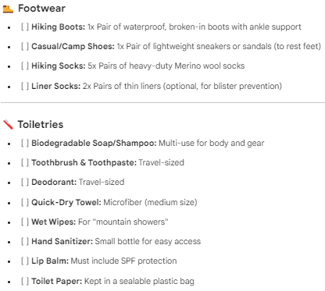
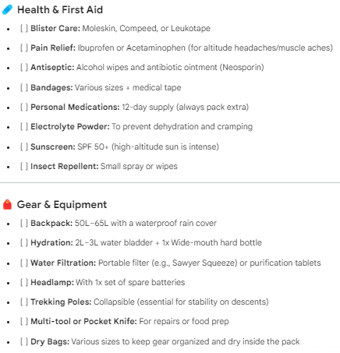
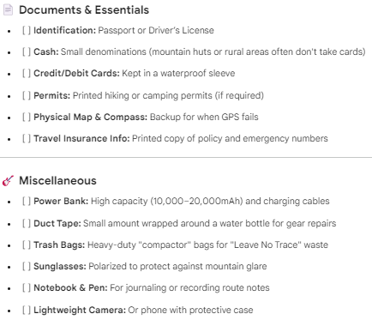

Comparison:
Existing Differences
1. Content (Items in checklist)
- Similarities:
  - Both include core items like:
    - Clothing (jackets, layers)
    - Footwear (hiking boots)
    - Toiletries
    - First aid
    - Gear (tent, flashlight, etc.)
- Differences:
  - Regenerated responses may:
    - Add new items (e.g., power banks, snacks, trekking poles)
    - Omit some items from original
    - Change level of detail (e.g., “jacket” vs “waterproof insulated jacket”)
Conclusion: Same idea, but variation in specific items and detail level
2. Structure & Organization
- Some regenerated outputs:
  - Use slightly different headings
  - Change order of categories
  - Merge or split sections
Example:
- Original: “Health & First Aid”
- Regenerated: “Medical Kit” or merged into “Essentials”
Conclusion: Structure is similar but not identical
3. Wording / Style
- Responses are rephrased
  - Example:
    - Original: “Warm layers for cold nights”
    - Regenerated: “Thermal clothing for low temperatures”
Conclusion: Same meaning, different wording
4. Level of Detail
- Some regenerated answers:
  - More concise OR more detailed than original
  - May include:
    - Extra tips (hydration, layering)
    - Fewer explanations

Aspect | Same or Different | Difference
Overall Content | Similar | Same categories but different items/details
Checklist Items | Different | Some added/removed items
Structure | Slightly Different | Category names/order may change
Wording | Different | Rephrased sentences
Detail Level | Slightly Different | More/less explanation
Formatting | Slightly Different | Markdown/checklist inconsistency

Final Conclusion
Even with the same 10-day mountain trip scenario, the regenerated responses are:
Not identical, but conceptually similar
Differences come from:
- Variation in wording
- Item selection
- Structure
- Level of detail

