Let’s see two quick and simple examples of the WITH clause below using the **Order Details** table from the well-known **Northwind** database.

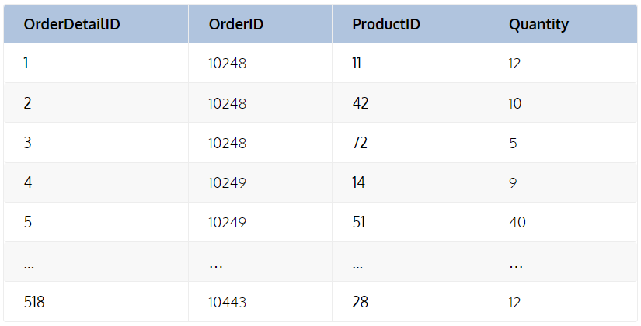

The objective of the first is to return the average quantity ordered per ProductID.

The objective of the second is to return the average number of orders, or sales made, by EmployeeID for all Shippers.