**Proposal:** Invest in St. Louis App

**Topic and Rationale:**

Exploring business investment and philanthropic areas of opportunity in St. Louis City.

Our app will enable users to interactively explore Saint Louis City Business, Crime, Education, Income, and Real Estate data by zip code using drop down menus and map visualizations so they may utilize the rendered results for strategic planning and business development decision making. Our app will offer users a simple and easy-to-use platform to view data by zip code instead retrieving and munging public data sets on their own.

Use cases – entrepreneurs, current business owners expanding, non-profits targeting areas of need, etc.

**Dataset:**

We will use the data previously compiled for Project 1 (https://github.com/rkalhorn/project1) with the addition of a Real Estate dataset.

* Business – Yelp
* Crime – City of St. Louis Open Statistics (https://www.stlouis-mo.gov/data/)
* Education - National Center for Educational Sciences (NCES): https://nces.ed.gov/ccd/schoolsearch/ and https://nces.ed.gov/surveys/pss/privateschoolsearch/
* Income - 2010 Census and 2016 est (Home Mortgage Disclosure Act from www.stlouis-mo.gov)
* Real Estate – TBD, Richard working on

**Dataflow Diagram:**

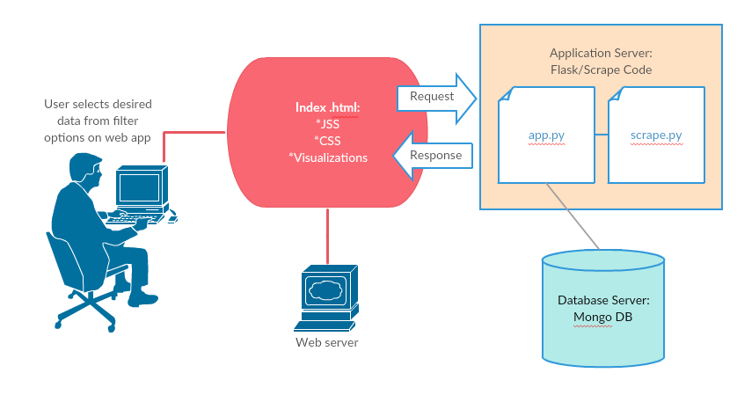

**Visualizations:**

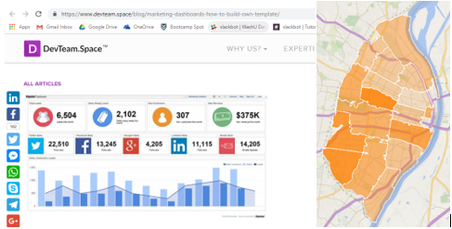

**Sketch of Final Design:**

Add screen shot of html layout (Rebecca)

**GitHub Repository:**

https://github.com/TBD