Two Forces of Substrate Heterogeneity: Sensitivity Gain and Quality Loss in Multi-Agent Cooperative Diagnosis
Ravikiran Kalluri¹
Taro Kanno²
Abstract
Cooperative diagnosis in small teams — where members combine partial evidence, communicate beliefs, and coordinate on a shared understanding — has been formalized in the Extended Mutual Belief Model (EMBM) of Okabe et al. (2025), an agent-based simulation in which each of three agents maintains a stack of seven Bayesian belief networks representing self, direct beliefs about teammates, and projected beliefs about how teammates in turn model each other. A near-universal assumption of this and related recursive-mutual-belief architectures is that all agents in a team share the same inference substrate. Real cooperative teams — particularly the increasingly common human–AI teams in operational settings — typically do not. We extend EMBM with pluggable inference engines (Bayesian belief network, hidden-Markov approximation, and decision tree) and use agent-based simulation to study three-agent teams in which one agent runs a different substrate from the others, crossed with a projection-mode manipulation that varies whether agents model teammates using their own substrate (naive projection) or the teammate’s true substrate (aware projection). Across two 17-node Bayesian networks, two mismatched-substrate axes, and eight hard scenarios per network with fifteen replicate runs per cell, we find that substrate heterogeneity produces two distinct effects that must be considered jointly: a sensitivity gain, in which aware mismatched teams detect substantially more inter-agent conflicts than matched teams in every condition tested; and an inference quality loss, in which the mismatched substrate degrades single-agent diagnostic accuracy in proportion to its inferential distance from exact Bayesian propagation. The signed effect of substrate mismatch on team accuracy is the balance of these two forces, and it can favor either heterogeneity or homogeneity depending on how much the mismatched substrate deviates from exact propagation. Naive projection systematically suppresses most of the sensitivity signal, producing an illusory-agreement pathology whose severity is bounded by the underlying substrate gap. We propose a two-force account of substrate heterogeneity in recursive-mutual-belief teams. All model code, simulation runners, and results data are publicly released for replication.
Keywords: Extended Mutual Belief Model (EMBM); team cognition; agent-based simulation; inference substrate heterogeneity; cooperative diagnosis; team situation awareness; recursive mutual beliefs; human–AI teaming

1. Introduction
Cooperative diagnosis under partial observability requires more than pooling evidence. It requires each agent to maintain not only a belief about the state of the world, but a belief about what its teammates believe, and a belief about what its teammates believe about its beliefs. Okabe et al. (2025) formalized this in the Extended Mutual Belief Model (EMBM), assigning each agent a stack of seven belief structures — one self-cognition, two direct beliefs about teammates, and four projected beliefs about teammates’ beliefs about others — which are updated through metacognitive conflict resolution across the diagnostic action sequence. EMBM has become an anchoring computational account of how team situation awareness is constructed through communication, and its published curves for a car-diagnosis domain are widely reproduced as a benchmark for multi-agent belief coordination.
EMBM, like nearly all recursive mutual-belief architectures we are aware of, assumes computational homogeneity: every agent, and every one of the seven belief structures inside every agent, runs on the same inference substrate. In the original formulation of Okabe et al. (2025), this substrate is a Bayesian belief network (BBN) with exact propagation over a shared causal graph. That assumption is analytically convenient — it lets projection be a straightforward act of running the same machinery under different priors — but it is empirically strong. Real cooperative diagnosis teams, whether biological or increasingly heterogeneous human-AI teams, do not share substrates. A radiologist and a triage algorithm do not compute posteriors in the same way; a pilot and a flight-management system do not represent uncertainty on the same scale; a domain expert and a large language model do not perform inference through the same operations, even when they are given the same evidence. Whether the EMBM machinery survives this heterogeneity — whether recursive mutual beliefs still coordinate a team when the teammates literally cannot represent each other’s inferences — is unknown.
We take up that question by extending EMBM with a pluggable inference substrate. The seven belief structures within each agent and across agents are no longer required to be BBNs. They implement a minimal three-operation interface — ingest(evidence), posterior(node), diagnosis(node, threshold) — that is sufficient for the full EMBM control logic while allowing the underlying computation to be a BBN, a hidden-Markov chain, a decision tree, or any other posterior-yielding architecture. Every engine consumes the same shared causal specification, so representational choice is manipulated while domain knowledge is held constant. Agents in a team can then be assigned different substrates, and the projection layer that models teammates' beliefs can be configured either as aware (each agent models its teammates using their true substrate) or as naive (each agent models its teammates using its own substrate, as if the assumption of homogeneity held).
The immediate question is whether heterogeneity is costly. Given that the tree engine, in particular, is a substantially weaker inference machine than a BBN — it holds no joint posterior, cannot integrate observations back through a causal chain, and commits crisply on argmax — one would predict that placing a tree agent in a team otherwise composed of BBN agents should hurt the team’s accuracy, and that this hurt should be larger when the tree teammate is modeled naively (as a BBN) than when it is modeled aware (as a tree). This is essentially the Anthropomorphization Trap hypothesis: assuming your heterogeneous teammate reasons as you do produces a false sense of mutual understanding and a coordination pathology.
The empirical picture is more nuanced. In this paper we report the results of a full 2×2×2 experimental design (network × mismatched-substrate axis × projection mode, plus the matched/mismatched composition contrast) run on two Bayesian networks — a controlled 17-node synthetic domain and the real Kanno car-diagnosis network — with eight difficulty-ranked scenarios per network, N=15 Monte Carlo runs per cell, and instrumentation that records not only final team accuracy but also the initial and final counts of inter-agent conflicts detected by each agent, decomposed by whether the actor’s own belief agreed with ground truth (a real conflict where help was needed) or disagreed with ground truth (a phantom conflict where the actor was already right and the detected mismatch was illusory from an oracle’s perspective).
Our contribution has three parts. First, we document the substrate-mismatch cost in a proper multi-network, multi-axis design: the cost is real and always positive when the mismatched substrate is inferentially weaker than BBN, but it is reversed when the mismatched substrate is inferentially close to BBN in the sense that its committed diagnoses seldom disagree with the BBN’s. Second, we identify a robust upstream mechanism — a sensitivity gain in initial conflict detection under aware projection with mismatched substrates — that replicates in all four (network × axis) cells with per-scenario perfect replication in three of them and 6/8 in the fourth. Third, we show that this sensitivity gain is only partially productive: roughly half of the extra conflicts detected are phantom, in the sense that the actor was already correct, so the mismatched-aware team is not smarter but sensitized. We synthesize these findings into a two-force account: the signed effect of substrate mismatch on team accuracy is (real-sensitivity gain) minus (single-agent inference quality loss), and both forces are measurable independently.
The rest of the paper is organized as follows. Section 2 reviews the EMBM framework and the small prior literature on substrate heterogeneity in recursive-belief multi-agent systems. Section 3 formalizes the extended model. Section 4 describes the experimental design and instrumentation. Section 5 reports the results, organized around the two forces. Section 6 discusses implications and boundary conditions.

2. Related work

2.1 Team cognition and mutual belief
The study of team cognition — how a group of agents collectively perceives, reasons about, and coordinates on a shared task — has a long empirical and theoretical history in human factors and cognitive ergonomics (Salas et al., 2008; Salas et al., 2011; Cooke et al., 2013; McNeese et al., 2020). Two broad computational traditions coexist. Holistic models, exemplified by Hutchins’s (1995) distributed cognition and Cooke et al.’s (2013) interactive team cognition, treat a team as a single system whose cognitive properties emerge from the interactions of its members without decomposing into individual belief structures. Collective models, in contrast, build team cognition compositionally from the beliefs of each individual member and the beliefs each holds about the others (Kanno et al., 2013).
Collective models trace back to formal accounts of mutual belief — the condition under which agents believe that they are sharing a belief with their teammates, thought to be necessary for coordinated collective action (Tuomela and Miller, 1988). Kanno, Furuta, and Kitahara (2013) formalized this for dyadic teams as a three-layer structure: an agent’s self-cognition (M), the agent’s direct belief about its partner’s cognition (M’), and the agent’s projected belief about how its partner in turn models the agent’s own cognition (M’’). The recursive-and-reflexive character of this structure — beliefs about beliefs about beliefs — is what distinguishes mutual-belief models from simpler shared-mental-model accounts (Cooke et al., 2000; Mohammed et al., 2015). Nonose, Kanno, and Furuta (2010) applied this framework to develop an evaluation method for team situation awareness, and subsequent work (Nonose et al., 2014) explored metacognitive effects on team behavior.

2.2 The Extended Mutual Belief Model
Mahardhika, Kanno, and Furuta (2016) extended the dyadic mutual-belief formulation to three-or-more-person teams and introduced mental subgrouping — the observation that in larger teams members typically do not model each teammate individually but chunk them into subgroups. Their formulation — henceforth EMBM — retains the three-layer structure per agent but expands each layer to hold multiple belief divisions corresponding to the number of teammates or subgroups. In a three-person team without subgrouping, each agent maintains seven belief structures: one self-cognition, two direct beliefs (one per teammate), and four projected beliefs (each teammate’s belief about each of the other two agents).
The direct implementation of EMBM as an agent-based simulation was undertaken by Okabe, Kanno, Cho, Furuta, Yoshida, Karikawa, Nonose, and Inoue (2025), who instantiated each of the seven belief structures per agent as a Bayesian belief network over a car-fault-diagnosis domain, defined an operational conflict-detection scheme (their Types I, II, and III) whose resolution drives an action-generation loop, and reported team-accuracy curves across scenarios varying in diagnostic difficulty and across model variations that ablated the mutual-belief layers. Their study established that the presence of mutual beliefs (M’ and M’’) generally improves team situational awareness relative to unaware baselines, while also identifying cases where mutual beliefs can produce a small negative effect through communication biased by an incorrect prior belief about what teammates already know. In their limitations section, Okabe et al. (2025) explicitly note: “It is recommended that this study be replicated with models other than BBN, such as the Markov model and decision tree, for cross-validation.” The present study answers that call, while extending it: rather than replicating with alternative substrates homogeneously, we ask what happens when substrates are heterogeneous across the team, and when the projection layer must itself commit to a substrate for its teammate model.

2.3 Situation awareness, metacognition, and computational cognition
Team situation awareness (TSA) is typically defined as a common understanding of the situation among team members (She and Li 2017; Rousseau et al. , 2004), and is considered a critical prerequisite for effective team coordination (Dourish & Bellotti, 1992; Gutwin & Greenberg, 2004). Different definitions emphasize either the actual overlap in individual situation awarenesses (an outside-observer view) or the believed overlap held by each member (an inside-team view); the mutual-belief architectures we build on are naturally suited to the second, because they distinguish between what is true of the world and what each agent believes about what each other agent knows (Kanno et al. , 2013).
The action-selection mechanism in EMBM is grounded in metacognition — cognition about one’s own cognition (Flavell, 1979; Nelson & Narens, 1994). In particular, EMBM implements metacognitive control as conflict detection and resolution across belief layers: when an agent detects that its own belief about a node differs from its belief about a teammate’s belief about that node (Type I), or from its projected belief about the teammate’s belief about itself (Type II) or about the third teammate (Type III), that conflict triggers a communication or observation action. This connects EMBM to a broader tradition of computational cognitive architectures (Anderson & Lebiere, 1998; Newell 1990) while addressing a limitation those architectures share — they were designed for individual cognition, not for the recursive belief structures that team cognition requires (Okabe et al. , 2025).

2.4 The substrate homogeneity assumption
Across the EMBM literature and the broader recursive-mutual-belief tradition, the belief structures within and across agents are almost universally assumed to run on the same inference substrate. In Okabe et al. (2025), all seven belief structures per agent, across all three agents, are BBNs with identical structure and CPTs; the manipulations tested vary which layers are present (ablations that remove M’ or M’’), not which computational machinery those layers use. The homogeneity assumption is analytically convenient — it lets projection be the straightforward act of running the same machinery under different priors — but it is empirically strong. Andrews et al.’s (2023) theoretical review of shared mental models in human-AI teams treats the transfer of the shared-mental-model construct from all-human teams to human-AI teams as an open question rather than a settled equivalence. Real cooperative diagnosis teams, particularly the increasingly common human-AI teams in which one member is an algorithm, and the others are humans, do not share a common substrate. A radiologist and a triage algorithm do not compute posteriors in the same way; a pilot and a flight-management system do not represent uncertainty on the same scale; a domain expert and a large language model do not perform inference through the same operations, even when they are given the same evidence.
Broader multi-agent simulation traditions have considered forms of parametric or belief-content heterogeneity (Crosscombe & Lawry, 2016; Li & Xiao, 2017), and agent-based models of team behavior have varied in group size, communication protocols, and coordination structures (Cao et al., 2022; Glinton et al., 2010). But substrate variation — where different agents literally compute inference through different mechanisms while representing the same domain, and where the projection layer must itself commit to a substrate for its teammate model — has not, to the authors’ knowledge, been embedded in a recursive-mutual-belief architecture. Discussions of substrate diversity have appeared in the human-AI teaming and human-machine cooperation literatures (Flemisch et al., 2019; Wright et al., 2015), and recent empirical work has shown that humans perform and cognize measurably differently when they perceive a teammate as artificial rather than human (Schelble et al., 2023) — a first-order behavioral analog of what we operationalize computationally as naive projection. What is missing from that empirical work is a formal recursive-belief structure to attach the projection-mode question to.

2.5 The projection question
We identify a specific operational concern that arises once substrates are heterogeneous, which we call the projection question. When agent A (running substrate X) needs to hold a belief about teammate B (running substrate Y), A must instantiate a projected-belief engine to hold that belief. If A instantiates the projected engine as substrate X — an X-flavored representation of what B thinks — we call that naive projection. If A instantiates the projected engine as substrate Y — a Y-flavored representation of what B thinks — we call that aware projection. Naive projection is not merely a cognitive laziness; it is a specific representational commitment. It amounts to modeling one’s heterogeneous teammate as computationally identical to oneself. This commitment is empirically consequential rather than merely theoretical: recent work in the theory-of-mind-in-LLMs literature has shown that some AI systems now pass classic false-belief tasks and exhibit internal belief-tracking mechanisms of their own (Kosinski, 2024), so treating a machine teammate as substrate-identical to oneself is no longer just a simplifying assumption — it is a specific misspecification of what the teammate actually computes. Its downstream consequences are computable and, as we show, non-trivial.

3. Model description (ODD protocol)
We describe the model following the Overview, Design concepts, and Details (ODD) protocol of Grimm et al. (2006, 2020). The seven ODD sections below (Purpose and patterns; Entities, state variables, and scales; Process overview and scheduling; Design concepts; Initialization; Input data; Submodels) cover the same content that a narrative model description would but in a form that facilitates comparison with other agent-based models in the recursive-mutual-belief and cooperative-diagnosis literatures.

3.1 Purpose and patterns
The purpose of the model is to characterize how heterogeneity in the inference substrate that agents use to represent and reason about a shared task affects the coordination dynamics of recursive-mutual-belief teams. The baseline behavior we seek to preserve is that of the Extended Mutual Belief Model (EMBM) of Okabe et al. (2025), whose published curves show that (i) matched three-agent teams with the second and third belief layers reach higher team situation awareness than teams lacking those layers, and (ii) matched team behavior is sensitive to threshold and scenario difficulty. Our extension is designed to probe two additional patterns that only emerge when substrates can differ across agents: a sensitivity gain, in which mismatched teams under the aware projection detect more inter-agent conflicts than matched teams, and an inference quality loss, in which the mismatched substrate degrades single-agent diagnostic accuracy. Section 5 reports these patterns and Section 6 develops their joint interpretation as a two-force account.

3.2 Entities, state variables, and scales
The model contains four kinds of entities.
Agents. Three agents, labeled A, B, and C, jointly diagnose a shared 17-node Bayesian network. Each agent maintains seven internal belief structures organized in three layers, following the EMBM of Mahardhika et al. (2016): one L1 self-cognition, two L2 direct beliefs (one per teammate), and four L3 projected beliefs (each teammate’s belief about each of the other two agents). Each belief structure is populated by an inference engine — a computational object over the shared causal specification that implements the interface described in §3.7.1. The kind of engine that populates each belief structure is a design variable governed by the substrate-composition and projection-mode manipulations of §4.
Belief structures. Each of the seven per-agent belief structures holds, at any point in time, a posterior distribution over each node’s state variable, a categorical diagnosis for each node (either a specific state or the sentinel UNCERTAIN), and a running record of evidence ingested so far. State cardinality varies by node (2 or 3 states in both networks).
The causal specification. A 17-node directed acyclic graph over discrete-state nodes with associated conditional probability tables (CPTs). Ten nodes are observable to at least one agent; seven are unobservable inference targets that must be reasoned about via projection and communication. The specification is held constant across all cells of the experimental design; it is described concretely in §3.7.5.
The scenario. A ground-truth assignment of states to all 17 nodes, drawn from the network’s joint distribution. A scenario represents a specific fault configuration the team must diagnose.
Scales. The model has no spatial extent. Time is discrete. A run consists of an observation phase of exactly 15 steps (each of the three agents observes each of its five assigned nodes once), followed by a cooperation phase of variable length (bounded above by 100 steps). Cell-level replication uses fifteen independent runs per (scenario, cell) combination.

3.3 Process overview and scheduling
Time advances in discrete steps. At t = 0, all agents have empty belief structures and no evidence. The two phases execute in sequence.
Observation phase (steps 1–15). At each step, one agent–node pair is drawn from the pending observation queue (initialized with three sub-queues of five agent-node pairs each). The agent observes the node’s ground-truth state, ingests this as hard evidence into its L1 self-cognition, then propagates the update to its L2 and L3 belief structures via a downward-effect submodel (agents update their beliefs about teammates’ beliefs based on their own new observation, following the intra-agent metacognitive control specified by Okabe et al. (2025, §2.4)). Observation-phase step order is randomized per run.
Cooperation phase (steps 16 to termination). At each step, one agent is selected uniformly at random from the set of agents with at least one pending detected conflict. The selected agent identifies its highest-importance conflict via the mutual-information node importance measure (§3.7.6) and executes one of three actions to resolve it: look-at (a direct observation of one of its own observable nodes); query (asking a teammate for that teammate’s diagnosis of a node); or inform (asserting the agent’s own diagnosis of a node to a teammate). The action is executed, evidence flows to the appropriate belief structures of sender, receiver, and the third agent (who hears the exchange), and all agents update their conflict lists. Cross-substrate evidence passing invokes the translation submodel (§3.7.4). The cooperation phase terminates when (i) no agent has any pending conflicts, (ii) five consecutive steps produce no change to any agent’s committed diagnosis vector, or (iii) 100 cooperation-phase actions have been executed.

3.4 Design concepts
Basic principles. The model rests on the recursive-mutual-belief formalism of Kanno et al. (2013), extended to three-person teams with mental subgrouping fixed at level one by Mahardhika et al. (2016), and further extended by Okabe et al. (2025) with a Bayesian belief network as the specific inference substrate for each of the seven belief structures per agent. Our contribution replaces the substrate-homogeneity assumption of Okabe et al. with a pluggable-substrate architecture.
Emergence. The two team-level phenomena we study — sensitivity gain and inference quality loss — are emergent in the technical sense: neither is representable in the state of any single agent at any single time step. Sensitivity gain is only measurable across paired conditions (matched vs mismatched) at the level of the initial-conflict snapshot; inference quality loss is only measurable at the end of the cooperation phase against ground truth.
Adaptation. Agents adapt their beliefs by ingesting evidence from observation and communication, but they do not adapt their inference substrate or its parameters during a run. Substrate choice is fixed at initialization.
Objectives. Agents have no explicit utility function. Actions are chosen to resolve the highest-importance detected conflict, where importance is defined by mutual information following Okabe et al. (2025, Eq. 3). This is a rule-based rather than optimization-based objective structure.
Learning. No agent learns. The inference engines are hand-specified from the causal specification rather than trained on data.
Prediction. Prediction is embedded in the L3 projected-belief structures: each agent maintains a prediction of what each teammate believes about the third teammate. The projection-mode manipulation (§3.7.2) varies whether these predictions use the target’s true substrate (aware) or the owner’s substrate (naive).
Sensing. Agents sense in two ways: direct observation of assigned nodes (perfect, deterministic), and communication with teammates (evidence transmitted through the translation layer of §3.7.4). No agent has direct access to any other agent’s internal state; every teammate’s belief is model-based.
Interaction. Agents interact through communication actions (query, inform) that always involve a sender and a receiver, with the third agent hearing the exchange and updating its own belief structures accordingly.
Stochasticity. Three sources: (i) the ground-truth scenario is sampled from the joint distribution of the network at initialization; (ii) observation-phase step order is randomized; (iii) cooperation-phase agent selection is uniform at random from the set of agents with pending conflicts. All stochasticity is seeded per (cell, scenario, replicate) combination for reproducibility.
Collectives. The three-agent team is the only collective. Mental subgrouping in the sense of Mahardhika et al. (2016) is fixed at level one — each agent models each other agent individually. Larger teams that would require subgrouping are discussed as a scope limitation in §6.5.
Observation. The model records team accuracy (fraction of correctly diagnosed nodes averaged across the three agents), the initial conflict count (total conflicts pending at the moment cooperation begins), and, for the phantom/real decomposition of §5.6, the ground-truth correctness of the observing agent’s own L1 belief at the moment each conflict is detected. Section 4.3 gives the formal definitions.

3.5 Initialization
At t = 0: the causal specification is loaded (§3.6); a ground-truth scenario is drawn or loaded; each agent’s seven belief structures are instantiated with the appropriate engine kinds according to the cell’s substrate composition and projection mode; and each belief structure is initialised to the network’s prior marginals (i.e., no evidence has been ingested yet). The observation queue for each agent is populated with that agent’s four observable nodes plus one further node drawn to reach five per agent, following the observability partition of §3.7.5.

3.6 Input data
The model consumes three kinds of input.
Causal specifications. For the Kanno network, we load Okabe et al.’s original Netica specification (agent1.dne) via a Netica file parser. For Domain17, we procedurally generate the specification from a fixed random seed (see §3.7.5).
Scenario pools. For each network, eight hard fault scenarios are pre-sampled from a pool of 120 scenarios drawn from the network’s joint distribution. Hardness is ranked by the number of non-nominal-state nodes in the ground-truth assignment (§4.2). The pools are serialised for reproducibility.
Cell configuration. Each experimental cell specifies (network, substrate-composition axis, projection mode, threshold THD, replication count) as an input record. The runner scripts (run_conflict_instrument.py, run_dual_metric.py) enumerate cells and dispatch runs.

3.7 Submodels

3.7.1 Inference engines
Each of the seven belief structures per agent is an inference engine implementing the interface:
InferenceEngine:
ingest(node, evidence) # incorporate hard or soft evidence about one node
posterior(node) -> distribution
diagnosis(node, THD) -> state | UNCERTAIN
The interface uses two conventions inherited directly from Okabe et al. (2025). THD (threshold) is a scalar between 0 and 1 that controls how confidently an agent must believe in a state before it commits to a categorical diagnosis: if the highest-probability state of a node has posterior probability at least THD, diagnosis returns that state; otherwise it returns the sentinel value UNCERTAIN, indicating the agent is deferring judgment. This threshold-plus-abstention scheme is what makes cooperation informative — agents that are UNCERTAIN about a node have a reason to observe or query it, and the metacognitive conflict detection of §3.7.3 treats UNCERTAIN-vs-committed disagreements as conflicts requiring resolution. Higher THD values produce more UNCERTAIN diagnoses; lower THD values produce more commitments. Okabe et al. (2025) study THD values of 0.75, 0.80, and 0.85; §4.2 explains our choice of THD = 0.55 and the substantive interpretation of that departure.
We implement three engines from a single shared causal specification (node states, edges, conditional probability tables):
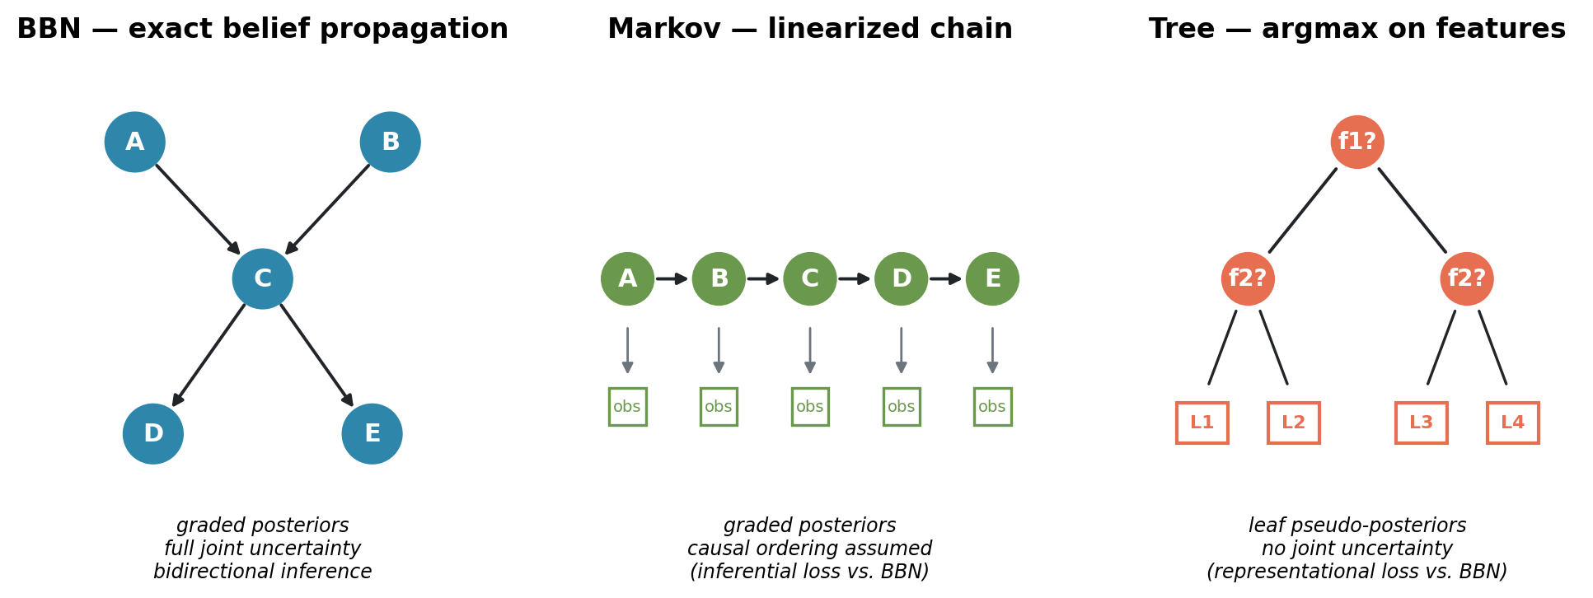
Figure 1. Three inference substrates instantiated from a shared causal specification.
BBN. Exact belief propagation over the causal DAG. Native soft evidence, graded posteriors. This is the EMBM baseline substrate.
Markov. A hidden-Markov-style probabilistic chain derived from the same DAG by linearizing it into a causal ordering and deriving transition/emission matrices from the CPTs. Graded posteriors, native soft evidence. The approximation lies in the causal-chain assumption: dependencies not captured in the chain are lost. This is an inferential loss — the machinery is probabilistic but weaker.
Tree. A decision-tree structure compiled from the CPTs. Leaf probabilities serve as pseudo-posteriors so that the threshold operator and soft-evidence ingest remain meaningful, but the underlying computation has no bidirectional causal inference: it can only infer designated target nodes from designated feature nodes. This is a representational loss — the substrate cannot represent full joint uncertainty at all.
All three engines are hand-specified from the same causal graph, not learned. This eliminates training-noise confounds and allows us to attribute any inter-engine differences to substrate structure rather than data quality.

3.7.2 Aware and naive projection
The projection question arises whenever agent A holds a belief about how teammate B represents a node. In the original EMBM, this projected belief is simply another BBN — because everything in the model is a BBN. Once substrates are heterogeneous, projection becomes a design choice.
Under aware projection, A instantiates each engine that models teammate B (whether the direct model of B or the projected model of what B thinks about C) using B’s actual substrate kind. If B runs Markov, A’s model of B is Markov.
Under naive projection, A instantiates each such engine using A’s own substrate kind. If B runs Markov but A runs BBN, A’s model of B is BBN — implicitly assuming B computes as A does.
Under matched compositions (all three agents run the same substrate), aware and naive projection produce identical instantiations. This is a specificity check we return to in the results.
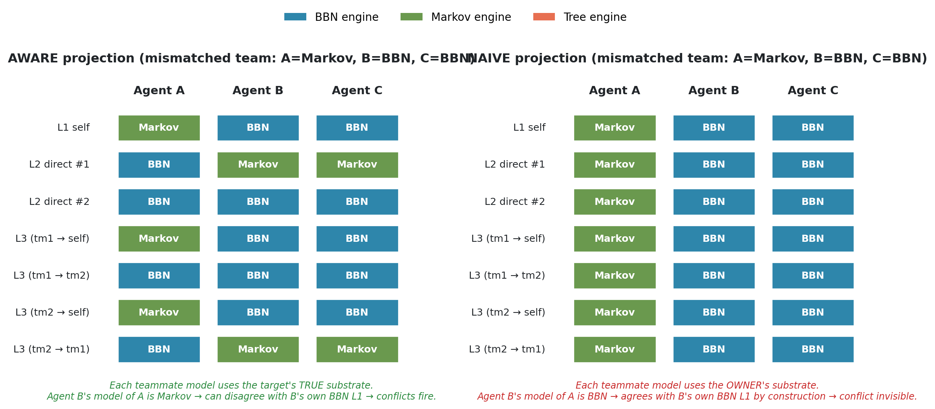
Figure 2. Which substrate populates each of the seven EMBM belief structures under aware versus naive projection. Under aware projection, each teammate model uses the target’s true substrate; under naive projection, every teammate model uses the owner’s substrate, making substrate heterogeneity structurally invisible.

3.7.3 Metacognitive conflict detection
Following EMBM, at any point during a run each agent A can detect three types of conflict per (node, teammate) pair:
- Type I: A’s own diagnosis of the node differs from A’s direct model of teammate B’s diagnosis.
- Type II: A’s own diagnosis differs from A’s model of B’s model of A.
- Type III: A’s own diagnosis differs from A’s model of B’s model of the third teammate C.
A conflict fires whenever the two compared diagnoses either commit to different states or one commits while the other is UNCERTAIN (following the EMBM convention that information gaps are also conflicts to be resolved). The action-selection procedure picks the highest-importance detected conflict and calls the resolution logic described in §3.3.
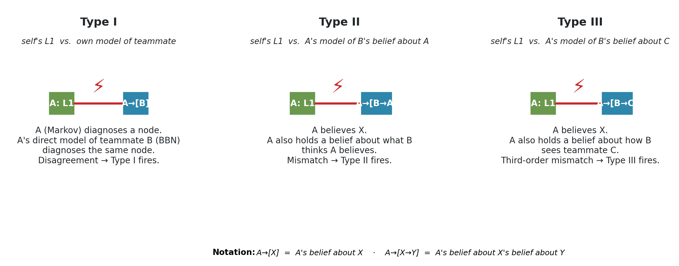
Figure 3. The three conflict types EMBM agents monitor at every step. Type I compares the agent’s own L1 belief against its direct model of a teammate; Types II and III compare L1 against projected beliefs about what the teammate believes about the agent and about the third teammate, respectively.

3.7.4 Cross-substrate translation
When an agent A (substrate X) communicates evidence to agent B (substrate Y), the evidence must be translated. We use the translation rule from Okabe et al. (2025) without modification: a diagnosis or posterior in X is passed to Y’s ingest interface, and Y absorbs it in the form its own substrate allows. Under BBN → Markov, a distribution becomes a soft evidence vector; under BBN → tree, a posterior collapses on argmax; under tree → BBN, a crisp label becomes a gamma-weighted point distribution. This translation layer is held constant across all experiments here, so any differences we observe are attributable to substrate choice or projection mode, not to translation.

3.7.5 Two network instantiations
The abstract model of §§3.7.1–3.7.4 is domain-agnostic. To ground it, we instantiate it on two 17-node Bayesian networks, chosen to jointly probe whether our findings depend on network topology or CPT structure. Both networks are held constant across all cells of the experimental design; agents in a given team share the same causal specification, but may run different inference engines over it.
Kanno. The car-diagnosis network of Okabe et al. (2025), imported directly from the authors’ Netica specification (agent1.dne), itself adapted from the original Norsys Netica car-diagnosis example. The 17 nodes represent car parts organized around a Starts outcome and its causal predecessors — battery, alternator, fuel path (tank, filter, fuel system), air path (filter, air), electrical (main fuse, plug voltage, spark plugs, spark quality), timing, distribution, starter motor, and lights. Ten nodes are observable, seven are unobservable inference targets. The observability partition into agents A, B, C is reconstructed from Figure 8 of Okabe et al. (2025): agent A observes starter motor, gas tank, alternator, and lights; agent B observes spark plugs, battery voltage, main fuse, and lights (overlap with A on lights); agent C observes air filter, fuel, gas filter, and main fuse (overlap with B on main fuse). The unobservable targets are plug voltage, starter, distribution, spark quality, air, timing, and starts. Because Okabe et al. (2025) has not released the source code publicly, our BBN engine and cooperation-phase mechanics are reimplemented from the paper’s algorithmic description; we validated the reimplementation by confirming that a matched all-BBN team on this network reproduces the qualitative shape of the published curves in Okabe et al.’s Figure 9 before any substrate manipulation was introduced.
Domain17. A hand-specified synthetic causal system, deliberately designed to exhibit richer multi-parent structure than the Kanno network. Whereas most of Kanno’s non-root nodes have one or two parents, Domain17 has five nodes with three parents each (Comm, ControlLoop, DataPath, Output, SystemHealth) and eight further nodes with exactly two parents. This is by design: the Markov engine’s causal-linearization approximation and the tree engine’s argmax-on-features approximation both lose more information on multi-parent nodes than on chain-like structures, so Domain17 provides an environment where the substrate manipulations are guaranteed to bite. The 17 nodes form a metaphor for a generic multi-subsystem device — power infrastructure (MainPower, Regulator, BusVoltage), timing and control (Clock, Firmware, Timing, ControlLoop), sensor chains (SensorL, SensorR), actuation and thermal (Actuator, Thermal), communication (Comm), data path (DataPath), output (Output), and roll-up health nodes (Stability, Integrity, SystemHealth). Node cardinality is mixed (eight nodes have two states, nine have three states). Root priors are hand-specified to skew mildly toward the nominal state so that fault scenarios are informative rather than trivial; conditional probability tables for non-root nodes are Dirichlet-sampled with sharpness 2.5 and parent-index-dependent bias, from a fixed random seed for reproducibility. Ten nodes are observable, seven are unobservable inference targets. The observability partition is: agent A → MainPower, Regulator, SensorL, Output; agent B → Clock, BusVoltage, SensorR, Thermal; agent C → Firmware, Actuator, SensorL, BusVoltage (overlaps with A on SensorL and with B on BusVoltage), following the overlap-with-partial-redundancy pattern of Okabe et al.’s Figure 8.
The two networks serve complementary roles. Kanno is the “canonical” network — using it grounds our results in the same substrate on which the original EMBM curves were established, so any effect we find there is directly comparable to the source study. Domain17 is the “controlled” network — using it lets us guarantee, by construction, that multi-parent structure is present in force, so that the substrate manipulations have real bite. Effects that appear in both networks generalize across topology and CPT structure; effects that appear in only one network can be examined for network-specific artifacts. Figure 4 shows the topology of both networks side by side.
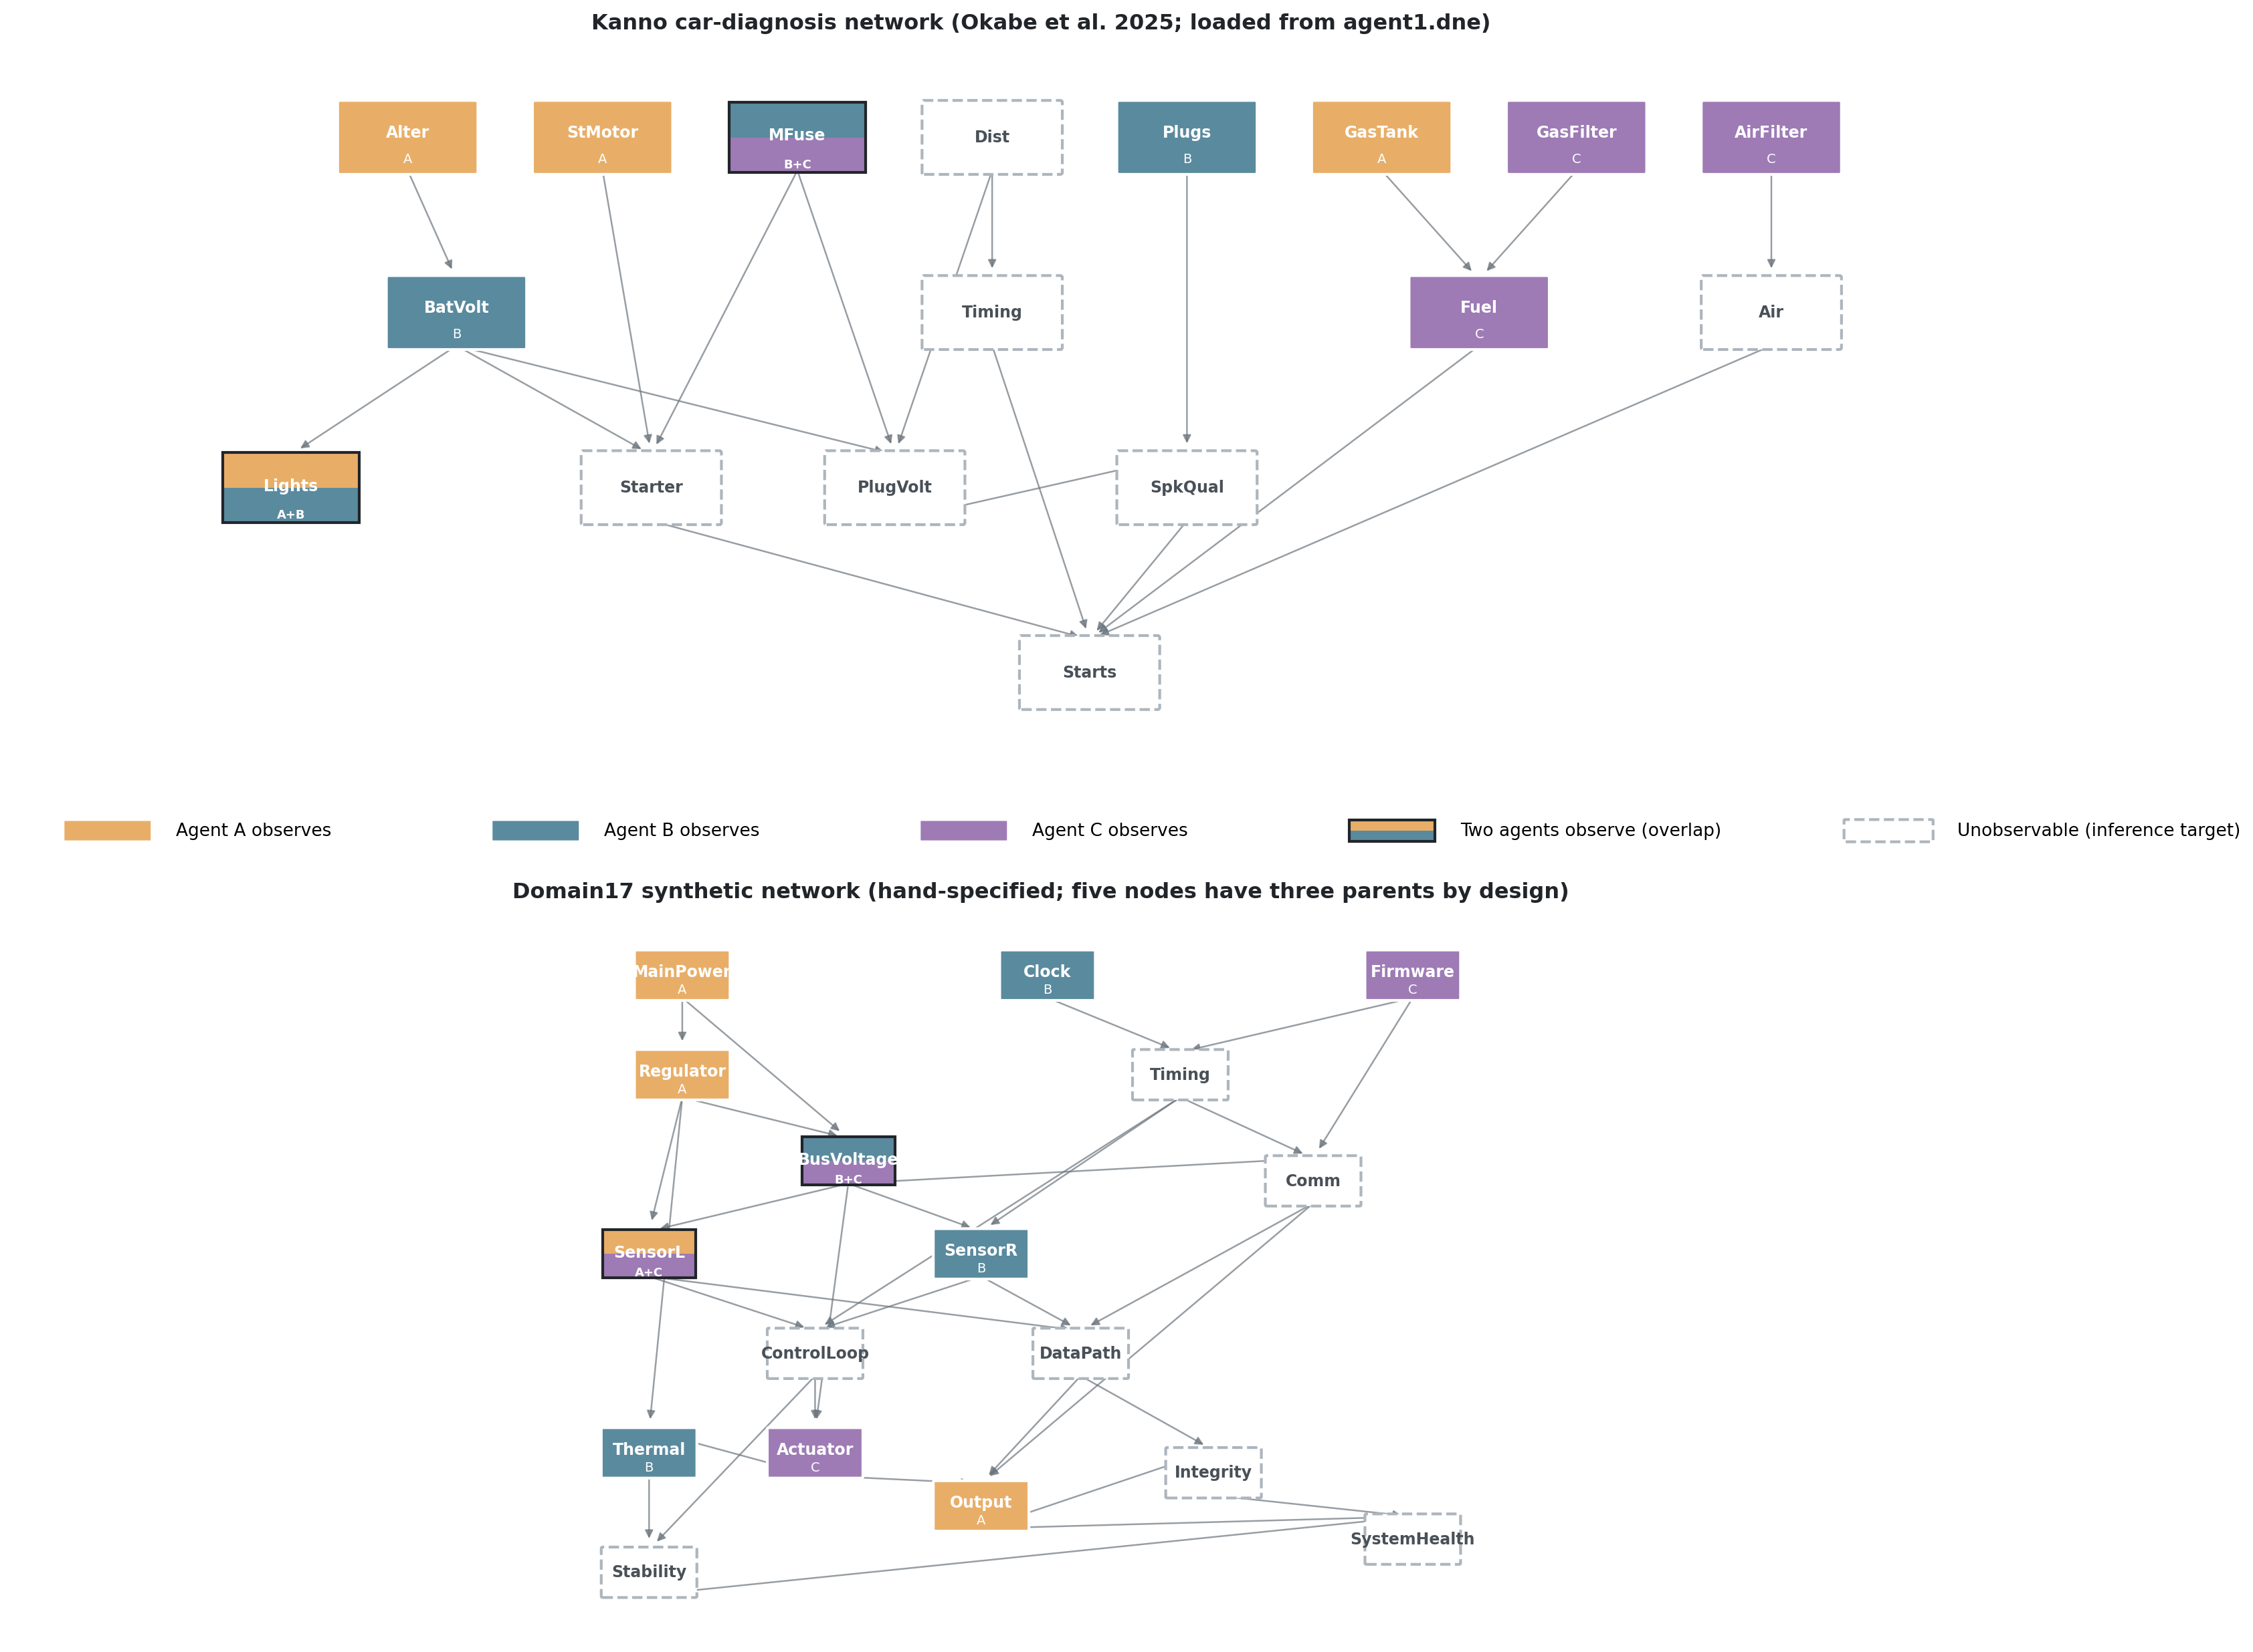
Figure 4. Bayesian network topologies of the two experimental substrates. Node fill color indicates which agent observes that node in the observability partition; half-and-half fills mark nodes observed by two agents (overlap zones from Okabe et al. 2025 Figure 8). Dashed borders mark unobservable nodes, which must be reasoned about via cooperative inference. Kanno (top) has predominantly single- and two-parent structure, with the sink node Starts having five parents. Domain17 (bottom) is deliberately denser: five nodes have three parents each (Comm, ControlLoop, DataPath, Output, SystemHealth), providing greater surface area for the tree engine’s argmax and the Markov engine’s causal-linearization approximations to bite.

3.7.6 Node importance
The action-selection procedure of §3.3 picks the highest-importance detected conflict, where node importance follows the mutual-information sum definition of Okabe et al. (2025, Eq. 3): the importance of node X is the sum of the pairwise mutual information between X and every other node in the network, computed under the network’s prior distribution. This measure is scenario-independent and is precomputed once per network. In case of ties or absent conflicts, the agent selects uniformly at random from the tied set.

4. Experimental design

4.1 The 2×2×2 design
We manipulate three factors:
- Network — two Bayesian networks. Domain17 is a controlled 17-node synthetic causal system with hand-specified CPTs designed to produce nontrivial partial-observability inference. Kanno is the 17-node car-diagnosis network from Okabe et al. (2025), imported directly from the authors’ Netica specification (agent1.dne).
- Mismatched substrate axis — the substrate assigned to agent A in mismatched compositions is either tree (representational loss) or markov (inferential loss). Agents B and C are always BBN.
- Projection mode — aware or naive.
Crossed with these three factors is the standard EMBM composition contrast: matched (all three agents BBN) versus mismatched (one agent on the axis substrate, two on BBN). The full cell structure per (network × axis) condition is therefore the 2×2 of {matched, mismatched} × {aware, naive}, and we run all four (network × axis) conditions, yielding a 2×2×2 = 8-cell design plus the two matched-baseline cells shared across axes.

4.2 Scenarios and replication
For each network, we pre-select eight hard scenarios drawn from a pool of 120 sampled fault configurations, ranked by hardness. Hardness is defined as the number of non-nominal-state nodes in the ground-truth fault configuration — a scenario with hardness h has h of its 17 nodes in a non-default (faulty or degraded) state, and 17-h in their nominal state. Higher hardness is more difficult because more of the diagnosis surface is non-obvious. For Kanno, the top-8 scenarios span hardness 7 to 9; for Domain17, hardness 12 to 15. Domain17 scenarios are systematically harder in this metric because the network’s node cardinalities are higher and its fault-propagation cascades produce more downstream deviations from nominal per root fault.
All cells within a network condition use the same eight scenarios, so per-scenario paired comparisons are possible. For Kanno, the hard-scenario pool clusters on BatVolt (battery voltage) faults, with four scenarios having BatVolt=dead (categorical fault) and four having BatVolt=weak (graded fault); this fault-type structure interacts with the aware-vs-naive projection manipulation in ways discussed in the results. For Domain17, the hard scenarios span multiple root-fault combinations without a single dominant fault-type structure.
Each cell within each scenario is run N = 15 times with different random seeds. Seeds are stratified so that a given cell/scenario/replicate combination is reproducible from a documented base seed. We use N = 15 rather than the original N = 100 of Okabe et al. (2025) primarily to fit our full 2×2×2 sweep within the computational budget available; sensitivity analysis on the single-metric run (Section 5.1) shows aggregate estimates are stable at both N = 15 and a supplementary N = 40 within the expected sampling error. Where our claims turn on per-scenario sign consistency (8/8 replication), the reduced N has no effect on the claim; where they turn on aggregate significance testing, the reduced N is a conservative choice (less statistical power) rather than a permissive one.
Threshold is held at THD = 0.55 throughout. This diverges from the original EMBM protocol (Okabe et al. 2025 use THD = 0.75, 0.80, 0.85). The rationale for the lower value is that lower thresholds produce more committed diagnoses per agent, and therefore more surface area for the aware-vs-naive projection distinction to bite: at higher thresholds, more nodes are UNCERTAIN in every agent’s beliefs, and UNCERTAIN-vs-UNCERTAIN comparisons across projection modes are structurally identical, so the aware/naive manipulation has less to affect. Our substrate-mismatch findings are therefore anchored to a low-threshold regime, and their extension to Okabe et al.’s higher-threshold regime is a natural follow-up study that we discuss in Section 6.5.

4.3 Metrics
Team accuracy. The primary EMBM dependent variable: the mean, across the three agents, of the fraction of nodes whose L1 (self) diagnosis equals the ground truth. We compute this at the end of the run. UNCERTAIN diagnoses are counted as incorrect (the full metric of §5.2).
Substrate gap. For each scenario, matched-aware accuracy − mismatched-aware accuracy. Positive values indicate substrate mismatch is costly (the classical trap prediction); negative values indicate mismatch is beneficial.
Aware gap. For each scenario, mismatched-aware accuracy − mismatched-naive accuracy. Positive values indicate the aware projection benefits mismatched teams (the naive-projection pathology of the Anthropomorphization Trap).
Initial conflict count. The total number of conflicts across all three agents, counted immediately after the observation phase and before any cooperation action is taken. This is the sensitivity measure: it isolates how many conflicts the projection machinery even sees, before the interactive dynamics kick in.
Phantom/real decomposition. For each detected conflict (node, type, teammate) in the initial-conflict snapshot, we classify it as phantom if the detecting agent’s own L1 diagnosis agrees with ground truth (the mismatch with the teammate model is illusory from an oracle’s perspective — the actor is already right and the conflict-resolution action would be wasteful) or real otherwise. This decomposition is not visible to the agents; it is computed externally for analysis only.
Specificity check. In each (network × axis) condition we verify that within matched compositions, aware and naive projections produce identical initial-conflict counts — a structural expectation of the model that serves as a design-validity check.

5. Results

5.1 The substrate gap: signed and axis-dependent
Table 1 reports the substrate gap and aware gap by (network, axis) condition, aggregated across the eight hard scenarios per network.
Table 1. Aggregate substrate and aware gaps.
Network | Mismatch axis | Substrate gap (m-a − mm-a) | t(7), p | Positive scenarios | Aware gap (mm-a − mm-n)
Domain17 | tree | +0.077 | +7.24, <0.001 | 8/8 | −0.020
Kanno | tree | +0.053 | +5.53, 0.001 | 8/8 | +0.023
Domain17 | markov | −0.019 | −0.95, 0.37 | 3/8 | +0.017
Kanno | markov | −0.002 | −0.29, 0.78 | 4/8 | +0.004
The substrate gap has a clear, replicable positive sign whenever the mismatched substrate is the tree engine, across both networks (t ≥ 5.5, p ≤ 0.001; 8/8 per-scenario replications in both). This is the classical substrate-mismatch cost. When the mismatched substrate is the Markov engine, however, the gap is at best zero and at worst mildly negative — mismatched teams marginally beat matched teams on Domain17 (mean −0.019, though not statistically distinguishable from zero at N=15), and are indistinguishable from matched teams on Kanno (mean −0.002).
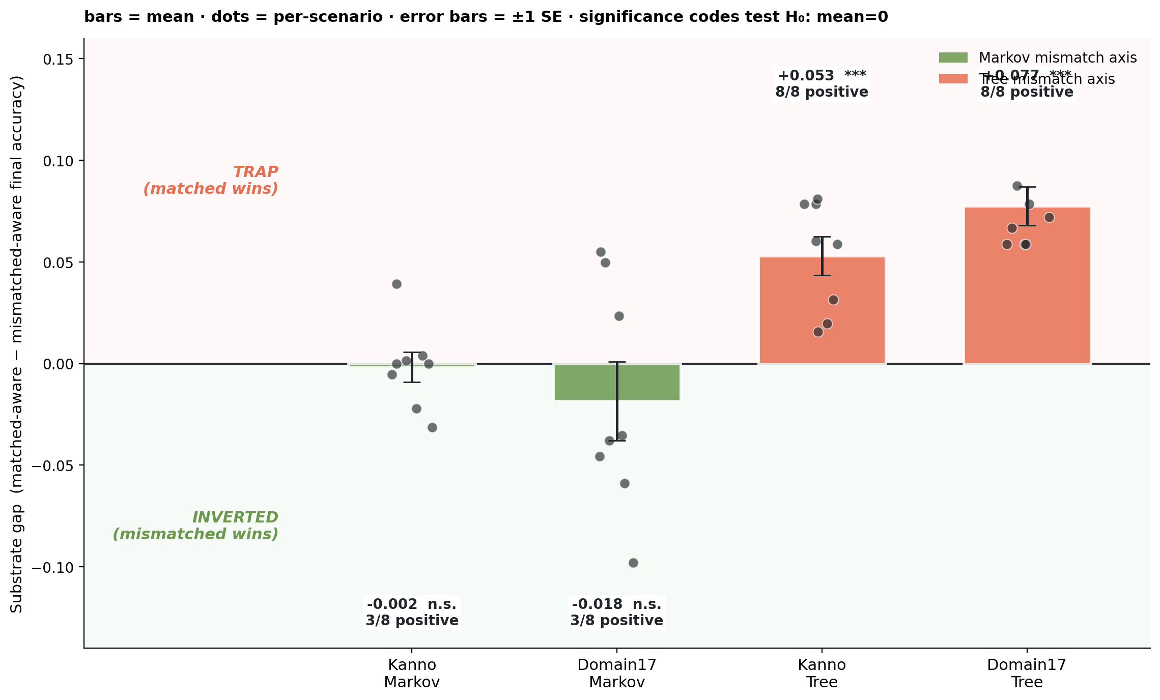
Figure 5. Substrate gap by (network × mismatched axis). Bars show mean, dots show per-scenario values, error bars are ±1 SE. Tree-axis conditions produce a robust positive substrate gap (matched wins, classical trap); Markov-axis conditions produce a null or mildly negative gap (mismatched wins or ties, inverted regime).
The aware gap — the classical Anthropomorphization Trap signal — is at aggregate positive but small and not statistically robust in any single condition. This aggregate obscures a scenario-level structure documented in prior work on this dataset: on Kanno-tree, the aware gap splits by fault type (dead battery: aware > naive; weak battery: naive > aware), producing a scenario-conditional trade-off rather than a monotone trap. We return to this in the discussion.

5.2 Metric-dependence: does the sign flip under abstention-aware accuracy?
Before proceeding to the mechanism analysis, we address a natural concern: because the full team-accuracy metric treats UNCERTAIN diagnoses as errors, differences in commitment rates across cells could mechanically inflate (or deflate) the substrate gap. To test this, we compute an alternative committed accuracy metric that scores only nodes where an agent’s diagnosis is not UNCERTAIN (correct / #committed), so that abstention neither helps nor hurts.
For the domain17-Markov condition — the cell where the sign might most plausibly reverse — we ran the full 2×2, with both metrics reported side by side. The aggregate substrate gap under the full metric is −0.019 (t = −0.95, p = 0.37, 3/8 scenarios contradict); under the committed metric it is −0.033 (t = −2.91, p = 0.023, 0/8 scenarios contradict). The sign does not flip; the effect becomes stronger and cleaner under the abstention-aware metric, moving from statistically undecidable to a clear negative result. Per-scenario, 3 of 8 scenarios flip sign between the two metrics, but the aggregate sign is unchanged.
The metric dependence is fully explained mechanically by cell-level commitment rates: the Pearson correlation between the per-scenario commit-rate difference (matched-aware minus mismatched-aware) and the per-scenario full-committed metric difference is r = +0.96, p < 0.001. Whenever the matched-aware team commits more than the mismatched-aware team, the full metric rewards it disproportionately relative to the committed metric. In this dataset, aggregate commit rates are essentially equal across cells (matched-aware 0.708, mismatched-aware 0.707), so the aggregate sub_gap is stable across metrics even though individual scenarios can flip.
We interpret this as evidence that the Markov surprise is not an abstention artifact. From this point on, all analyses use the full metric for continuity with the EMBM literature.

5.3 The sensitivity mechanism: mismatched-aware teams detect more conflicts
Table 2 reports the initial conflict counts by cell and the (mismatched-aware minus matched-aware) contrast.
Table 2. Initial conflict counts and the sensitivity contrast.
Cell | m-a | m-n | mm-a | mm-n | mm-a − m-a | t(7) | p | Pos
Domain17 tree | 13.50 | 13.50 | 44.25 | 6.75 | +30.75 | +12.87 | <0.0001 | 8/8
Domain17 markov | 13.50 | 13.50 | 34.88 | 6.75 | +21.38 | +11.15 | <0.0001 | 8/8
Kanno tree | 12.75 | 12.75 | 22.88 | 3.75 | +10.12 | +8.04 | 0.0001 | 8/8
Kanno markov | 12.75 | 12.75 | 15.38 | 12.75 | +2.62 | +3.86 | 0.006 | 6/8
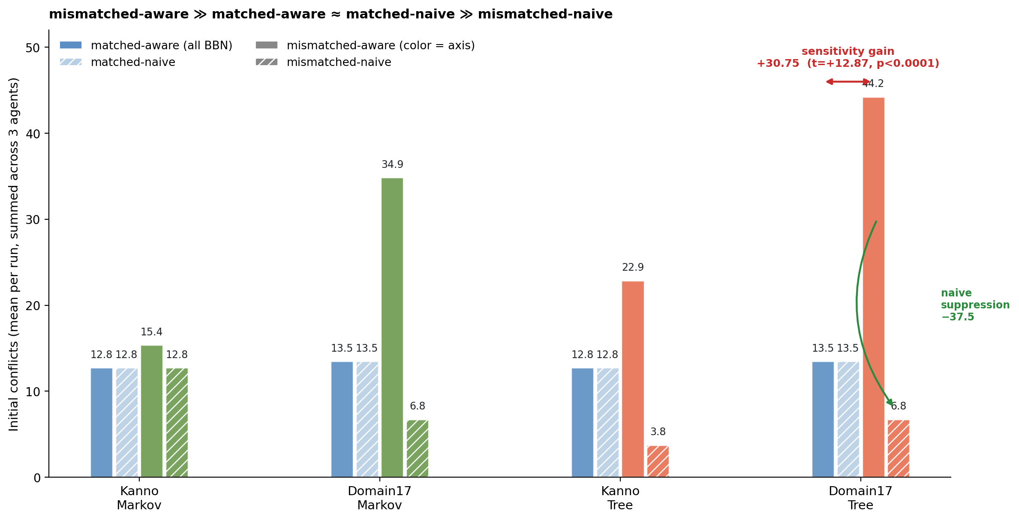
Figure 6. Initial conflict counts across the 2×2×2 design. Matched-aware and matched-naive produce identical counts in every cell (specificity check); mismatched-aware dramatically exceeds matched-aware in every cell (sensitivity gain, red arrow shown for Domain17-Tree); mismatched-naive collapses back below matched-aware in every cell (naive suppression, green arrow shown for Domain17-Tree).
The sensitivity gain — mismatched-aware detects strictly more initial conflicts than matched-aware — is replicated across all four (network × axis) conditions, with 8/8 per-scenario replication in three of them and 6/8 in the fourth. The effect size varies substantially, from +2.6 conflicts (Kanno-Markov) to +30.8 (Domain17-tree). Its magnitude tracks approximately how much the mismatched substrate’s diagnoses diverge from BBN’s: tree, which cannot represent joint uncertainty, produces large divergence and large sensitivity gain; Markov on Kanno, whose CPTs concentrate most mutual information in dominant parents so that the Markov approximation is nearly lossless, produces small divergence and small sensitivity gain. The relationship is monotone across the four cells.

5.4 The illusory-agreement mechanism: naive projection suppresses the signal
Table 3 reports the mismatched-aware minus mismatched-naive contrast.
Table 3. Naive suppression of mismatch-induced conflicts.
Cell | mm-a − mm-n | t(7) | p | Positive scenarios
Domain17 tree | +37.50 | +14.43 | <0.0001 | 8/8
Domain17 markov | +28.12 | +10.84 | <0.0001 | 8/8
Kanno tree | +19.12 | +5.48 | 0.001 | 8/8
Kanno markov | +2.62 | +3.86 | 0.006 | 6/8
In every cell, naive projection detects substantially fewer initial conflicts than aware projection in the mismatched composition. The suppression averages 80% of the conflicts that aware projection surfaces — that is, four out of five conflicts that aware projection would have flagged are structurally invisible to naive projection because the naive engine models the mismatched teammate as if it computed the same way as the modeling agent, producing (falsely) agreeing diagnoses. This is the illusory-agreement mechanism at operational precision.

5.5 Specificity check: matched teams show no aware/naive difference
In every one of the four (network × axis) conditions, and in every one of the eight scenarios per condition, matched-aware and matched-naive teams produce identical initial conflict counts (t = 0.00, p = 1.00, all scenarios). This is a structural consequence of the model — when all agents run the same substrate, aware and naive projections instantiate identical engines — and it serves as a design-validity check: the aware/naive difference documented in Section 5.4 is not a generic property of the projection-mode manipulation but is specifically a signature of substrate heterogeneity.

5.6 Phantom vs. real: the extra conflicts are only half productive
The sensitivity gain of Section 5.3 raises the question: are the extra conflicts detected by mismatched-aware teams useful — do they surface nodes where the detecting agent’s own L1 is wrong and needs correction — or are they noise, illusory disagreements with a teammate model on nodes where the actor is already right? Table 4 decomposes the sensitivity gain into extra real conflicts (actor’s L1 disagrees with ground truth) and extra phantom conflicts (actor’s L1 agrees with ground truth).
Table 4. Phantom/real decomposition of the mismatched-aware − matched-aware extra conflicts.
Cell | Extra real | Extra phantom | Phantom %
Domain17 tree | +17.25 | +13.50 | 43.9%
Domain17 markov | +10.50 | +10.88 | 50.9%
Kanno tree | +8.25 | +1.88 | 18.5%
Kanno markov | +0.75 | +1.88 | 71.4% (small N)
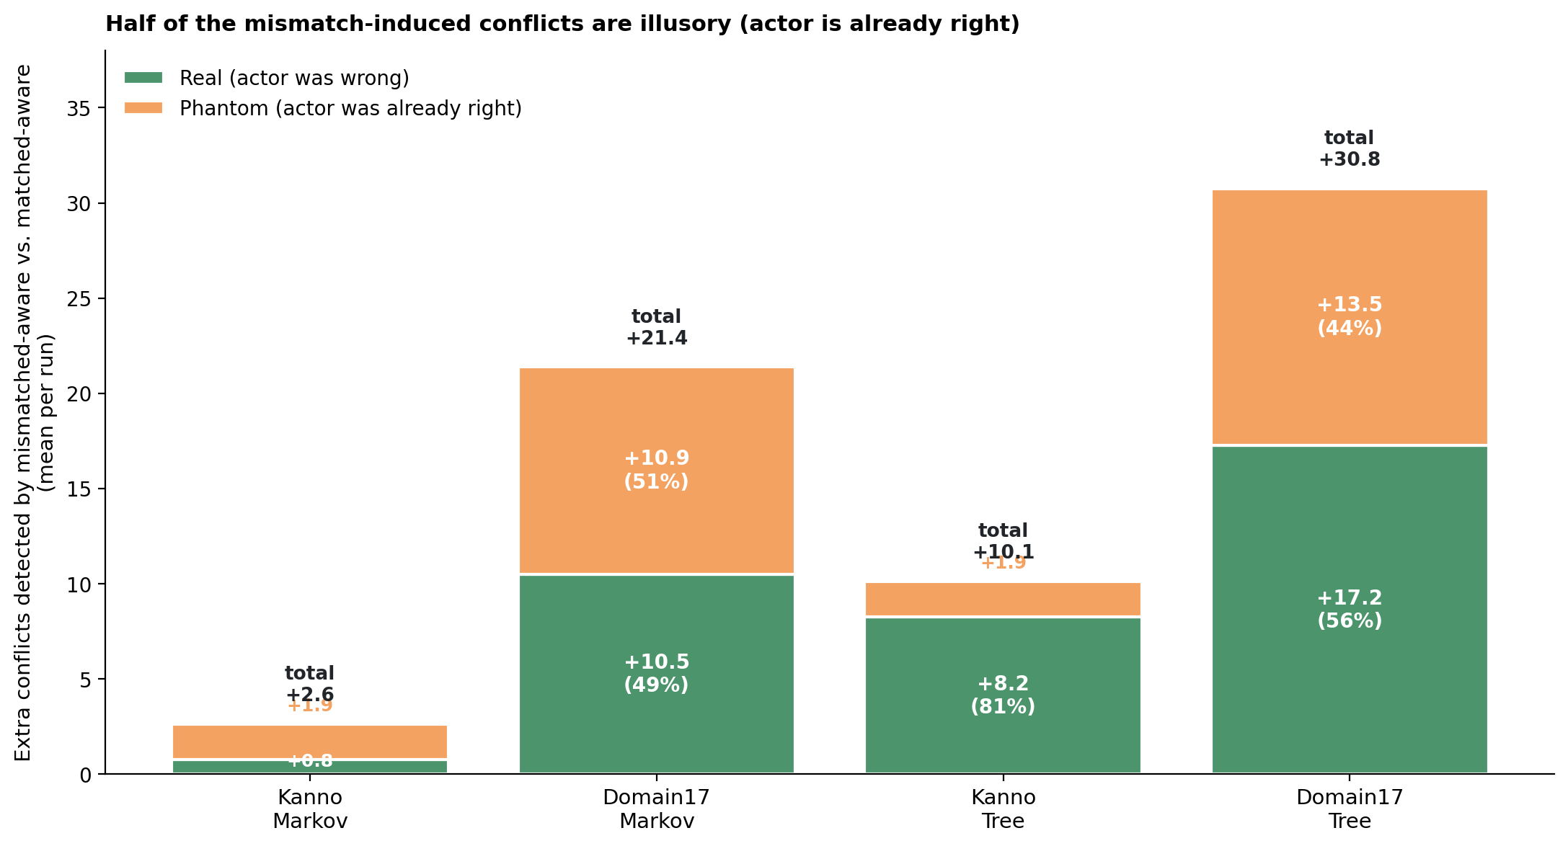
Figure 7. Phantom vs. real decomposition of the mismatched-aware minus matched-aware extra initial conflicts. Green = extra real conflicts (actor’s L1 disagrees with ground truth, so coordination help is warranted); orange = extra phantom conflicts (actor is already right; the detected disagreement is illusory from an oracle’s perspective and any action taken on it is wasted).
Two observations. First, the real component of the sensitivity gain is significant and non-zero in three of four cells (Kanno-Markov aside, whose totals are close to noise), so the mechanism is not purely illusory disagreement — mismatched-aware teams really do detect nodes where they are genuinely wrong and could benefit from help. Second, the phantom component is also large in most cells. Roughly half of the extra sensitivity is unproductive: it consists of conflicts over nodes where the detecting agent is already correct, so acting on them would waste actions and could even propagate errors.
The phantom fraction is not uniform across cells. Kanno-tree has the lowest phantom fraction (18.5% — the extra sensitivity is 81% productive) yet still shows a large positive substrate gap (matched wins by +0.053). Domain17-Markov has a middling phantom fraction (51%) and shows a mildly negative substrate gap (mismatch wins by 0.019). This is important: phantom fraction alone does not predict substrate-gap sign. The sign depends on the second force, which we take up next.

5.7 The two-force account
Sections 5.3–5.6 identify a first mechanism: substrate mismatch under aware projection produces a sensitivity gain, most of which is real but a substantial fraction of which is phantom. But the outcome data of Section 5.1 show that this sensitivity gain does not translate into a corresponding accuracy gain. On Kanno-tree, mm-aware surfaces +8.25 extra real conflicts per scenario — nodes where at least one agent is genuinely wrong and needs coordination help — yet mm-aware loses to m-aware by 0.053 in team accuracy. The sensitivity is productive, but the team is nonetheless worse.
The missing piece is a second force: the quality of single-agent inference. Placing a tree engine in an otherwise BBN team downgrades the tree agent’s own L1 diagnoses, regardless of how well the projection layer models heterogeneity. The tree agent contributes a weaker inference to the team’s post-cooperation belief state. The substrate gap is the balance of this quality loss against the (real component of the) sensitivity gain:
substrate gap ≈ (inference quality loss) − (real sensitivity gain) × (action efficacy)
Where action efficacy captures how often a detected real conflict translates into a beneficial action outcome given the noisy translation and idle-terminator dynamics of the coop phase.
The four cells fit this account cleanly. On Kanno-Markov, both terms are small (Markov ≈ BBN in inferential power on Kanno’s CPTs), so the substrate gap is near zero (−0.002). On Domain17-Markov, quality loss is small but real-sensitivity gain is +10.5 — so mismatch wins (−0.019). On Kanno-tree, quality loss is large (tree << BBN in inferential power) and real-sensitivity gain is +8.25 — so mismatch loses (+0.053). On Domain17-tree, both terms are large, but quality loss dominates: mismatch loses (+0.077).
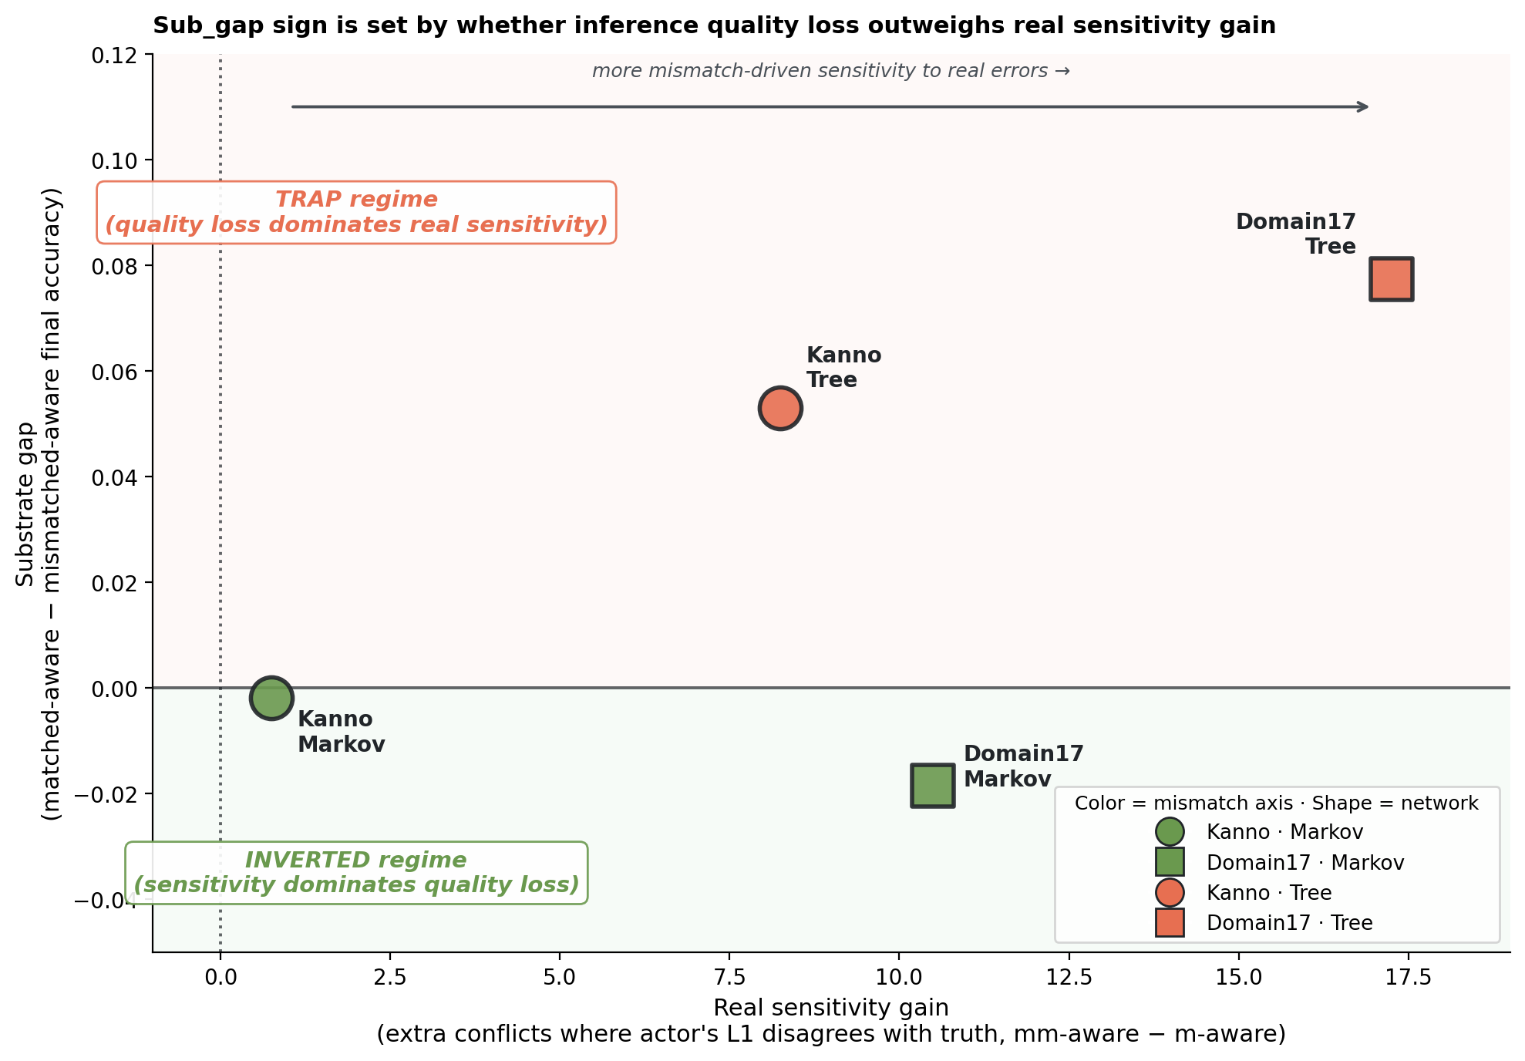
Figure 8. The two-force account visualized. The x-axis is the real sensitivity gain (extra conflicts in mm-aware where the actor’s own L1 is wrong); the y-axis is the substrate gap. Color indicates the mismatched-axis substrate; marker shape indicates the network. The four cells occupy different regions of the two-force space: near-origin (Kanno-Markov, both forces small); high-sensitivity/negative-gap (Domain17-Markov, sensitivity wins); moderate-sensitivity/positive-gap (Kanno-Tree, quality loss wins); high-sensitivity/large-positive-gap (Domain17-Tree, quality loss still wins despite large sensitivity).
This decomposition also explains why the phantom fraction does not predict the outcome sign: phantom conflicts do not directly contribute to accuracy (they lead to wasteful actions but not necessarily to incorrect final diagnoses), so the sensitivity term in the outcome equation is best approximated by the real sensitivity gain, not the total sensitivity gain. Phantom conflicts are a “cost of sensitivity” that reduces action-efficacy but does not change the sign of the substrate gap.

6. Discussion

6.1 The two forces are both real and both necessary
The 2×2×2 design lets us make a claim we could not make from any single (network, axis) cell. Substrate mismatch is not one thing. It is at minimum two things: a sensitivity gain that surfaces additional conflicts and is bounded by how much the mismatched substrate’s committed diagnoses diverge from BBN’s, and an inference quality loss that is bounded by how much worse the mismatched substrate is at getting individual nodes right. Both forces are measurable at the level of individual scenarios in ways that generalize across networks. The signed effect of mismatch on team accuracy is the balance.
This reframes the Anthropomorphization Trap. The original trap thesis — matched > mismatched-aware > mismatched-naive — turns out to hold, on aggregate, only when the mismatched substrate is inferentially weaker than BBN. When the mismatched substrate is inferentially close to BBN (Markov on either network), aggregate mismatch is either neutral or mildly beneficial, and the aware/naive ordering becomes empirically noisy. The trap is not a single-mechanism claim; it is a compound one, and its aggregate direction depends on which of the two forces dominates in a given (network, axis) regime.

6.2 What naive projection does
Sections 5.4 and 5.5 give an operationally precise account of naive projection. Under matched compositions, naive projection is a null operation — indistinguishable from aware projection because everyone runs the same substrate. Under mismatched compositions, naive projection is a conflict-detection suppressor: it hides the disagreements that substrate heterogeneity produces, by structurally instantiating projected engines that agree with the detecting agent’s own inference by construction. This is neither a form of cognitive laziness nor a lack of information — it is a definite representational commitment that renders substrate heterogeneity invisible.
The interesting consequence is that naive projection is bounded in its harm by the size of the substrate gap. When the substrate gap is small (Kanno-Markov), naive projection has little to suppress, so its accuracy penalty is small (aware gap +0.004). When the substrate gap is large (Domain17-tree), naive projection has much to suppress, and correspondingly more accuracy is left on the table. This inverts the intuition that naive projection should always be costly: it is costly only when there is a signal to be erased.

6.3 Phantom conflicts and the sensitivity ceiling
The phantom/real decomposition surfaces a further subtlety. Not all sensitivity is productive. The extra conflicts detected under aware projection with mismatched substrates include a substantial fraction (typically 40–50%) in which the detecting agent is already correct and the perceived mismatch is illusory from an oracle’s perspective. These phantom conflicts drive the coop phase to spend actions on nodes that did not need action, potentially degrading the team’s action efficiency.
This gives a natural ceiling on the sensitivity gain. Even when a team can detect a great many mismatch-induced conflicts (Domain17-tree, +30.8 extras), the team is only marginally better off in coordination terms because half of that extra activity is misdirected. The tree engine’s L1 quality loss is what tips this from a wash into an accuracy loss.
The phantom effect is not merely a nuisance: it may be the mechanism linking substrate diversity to dysfunctional coordination. A team of agents with different substrates is not a team with more perspectives to bring to bear; it is a team that generates additional disagreements, most of which are structurally illusory. In a real human-AI teaming context, one could reasonably ask whether a majority of disagreements between a human expert and a model are “real” (the human is wrong and would benefit from the model’s flag) or “phantom” (the human is right and the flag will simply produce friction). Extending this to real teams is speculative, but the framework generalizes.

6.4 The Markov finding
The most surprising cell in Table 1 is Domain17-Markov, where the substrate gap is mildly negative — mismatched teams marginally beat matched teams. In an earlier draft of this project, we identified this as an unresolved anomaly. With the two-force account in hand, it is no longer anomalous. Domain17-Markov satisfies exactly the conditions where sensitivity gain (real +10.5) outweighs quality loss (small — Markov’s dominant-parent-mediated approximation is close to BBN on Domain17’s CPTs). It fits the account.
The Markov approximation being nearly lossless on many real Bayesian networks is a familiar practical observation, driven by the concentration of mutual information in dominant parent edges when CPTs are strongly informative. The finding here is that this near-losslessness has a cooperative-diagnosis consequence: a Markov agent can be added to a BBN team without an accuracy cost, and the sensitivity signal it generates is a modest positive contribution.

6.5 Boundary conditions and limitations
Several boundary conditions bear noting. First, all teams in this study are three-person. This choice is inherited from Okabe et al. (2025), who justify it on the grounds that a three-person team is the minimum non-trivial unit for studying recursive mutual belief: a two-person dyad has no third-party belief structure to project, while a three-person team introduces the L3 projected-belief layer (agent A’s belief about agent B’s belief about agent C) without yet requiring the mental-subgrouping machinery of Mahardhika et al. (2016). This is a defensible starting point but a real limitation for external validity. Typical project management teams, software development teams, and emerging human-AI teams in operational settings have five to nine members, not three. Extending the substrate-heterogeneity manipulation to larger teams raises questions that our results do not resolve. The number of belief structures per agent grows roughly quadratically with team size in the absence of subgrouping (7 at N=3, 21 at N=5, 43 at N=7, 73 at N=9), which means the substrate-instantiation choices multiply and the aware-vs-naive projection distinction touches many more engines. Larger teams also admit richer heterogeneity structures that we cannot study at N=3 — one-outlier-of-N (a natural generalization of our two-vs-one design), majority-minority splits, and substrate-clustered subteams where members using the same substrate co-locate — each with potentially different two-force balances. The two-force account makes qualitative predictions that we would expect to survive scaling: sensitivity gain should scale approximately with the number of substrate-crossing projected engines, quality loss should scale with the fraction of teammates on the lower-quality substrate, and naive projection should continue to suppress the aware-projection sensitivity signal. Whether these components combine at larger N to preserve, amplify, or reverse the substrate-gap signs we observe here is an empirical question we cannot settle from a three-person study. This is the most consequential open extension of the framework.
Second, all results reported here are at THD = 0.55. Preliminary sweeps at THD = 0.65 (on Kanno-tree) show the sensitivity mechanism intact but the aware-vs-naive accuracy consequences change with threshold — this is expected, since higher thresholds produce fewer commitments and therefore less surface area for aware/naive to bite. A full THD × cell sweep is a natural next step in the study.
Third, our N=15 per cell is lower than the original EMBM protocol's N=40. Aggregate estimates are stable at this N; per-scenario estimates carry larger uncertainty. Where our claims turn on 8/8 replication of a sign, replication is at 8/8 regardless of N; where they turn on aggregate significance testing, the reduced N is a conservative choice (less power) rather than a permissive one.
Fourth, we used hand-specified engines throughout. Learned engines (e.g., a decision tree trained on fault data rather than compiled from CPTs) would introduce training-noise confounds that we deliberately avoided. Extending the framework to learned engines is a natural direction, but it requires care to disentangle substrate structure from the training regime.
Fifth, we studied three substrates. Others — for example, large language models used as approximate posterior estimators — would extend the analysis but require new translation rules. Nothing in the two-force account is specific to the three substrates we used.
Sixth, the phantom/real decomposition is defined at the level of the initial-conflict snapshot, before cooperation. Extending it to the full cooperation trajectory would require tracking whether each action taken during coop resolved a real or phantom conflict at the moment it was taken. This is a next-instrumentation step.

7. Conclusion
Substrate heterogeneity in recursive-mutual-belief teams is not a single force. It is at least two: a sensitivity gain that surfaces additional inter-agent conflicts when projection is aware of heterogeneity, and an inference quality loss that scales with the extent to which the mismatched substrate degrades single-agent diagnostic accuracy. The signed effect of mismatch on team accuracy is the balance, and it can go either way depending on the (network, axis) regime.
The two forces are separately measurable and separately robust. The sensitivity gain replicates with per-scenario perfect (8/8) or near-perfect (6/8) sign consistency in all four (network × axis) cells we studied. The naive-projection suppression of that sensitivity replicates similarly, and the matched-team specificity check confirms both effects arise specifically from heterogeneity rather than from projection mode per se. The phantom/real decomposition shows the sensitivity gain is real but not fully productive.
The Anthropomorphization Trap — the original hypothesis that assuming your heterogeneous teammate reasons like you do costs accuracy — is best understood as a consequence of these two forces plus the naive-projection suppression, rather than as a single-mechanism prediction. When the substrate gap is large, naive projection loses meaningful information about disagreements, so aware projection wins. When the substrate gap is small, naive projection has little to lose. Whether a mismatch is beneficial or harmful in the first place depends on whether the two underlying forces are balanced toward sensitivity or quality.
We suggest that recursive-mutual-belief models of team cognition are best formulated with pluggable inference substrates from the outset. Homogeneity assumptions are analytically convenient but empirically restrictive, and — as this paper shows — the coordination dynamics they hide are not merely additive corrections but structurally distinct forces whose balance is the actual dependent variable of interest.

Acknowledgments
[Reserved.]

Data availability
All experimental scripts and results JSONs are available at https://github.com/rkallur2/abm. The 2×2×2 design can be reproduced using run_conflict_instrument.py {domain17|kanno} {tree|markov} with the documented base seeds (900_000, 910_000, 500_000, 800_000 for the four cells, respectively).

References
Anderson, J. R., & Lebiere, C. (1998). The atomic components of thought. Mahwah, NJ: Lawrence Erlbaum Associates.
Andrews, R. W., Lilly, J. M., Srivastava, D., & Feigh, K. M. (2023). The role of shared mental models in human-AI teams: A theoretical review. Theoretical Issues in Ergonomics Science, 24(2), 129–175. https://doi.org/10.1080/1463922X.2022.2061080
Cao, S., MacLaren, N. G., Cao, Y., Marshall, J., Dong, Y., Yammarino, F. J., … Ruark, G. A. (2022). Group size and group performance in small collaborative team settings: An agent-based simulation model of collaborative decision-making dynamics. Complexity, 2022, 8265296. https://doi.org/10.1155/2022/8265296
Cooke, N. J., Salas, E., Cannon-Bowers, J. A., & Stout, R. J. (2000). Measuring team knowledge. Human Factors, 42(1), 151–173. https://doi.org/10.1518/001872000779656561
Cooke, N. J., Gorman, J. C., Myers, C. W., & Duran, J. L. (2013). Interactive team cognition. Cognitive Science, 37(2), 255–285. https://doi.org/10.1111/cogs.12009
Crosscombe, M., & Lawry, J. (2016). A model of multi-agent consensus for vague and uncertain beliefs. Adaptive Behavior, 24(4), 249–260. https://doi.org/10.1177/1059712316661395
Dourish, P., & Bellotti, V. (1992). Awareness and coordination in shared workspaces. In Proceedings of the 1992 ACM Conference on Computer-Supported Cooperative Work (pp. 107–114). https://doi.org/10.1145/143457.143468
Flavell, J. H. (1979). Metacognition and cognitive monitoring: A new area of cognitive-developmental inquiry. American Psychologist, 34(10), 906–911. https://doi.org/10.1037/0003-066X.34.10.906
Flemisch, F., Abbink, D. A., Itoh, M., Pacaux-Lemoine, M.-P., & Weßel, G. (2019). Joining the blunt and the pointy end of the spear: Towards a common framework of joint action, human–machine cooperation, cooperative guidance and control, shared, traded and supervisory control. Cognition, Technology & Work, 21, 555–568. https://doi.org/10.1007/s10111-019-00576-1
Glinton, R., Scerri, P., & Sycara, K. P. (2010). Exploiting scale invariant dynamics for efficient information propagation in large teams. In Proceedings of the 9th International Conference on Autonomous Agents and Multiagent Systems (AAMAS) (pp. 21–30).
Grimm, V., Berger, U., Bastiansen, F., Eliassen, S., Ginot, V., Giske, J., … DeAngelis, D. L. (2006). A standard protocol for describing individual-based and agent-based models. Ecological Modelling, 198(1–2), 115–126. https://doi.org/10.1016/j.ecolmodel.2006.04.023
Grimm, V., Railsback, S. F., Vincenot, C. E., Berger, U., Gallagher, C., DeAngelis, D. L., … Ayllón, D. (2020). The ODD protocol for describing agent-based and other simulation models: A second update to improve clarity, replication, and structural realism. Journal of Artificial Societies and Social Simulation, 23(2), 7. https://doi.org/10.18564/jasss.4259
Gutwin, C., & Greenberg, S. (2004). The importance of awareness for team cognition in distributed collaboration. In E. Salas & S. M. Fiore (Eds.), Team cognition: Understanding the factors that drive process and performance (pp. 177–201). American Psychological Association.
Hutchins, E. (1995). Cognition in the wild. Cambridge, MA: MIT Press.
Kanno, T., Furuta, K., & Kitahara, Y. (2013). A model of team cognition based on mutual beliefs. Theoretical Issues in Ergonomics Science, 14(1), 38–52. https://doi.org/10.1080/1464536X.2011.573010
Kosinski, M. (2024). Evaluating large language models in theory of mind tasks. Proceedings of the National Academy of Sciences, 121(45), e2405460121. https://doi.org/10.1073/pnas.2405460121
Li, J., & Xiao, R. (2017). Agent-based modelling approach for multidimensional opinion polarization in collective behaviour. Journal of Artificial Societies and Social Simulation, 20(2), 4. https://doi.org/10.18564/jasss.3385
Mahardhika, D., Kanno, T., & Furuta, K. (2016). Team cognition model based on mutual beliefs and mental subgrouping. Journal of Interaction Science, 4, 1–10. https://doi.org/10.1186/s40166-016-0014-6
McNeese, M., Salas, E., & Endsley, M. R. (Eds.). (2020). Foundations and theoretical perspectives of distributed team cognition. Boca Raton, FL: CRC Press.
Mohammed, S., Hamilton, K., Tesler, R., Mancuso, V., & McNeese, M. (2015). Time for temporal team mental models: Expanding beyond “what” and “how” to incorporate “when.” European Journal of Work and Organizational Psychology, 24(5), 693–709. https://doi.org/10.1080/1359432X.2015.1024664
Nelson, T. O., & Narens, L. (1994). Why investigate metacognition. In J. Metcalfe & A. P. Shimamura (Eds.), Metacognition: Knowing about knowing (pp. 1–25). Cambridge, MA: MIT Press.
Newell, A. (1990). Unified theories of cognition. Cambridge, MA: Harvard University Press.
Nonose, K., Kanno, T., & Furuta, K. (2010). An evaluation method of team situation awareness based on mutual belief. Cognition, Technology & Work, 12, 31–40. https://doi.org/10.1007/s10111-008-0127-y
Nonose, K., Kanno, T., & Furuta, K. (2014). Effects of metacognition in cooperation on team behaviors. Cognition, Technology & Work, 16, 349–358. https://doi.org/10.1007/s10111-013-0265-8
Okabe, N., Kanno, T., Cho, S., Furuta, K., Yoshida, H., Karikawa, D., Nonose, K., & Inoue, S. (2025). Modeling and simulation of three-person team cooperation considering mutual beliefs. Cognition, Technology & Work, 27(1), 159–179. https://doi.org/10.1007/s10111-025-00791-z
Rousseau, R., Tremblay, S., & Breton, R. (2004). Defining and modeling situation awareness: A critical review. In S. Banbury & S. Tremblay (Eds.), A cognitive approach to situation awareness: Theory and application (pp. 3–21). Aldershot, UK: Ashgate.
Salas, E., Cooke, N. J., & Rosen, M. A. (2008). On teams, teamwork, and team performance: Discoveries and developments. Human Factors, 50(3), 540–547. https://doi.org/10.1518/001872008X288457
Salas, E., Fiore, S. M., & Letsky, M. P. (Eds.). (2011). Theories of team cognition: Cross-disciplinary perspectives. New York: Routledge.
Schelble, B. G., Flathmann, C., McNeese, N. J., O’Neill, T., Pak, R., & Namara, M. (2023). Investigating the effects of perceived teammate artificiality on human performance and cognition. International Journal of Human–Computer Interaction, 39(13), 2686–2701. https://doi.org/10.1080/10447318.2022.2085191
She, M., & Li, Z. (2017). Team situation awareness: A review of definitions and conceptual models. In D. Harris (Ed.), Engineering psychology and cognitive ergonomics: Performance, emotion and situation awareness (EPCE 2017), Lecture Notes in Computer Science, vol. 10275 (pp. 406–415). Cham: Springer. https://doi.org/10.1007/978-3-319-58472-0_31
Tuomela, R., & Miller, K. (1988). We-intentions. Philosophical Studies, 53, 367–389. https://doi.org/10.1007/BF00353512
Wright, J. L., Chen, J. Y. C., Barnes, M. J., & Boyce, M. W. (2015). The effects of information level on human–agent interaction for route planning. Proceedings of the Human Factors and Ergonomics Society Annual Meeting, 59(1), 811–815. https://doi.org/10.1177/1541931215591247

