**EGR150 Section AY: Preliminary Project Agreement.**

**Full Name**: Rofael Aleezada (<-- your name, not mine!)

**Project Name**: SEC Team Database (<-- Creative but realistic.)

**Description**: Brings up detailed information about a selected team in the SEC. (<-- Short but descriptive)

**Category**: Sports, Data

Examples:

Engineering, Educational, Mathematical, Inventory, Image, Game

**File Name**: SECDatabase.fig

**Summary**: An initial dropdown box will contain a list of teams in the SEC. After selecting a team, the GUI will show data pertaining about the team (location, year joined, etc). A radio button will display additional info about the team when pressed (year founded, population, awards won, etc.). A second radio button will display a graph of the team’s ranking over the last 10 years, and it will also show a dropdown box and a textbox showing the selected team’s position in a leaderboard for a year selected in the dropdown box.

Fill in the information above and design constraints below

(again put in the Canvas Module for Final Project—with this assignment)

**Design constraints** (________ are for you to fill in):

1. Use the GUI template to create at least a one page GUI
2. Read in an image of SEC logo and team logo when selected to my GUI
3. Display data of rank over the last 10 years as a graph or chart
4. Use a logic statement to determine which team has been selected.
5. Use an if or switch statement to change the information displayed based on the selected team.
6. Use a for or while loop to populate the structures that will be used to store the data for each team.
7. Include significant calculations for comparing teams based on their rank history.
8. Will have input data of selecting a team from the initial dropdown box. that can be updated periodically and output data of data about the selected team retrievable for each user
9. The ability to handle incorrect input by the program asking for a selection from the initial dropdown menu.
10. Use structures to store information based on the selected team.
11. Use a radio button to show additional data for each team.
12. Access the latest information from an online reference.

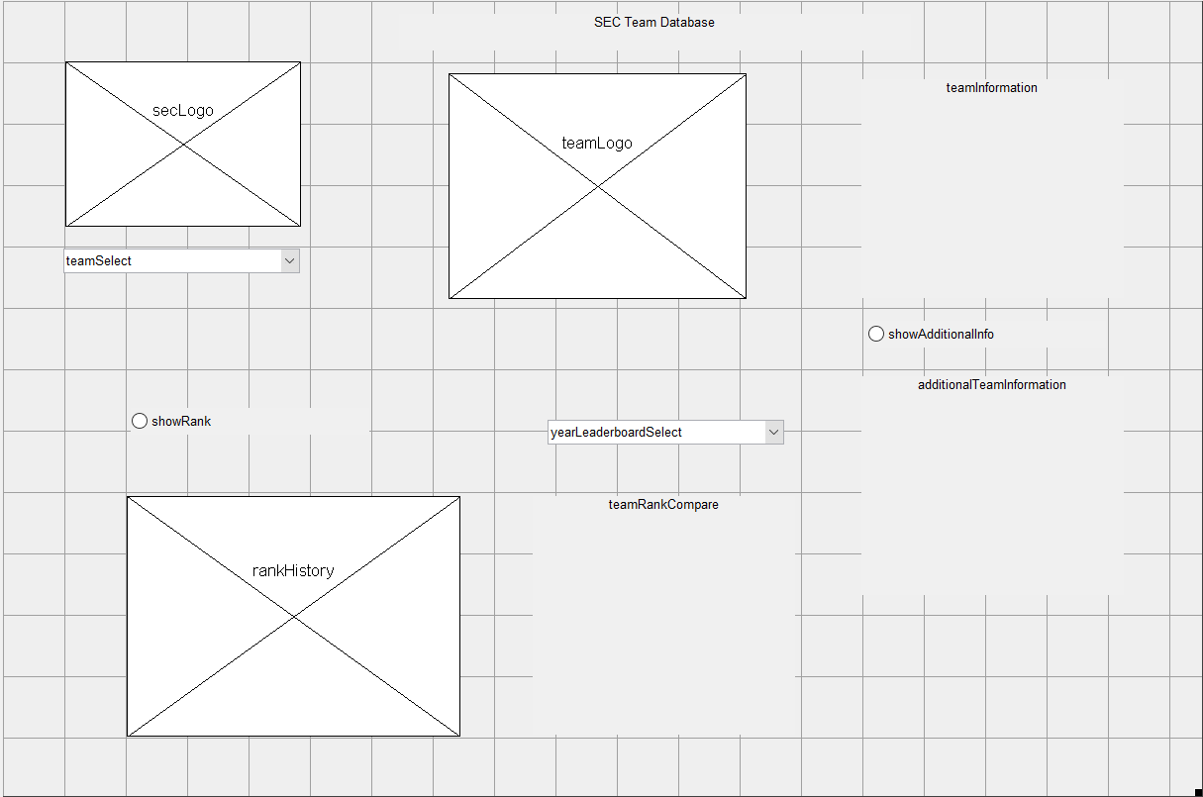

**Grading**: Some minor changes may occur between now and the presentations.

However this is very, very close to what you can expect.

**Requirement Value**

=========================================================================

Preliminary agreement submission and approval 10

Final agreement submission and approval 10

Meeting first 9 design constraints 180

Meeting your performance requirements 40

Creativity 30

Utility 30

=========================================================================

300

**Extra credit**

effort above minimum requirements up to 100 pts

code

elements

esthetics

meeting would like to constraint

=========================================================================

Remember projects must include (incomplete projects will receive a 0)--due dates are firm (in the real world you probably will get fired for missing due dates or not producing all the deliverables):

1. in a word file (should put some in a power point for presentation)

a. a screen shot of the completed GUI template

b. a screen shot of the GUI when it first opens

c. the complete code (start on a new page)

d. the design specifications and what lines in the GUI meet this

specification

e. a list of all sources you borrowed code from and modifications

you made (if we find a source you did not cite--you get a zero

for the project and may fail the course).

2. the code file

3. the figure file

4. all files and images read into the GUI. If any of these are updatable

one representative example will suffice.

5. One example output file

6. Preliminary project agreement submitted and approved (face to face

time will be available after class on 11/9)

7. Final project agreement submitted and approved (if significantly

different from preliminary agreement)

8. Short presentation of GUI to the class

Due dates

6. In final project module and approved 11/9

7. In final project module 11/18 approval 11/20

8. Sign up last 2 days of class and final period

1-5. In final project module 12/2