OpenJUMP SpatiaLite Plugin v. 1.4 manual

Installation on Windows

Download either 32-bit or 64-bit Windows package of the plugin. Unzip the package and place all the files in the zipped folder in the JUMP_HOME/lib/ext folder.

The contents of the Windows packages:
- spatialiteplugin-1.4.jar - the main plugin
- sqlite-jdbc-3.8.7.jar - JDBC driver for SQLite database
- mod_spatialite.dll - SpatiaLite extension v. 4.2.1-RC1
- 10 other dll files - required native libraries for mod_spatialite

Installation on Linux and Mac

Linux and Max user can take the plarform independent spatialiteplugin-1.4.jar and sqlite-jdbc-3.8.7.jar files from either of the Windows packages and put them into their JUMP_HOME/lib/ext folder. However, they must compile the mod_spatialite extension by themself and ensure that both the extension and the required dependencies can be found from the path. Buildign instructions for Linux are available at http://www.gaia-gis.it/gaia-sins/linux_how_to.html.

Using the SpatiaLite Plugin

Check your Java version

Check from the OpenJUMP info that the Java version is of the same architecture as the plugin. Both must be either 32-bit or 64-bit.

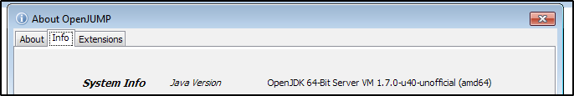

It may be necessary to edit the oj_windows.bat file for selecting the desired Java version.

rem -- uncomment to manually set java home --
set JAVA_HOME=C:\path\to\a\specific\jre

Connect SpatiaLite database

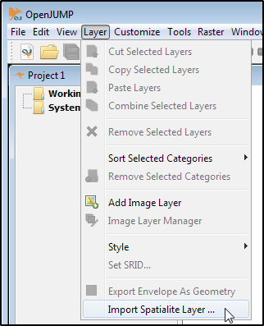

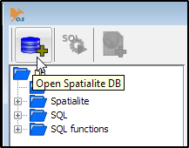
Only the first button in the user interface is active if SpatiaLite database is not connected.

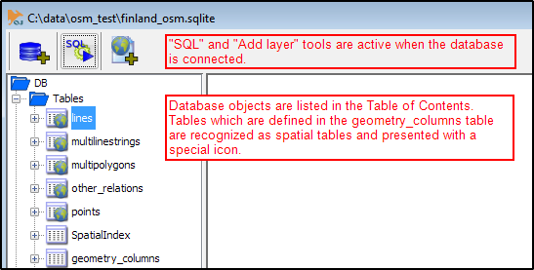

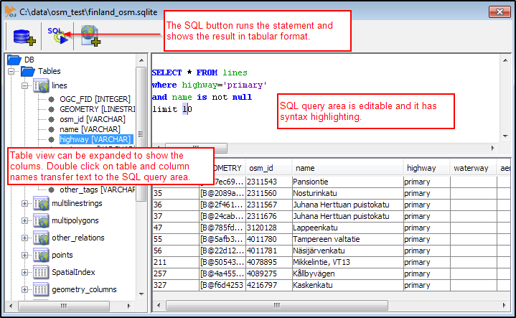

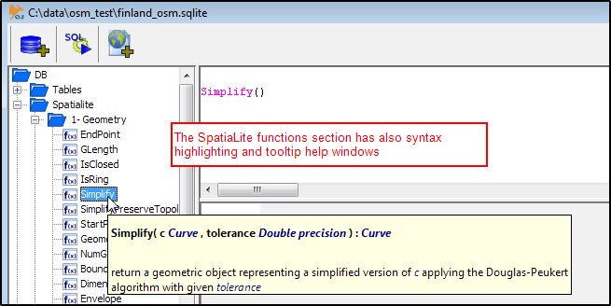

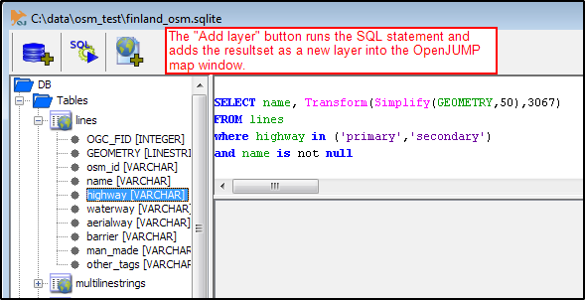

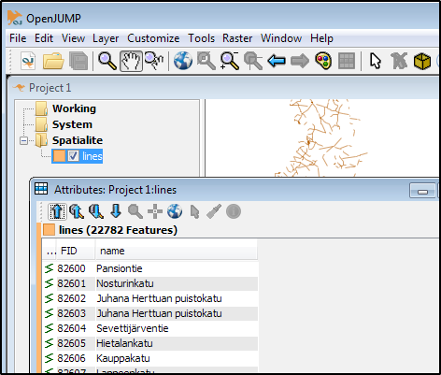

Troubleshooting

If the connection with SpatiaLite database fails and the ”Execute SQL query” and ”Add layer” tools stay grayed check the Output window of OpenJUMP for further information. Most common reason is that the architecture of the mod_spatialite does not correspond with the Java and there is a mismatch between 32-bit and 64-bit componets. Check the output window also in case of any other trouble with the plugin.
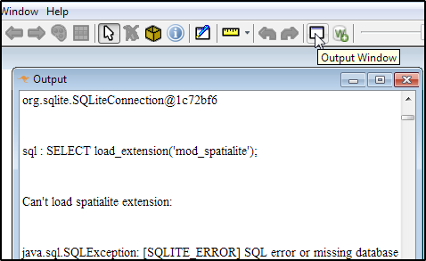

Known issues

The OpenJUMP SpatiaLite Plugin is unfortunately a bit buggy. There is another more robust SpatiaLite enabled plugin, the JUMP DB Query Plugin which is also included by default to the OpenJUMP Plus version https://sourceforge.net/p/jumpdbqplugin/wiki/Documentation/. The SpatiaLite plugin is user friendly because of the file browser, table view, SpatiaLite function catalogue etc. but it has at least these known issues:

- The plugin may jam totally if the resultset of the query contains columns with only NULL values. Drop such columns out from the SELECT statement.
- DATE columns which contain text strings e.g. ISO 8601 dates ”2015-05-03T15:38:45Z” can make the plugin to jam.
- Plugin does not reuse the previous connection if the UI window is closed in between. However, the previously used SQL statement stays in the query area which makes user to believe that reconnecting is not needed.
- Resultset that contains empty geometries cannot be presented on a map.
- The text area for the SQL queries does not support common keyboard shortcuts like Ctrl-c, Ctrl-v, of Ctrl-a for copy, paste, and select all.

Development

The SpatiaLite plugin was initially made by Jorge Alvaraz for SpatiaLite version 1.0. It became unfunctional when new SpatiaLite versions appeared until Michaël Michaud and Jukka Rahkonen managed it to work again with SpatiaLite v. 4.x binaries. The plugin is practically unmaintained at the moment but questions and patches are always welcome. Send them to OpenJUMP users list https://groups.google.com/forum/#!forum/openjump-users, to OpenJUMP-devel list https://lists.sourceforge.net/lists/listinfo/jump-pilot-devel, or to me:
jukka.rahkonen@latuviitta.fi

