Topology extension for OpenJUMP
v 0.1 (2010-05-21) by Michaël Michaud

General concepts
Topology Extension is a set of plugins bundled as a jar file to be placed in OpenJUMP plugin directory (default plugin directory is lib/ext).
All plugins from Topology extension are related to topology error detection and correction.
Important : this extension works on geometries and heavily uses JTS capabilities. On the other hand, graph extension uses JGraphT capabilities and works on graphs built from feature relations.
This extension has no external dependency, but JTS and OpenJUMP.
TODO : create a plugin to expose different implementations of JTS Noder.

Topology extension plugins and common options
Every plugin from topology extension is installed in the Plugins menu of OpenJUMP, in a submenu called... Topology.
Most options have a tooltip giving more details about option signification.

Remove micro-segments PlugIn

This plugin removes micro-segments from LineStrings or Polygons.
This process is often needed before a cleaning process involving topology.
Indeed, most cleaning process use a distance threshold to decide if two features (resp. nodes, segments) should be snapped together, and presence of micro-segments less than this threshold inside single geometries often disrupt the process.
What the plugin do and what it doesn't do :
- "Remove micro-segment" carefully chooses the point to remove from the geometry so that the deformation is minimal : micro-segments have two vertices. Vertices located on the geometry boundary are never removed, and if both vertices are strictly inside the linestring, the plugin removes the vertex where interior angle is the closest to flat angle (180°);

- "Remove micro-segment" processes only LineStrings and Polygons yet. GeometryCollections are just ignored.
- "Remove micro-segment" does not check if the vertex it will remove is used by another geometry. The process, which is purely geometric, may break topology consistency. Hopefully, other topologic correction tools should be able to repare what has been broken.

Special use-cases :
"Remove micro-segments" is able to fix invalid polygons with a very small self-intersection :
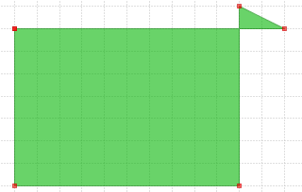
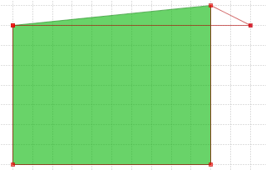
Note that the problem is fixed by the removal of a point, which only works if self-intersection is made of a single micro-segment.
Currently, OpenJUMP lacks a user-friendly-tool to fix larger self-intersection problems. A quite complex process could be to create linestrings from polygon boundaries, node those linestrings, polygonize the result, remove polygons representing holes, get attributes back using matching tools...

Network topology cleaning PlugIn

This plugin can process a dataset representing a network, and detect and/or fix some common topologic errors like
- node mismatches : nodes closed to each other but not exactly the same
- undershoot : a linestring end is close to another linestring but is not snapped on it
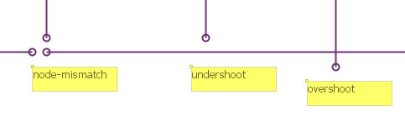
- overshoot : a linestring crosses another one and end just after the intersection
Formal definition : network topology cleaning plugin finds every node of a network (end-points of the network linestrings) which are closed enough to another LineString (closed-enough being user-defined), but not snapped on this LineString (no common vertex).
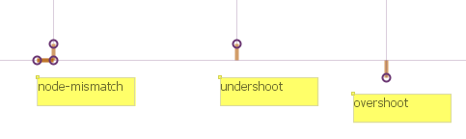
Anomalies can be either detected or corrected.

The network topology cleaning plugin main parameters
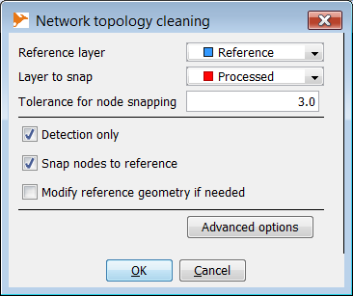
The main parameter is the distance threshold between a node of the layer to process and a feature of the reference layer :

 | 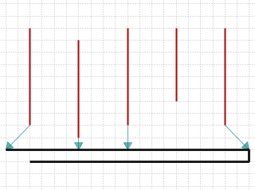
Tolerance is 3 meters. The 1st, 2nd, 3rd and 5th feature are under the tolerancere. | Detection :  1st feature is at less than 3 m from a reference node  2nd and 3rd features are at 1m from a reference segment, at 2 meters from another one and at more than 3m from any vertex  4th feature is at more than 3 meter from the reference feature  5th feature is at less than 3 m from a reference vertex | Correction :  1st and last features are properly snapped to reference  2nd and 3rd features are snapped, but a vertex needed to be inserted into the reference layer.

Advanced options : degree 3 nodes

An option is available to deal with degree 3+ nodes of the processed layer. It maybe useful to decrease the tolerance parameter for these nodes, because if they are not snapped on the reference layer, there is a higher probability that it should not be snapped.
Default value of degree 3 nodes snap tolerance is 1/5 base tolerance.
Changing the tolerance for degree 3+ nodes or setting it back to default is quite easy :
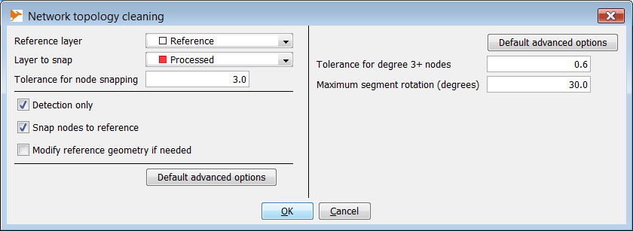

Degree of the lower node of vertical features 2, 3 and 4 = 3 (this means that feature extremities not only snap another feature, they share their node with another feature node) | Mismatch indicators are created for every node at less than 3 m from the reference feature but... | only the degree 1 nodes are snapped.  Degree 3 nodes would have been snapped if they were under the default tolerance (here, 3/5 = 0,6 m)

Advanced options : rotation parameter
There is a second editable parameter which is a rotation tolerance.
Rotation tolerance is available for pendant nodes only (degree 1). Indeed, using a rotation tolerance on degree 2+ nodes would have bad side effects as it could break many connected features just because of their segment orientation.
Here, we have two candidate features at the same distance from the reference layer : 2 m | Both could be snapped to the reference, but for the first one, the snap will rotate the segment much more than for the second one | Finally, with the rotation tolerance set to 15°, the first feature is not snapped while the second one is.

When several vertices are found within the distance tolerance rotation criteria is used to determine which vertex to snap to
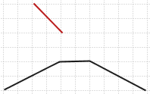 | 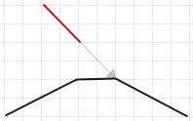 | 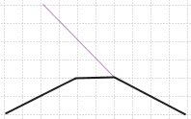
The red LineString is within the 3 m tolerance and both vertices of the nearest reference segment are in the 3 m tolerance. | The choosen snap vertex is not the nearest one... | but the one introducing the smallest segment rotation.

Corner cases
Corner cases and situations where the plugin may give weird results
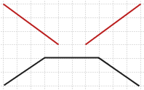 | 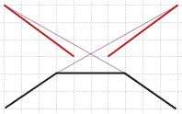 | 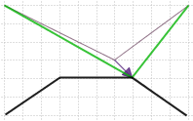
Because of the angle criteria preference, in this case where both vertices are within the distance tolerance (4 m) and where segment rotations are minimized... | the process resuls in two crossing lines. | A work-around is to pre-process the input layer to eliminate the node-mismatch, then to process the result.

Output options
Detection : a layer will be created with translation vectors needed to snap nodes to reference features. See below this layer attributes | Correction : a copy of the processed layer is done and nodes of this copy located near but not snapped to the reference layer will be snapped. | Reference correction : this option is only available if the reference layer is editable.  If checked, missing vertices will be inserted in the reference layer just where the processed feature has been snapped to.

Mismatch vector layer

SNAP attribute shows if the node has finally is been snapped on a reference node, on a reference vertex, on a reference segment, or not snapped at all :
Snap to node : the node has been snapped on a reference node
Snap to vertex : the node has been snapped to a reference vertex
Snap to segment : node has been snapped in the middle of a reference segment
Not snapped : the node has not been snapped
Not snapped (D > xx) : the node has not been snapped because it is over the distance tolerance (the degree 3+ one, otherwise, there is no reason to have a mismatch vector)
Not snapped (A > xx) : the node has not been snapped because the result would have been over the rotation angle tolerance

For snapped nodes, attribute "Rotation" gives the angle the node segment has been rotated to snap the reference feature (in degrees).

Coverage cleaning PlugIn (to be done)

This plugin cleans a coverage layer with small defects like overlaps and/or gaps.
It is based on Java Conflation Suite (mainly coded by Martin Davis, JTS architect), released by Vividsolutions. The only improvements added from the original plugin are
small performance improvements
full support of polygons with holes
Attention : ça ne semble pas marcher dans le cas où les contours limitrophes ne sont pas dans le même sens (ex. un contour extérieur dans le sens cw et l'autre dans le sens ccw).
How the plugin works ? The plugin tries to match each segment of each polygon with segments of neighbour polygons. Segments match when :
- they are not topologically equals (not equals and not equals with opposite segment)
- the minimum distance between segments is less than the user-defined tolerance,
- the angle between both segment is less than the user-defined tolerance
- the orthogonal projection of each segment on the matched one is non null
If matched segments are found on a contour, matching contours are merged by :
- snapping vertices of matched segments when they are close enough
- inserting missing vertices in each ring (a vertex is missing when a point of a matched segment has no matched vertex)
