Homework #5, Choice #1

Rachel Kanaziz

11/11/2019

# Homicide Data

homicide_raw <- read_csv("../data/homicide-data.csv")

## Parsed with column specification:  
## cols(  
## uid = col_character(),  
## reported_date = col_double(),  
## victim_last = col_character(),  
## victim_first = col_character(),  
## victim_race = col_character(),  
## victim_age = col_character(),  
## victim_sex = col_character(),  
## city = col_character(),  
## state = col_character(),  
## lat = col_double(),  
## lon = col_double(),  
## disposition = col_character()  
## )

## Clean Data

Filter the data for the city of Denver

denver <- homicide_raw %>%   
 filter(city == "Denver") %>%   
 unite(cord, lat, lon, sep = ",") %>%   
 select(cord, disposition, victim_race)

## Map Boundaries

In this section, I used the zip codes for the Denver area to create boundaries for my base map.

denver_zips <- zctas(cb = TRUE, starts_with = c("800", "801", "802", "803", "806"))  
plot(denver_zips)

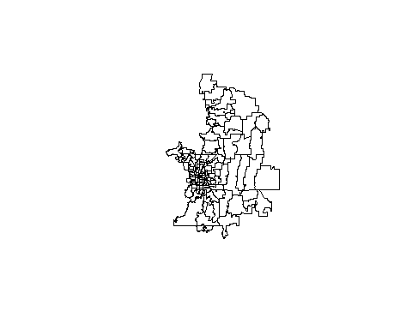

## Number of Homicides by Victim Race

Here, I determined the three race groups (balck, white, hispanic) with the highest number of victim homicides.

race <- denver %>%   
 group_by(victim_race) %>%   
 mutate(count=n()) %>%   
 arrange(desc(count)) %>%   
 ungroup()  
  
denver2 <- denver %>%  
 filter(victim_race == c("Black", "White", "Hispanic"))