**PROCESS DOCUMENTATION FOR PB&J SANDWICH**

Latest edited date: 10/26/2015

**Requirements**

1. Sliced Bread (of your choice)
2. Peanut Butter Jar (of your choice)
3. Jelly or Jam Jar (of your choice)
4. Box of Ritz Crackers
5. 1 Butter Knife
6. 1 Cutting Knife
7. 1 Plate (for serving)
8. Counter top for making the sandwich

**Procedure to make a sandwich**

1. Take out two slices of bread from the packet and place it on the counter.
2. Open the peanut butter jar and stir the peanut butter lightly with the help of a clean butter knife. Take out some peanut butter from the jar with the help of the butter knife.
3. Spread the peanut butter evenly on one slice of bread and place it on the counter, peanut butter side facing upwards.

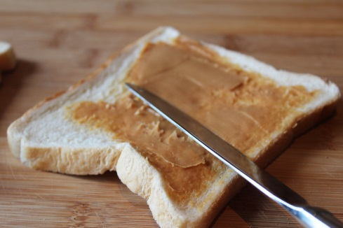

**Figure 1 - Spread Peanut Butter on Bread Slice (Stewart, n.d.)**

1. Take two Ritz crackers and crush them with your hands into medium sized granules and not too finely.

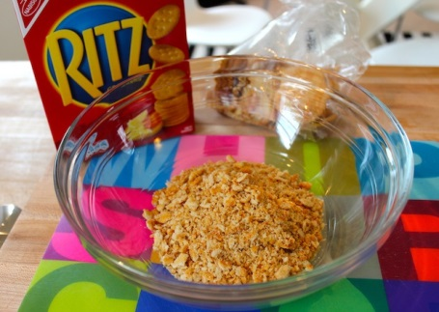

**Figure 2 - Crushed Ritz Crackers Granules (Janelle, n.d.)**

1. Sprinkle these granules evenly on the bread slice which has the peanut butter on it. These granules add a crunchy twist to the traditional PB&J Sandwich. It is not mandatory to put these in your sandwich.

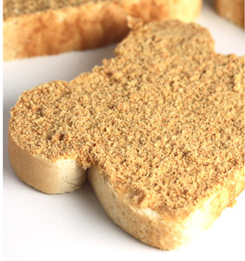

**Figure 3 - Bread with peanut butter and crushed Ritz crackers granules (Cleobuttera et al., 2014)**

1. Wash and wipe the butter knife clean so that there is no peanut butter residue on it.
2. Repeat steps 2 and 3 for Jelly/Jam.

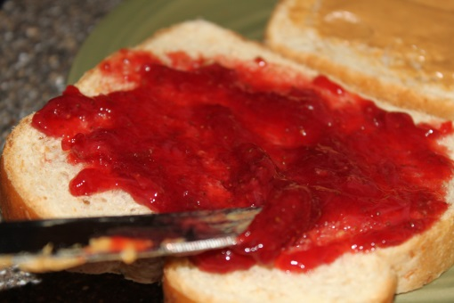

**Figure 4 - Spread Jelly/Jam on Bread Slice (Br, 2016)**

1. Place the bread slice with Jelly/Jam on it on the palm of one hand and the other slice containing the peanut butter and Ritz crackers granules on the other. Place the bread slice with the Jam/Jelly on the other one together quickly so that the liquids don’t make a mess.
2. Once you have put the two slices together, place it on the counter.
3. Cut the sandwich with the help of a clean cutting knife and serve it on a plate.

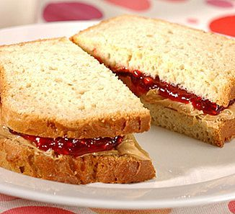

**Figure 5 - PB&J Sandwich (Hamster, 2008)**

**Note:**

1. Be careful while using sharp objects such as a knife.
2. Please read ingredients on the jars to ensure there are no allergies to any of them.
3. To contact the author of the document you can send an email to the ID mentioned in the header of the document.

**Word Count -** 374 words

**References**

1. Stewart, N. The elvis sandwich, toasted elvis, banana peanut butter and nutella, sweet toasties, chocolate toasties, food for kids - the chocolate Elvis Toastie - image 3. Retrieved October 26, 2016, from http://kidrecipes.com.au/the-chocolate-elvis-toastie/the-elvis-sandwich-toasted-elvis-banana-peanut-butter-and-nutella-sweet-toasties-chocolate-toasties-food-for-kids-im16845/
2. Janelle. New England baked cod with Ritz cracker Crumbs. Retrieved October 26, 2016, from http://thechicbrulee.com/2013/07/25/new-england-baked-cod-with-ritz-cracker-crumbs/
3. Cleobuttera, sallam, R., Bakir, I., M, N., App, C., & @twopickypigs, C. (2014, November 24). Home. Retrieved October 26, 2016, from Breakfast, Muffins and Donuts, http://cleobuttera.com/breakfast-muffins-and-donuts/grilled-smores-sandwich/
4. Br, A. (2016). Anne Br. Retrieved October 26, 2016, from https://plus.google.com/105067701593918431549
5. Hamster, I. (2008). How to make the best PB+J ever with a CRUNCH! Retrieved October 26, 2016, from http://www.instructables.com/id/How-To-make-the-best-PBJ-ever-with-a-CRUNCH/