Project Report

Course Name (NICF) | NICF Diploma in Infocomm Technology (Data)
Product Name (Marketing & Sales) | Professional Diploma in Data Science
Module Name (NICF) | NICF Basic R Programming (SF)
Product Name (Marketing & Sales) | Basic R Programming

Student name |  | Assessor name
Goh Rui Kun |  | Kishan
Date issued | Completion date |  | Submitted on
15th Sept 2020 | 28th Sept 2020 |  | 28th Sept 2020
Project title | Design and deploy Forecasting Model

Learner declaration
I certify that the work submitted for this assignment is my own and research sources are fully acknowledged.

Student signature: RK Date: 28th Sept 2020

Content
- Project Overview 1
- Project Technical Environment 2
- Forecasting Model 3
- Setting up the Forecasting Model 4
- R Code for Data Filtering and Transformation
- Transformed Data 6
- Correlation Analysis Process and Output 7
- Implementing Seasonal Forecasting Model 8
- Refine Model 9
- Forecast Output after Model Adjustment: 10

Project Overview: Describe the Project along with Project Outcomes (Explain the Project in your own words in 15 – 20 lines)

In this project, I am using Azure Machine learning along with R & Python programming script to build, evaluating and forecast using linear regression model.
The dataset we are using contains a time series of dairy production observation which focus on 3 products (cheese, Ice cream, Milk) in quantity for each month. The goal is to forecast the monthly milk production for the state of California.
As the trend line is non-linear, rather it is polynomial, I have included square and cube of the month count in the first R script. We will then use polynomial regression of the time series trend.
On the second R script, I am using it to create data visualisation with the help of ggplot and dplyr library. I have plotted using line and boxplot visualization.
After that I use metadata editor to converts the Month column into categorical.
I then filter the column that I want using select column module, which select the column I need in the model.
One the third R script I divided and split the data into train and test set. For the test set I extract the last 12 months data to test with the trained data. The purpose is to test the trained data on how well the model perform and achieve the acceptable score.
For the model, I used linear regression model without the intercept terms just to eliminate the bias and to compute our prediction in Microsoft Excel using polynomial formula.
For the fourth R script, it is used for the model performance, it outputs RMS error for the times series and using the test data to test the forecast accuracy.
I have compute several charts for evaluating the model, overall it is normally distributed and only a few outliners.

Project Technical Environment: (Describe the MS AML Architecture with Tools used)
Microsoft Azure Machine learning(AML) is a collaborative, easy to use, drag and drop tools to build, test, and deploy predictive analytics solution on data in the cloud and web based environment.
AML uses interactive and visual workspace to build, test and deploy on a predictive analysis model. Users can drag and drop imported dataset like csv files as well as analysis modules and connect them to join as an experiment. AML have modules like data transformation, machine learning model like linear regression even advanced topics like OpenCV and text Analytics. Users can even convert their trained experiment into a predictive experiment which can then publish it as a web service and can be accessed by other users.
User can even load their working python script as zip file and connect it with execute R script modules to run it. The R script can clean and compute data. The edit metadata module can allow user to change metadata in the dataset. The select column module can allow the user to filter out the data from the dataset.
The linear regression module is a machine learning algorithm for forecasting using supervised learning. It is to predict dependent or label variable based on 1 or more independent variable. Example y is dependent variable and x is independent variable.
The train model module allows user to choose which are the variables that they want to predict which is the dependent variable.
The score model module will compute the predicted value using the trained machine learning model or algorithm. The result must be close to the dependent variable for proof of worked model.
The evaluate model module will compute the result how efficient the model is, closest to 1 is the best model.
For the convert to CSV module which will create the dataset in CSV format for downloading and further analysis using other tools like Microsoft Excel or PowerBI.
- Forecasting Model: (Explain the Forecasting model which you are designing and deploying on Azure AML) (steps of forecasting model)
First upload the dataset into AML environment as well as the R zip file.
Second create the first execute R script module that code to trim the month column into 3 character to ensure consistent, add a POSIXct column using R, add a month count, month squared and month cubed to compute polynomial values into the dataset. Third create edit metadata module and convert the column into categorical feature. Fourth create select column module to filter out the required column for forecasting. Fifth create the execute R script 2 to create initial visualization using polynomial plot function like ggplot and dplyr libraries. Sixth create execute R script 3 to split the data into training and test data. Training data have 216 rows and test data have 12 rows. Seventh create a linear regression module and train model to connect them together. The train model will load the training data for the algorithm and create the forecast model. Eighth create score model to compute the predicted values by apply it with the trained model. Ninth create evaluate model to measure hoe good the model is, closest to 1 is the best model. Tenth create R script 4 to create visualization to plot the predicted milk production and actual milk production over the entire time period, box plot of the month to month variation, quantile to quantile normal plot od residuals, the histogram of the residuals and compute RMSE values of the residuals.

- Setting up the Forecasting Model: (Explain the Process for setting up Forecasting Model using AML Studio) (screenshot of AML) screenshot of all the above steps
First upload the dataset and R script zip file to the AML by clicking “+NEW”
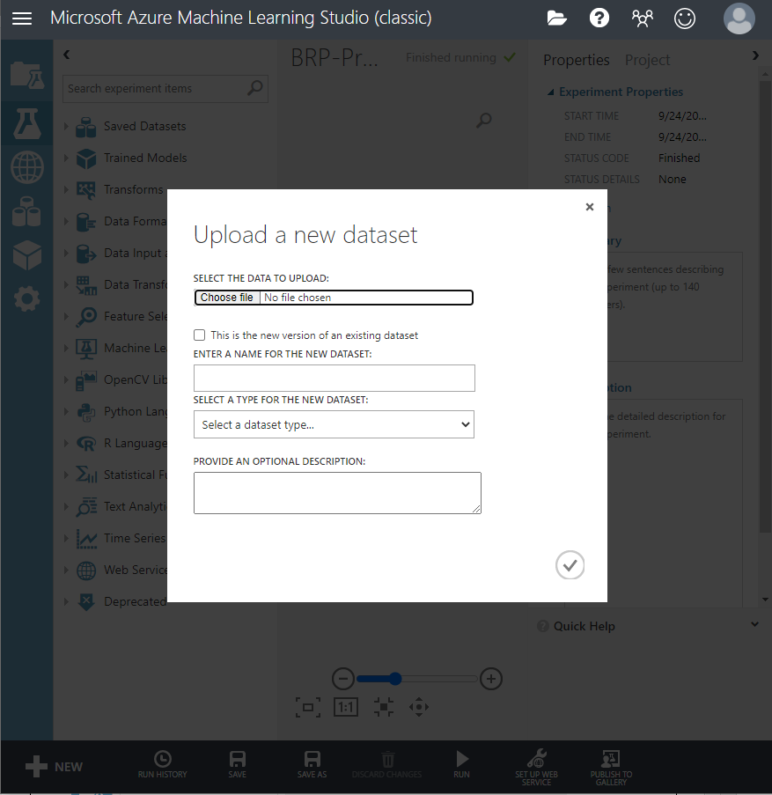

Next load the dataset and R script Zip file to the AML experiment
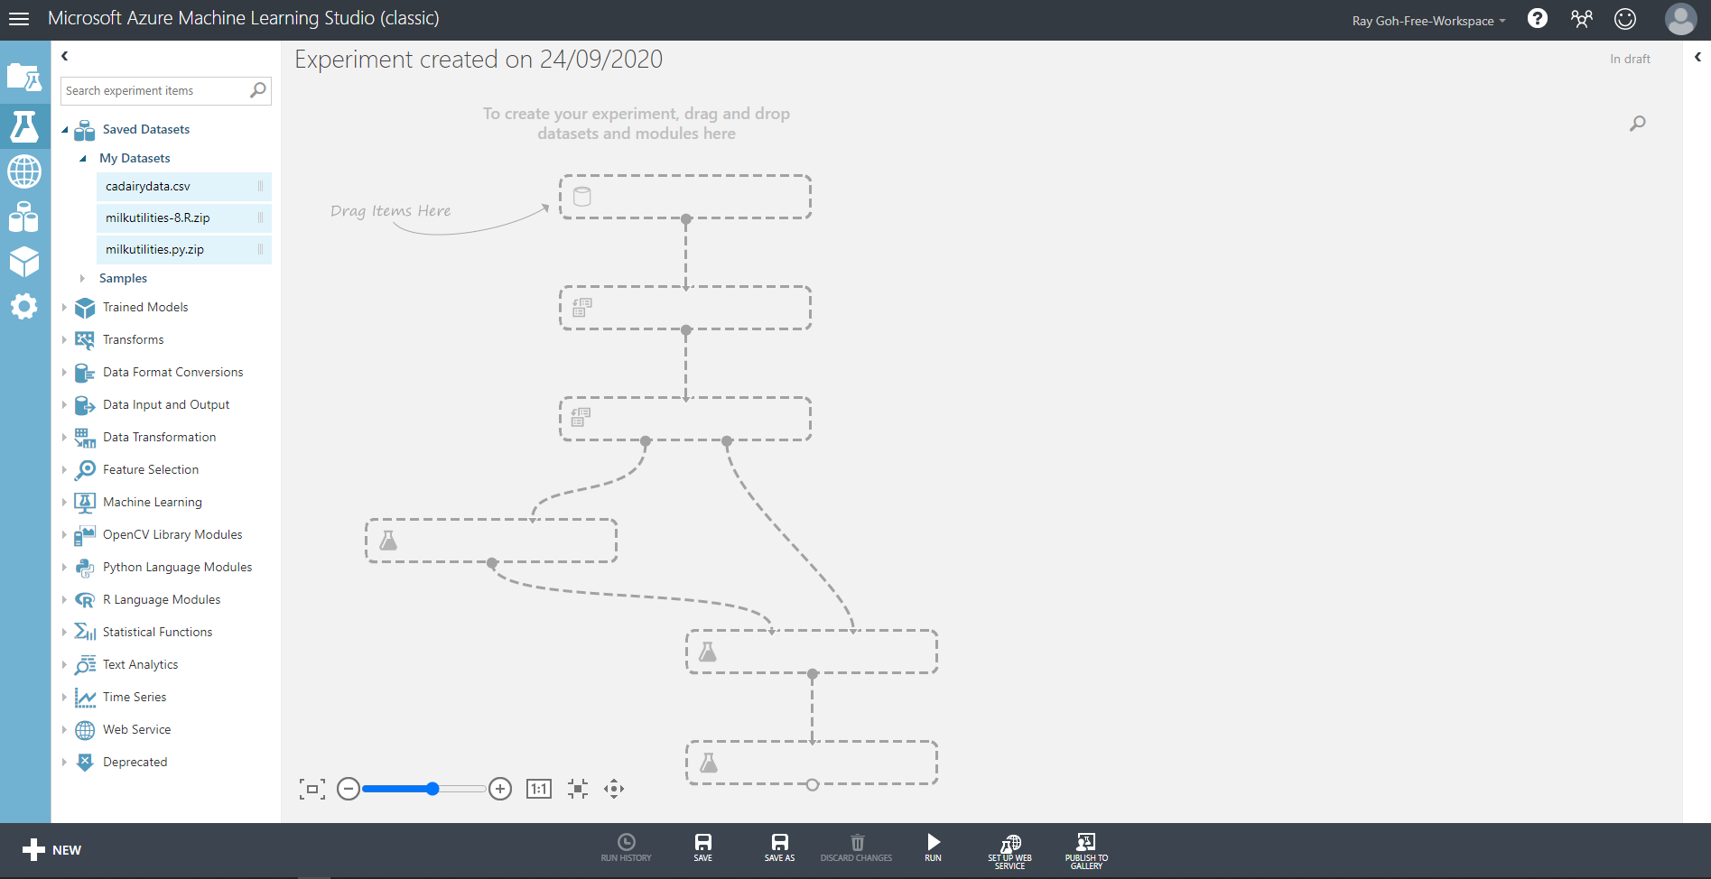
Next drag and drop the dataset and R script Zip to AML
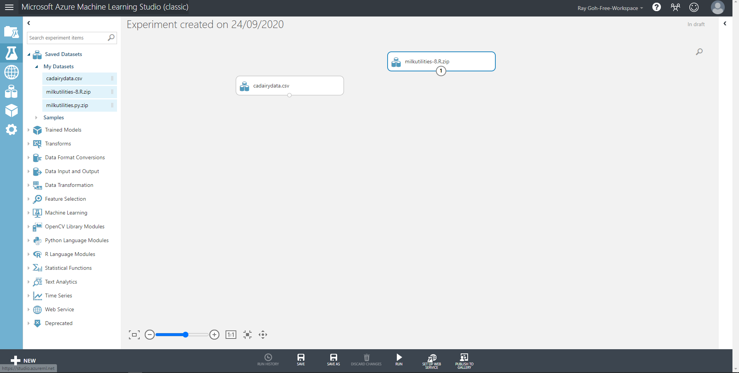
Next drag and drop Execute R Script 1 to the experiment and connect them together. Input the code and run the module.
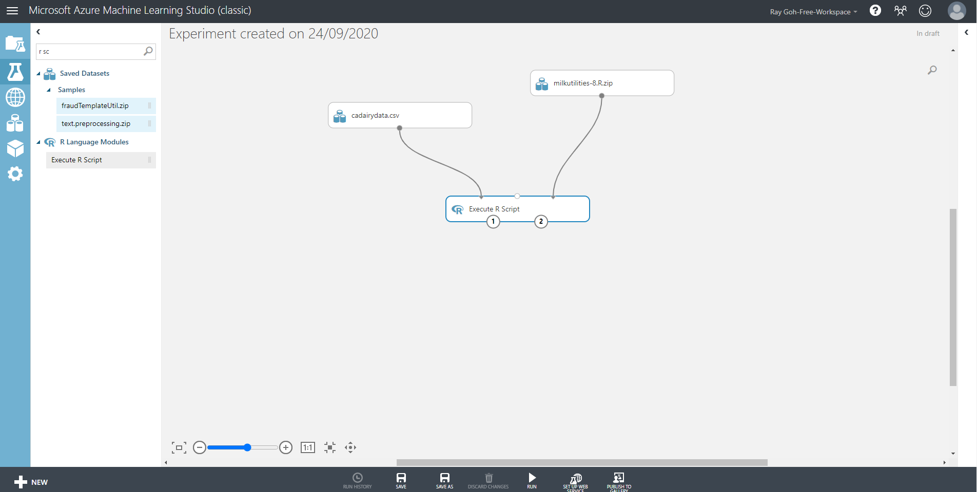

Drag and drop Edit Metadata module to AML and make the month column categorical, run the module.
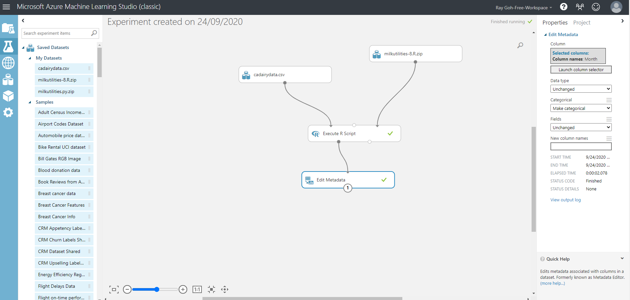

Drag and drop Select Columns in Dataset module in AML, launch column selector and choose Month.Count, Month, Month.Number.Squared, Month.Number.Cubed and Milk.prod. Run the module.
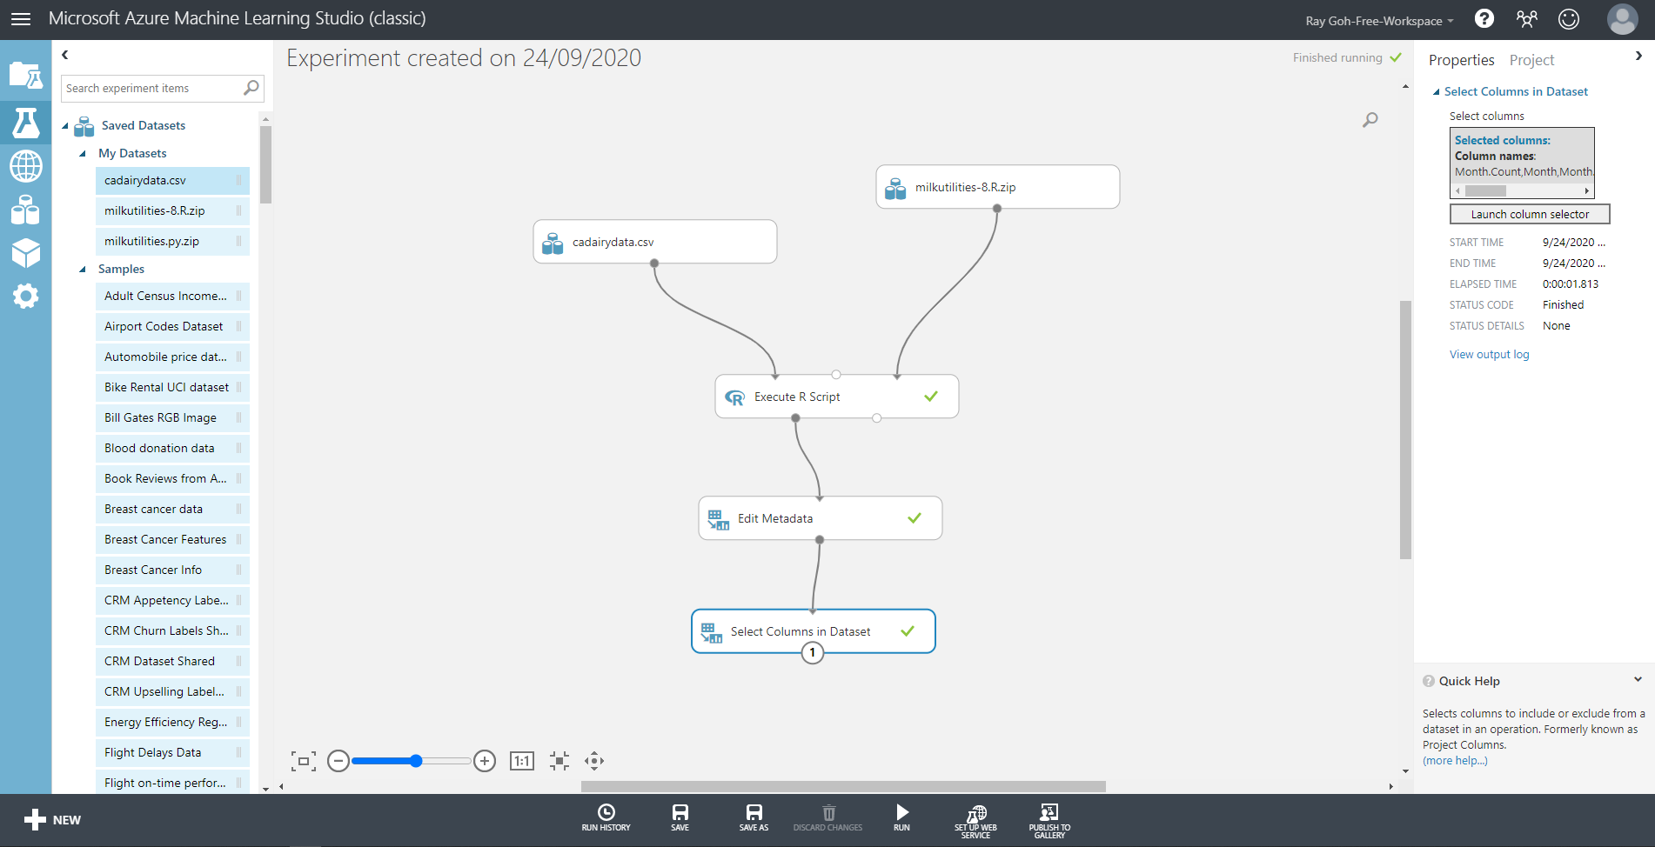

Drag and drop Execute R Script 2 to AML to perform initial visualization using polynomial regression functions. Run the module
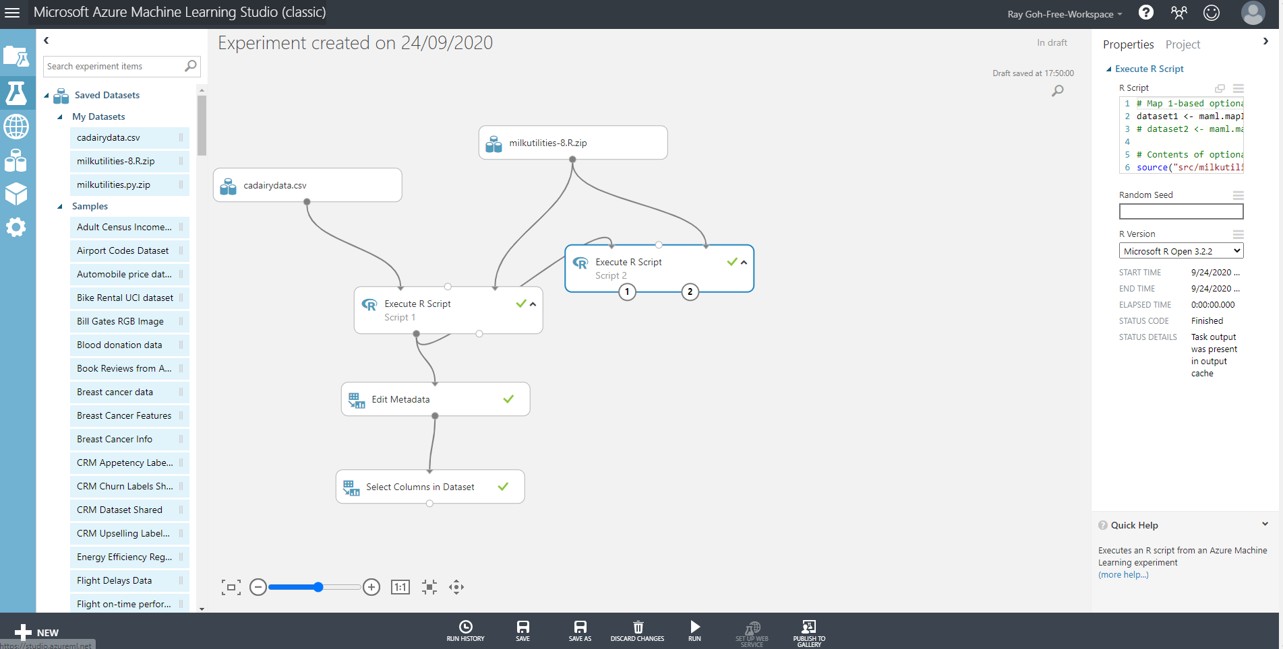

Drag and drop Execute R Script 3 to AML to split the dataset into training (216 rows) and test (12 rows). Run the module.
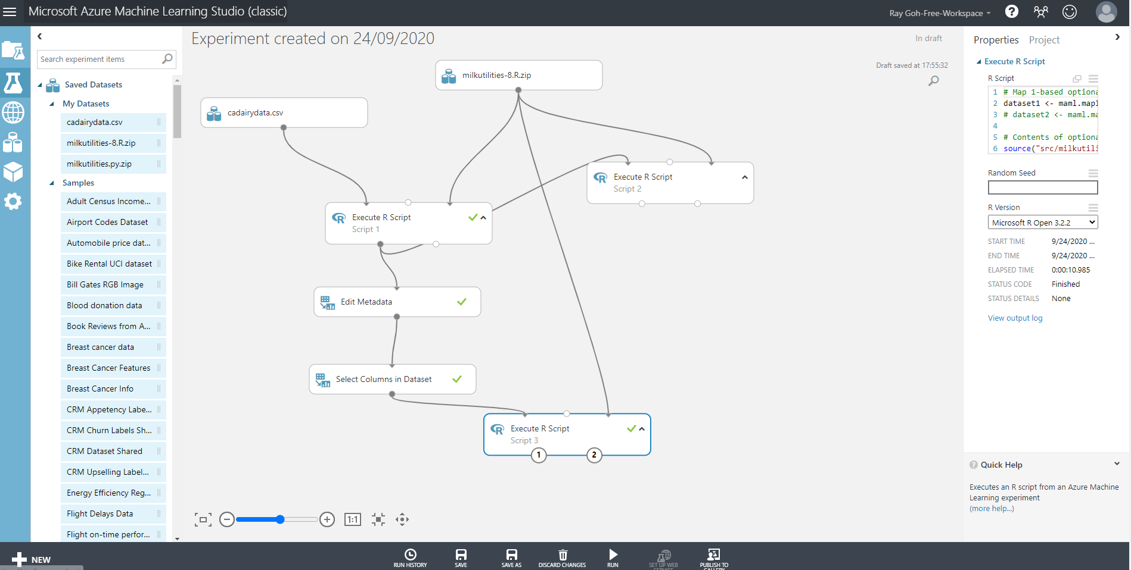

Drag and drop Linear Regression and Train Model. Connect them with R script 3 together. Uncheck Include intercept term for linear regression.
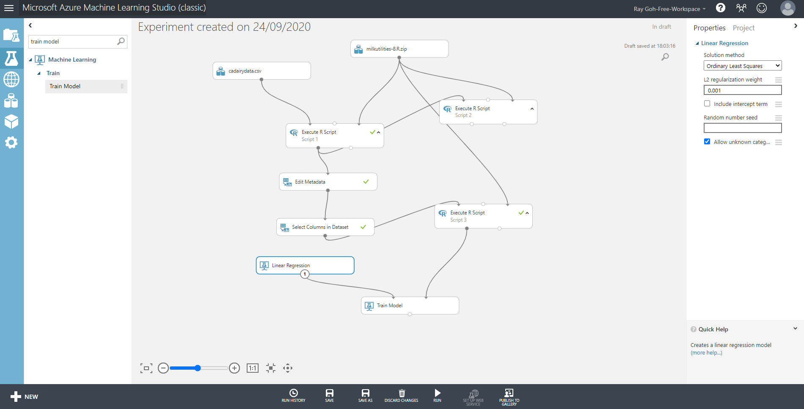

On the Train Model select Milk.Prod which you want to predict. Run all the modules.
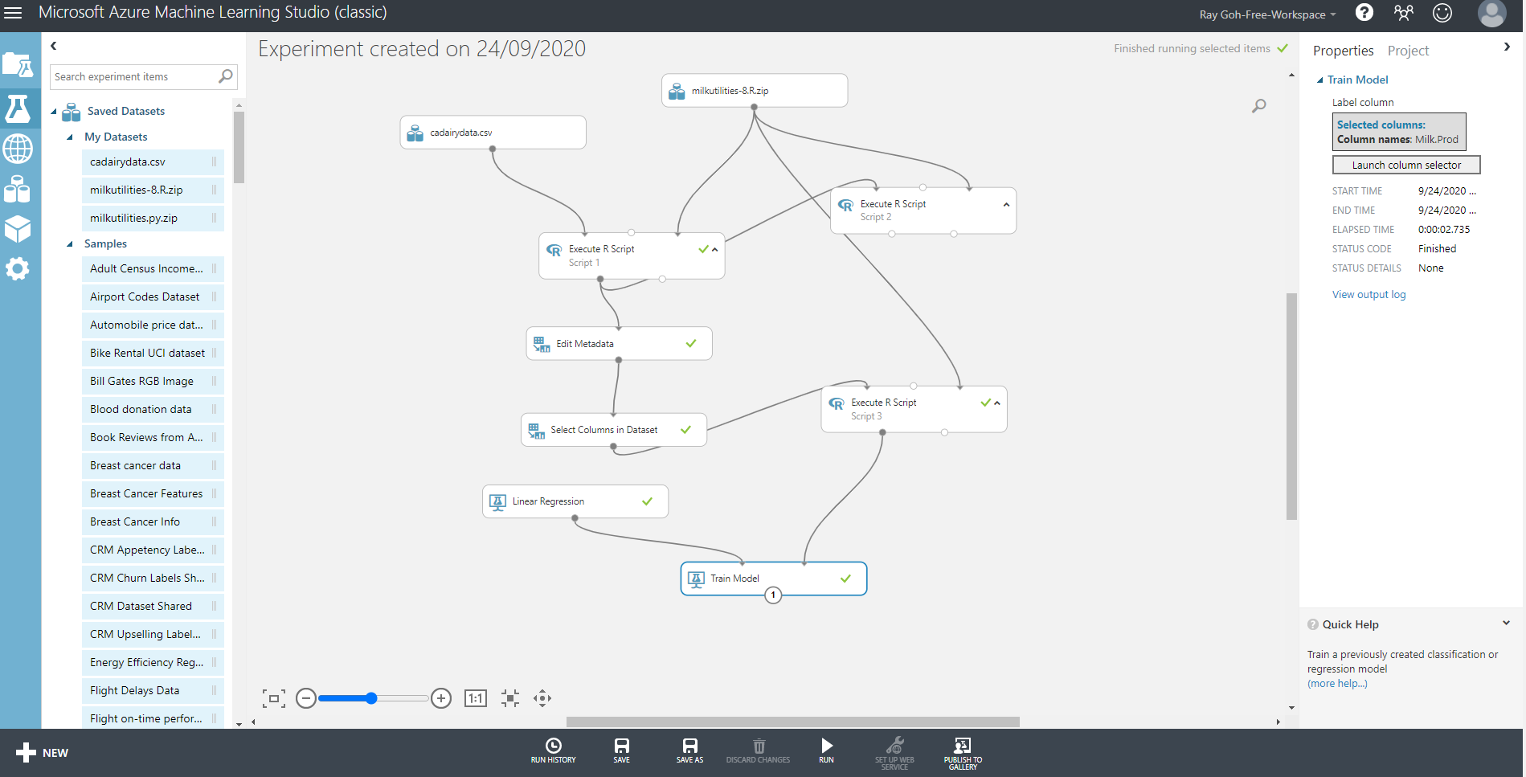

Drag and drop Score Model module to connect it with Edit Metadata and score model to compute the predicted values (Scored Labels).
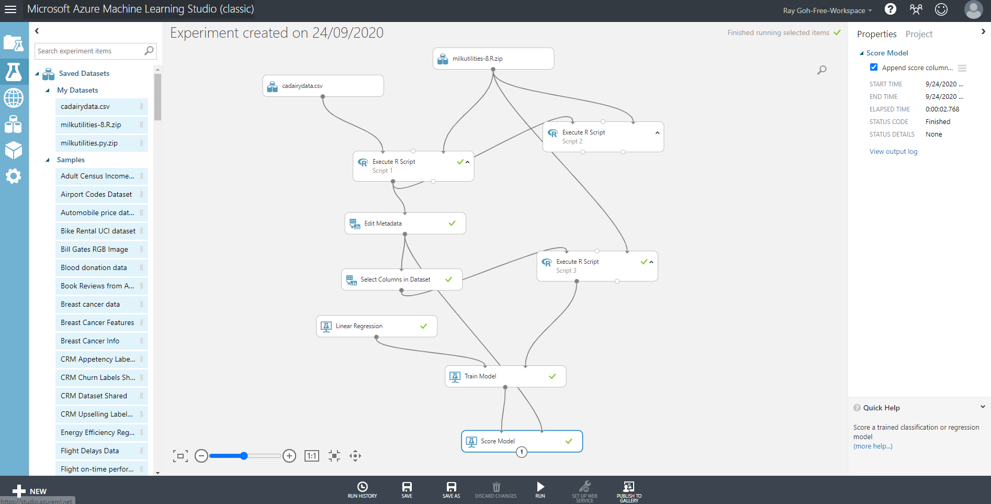

Drag and drop Evaluate Model to AML and connect it to the score model to compute how well the model fit to the test data with accuracy.
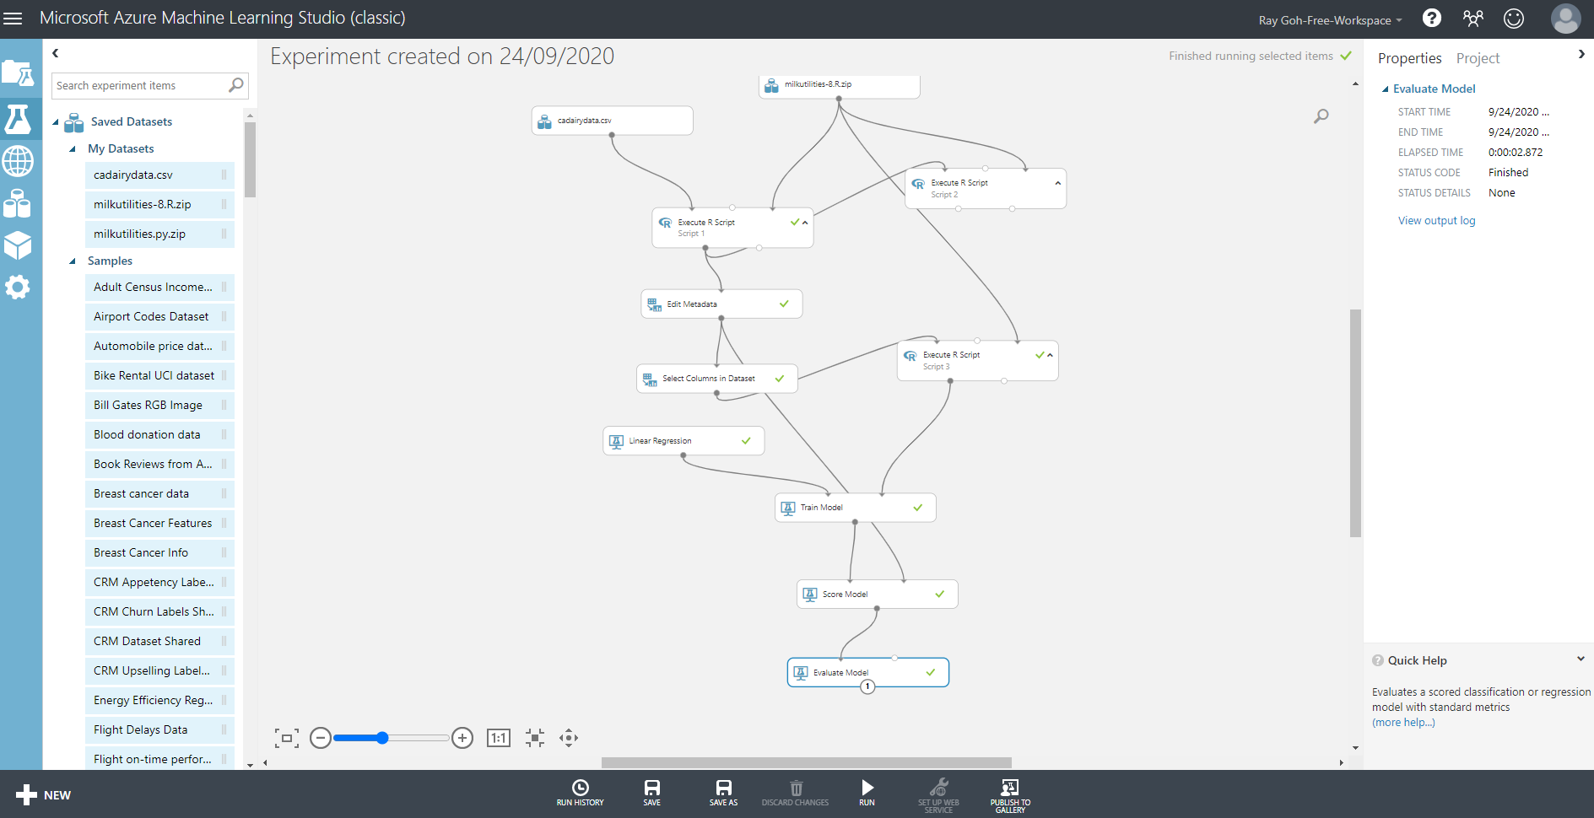

Drag and drop Execute R script 4 to AML and plot the predicted milk production and actual milk production for the entire 228 months, boxplot of month to month variation in the residuals which is the difference between actual and predicted milk production values, the quantile to quantile normal plot of the residuals and compute the RMSE values of the residuals.
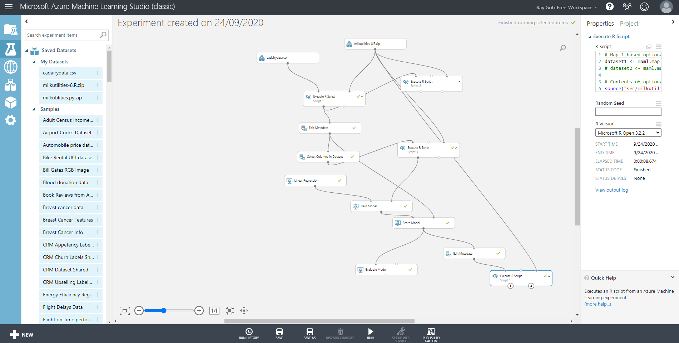

Drag and drop Select Columns in Dataset module in AML and connect it to Edit Metadata module. On the Select Columns in Dataset, launch column selector and select Year, Month, Milk.Prod, Month.Count, Month.Number.Squared, Month.Number.Cubed and ScoredLabels columns.
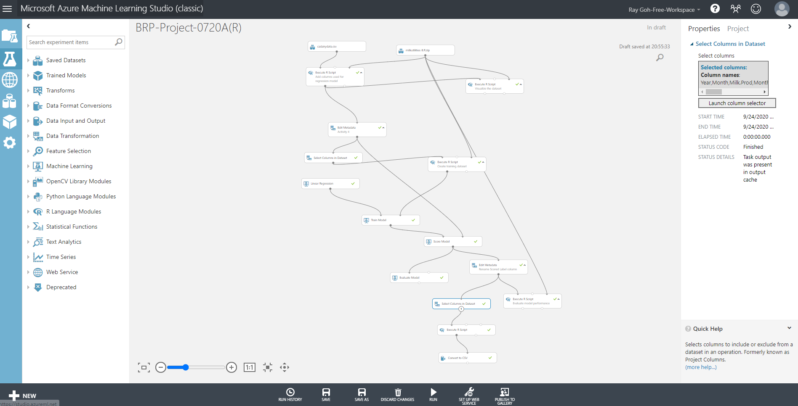
Next drag and drop Execute R script 5 to manipulate the data to fill up the Year, Month, Month.Count, Month.Number.Squared and Month.Number.Cubed.
Finally, drag and drop Convert to CSV and run all the modules and save the CSV file on your local drive.

Python Script
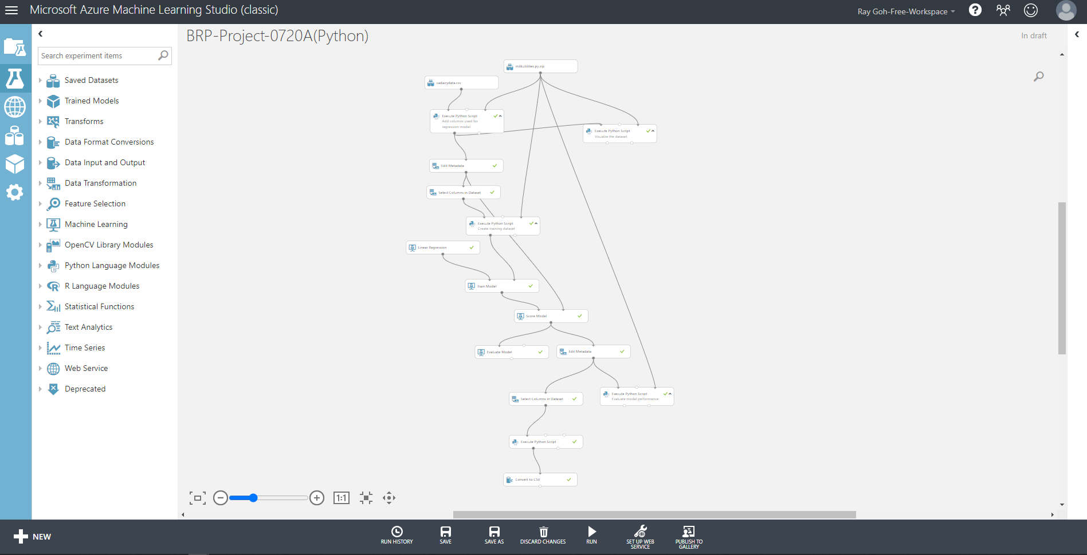

- R Code / Python code for Data Filtering and Transformation: (Attach the R Code used in the Project for Data Transformation)
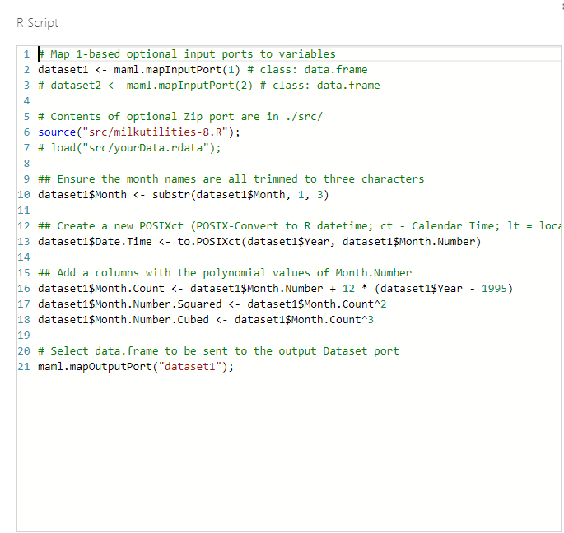
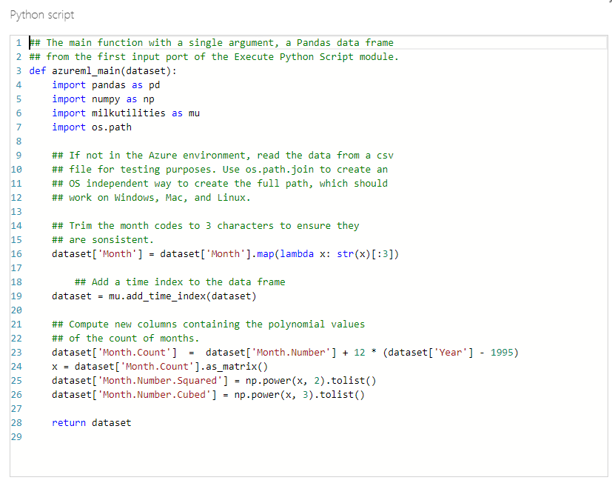

- Visualized Data: (Attach the transformed data as Annexure)
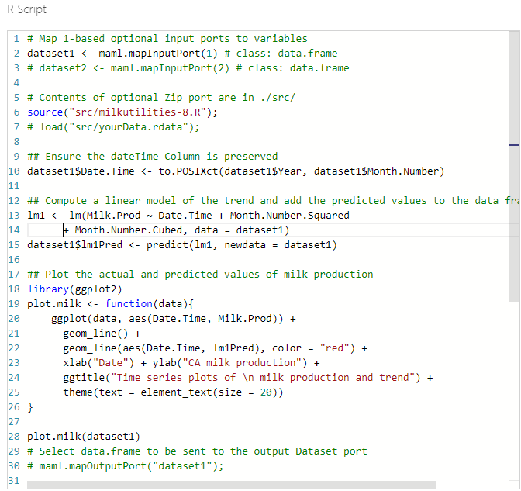
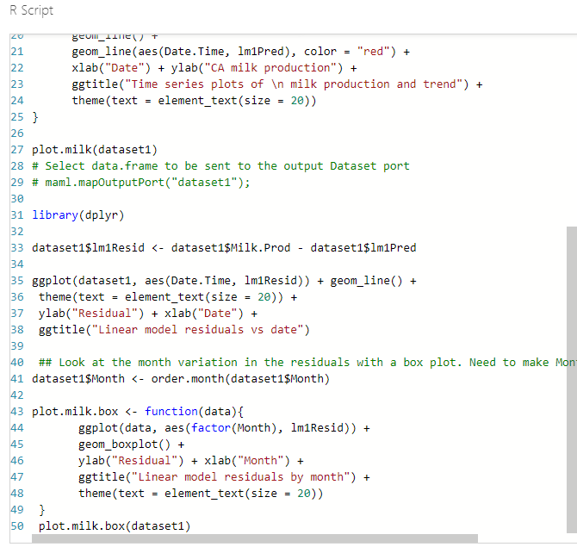

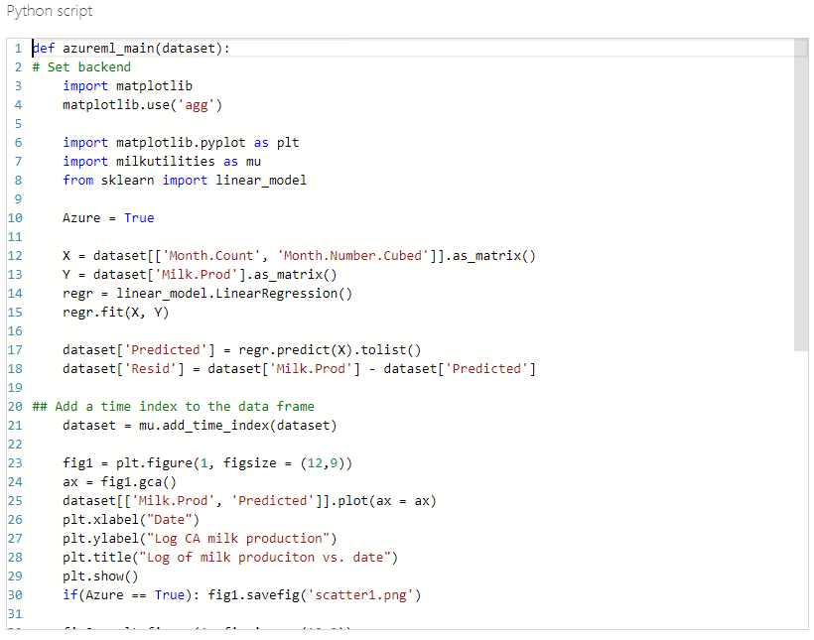

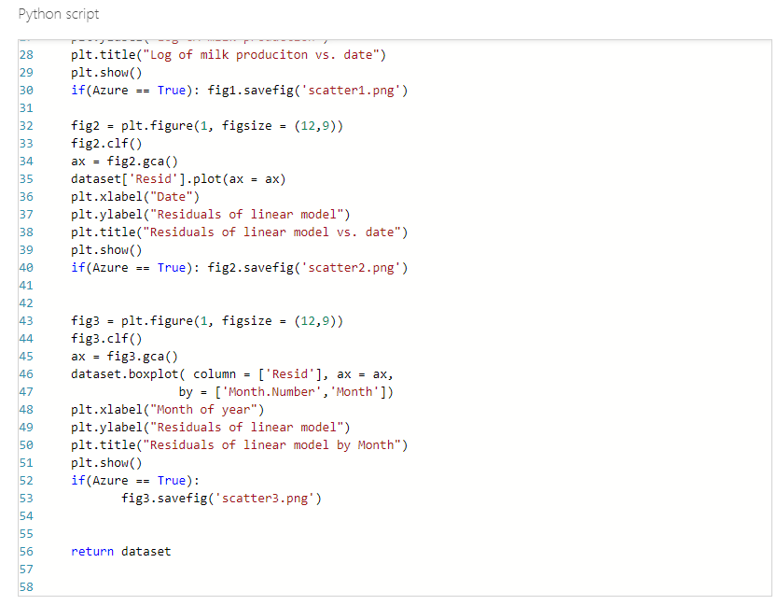
- Training dataset: (Explain how you performed the script3 along with the output as Annexure) (script 3 output)
R script 3 is used to split the dataset into training and test set. The training set consist of 216 rows and test set consist of 12 rows.
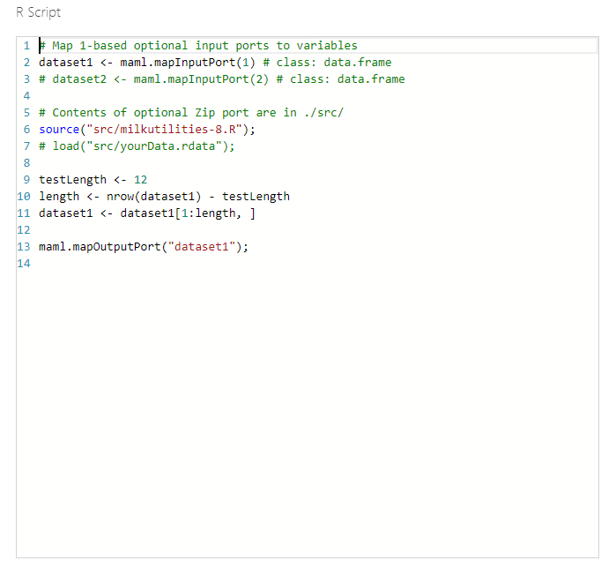
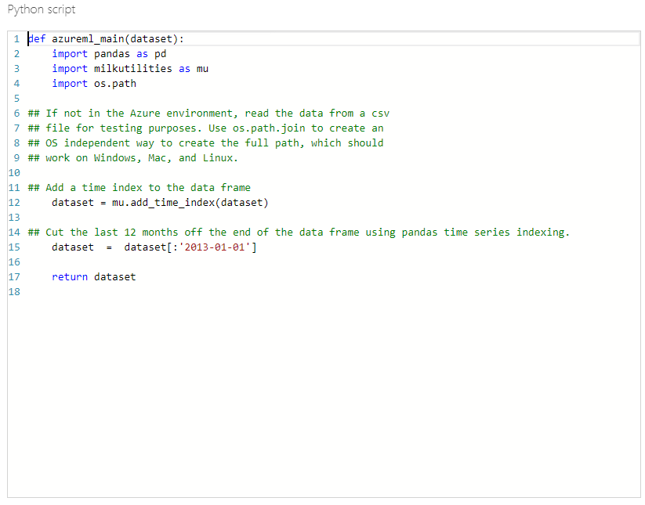

- Implementing script 4: (Explain how you have evaluated the Seasonal Forecasting Model)
Script 4 is used to evaluate how well the model fit the test data using 5 graphic plots and compute of root mean square error(RMSE) for the training set (216 rows) and test set(12 rows).
The 5 plots are actual milk production and predicted milk production against date plot which provide visualization between the actual and predicted milk production. The residuals against date plot which provide visualization of the residuals indicator between actual and predicted milk production. The boxplot of the month to month variation in the residuals which visualize the residuals within the month categories. The quantile to quantile normal plot of the residuals plot provides if the training and test set have common distribution. The histogram of the residuals plot which provides the type of distribution that the residuals have.
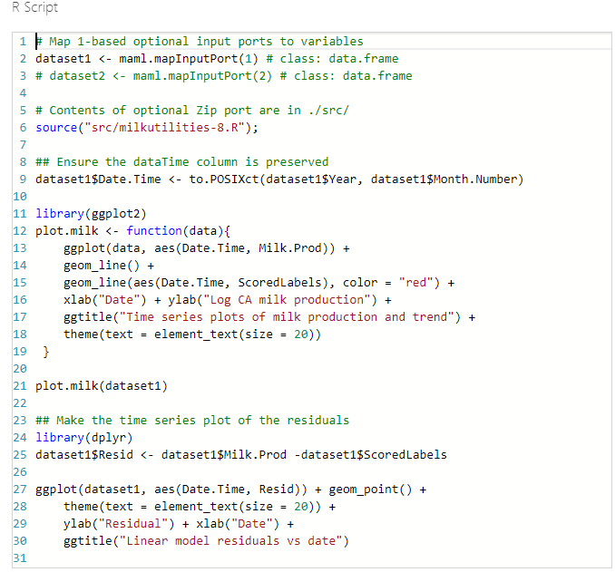
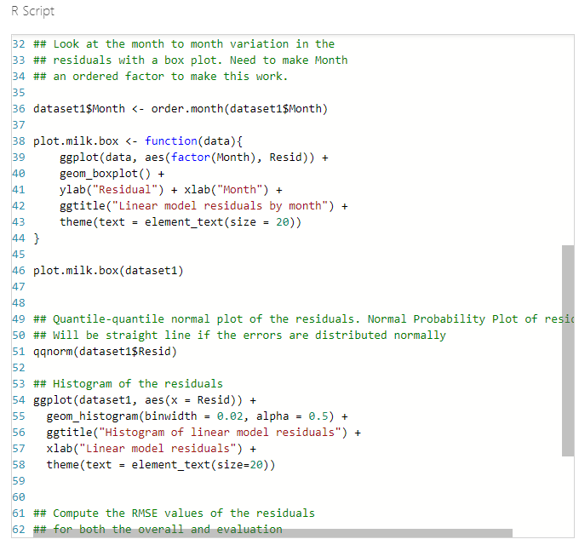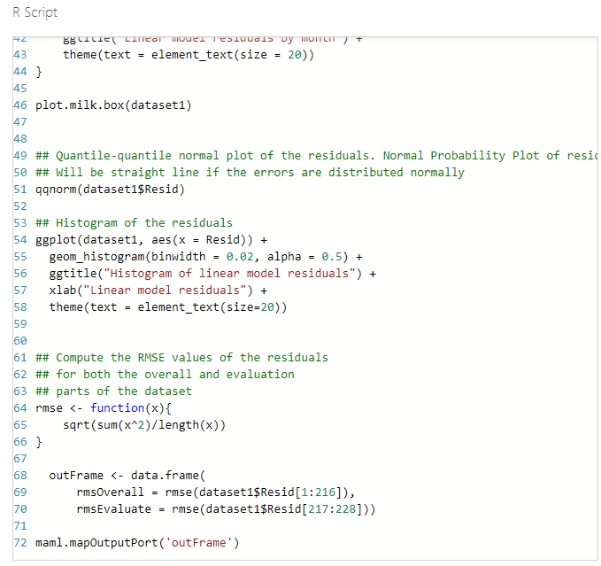
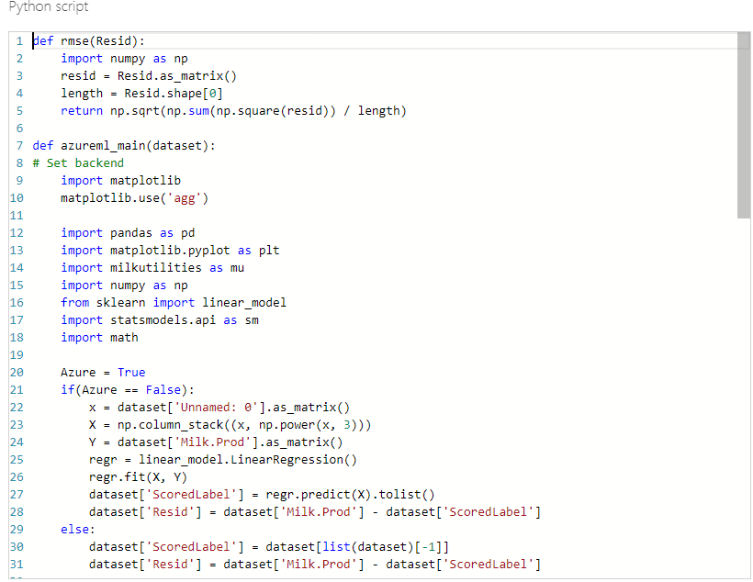
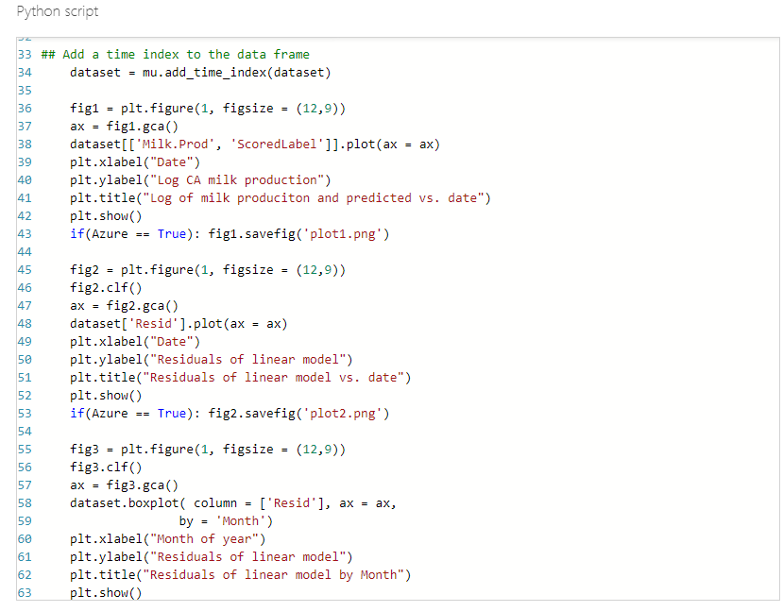
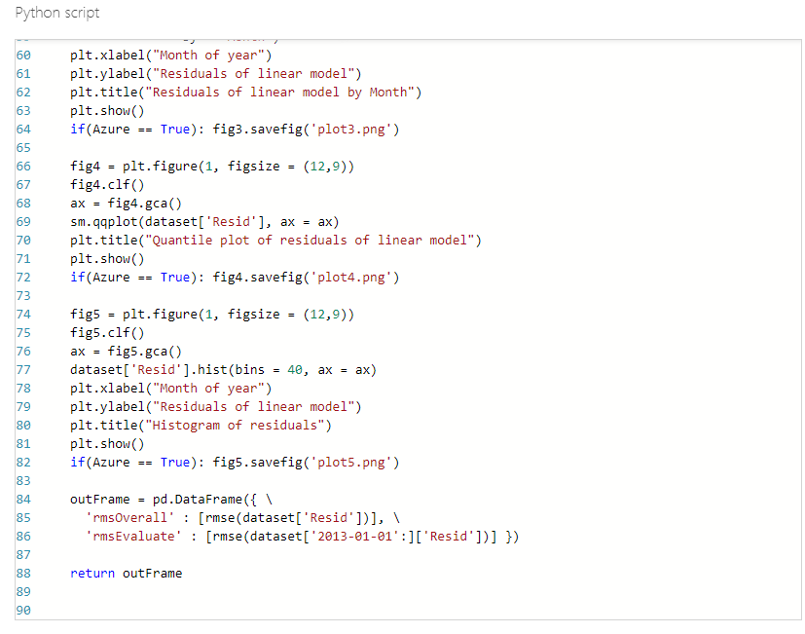

- Refine Model: (Explain how you have refined the model along with Input, Process and Output)
The initial model using 1 independent variable(month.count)
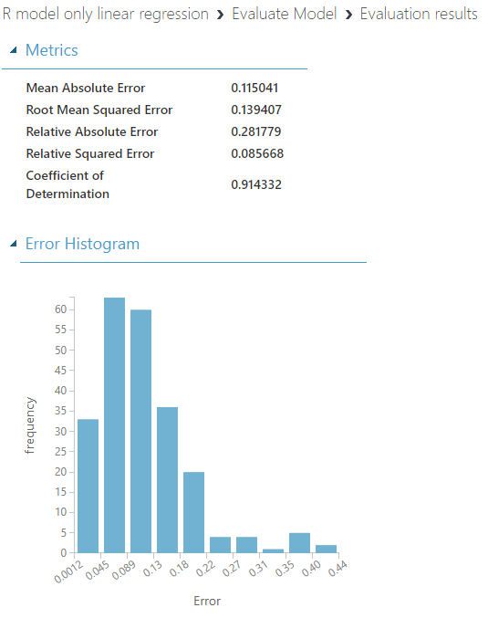

Next using 2 independent variables (Month. Count and Month.Number.Squared)
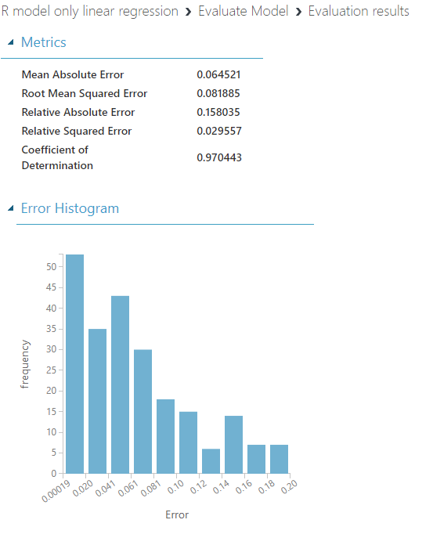

Next using 3 independent variables (Month.Count, Month.Number.Squared and Month.Number.Cubed)
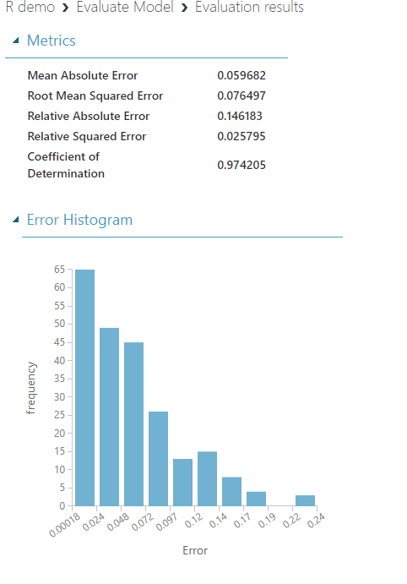

- Annexure 1
  - Script1
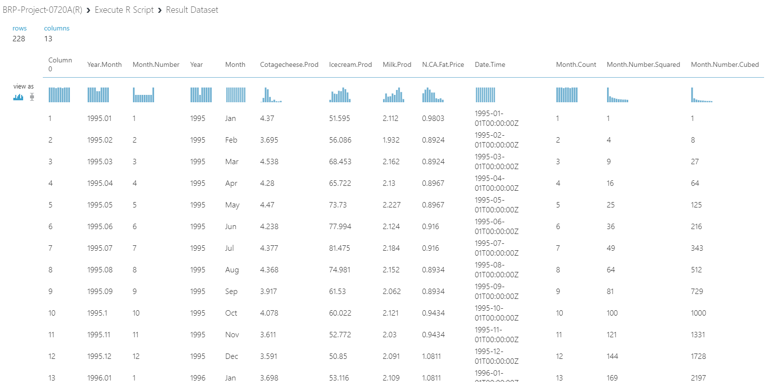

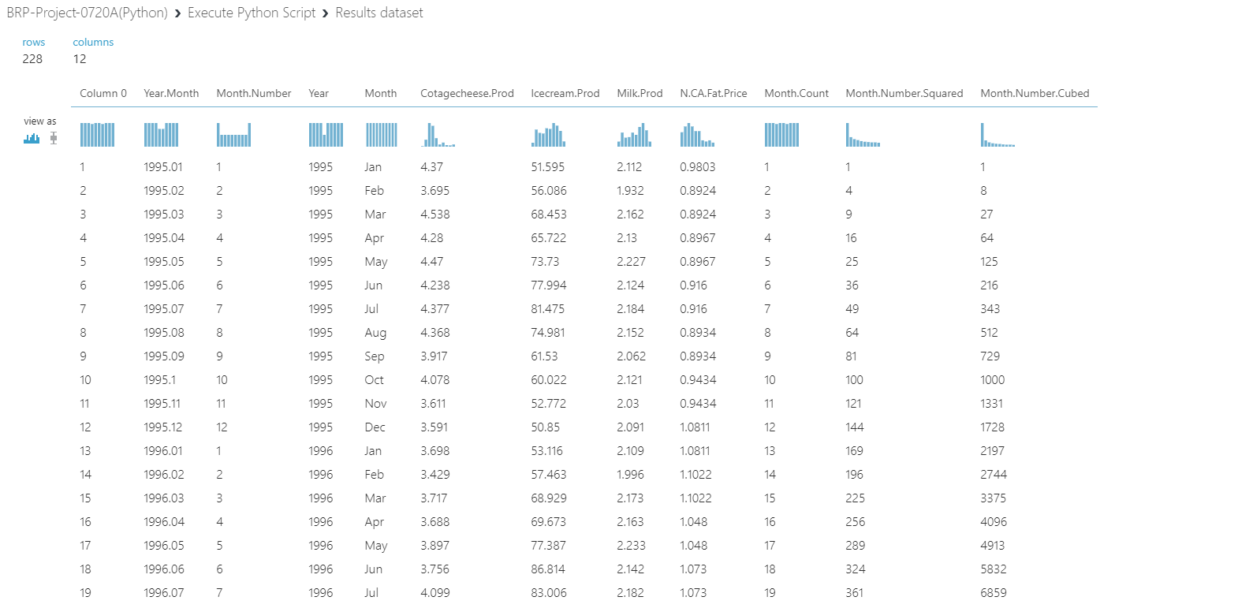

- Annexure 2
  - Script 2
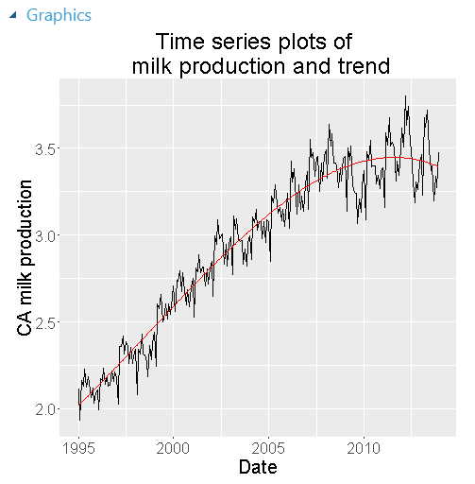

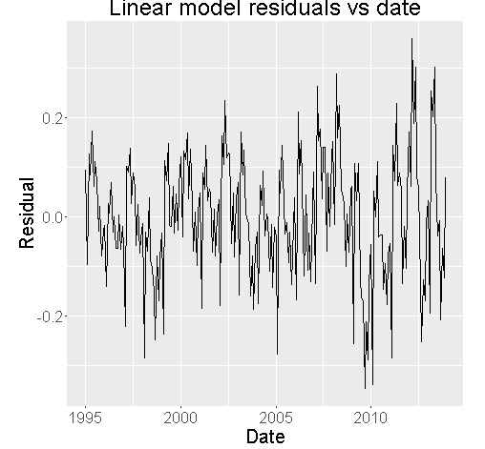

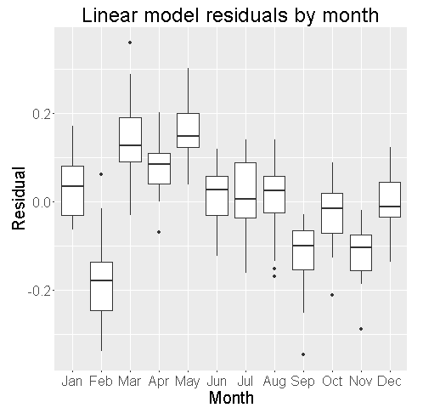
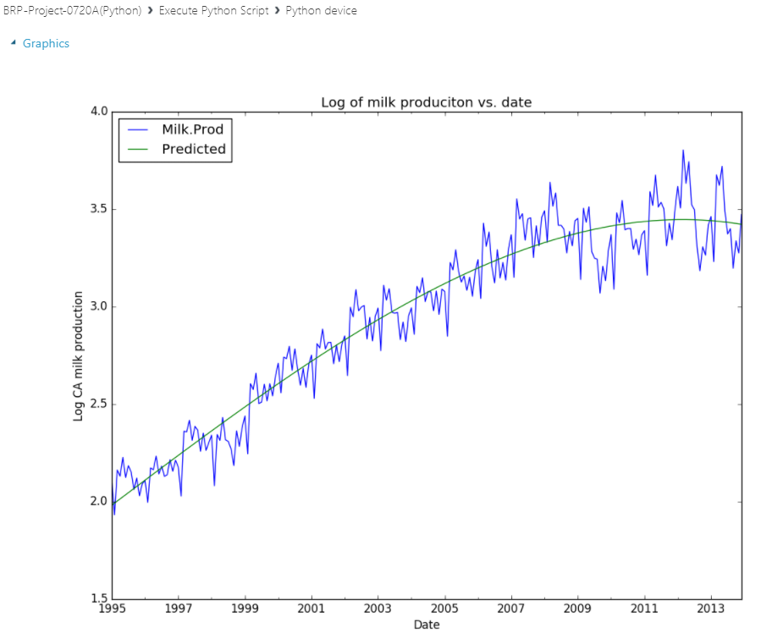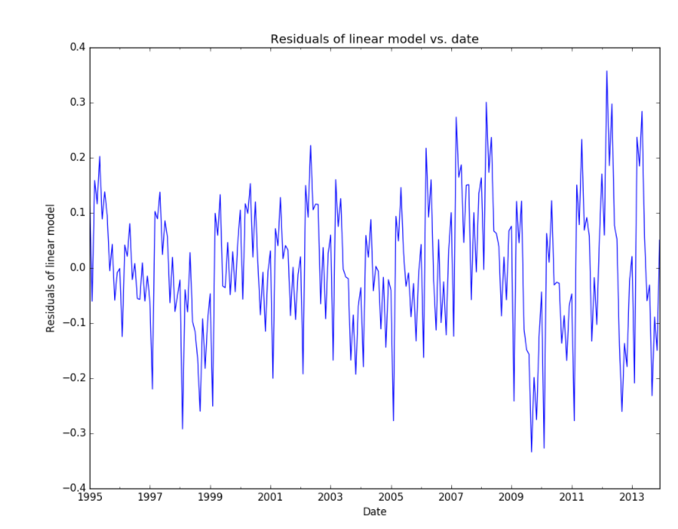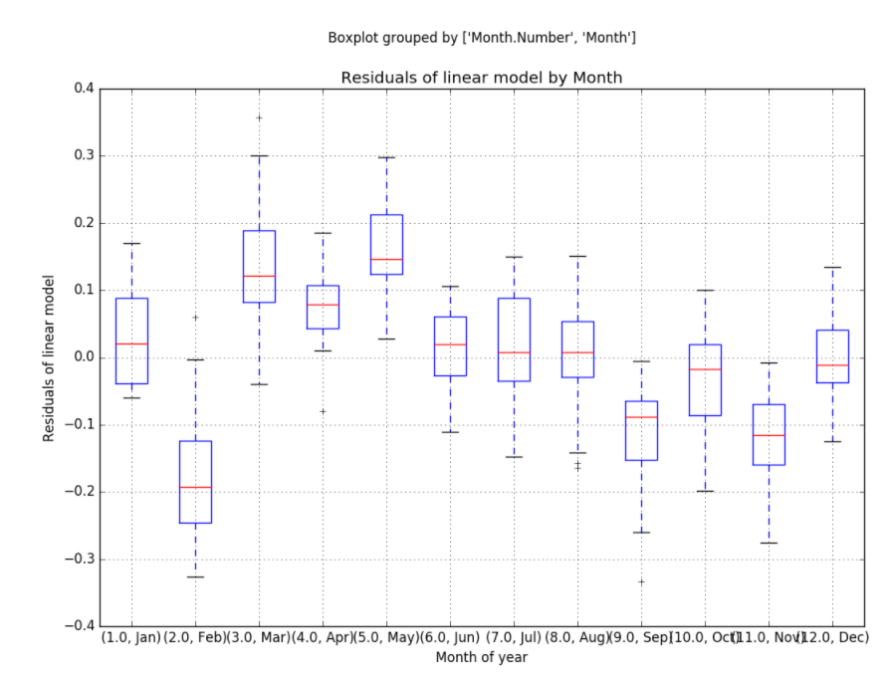
- Annexure 3
  - Script 3
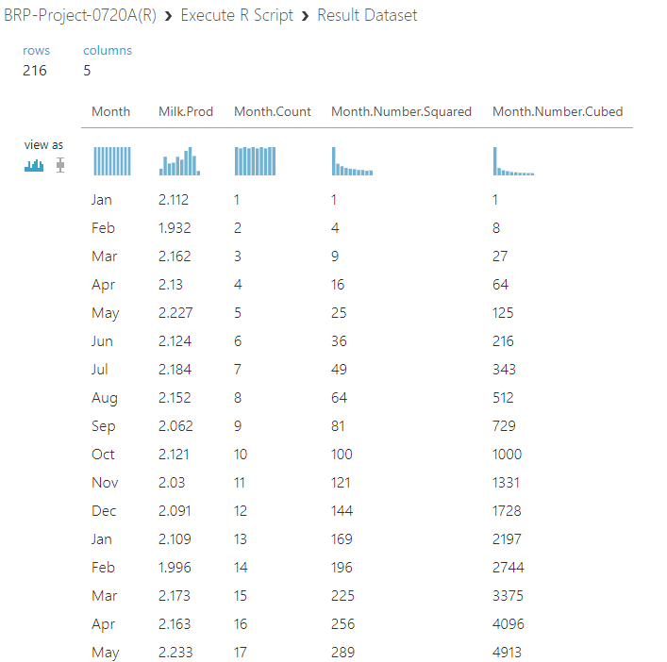

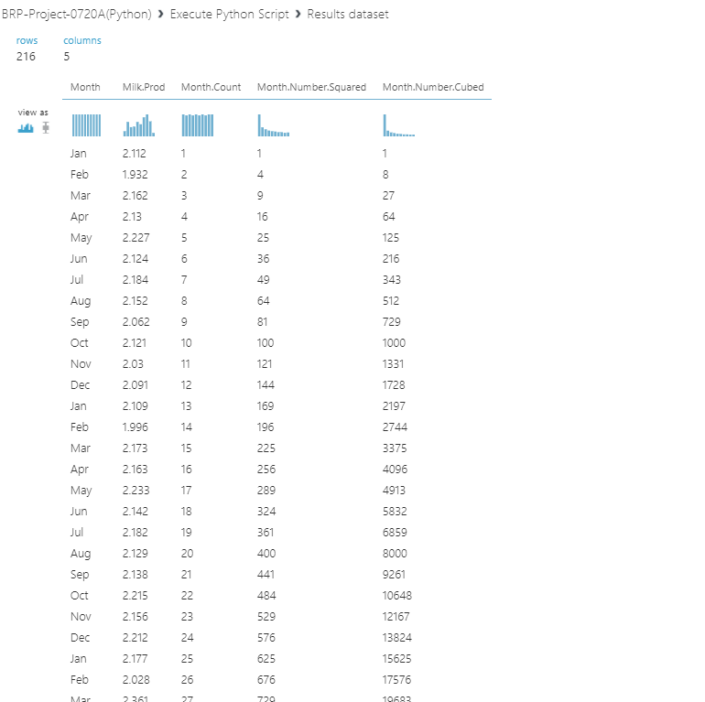

- Annexure 4
  - Script 4
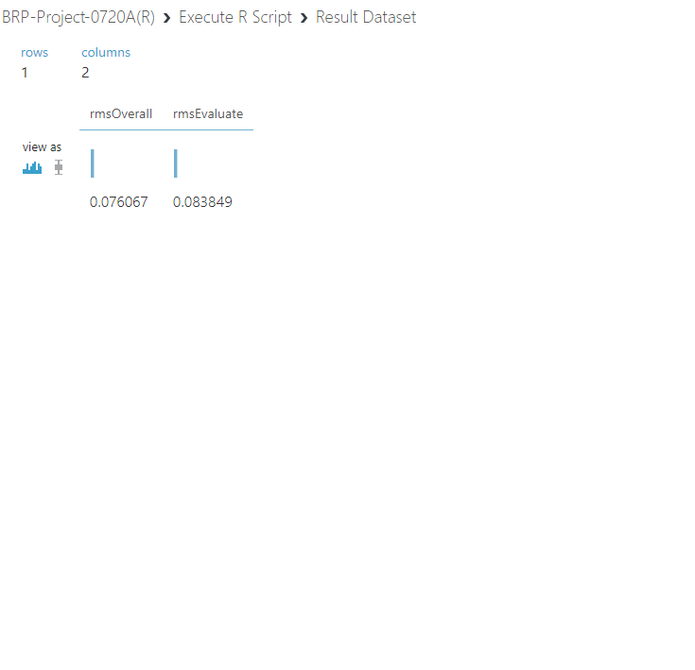

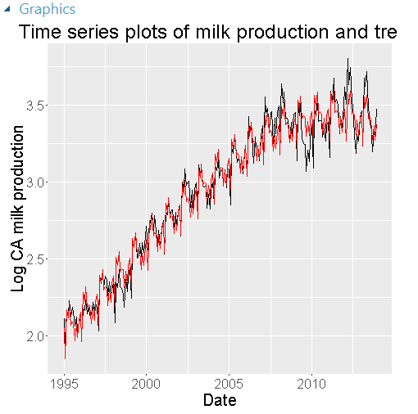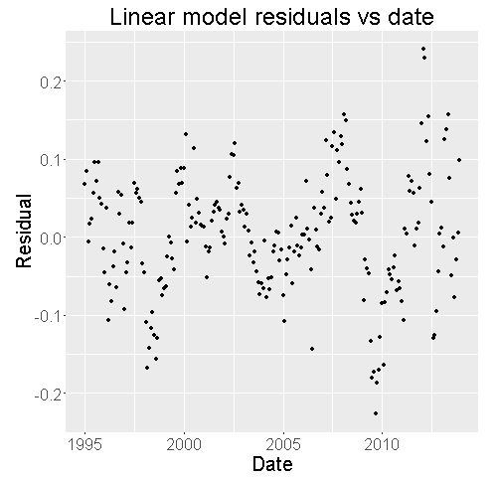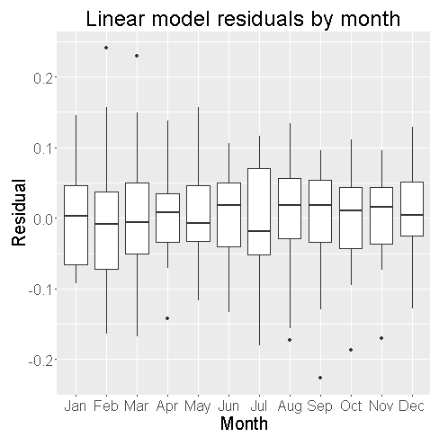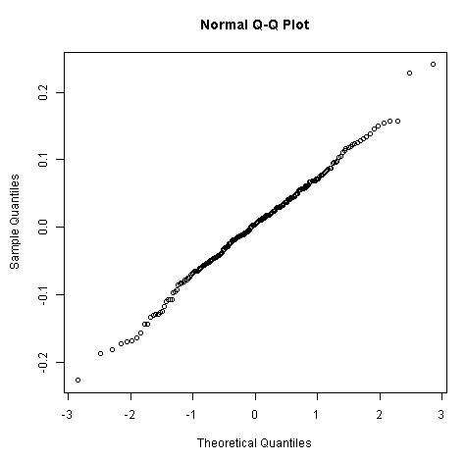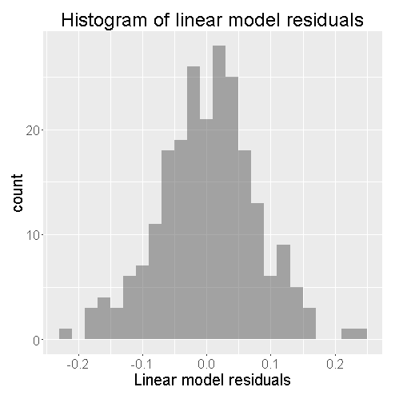
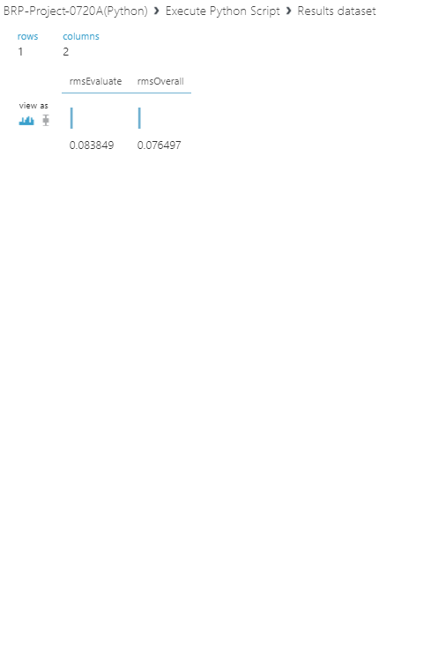

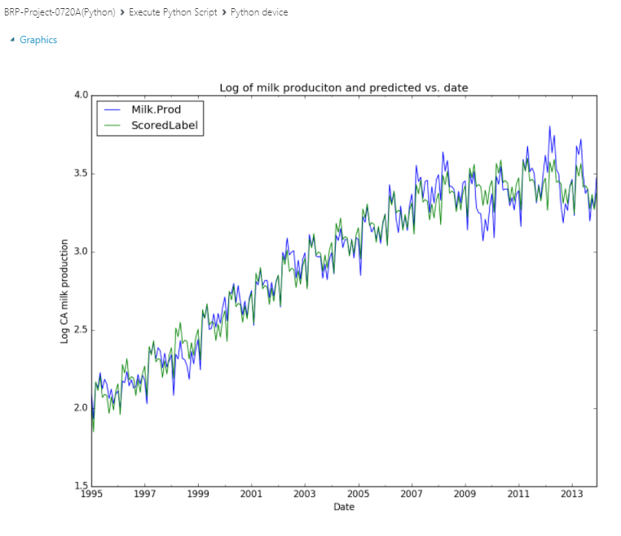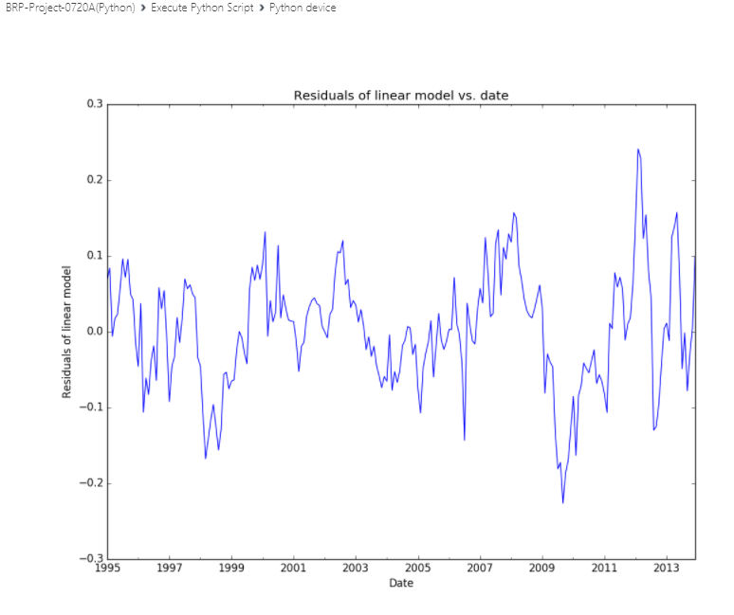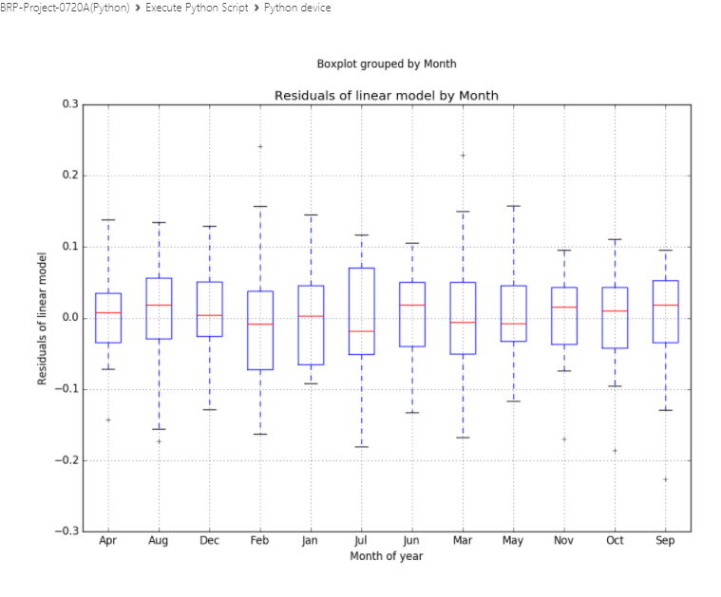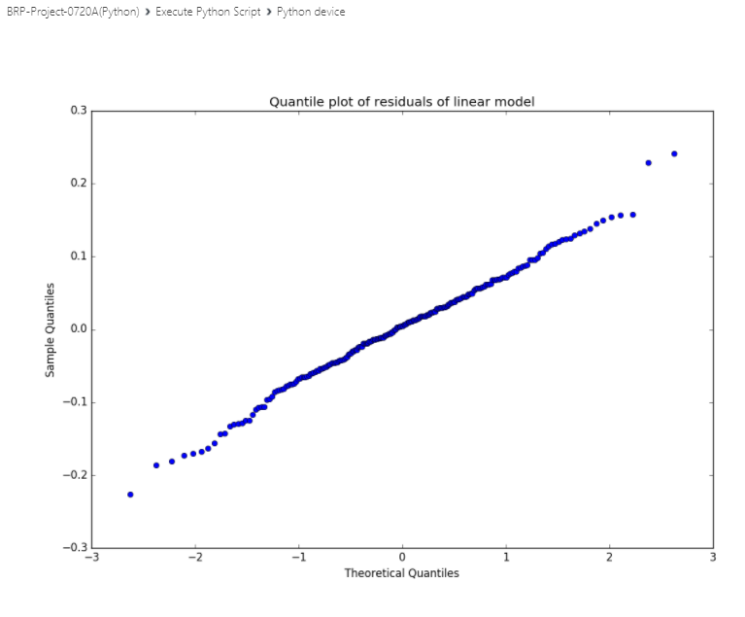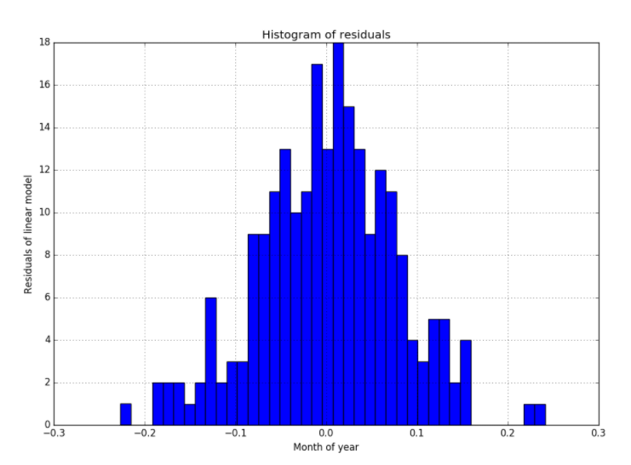
- Forecast Output after Model Adjustment: (Explain the Forecast Output after you have adjusted the model based on actual production data
In the linear regression modules, I have unchecked include intercept weight and input values to 0.001 for L2 regularization weight field.
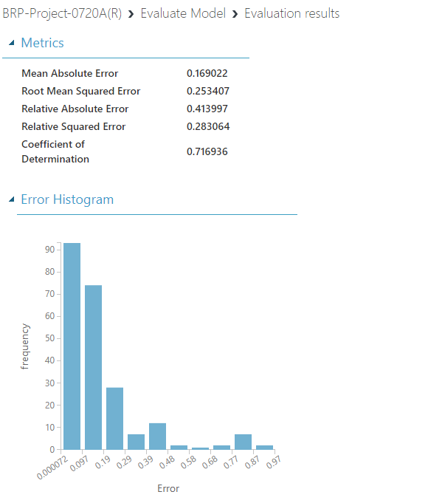
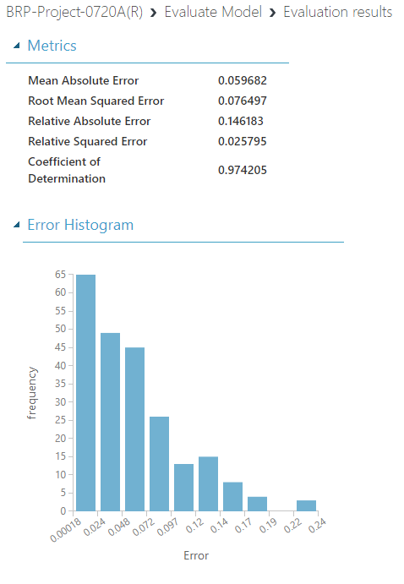

Excel:
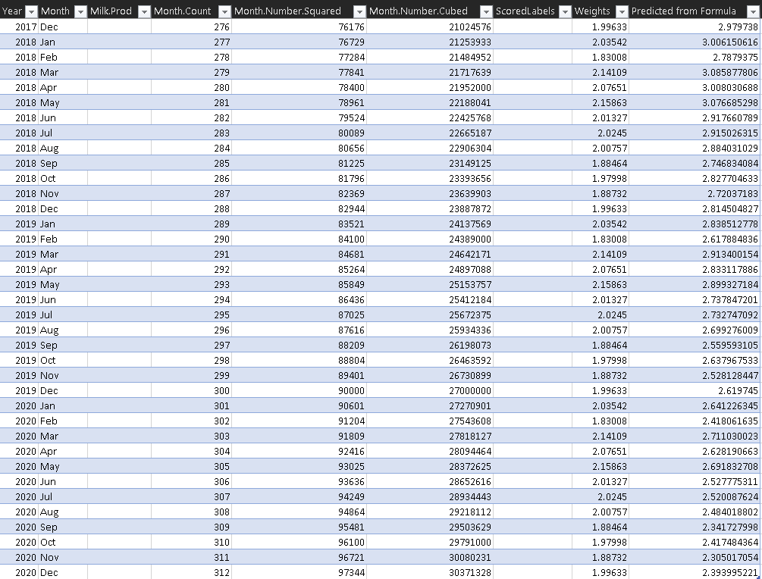
PowerBI:
