9GRadio
RDF (Direction Finder) User Guide
Getting accurate, reliable bearings and fixes from the RDF tab

1. What RDF Does
The RDF (Direction Finder) tab turns your RTL-SDR receiver into a compass-ranging instrument. While active, it continuously samples signal strength on the currently tuned frequency (or an MLAT-linked station/aircraft) and combines that with bearing samples from your device's compass to build up a direction estimate toward the target.
On its own, a single receiver can only produce a bearing — a direction, not a fixed point. RDF becomes dramatically more useful when combined with other linked MLAT stations: multiple simultaneous bearings/ranges on the same target let the app trilaterate an actual latitude/longitude fix instead of a single ray, which is the single biggest factor in accuracy. This is what makes RDF useful precisely for the aircraft/vessels/transmitters that have no self-reported position — there is no ADS-B or AIS fix to fall back on, so the bearing/range solve from your receiver (and any linked peers) is the only source of a position estimate.

2. How RDF Fits In: MLAT vs. RSSI Fingerprinting vs. RDF Trilateration
This app can locate a target three different ways at once. They are not competing implementations — they form a deliberate accuracy ladder, all feeding into one fusion point, so you always see the best available fix rather than three conflicting numbers.

2.1 The Three Sources
- MLAT (TDOA multilateration) — the “real” method. Requires 3+ fixed stations (known altitude) or 4+ (unknown altitude) to independently hear the exact same message, then solves position from timing differences between them. Accurate to tens of metres. Its station-count floor is a hard requirement, not a tunable setting — TDOA's accuracy depends on it.
- RSSI fingerprinting — a fallback for when only 1–2 stations hear a transmission, below MLAT's floor. Estimates range from signal-strength decay using a self-calibrating path-loss curve per station/protocol — it trains itself for free from real MLAT solves, no manual survey needed. Coarse: meters-to-hundreds-of-meters, because path loss is logarithmic and ordinary signal scatter swings the estimate a lot. Not a replacement for MLAT.
- RDF trilateration — what this guide covers: your phone's directional-antenna compass-ranging sessions, combined with any linked peers doing RDF on the same target. Accuracy scales with sample count and geometry: one station is just a bearing ray (least accurate), two stations with a confirmed bearing resolves the usual ambiguity, three-plus stations gets a real overdetermined solve that can approach MLAT-grade accuracy.

2.2 Which One Wins: the Fusion Ladder
Every update, the app ranks all currently-available sources for a target into 7 tiers, best to worst, and always shows the best one — upgrading to a better source immediately, but holding briefly before downgrading so one missed update doesn't yank a precise fix back to a coarse ring:
Tier | Source
1 (best) | MLAT TDOA — always wins outright over anything RSSI-derived once it exists.
2 | RDF, 3+ stations, least-squares solve.
3 | RDF, 2 stations, bearing-resolved — directional antenna breaks the ambiguity a fixed omni station can't.
4 | RSSI fingerprint, 2-station estimate — ambiguity left unresolved (reported at the midpoint).
5 | RDF, 2 stations, ambiguous — same situation, phone side.
6 | RDF, 1 station with a bearing, or RSSI fingerprint, 1 station — a ray beats a ring.
7 (worst) | RDF, 1 station, no bearing — “somewhere on this ring,” the least specific estimate that still carries any information.
In short: MLAT (tens of metres) is dramatically more accurate than RDF or fingerprinting whenever it's available; a well-sampled multi-station RDF session is the next best thing and can approach MLAT-grade; a single-station RDF bearing ray or a lone fingerprint estimate are both coarse, last-resort indications rather than fixes to rely on.

2.3 How They Feed Each Other
RSSI fingerprinting isn't just downstream of MLAT for display purposes — it's trained by it. Every successful MLAT solve feeds a (distance, RSSI) sample per contributing station into the fingerprint model. There's one important purity rule: a solved MLAT or RDF trilateration fix is only used as training ground truth for protocols with no self-reported GPS position of their own (ACARS, digital voice, RF-only, RDS). Anything that self-reports its own position (ADS-B, AIS, APRS) trains the fingerprint model only from that pure, independently-decoded GPS position — never from a solved fix — since a solved fix already has its own geometry/timing/RSSI error baked in, and using it to train the same curve would pollute it.
This is also why linking more MLAT stations helps RDF indirectly, not just directly: more stations means more MLAT solves, which means better-calibrated fingerprint curves, which raises the floor for whatever this app falls back to whenever your RDF session or the fixed network alone can't yet produce a full TDOA fix.

3. Before You Start: What Drives Accuracy
RDF's precision depends almost entirely on four things. Get these right and everything downstream — bearing, distance, and any trilaterated fix — improves.

3.0 Directional Antenna, Rigidly Aligned to the Device
RDF derives bearing from how signal strength changes as you sweep the receiver — it reads the momentary RSSI and cross-references it against whatever heading the phone/tablet's compass reports at that same instant. This only produces a meaningful bearing if:
Hardware requirement — read this first
• You are using a directional antenna (e.g. Yagi, log-periodic, patch) — an omnidirectional antenna has no strong-signal boresight to sweep for, so RDF cannot derive a bearing from it at all.
• The antenna is rigidly mounted to the same phone/tablet running the app, physically fixed so its boresight and the device's compass heading always point the same direction.
• The antenna and device are kept aligned at all times during a session — if the antenna twists relative to the device (loose mount, handheld with slipping grip, cable tension pulling it off-axis), every sample taken while misaligned is silently wrong: the app has no way to detect the mismatch, it will just report a confident-looking but incorrect bearing.
In practice this means: mount the antenna and device together on a single rigid bracket or handheld rig before starting a session, and rotate the whole assembly as one unit when sweeping for a peak — never re-aim the antenna alone, and never rotate just the device to check the screen without the antenna following it exactly.

3.1 Number of Linked MLAT Stations
The single biggest lever you have. With only one receiver (yourself), RDF can only produce a single bearing ray — shown as Trilateration: SINGLE_BEARING_RAY — with a very large uncertainty radius (tens of kilometres). Every additional linked station that also has a solve on the same target tightens the fix:
Rule of thumb
• 1 station (you only): bearing ray only, large uncertainty (often 50+ km).
• 2 stations: a crossed-bearing fix, uncertainty typically drops to single-digit km.
• 3+ stations with real TDOA correlation: tight trilaterated fix, uncertainty in the tens-to-hundreds of metres.
Check the “Linked Stations” list at the bottom of the RDF tab and the Linked: N counter at the top of the dial — more linked, actively-reporting peers is always better.

3.2 Target Selection
RDF's entire purpose is to estimate the position of a transmitter whose location is not already known from its own reports — an aircraft with no ADS-B position, a vessel with no AIS position, or any RF emitter with no self-reported location at all. A target that already has a known POSITION doesn't need RDF; it's only listed in the Aircraft/Vessel Table as a reference. Pick your RDF target from the ones still missing a fix:
- Prefer targets marked no pos in the Aircraft/Vessel Table — these are exactly the ones RDF exists to locate, by combining bearing/range samples from your receiver with any other linked MLAT stations that also hear it.
- Prefer targets with a recent AGE (0s–2s) — a target that hasn't reported in tens of seconds will produce a stale, drifting bearing regardless of whether it has a position.
- Stronger, closer signals (higher POWER / “Hot” SIGNAL reading) yield cleaner bearing samples than weak, distant, or intermittent ones.
- For RF-only (non-ADS-B/AIS/MLAT) targets, use the “Track current tuner frequency” toggle instead of manually typing a frequency — this guarantees RDF is always ranging on exactly what your tuner is receiving.

3.3 Antenna & Device Placement
- Double-check antenna-to-device alignment before every session, not just once at setup — mounts loosen and cables snag over time.
- Keep the antenna's boresight vertical/level as appropriate for its design and clear of metal obstructions (vehicle roofs, railings, large appliances) that distort both signal strength and compass heading.
- Keep the phone/tablet compass away from magnets, speakers, and other sources of magnetic interference — compass drift shows up directly as bearing error, and is indistinguishable in the data from an antenna that's slipped out of alignment.
- Recalibrate the device compass (a figure-8 motion) if you see the compass ring (the blue indicator on the dial) jumping erratically between samples.
- When possible, take bearing samples from more than one physical location — movement between samples improves the geometry of a single-station bearing ray.

4. Step-by-Step Walkthrough

Step 1 — Identify a Target With No Known Position
Before opening RDF, check the ADS-B Aircraft Tracker for targets still missing a fix — look in the POSITION column for no pos. In the example below, ICAO 044044 (no callsign decoded yet) is exactly this kind of target: no position, but reporting recently (16s old) and worth ranging on. This is the target used throughout the rest of this guide.
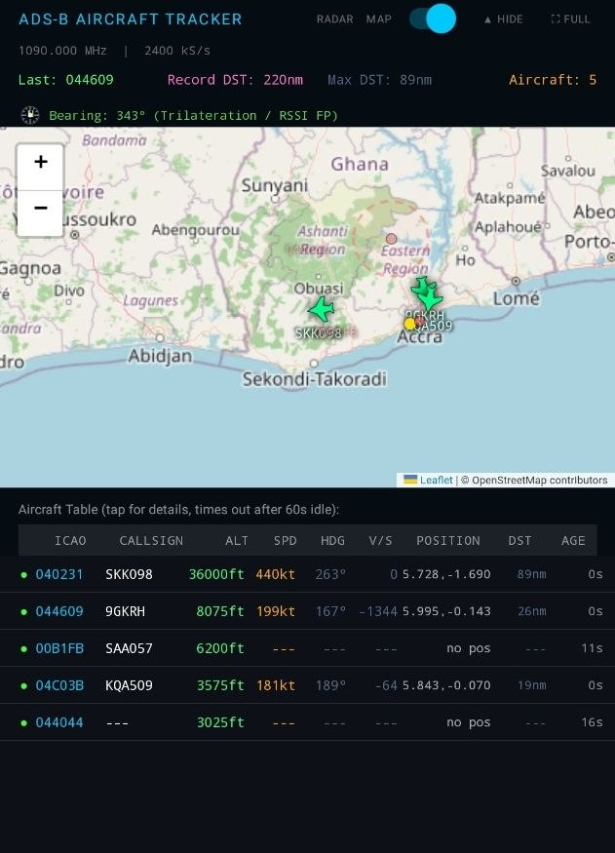
ADS-B Aircraft Tracker — 044044 has no pos in the table, making it a genuine RDF candidate; a target that already shows a position (like 9GKRH) doesn't need RDF to locate it.
- Open the ADS-B tab and find a target marked no pos in the Aircraft Table.
- Note its AGE (lower is better) — a very old, stale report still isn't worth ranging on even without a position.
- Switch to the RDF tab (compass-drop icon in the tab strip).

Step 2 — Select the Target and Start the Session
In the Target dropdown, pick the matching entry (format is protocol:id, e.g. ADSB:044044). The panel below shows Power, Signal, Bearing, and Distance for whatever solve currently exists for that target, plus the current Trilateration mode and Uncertainty radius. Review the Linked Stations list at the bottom — more entries here means a better fix once you start.
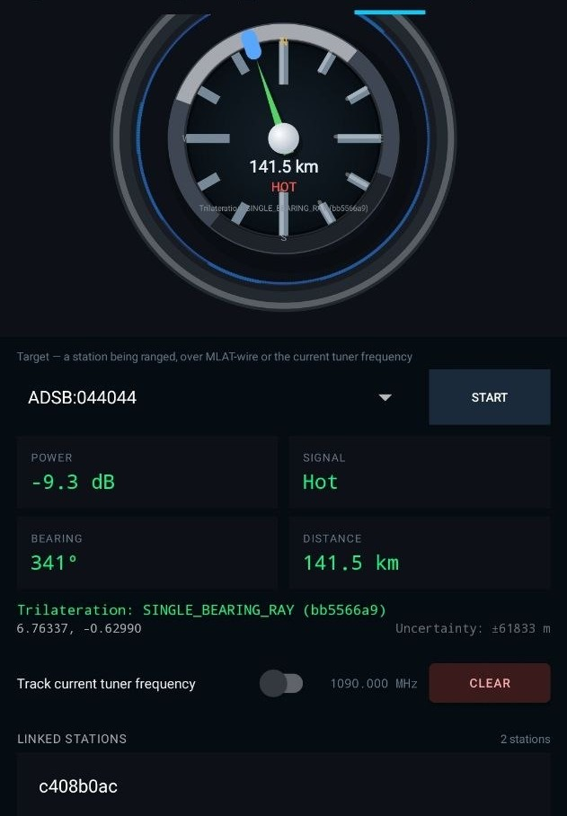
Target picker in the idle state, before starting a session — note the Linked Stations count and the current Trilateration mode/Uncertainty.
- Select your target from the dropdown.
- Confirm SIGNAL reads at least “Warm” before starting — starting on a very weak/cold signal wastes early samples.
- Tap START.

Step 3 — Monitor the Active Session
Once running, the header reads “RDF active — sighting <station>” and the dial begins filling in bearing samples (the small ticks around the outer ring). Watch the Used: N counter — it's the number of bearing samples currently contributing to the solve. Let it accumulate rather than stopping immediately after the first reading.
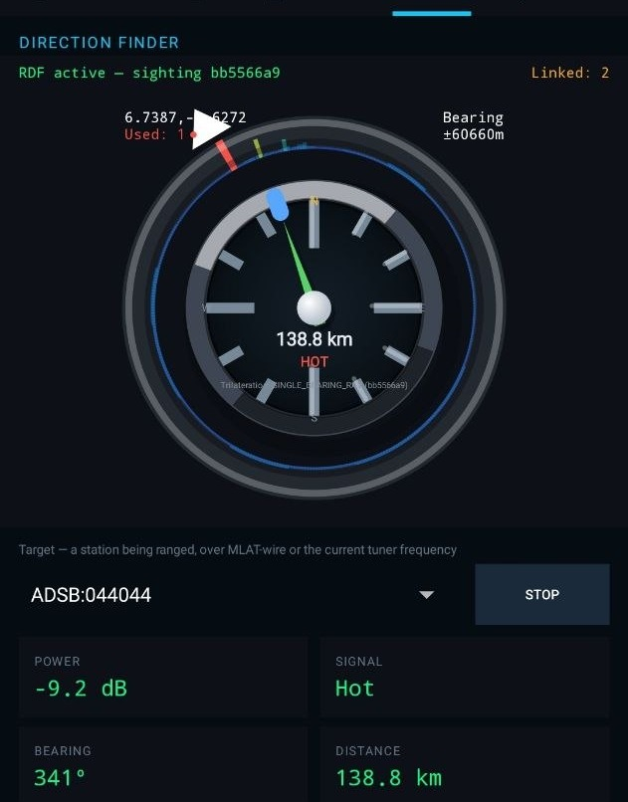
Active RDF session — the dial fills in bearing samples over time; Used: N and Uncertainty both improve as more samples and stations contribute.
- Leave the session running for at least 15–30 seconds, or until Used: N stops climbing and Uncertainty stabilises.
- Slowly sweep the antenna+device assembly together, as one rigid unit, through the arc where you expect the target to be — this is what lets RDF find the true signal peak instead of relying on a single static reading.
- Watch for the Trilateration mode to upgrade from SINGLE_BEARING_RAY to a multi-station fix as other linked stations report in.
- Tap STOP when you have a stable, low-uncertainty fix, or when you're switching targets.

5. Reading the Dashboard
Quick reference for every field shown on the RDF panel:
Field | Meaning
POWER | Raw signal level in dB for the current target on the tuned frequency.
SIGNAL | Qualitative read of POWER — Cold / Warm / Hot. Aim to start sessions at Warm or better.
BEARING | Compass heading (°) from this receiver toward the target.
DISTANCE | Estimated range to the target — from trilateration if multiple stations agree, otherwise a rough single-station estimate.
Trilateration | The solve method currently in use, e.g. SINGLE_BEARING_RAY (one station only) up to a full multi-station TDOA/RSSI-fingerprint fix. More linked stations upgrade this automatically.
Uncertainty | Radius (metres) of positional error around the fix. Large values (tens of km) mean “trust the bearing line, not the dot”; small values (hundreds of metres or less) mean a tight fix.
Linked / Linked Stations | Count and list of other MLAT-wire peer receivers currently contributing to this device's solves.
Track current tuner frequency | When on, RDF automatically re-targets whatever frequency the main tuner is on — use for live RF/voice targets instead of manual entry.

6. Troubleshooting & Tips
- Stuck on SINGLE_BEARING_RAY with huge Uncertainty: no other linked station currently has a solve on this target. Confirm peers are online (PEERS counter, top of screen) and that they can also hear the same target.
- Bearing jumping around between samples: recalibrate the device compass, check for nearby magnetic interference, and re-check the antenna's mount — this looks identical to compass drift but is often the antenna having slipped out of alignment with the device.
- Confident-looking bearing that's clearly wrong once cross-checked against another linked station: verify the antenna is still rigidly aligned to the device — a misaligned antenna produces a normal-looking, high-confidence reading with no error indication, since the app has no independent way to detect the mismatch.
- SIGNAL stuck at Cold: the target is likely too weak or out of practical range on this frequency — pick a stronger/closer target instead, or improve antenna placement.
- Distance/fix not improving even with samples accumulating: give it more time — Used: N needs several samples spread over time (and ideally position) to converge; a session started seconds ago won't yet reflect the best achievable accuracy.
- Target keeps disappearing from the picker: it may have gone stale (no fresh reports in a while) — return to the ADS-B/AIS tab to confirm it's still actively reporting before re-selecting it.
9GRadio — RDF User Guide

