9GRadio
Complete User Guide
RTL-SDR • All Supported Protocols
Version 1.1 (Illustrated) | 2026
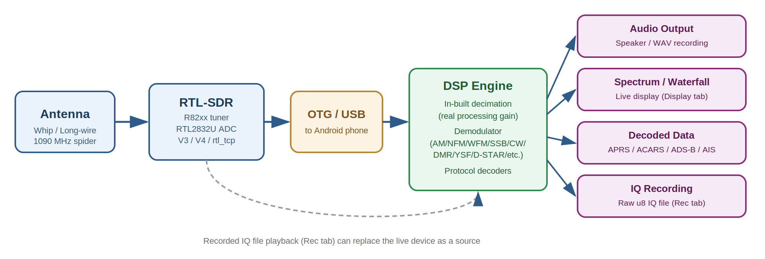
Figure 0.1 — End-to-end signal chain: antenna → RTL-SDR → phone → DSP engine → outputs

1. Introduction
9GRadio is an Android SDR (Software-Defined Radio) application that turns any RTL-SDR USB dongle into a full-featured radio receiver. It supports analogue voice modes, digital voice protocols, data protocols, and aircraft/maritime tracking — all from one unified interface.

Figure 1.1 — How signal flows from antenna to the outputs you interact with in the app

1.1 Supported Hardware
- RTL-SDR Blog V4 (recommended — built-in HF upconverter, extended tuning)
- RTL-SDR Blog V3 and generic RTL2832U dongles (direct-sampling for HF)
- rtl_tcp / rtl_tcp_andro network sources
- Recorded IQ files (.raw, .cu8, etc.) for offline playback

1.2 Frequency Range
- Standard tuner range: 500 kHz – 1 766 MHz
- V4 / extended range: below 500 kHz and above 1 766 MHz (enable "Out of Band" in Settings tab)
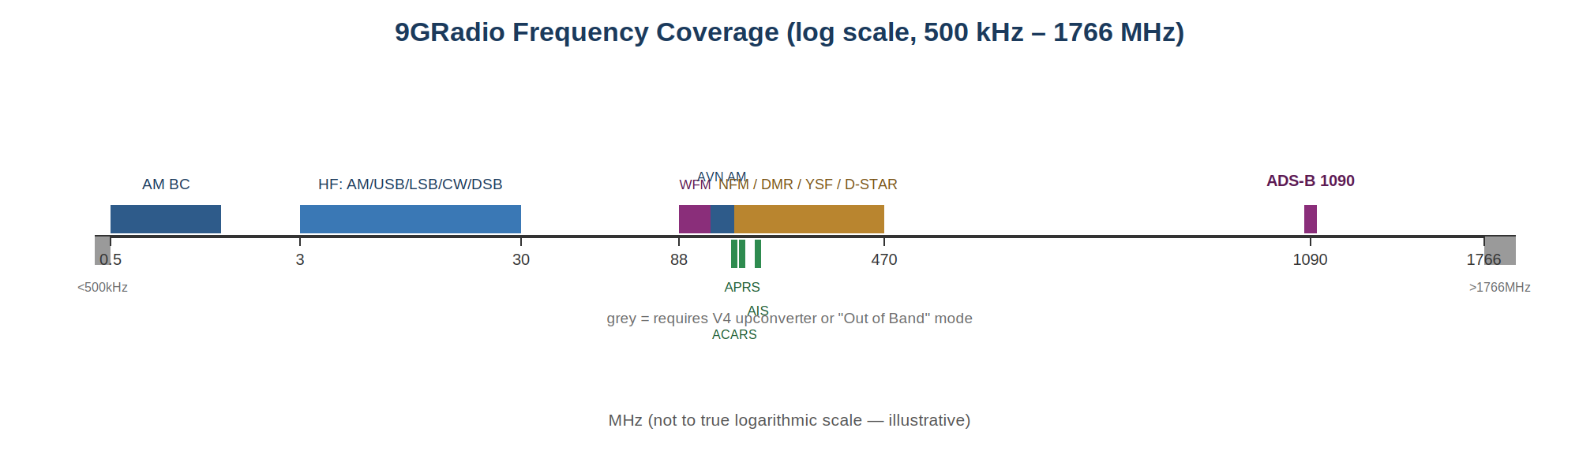
Figure 1.2 — Approximate frequency coverage and where each mode/protocol sits

1.3 Quick-Start
- Plug your RTL-SDR dongle into the phone via OTG cable.
- Open 9GRadio — the app requests USB permission and connects automatically.
- Choose a mode from the Mode tab (e.g. NFM for VHF public-safety).
- Tune using the spectrum, waterfall, or Tune tab dial.
- Adjust Gain manually (start at 20–30 dB) with RTL AGC and Tuner AGC off.

2. Interface Overview

2.1 Main Screen
The main screen shows the spectrum (top), waterfall (middle), and the tabbed control drawer (bottom sheet). Tap and hold the frequency display to enter a frequency manually.
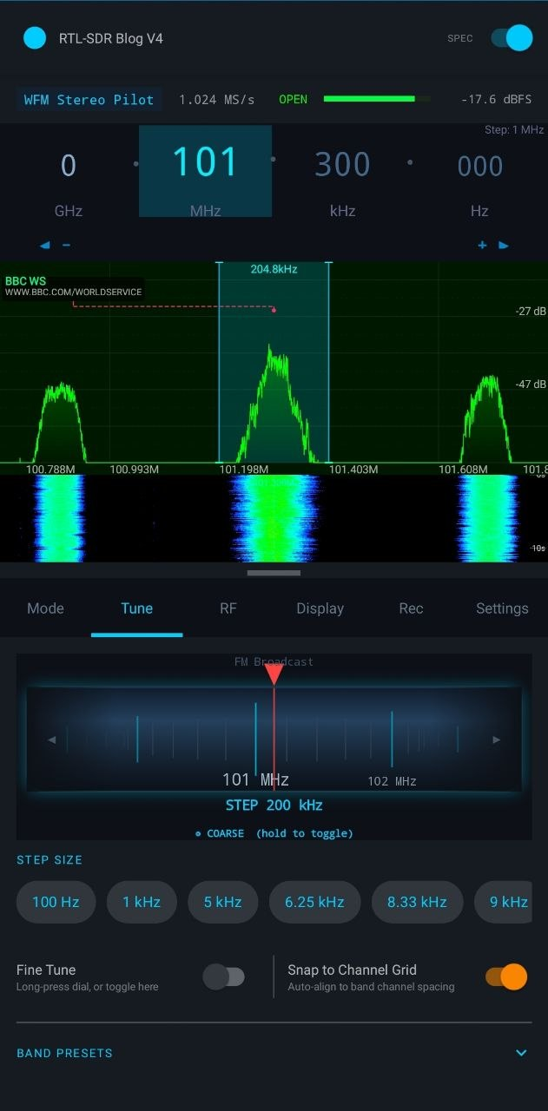
Figure 2.1 — Main screen: frequency display, spectrum, waterfall, and the Tune tab (tuning dial, step size, band presets)

2.2 Control Tabs
Tab | Purpose
Mode | Select demodulation mode (analogue + digital) and memory slots
Tune | Tuning dial, step size, band presets, snap-to-channel
RF | Gain, AGC, squelch, volume, bias-tee, noise blanker/reducer, IF filter, sample rate, PPM
Display | FFT size, decimation (display zoom only — see §4.2), waterfall palette, spectrum theme, frame averaging, dB range
Rec | IQ and audio recording controls plus playback of saved files
Settings | Out-of-band mode, device info, scanner, bookmarks, EiBi, MLAT
APRS | Packet log, map (shown only in APRS mode)
ACARS | Message log (shown only in ACARS mode)
ADS-B | Aircraft table + live map/radar (shown only in ADS-B mode)
AIS | Ship table + live map (shown only in AIS mode)
DMR / YSF / D-STAR / Dig | Recent calls list (shown only in respective digital mode)
Scan | Frequency scanner (opens via Scanner button or FAB)
EiBi | Shortwave broadcast schedule browser (opens via EiBi chip on Mode tab)
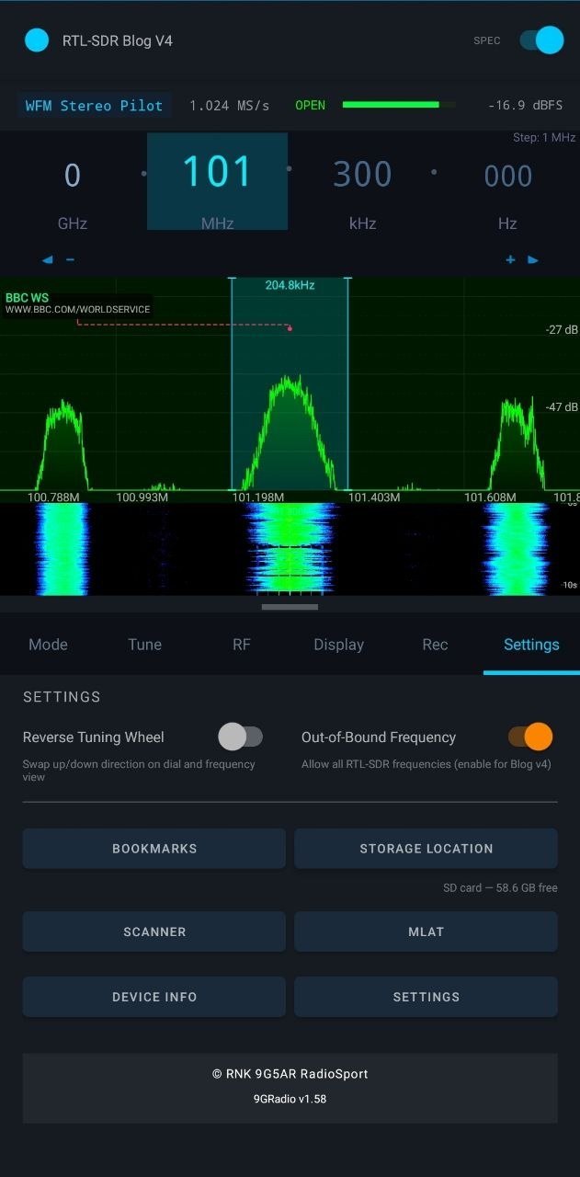
Figure 2.2 — Settings tab: Bookmarks, Storage Location, Scanner, MLAT, Device Info, and Out-of-Bound Frequency toggle

3. Supported Protocols & Modes
Every mode is selected from the Mode tab. Analogue modes appear on the top row; digital and data modes on the bottom row.
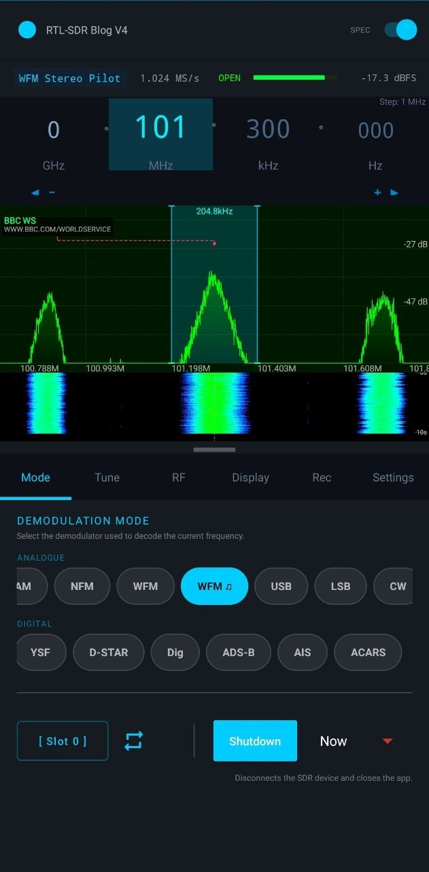
Figure 3.1 — Mode tab: analogue and digital mode buttons, plus the memory slot control and Shutdown Timer

3.1 Analogue Voice Modes

AM — Amplitude Modulation
Used for shortwave broadcasts (3–30 MHz), aviation voice (108–137 MHz), and AM broadcast (530–1700 kHz).
Setting | Recommended Value
Sample rate | 1.024 MS/s (HF); 1.92 MS/s (MW/SW)
Decimation | ÷64 → 16 kHz effective
Gain | Manual 20–35 dB, RTL AGC off, Tuner AGC off
IF / AM bandwidth | 4–6 kHz (SW), 9 kHz (MW channel spacing)
Squelch | −120 dB (open) for weak-signal SW
Direct sampling (HF) | Q-Branch (RTL-SDR V3/generic); Off for V4
★ For HF shortwave AM use 1.024 MS/s → Decimation ÷64 → 16 kHz. Higher sample rates cost battery without meaningful gain on most signals.

NFM — Narrow FM
The default mode. Covers VHF/UHF public safety, amateur, marine, and commercial radio (typically 25 kHz channels).
Setting | Recommended Value
Sample rate | 1.024 MS/s or 2.048 MS/s
IF bandwidth | 12.5–25 kHz (mode default auto)
Squelch | Start at −65 dB; raise until noise drops
Gain | 20–40 dB manual

WFM — Wide FM (Mono) / WFM ♫ — Wide FM Stereo
Standard FM broadcast (88–108 MHz). WFM ♫ enables stereo pilot decoding and RDS (Radio Data System) text display.
Setting | Recommended Value
Sample rate | 1.92 MS/s or 2.048 MS/s
IF bandwidth | 200 kHz (auto)
Decimation | ÷1 (Off) — full bandwidth needed for pilot
RDS display | Appears automatically in WFM ♫ mode

USB / LSB — Single Sideband
USB (Upper Sideband) is the standard for HF ham, maritime, and aeronautical voice above 10 MHz. LSB is used below 10 MHz on ham bands.
Setting | Recommended Value
Sample rate | 1.024 MS/s (HF)
IF bandwidth | 2.4–3.0 kHz (auto per mode)
Decimation | ÷64 → 16 kHz
Gain | 25–40 dB; adjust for minimum noise
Direct sampling | Q-Branch for V3/generic RTL-SDR on HF
ℹ USB and LSB always use automatic IF bandwidth — the slider is locked for these modes.

CW / CWR — Morse Code
CW is standard Morse; CWR is reverse-polarity Morse. The IF filter can be narrowed from 800 Hz down to 100 Hz to improve S/N on weak signals.
Setting | Recommended Value
IF bandwidth | 100–500 Hz (contest); 500–800 Hz (general)
Sample rate | 1.024 MS/s
Decimation | ÷64

DSB — Double Sideband
Demodulates both sidebands simultaneously. Useful for AM signals without a carrier (DSB-SC), aircraft ILS, and some utility stations.
Setting | Recommended Value
IF bandwidth | 4–6 kHz (default)
Use case | DSB-SC, ILS, utility HF

3.2 Digital Voice Modes
All digital voice modes use the built-in mbelib-neo vocoder (statically linked — no external plugin needed). A "Recent Calls" tab appears automatically when a digital voice mode is selected.

DMR — Digital Mobile Radio
TDMA digital voice used widely by public safety, commercial, and amateur radio. Supports Tier I (simplex), Tier II (conventional), and repeater operation.
Setting | Recommended Value
Channel spacing | 12.5 kHz
Sample rate | 1.024 MS/s or 2.048 MS/s
Squelch | Typically −65 to −75 dB
Gain | Manual 20–40 dB
Vocoder | mbelib-neo built-in (no action required)
★ The DMR tab shows caller ID, talk-group, time slot, and colour code from decoded frames.

YSF — Yaesu System Fusion
Yaesu's digital voice mode used on the amateur VHF/UHF bands. Supports Voice Full Rate (VFR) and Voice Half Rate (VHR).
Setting | Recommended Value
Channel spacing | 12.5 kHz
Sample rate | 1.024 MS/s
Squelch | −65 to −75 dB

D-STAR — Digital Smart Technologies for Amateur Radio
ICOM's GMSK digital voice protocol for amateur radio. Decoded frames show source/destination callsign, message, and GPS position when available.
Setting | Recommended Value
Channel spacing | 6.25 kHz (DV) / 128 kHz (DD)
Sample rate | 1.024 MS/s
Squelch | −65 to −70 dB

DIG — Generic Digital (P25 / NXDN / other)
A catch-all digital mode that attempts to decode additional vocoder-based protocols not covered by the named modes above. Useful for experimentation.

RAW — Raw IQ
Passes the raw complex IQ samples directly with no demodulation. Useful for inspecting signals, feeding external decoders, or verifying hardware.

3.3 Data & Telemetry Protocols

APRS — Automatic Packet Reporting System
VHF packet-radio protocol (144.390 MHz in North America; 144.800 MHz in Europe) carrying position beacons, weather data, messages, and objects.
Setting | Recommended Value
Fixed frequency | 144.390 MHz (NA) / 144.800 MHz (EU) — auto-set on mode select
Sample rate | 1.024 MS/s
IF bandwidth | Auto (locked)
Map | APRS tab shows station positions; tap a pin for details
Station timeout | 30 minutes (stations removed after silence)
★ The APRS tab splits into a packet log (below) and a live map (above). Collapse the map to see more packets.

ACARS — Aircraft Communications Addressing and Reporting System
VHF data link used by commercial aviation for pre-departure clearances, ATIS, and engine health reports. 9GRadio decodes all four ACARS frequencies simultaneously.
Setting | Recommended Value
Centre frequency | 131.550 MHz (auto-set) — covers all four channels
Channels decoded | 131.550, 131.725, 131.825, 131.850 MHz (simultaneous)
Sample rate | ≥ 2.048 MS/s (auto-bumped on mode select)
Squelch | Leave open (−120 dB); ACARS decodes gated signals
ℹ ACARS mode forces a wide capture; sample rate is raised automatically if the current rate is insufficient.

ADS-B — Automatic Dependent Surveillance–Broadcast
1090 MHz aircraft transponder data: position, altitude, speed, heading, ICAO hex code, and flight number. Decoded in real time on a live map with radar overlay.
Setting | Recommended Value
Fixed frequency | 1090.000 MHz (auto-set)
Antenna | 1090 MHz vertical strongly recommended (spider, coax-stub)
Sample rate | 2.048 MS/s or 2.4 MS/s
Gain | 35–45 dB; reduce if strong signals cause intermod
Spectrum/waterfall | Can be disabled to save CPU (toggle in toolbar)
Aircraft timeout | 60 s without a new frame → removed from table/map
Record distance | All-time farthest aircraft persisted across sessions
MLAT | Multi-lateration supported via Settings > MLAT
★ Long-press the Record Distance label to see full details of the best-ever aircraft catch.

AIS — Automatic Identification System
VHF maritime transponder protocol. Decodes vessel name, MMSI, position, course, speed, and ship type on a live map.
Setting | Recommended Value
Fixed frequency | 162 MHz (covers both AIS Ch 87B & 88B — auto-set)
Sample rate | 1.024 MS/s
Antenna | VHF marine whip or discone
Ship timeout | Configurable; default follows AIS_TARGET_TIMEOUT_MS

4. RF & DSP Settings

4.1 Gain
Manual gain is strongly recommended for all analogue and digital modes. The gain slider sets the R82xx tuner LNA/Mixer/VGA stage.
Control | When to use
Manual Gain (slider) | All modes — set once per band, then fine-tune for minimum noise
Tuner AGC | Only when you cannot set gain manually (moving vehicle, scanning wide range)
Hardware AGC | Rarely — controls the RTL2832U IF stage; leave off unless advised
ℹ RTL AGC and Tuner AGC should both be OFF for HF, SSB, CW, and weak-signal work.

4.2 Sample Rate & Decimation
The sample rate sets the captured IQ bandwidth. 9GRadio uses decimation in two distinct, independent ways — see the diagram below — and this section covers the automatic in-built decimation that feeds the demodulator, which provides real processing gain (≈3 dB per doubling of the decimation factor).
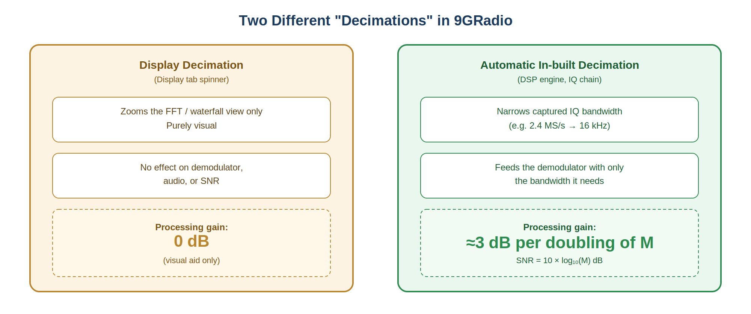
Figure 4.1 — Display decimation (visual only) vs. automatic in-built decimation (real processing gain)
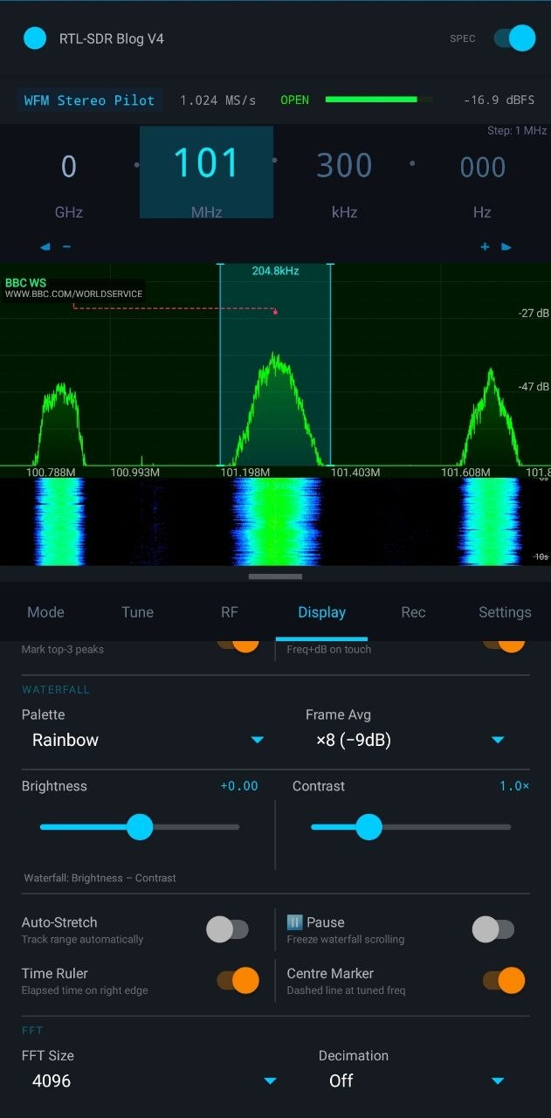
Figure 4.1b — Display tab: the Decimation spinner (bottom right, currently Off) — this is the visual-only zoom control, not the DSP engine's processing-gain decimation
Rate | ÷Decim | Effective BW | Ideal Gain | Best for
2.4 MS/s | ×150 | 16 kHz | +21.8 dB | Maximum SNR, HF
2.4 MS/s | ×50 | 48 kHz | +17.0 dB | Wide HF coverage
1.024 MS/s | ×64 | 16 kHz | +18.1 dB | Android (recommended)
1.024 MS/s | ×32 | 32 kHz | +15.1 dB | NFM, APRS, AIS
1.92 MS/s | ×1 | 1.92 MHz | +0 dB | WFM broadcast
2.048 MS/s | ×1 | 2.048 MHz | +0 dB | ADS-B, ACARS
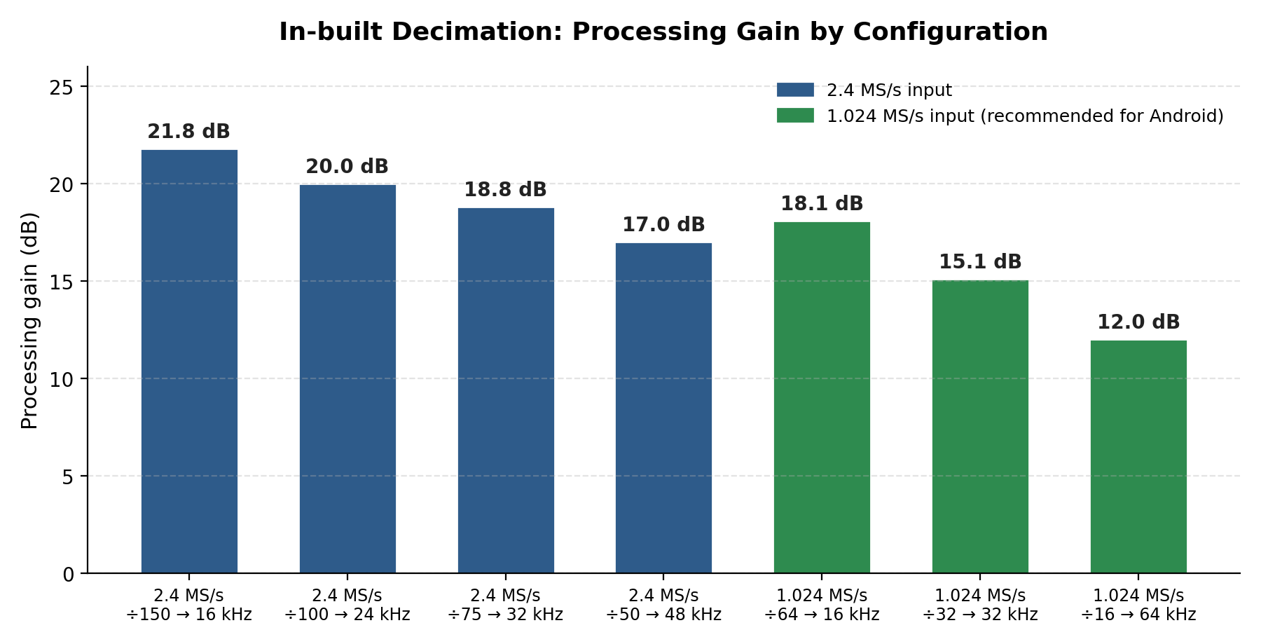
Figure 4.2 — Processing gain achieved by common sample-rate / decimation combinations
★ For Android + HF: use 1.024 MS/s → ÷64 → 16 kHz. Move to 2.4 MS/s only when the ~3.7 dB gain is demonstrably useful and your phone can sustain it thermally.

4.3 IF Bandwidth (Protocol Filter)
The IF filter width limits how much of the spectrum the demodulator sees. Narrower = better SNR but more sensitive to frequency offset.
Mode | Typical range | Notes
CW / CWR | 100–800 Hz | Narrow for contest; wider for general CW
SSB (USB/LSB) | 2.4–3.0 kHz | Auto — slider locked
DSB | 4–6 kHz | Mode default auto
AM | 4–9 kHz | 5–6 kHz ideal for SW; 9 kHz for MW
NFM | 12.5–25 kHz | Auto per channel plan
WFM/WFM ♫ | 200 kHz | Auto — do not narrow
APRS | Auto | Locked — changing causes artefacts
DMR/YSF/DSTAR | 12.5 kHz | Fixed by protocol
ADS-B | Auto | Wideband; do not restrict

4.4 Noise Blanker & Noise Reducer
- Noise Blanker — suppresses impulsive noise (ignition, switching power supplies). Enable on mobile installations.
- Noise Reducer — spectral subtraction post-demodulation. Reduces background hiss at the cost of some audio artefacts. Best on NFM voice.
ℹ Both features reset their calibration when toggled — apply after the signal is stable.
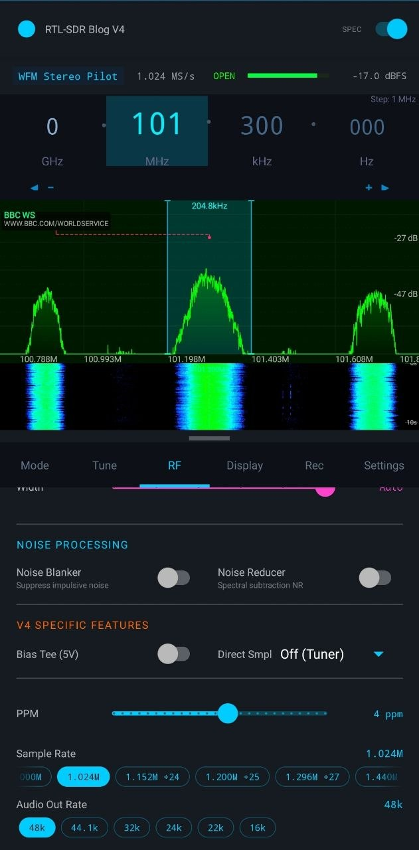
Figure 4.4 — RF tab: Noise Processing, V4-specific features (Bias Tee, Direct Sampling), PPM, and Sample Rate selector

4.5 PPM Correction
Compensates for oscillator frequency error. Most dongles drift ±30–100 ppm. Use a known reference signal (e.g. a broadcast station or GPS-disciplined beacon) to calibrate. The value is shared between the RF tab slider and Settings > PPM.

4.6 Bias Tee
Supplies 5 V DC on the antenna connector to power an active antenna or LNA. Only available on RTL-SDR Blog V3/V4 and compatible hardware. Do NOT enable with a passive antenna — it will damage the dongle.

4.7 Direct Sampling (HF)
Allows HF signals to bypass the R82xx tuner and connect directly to the RTL2832U ADC. Required for HF reception on V3/generic dongles.
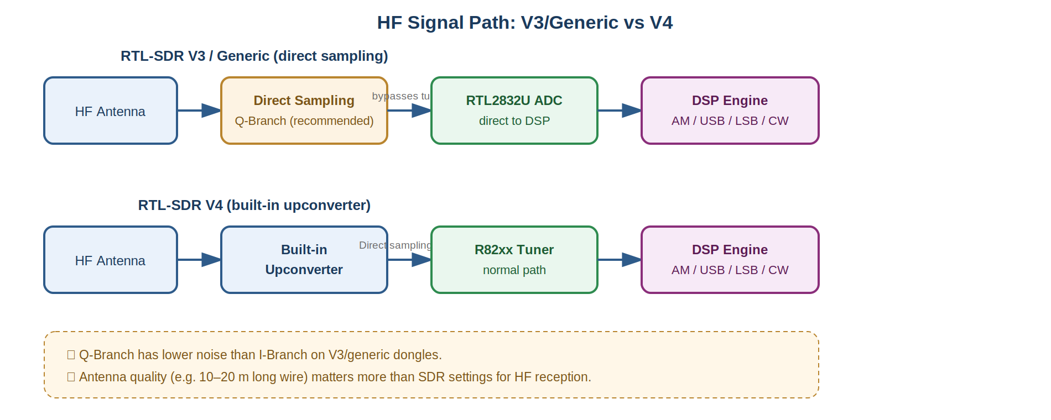
Figure 4.3 — HF signal path: direct sampling (V3/generic) vs. built-in upconverter (V4)
Setting | Use
Off (Tuner) | All frequencies above ~24 MHz; V4 for all HF
Q-Branch | HF on V3/generic — recommended; lower noise than I-Branch
I-Branch | Experimental HF on V3/generic; try if Q-Branch is noisier

5. Memory Slots & Bookmarks

5.1 Per-Protocol Memory Slots
Every demodulation mode has 9 independently cycling memory slots (Slot 0–8). Slot 0 is the mode's default; slots 1–8 let you store different frequency/gain/filter configurations for the same protocol.
- Tap [ Slot # ] to cycle forward (or backward with the reverse button).
- Each cycle saves the current settings into the outgoing slot before loading the new one.
- A never-used slot is automatically seeded from Slot 0 on first visit.
- Slot 9 is reserved for EiBi station tuning and is never cycled normally.
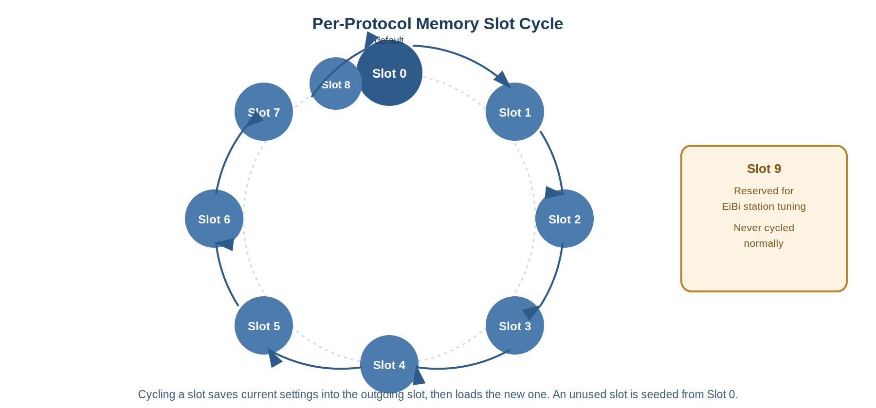
Figure 5.1 — Memory slot cycling order and the special-purpose Slot 9
ℹ Settings saved per slot include: frequency, gain, AGC state, sample rate, decimation, IF bandwidth, squelch, volume, bias-tee, noise blanker/reducer, PPM, waterfall palette, spectrum theme, dB range, and more.

5.2 Bookmarks
Bookmarks store a frequency, mode, label, colour, and optional notes. They are organised into named lists and support favouriting. Access them via the Bookmark FAB or Settings tab.

5.3 Memory Channels
Memory channels are richer than bookmarks — they also store gain, squelch, bias-tee, direct-sampling mode, and PPM. Load a channel and the radio reconfigures completely. Save the current state as a channel from the Memory Activity.

6. EiBi Shortwave Schedule Browser
The EiBi tab is a built-in shortwave broadcast schedule (sourced from Eibi.de). It is not a demodulation mode — it overlays on whatever mode is active, letting you browse and tune stations without changing protocol.

6.1 Opening EiBi
- Tap the EiBi chip on the right end of the Mode tab's analogue row.
- The EiBi tab appears in the drawer. Tap any row to tune the radio to that station's frequency in the appropriate mode (AM/USB/LSB).

6.2 Filter Options
Filter | Description
Language | Show only entries matching selected language codes
Mode | Limit to AM / USB / LSB / CW / DSB transmissions
Target Area | Filter by ITU target region (e.g. Eu, NAm, SEA)
Broadcast Only | Hide utility / non-broadcast stations
Reliable Only | Hide entries flagged irr/tent/test/alt/harm/imod in EiBi
On Air Now | Show only entries currently within their UTC transmission window
Hide Dead Bands | MUF-based propagation estimate: hides frequencies unlikely to propagate to your location right now
★ "Hide Dead Bands" uses your GPS location and a compact F2-layer ionospheric model. It needs a location fix to work — no fix = no filtering.

6.3 Schedule Updates
The EiBi schedule auto-downloads when the tab is opened and silently refreshes every 4 hours while the tab is visible. Schedules older than 7 days are automatically re-fetched. EiBi publishes new schedules twice a year (ITU A/B seasons).

7. Frequency Scanner
The scanner is independent of demodulation mode. Open it via the Scanner FAB or the Scanner button on the Settings tab.

7.1 Scan Modes
- Scan — steps through a defined frequency range, stopping on active channels above the squelch threshold.
- Search — wider, continuous sweep optimised for discovering unknown activity.

7.2 Key Scanner Settings
Setting | Description
Start / Stop frequency | Defines the sweep range
Step size | Frequency increment per hop
Squelch threshold | Signals below this are skipped
Dwell time | How long to listen on an active channel before moving on
Mode | Demodulation mode used during scan pauses
ℹ The scanner captures a pre-scan RF snapshot and restores it when scanning stops, so your regular mode settings are never overwritten.

8. Recording & Playback

8.1 IQ Recording
Records the raw complex I/Q samples as received from the dongle. The file can be replayed through any compatible SDR application (9GRadio, GNU Radio, SDR#, etc.) at the original sample rate.
- Start/stop from the Rec tab or the Record IQ button.
- Files are saved to the configured storage location (Settings > Storage).
- Format: unsigned 8-bit (u8) IQ, matching RTL-SDR conventions.
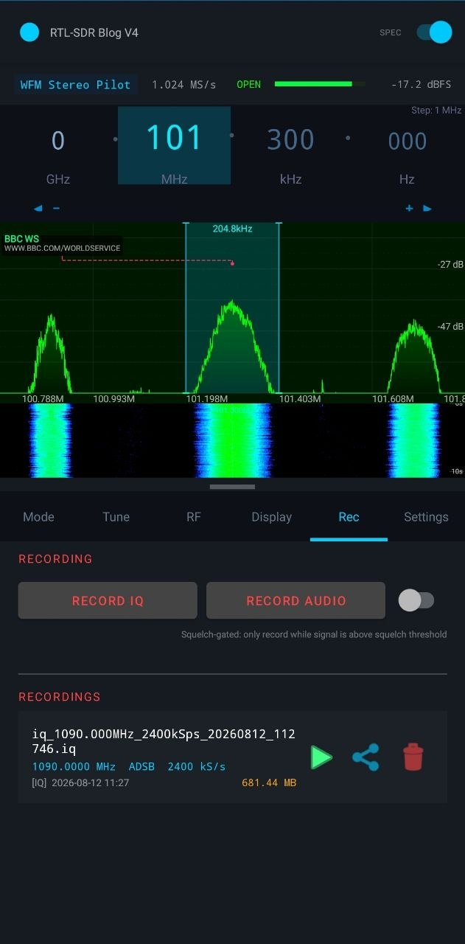
Figure 8.1 — Rec tab: Record IQ / Record Audio controls and a saved IQ recording (frequency, mode, sample rate, timestamp, file size)

8.2 Audio Recording
Records the post-demodulation audio as a WAV file at 48 kHz. The file can be played in any audio player.

8.3 IQ File Playback
Play back a previously recorded IQ file through the same DSP pipeline as a live device. Useful for offline analysis or demonstrating reception to others.
- Open via the "Play IQ File..." button in the Rec tab.
- Specify the original sample rate and centre frequency if the file name does not encode them.
- Looping mode replays the file continuously.

8.4 Recordings List
The Rec tab shows all recordings with type, duration, file size, and timestamp. Tap the play button to replay; tap share to export; tap delete to remove.

9. MLAT — Multi-Lateration (ADS-B)
MLAT improves aircraft position accuracy by comparing the Time Difference of Arrival (TDOA) of ADS-B signals between multiple cooperating ground stations. 9GRadio includes both a client and server implementation.

9.1 Enabling MLAT
- Go to Settings > MLAT to configure the station and network.
- A live MLAT status bar appears in the toolbar when the engine is running, showing peer count, observation exchange, and last fix.

9.2 MLAT Status Indicators
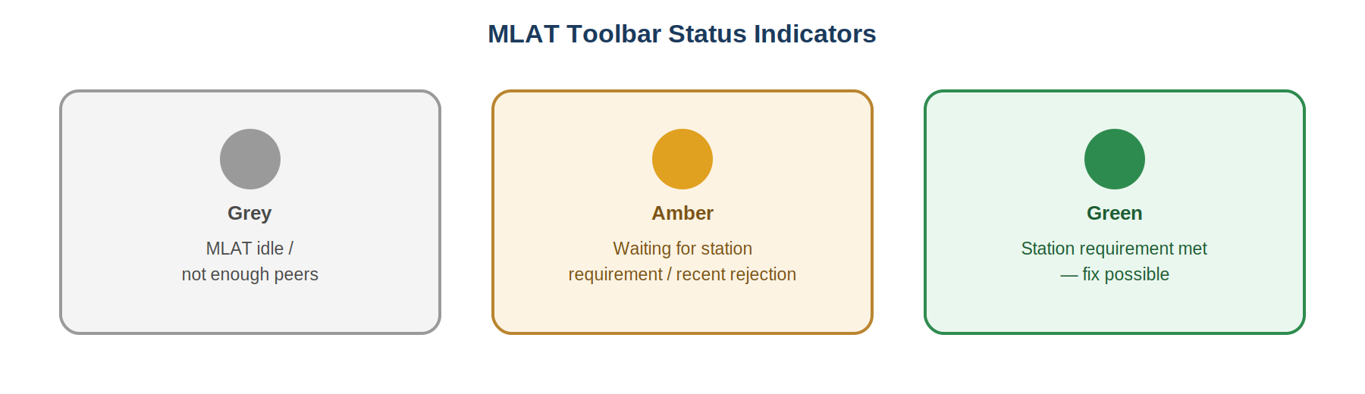
Figure 9.1 — Toolbar status-light meanings
Colour | Meaning
● Grey | MLAT idle / not enough peers
● Amber | Waiting for station requirement or recent rejection
● Green | Station requirement met — fix possible

10. Tips & Troubleshooting

10.1 No Audio / Silence
- Check the Volume slider in the RF tab (should be > 0%).
- Check Squelch — if set too high, valid signals are gated out. Lower to −120 dB to open completely.
- Ensure the correct mode is selected (e.g. USB vs LSB for HF voice).
- Verify the RTL-SDR is connected and the connection state is "Connected".
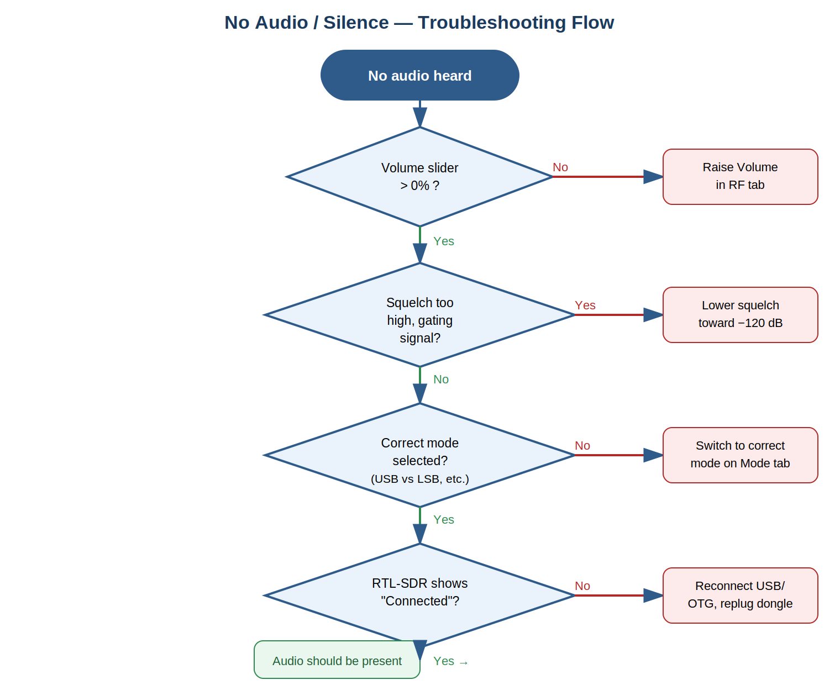
Figure 10.1 — Step-by-step flow for diagnosing no-audio issues

10.2 USB Dropouts / Instability
- Try a shorter, higher-quality OTG cable.
- Reduce sample rate from 2.4 MS/s to 1.024 MS/s.
- Enable USB power saving workaround in the phone's developer options if available.
- Close other apps consuming CPU/USB bandwidth.

10.3 HF Reception Is Poor
- Use direct sampling Q-Branch for RTL-SDR V3/generic. The V4 has a built-in upconverter — leave direct sampling Off.
- Antenna quality matters more than SDR settings on HF. A long wire (10–20 m) is far more effective than doubling the sample rate.
- Disable Tuner AGC and RTL AGC; set gain manually to 20–35 dB.
- Use decimation ÷64 with 1.024 MS/s for maximum processing gain on narrow signals.

10.4 ADS-B Range Is Short
- Use a dedicated 1090 MHz antenna — a simple coaxial collinear or spider antenna outperforms a whip.
- Reduce gain if overload symptoms appear (broad noise peaks, ghosting). Try 35–40 dB.
- Disable spectrum/waterfall in the ADS-B tab toolbar to free CPU for decoding.
- Place the antenna outdoors or near a window with a clear sky view.

10.5 Digital Mode Not Decoding
- Confirm the frequency is correct — most digital modes have narrow channel plans.
- Ensure the squelch is low enough to pass the signal (−65 to −75 dB is a good starting point).
- For DMR/YSF/D-STAR: the mbelib-neo vocoder is always active; no plugin is needed.
- For ACARS: sample rate must be ≥ 2.048 MS/s — the app raises it automatically but verify after mode switch.

10.6 Battery / Thermal Management
- Use 1.024 MS/s instead of 2.4 MS/s for a 3.7 dB theoretical SNR trade-off that saves significant CPU, heat, and battery.
- Turn off the spectrum/waterfall display in ADS-B and AIS modes when not needed.
- Use the Shutdown Timer (Mode tab) to automatically disconnect the SDR after a set interval.

11. Decimation & SNR Reference
This section covers the automatic in-built decimation performed by the DSP engine (e.g. 2.4 MS/s down to 16 kHz), not the Display-tab decimation, which only zooms the FFT/waterfall and carries no processing gain (see §4.2).
Processing gain (SNR improvement from in-built decimation) follows: SNR = 10 × log₁₀(M) dB, where M is the decimation factor. Each doubling of M adds approximately 3 dB because the integrated noise bandwidth halves while the in-band signal is retained.
Input rate | Factor (M) | Output BW | Processing gain | Best use
2.4 MS/s | 150 | 16 kHz | 21.8 dB | Max SNR, HF SW
2.4 MS/s | 100 | 24 kHz | 20.0 dB | HF voice
2.4 MS/s | 75 | 32 kHz | 18.8 dB | HF / NFM
2.4 MS/s | 50 | 48 kHz | 17.0 dB | Wide HF
1.024 MS/s | 64 | 16 kHz | 18.1 dB | Android recommended
1.024 MS/s | 32 | 32 kHz | 15.1 dB | NFM, APRS
1.024 MS/s | 16 | 64 kHz | 12.0 dB | Wide NFM
1.024 MS/s | 1 | 1.024 MHz | 0 dB | Wideband scan
2.048 MS/s | 1 | 2.048 MHz | 0 dB | ADS-B, ACARS
ℹ Starting at 2.4 MS/s provides a theoretical 3.7 dB processing-gain advantage over 1.024 MS/s for any given output rate, at the cost of higher USB bandwidth, CPU load, heat, and battery consumption.

9GRadio
Android SDR • RTL-SDR • All Protocols
AM NFM WFM USB LSB CW DSB APRS ACARS ADS-B AIS DMR YSF D-STAR DIG RAW

