Assignment 4

Michael Hotaling

2020-09-20

## Markdown Basics

## Favorite Foods

1. Pizza
2. Tacos
3. Pad Thai

## Images

Me

Me

## Add a Quote

The path of the righteous man is beset on all sides by the Inequities of the selfish and the tyranny of evil men Blessed is he who, in the name of charity and good will shepherds the weak through the valley of darkness for he is truly his brother’s keeper and the finder of lost children And I will strike down upon thee with great vengeance and furious Anger those who attempt to poison and destroy my brothers And you will know My name is the Lord when I lay my vengeance upon thee. Ezekiel 25:17 Add an Equation —

## Add a Footnote

A footnote will follow.[1]

## Add Citations

* R for Everyone (Lander 2014)
* Discovering Statistics Using R (Field, Miles, Field 2012)

## Inline Code

2 plus 2 is equal to 4

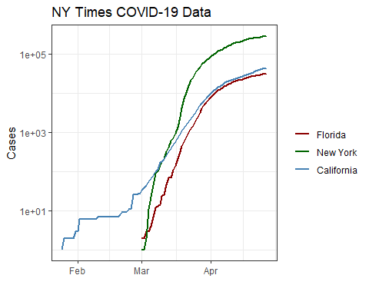

## R4DS Heights vs Earnings

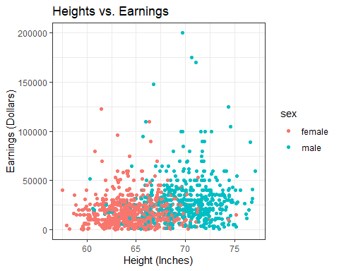

## Tables

## Knitr Table with Kable

One Ring to Rule Them All

|  |  |  |  |  |
| --- | --- | --- | --- | --- |
| name | race | in_fellowship | ring_bearer | age |
| Aragon | Men | TRUE | FALSE | 88 |
| Bilbo | Hobbit | FALSE | TRUE | 129 |
| Frodo | Hobbit | TRUE | TRUE | 51 |
| Galadriel | Elf | FALSE | FALSE | 7000 |
| Sam | Hobbit | TRUE | TRUE | 36 |
| Gandalf | Maia | TRUE | TRUE | 2019 |
| Legolas | Elf | TRUE | FALSE | 2931 |
| Sauron | Maia | FALSE | TRUE | 7052 |
| Gollum | Hobbit | FALSE | TRUE | 589 |

## Pandoc Table

The Lord of the Rings

|  |  |  |  |  |
| --- | --- | --- | --- | --- |
| Name | Race | In Fellowship? | Is Ring Bearer? | Age |
| Aragon | Men | Yes | No | 88 |
| Bilbo | Hobbit | No | Yes | 129 |
| Frodo | Hobbit | Yes | Yes | 51 |
| Sam | Hobbit | Yes | Yes | 36 |
| Sauron | Maia | No | Yes | 7052 |

## References

Field, A., J. Miles, and Z. Field. 2012. *Discovering Statistics Using R.* SAGE Publications. <https://books.google.com/books?id=wd2K2zC3wIC>

Lander, j. P. 2014. *R for Everyone: Advanced Analytics and Graphics* Addison-Wesley Data and Analytics Series. Addison-Wesley. <http://books.google.com/books?id=3eBVAgAAQBAJ>

1. This is a footnote.