ASSIGNMENT 4

Rajasekhar Reddy Karna

2020-09-23

## Markdown Basics

R provides authoring framework for Data Science. Users can use Markdowns to connect to data and run code. Also generates high quality reports to share with audience.

R Markdown is plain text file with extension as .Rmd. It has 3 types of content: - Code chunks to run - Text to display - Metadata to guide build process

Users can customize code on how text to display or parameterize to use in render time.

R Markdown support dozens of static and dynamic output formats, such as HTML, pdf, word, slide shows, notebook, latex, etc…Easy to track in version control tools like GIT and easy to deploy.

## Favorite Foods

* Biryani
* American / Italian food
* Thai food

## Images

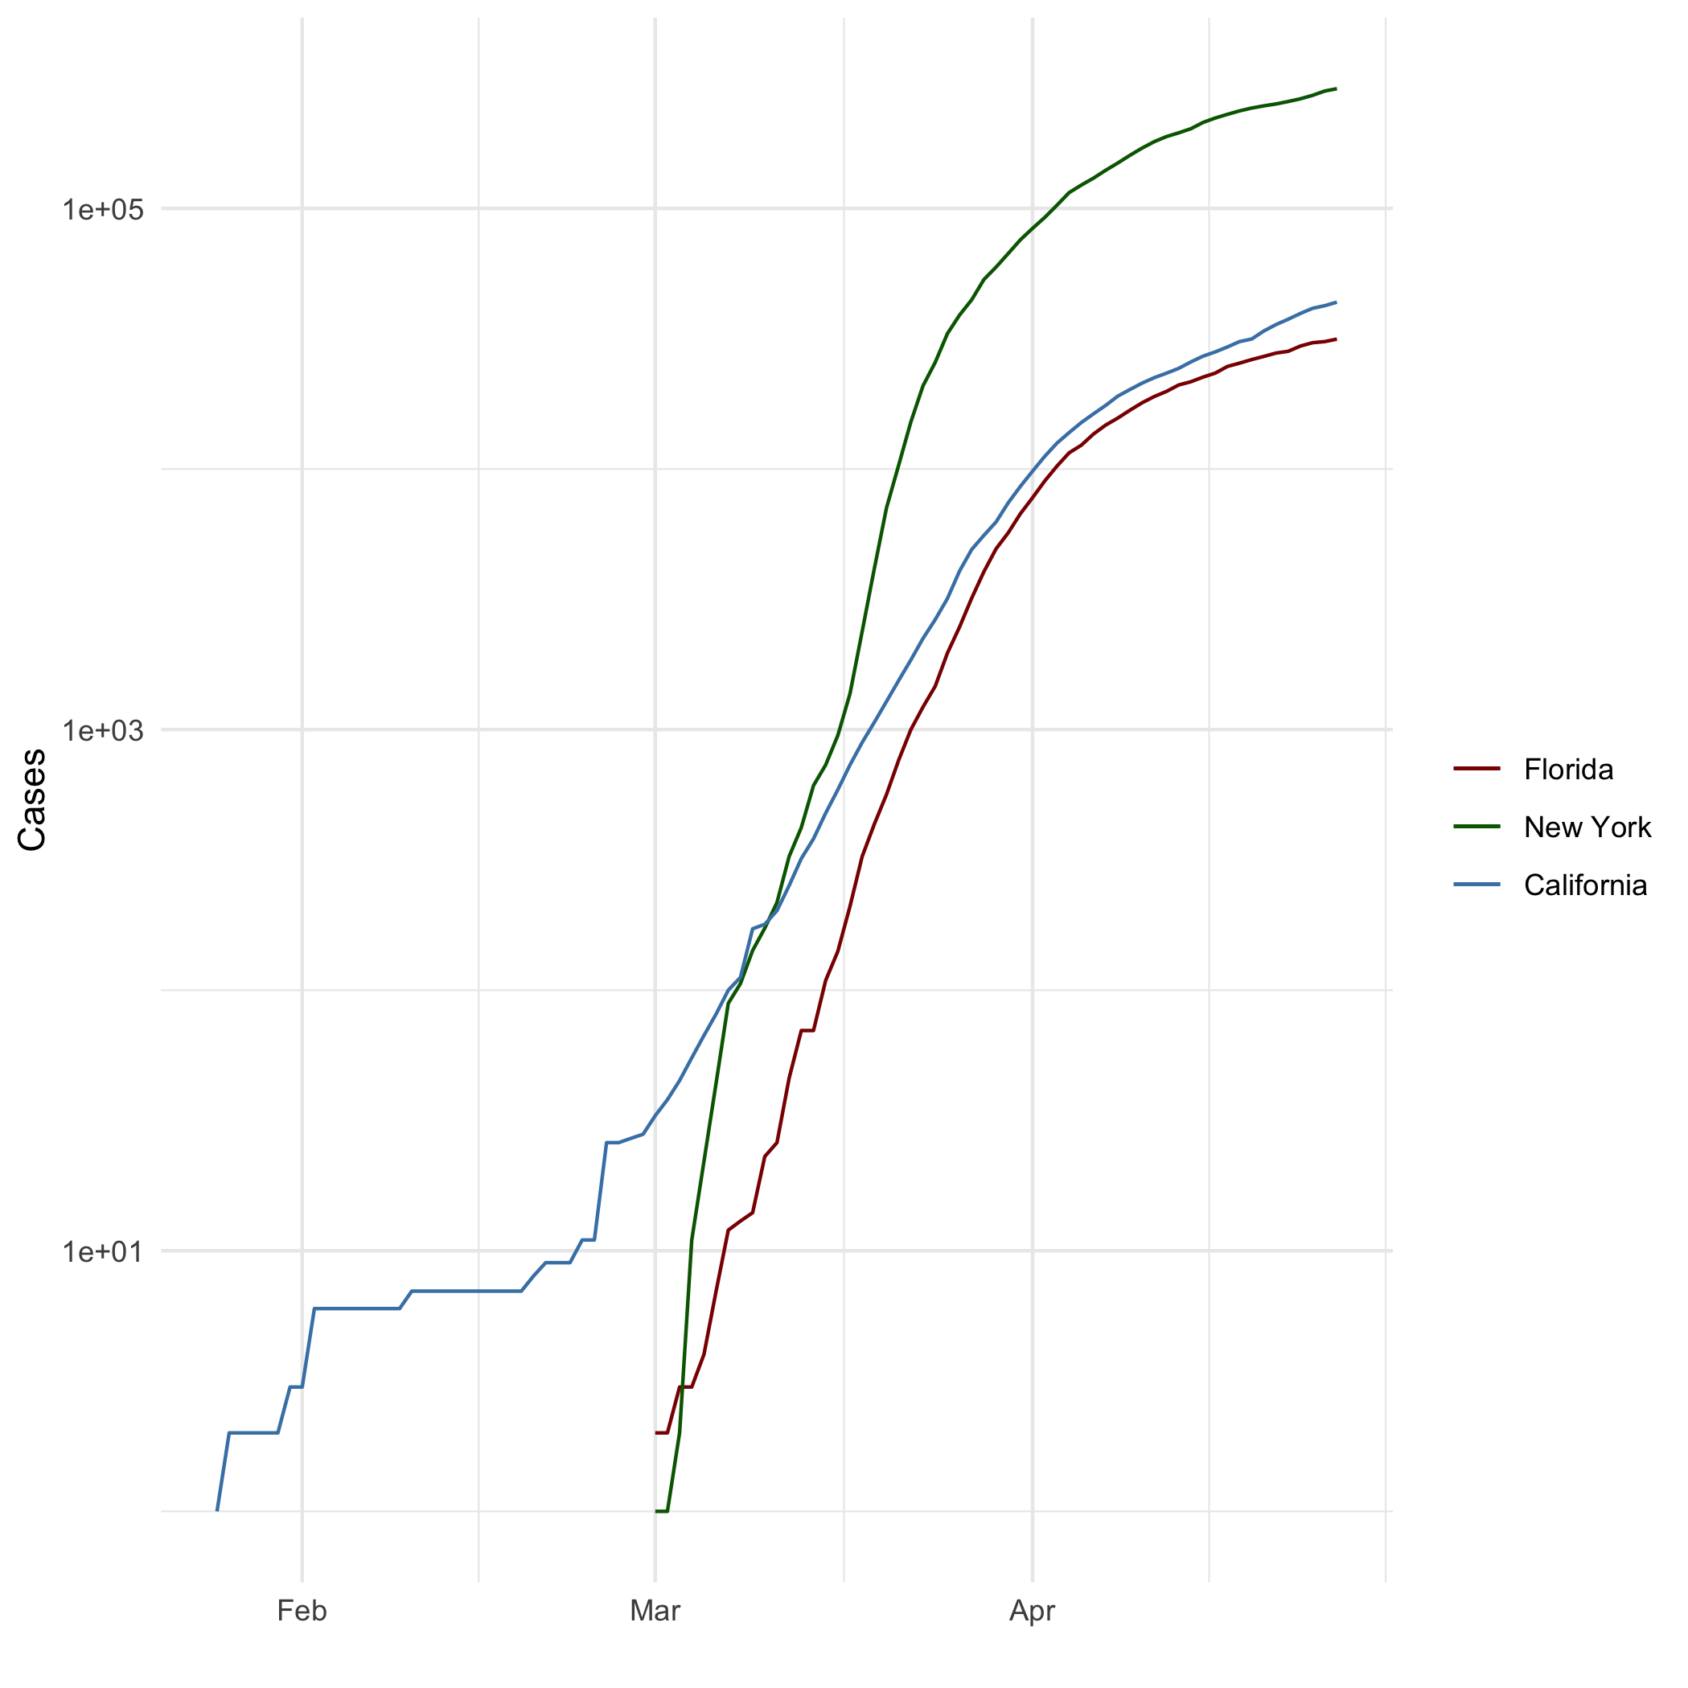

All Cases (Log Plot)

## Add a Quote

Life is full of emotions. Give a touch of positive hope to add smile to those emotions!

## Add an Equation

$$\frac{1}{\sqrt{x}}$$

## Add a Footnote

Summary always makes easy to understand.

## Add Citations

* R for Everyone. Pearson Education, 2017. 2nd Edition.
* Discovering Statistics Using R. Sage Publications, 2012.

## Inline Code

## NY Times COVID-19 Data

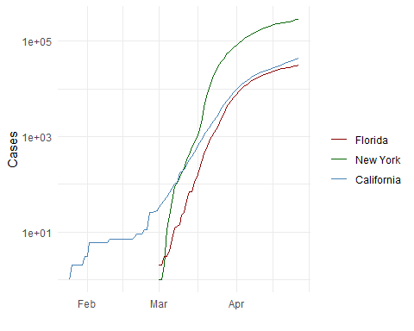

## R4DS Height vs Earnings

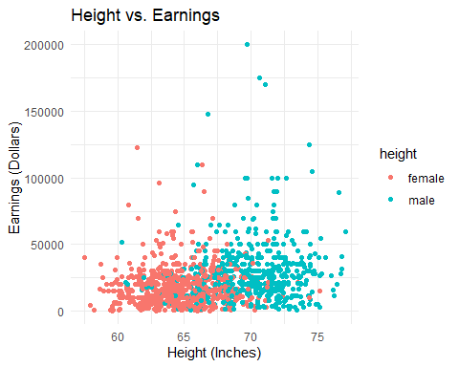

# Tables

## Knitr Table with Kable

One Ring to Rule Them All

|  |  |  |  |  |
| --- | --- | --- | --- | --- |
| name | race | in_fellowship | ring_bearer | age |
| Aragon | Men | TRUE | FALSE | 88 |
| Bilbo | Hobbit | FALSE | TRUE | 129 |
| Frodo | Hobbit | TRUE | TRUE | 51 |
| Galadriel | Elf | FALSE | FALSE | 7000 |
| Sam | Hobbit | TRUE | TRUE | 36 |
| Gandalf | Maia | TRUE | TRUE | 2019 |
| Legolas | Elf | TRUE | FALSE | 2931 |
| Sauron | Maia | FALSE | TRUE | 7052 |
| Gollum | Hobbit | FALSE | TRUE | 589 |

## Pandoc Table

##   
##   
## +-----------+--------+---------------+-------------+------+  
## | name | race | in_fellowship | ring_bearer | age |  
## +===========+========+===============+=============+======+  
## | Aragon | Men | TRUE | FALSE | 88 |  
## +-----------+--------+---------------+-------------+------+  
## | Bilbo | Hobbit | FALSE | TRUE | 129 |  
## +-----------+--------+---------------+-------------+------+  
## | Frodo | Hobbit | TRUE | TRUE | 51 |  
## +-----------+--------+---------------+-------------+------+  
## | Galadriel | Elf | FALSE | FALSE | 7000 |  
## +-----------+--------+---------------+-------------+------+  
## | Sam | Hobbit | TRUE | TRUE | 36 |  
## +-----------+--------+---------------+-------------+------+  
## | Gandalf | Maia | TRUE | TRUE | 2019 |  
## +-----------+--------+---------------+-------------+------+  
## | Legolas | Elf | TRUE | FALSE | 2931 |  
## +-----------+--------+---------------+-------------+------+  
## | Sauron | Maia | FALSE | TRUE | 7052 |  
## +-----------+--------+---------------+-------------+------+  
## | Gollum | Hobbit | FALSE | TRUE | 589 |  
## +-----------+--------+---------------+-------------+------+  
##   
## Table: The Lord of the Rings

# References

<https://rmarkdown.rstudio.com/lesson-1.html> — R Markdown basics R for Everyone. Pearson Education, 2017. 2nd Edition. <https://rstudio.com/wp-content/uploads/2016/03/rmarkdown-cheatsheet-2.0.pdf?_ga=2.247973831.1388722509.1600630414-1304384236.1598891840> – R Markdown cheat sheet for reference. Slake for students feedback and reference comments.