Team Members: Karthick Ramasubramanian, Harsh Mehta, Jonathan Jan

**Replicating the S&P 500:**

1. We started tracking the S&P 500 at 2010-12-31.
2. We sorted all S&P 500 securities in decreasing order of market capitalization and chose the top 40. The number of stocks in our portfolio remains constant at 40.
3. We are reconstituting at the end of every year and rebalancing quarterly.
4. To rebalance our portfolio (every quarter), we simply adjust the weights according to the market-value weighted S&P 500. To reconstitute (annually), we take the top stocks in S&P 500 based on market value and build our portfolio weight adjusted by their market cap.

Assumptions

1. While reconstituting or rebalancing at no effect to the total value of the portfolio. (no transaction cost, tax etc.)
2. ** Number of shares outstanding is assumed to be constant for the last ten years for the companies chosen.

On choosing 40 stocks in S&P.

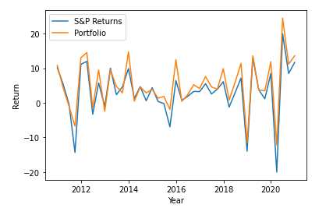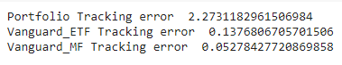

** Return compared from 2011-03 to 2020-12.

The tracking can be improved by choosing more stocks, but it is our opinion that having 40 stocks in the portfolio provides a good balance between tracking error and transaction costs. Also, it is important to note that both the ETF and the Mutual fund are not restricted to rebalance quarterly and reconstitute annually. This flexibility enables them to closely follow the S&P 500.

**Replicating the DJIA:**

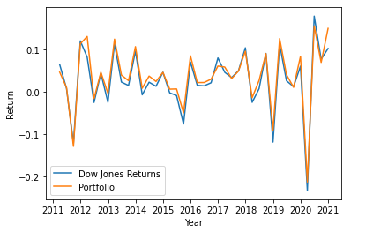

1. To replicate the DJIA, we first scraped Wikipedia for its constituents and used yahoo finance to get the daily returns of the constituents present at the beginning of the year.
2. To rebalance our portfolio (every quarter), we simply take equal weights as in DJIA. There is no rebalancing and only reconstituting every year if there is a change in the 30 stocks.

Assumptions – same as the ones used to replicate the S&P 500.