**Setting up the Direct FE2 model in ABAQUS**

This document gives a short description about the python scripts used to set up Direct FE2 models in ABAQUS.

Two python scripts are used- (A) one for placing the RVEs at the macroscale integration points(*micro_RVE_placement-lin_v2.py*) that needs to be run on ABAQUS CAE GUI and (B) another script(*input_file_PBCs-2D_v5.py*) that modifies the input file to apply the MPCs that can be run from the ABAQUS command prompt.

Make sure the part names and set name are in the same case(upper or lower case) as suggested to avoid errors.

The macroscale part is assigned a negligible stiffness and Poisson’s ratio.

1. **Constructing the Direct FE2 model geometry**
2. Build the macro-scale model in ABAQUS as shown in Figure 1. Ensure that the macro-model is bigger than the RVE micro-structure. The macroscale part is assigned a negligible stiffness and Poisson’s ratio.
3. Mesh the macroscale part. These elements serve as the macroscale-elements and these nodes are the macroscale element nodes- as can be seen in Figure 1.

Figure Example part (macro-scale)

1. Create an instance in the assembly module
2. Create a job and generate the input file for the job.
3. Update the following lines in Script (A) as per the comments



The second keyword needs to be updated in case the macroscale part is not meshed with CPS4 elements with the appropriate element type that can be determined from the input as shown in Figure2.

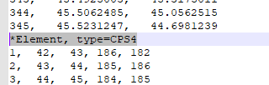

Figure 2 macroscale mesh element type from input file

The file f1 is the ABAQUS input file generated in step-4 above. Fill the input file name

1. Update the following variables as per your model

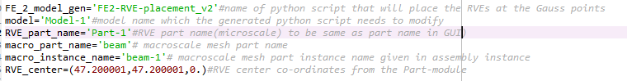

The RVE center is the coordinates of the geometric centre of the RVE as shown in Figure 3.

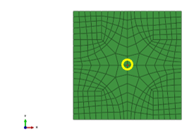

Figure geometric center node of RVE

1. If the RVE is not modelled yet, the RVE Part is to be named with the value of RVE_part_name used in Step-6. Create geometry or node sets with the four Edges and Vertices with the names in Figure 4.

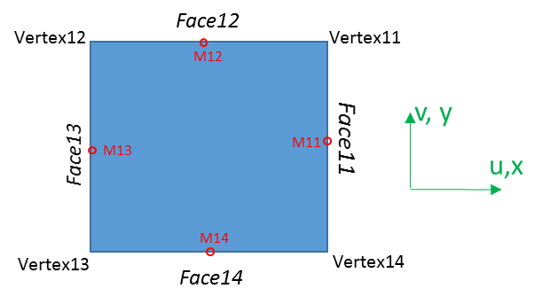

Figure Microstructure

1. The RVE is assigned the respective constitutive properties of the individual phases. The RVEs need to be scaled in volume as per equation 7 in [1]. Since rectangular macroscale elements are used, equation 8[1] is also applicable. This scaling can be easily carried out in ABAQUS by assigning a thickness while defining section in the property module

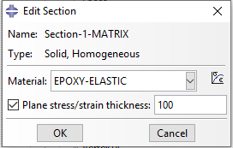

Figure 5 2D Volume scaling by assigning section thickness

1. In ABAQUS CAE GUI, run the modified script to generate the placement script with the name given in Step-6. Then, run the placement script that is generated in the directory to place the RVEs in the designated model and the assembly will appear as shown in Figure 5.

Figure Direct FE2 model with the microscale RVEs positioned at macroscale integration points

1. Ensure all other aspects of the model such as Steps and Loads are set up before moving onto the next section.
2. **Imposing the RVE Periodic Boundary Conditions**

Once the FE2 model has been generated by the script and checked, we can proceed to impose the boundary conditions for the RVEs based on the macroscale nodes. These boundary conditions for the RVE are applied as multi-point constraints in the form of equations(16 and 17)

The macroscale nodes need to be defined with names Nxx-RP, where xx is the node number and the RVEs need to be placed in the Gauss points as will be carried out if script (A) has been correctly executed.

1. After ensuring the RVE edges, vertices and mid-points are named with set names as described above in Figure 4, generate the input file (after carrying out all the steps in (A).)
2. Update the following lines as per the comments below

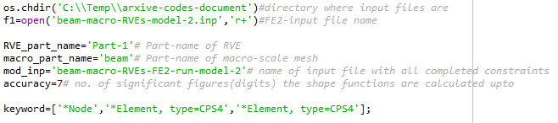

Figure 7 inputs for MPCs python script

1. As per your input files f1 , update the second and third keywords in



2nd keyword refers to the Element type of RVE



Figure 8 RVE mesh element type from input file

3rd keyword refers to the element type of the macroscale mesh which is the same used in the RVE position script described in section A step-5.

1. Run the script in Abaqus cae nogui command line or python 2.7 command line.
2. The modified input file with the specified name should be generated in the directory after the script is executed.
3. The input file(with extension .inp) with name given in mod-inp in Figure 7 will contain the FE2 input file ready to run using Abaqus Command.

A comparison of the computational costs for Direct FE2 and the classical FE2 is carried out in a review article[2].

Reference:

[1] V.B.C. Tan, K. Raju, H.P. Lee, Direct FE2 for concurrent multilevel modelling of heterogeneous structures, Comput. Methods Appl. Mech. Eng. 360 (2020) 112694. https://doi.org/https://doi.org/10.1016/j.cma.2019.112694.

[2] K. Raju, T.-E. Tay, V.B.C. Tan, A review of the FE2 method for composites, Multiscale Multidiscip. Model. Exp. Des. (2021). https://doi.org/10.1007/s41939-020-00087-x. https://rdcu.be/cd0sW