Rebecca Karunakaran

IST 659-42024

Karate Studio Management System

Table of Contents

Summary 3

Stakeholder 3

Business Rules 3

Expectations and Outcomes 4

Conceptual ERD Model 5

Normalized Logical Model 6

Physical Database design 7

Data creation 10

INSERT, UPDATE, DELETE AND alTER SCRIPT 10

Views 15

Studio Info View 15

Class Schedule Studio Location View 17

Event Schedule Studio Location View 18

Student Information View 19

Employee Information View 21

STORED PROCEDURES AND FUNCTIONS 22

sp_AddModify_Employee_Info 22

sp_AddModify_Student_Info 26

IMPLEMENTATION 35

STUDIO LOCATION INFORMATION ACCESS REPORT 35

CLASS SCHEDULE FOR STUDIO ACCESS REPORT 36

EVENT SCHEDULE BY STUDIO ACCESS REPORT 37

STUDIO INFORMATION BY STUDIO ACCESS REPORT 37

Employee schedule ACCESS REPORT 38

Employee MAINTENANCE ACCESS form 39

Student MAINTENANCE ACCESS form 39

REFLECTION 40

# Summary

I have decided to build a database for a Karate Studio where my daughter takes Karate lesson.

The Karate Studio has multiple locations. Each location has a number of Karate classes like ’freshman’, ’sophomore’,’ junior’,’ senior’,’ graduate’ and ’adult class’ and each class can have a number of sessions scheduled. Employees at the studio can be of the following type – full-time, part-time and apprentice. Apart from classes, the studio also hosts a number of events like belt award ceremony, movie night, ice cream social etc. that need to be scheduled and tracked.

# Stakeholder

The owners of the studio are the stakeholders for this project and would like a database to access and maintain student and employee information and track class schedules for all their locations.

# Business Rules

Each studio location has one or more of classes and a class can be held in one of more studio location. A class can have multiple sessions and each session is for one class only. Each session can have one or more students and a student can be register for only one session at any given time. A student may have a Parent (An Adult Student will not have Parent Information) and a Parent must have one or many Students.

Studio employees can be full-time, part-time and apprentices. An employee can work in one or more studio location and a studio location can have one of more employees. Salaries for the employee also various depending on the employee type. A studio can have multiple events scheduled and an event can be scheduled for one or more studio locations.

# Expectations and Outcomes

The stakeholders want to be able to use this database for the following –

1. Track general information about their studio locations like the address, studio manager etc.

There are 2 ways to view the studio location information

* Using a Database View StudioInfoView (page 15)
* MS Access Report ‘Studio Location Information’ (page 35)

1. Track and maintain information about all their employees like address, salary and employee schedule.

The stakeholder can use one of the following ways to maintain Employee information

* A Stored Procedure sp_AddModify_Employee_Info (page 22)
* MS Access Form ‘Employee Maintenance Form’ (page 39)

1. Class Schedule for their studio locations.

Class Schedule can be tracked using

* Database View ClassScheduleStudioLocationView (page 17)
* MS Access Report ‘Class Schedule For Studio Location Report’ (page 36)

1. Track and maintain information about the students like name, address and class they are currently registered for.

The stakeholder can use one of the following ways to maintain Student information

* A Stored Procedure sp_AddModify_Student_Info (page 26)
* MS Access Form ‘Student Maintenance Form’ (page 39)

1. Event Schedule for their studio locations.

Event Schedule can be viewed using

* Database View EventScheduleStudioLocationView (page 18)
* MS Access Report ‘Event Schedule by Studio Report’ (page 37)

# Conceptual ERD Model



**Attribute Property Used -**

**r** is a Required attribute.

**c** is a composite attribute

**u** is a unique attribute.

**d** is a derived attribute.

**m** is a multivalued attribute.

# Normalized Logical Model



**Rules –**

* I have added an associative entity to any many-to-many relationships
* I have chosen to use surrogate keys for all the entities including any associative entities.
* Any composite attribute has been decomposed to their constituent parts
* Multi-value attributes have been moved to a separate table like ‘EventDate’ which I decided to move to the associative entity ‘Event_Location_Schedule’.
* All data types are varchar unless they are used for mathematical computations. Hence, only the attribute ‘Salary’ has been defined as numeric
* The ‘Event_Date’ attribute is defined as ‘DateTime’ since I want to capture not only the date of the event but also the start-time
* The ‘DOB’ attribute is defined as ‘Date’

# Physical Database design

|  |  |
| --- | --- |
| **Table Name** | **Brief Description** |
| Student | Main table to maintain information for a given student |
| Class | Table that contains information on a given class like name, size etc. |
| Class_Schedule | Contains Information on the schedule for a class like class start/end time, instructor assigned to the class etc. |
| Class_Location | An associative table between tables Class and Studio_Location |
| Studio_Location | Contains information about all the studio locations like name, address etc. |
| Parent | For students that are minors, information about the parent is stored in this table |
| Adult_Student_Info | For adult students, information about the student like address is stored in this table |
| Employee | Main table to maintain employee information |
| Employee_Type | Employee type information like full-time/part-time/apprentice is store in this table |
| Employee_Location | An associative table between tables Employee and Studio_Location |
| Event | Main table to store events |
| Event_Location_Schedule | An associative table between tables Event and Studio_Location |
|  |  |

/*-----Create Table Scripts---------*/

Drop table if exists Student

Drop table if exists Employee_Location

Drop table if exists Class_Schedule

Drop table if exists Class_Location

Drop table if exists ClassidenF

Drop table if exists Event_Location_Schedule

Drop table if exists Studio_Location

Drop table if exists Parent

Drop table if exists Employee

Drop table if exists Employee_Type

Drop table if exists [Event]

Drop table if exists [Adult_Student_Info]

--Table : Employee_Type

Create table Employee_Type(

Employee_Type_ID int identity not null,

Employee_Type varchar(20) not null,

Constraint Employee_Type_PK Primary Key(Employee_Type_ID),

Constraint Employee_Type_U1 Unique (Employee_Type)

)

GO

--Table : Employee

Create table Employee(

Employee_ID int identity not null,

Employee_First_Name varchar(20) not null,

Employee_Last_Name varchar(20) not null,

SSN varchar(9) not null,

DOB Date not null,

Street_Address varchar(15) not null,

City varchar(15) not null,

State varchar(15) not null default 'California',

ZipCode varchar(5) not null,

Salary numeric(9,2) not null,

Employee_Type_ID int not null,

Constraint Employee_PK Primary Key(Employee_ID),

Constraint Employee_FK1 Foreign Key(Employee_Type_ID) references Employee_Type(Employee_Type_ID)

)

GO

--Table Sudio_Location

Create table Studio_Location(

Studio_Location_ID int identity not null,

Location_Name varchar(30) not null,

Location_Addresss varchar(15) not null,

City varchar(15) not null,

State varchar(15) not null,

ZipCode varchar(5) not null,

Start_Year char(4) not null,

Manager_ID int not null,

Constraint Studio_Location_PK Primary Key (Studio_Location_ID),

Constraint Studio_Location_FK Foreign Key (Manager_ID) references Employee(Employee_ID)

)

GO

--Table : Employee_Location

Create table Employee_Location(

Employee_Location_ID int identity not null,

Employee_ID int not null,

Studio_Location_ID int not null,

Constraint Employee_Location_PK Primary Key (Employee_Location_ID),

Constraint Employee_Location_FK1 Foreign Key (Employee_ID) references Employee(Employee_ID),

Constraint Employee_Location_FK2 Foreign Key (Studio_Location_ID) references Studio_Location(Studio_Location_ID)

)

GO

--Table : Class

Create table Class(

Class_ID int identity not null,

Class_Name varchar(20) not null,

Class_Description varchar(30) not null,

Max_Class_Size int not null,

Constraint Class_PK Primary Key (Class_ID),

Constraint Class_U1 Unique(Class_Name)

)

GO

--Table Class_Location

Create table Class_Location(

Class_Location_ID int identity not null,

Class_ID int not null,

Studio_Location_ID int not null,

Constraint Class_Location_PK Primary Key (Class_Location_ID),

Constraint Class_Location_FK1 Foreign Key (Class_ID) references Class(Class_ID),

Constraint Class_Location_FK2 Foreign Key (Studio_Location_ID) references Studio_Location(Studio_Location_ID)

)

GO

--Table Parent

Create table Parent(

Parent_ID int identity not null,

Parent_First_Name varchar(30) not null,

Parent_Last_Name varchar(30) not null,

Street_Address varchar(15) not null,

City varchar(15) not null,

State varchar(15) not null,

ZipCode varchar(5) not null,

Email varchar(50) not null,

Phone varchar(15) not null,

Constraint Parent_PK Primary Key (Parent_ID)

)

GO

--Table Class_Schedule

Create table Class_Schedule(

Class_Schedule_ID int identity not null,

Class_Location_ID int not null,

Instructor_ID int not null,

Class_Start_Time varchar(6) not null,

Class_End_Time varchar(6) not null,

Day_Of_The_Week varchar(10) not null,

Constraint Class_Schedule_PK Primary Key (Class_Schedule_ID),

Constraint Class_Schedule_FK1 Foreign Key (Class_Location_ID) references Class_Location(Class_Location_ID),

Constraint Class_Schedule_FK2 Foreign Key (Instructor_ID) references Employee(Employee_ID)

)

GO

--Table Student

Create table Student(

Student_ID int identity not null,

Student_First_Name varchar(30) not null,

Student_Last_Name varchar(30) not null,

DOB Date not null,

Parent_ID int, -- I made this field optional since adult students may not have a parent

Class_Schedule_ID int not null,

Constraint Student_PK Primary Key (Student_ID),

Constraint Student_FK1 Foreign Key (Parent_ID) references Parent(Parent_ID),

Constraint Student_FK2 Foreign Key (Class_Schedule_ID) references Class_Schedule(Class_Schedule_ID)

)

GO

--Table Event

Create table [Event](

Event_ID int identity not null,

Event_Name varchar(20) not null,

Event_Description varchar(30) ,

Constraint Event_PK primary key (Event_ID),

Constraint Event_U1 unique (Event_Name)

)

GO

--Create table Event_Location_Schedule

Create table Event_Location_Schedule(

Event_Location_Schedule_ID int identity not null,

Studio_Location_ID int not null,

Event_ID int not null,

Event_Date DateTime not null,

Constraint Event_Location_Schedule_PK Primary Key (Event_Location_Schedule_ID),

Constraint Event_Location_Schedule_FK1 Foreign Key(Studio_Location_ID) references Studio_Location(Studio_Location_ID),

Constraint Event_Location_Schedule_FK2 Foreign Key(Event_ID) references [Event](Event_ID)

)

GO

--Create table Adult_Student_Info

Create table Adult_Student_Info(

Adult_Student_Info_ID int identity not null,

Street_Address varchar(15) not null,

City varchar(15) not null,

State varchar(15) not null,

ZipCode varchar(5) not null,

Email varchar(50) not null,

Phone varchar(15) not null,

Constraint Adult_Student_Info_PK Primary Key (Adult_Student_Info_ID)

)

GO

/*-----End Create Table Scripts---------*/

# Data creation

## INSERT, UPDATE, DELETE AND alTER SCRIPT

/*---- Needed to make some corrections to the tables---------------*/

--Typo in Column Name Location_Address

SP_RENAME 'Studio_Location.Location_Addresss', 'Location_Address', 'COLUMN'

GO

-- Increasing the of some column since they could hold longer string values

Alter table Employee

Alter Column Street_Address varchar(30) not null

GO

Alter table Studio_Location

Alter Column Location_Address varchar(30) not null

GO

Alter table Parent

Alter Column Street_Address varchar(30) not null

GO

--Need to change some columns

Alter table Class

Add Age_Group varchar(15) not null

GO

Alter table Class

Alter Column Class_Description varchar(50) not null

GO

Alter table [Event]

Alter Column Event_Name varchar(30) not null

GO

Alter table [Event]

Alter Column Event_Description varchar(50)

GO

--Added FK to table Student for table Adult_Student_Info

Alter table Student

Add Adult_Student_Info_ID int -- I made this an optional since only Adult Sudents will have this field populate

GO

Alter table Student

Add Constraint Student_FK3 Foreign Key (Adult_Student_Info_ID) references Adult_Student_Info(Adult_Student_Info_ID)

GO

/*----End Needed to make some corrections to the tables---------------*/

/*----Insert Record into tables ------*/

--Table Employee_Type

Insert into Employee_Type(Employee_Type)

values('FullTime'),('PartTime'),('Apprentice')

GO

--Review to see if data is correct

Select * from Employee_Type

GO

--Table Employee

--I'm not including the State Column in the insert because I want it to default to 'California'

Insert into Employee(Employee_First_Name, Employee_Last_Name, SSN, DOB, Street_Address, City, ZipCode, Salary, Employee_Type_ID)

values('Daniel','Martinez','600345999','03/04/2000','34 Cross Street','San Jose','97654',40000,1)

--The rest of the inserts have State Column specified

Insert into Employee(Employee_First_Name, Employee_Last_Name, SSN, DOB, Street_Address, City, State, ZipCode, Salary, Employee_Type_ID)

values('Gina','Daniel','603853856','09/21/2003','3435 Mulberry Ct','San Jose','California','93411',10000,3)

Insert into Employee(Employee_First_Name, Employee_Last_Name, SSN, DOB, Street_Address, City, ZipCode, Salary, Employee_Type_ID)

values('Kim','Lee','938647846','01/20/1995','456 HorseShoe Lane','San Jose','94633',60000,1)

Insert into Employee(Employee_First_Name, Employee_Last_Name, SSN, DOB, Street_Address, City, ZipCode, Salary, Employee_Type_ID)

values('Sam','Victor','653647888','07/22/1999','BlueCross Road','Santa Clara','97364',60000,2)

Insert into Employee(Employee_First_Name, Employee_Last_Name, SSN, DOB, Street_Address, City, ZipCode, Salary, Employee_Type_ID)

values('Shirley','Lou','65367833','03/04/2001','First Street','Sunnyvale','95633',60000,2)

--Review to see if data is correct

Select * from Employee

GO

-- Table Studio Location

Insert into Studio_Location(Location_Name,Location_Address,City,State, ZipCode,Start_Year,Manager_ID)

values('America''s Best Karate','12 street','San Jose','California','93532','2015',3)

Insert into Studio_Location(Location_Name,Location_Address,City,State, ZipCode,Start_Year,Manager_ID)

values('Victory Marital Arts','3444 Mckee Avenue','Santa Clara','California','93266','2010',3)

Insert into Studio_Location(Location_Name,Location_Address,City,State, ZipCode,Start_Year,Manager_ID)

values('Xtremen Martial Arts','78 Walnut Grove','Sunnyvale','California','95623','2017',4)

--Review to see if data is correct

Select * from Studio_Location

GO

--Delete from Studio_Location since I accidently inserted duplicate rows

Delete from Studio_Location where Studio_Location_ID between 1 and 7

GO

--Table Class

Insert into Class(Class_Name,Class_Description,Max_Class_Size,Age_Group)

values('Freshman','Beginner''s Class Belts - white to yellow1 belt',30, '5 and above')

Insert into Class(Class_Name,Class_Description,Max_Class_Size,Age_Group)

values('Sophomore','Intermediate 1 - orange to green1',30, '5 and above')

Insert into Class(Class_Name,Class_Description,Max_Class_Size,Age_Group)

values('Junior','Intermediate 2 - purple to blue1',30, '5 and above')

Insert into Class(Class_Name,Class_Description,Max_Class_Size,Age_Group)

values('Senior','Advanced - brown to red-black',30, '5 and above')

Insert into Class(Class_Name,Class_Description,Max_Class_Size,Age_Group)

values('Graduates','Proficient - black belt',20, '10 and above')

Insert into Class(Class_Name,Class_Description,Max_Class_Size,Age_Group)

values('Adult','Cardio Class',20, '14 and above')

Insert into Class(Class_Name,Class_Description,Max_Class_Size,Age_Group)

values('Pee-Wee','Toddlers',20, '3 and above')

--Review to see if data is correct

Select * from Class

GO

--Table Class_Location

Insert into Class_Location(Class_ID,Studio_Location_ID)

values(1,8),(1,10),(2,8),(2,9),(2,10),(3,9),(3,10) ,(4,8),(5,9),(6,10),(6,8),(7,8) ,(5,8),(2,8),(3,10)

--Review to see if data is correct

select * from Class_Location

--Remove Duplicates

delete from Class_Location

where Class_Location_ID=22

delete from Class_Location

where Class_Location_ID=23

--Review to see if data is correct

select * from Class_Location

GO

--Table Class_Schedule

Insert into Class_Schedule(Class_Location_ID,Instructor_ID,Class_Start_Time,Class_End_Time,Day_Of_The_Week)

values(9,1,'5:30pm','6:30pm','Monday')

Insert into Class_Schedule(Class_Location_ID,Instructor_ID,Class_Start_Time,Class_End_Time,Day_Of_The_Week)

values(9,1,'4:30pm','6:00pm','Friday')

Insert into Class_Schedule(Class_Location_ID,Instructor_ID,Class_Start_Time,Class_End_Time,Day_Of_The_Week)

values(10,2,'5:00pm','6:00pm','Wednesday')

Insert into Class_Schedule(Class_Location_ID,Instructor_ID,Class_Start_Time,Class_End_Time,Day_Of_The_Week)

values(11,2,'2:30pm','3:30pm','Saturday')

Insert into Class_Schedule(Class_Location_ID,Instructor_ID,Class_Start_Time,Class_End_Time,Day_Of_The_Week)

values(11,3,'5:30pm','6:30pm','Monday')

Insert into Class_Schedule(Class_Location_ID,Instructor_ID,Class_Start_Time,Class_End_Time,Day_Of_The_Week)

values(12,4,'4:30pm','5:30pm','Tuesday')

Insert into Class_Schedule(Class_Location_ID,Instructor_ID,Class_Start_Time,Class_End_Time,Day_Of_The_Week)

values(13,5,'5:30pm','6:30pm','Friday')

Insert into Class_Schedule(Class_Location_ID,Instructor_ID,Class_Start_Time,Class_End_Time,Day_Of_The_Week)

values(12,5,'1:30pm','3:30pm','Saturday')

Insert into Class_Schedule(Class_Location_ID,Instructor_ID,Class_Start_Time,Class_End_Time,Day_Of_The_Week)

values(14,2,'5:30pm','6:30pm','Monday')

Insert into Class_Schedule(Class_Location_ID,Instructor_ID,Class_Start_Time,Class_End_Time,Day_Of_The_Week)

values(15,1,'7:00pm','8:30pm','Tuesday')

Insert into Class_Schedule(Class_Location_ID,Instructor_ID,Class_Start_Time,Class_End_Time,Day_Of_The_Week)

values(16,3,'7:00pm','8:30pm','Thursday')

Insert into Class_Schedule(Class_Location_ID,Instructor_ID,Class_Start_Time,Class_End_Time,Day_Of_The_Week)

values(19,3,'5:00pm','6:30pm','Saturday')

--Review to see if data is correct

Select * from Class_Schedule

GO

Update Class_Schedule

set Class_Start_Time = '5:30pm'

where Class_Schedule_ID = 24

Update Class_Schedule

set Class_Start_Time = '5:00pm'

where Class_Schedule_ID = 23

Select * from Class_Schedule

GO

--Table Parent

Insert into Parent(Parent_First_Name,Parent_Last_Name,Street_Address, City, State, ZipCode,Email,Phone)

values('Rebecca','Karunakaran','264 Joshua Court','San Jose','California','97656','Rebecca_Karunakaran@gmail.com','408-865-9776')

Insert into Parent(Parent_First_Name,Parent_Last_Name,Street_Address, City, State, ZipCode,Email,Phone)

values('James','Smith','6 Washington Way','Santa Clara','California','97656','James_Smith@yahoo.com','408-463-5424')

Insert into Parent(Parent_First_Name,Parent_Last_Name,Street_Address, City, State, ZipCode,Email,Phone)

values('Gina','Parker','78 North Street','San Jose','California','95432','Gina_Parker@gmail.com','765-443-5235')

Insert into Parent(Parent_First_Name,Parent_Last_Name,Street_Address, City, State, ZipCode,Email,Phone)

values('John','Franklin','336 Main Street','Sunnyvale','California','94322','John_Franklin@hotmail.com','408-459-1112')

--Review to see if data is correct

Select * from Parent

GO

--Table Student

Insert into Student(Student_First_Name,Student_Last_Name,DOB,Parent_ID,Class_Schedule_ID)

values('Liam','Smith','01/20/2010',2,12)

Insert into Student(Student_First_Name,Student_Last_Name,DOB,Parent_ID,Class_Schedule_ID)

values('Ava','Smith','01/20/2012',2,13)

Insert into Student(Student_First_Name,Student_Last_Name,DOB,Parent_ID,Class_Schedule_ID)

values('Nia','Karunakaran','06/06/2011',1,19)

Insert into Student(Student_First_Name,Student_Last_Name,DOB,Parent_ID,Class_Schedule_ID)

values('Kevin','Parker','09/11/2008',3,32)

Insert into Student(Student_First_Name,Student_Last_Name,DOB,Parent_ID,Class_Schedule_ID)

values('Joseph','Frankin','01/20/2007',4,28)

--Inserted an Adult Records who will not have a Parent Record

Insert into Student(Student_First_Name,Student_Last_Name,DOB,Parent_ID,Class_Schedule_ID)

values('Zion','Charles','01/20/1998',NULL,32)

Insert into Student(Student_First_Name,Student_Last_Name,DOB,Parent_ID,Class_Schedule_ID)

values('Gina','Davis','01/20/1985',NULL,32)

--Review to see if data is correct

select * from Student

GO

--Updating Student Zion Charles to an Adult class since he is over 18years

Update Student

set Class_Schedule_ID = 34

where Student_ID = 11

GO

--Updating Student Gina Davis to an Adult class since she is over 18years

Update Student

set Class_Schedule_ID = 34

where Student_ID = 12

GO

--Added new table Adult_Student_Info and need to update values in the Student table for the Adult record

Update Student

Set Adult_Student_Info_ID = 1

where Student_ID = 11

GO

Update Student

Set Adult_Student_Info_ID = 2,

where Student_ID = 12

GO

--Review to see if data is correct

select * from Student

GO

--Table Event

Insert into [Event](Event_Name,Event_Description)

values('Black Belt Ceremony','Black Belt will be awraded to qualifying students'),

('Ice-Cream Social',null), ('Movie Night',null)

--Review to see if data is correct

Select * from [Event]

GO

--Table Event_Location_Schedule

Insert into Event_Location_Schedule(Studio_Location_ID,Event_ID,Event_Date)

values(8,1,'06/09/2018 5:00PM'), (8,2,'09/09/2018 6:30PM'), (9,1,'07/05/2018 5:30PM'), (10,3,'08/23/2018 7:00 PM'), (10,1,'06/20/2018 4:00PM')

GO

--Review to see if data is correct

Select * from Event_Location_Schedule

GO

--Table Employee_Location

Insert into Employee_Location(Employee_ID,Studio_Location_ID)

values(1,8),(1,10),(2,9),(3,8),(4,8),(5,10),(3,9)

GO

--Review to see if data is correct

Select * from Employee_Location

GO

--Table Adult_Student_Info

Insert into Adult_Student_Info(Street_Address,City,State,ZipCode,Email,Phone)

values('56 Blue Hawk Dr','Morgan Hill','California','95436','Zion_Charles@yahoo.com','408-938-8473')

GO

Insert into Adult_Student_Info(Street_Address,City,State,ZipCode,Email,Phone)

values('600 Shorelane','Sunnyvale','California','92323','Gine_Davis@hotmail.com','408-364-2222')

GO

--Review to see if data is correct

Select * from Adult_Student_Info

GO

/*-----------End Insert Statements------------------*/

## Views

### Studio Info View

**PURPOSE**

One of the request from the stakeholder was to be able to track general information about their studio locations like the address, studio manager etc. The StudioInfoView was built to display the requested information.

------View to track Studio Information -----------

drop View StudioInfoView

GO

Create View StudioInfoView As

Select Studio_Location.Location_Name,

Studio_Location.Location_Address as StreetAddress ,

Studio_Location.City,

Studio_Location.State ,

Studio_Location.ZipCode,

(Employee.Employee_First_Name + ' ' + Employee.Employee_Last_Name) as Manager,

Count(Employee.Employee_ID) as TotalEmployees -- Used Aggregate Function Count to find total employee for a studio

From Studio_Location

Join Employee on Studio_Location.Manager_ID = Employee.Employee_ID

join Employee_Location on Employee_Location.Studio_Location_ID = Studio_Location.Studio_Location_ID

Group by Studio_Location.Location_Name,

Studio_Location.Location_Address ,

Studio_Location.City,

Studio_Location.State ,

Studio_Location.ZipCode,

(Employee.Employee_First_Name + ' ' + Employee.Employee_Last_Name)

GO

Select * from StudioInfoView

GO

**RESULT**

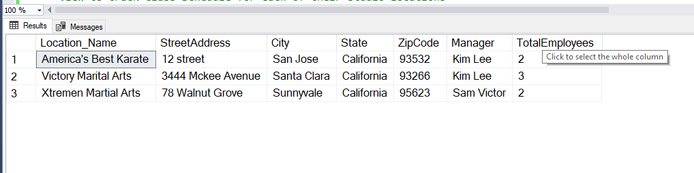

### Class Schedule Studio Location View

**PURPOSE**

The Stakeholders also wanted a way to view the Class Schedule for all their Studios. This view was built to enable to get that information.

-----View to track Class Schedule for each of their studio locations --------

Drop View ClassScheduleStudioLocationView

GO

Create View ClassScheduleStudioLocationView as

Select Studio_Location.Location_Name as Studio,

Class.Class_Name as Class,

(Class_Schedule.Class_Start_Time + ' to ' + Class_Schedule.Class_End_Time) as ClassTiming,

Class_Schedule.Day_Of_the_Week as Day,

(Employee.Employee_First_Name + ' ' + Employee.Employee_Last_Name) as Instructor

from Class_Schedule

join Class_Location on Class_Schedule.Class_Location_ID = Class_Location.Class_Location_ID

join Class on Class_Location.Class_ID = Class.Class_ID

join Studio_Location on Class_Location.Studio_Location_ID = Studio_Location.Studio_Location_ID

join Employee on Class_Schedule.Instructor_ID = Employee.Employee_ID

GO

Select * from ClassScheduleStudioLocationView

GO

**RESULT**

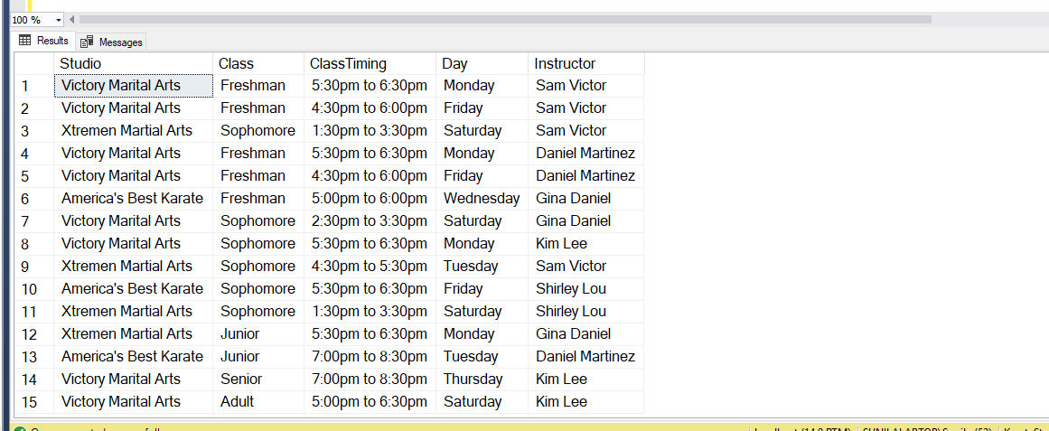

### Event Schedule Studio Location View

**PURPOSE**

The Stakeholders also wanted a way to view the Event Schedule for all their Studios. This view was built to enable to get that information.

-----View to track Event Schedule for each of their studio locations --------

Drop View EventScheduleStudioLocationView

GO

Create View EventScheduleStudioLocationView as

Select Studio_Location.Location_Name as Studio,

Event.Event_Name as Event,

(FORMAT(Event_Location_Schedule.Event_Date,'dd/MM/yy') + ' ' + FORMAT(Event_Location_Schedule.Event_Date,'hh:mm tt')) as Date -- want to convert into readable format with AM/PM

from Event_Location_Schedule

join Event on Event_Location_Schedule.Event_ID = Event.Event_ID

join Studio_Location on Event_Location_Schedule.Studio_Location_ID = Studio_Location.Studio_Location_ID

GO

**RESULT**

--View Event for all Studios

Select * from EventScheduleStudioLocationView

order by Studio

GO

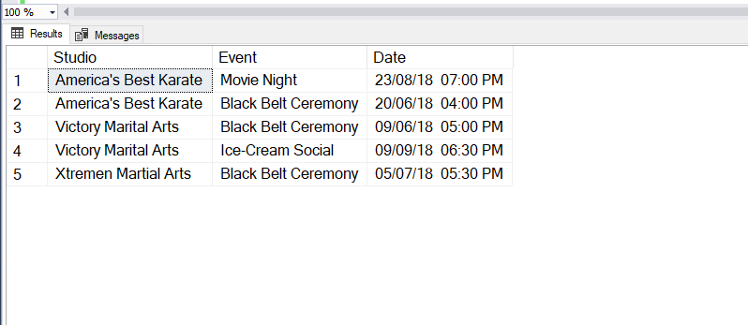

--View Event per Studio

Select * from EventScheduleStudioLocationView

where Studio = 'Victory Marital Arts'

GO

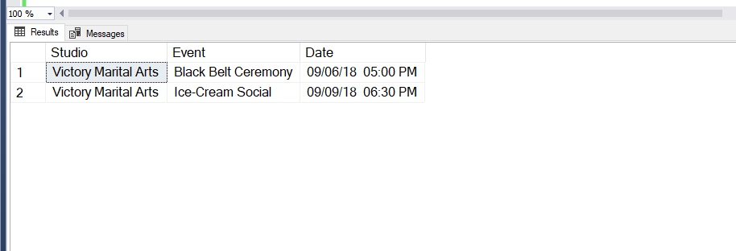

### Student Information View

**PURPOSE**

The Stakeholders want to track information about the students like name, address and class they are currently registered for. The StudentInformationView does just that.

-----View to track Student Information --------

Drop View StudentInformationView

GO

Create View StudentInformationView as

Select(Student.Student_First_Name + ' ' + Student.Student_Last_Name) as StudentName,

isnull((Parent.Parent_First_Name + ' ' + Parent.Parent_Last_Name),'N/A') as ParentName, --Adult Students will not have a Parent Record

convert(varchar, Student.DOB, 101) as DOB,

(DATEDIFF (yy, Student.DOB, GETDATE())) as Age,

(Case When Student.Parent_ID is not null then Parent.Phone else Adult_Student_Info.Phone end) as ContactNumber,

Studio_Location.Location_Name as Studio,

Class.Class_Name as Class ,

Class_Schedule.Day_Of_The_Week as Day,

(Class_Schedule.Class_Start_Time + ' to ' + Class_Schedule.Class_End_Time) as ClassTiming

from Student

left join Parent on Student.Parent_ID = Parent.Parent_ID -- left join to get Student records that have not Parent Records because they are Adults

join Class_Schedule on Student.Class_Schedule_ID = Class_Schedule.Class_Schedule_ID

join Class_Location on Class_Schedule.Class_Location_ID = Class_Location.Class_Location_ID

join Studio_Location on Class_Location.Studio_Location_ID = Studio_Location.Studio_Location_ID

left join Adult_Student_Info on Student.Adult_Student_Info_ID =Adult_Student_Info.Adult_Student_Info_ID

join Class on Class_Location.Class_ID = Class.Class_ID

GO

**RESULT**

--View Students for all Studios

Select * from StudentInformationView

order by Studio,Class

GO

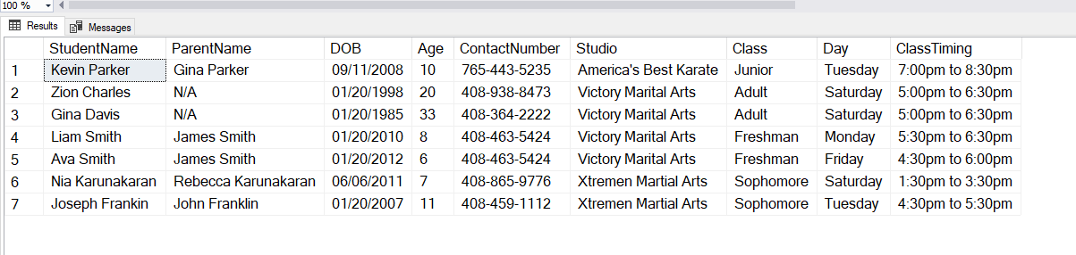

--View Students per Studio

Select * from StudentInformationView

where Studio = 'Victory Marital Arts'

GO

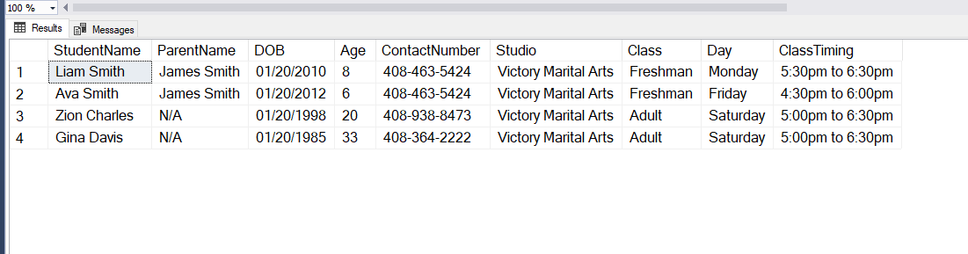

### Employee Information View

**PURPOSE**

This view allows the stakeholder view all their employee’s schedule and as well allows individual employee to view their individual schedule.

-----View to track Employee Information --------

Drop View EmployeeInformationView

GO

Create View EmployeeInformationView as

Select (Employee.Employee_First_Name + ' ' + Employee.Employee_Last_Name) as EmployeeName,

Studio_Location.Location_Name as Studio,

Class.Class_Name,

(Class_Schedule.Class_Start_Time + ' to ' + Class_Schedule.Class_End_Time) as ClassTiming,

Class_Schedule.Day_Of_The_Week Day

from Employee

join Class_Schedule on Class_Schedule.Instructor_ID = Employee.Employee_ID

join Class_Location on Class_Schedule.Class_Location_ID = Class_Location.Class_Location_ID

join Class on Class_Location.Class_ID = Class.Class_ID

join Studio_Location on Class_Location.Studio_Location_ID = Studio_Location.Studio_Location_ID

**RESULT**

select * from EmployeeInformationView

order by EmployeeName,Studio

GO

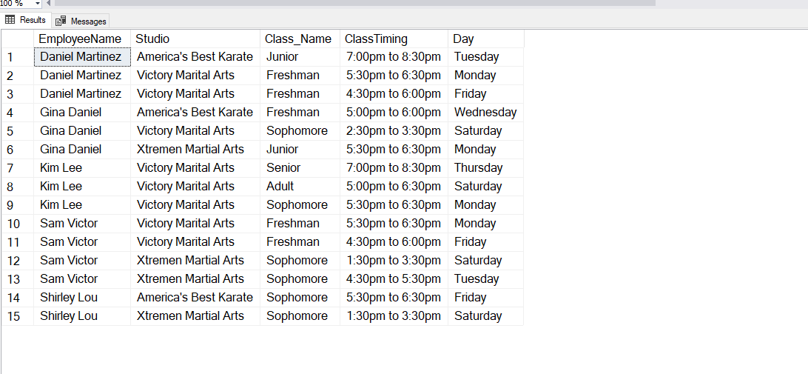

select * from EmployeeInformationView

where EmployeeName = 'Sam Victor'

GO

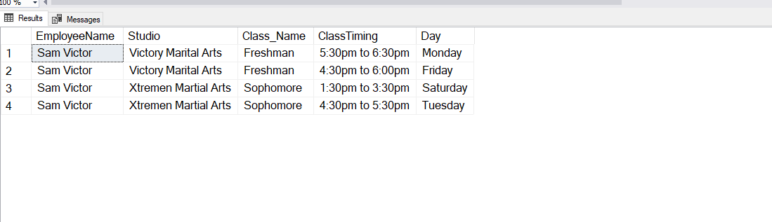

## STORED PROCEDURES AND FUNCTIONS

### sp_AddModify_Employee_Info

**PURPOSE**

The Stakeholders wanted to be able to maintain information about all their employees like address, salary and employee schedule. This stored procedure allows them to both add or update employee information.

--Function to retrieve the Employee_Type_ID for a given Employee_Type to be used in

--Stored Procedure sp_AddModify_EMployee_Info

Create Function dbo.Lookup_EmployeeType_ID(@Employee_Type varchar(20))

Returns int as

Begin

Declare @returnValue int

Select @returnValue = Employee_Type_ID

from Employee_Type

Where Employee_Type = @Employee_Type

--Send the Employee_Type_ID back

return @returnValue

End

Go

--Check to see if function works correctly

Select *, dbo.Lookup_EmployeeType_ID(Employee_Type) as ReturnValueFromFN

from Employee_Type

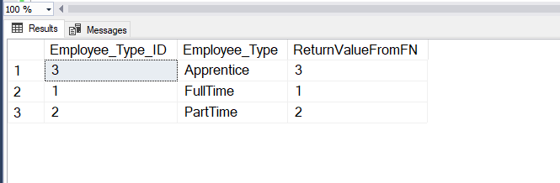

---Stored Procedure to Add/Modify Employee Information

Drop Procedure dbo.sp_AddModify_EMployee_Info

Create Procedure sp_AddModify_Employee_Info(

@Employee_First_Name varchar(20),

@Employee_Last_Name varchar(20),

@Employee_SSN varchar(9),

@Employee_DOB Date,

@Street_Address varchar(30),

@City varchar(15),

@State varchar(15),

@ZipCode varchar(5),

@Salary numeric(9,2),

@Employee_Type varchar(20)

)

AS

Begin

Declare @Employee_Type_ID int

--Get the Employee_Type_ID fisrt for the Employee_Type provided as the input parameter

Select @Employee_Type_ID = dbo.Lookup_EmployeeType_ID(@Employee_Type)

From Employee_Type

--Check to see if the record exist. If it does, update the record otherwise add the record

If Exists (Select * from Employee

where Employee_First_Name = @Employee_First_Name

and Employee_Last_Name = @Employee_Last_Name)

Begin

Update Employee

Set SSN = @Employee_SSN,

DOB = @Employee_DOB,

Street_Address = @Street_Address,

City = @City,

State = @State,

ZipCode = @ZipCode,

Salary = @Salary,

Employee_Type_id = dbo.Lookup_EmployeeType_ID(@Employee_Type) – Lookup function

Where Employee_First_Name = @Employee_First_Name

And Employee_Last_Name = @Employee_Last_Name

End

Else

Begin

Insert into Employee(Employee_First_Name, Employee_Last_Name, SSN, DOB, Street_Address, City, State, ZipCode, Salary, Employee_Type_ID)

values(@Employee_First_Name, @Employee_Last_Name, @Employee_SSN, @Employee_DOB, @Street_Address, @City, @State, @ZipCode, @Salary, @Employee_Type_ID)

Return @@IDENTITY

End

End

Go

--Check to see if the stored procedure works correctly

--Let’s view the existing Employee table

select * from Employee

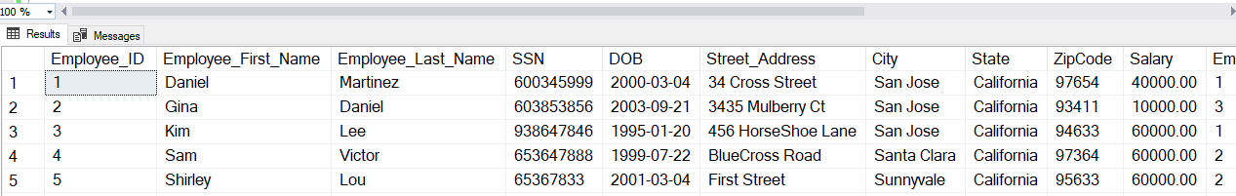

--Insert a new record via stored procedure

Declare @ReturnValue int

EXEC @ReturnValue = dbo.sp_AddModify_Employee_Info

@Employee_First_Name = 'Liam',

@Employee_Last_Name = 'Mathew',

@Employee_SSN = '6993673333',

@Employee_DOB = '08/20/1995',

@Street_Address = '56 Main Stree',

@City = 'San Jose',

@State = 'California',

@ZipCode = '93456',

@Salary = 40000,

@Employee_Type = 'PartTime'

GO

SELECT * FROM Employee where Employee_ID = @ReturnValue

GO

--We see our new record being inserted

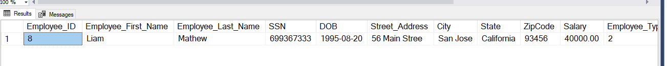

--Update the same record, changing city from 'San Jose' to 'Sunnyvale' via the stored procedure

EXEC dbo.sp_AddModify_Employee_Info @Employee_First_Name = 'Liam',

@Employee_Last_Name = 'Mathew',

@Employee_SSN = '6993673333',

@Employee_DOB = '08/20/1995',

@Street_Address = '56 Main Stree',

@City = 'Sunnyvale',--'San Jose' to 'Sunnyvale

@State = 'California',

@ZipCode = '93456',

@Salary = 40000,

@Employee_Type = 'PartTime'

GO

--Let’s confirm the record was successfully updated

select * from Employee

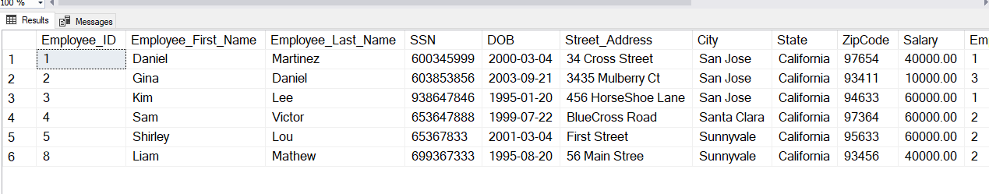

### sp_AddModify_Student_Info

**PURPOSE**

The Stakeholders wanted to be able to maintain information about all their student like address, dob, class schedule etc. This stored procedure allows them to both add or update student information.

--Before we implement the stored procedure, we need to implement 2 functions that will be called by our stored procedure

--Function to retrieve the Class_Schedule_ID based on the input parameters

Drop Function dbo.Lookup_Class_Schedule_ID

Create Function dbo.Lookup_Class_Schedule_ID(@Class varchar(20),@Studio varchar(30),@Day_Of_Week varchar(10),@Class_Start_Time varchar(6))

Returns int as

Begin

Declare @returnValue int , @Class_Location_ID int, @Class_ID int, @Studio_Location_ID int

--Get the Class_ID and Studio_Location_ID

Select @Class_ID = Class_ID from Class where Class_Name = @Class

Select @Studio_Location_ID = Studio_Location_ID from Studio_Location where Location_Name = @Studio

--Get the Class_Location_ID first

Select @Class_Location_ID = Class_Location_ID

from Class_Location

Where Class_ID = @Class_ID

And Studio_Location_ID = @Studio_Location_ID

Select @returnValue = Class_Schedule_ID

from Class_Schedule

Where Class_Location_ID = @Class_Location_ID

and Day_of_the_Week = @Day_Of_Week

and Class_Start_Time = @Class_Start_Time

--Send the Class_Schedule_ID back

return @Class_Location_ID

End

Go

--Check to see if function works correctly

Select Class.Class_Name, Studio_Location.Location_Name,Class_Schedule.Class_Schedule_ID,Class_Schedule.Class_Location_ID,

dbo.Lookup_Class_Schedule_ID(Class.Class_Name, Studio_Location.Location_Name,Class_Schedule.Day_Of_The_Week,Class_Schedule.Class_Start_Time) as ReturnValueFromFunction

from Class_Schedule

join Class_Location on Class_Schedule.Class_Location_ID = Class_Location.Class_Location_ID

join Class on Class.Class_ID = Class_Location.Class_ID

join Studio_Location on Class_Location.Studio_Location_ID = Studio_Location.Studio_Location_ID

order by Class_Schedule_ID desc

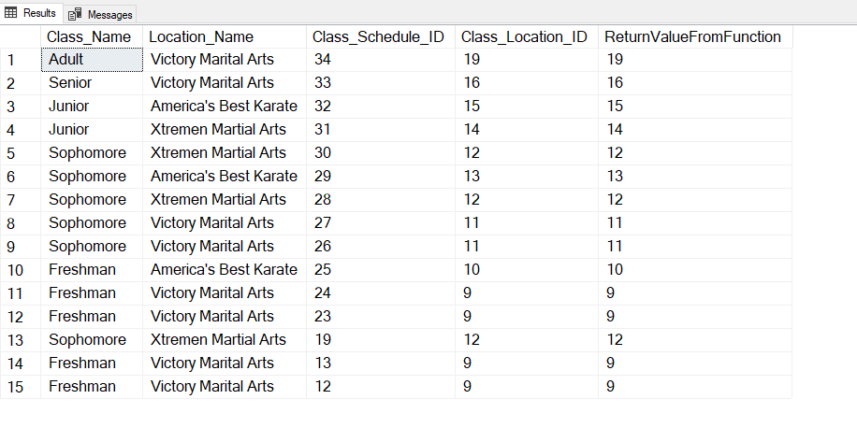

--Function to check if the class is full

Drop Function dbo.Is_Class_Full

Create Function dbo.Is_Class_Full(@Class varchar(20),@Studio varchar(30),@Day_Of_Week varchar(10),@Class_Start_Time varchar(6))

Returns int as

Begin

Declare @returnValue int , @Class_Size int , @Class_Count int

--Get the Class Size

Select @Class_Size = Max_Class_Size from Class where Class_Name = @Class

-- Get the Count of Student for the given class/studio/dayofweek/starttime combination

Select @Class_Count = count(Student_ID)

from Student

inner join Class_Schedule on Student.Class_Schedule_ID = Class_Schedule.Class_Schedule_ID

join Class_Location on Class_Location.Class_Location_ID = dbo.Lookup_Class_Schedule_ID(@Class, @Studio,@Day_Of_Week,@Class_Start_Time)

--Send the return value which indicates whether class is full or no

If (@Class_Count < @Class_Size )

Select @returnValue = 0 --Class is not full

else

Select @returnValue = 1 --Class is full

return @returnValue

End

GO

--Check to see if function works correctly

Select Class.Class_Name, Studio_Location.Location_Name,Class_Schedule.Class_Start_Time, Class_Schedule.Day_Of_The_Week,count(Student_ID) as Count,

dbo.Is_Class_Full(Class.Class_Name, Studio_Location.Location_Name,Class_Schedule.Day_Of_The_Week,Class_Schedule.Class_Start_Time) as ReturnValueFromFunction

from Student

join Class_Schedule on Student.Class_Schedule_ID = Class_Schedule.Class_Schedule_ID

join Class_Location on Class_Schedule.Class_Location_ID = Class_Location.Class_Location_ID

join Class on Class.Class_ID = Class_Location.Class_ID

join Studio_Location on Class_Location.Studio_Location_ID = Studio_Location.Studio_Location_ID

group by Class.Class_Name, Studio_Location.Location_Name,Class_Schedule.Class_Start_Time, Class_Schedule.Day_Of_The_Week

order by Class_Name, Studio_Location.Location_Name

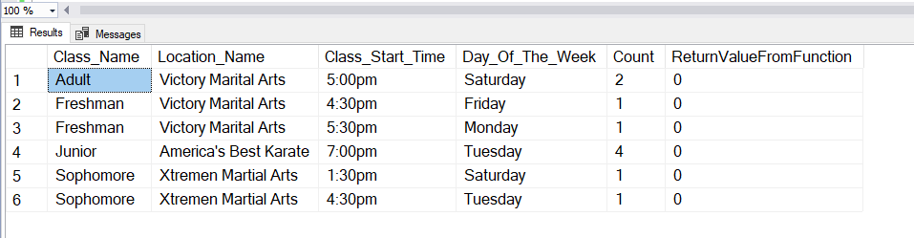

---Stored Procedure to Add/Modify Student Information

Drop Procedure dbo.sp_AddModify_Student_Info

Create Procedure sp_AddModify_Student_Info(

@Student_First_Name varchar(20),

@Student_Last_Name varchar(20),

@Student_DOB Date,

@Parent_First_Name varchar(20),

@Parent_Last_Name varchar(20),

@Street_Address varchar(30),

@City varchar(15),

@State varchar(15),

@ZipCode varchar(5),

@Email varchar(50),

@Phone varchar(15),

@Class varchar(20),

@Studio varchar(30),

@Day_Of_Week varchar(10),

@Class_Start_Time varchar(6)

)

As

Begin

Declare @IsAdult char(1), @Class_Schedule_ID int, @Parent_ID int, @Adult_Student_Info int, @Is_Class_Full int

--Check to see if the Student is an Adult or not, this will determine which to add the contact information

If (datediff(yy,@Student_DOB,getdate()) >= 18)

select @IsAdult=1

Else

select @IsAdult=0

--Get the Class_Schedule_ID based on the input parameters

Select @Class_Schedule_ID = dbo.Lookup_Class_Schedule_ID(@Class,@Studio,@Day_Of_Week,@Class_Start_Time)

From Class_Schedule

--Check to see if the record exist. If it does, update the record otherwise add the record

If Exists (Select * from Student

where Student_First_Name = @Student_First_Name

and Student_Last_Name = @Student_Last_Name)

Begin

--Record Exists so Modify

Update Student

Set DOB = @Student_DOB,

Class_Schedule_ID = @Class_Schedule_ID

Where Student_First_Name = @Student_First_Name

And Student_Last_Name = @Student_Last_Name

If (@IsAdult=0)

Begin

--If Student is a Minor, the address is stored in the Parent table

Update Parent

Set Street_Address = @Street_Address,

City = @City,

State = @State,

ZipCode = @ZipCode,

Email = @Email,

Phone = @Phone

Where Parent_ID = (Select Parent_ID from Student where

Student_First_Name = @Student_First_Name

And Student_Last_Name = @Student_Last_Name)

End

Else

Begin

-- Student is an Adult, the address is stored in Adult_Student_Info table

Update Adult_Student_Info

Set Street_Address = @Street_Address,

City = @City,

State = @State,

ZipCode = @ZipCode,

Email = @Email,

Phone = @Phone

Where Adult_Student_Info_ID = (Select Adult_Student_Info_ID from Student where Student_First_Name = @Student_First_Name

And Student_Last_Name = @Student_Last_Name)

End

End

Else

Begin

--Record does not exists so Add

-- But first see if the class is full or not

Select @Is_Class_Full = dbo.Is_Class_Full(@Class, @Studio,@Day_Of_Week,@Class_Start_Time)

If (@Is_Class_Full = 0) -- which means it not full

Begin

If (@IsAdult=0)

Begin

--Student is a minor, so add the Parent Record first

Insert into Parent(Parent_First_Name,Parent_Last_Name,Street_Address, City, State, ZipCode,Email,Phone)

values(@Parent_First_Name,@Parent_Last_Name,@Street_Address, @City, @State, @ZipCode,@Email,@Phone)

-- we should get the Parent_ID from the newly added record

Select @Parent_ID = @@IDENTITY

--Finally insert the student record

Insert into Student(Student_First_Name,Student_Last_Name,DOB,Parent_ID, Class_Schedule_ID)

values (@Student_First_Name, @Student_Last_Name, @Student_DOB, @Parent_ID,@Class_Schedule_ID)

End

Else

Begin

--Student is an adult, so add a Adult_Student_Info Record first

Insert into Adult_Student_Info(Street_Address,City,State,ZipCode,Email,Phone)

values(@Street_Address, @City, @State, @ZipCode, @Email, @Phone)

-- we should get the Adult_Student_Info_ID from the newly added record

Select @Adult_Student_Info = @@IDENTITY

--Finally insert the student record

Insert into Student(Student_First_Name,Student_Last_Name,DOB,Class_Schedule_ID, Adult_Student_Info_ID)

values (@Student_First_Name, @Student_Last_Name, @Student_DOB,@Class_Schedule_ID , @Adult_Student_Info)

End

End

End

End

GO

--Update existing student who is a minor to change the DOB from '01/02/2012' to '03/05/2012

-- and Street Address from '6 Washington Way' to '600 Washington Way'

select * from Student

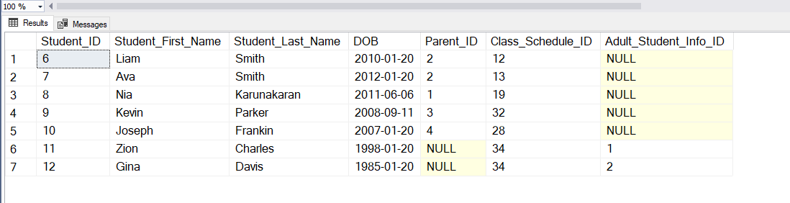

select * from Parent

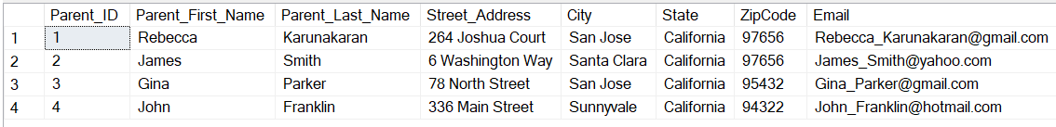

--Get the Class Schedule Info for 'Ava Smith'

select Class.Class_Name,Studio_Location.Location_Name , Class_Schedule.Day_Of_The_Week, Class_Schedule.Class_Start_Time

from Student

join Class_Schedule on Student.Class_Schedule_ID = Class_Schedule.Class_Schedule_ID

join Class_Location on Class_Schedule.Class_Location_ID = Class_Location.Class_Location_ID

join Class on Class_Location.Class_ID = Class.Class_ID

join Studio_Location on Studio_Location.Studio_Location_ID = Class_Location.Studio_Location_ID

where Student.Student_First_Name = 'Ava' and Student.Student_Last_Name = 'Smith'

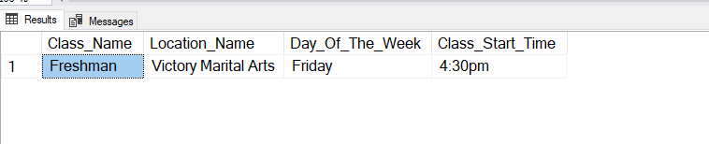

--Execute the Stored Procedure to Update a student who is a minor to change the DOB from '01/02/2012' to '03/05/2012

-- and Street Address from '6 Washington Way' to '600 Washington Way

EXEC dbo.sp_AddModify_Student_Info 'Ava','Smith','03/05/2012','James','Smith','600 Washington Way',

'Santa Clara','California','97656','James_Smith@yahoo.com','408-463-5424',

'Freshman','Victory Marital Arts','Friday','4:30pm'

--Let’s validate if the record was updated successfully

Select * from Student where Student_First_Name = 'Ava' And Student_Last_Name = 'Smith'

--Yes, DOB was changed successfully '01/02/2012' to '03/05/2012

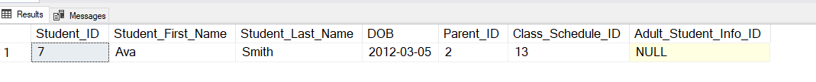

Select * from Parent where Parent_ID = (select Parent_ID from Student

where Student_First_Name = 'Ava' And Student_Last_Name = 'Smith' )

--Yes, Street Address was changed successfully '6 Washington Way' to '600 Washington Way'



--Update existing student 'Zion Charles' who is an Adult to change the DOB from '01/20/1998' to '01/25/1998'

-- and Email from 'Zion_Charles@yahoo.com' to 'Zion_Charles@hotmail.com'

select * from Student where Student_First_Name ='Zion' and Student_Last_Name = 'Charles'

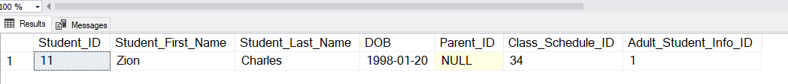

select * from Adult_Student_Info where Adult_Student_Info_ID = 1



--Get the Class Schedule Info for 'Zion Charles'

select Class_Schedule.class_schedule_ID,Class.Class_Name,Studio_Location.Location_Name , Class_Schedule.Day_Of_The_Week, Class_Schedule.Class_Start_Time

from Student

join Class_Schedule on Student.Class_Schedule_ID = Class_Schedule.Class_Schedule_ID

join Class_Location on Class_Schedule.Class_Location_ID = Class_Location.Class_Location_ID

join Class on Class_Location.Class_ID = Class.Class_ID

join Studio_Location on Studio_Location.Studio_Location_ID = Class_Location.Studio_Location_ID

where Student.Student_First_Name = 'Zion' and Student.Student_Last_Name = 'Charles'

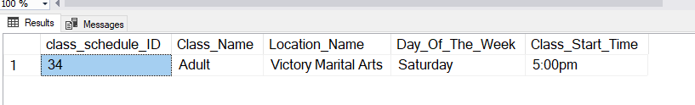

--Execute the Stored Procedure to Update the record

EXEC dbo.sp_AddModify_Student_Info 'Zion','Charles','01/25/1998',NULL,NULL,'56 Blue Hawk Dr',

'Morgan Hill','California','95436','Zion_Charles@hotmail.com','408-938-8473',

'Adult','Victory Marital Arts','Saturday','5:00pm'

--Yes, DOB changed from '01/20/1998' to '01/25/1998'

-- and Email from 'Zion_Charles@yahoo.com' to 'Zion_Charles@hotmail.com'

select * from Student where Student_First_Name ='Zion' and Student_Last_Name = 'Charles'



select * from Adult_Student_Info where Adult_Student_Info_ID = 1



---Let's use the Stored Proc to Add a new student who is a minor

--Execute the Stored Procedure to Update the record

EXEC dbo.sp_AddModify_Student_Info 'Taylor','Swift','01/25/2003','Ronald','Smith','34 Hollywood Dr',

'San Jose','California','95452','Ronald_Smith@gmail.com','408-256-2436',

'Junior','America''s Best Karate','Tuesday','7:00pm'

--Let’s check if the record was inserted correctly. Since the student is a minor, we should a parent record inserted as well

select * from Student

select * from Parent

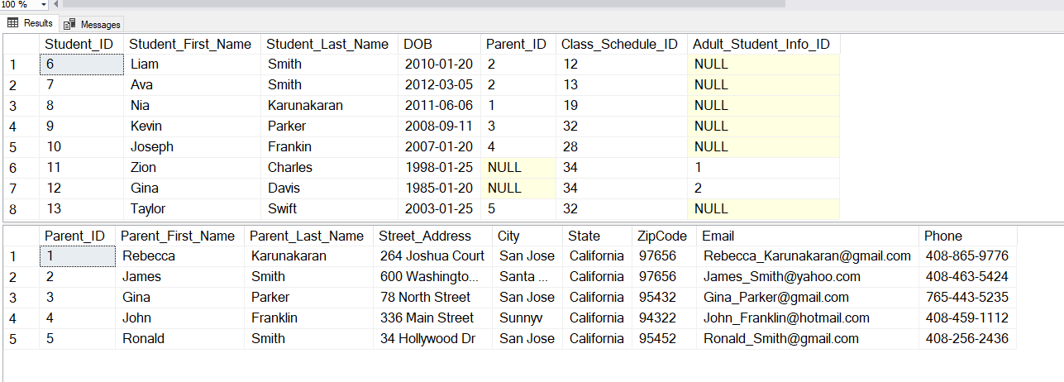

---Let's use the Stored Proc to Add a new student who is an Adult

--Execute the Stored Procedure to Update the record

EXEC dbo.sp_AddModify_Student_Info 'Tom','James','01/25/1990',NULL,NULL,'34 Eagle Lane',

'San Jose','California','93432','Tom_James@yahoo.com','125-343-6564',

'Junior','America''s Best Karate','Tuesday','7:00pm'

--Let’s check if the record was inserted correctly. Since the student is an Adult, the ParentID in the Student table should be null

--and a record should be inserted in table Adult_Student_Info

select * from Student

select * from Adult_Student_Info

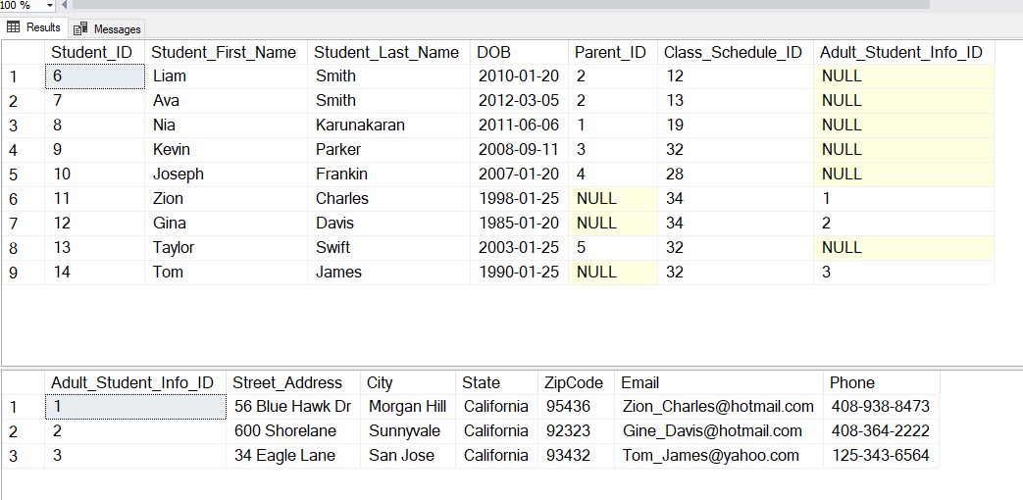

# IMPLEMENTATION

I have decided to MS Access to implement the Data Entry/Maintenance screens and Reports for my stakeholders. This was my first time using this tool so there was some learning curve involved but the tool itself proved to be user friendly and easy to use.

## STUDIO LOCATION INFORMATION ACCESS REPORT

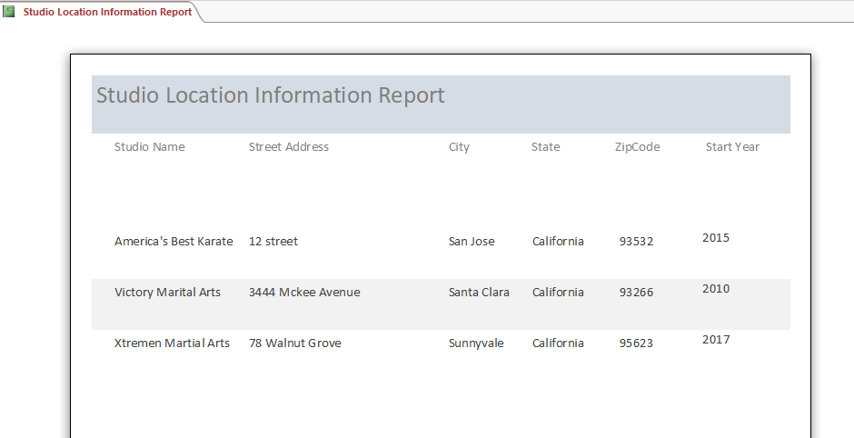

## CLASS SCHEDULE FOR STUDIO ACCESS REPORT

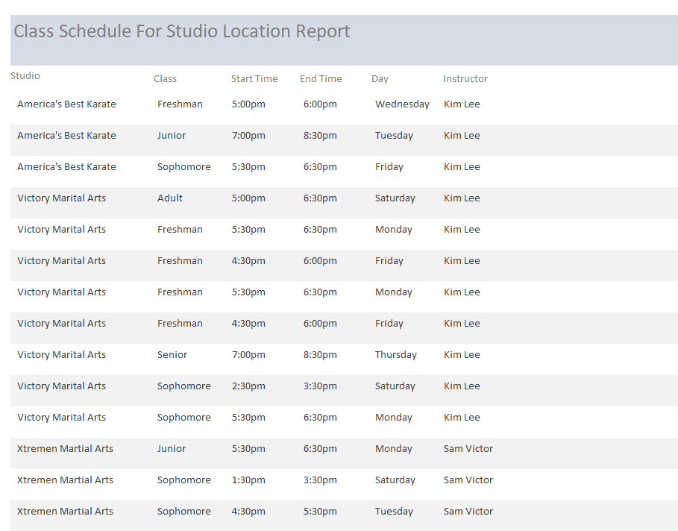

## EVENT SCHEDULE BY STUDIO ACCESS REPORT

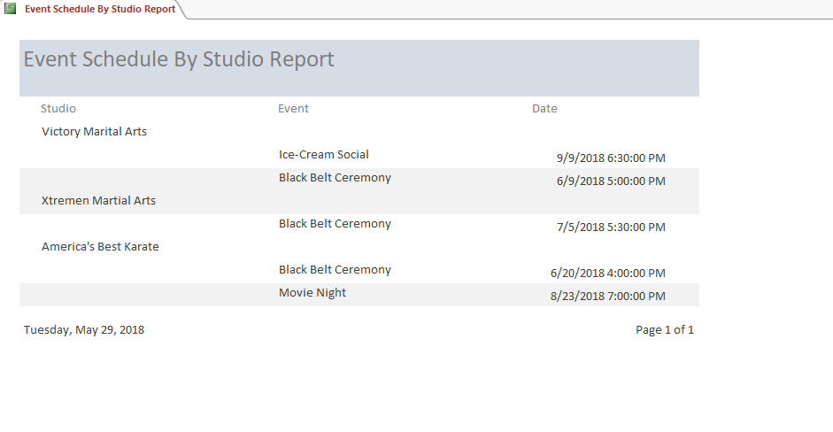

## STUDIO INFORMATION BY STUDIO ACCESS REPORT

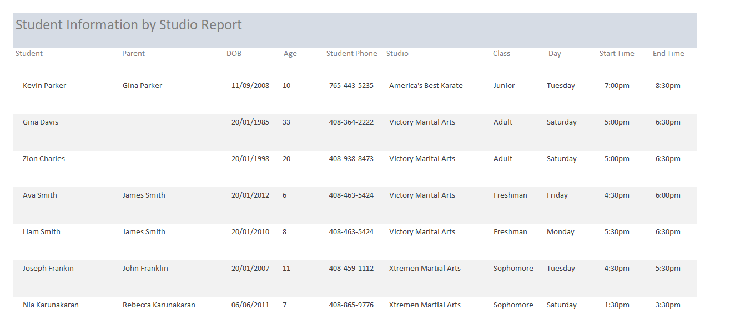

## Employee schedule ACCESS REPORT

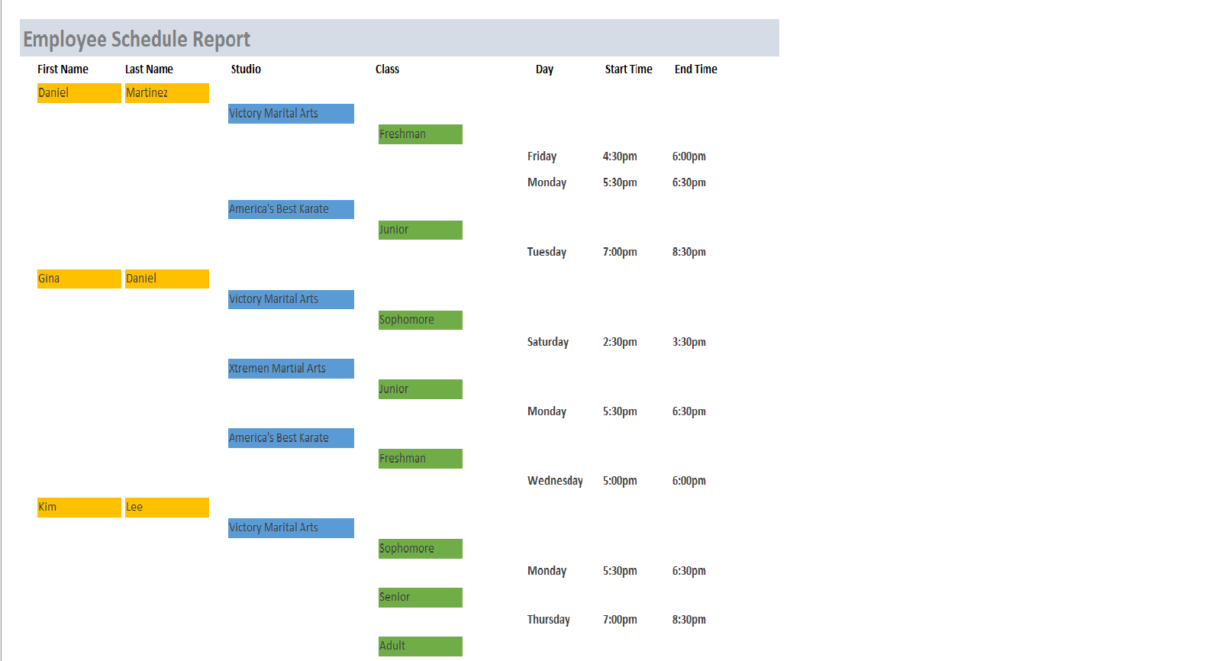

## Employee MAINTENANCE ACCESS form

MS Form to view existing employee as well as add new employees

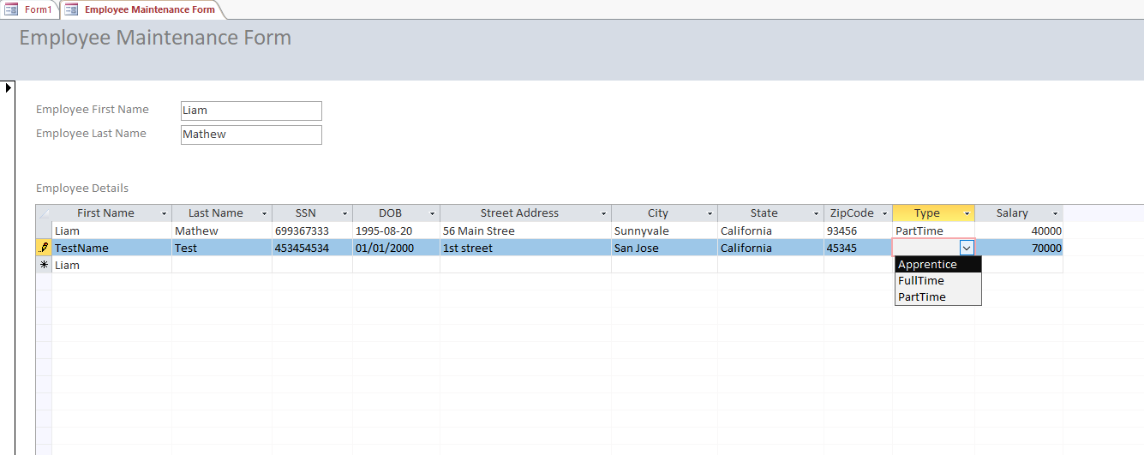

## Student MAINTENANCE ACCESS form

MS Form to view existing students as well as add new students

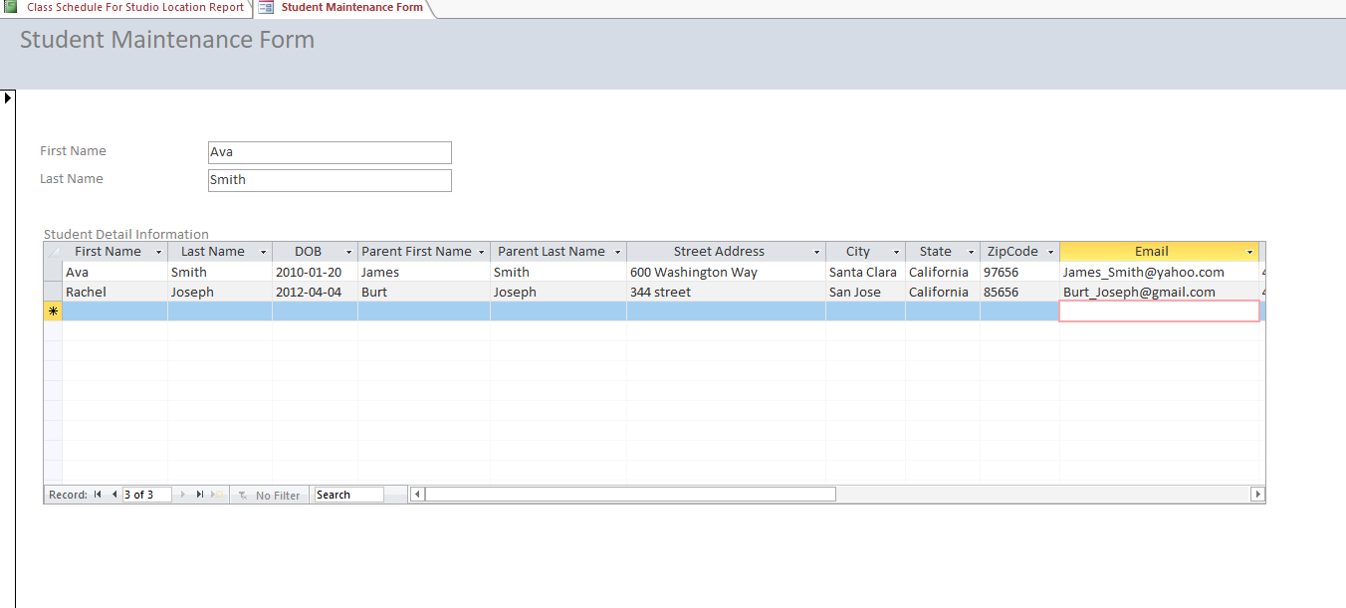

# REFLECTION

Having prior knowledge and experience with RDBMS like MS SQL and Oracle it was nice to brush on the data modeling process. Here are some thoughts that I’d like to share

* As an IT professional I have noticed that most people don’t invest enough time to create the conceptual and normalized data model. This project has made me realize the importance of investing the time to create the data model which is the foundation to any database.
* Once the data model has been created, most people in the real world don’t update it when the business requirement changes. During the project, I had to make several changes to the data model but once it was updated, it helped me design and implement the database objects without having to go the database to see the table structure or relationships.
* Last but not least, this project has reiterated that the database is the foundation to any project and investing the time to get it right definitely pays off when it come to implementing the User Interface.