Rumen Kasabov  
ID: 10128754  
Tutorial Section: T01

Group partner: Michael Radke

~~~

* To run the proxy server in terminal:

$python3.6 proxy.py [logOptions] -replace [optionOne] [optionTwo] srcPort server dstPort

Where:

* [logOptions] can be any of the supported logging formats.
* ‘-replace’ command indicates we want to replace patterns in the communication data provided by the client source connection and the remote server.
* [optionOne] is any string we wish to replace in the communication data
* [optionTwo] is the string that is going to replace [optionTwo]  
  + For example, ‘-replace HTTP/1.1 HTTP/1.2’ in the arguments when running proxy.py replaces any occurrence of the string HTTP/1.1 in the communication data with the string HTTP/1.2
* ‘srcPort’ is our client source port
* ‘server’ is the remote server address
* ‘dstPort’ is the remote server port
* Supported logging formats:  
  + –raw
  + –strip
  + –hex
  + autoN – where N is any number of bytes
* Sample outputs of logging formats:  
  + –raw format output:

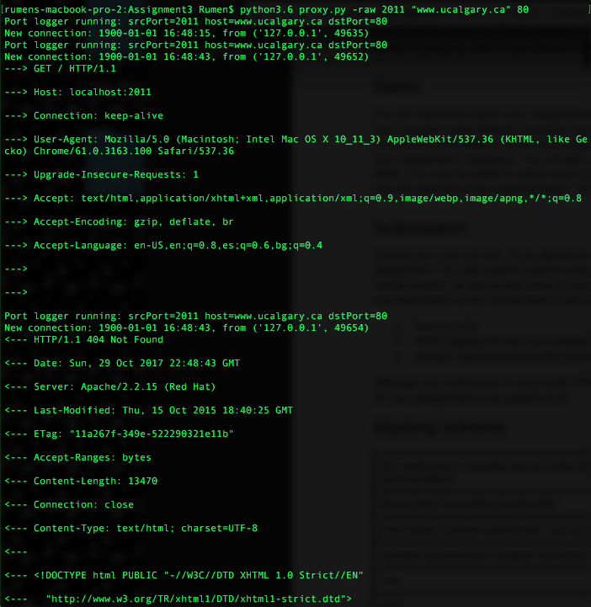

* –strip format output:

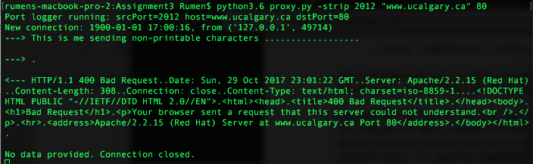

Note: For the server response, there is only one ‘<---‘ since strip replaces all \n characters with dots and the arrows rely on newlines.

* –hex format output:

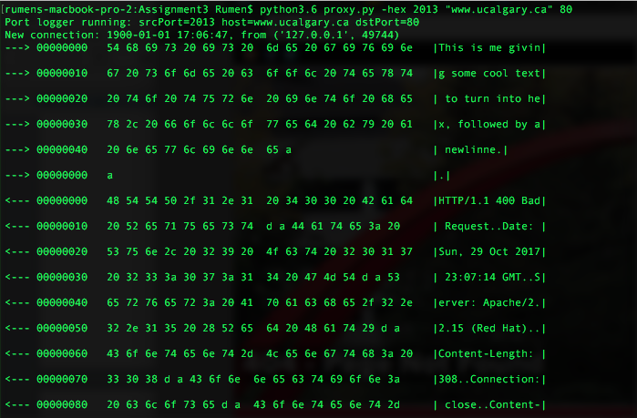

* autoN format output:

:::Screen Shot 2017-10-29 at 5.14.00 PM.png

Note: This is what we give on the client source netcat connection to the proxy server.

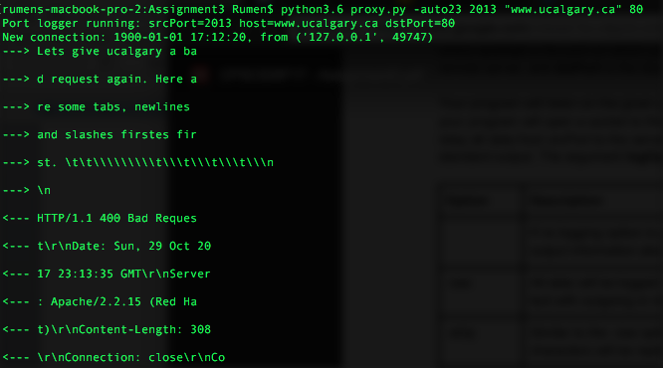

Note: This is the proxy server logging for auto23 where the tabs slashes and newlines are displayed accordingly