**Edge Proposal: Blue Bikes**

Dev Das, James Hennessy, Rahul Kasar, Semi Hasaj

**Problem**  
Nearly every Blue Bike user in Boston has experienced wanting to ride a blue bike, only to discover the docking station is empty. Due to asymmetric supply and demand of Blue Bike stations, many customers find themselves unable to ride at various times in the day, and often ask themselves whether they should wait for a bike to arrive or not.

**Proposed Solution**  
In order to improve the general Blue Bike user experience, our analysis aims to:

1. Provide Blue Bike with a list of bike stations that would benefit most from interventions aimed to both improve customer experience and potentially increase revenue (e.g., stations that require more capacity, or frequent re-filling).
2. Provide Blue Bike customers with an estimate regarding how long they should wait until they can expect a bike station to become non-empty.

**Methodology**

1. **Build a predictive analytics model for labeling:** Given the time of day, predict a label to predict whether there are any bikes docked at a station (Yes or No).
   1. Outputs: Labels of 0 or 1 (0 if no bikes, 1 if one or more bikes are docked).
2. **Build a predictive analytics model for wait times:** Given that station X at time Y has no bikes, predict how long it will take for a bike to arrive (i.e., become non-empty).
   1. Outputs: A calculated wait time for an empty station X given a time of day Y.
3. **Potential Interventions**: Provide intervention analysis for stations where wait times are significant.
   1. Intervention 1: Refill the bike station more often
      1. Increase current infrastructure to restock bike stands at more frequent occurrences.
      2. Pros: Satisfies more demand. Cons: High variable cost to restock more often.
   2. Intervention 2: Add more capacity to high demand bike stations
      1. Based on wait times, add more bike docks and bikes to high demand stations so that each of these stands can satisfy customer demand.
      2. Pros: Solves problem of docks always being full or empty. Cons: High fixed cost of adding new docks.
   3. Intervention 3: Incentivize plans for riders to docks bikes at lower demand stations
      1. Subsidize rides for instances where demand is high so that bikers will park bikes at lower demand areas.
      2. Pros: Cost of moving bikes not fully on Blue Bike (should reduce cost). Cons: Cost of subsidizing bikes will decrease profit, and we must assume users will want to move their bikes to lower demand areas.

**Appendix**

**Data Screenshot:**

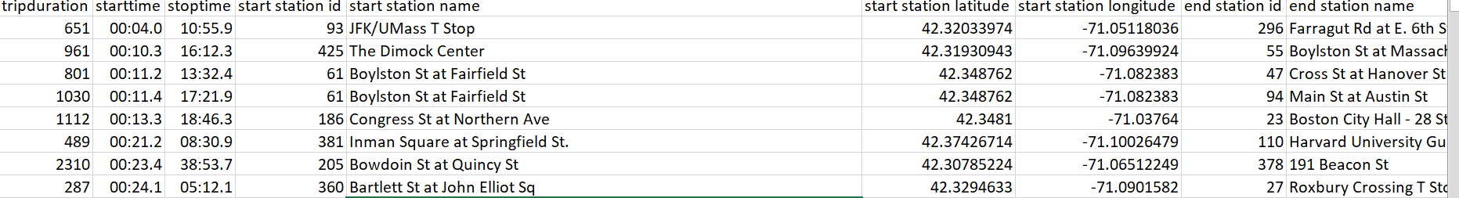

**Graphs:**

**EDA Ideas**

* 1. What are the top 15 single use stations.
  2. When are the most single uses occurring.
  3. Calculate yearly revenue.