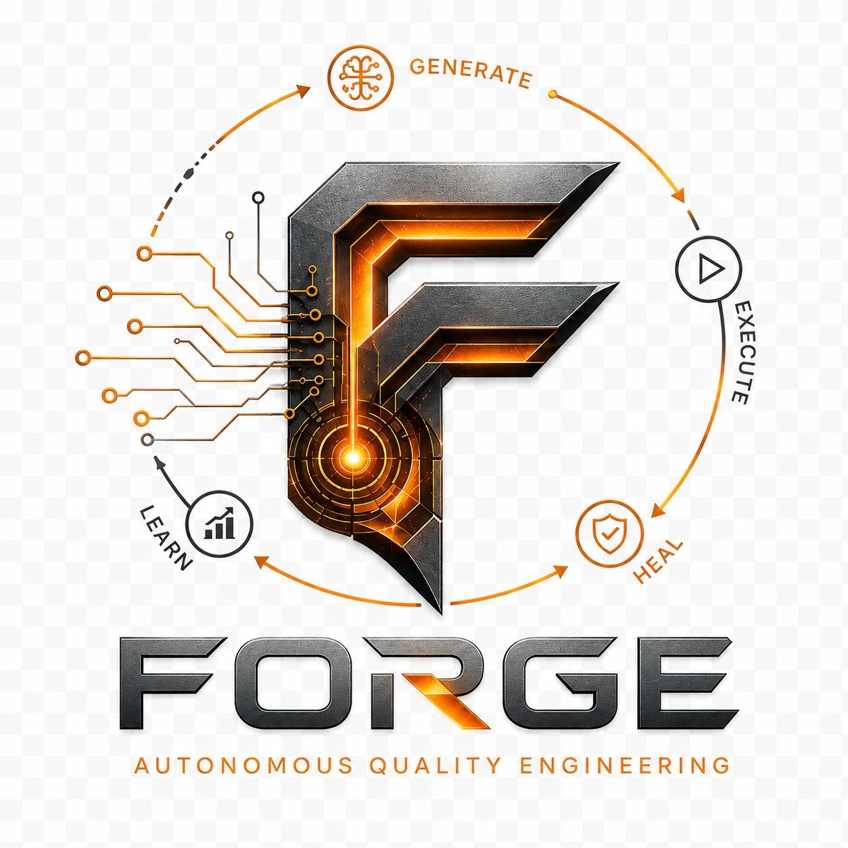
FORGE
Autonomous Quality Engineering

Technical Product Brief
Version 1.0 · June 2026
Raj Kasthuri · Senior Quality Engineering Leader

1. Executive Summary
FORGE is an AI-augmented, app-agnostic autonomous quality engineering platform built to eliminate the two most expensive problems in enterprise QE: slow application onboarding and brittle, manually-maintained test suites.

Most test automation frameworks require weeks of setup per application — writing page objects by hand, reverse-engineering selectors, building fixture scaffolding from scratch. FORGE eliminates that entirely. Point it at any application, and it crawls the interface, classifies every interactive element, detects user flows, and generates a complete, runnable test suite — automatically.

FORGE operates on a continuous four-stage autonomous loop:

⚡ GENERATE | ▶ EXECUTE | 🔧 HEAL | 📈 LEARN
Crawl any app. Classify every element. Detect flows. Produce Page Objects, Fixtures, Specs, and API Clients automatically. | Run the full suite across browsers and APIs in parallel. CI/CD via GitHub Actions. Live streaming output in the Platform UI. | Self-healing engine fires on selector drift. SmartLocator strategy chain. Vision fallback. Zero manual intervention required. | AI pipeline analyses results. Coverage gaps identified. Trends tracked. Release notes generated. Model updated for next cycle.

FORGE is not an AI that replaces testers. It is an AI-powered engine that removes repetitive, low-value work so engineers can focus on what matters: test strategy, coverage decisions, and quality advocacy.

App Types Supported | Tests Generated | Proof of Concept Results
Web UI · REST API  Mobile (Phase 6)  IoT · Cloud · Data (stub) | Page Objects  Fixtures  Spec files  API Clients | SauceDemo: 210 tests  Restful Booker: 21 tests  OrangeHRM: 22 pages

2. The Problem
Enterprise test automation consistently fails to deliver on its promise. The reasons are well-known inside every QE organisation:

- Brittle tests. Test suites break every release cycle because selectors are brittle and nobody owns maintenance.
- Slow onboarding. Onboarding a new application takes weeks of manual page object authoring before a single test runs.
- AI without context. AI tools generate plausible-looking test code that fails because the AI has no knowledge of the actual application under test.
- Reactive coverage. Coverage is reactive — tests are written after bugs are found, not before features ship.
- Zero reusability. Every framework is hardcoded to one application and cannot be reused without significant rework.

The result is a QE function that is always catching up, never ahead, and increasingly expensive to maintain. FORGE was designed to solve all five problems simultaneously.

3. The FORGE Approach
FORGE is built on three non-negotiable architectural principles:

Principle 1 — App-Agnostic by Design
FORGE contains zero hardcoded application references in its core. Every selector, credential, URL, and configuration value comes from the app's onboarding config or environment variables. The same framework that tests SauceDemo tests OrangeHRM, a REST API, or an enterprise SPA — without modification.

Principle 2 — Onboarding-First
Before a single test is written, FORGE builds a structured App Model of the application: every page, every element, every user flow, every role. This model is the source of truth for test generation, self-healing, coverage analysis, and verification. Tests generated without an App Model are guesses. Tests generated from a verified App Model are grounded in reality.

Principle 3 — Continuous Autonomous Loop
FORGE does not run once and stop. It operates in a continuous Generate → Execute → Heal → Learn cycle. Every run improves the model. Every healing event promotes a better selector. Every trend analysis informs the next coverage decision. The framework gets smarter with every cycle.

4. Core Capabilities

4.1 Universal Onboarding Engine
The onboarding engine operates in three sequential stages accessible through both a CLI and the no-code Platform UI:

Stage | What It Does
Crawl | Launches a browser (or reads an API spec), authenticates as each configured role, discovers every page via BFS and SPA-aware navigation, and classifies all interactive elements using a multi-strategy selector chain.
Verify | Navigates to every discovered page with a live browser, confirms each element is present, runs each detected flow end-to-end, and reports pass/fail with confidence scoring. Self-healing fires automatically on selector drift.
Generate | Produces typed Page Object files, fixtures, and runnable Playwright spec files from the verified App Model. Generated artifacts land in a staging folder for review before promotion to the main test suite.

Supported application types:
- Web UI — single-page applications, multi-page apps, authenticated portals
- REST API — OpenAPI/Swagger spec parsing or inline endpoint definition
- Mobile, IoT, Cloud, Data — architecture stubbed and ready for Phase 6+

4.2 Self-Healing Engine
The self-healing engine activates automatically during Verify and test execution. When a primary selector fails, FORGE cascades through a strategy chain — role-based, text-based, CSS, data-test — and promotes the first working strategy to primary. Healing events are logged, stored in the database, and surfaced in the Platform UI.

Component | Function
SmartLocator | Executes the strategy chain in priority order, returning the first working selector.
HealStore | Persists every healing event to the SQLite/PostgreSQL storage layer.
HealReporter | Surfaces healing frequency and patterns in the release notes and dashboard.
VisionHealer | Uses Claude Vision as a last-resort fallback when all selector strategies fail.

4.3 AI Test Generation
FORGE supports multiple test generation input modes:

- Mode 1: App Model — generates specs directly from crawled flows and verified elements.
- Mode 2: Natural Language — describe what to test in plain English; AI produces a Playwright spec mapped to the App Model.
- Mode 3: Coverage Gap Analysis — identifies untested areas and generates specs to fill them automatically.
- Mode 4: User Stories + Acceptance Criteria — maps each AC to a test case and automates it. (Phase 7)

4.4 Storage Layer
FORGE uses a dual-database architecture: SQLite for local development, PostgreSQL for enterprise deployment. The 14-table schema persists run history, healing events, AI usage and cost tracking, coverage gaps, assertions, and DOM snapshots on failure.

4.5 Platform UI — No-Code Control Surface
FORGE ships with a branded no-code web platform (port 4300) providing nine tabs:

Tab | Phase | Function
ONBOARD | 5.5 | Crawl, Verify, Generate with credential input — no file editing required
RUN TESTS | 3.8a | Execute any suite with browser selection and live streaming output
DASHBOARD | 3.8b | Run history, pass rates, healing trends, coverage heatmap
GENERATE | 3.8c | Natural language test generation with preview and save
COVERAGE | 3.8e | Gap analysis, untested area identification, gap-to-test generation
RELEASE NOTES | 3.8e | AI-generated release notes from run history
ASK | 3.8f | Natural language query over the test knowledge base
VISUAL | 3.8g | Visual regression baseline and comparison
PERFORMANCE | 3.8h | Performance baseline capture and trend comparison

4.6 CI/CD Integration
FORGE runs on GitHub Actions using the official Microsoft Playwright Docker image. The CI pipeline executes the full test suite across Chromium and WebKit in parallel, stores results to the database, and generates trend data automatically.

5. Architecture Overview

5.1 Technology Stack

Layer | Technology
Test Runner | Playwright 1.58 + TypeScript
Runtime | Node.js 24
AI Engine | Anthropic Claude API (claude-sonnet-4-6)
Storage | SQLite (default) · PostgreSQL (enterprise) via Kysely ORM
CI/CD | GitHub Actions · Microsoft Playwright Docker
Platform UI | Vanilla JS · Node.js HTTP server · port 4300

5.2 Repository Structure

Directory | Contents
src/core/ | Framework internals — onboarding, healing, storage, AI client, config, types
src/pipeline/ | AI pipeline scripts — triage, generation, coverage, trends, notifications
src/platform/ | Platform UI server, dashboard, query server, reporter
src/apps/desktop/ui/ | Web UI app configs, pages, tests, fixtures, generated artifacts
src/apps/desktop/api/ | REST API app configs, clients, tests, generated artifacts
src/apps/mobile/ | Mobile app stubs (Phase 6)

Zero application-specific values exist in src/core/, src/pipeline/, or src/platform/. All credentials, selectors, and URLs come from per-app onboarding configs or environment variables.

5.3 Key Design Decisions

- Dual database: SQLite default with PostgreSQL enterprise option — zero infrastructure for local use, full scalability when needed.
- Selective snapshots: DOM snapshots only on failure with configurable 30-day purge — storage stays lean.
- Safe generation: Generated artifacts always land in generated/ — human-authored tests are never overwritten.
- Element addressing: App Model element IDs in {pageId}:{name} format — globally unique across all pages.
- Cost tracking: All AI costs tracked per call with SDET hourly rate ROI computation.

6. Proof of Concept Results
FORGE has been validated against three production applications of increasing complexity:

Target 1 — SauceDemo (Web UI, Multi-page)
Metric | Result
App type | Web UI · E-commerce · Standard multi-page
Pages crawled | 6 pages across 2 authenticated roles
Tests passing | 210 tests across Chromium and WebKit
Self-healing | Validated — strategy promotion confirmed in production
Generated artifacts | Page Objects, Fixtures, Spec files, Visual baselines

Target 2 — Restful Booker (REST API)
Metric | Result
App type | REST API · No live OpenAPI spec endpoint
Endpoints mapped | 8 endpoints across Auth, Booking CRUD, Health
Handwritten tests | 12/12 passing (AB001–AB012)
Generated tests | 9/9 passing — ApiClient, fixtures, spec all generated
Verification | 2/2 endpoints verified, confidence HIGH, no browser launched

Target 3 — OrangeHRM (SPA, Authenticated, Enterprise)
Metric | Result
App type | Web UI · Vue.js SPA · Enterprise HRMS
Pages crawled | 22 pages across 10 modules (Admin, PIM, Leave, Time, Recruitment, Performance, Directory, Maintenance, Claim, Buzz)
Authentication | Form-based login with SPA routing — fully automated
Elements verified | 27/27 passing · 19 self-healing events fired and resolved
Flows verified | 1/1 passing · confidence HIGH
Generated artifacts | 22 Page Objects · Fixtures · Spec file

7. Roadmap

Phase | Focus | Key Deliverables
Phase 6 | Mobile / SPA | Appium integration, mobile app onboarding, React Native support
Phase 7 | Enterprise Integrations | Jira, TestRail, Slack — bidirectional sync with test management
Phase 7.1 | User Stories → Tests | AC-to-test-case mapping, automated spec generation from requirements
Phase 7.2 | Manual Test Conversion | Step/expected-result input → automated Playwright spec
Phase 4.7 | POM Auto-Update | Detect element drift post-release, propose POM updates automatically
Phase 8 | FORGE SME Agent | Autonomous SDET contractor agent — tiered access, kill switch, phased autonomy
Documentation | Full docs sprint | API reference, user guide, onboarding tutorials, video walkthroughs

8. About

FORGE was designed and built by Raj Kasthuri, a Senior Quality Engineering leader with 25+ years of experience spanning WinRunner, QTP, Selenium, and AI-augmented Playwright — across financial services, QSR, telecom, retail, and mortgage technology.

Previous enterprise clients include Chick-fil-A, Cox Communications, NCR, FleetCor, LendMark Financial, and Equifax USIS, where Raj led a large-scale mainframe-to-GCP transformation.

FORGE reflects a core belief: foundational QE knowledge must underpin all AI work. The framework was not built to replace quality engineers — it was built to make them dramatically more effective.


FORGE
Autonomous Quality Engineering
github.com/rkasthuri/e2e-ai-testing-framework

