Robert Kaszubski

CSC 555 Project Phase 2

**Part 1)**

Load in data:

lineorder = LOAD '/user/ec2-user/lineorder.tbl' USING PigStorage('|') AS (lo_orderkey:int, lo_linenumber:int, lo_custkey:int, lo_partkey:int, lo_suppkey:int, lo_orderdate:int, lo_orderpriority:chararray, lo_shippriority:chararray, lo_quantity:int, lo_extendedprice:int, lo_ordertotalprice:int, lo_discount:int, lo_revenue:int, lo_supplycost:int, lo_tax:int, lo_commitdate:int, lo_shipmode:chararray);

customer = LOAD '/user/ec2-user/customer.tbl' USING PigStorage('|') AS (c_custkey:int, c_name:chararray, c_address:chararray, c_city:chararray, c_nation:chararray, c_region:chararray, c_phone:chararray, c_mktsegment:chararray);

Testing:

lineorderG = GROUP lineorder ALL;

Count = FOREACH lineorderG GENERATE COUNT(lineorder);

DUMP Count;

customerG = GROUP customer ALL;

Count = FOREACH customerG GENERATE COUNT(customer);

DUMP Count;

Data loads successfully:

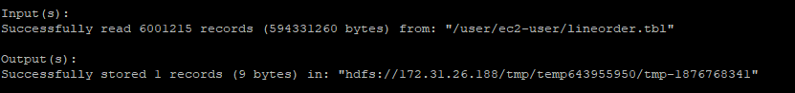

PIG QUERY:

cfilter = FILTER customer BY c_region == 'AFRICA';

lofilter = FILTER lineorder BY (lo_discount == 6 OR lo_discount > 8);

CLJoin = JOIN cfilter BY (c_custkey), lofilter BY (lo_custkey);

GByNation = GROUP CLJoin BY c_nation;

Agg = FOREACH GByNation GENERATE group,

AVG(CLJoin.lo_extendedprice) as AVGL;

SAgg = ORDER Agg BY $1 DESC;

STORE SAgg INTO 'Final1' using PigStorage(',');

Output (DUMP SAgg;):

Output written to HDFS:

**Part 2)**

Pass 1 (Join Lineorder and Part tables)

Pass1Mapper.py

Key = partkey

Value = brand1_part or revenue_orderdate_lo

Pass1Reducer.py

Perform the Join

Key = partkey

Value = brand_revenue_orderdate

Sample Run using smaller lineorder table and saving Results:

Pass 2 (join results + dwdate)

Pass2Mapper.py

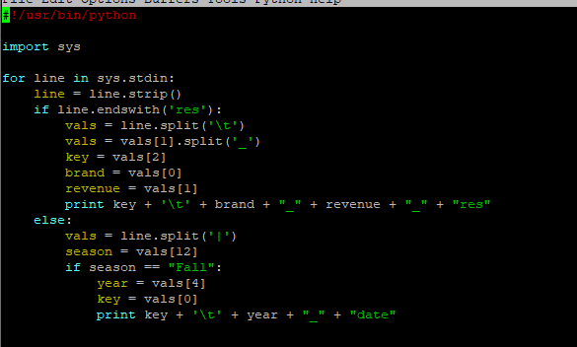

Key: orderdate or datekey

Value: year_date or brand_revenue_res

Pass2Reducer.py

Key: orderdate/datekey

Value: year_brand_revenue

Test run of Pass 2 using results of Pass1 (with smaller lineorder tbl)



Pass 3 (Group)

Pass3Mapper.py

Key = year_brand

Value = revenue

Pass3Recuder.py

Key = year_brand

Value = sum(revenue)



RUNNING WITH HADOOP STREAMING:

Using full lineorder table now

Pass 1:

Create Pass 1 directory and place the lineorder and part tables in it.

Command:

hadoop jar hadoop-streaming-2.6.4.jar -input /data/Pass1 -mapper Pass1Mapper.py -file ../Pass1Mapper.py -reducer Pass1Reducer.py -file ../Pass1Reducer.py -output /data/Pass1/result

Results will be saved to /data/Pass1/result

Sample output of Pass 1:

Pass 2:

Create directory for Pass 2

Move dwdate table and Result file from Pass 1:

Command:

hadoop jar hadoop-streaming-2.6.4.jar -input /data/Pass2 -mapper Pass2Mapper.py -file ../Pass2Mapper.py -reducer Pass2Reducer.py -file ../Pass2Reducer.py -output /data/Pass2/result

Results saved to /data/Pass2/result

Sample Output:

Pass 3:

Create directory for pass 3 and transfer Pass 2 results:



Command:

hadoop jar hadoop-streaming-2.6.4.jar -input /data/Pass3 -mapper Pass3Mapper.py -file ../Pass3Mapper.py -reducer Pass3Reducer.py -file ../Pass3Reducer.py -output /data/Pass3/result

Results saved to /data/Pass3/result



Final Output:

**Part 3)**

I generated my data using the following python code numgenfinal.py:

Ran with the following command:



Part3data file:

I also wrote a python file called rngcenters.py that read the data generated and picked 4 random points as the initial centers. It wrote them into a file, numbering each cluster with a tab between them just as the reducer will later return.

Mapper:

Key= Cluster#

Val = DataPoints

With sort -n

Reducer

Key= Cluster#

Val = CenterPoints

Output from reducer: new centers

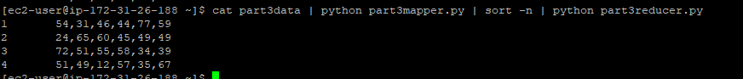

Running with Hadoop Streaming:

I made a new directory in hadoop with data file

ITERATION 1:

Initial Centers:

Command:

hadoop jar hadoop-streaming-2.6.4.jar -input /data/part3/part3data -file ../centers.txt -mapper part3mapper.py -file ../part3mapper.py -reducer part3reducer.py -file ../part3reducer.py -output /data/part3/iter1c

New Centers:

ITERATION 2

Replacing centers.txt with new centers:



Command:

hadoop jar hadoop-streaming-2.6.4.jar -input /data/part3/part3data -file ../centers.txt -mapper part3mapper.py -file ../part3mapper.py -reducer part3reducer.py -file ../part3reducer.py -output /data/part3/iter2

New Centers:

ITERATION 3

Replacing center.txt file



Command

hadoop jar hadoop-streaming-2.6.4.jar -input /data/part3/part3data -file ../centers.txt -mapper part3mapper.py -file ../part3mapper.py -reducer part3reducer.py -file ../part3reducer.py -output /data/part3/iter3

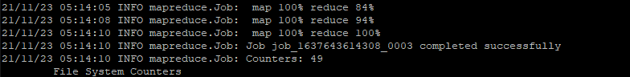

New Centers:

ITERATION 4:

Replacing file:



Command

hadoop jar hadoop-streaming-2.6.4.jar -input /data/part3/part3data -file ../centers.txt -mapper part3mapper.py -file ../part3mapper.py -reducer part3reducer.py -file ../part3reducer.py -output /data/part3/iter4

New Centers:

