Docker 6th Assignment

==================================================================

**Task List: Docker Image Creation and Deployment**

1. **Create Directories:**  
   - Establish two directories named "DHUB" and "AWSECR."

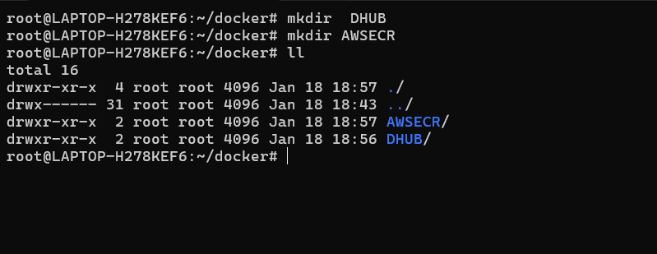

==================================================================

2. **Dockerfile Creation:**

- Develop two Docker files to construct custom images with the following specifications:  
     - Base image: Ubuntu  
     - Install packages: httpd  
     - Add "I am from Docker Hub" to the index.html file for DHUB directory and "I am from ECR" for AWSECR directory.  
     - Set environment variable ENV_NAME=DHUB for the DHUB directory and ENV_NAME=AWSECR for the AWSECR directory.  
  - Start http service using ENTRYPOINT   
  - Expose port 80.

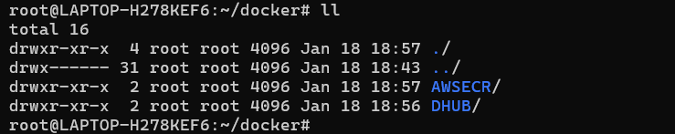

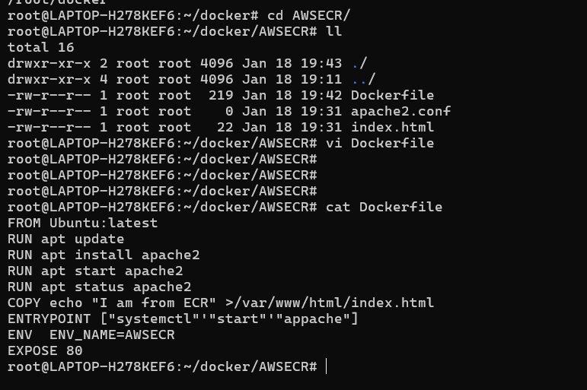

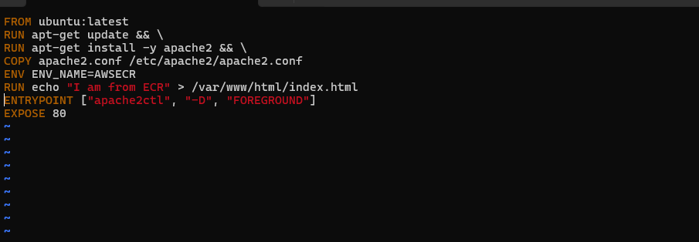

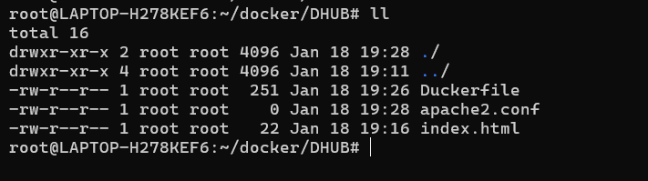

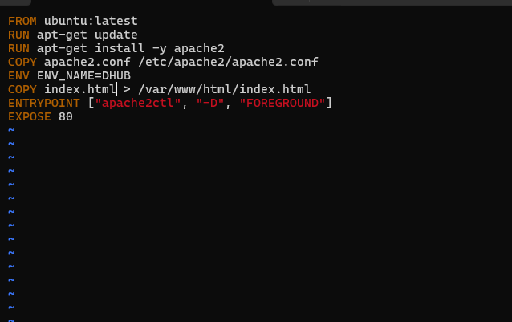

3. **Build Custom Images:**

   - Utilize the docker build command to build the custom images.  
   - List all available images using docker images.

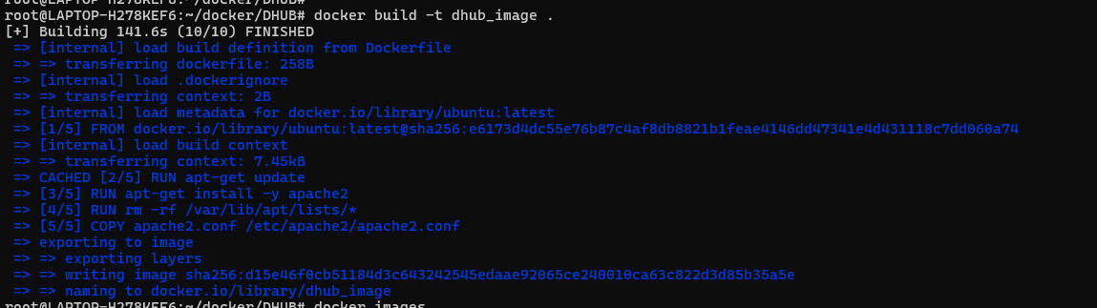

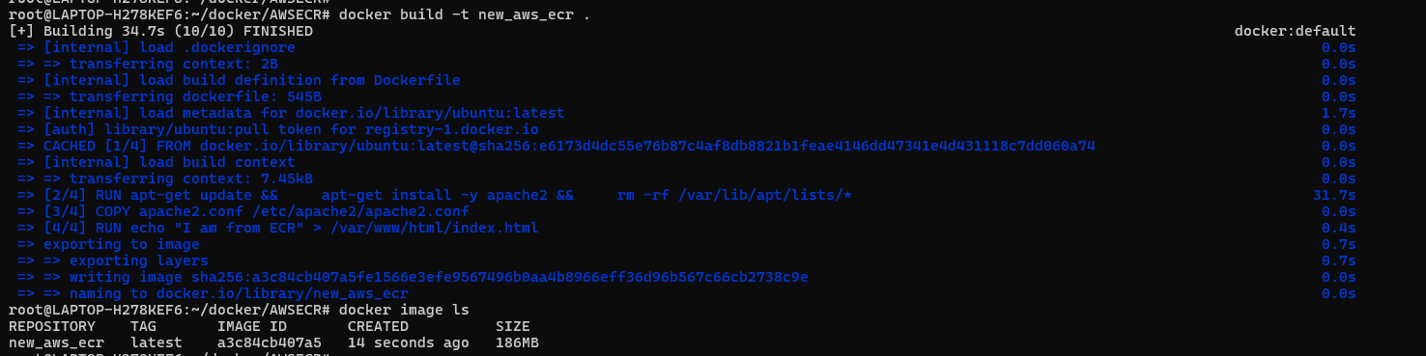



==============================================================

4. **Push Images to Repositories:**

   - Push the Docker image to Docker Hub.  
   - Push the Docker image to AWS ECR.

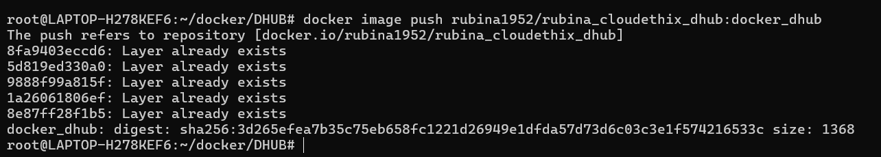

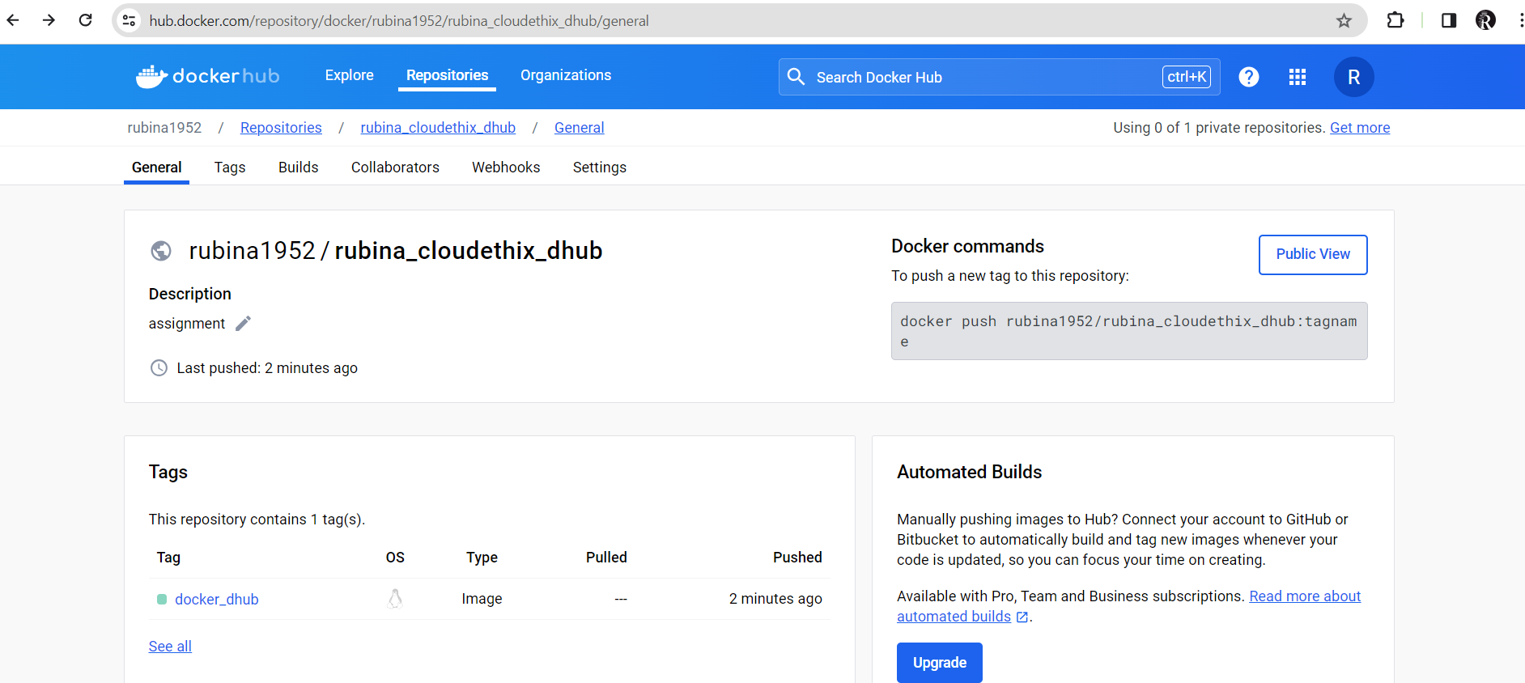



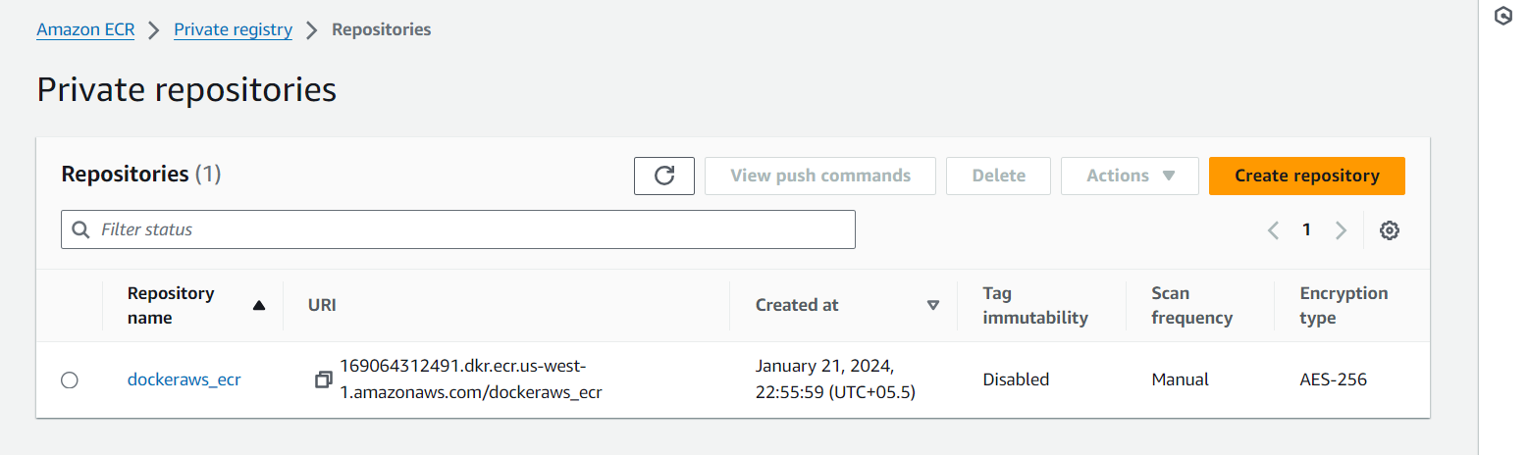

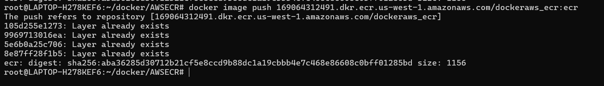

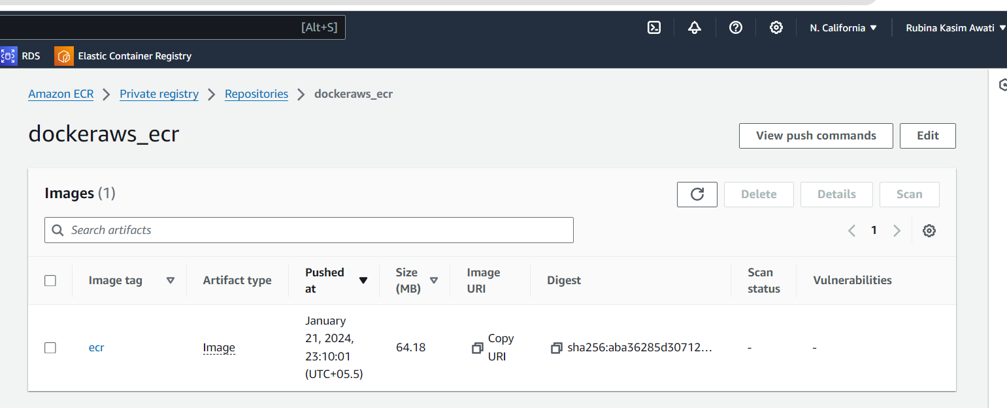

.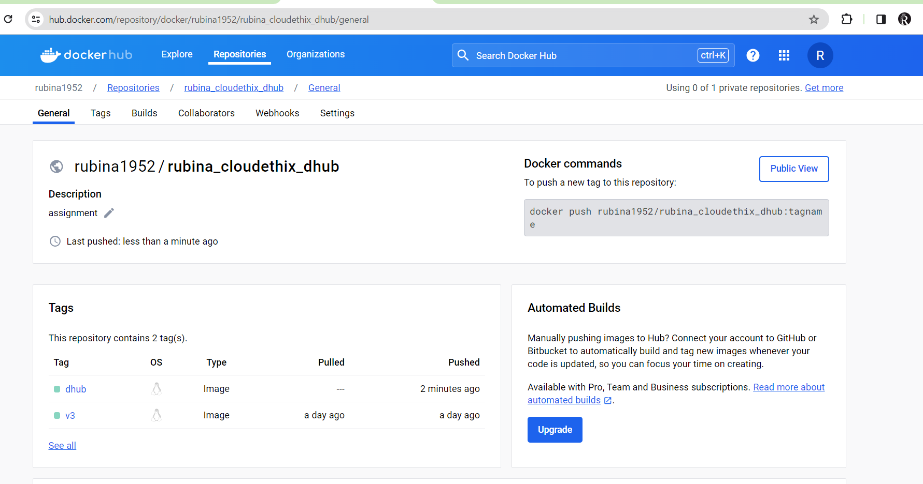

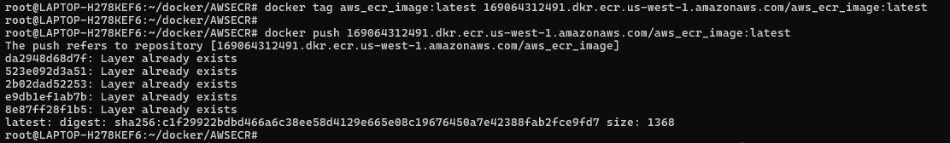

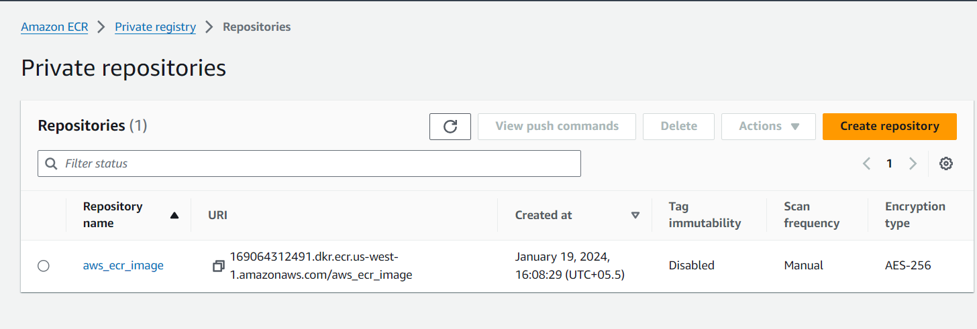

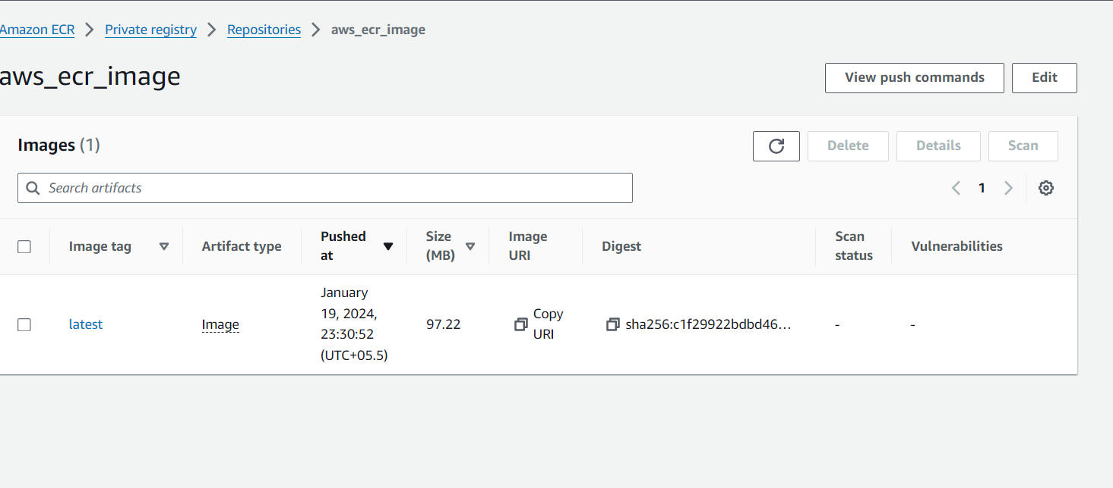

==================================================================

5. **Run Containers:**

   - Execute a container from the Docker Hub image, naming it "I_AM_FROM_DHUB," and mapping host port 8081 to the container.

   ```  
   docker run -d -p 8081:80 --name I_AM_FROM_DHUB your_docker_hub_image

# - Execute a container from the AWS ECR image, naming it "I_AM_FROM_ECR," and mapping host port 8082 to the container.

# 

# ```    docker run -d -p 8082:80 --name I_AM_FROM_ECR your_aws_ecr_image

   ```

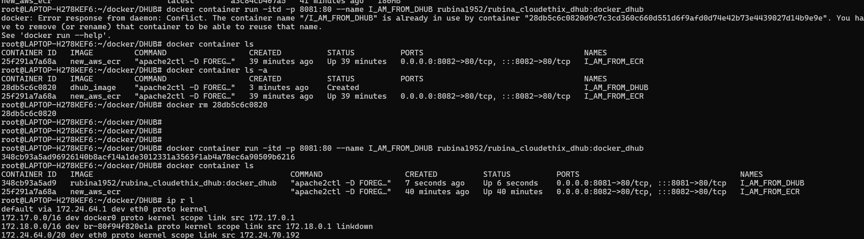

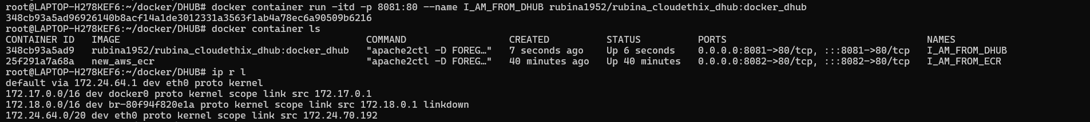

===========================================================================

# 6. **Access Pages from Browser:**

# - Open a web browser and access the pages:      - For Docker Hub: <http://localhost:8081>      - For AWS ECR: <http://localhost:8082>

# 