**Docker Assignment 03**

===================================================================

1. Run four HTTPD Docker containers with distinct, meaningful names, and apply restart policies (NO, On-Failure, Always, and Unless-Stopped) to each of the four containers, respectively.                         Demonstrate that the restart policies function as expected.



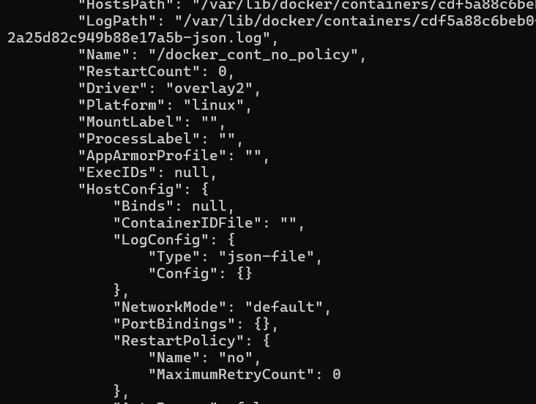

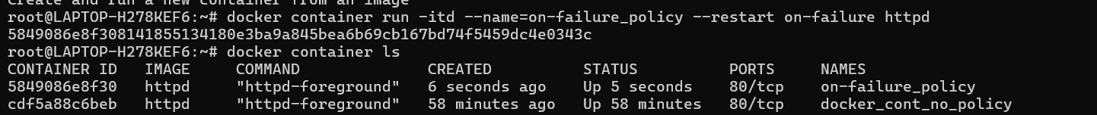

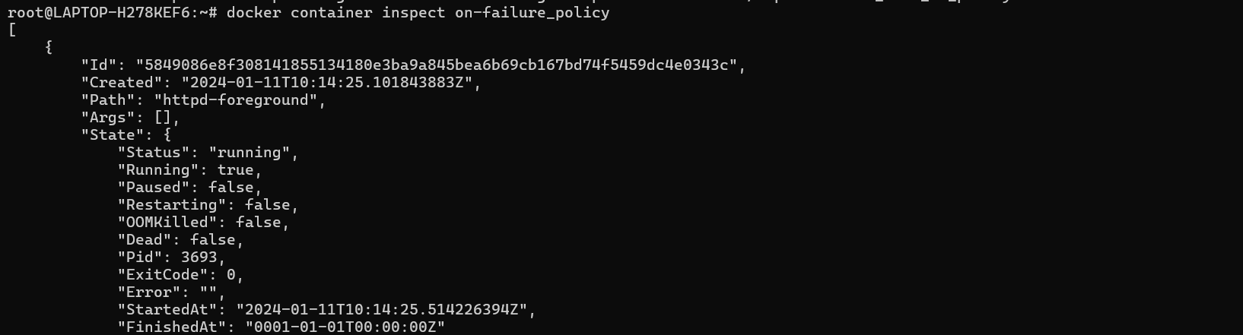

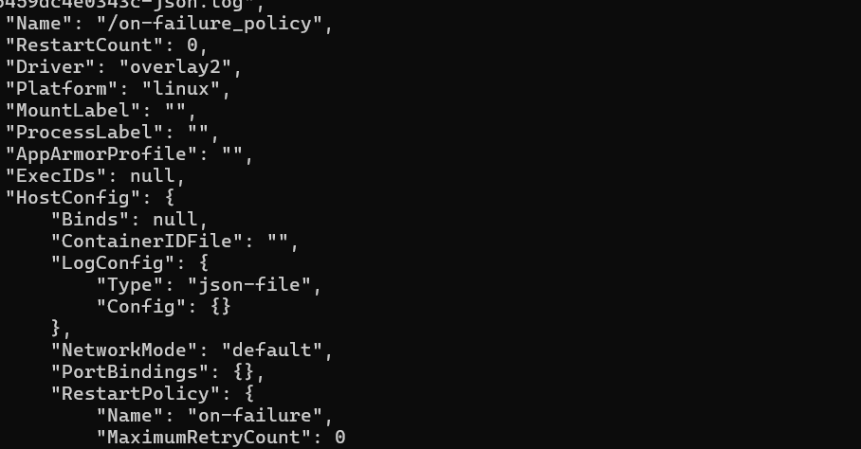

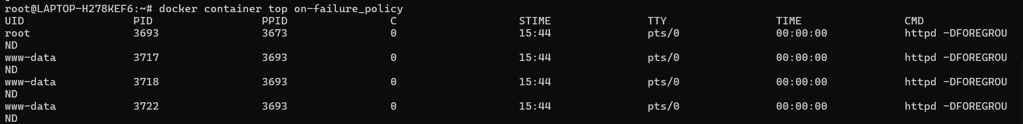

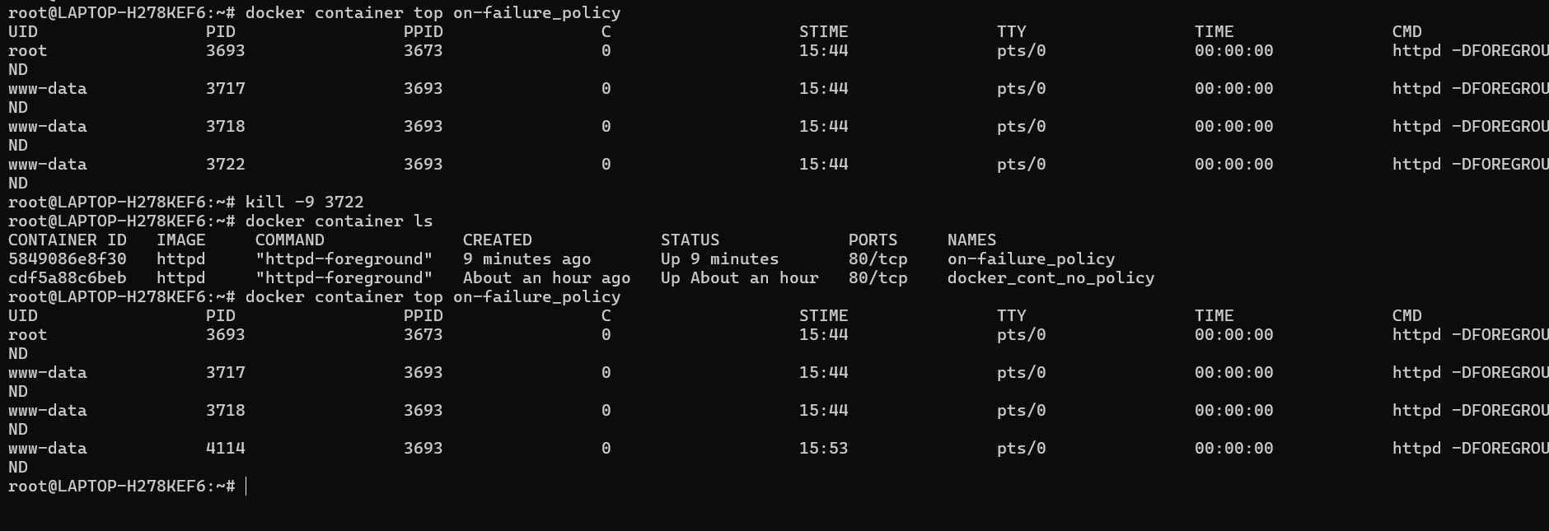

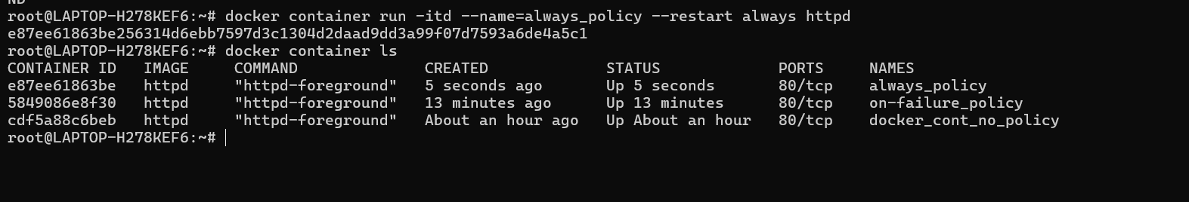

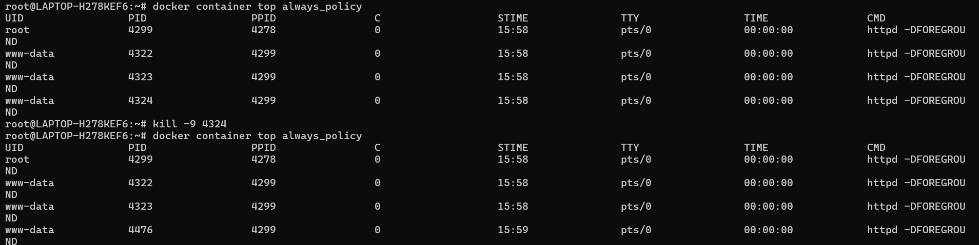



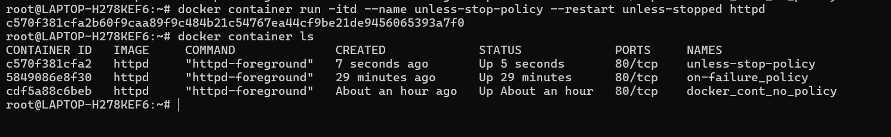

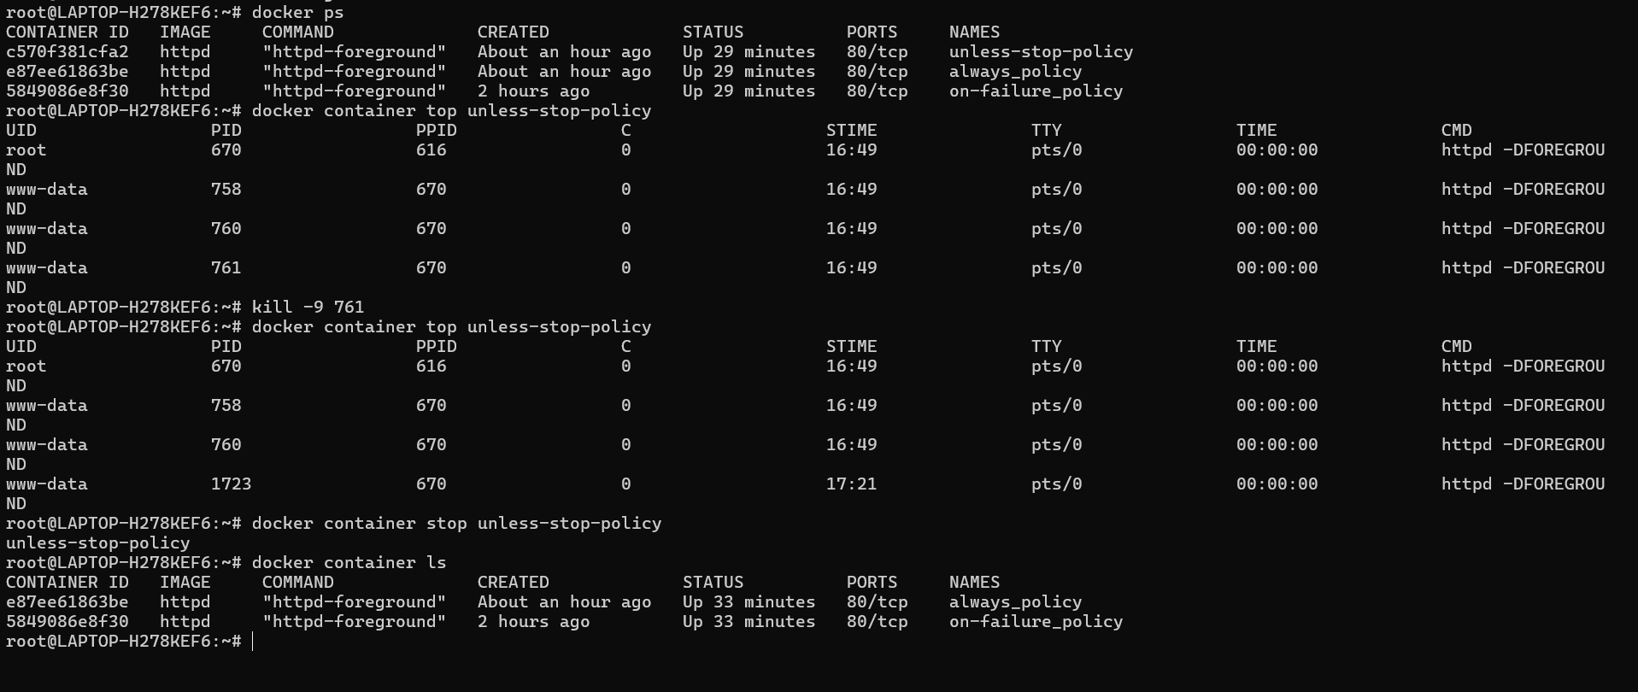

===================================================================

2. Change the restart policy of a above running container from the default to a custom policy using the docker update command. e.g. docker update --help

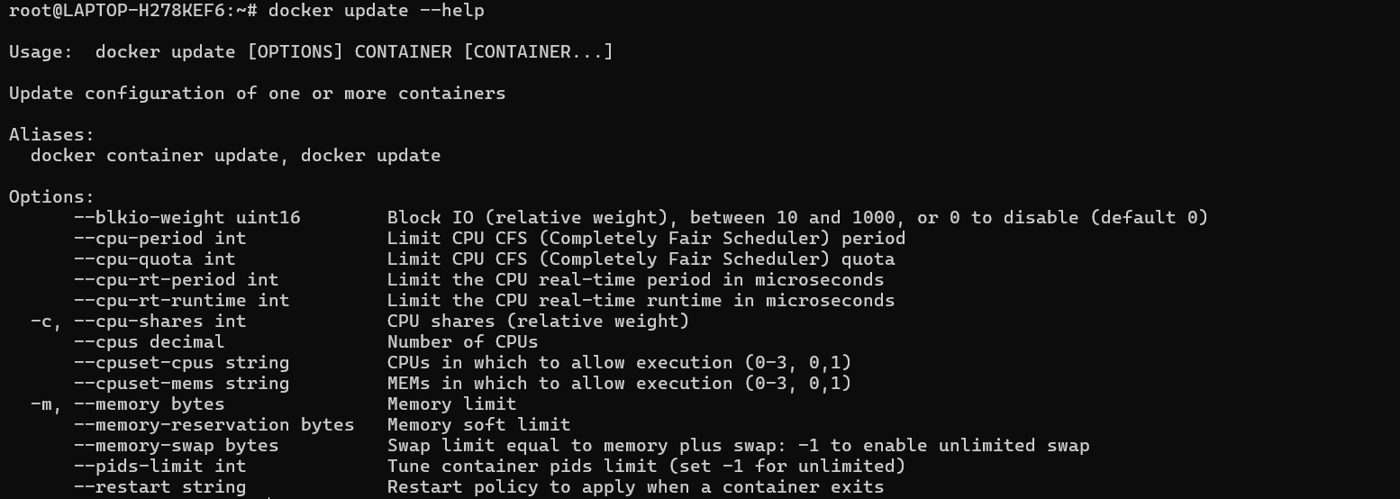

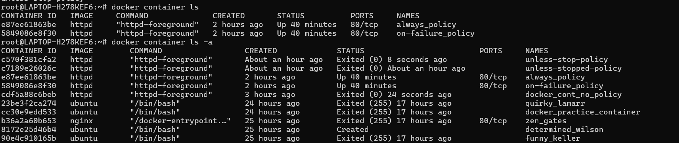

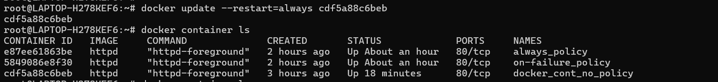

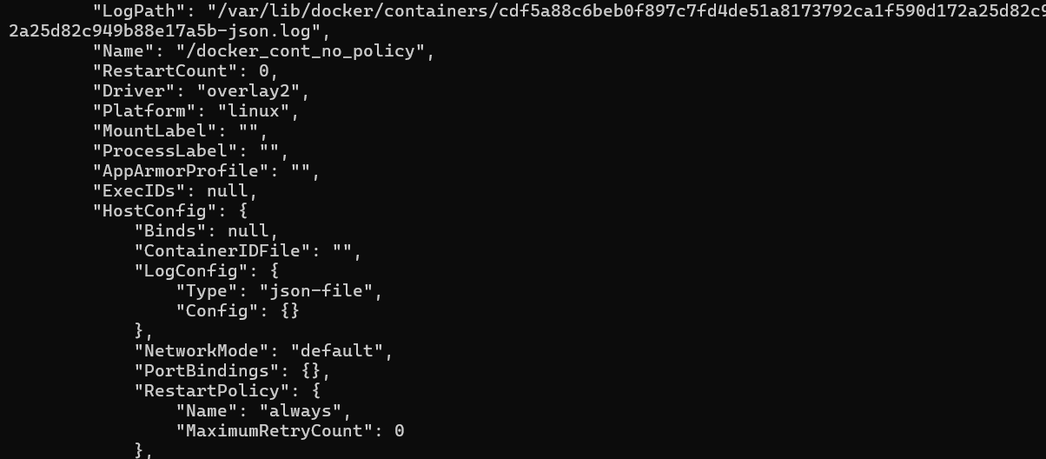

===================================================================

       3. Launch an NGINX container with a meaningful name and expose it on the host's port 80.

            Create an "index.html" file containing the text "Hello there, Let's be the Team CloudEthiX," and copy the file to the container's "/usr/share/nginx/html/" location.

           Access the container in a browser to verify that the webpage displays correctly.

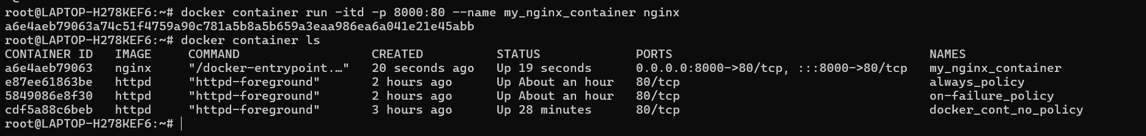





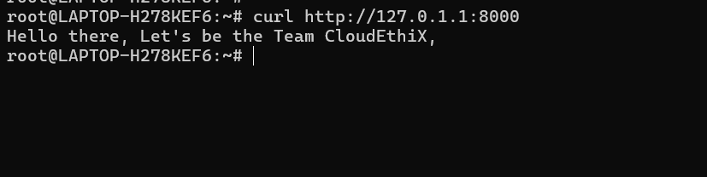

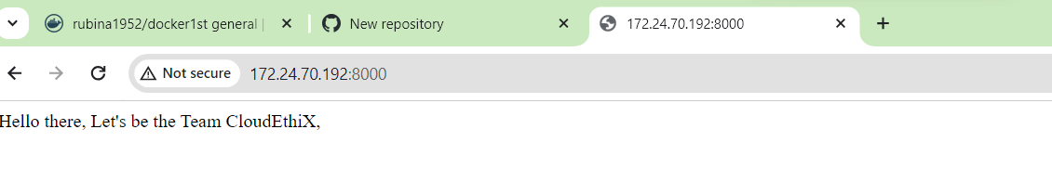============================================================

4. Run a docker container with CPU and Memory limit.  docker container run --help   
    ref links :- <https://phoenixnap.com/kb/docker-memory-and-cpu-limit>  
                     <https://www.baeldung.com/ops/docker-memory-limit>

Solution:-

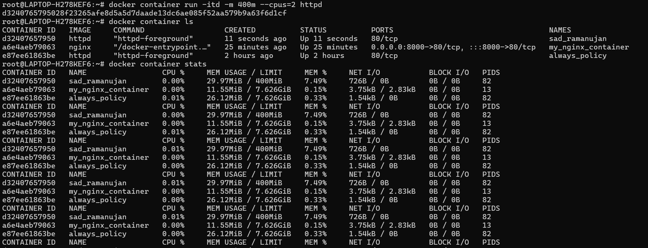

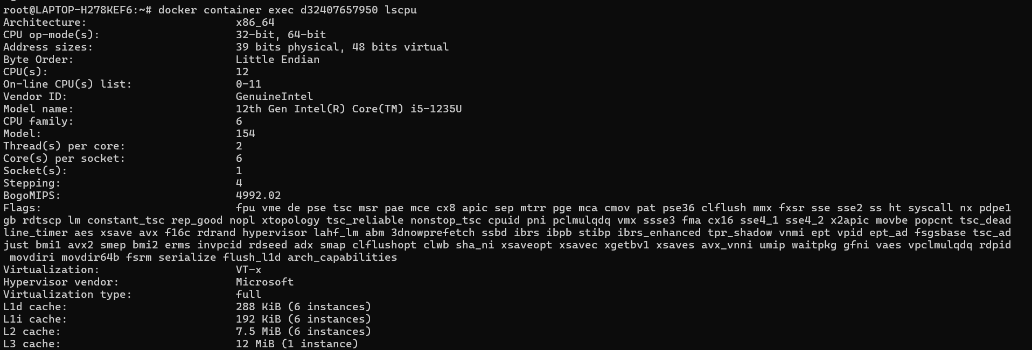

==================================================================

    5.  Update CUP and Memory of docker container using docker update.  
    ref links :- <https://docs.docker.com/engine/reference/commandline/update/>

How to Limit Docker Memory and CPU Usage | phoenixNAP KB

Limit Docker memory and Docker CPU usage to ensure optimal performance. Follow the steps of this guide to learn how to set limits.

Solution:-

