Docker Assignment -05

==================================================================

1. Push the Redis images tagged as version 1 and 3 to your Docker Hub repository, named "yourname_cloudethix_redis."

Solution:-

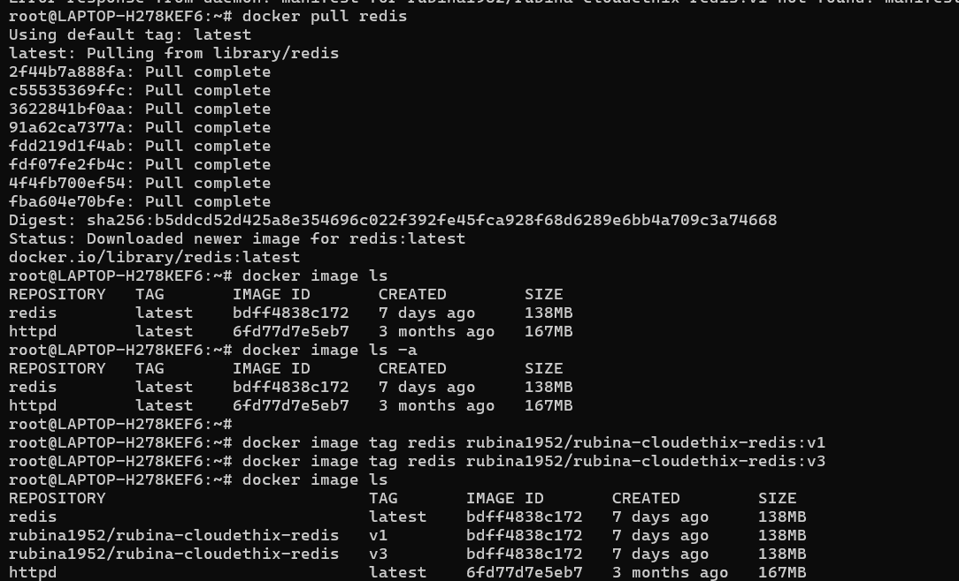

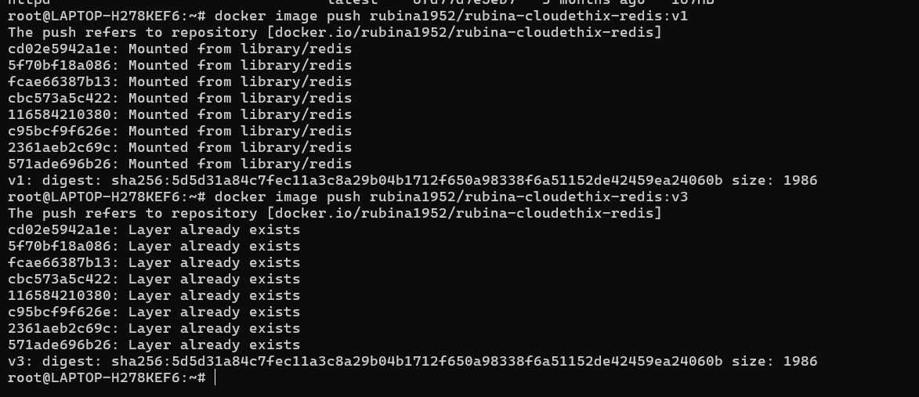

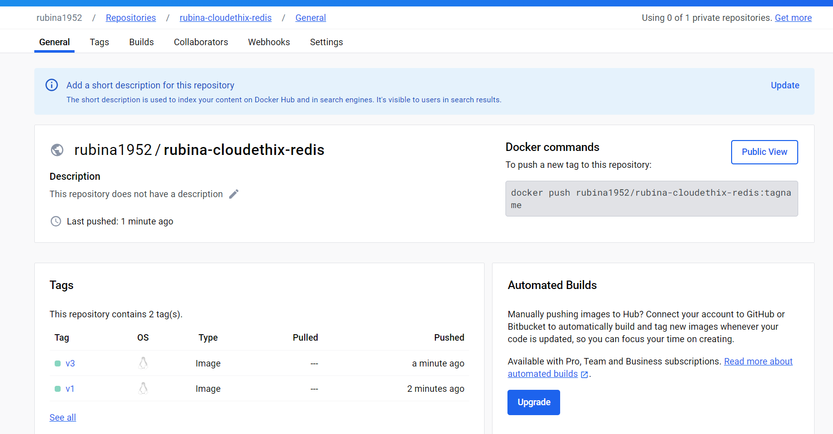

================================================================

02. Create a remote Git repository and add the Docker file and index.html files. Clone the repository locally and create a release branch.

              Build the Docker image from the release branch with a meaningful tag, then run a container from the image and expose it on host port 8383.

              Check the webpage in a browser, and upon success, push the image to your Docker Hub repository named "yourname_cloudethix_nginx."

              Finally, push the release branch to the remote Git repository and merge it by creating a pull request.

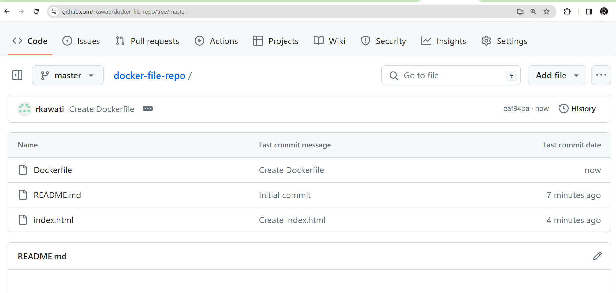

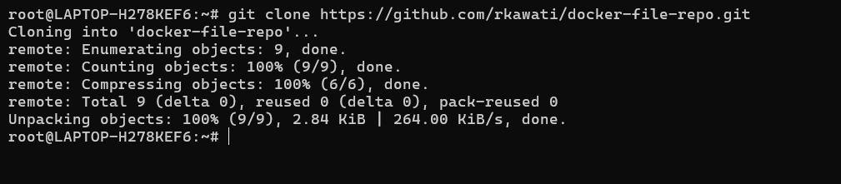

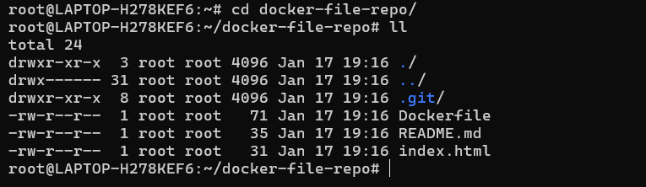

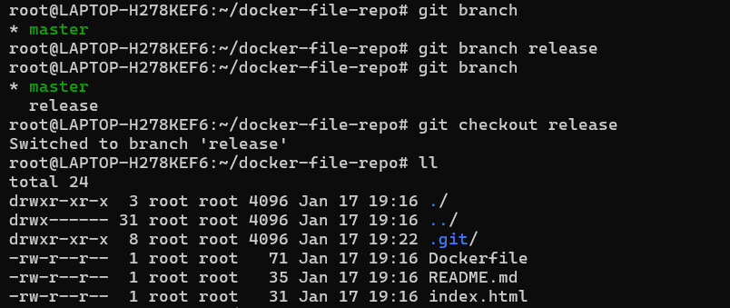

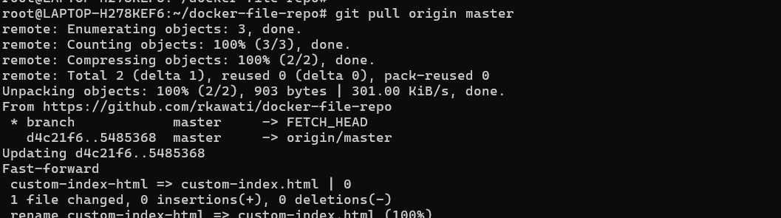



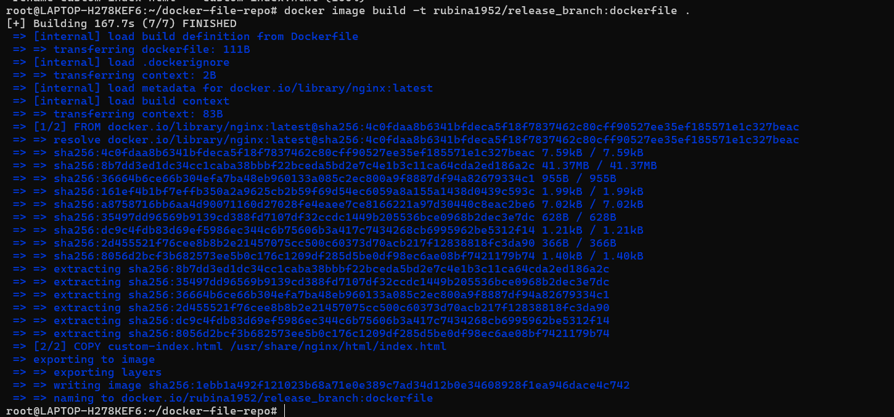

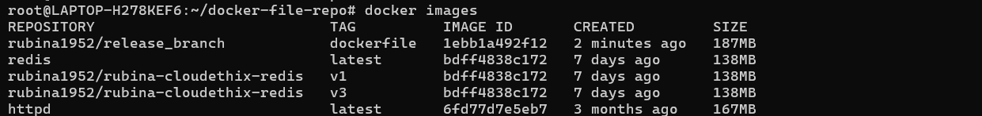

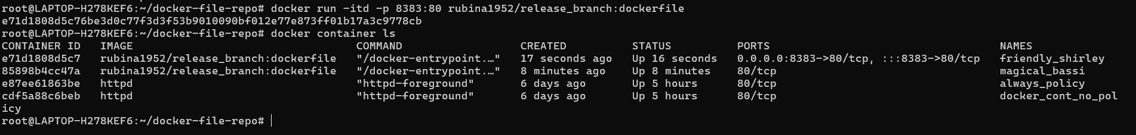

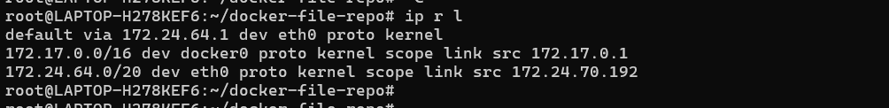

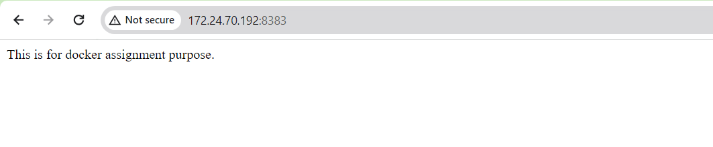

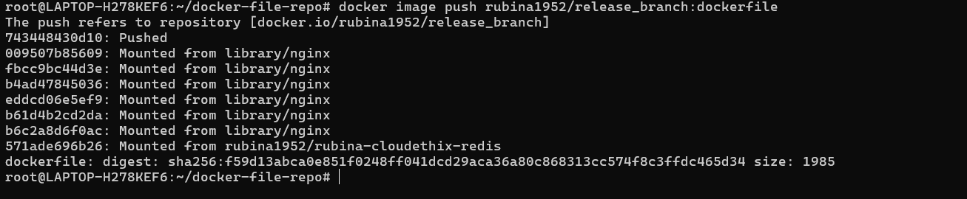

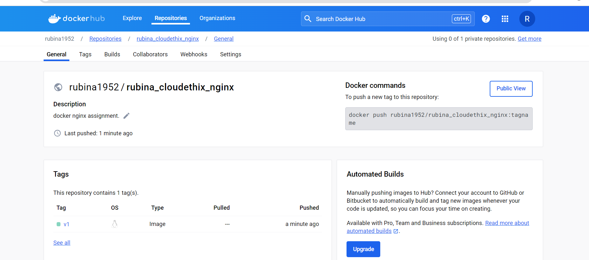

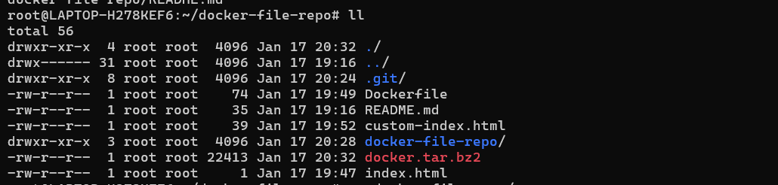

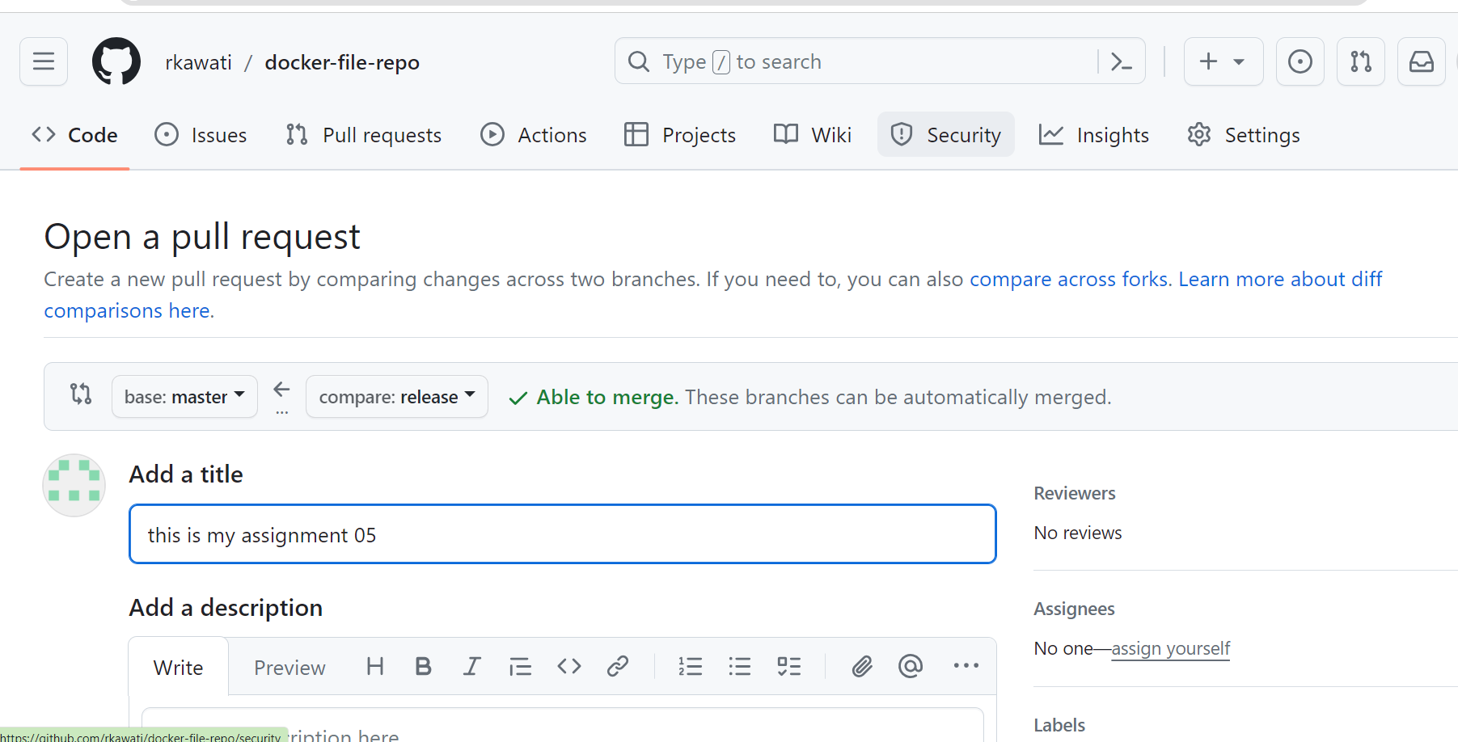

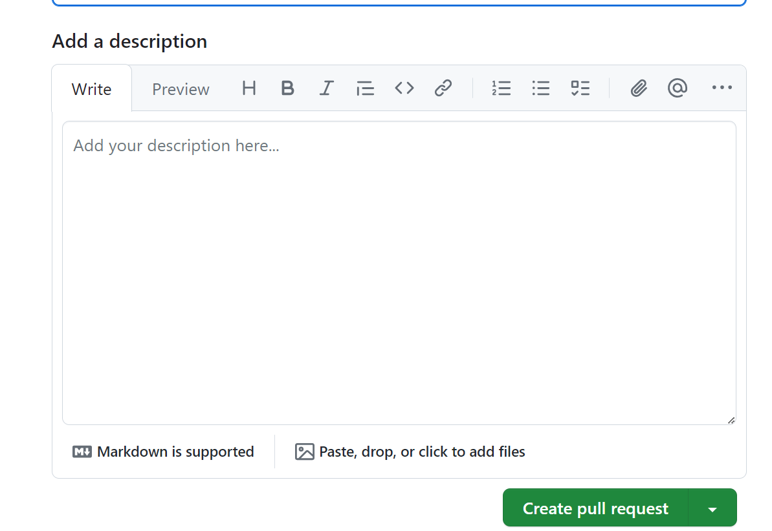

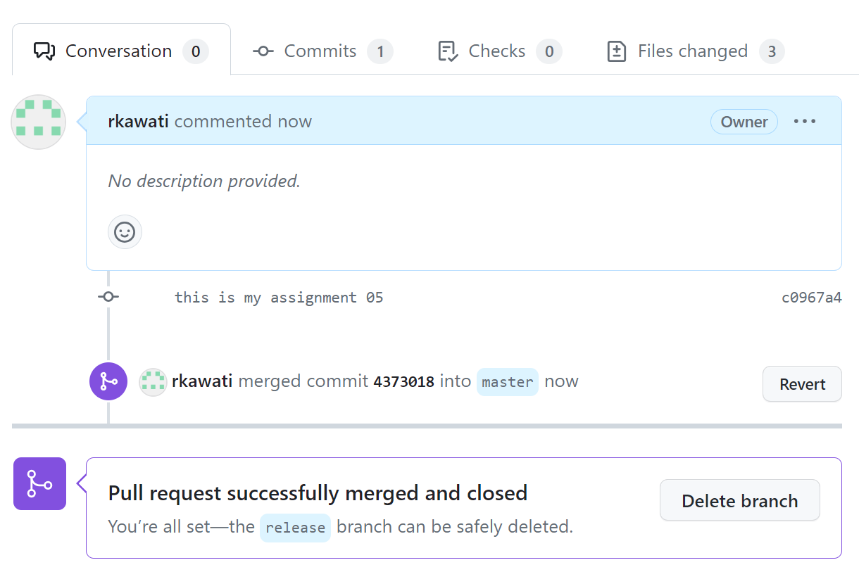

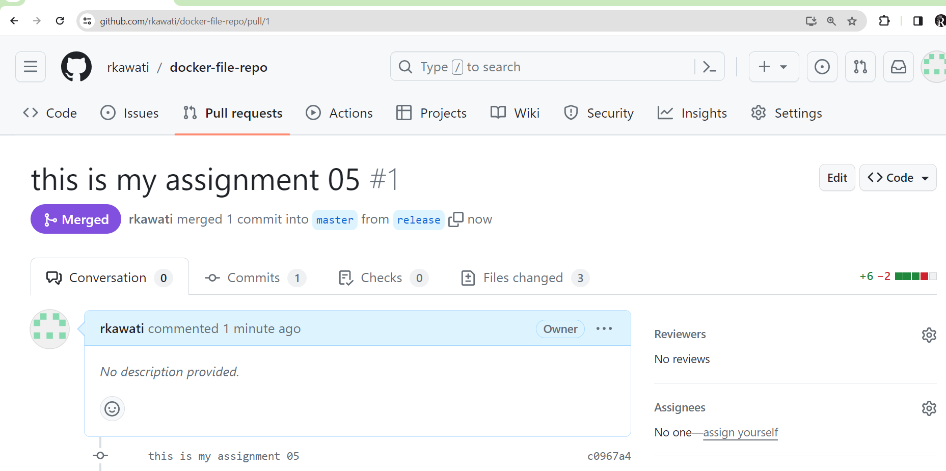

==================================================================

03. Save all local Redis images as a .tar file in the master branch of your local repository.

             Delete all Redis images from your local system and push the master branch to the remote repository.

             Load the Redis images from the tar file to your local system, and verify that all images have been loaded correctly.

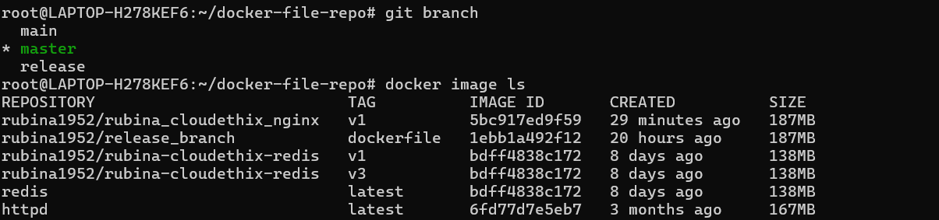



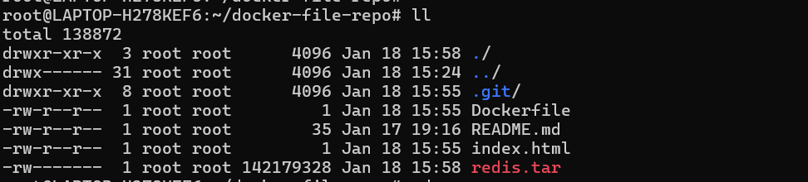

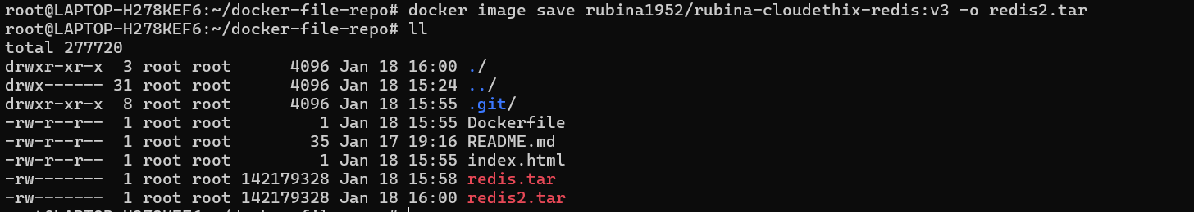

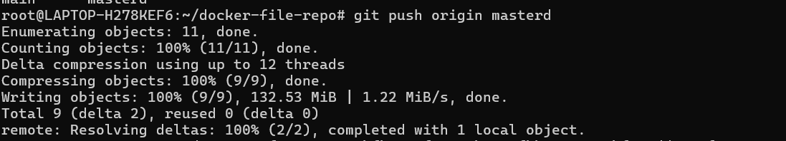

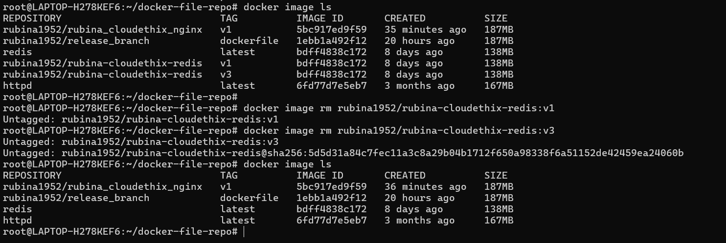

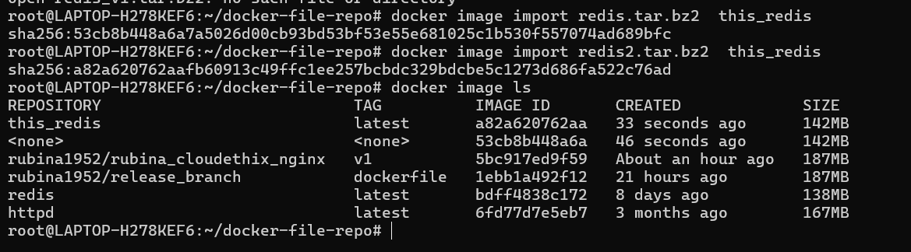

============================================================

  04. Pull the Busy-box image to your local system, tag it, and push it to the Docker Hub repository "yourname_cloudethix_busybox."

             Export the Docker image from the NGINX container, create a .tar file, and import the tar file to create a Docker image with a meaningful name.

             After importing the image, tag it and push it to the "yourname_cloudethix_busybox" Docker Hub repository.

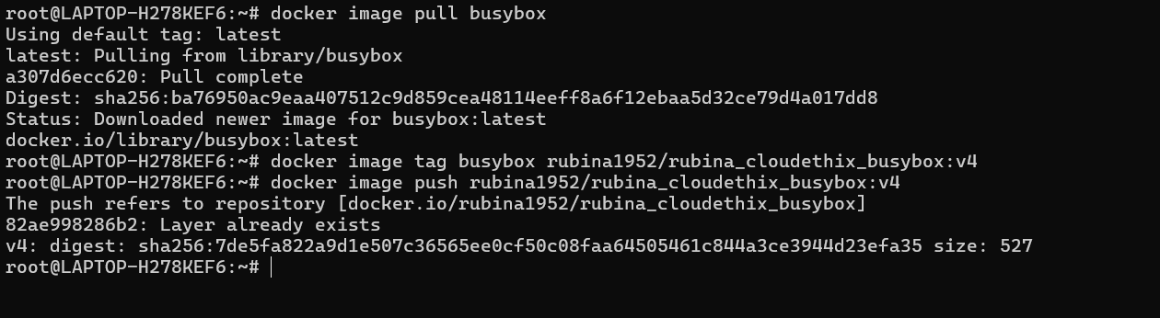

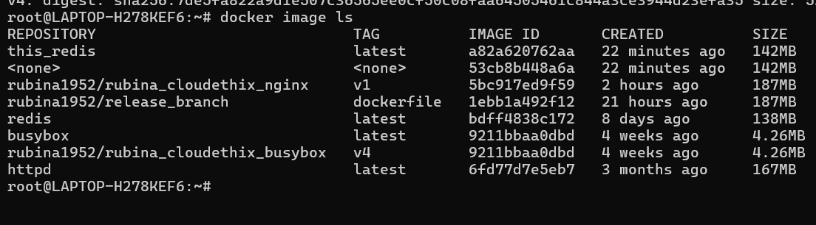

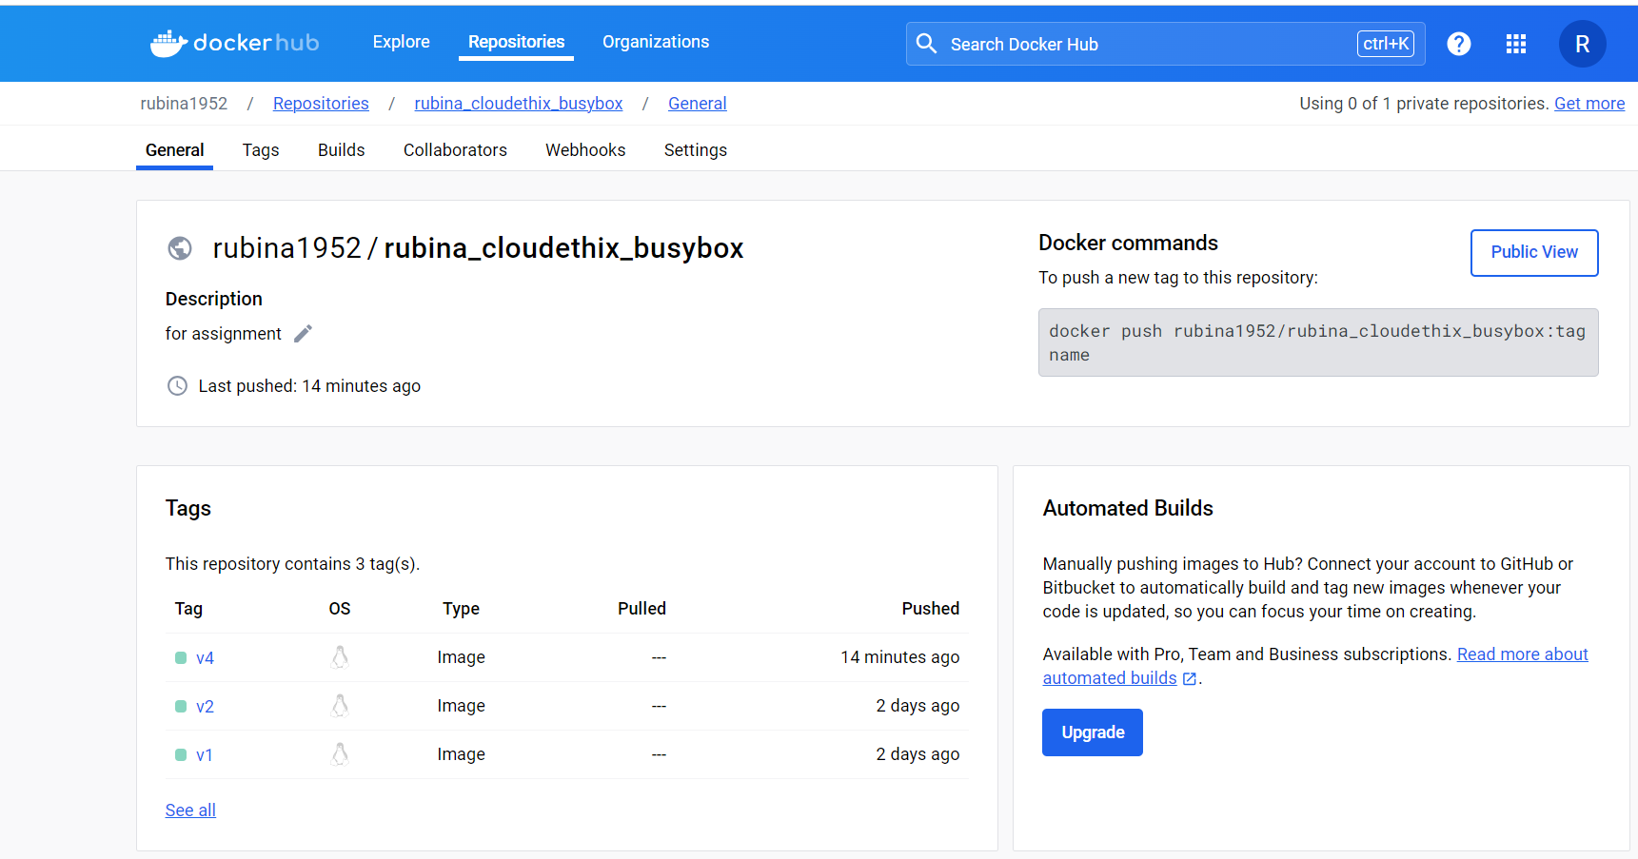

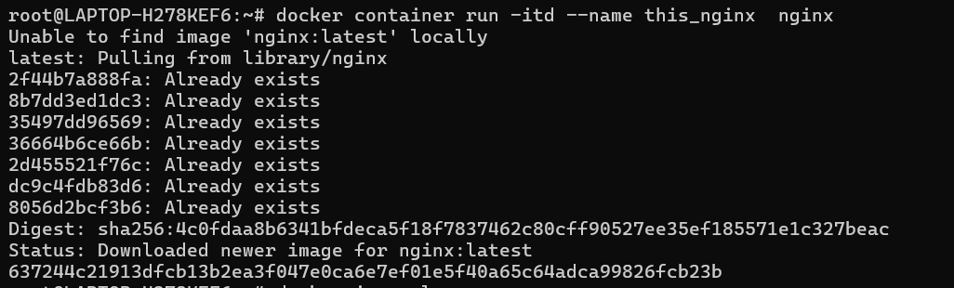

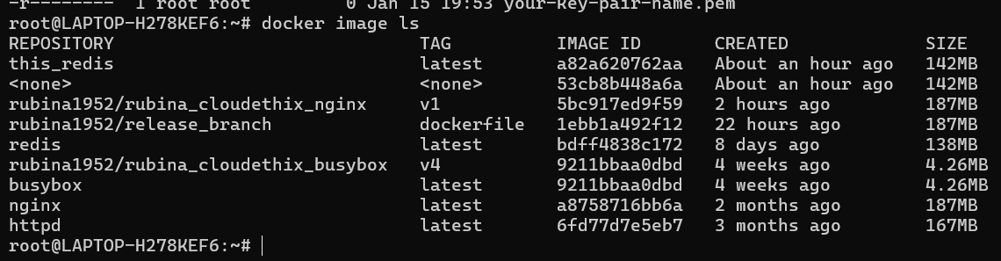

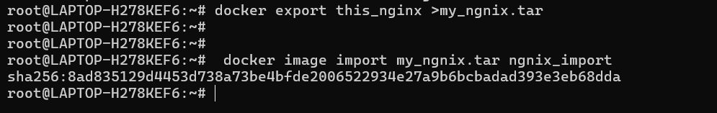

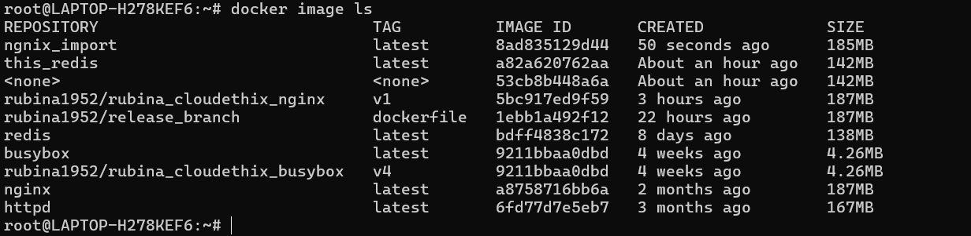

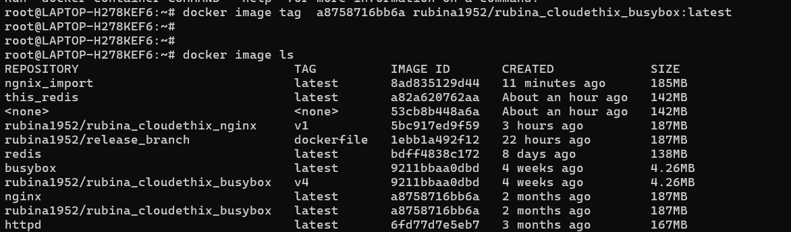

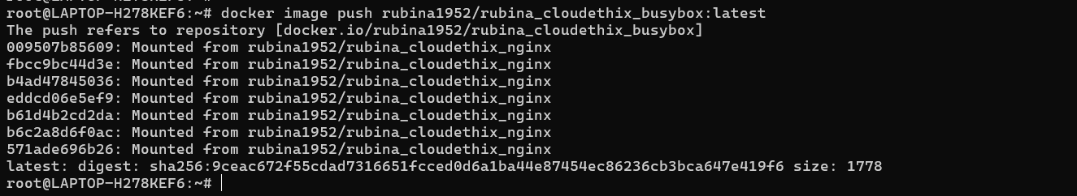

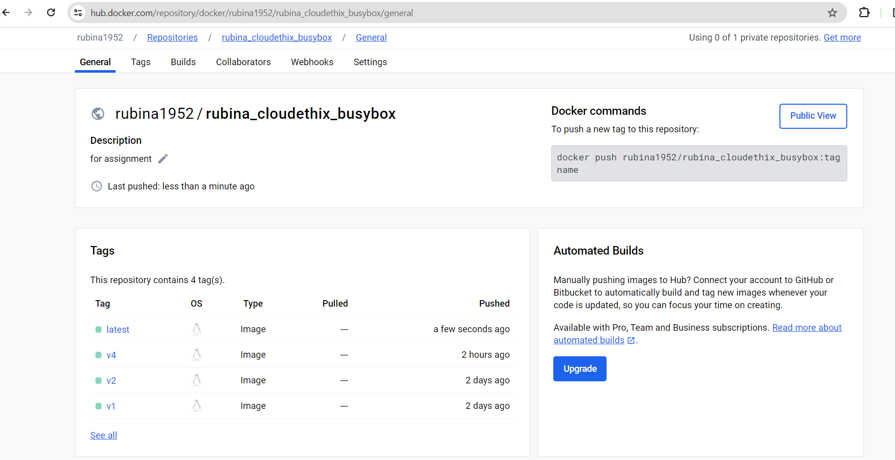

==================================================================

  05. Dockerfile creation: Create a simple Dockerfile to build a custom image with the following specifications:  
      1. Base image: Ubuntu  
      2. Install packages: curl, vim, and git  
         3. Set an environment variable: MY_NAME=Your_Name  
      4. Build the custom image using docker build and list all available images using docker images.

