DOCKER ASSIGNMENT 02

==================================================================================

8. Clone the lancachenet / ubuntu-nginx Git repository locally and build a Docker image from the provided Docker file. Be sure to add relevant tags when building the image.

Solution:-

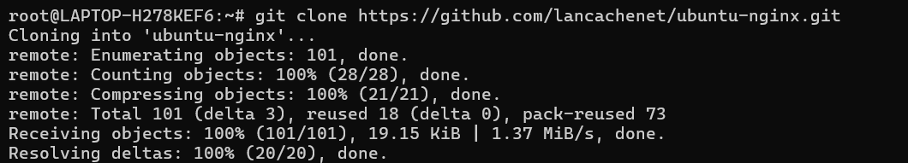

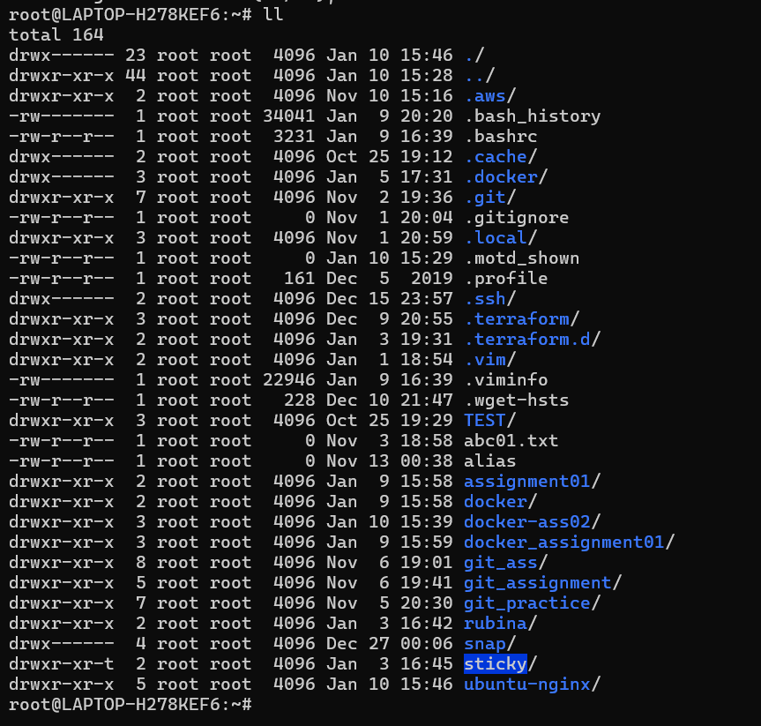

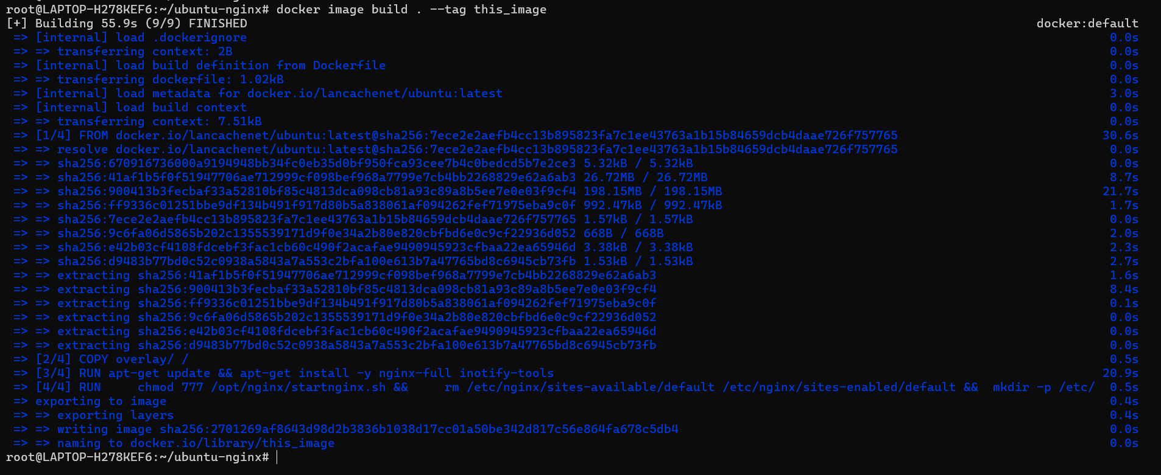

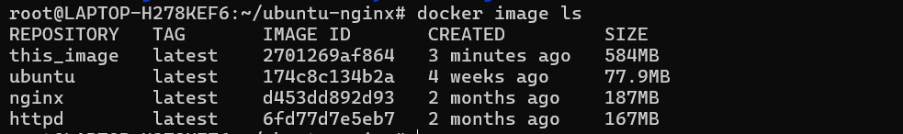

==================================================================================

9] After building the image, run a Docker container using the image and check

the webpage using the curl command to ensure it’s accessible.

Solution:-

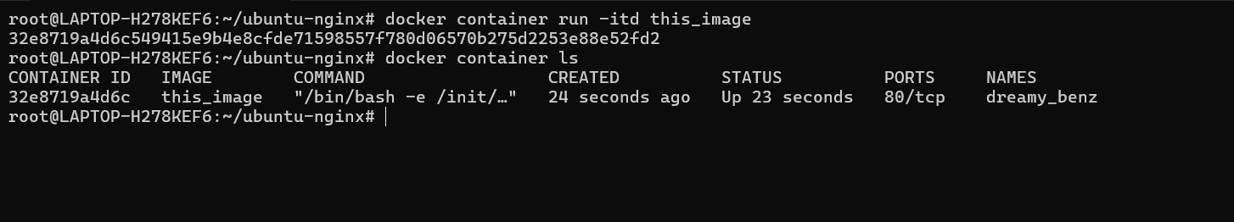

==================================================================================

10] Launch an Ubuntu container, demonstrate that the escape sequence is

functional, and reattach the container after detaching it with the escape sequence. Then, check the container's IP address.

Solution:-

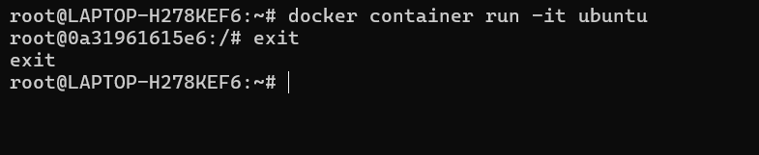

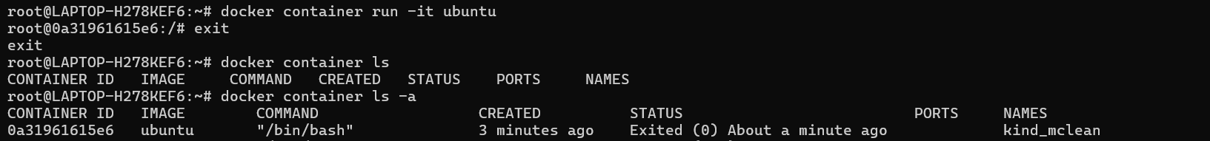

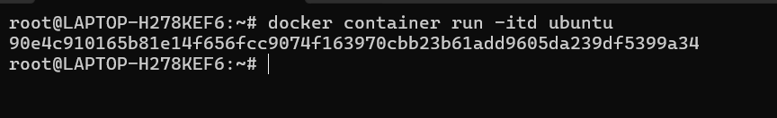

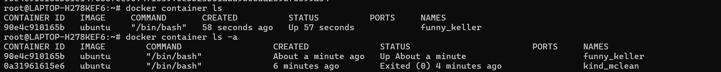

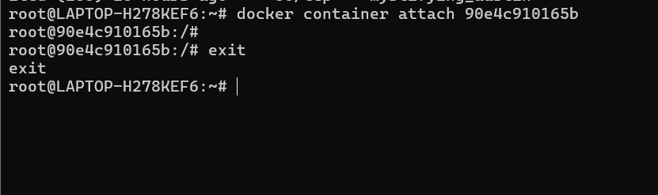

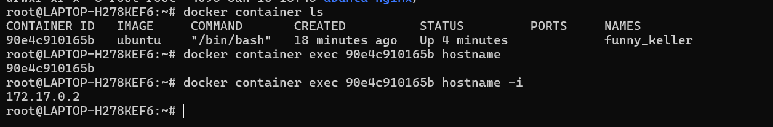

11] Use a Docker command to inspect the hostname and /etc/hosts file of the

httpd container.

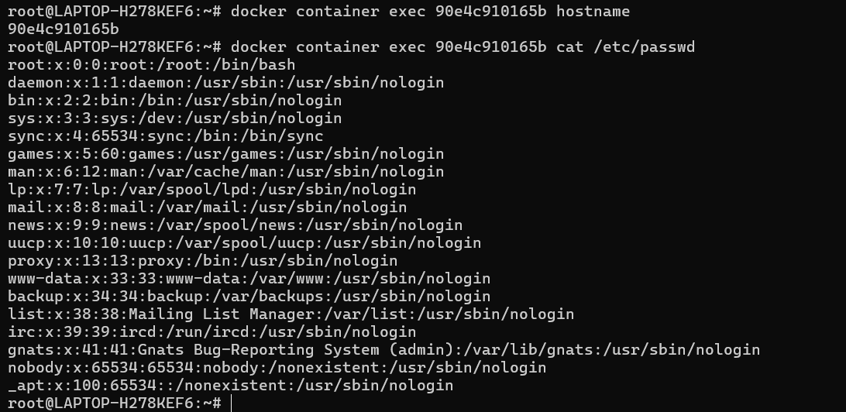

==================================================================================

*12. Use a Docker command to inspect the hostname and /etc/hosts file of the httpd container.*

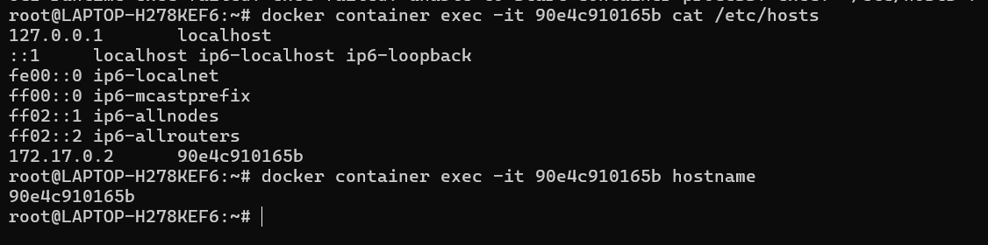

==================================================================================

13. Run a Docker command to inspect a container created with the lancachenet/ubuntu-nginx repository, and monitor the container's resource usage and stats with the TOP command.

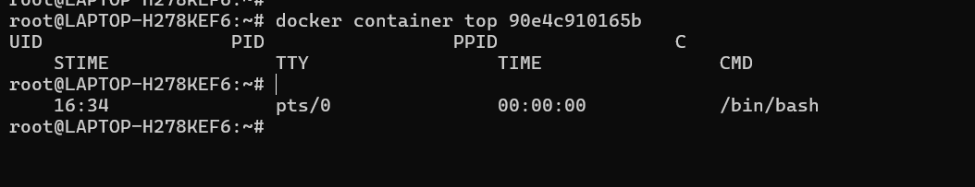

14. Start a new Nginx container and review the logs for both Nginx containers*.*



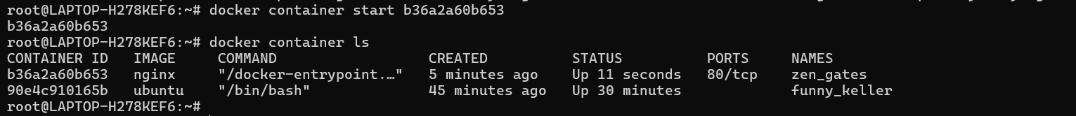

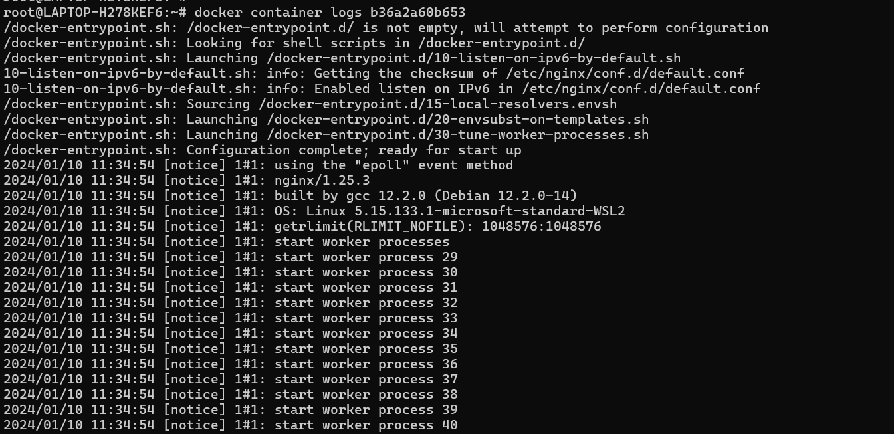

15. Examine system events, filtering them by date and the last 30 minutes. Additionally, apply two filters simultaneously using name and event.

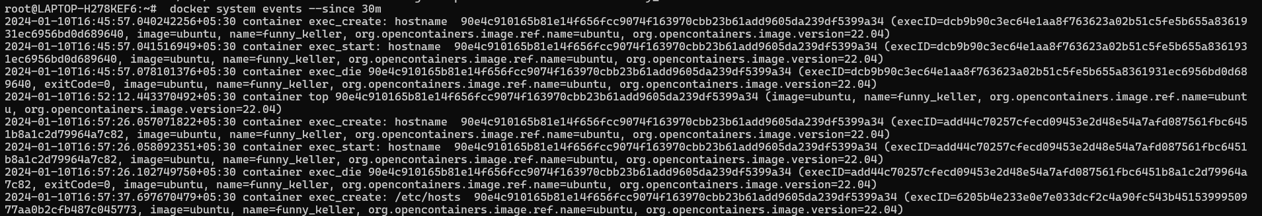

16. Create a Docker container using the Ubuntu image, assign it a meaningful name, and set the hostname to "cloudethix.com." Stop or kill the container, check its exit code, and examine the container's log for more information.

Solution:-

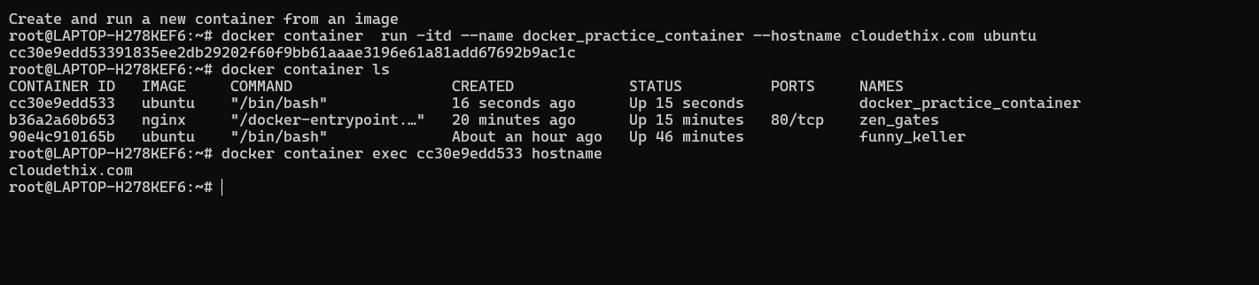

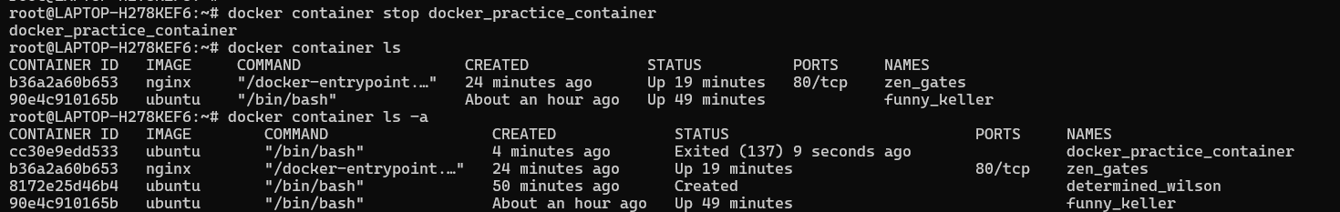

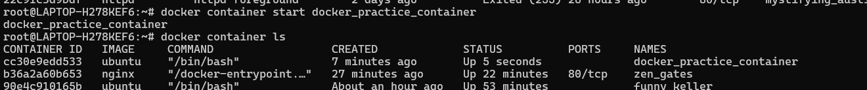



==================================================================================

17. Instantiate and start an Ubuntu container with a random name, then rename it to "Ubuntu01." Launch another container named "Ubuntu02" and check the hostname of both containers. Pause and un-pause the "Ubuntu02" container, and stop, start, and restart the "Ubuntu01" container. Inspect the stats and system events of both containers, then kill and delete them, ensuring that directories created by the containers are removed.

Solution:-





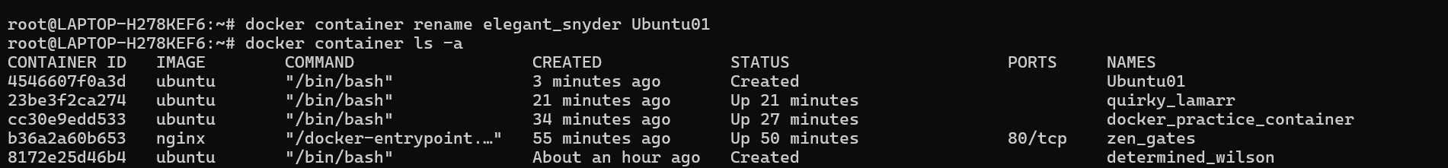

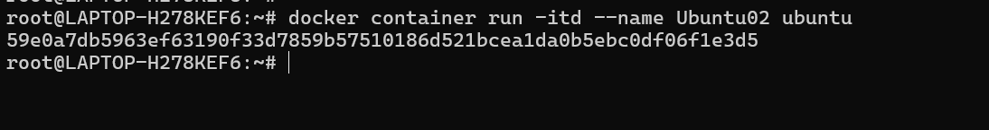

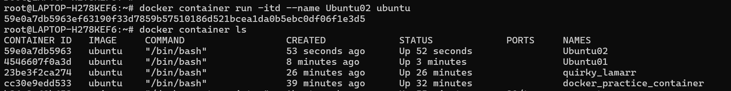

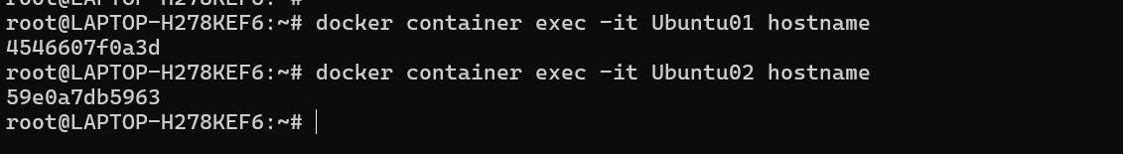

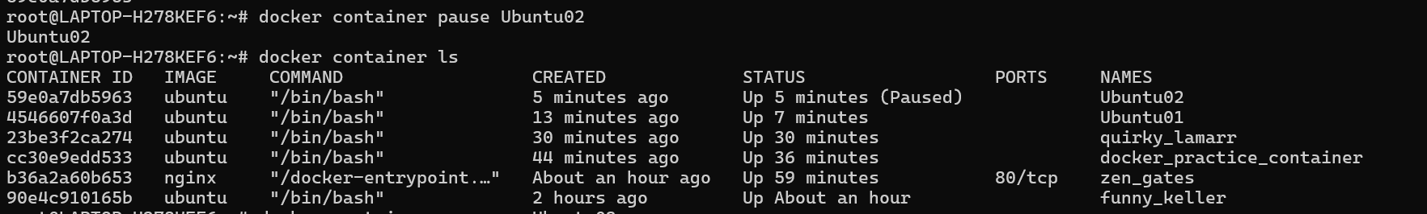

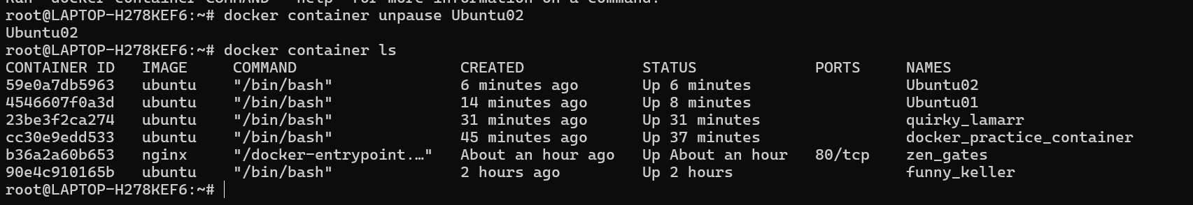

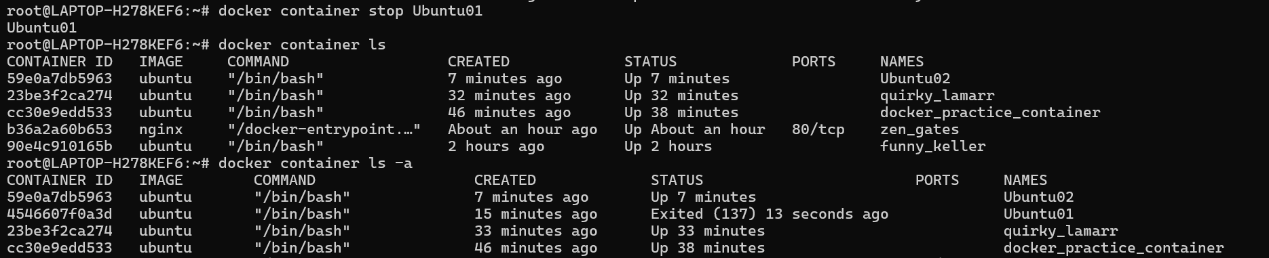

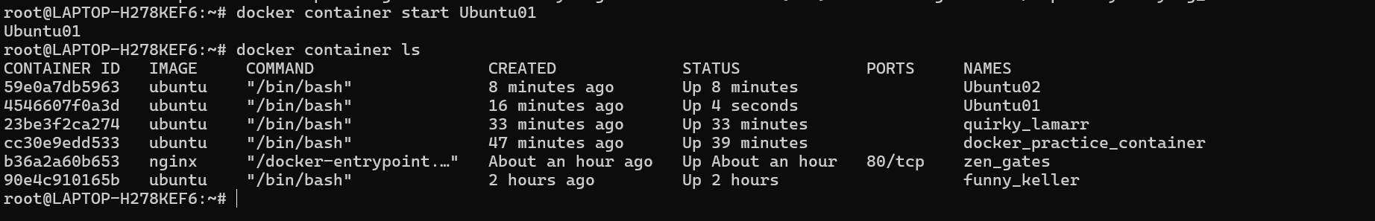



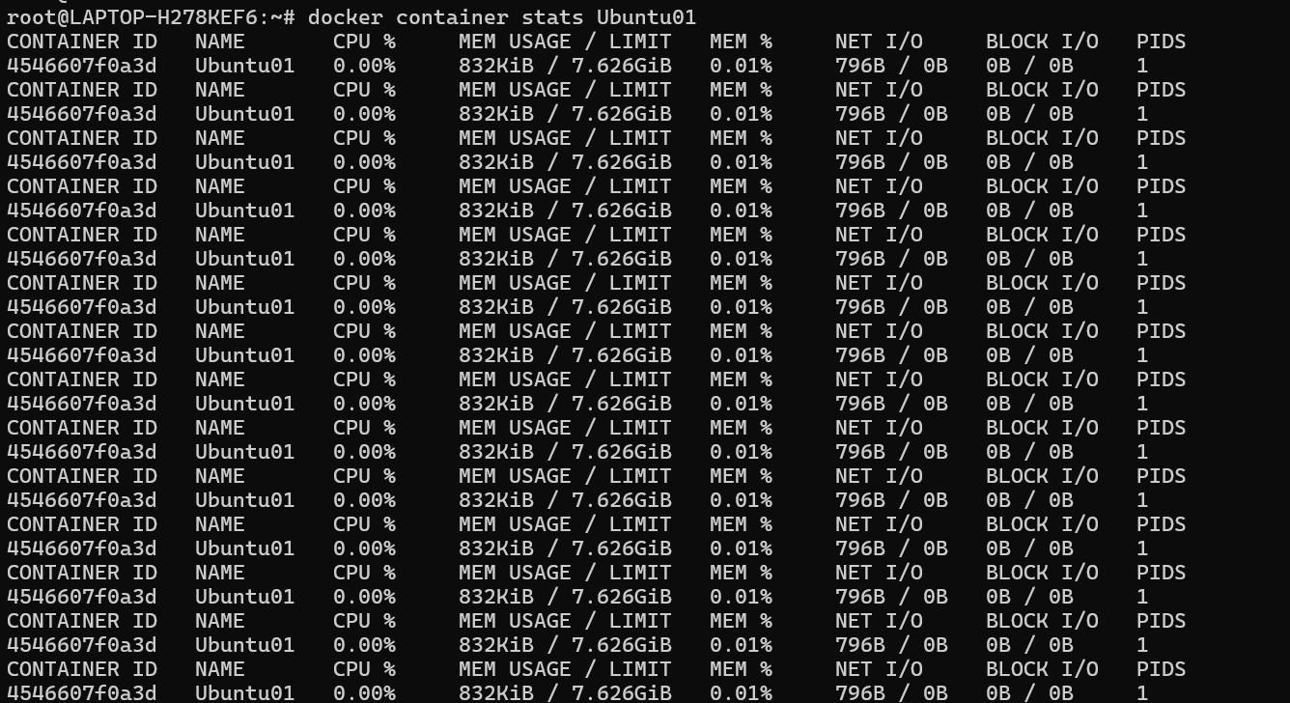

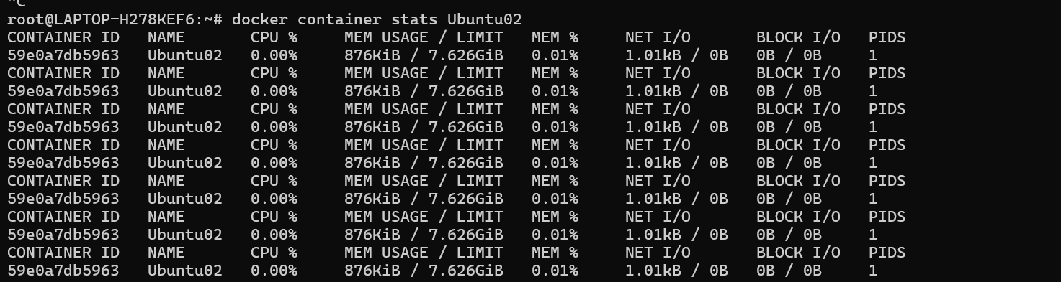



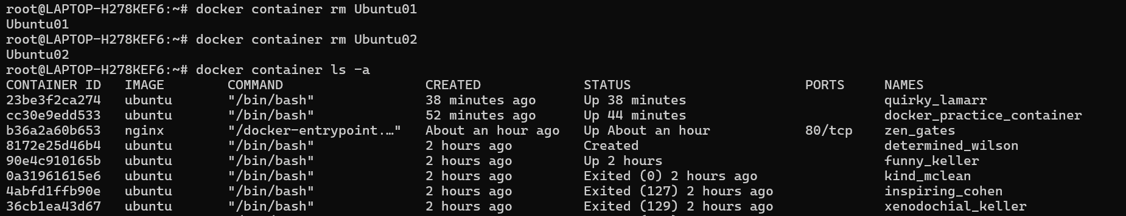

==================================================================================

17] Create a Docker Hub account, set up a repository with meaningful name.

Soluon: -

