**Docker First Assignment**

Q.1. 1]Docker installation: Install Docker on your local system (Windows,

macOS, or Linux). Verify the installation by running the docker -- version and docker info commands.

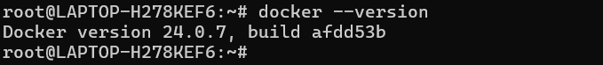

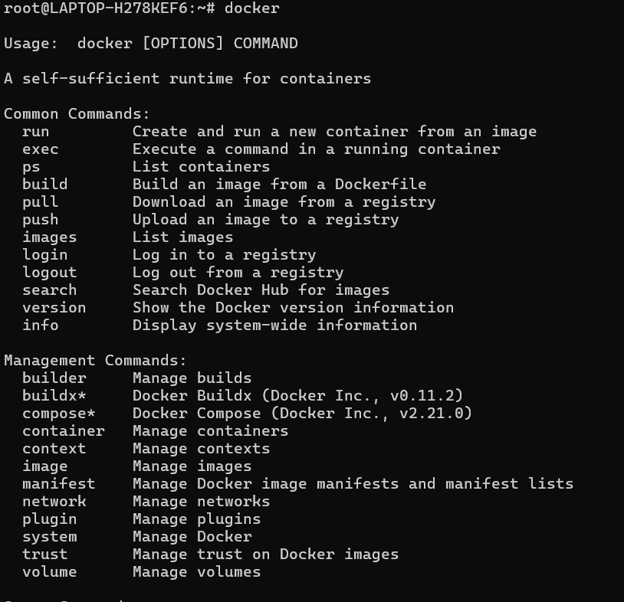

2]Working with Docker images: Search for the official Ubuntu image

on Docker Hub, pull it to your local system using docker pull, and list

all available images on your system using docker image.

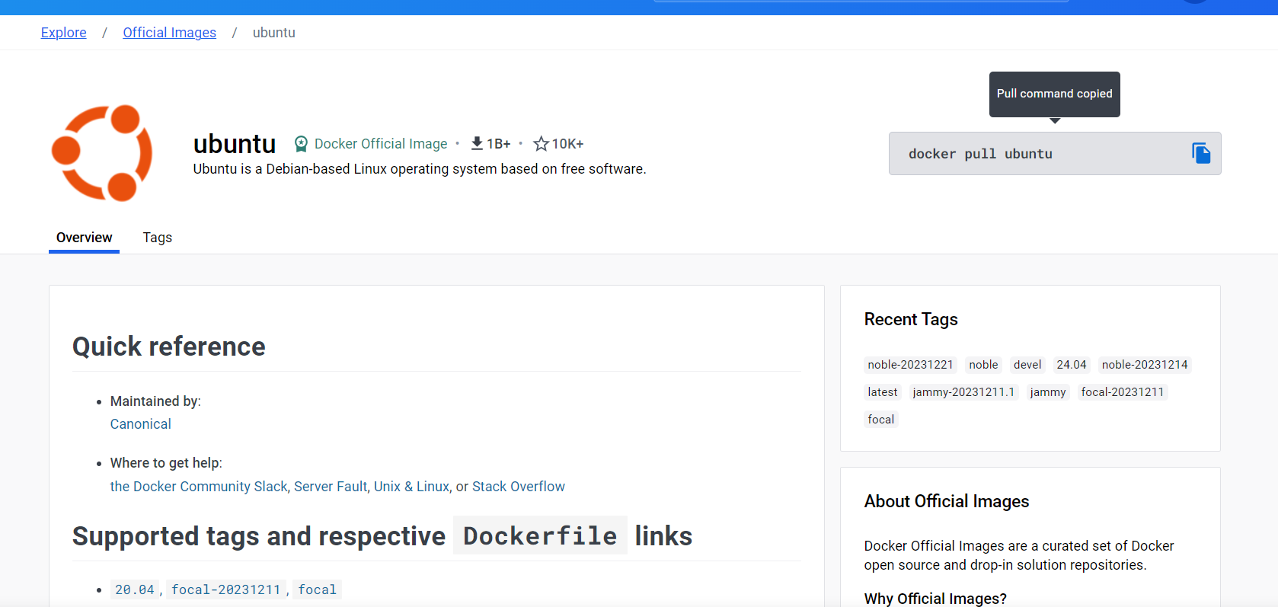

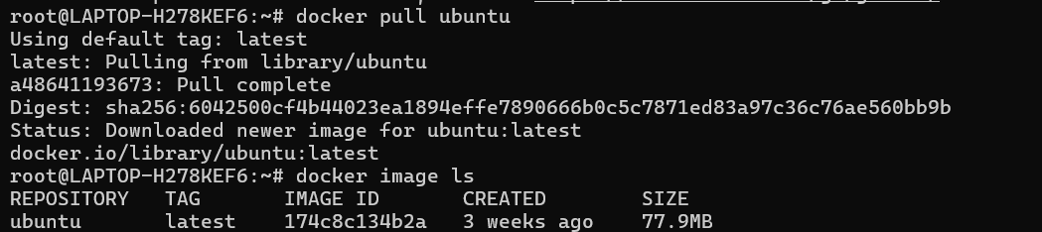

3] Creating a Docker container: Run a Docker container using the

Ubuntu image, and execute a command inside the container (e.g.,

echo "Hello, Docker!").

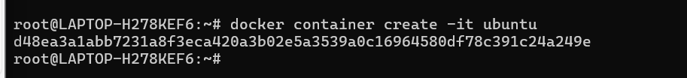

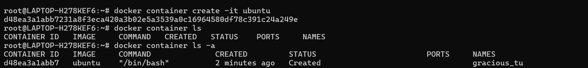

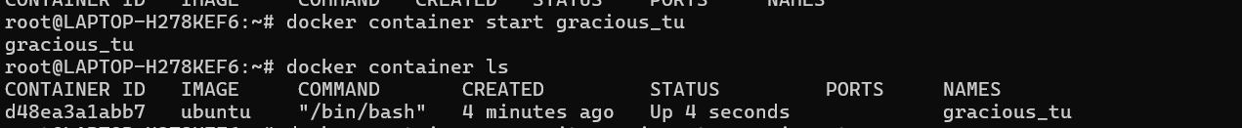



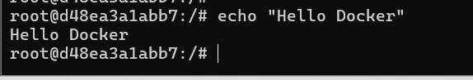

4] Inspect the Ubuntu Docker container to ensure it is in the

"created" state only.

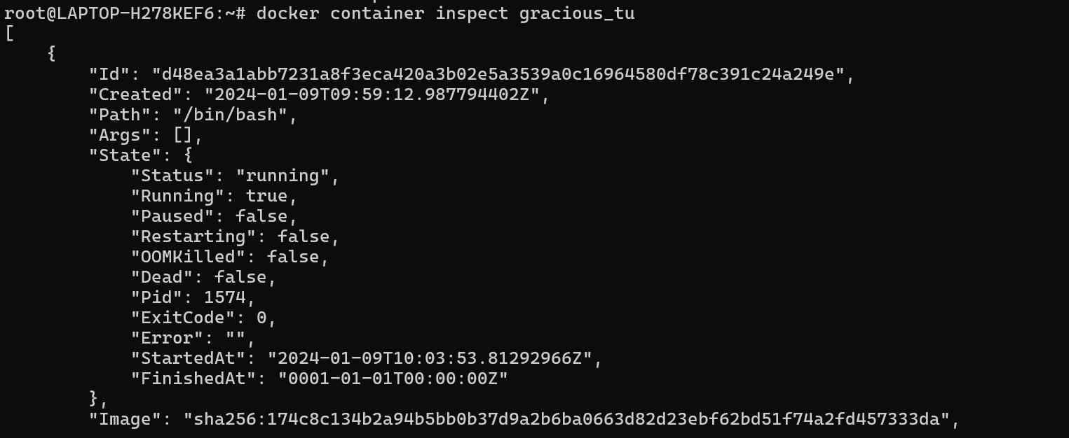

==================================================================================

5] Execute the Ubuntu Docker container and confirm that the

container's state is “running”.



=================================================================================

6] Launch an HTTP container, verify its state, and then remove the

container and image from your local system.

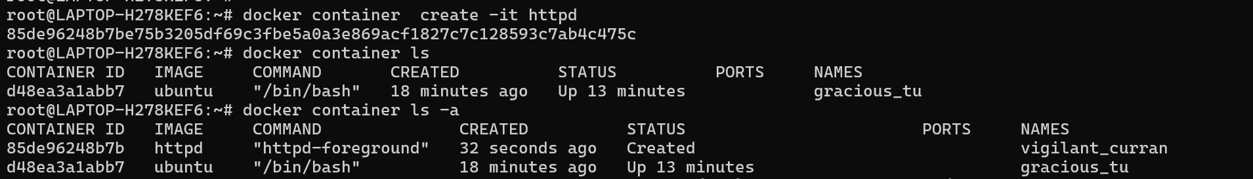

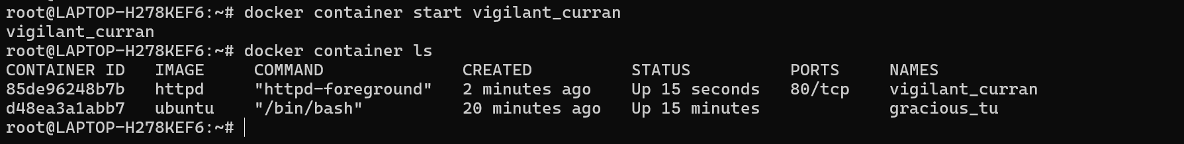

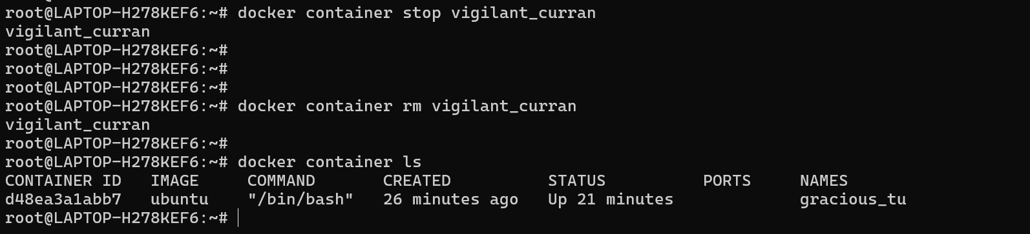

=================================================================================

7] Execute a command to display a filtered list of containers, showing

only their short t container IDs.

