EQ testing
I set up a waveform generator to create an HF signal with white noise modulation and fed that to the sBitx. I connected the headphone output to a spectrum analyzer set to the audio range.
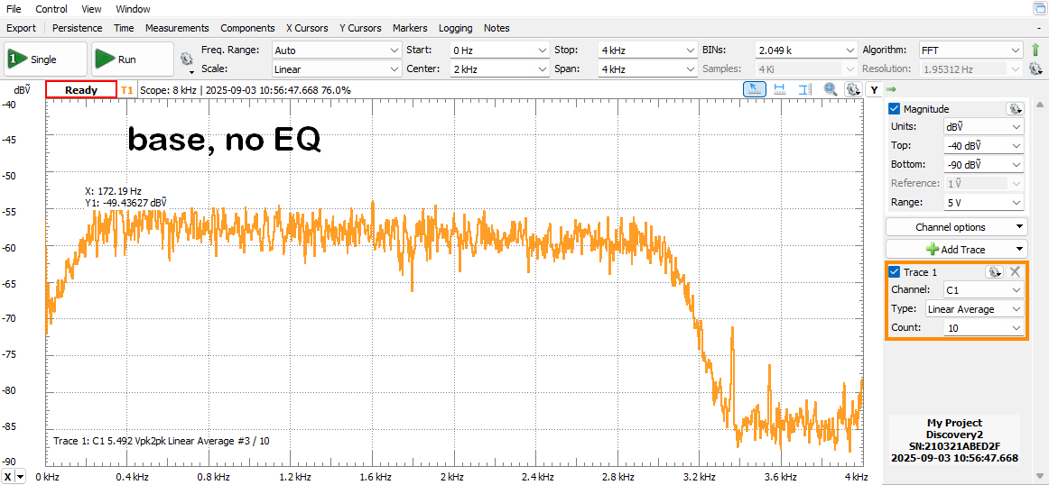
Then I set the RxEQ in v5.01 to have gain at 700 Hz and o gain on all other sliders. You see a response at 1400 Hz.

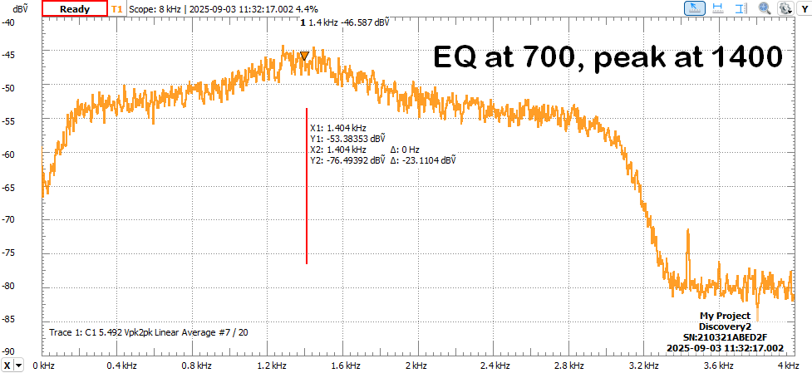
I then changed the constant 48000.0 to 96000.0 in sbitx.c for both Rx and Tx Eqs and now see a peak at 700 Hz as expected.

