Installation_Task
Q4.Create a Program and execute a script in Python
Print(“Hello World”)
a = 45
b = 5
c = a+b
Print(“Sum is :”, c)

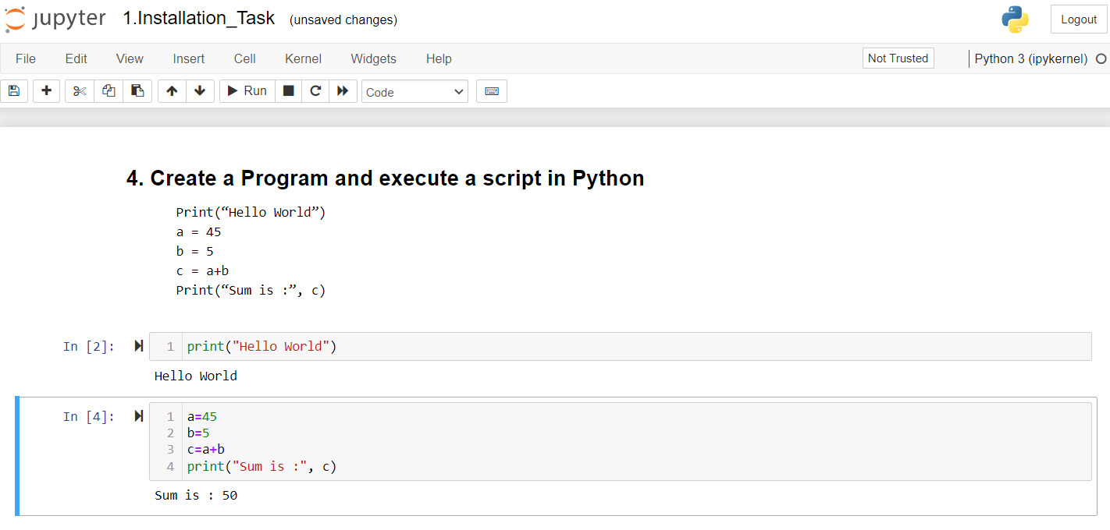

RunCode_Task
Q2.Use Jupyter Notebook to execute following code, try to guess what is happing in this code

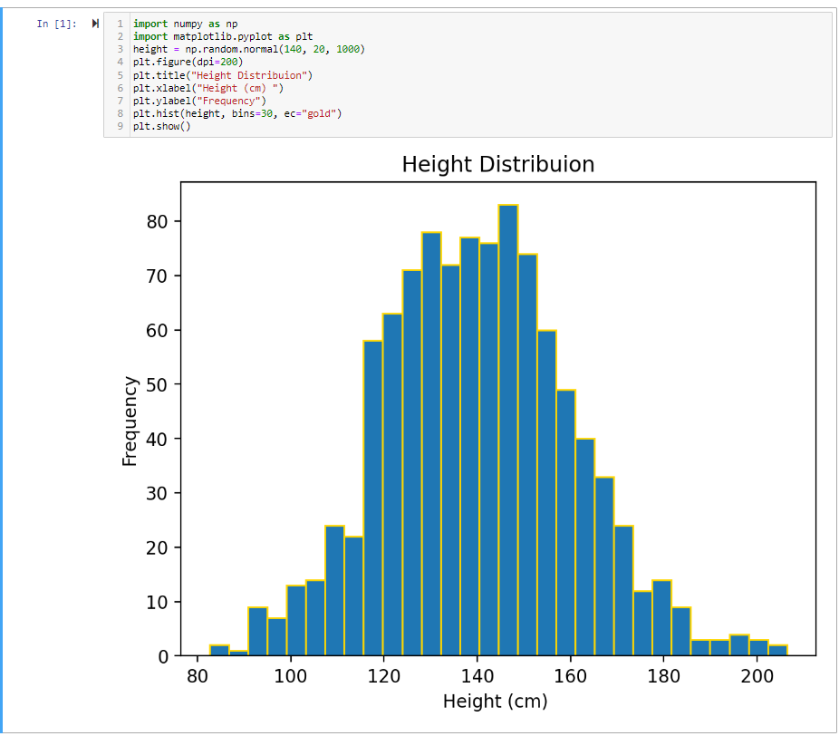

Q3.Write down above code using vim on same working directory, and execute it using python interpreter, tell us difference between jupyter and notepad
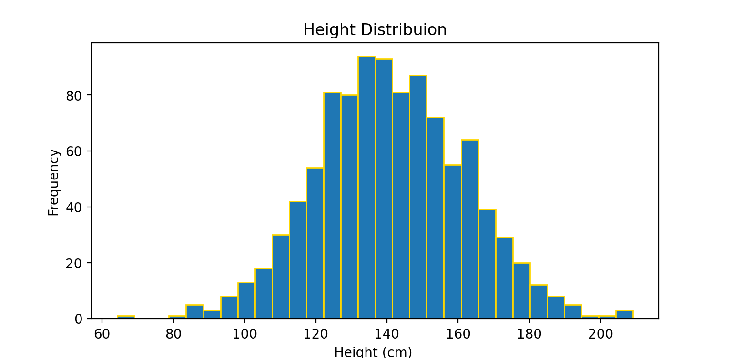
Q4.Write Down difference between interpreter and compiler
A4. A Compiler takes a program as a whole. An Interpreter takes single lines of a code. The Compilers generate intermediate machine codes. The Interpreters never generate any intermediate machine codes.
A Compiler displays every error and warning while compiling. So, you can’t run this program unless you fix the errors.
Whereas, an Interpreter reads every statement, then displays the errors, if any. A user must resolve these errors in order to interpret the next line.

Q5.What is Data Structure, why we need one in programs?

A5. Data Structures are necessary for designing efficient algorithms. It provides reusability and abstraction. Using appropriate data structures can help programmers save a good amount of time while performing operations such as storage, retrieval, or processing of data. Manipulation of large amounts of data is easier.

DataType_Declear_Task
Q1.What are Data Structures? List some of data structures and their use in real world application?
A1. Data structures are a specific way of organizing data in a specialized format on a computer so that the information can be organized, processed, stored, and retrieved quickly and effectively.
Here are some commonly used data structures and their real-world applications:

- Arrays: Arrays are a basic and simple data structure that stores a fixed-size sequence of elements of the same type. They are used in various applications, such as storing and manipulating collections of data, implementing matrices and vectors, and representing images and audio.

- Linked Lists: Linked lists are dynamic data structures that consist of nodes, each containing a value and a reference to the next node. They are used in scenarios where efficient insertion and deletion operations are required, such as implementing stacks, queues, and managing memory allocation in operating systems.

- Stacks: Stacks are data structures that follow the Last-In-First-Out (LIFO) principle. They are used in applications like function call stack management, expression evaluation, and backtracking algorithms.

- Queues: Queues are data structures that follow the First-In-First-Out (FIFO) principle. They are used in scenarios where elements need to be processed in the order they are added, such as task scheduling, message queues, and breadth-first search algorithms.

- Trees: Trees are hierarchical data structures that consist of nodes connected by edges. They are used in a wide range of applications, including file systems, organization hierarchies, decision trees, and searching algorithms like binary search trees and AVL trees.

- Graphs: Graphs are non-linear data structures that consist of vertices (nodes) and edges connecting them. They are used to model complex relationships and connectivity, such as social networks, routing algorithms, and data analysis.

- Hash Tables: Hash tables, also known as hash maps, are data structures that provide efficient lookup, insertion, and deletion operations. They are used in applications requiring fast retrieval, like caching, database indexing, and implementing dictionaries.

- Heaps: Heaps are specialized tree-based data structures that satisfy the heap property. They are used in priority queues, sorting algorithms like heap sort, and graph algorithms like Dijkstra's algorithm.

Q3.Create a list data type and store names of your friends in it (at least 5), check out what are methods available in list data type, try to figure out their working using help function in python.
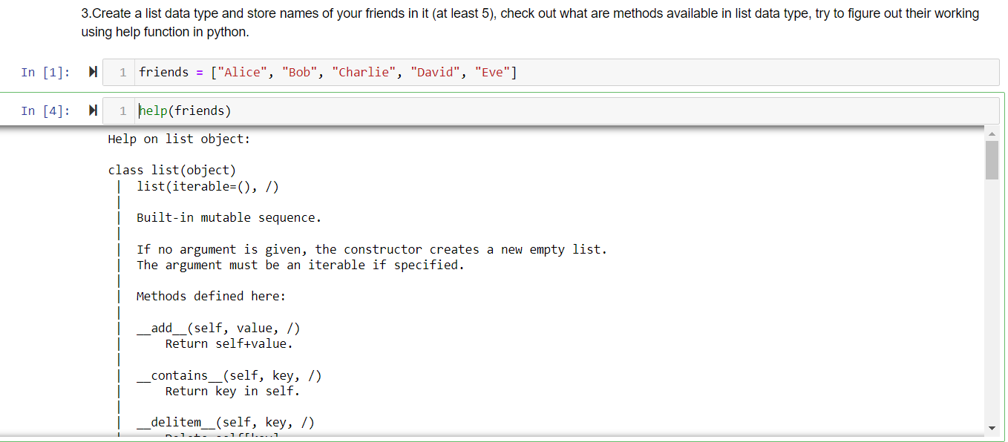

Q4.What is difference between ordered data type and unordered data type?

A4. An ordered collection means that the elements of the collection have a specific order. The order is independent of the value. A List is an example. A sorted/unordered collection means that not only does the collection have order, but the order depends on the value of the element. Eg.: Dictionaries.

Q5.Write down types of each value given? (In python)
  - 100
  - 105.5
  - 192.56j
  - 10+6j
  - ‘10’
  - ‘Hello world’
  - [ 10, 20, 50, 100]
  - {‘name’: ‘sachin’, ‘age’: 24, ‘language’: ‘python’}

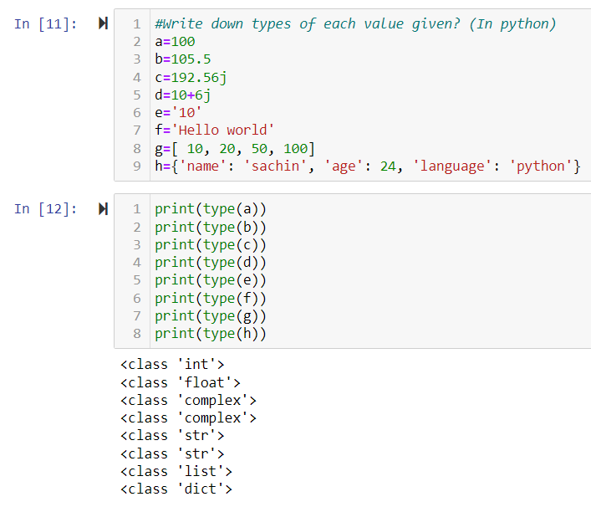

StringMethods_Task
Q1.Explore split, strip, replace, center, title methods of string data type in python
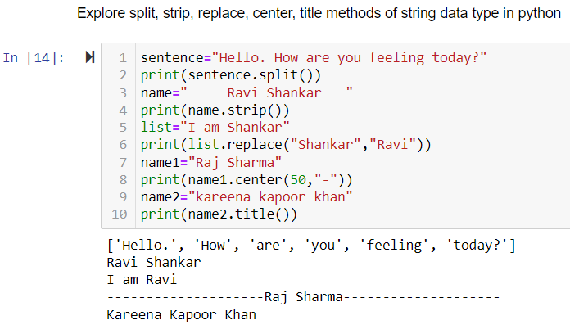

Q2.Explore append, pop, remove, sort methods of list data type
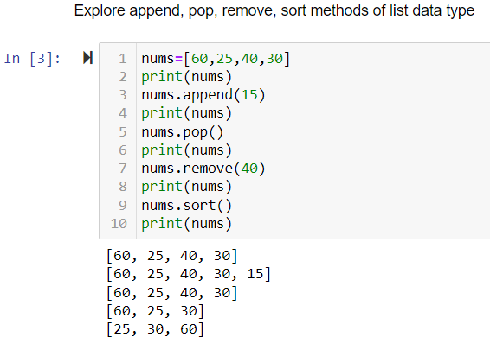

Q3.Create 5 real time lists to store some useful information in python eg. Language = [ ‘java’, ‘c’, ‘c++’, ‘ruby’ ]
A3. language = ['Java', 'C', 'C++', 'Ruby']
fruits = ['Apple', 'Banana', 'Orange', 'Mango', 'Strawberry']
cities = ['New York', 'London', 'Tokyo', 'Paris', 'Sydney']
car_brands = ['Toyota', 'Honda', 'BMW', 'Mercedes-Benz', 'Ford']
social_media = ['Facebook', 'Instagram', 'Twitter', 'LinkedIn', 'YouTube']

Q4.What is difference between mutable and immutable data types in python
A4. The major difference between mutable and immutable objects in Python is that mutable objects can be modified or changed after their creation but the immutable objects can not be modified after their creation.

Q5.What are identifiers, list rules of identifiers in python
A5. An identifier is a user-defined name given to identities like class, functions, variables, modules, or any other object in Python.
- Identifiers cannot be a keyword.
- Identifiers are case-sensitive.
- It can have a sequence of letters and digits. However, it must begin with a letter or _. The first letter of an identifier cannot be a digit.
- It's a convention to start an identifier with a letter rather _.
- Whitespaces are not allowed.
- We cannot use special symbols like !, @, #, $, and so on.

DifferentDataType_Task
Q1.What is difference between shallow copy and deep copy?
A1. x = y that's not how we copy data in python
x = y.copy() yeah this is the way to copy something in python

import copy
x = copy.deepcopy(y) if you want to create entire separate copy

deep copy vs shallow copy ?
When you write `x=y.copy()` is known as Shallow copy and does not guarantee you that your data is going to be saved in memory or if you change your original object it is going to be changed the copied object as well. This method will only work if the data is immutable or let’s say you are using a collection in which every item is immutable. But if you are having a collection and inside that collection there are items which are mutable then you need to use: `import copy` & `x=copy.deepcopy(y)` these methods to copy your data in python.

Q2.You want to create a library management application, you need to store data about books, students in your program, how will you store data inside python using list? Create some lists with fake data to store information about library management.
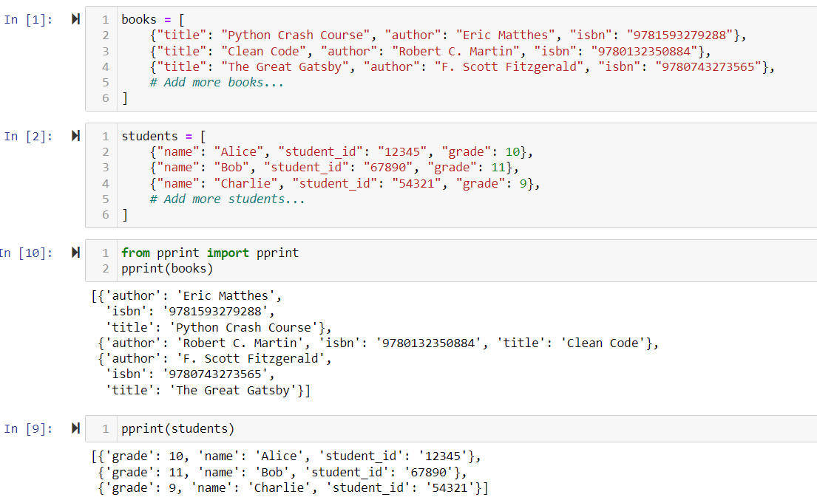

Q3.This chapter introduced assignment statements, like spam = 10. What is the difference between an expression and a statement?

A3. The key difference between expressions and statements is that expressions have values and can be evaluated, while statements are actions or instructions that perform a task or define the structure of a program. Expressions are often used within statements to provide values or perform computations.

Q4.Define following
  - Atomic data types / Primary data types
  - Secondary data type / User Defined Data Type
A4. Atomic data types are a subset of primary data types. They represent the basic building blocks of data in a programming language, while primary data types encompass both atomic and composite data types.
Example of statements: Assignment statement: `spam = 10`
"User-defined data type" refers to data types created by programmers, while "secondary data type" is not a commonly used term and does not have a specific meaning in programming.

Q5.What is UDF?
A5. UDF stands for User-Defined Function. It refers to a function that is defined by the user or programmer in a programming language. A user-defined function allows you to define logic to perform a specific task within a program.

In most programming languages, including Python, you can create your own functions using the def keyword, followed by the function name, parentheses for parameters (if any), and a colon to start the function's body. You can then define the function's code block and specify what operations it should perform.

ProjectData_Task
Q1.Write down 10 projects ideas you want to implement using python
A1.
1. Task Manager
2. Weather App
3. Quiz Game
4. Expense Tracker
5. URL Shortener
6. Chatbot
7. Image Recognition
8. Movie Recommendation System
9. Social Media Analytics
10. E-commerce Website

Q2.Create at list 5 objects using list, dictionary, it will be good if you store realistic data
A2. student = {
"name": "John Smith",
"age": 20,
"major": "Computer Science",
"courses": ["Introduction to Programming", "Data Structures", "Web Development"],
"gpa": 3.8
}

book = {
"title": "To Kill a Mockingbird",
"author": "Harper Lee",
"year": 1960,
"genre": ["Fiction", "Classic"],
"isbn": "9780061120084"
}

shopping_cart = [
{"item": "T-shirt", "price": 15.99, "quantity": 2},
{"item": "Jeans", "price": 39.99, "quantity": 1},
{"item": "Shoes", "price": 49.99, "quantity": 1}
]

recipe = {
"name": "Spaghetti Bolognese",
"ingredients": ["Pasta", "Ground Beef", "Tomato Sauce", "Onion", "Garlic"],
"prep_time": 30,
"instructions": "..."
}

employee = {
"name": "Emily Johnson",
"age": 32,
"position": "Software Engineer",
"department": "Engineering",
"salary": 80000
}

Q3.What is duck typing in python, what are Dunder or special methods?
A3. Duck Typing in Python:
Duck typing is a concept in Python that focuses on an object's behavior rather than its specific type or class. If an object supports the necessary methods and attributes needed for a particular operation, it can be treated as if it belongs to a specific type or class, regardless of its actual type.

Dunder (Special) Methods:
Dunder methods are also known as magic methods or special methods. They allow you to override default behavior and implement custom functionality for your objects. By defining these methods, you can make your objects act like built-in types and provide support for various operations such as iteration, comparison, arithmetic operations, and more.

Here are a few examples of dunder methods:

__init__: Initializes an object of a class.
__str__: Returns a string representation of the object.
__len__: Returns the length of the object.
__getitem__: Enables indexing and accessing elements of an object.
__add__: Defines the behavior for the addition operator (+) between objects.

Q4.What are operators? How many types of operators are there in python?
A4. Operators are symbols or special keywords that perform specific operations on one or more operands (values or variables). Operators allow you to manipulate data, perform calculations, compare values, and control the flow of your program.

In Python, there are several types of operators:

1. Arithmetic Operators
2. Assignment Operators
3. Comparison Operators
4. Logical Operators
5. Bitwise Operators
6. Membership Operators
7. Identity Operators
8. Ternary Operator (Conditional Operator)

Operators
- What are the two values of the Boolean data type? How do you write them?
A1. True and False

- What are the three Boolean operators?
A2. and, or, not

- Write out the truth tables of each Boolean operator (that is, every possible combination of Boolean values for the operator and what they evaluate to).
A3. - AND operator:

A | B | A AND B
T | T | T
T | F | F
F | T | F
F | F | F

- OR operator:

A | B | A OR B
T | T | T
T | F | T
F | T | T
F | F | F
- NOT operator:

A | NOT A
T | F
F | T

- What do the following expressions evaluate to?
(5 > 4) and (3 == 5)
not (5 > 4)
(5 > 4) or (3 == 5)
not ((5 > 4) or (3 == 5))
(True and True) and (True == False)
(not False) or (not True)
A4. - (5 > 4) and (3 == 5) evaluates to False.
- not (5 > 4) evaluates to False.
- (5 > 4) or (3 == 5) evaluates to True.
- not ((5 > 4) or (3 == 5)) evaluates to False.
- (True and True) and (True == False) evaluates to False.
- (not False) or (not True) evaluates to True.

- What are the six comparison operators?
A5. The six comparison operators are:
- Greater than (>)
- Less than (<)
- Greater than or equal to (>=)
- Less than or equal to (<=)
- Equal to (==)
- Not equal to (!=)

- What is the difference between the equal to operator and the assignment operator?
A6. The equal to operator (==) is used for comparing values, while the assignment operator (=) is used for assigning values to variables.

- Explain what a condition is and where you would use one.
A7. Condition is a statement where we check whether certain criteria is fulfilled or not. We can use it to check whether a number is odd or even in if - elif - else.

If_Else
- Write a Python program to check whether a number is negative, positive or zero.
Ans:
num = float(input("Enter a number: "))
if num > 0:
print("Positive number")
elif num == 0:
print("Zero")
else:
print("Negative number")

- Write a Python program to check whether a number is divisible by 5 and 11 or not.
Ans:
num = int(input("Enter a number: "))
if num % 5 == 0 and num % 11 == 0:
print(num, "is divisible by both 5 and 11")
else:
print(num, "is not divisible by both 5 and 11")

- Write a Python program to check whether a year is leap year or not.
Ans:
year = int(input("Enter a year: "))
if (year % 4 == 0 and year % 100 != 0) or (year % 400 == 0):
print(year, "is a leap year")
else:
print(year, "is not a leap year")

- Write a Python program to check whether a character is alphabet or not.
Ans:
ch = input("Enter a character: ")
if (ch >= 'a' and ch <= 'z') or (ch >= 'A' and ch <= 'Z'):
print(ch, "is an alphabet")
else:
print(ch, "is not an alphabet")

- Write a Python program to input any alphabet and check whether it is vowel or consonant.
Ans:
l = input("Input a letter of the alphabet: ")
if l in ('a', 'e', 'i', 'o', 'u'):
print("%s is a vowel." % l)
elif l == 'y':
print("Sometimes letter y stand for vowel, sometimes stand for consonant.")
else:
print("%s is a consonant." % l)
- Write a Python program to input any character and check whether it is alphabet, digit or special character.
Ans:
ch = input("Enter any character: ")
if ((ch >= 'a' and ch <= 'z') or (ch >= 'A' and ch <= 'Z')):
print(ch, "is an alphabet.")
elif (ch >= '0' and ch <= '9'):
print(ch, "is a digit.")
else:
print(ch, "is a special character.")

- Write a Python program to check whether a character is uppercase or lowercase alphabet.
Ans:
ch = input("Enter any character: ")
if (ch.isupper()):
print(ch, "is an uppercase alphabet.")
elif (ch.islower()):
print(ch, "is a lowercase alphabet.")
else:
print(ch, "is not an alphabet.")

- Write a Python program to input week number and print weekday.
Ans:
weekday = int(input("Enter weekday number (1-7) : "))
if weekday == 1:
print("\nMonday")
elif weekday == 2:
print("\nTuesday")
elif weekday == 3:
print("\nWednesday")
elif weekday == 4:
print("\nThursday")
elif weekday == 5:
print("\nFriday")
elif weekday == 6:
print("\nSaturday")
elif weekday == 7:
print("\nSunday")
else:
print("\nPlease enter any weekday number (1-7)")

- Write a Python program to input angles of a triangle and check whether triangle is valid or not.
Ans:
a = int(input('Please Enter the First Angle of a Triangle: '))
b = int(input('Please Enter the Second Angle of a Triangle: '))
c = int(input('Please Enter the Third Angle of a Triangle: '))

# checking Triangle is Valid or Not
total = a + b + c

if total == 180:
print("This is a Valid Triangle")
else:
print("This is an Invalid Triangle")
- Write a Python program to check whether the triangle is equilateral, isosceles or scalene triangle.
Ans:
print("Input lengths of the triangle sides: ")
x = int(input("x: "))
y = int(input("y: "))
z = int(input("z: "))

if x == y == z:
print("Equilateral triangle")
elif x==y or y==z or z==x:
print("isosceles triangle")
else:
print("Scalene triangle")

- Write a Python program to input marks of five subjects Physics, Chemistry, Biology, Mathematics and Computer. Calculate percentage and grade according to following:
Percentage >= 90% : Grade A
Percentage >= 80% : Grade B
Percentage >= 70% : Grade C
Percentage >= 60% : Grade D
Percentage >= 40% : Grade E
Percentage < 40% : Grade F
Ans:
def calculate_grade():
physics = float(input("Enter Physics marks: "))
chemistry = float(input("Enter Chemistry marks: "))
biology = float(input("Enter Biology marks: "))
mathematics = float(input("Enter Mathematics marks: "))
computer = float(input("Enter Computer marks: "))

total_marks = physics + chemistry + biology + mathematics + computer
percentage = (total_marks / 500) * 100

if percentage >= 90:
grade = 'A'
elif percentage >= 80:
grade = 'B'
elif percentage >= 70:
grade = 'C'
elif percentage >= 60:
grade = 'D'
elif percentage >= 40:
grade = 'E'
else:
grade = 'F'

print(f"Total Marks Obtained: {total_marks}")
print(f"Percentage: {percentage:.2f}%")
print(f"Grade: {grade}")

calculate_grade()

- Write a Python program to input basic salary of an employee and calculate its Gross salary according to following:
Basic Salary <= 10000 : HRA = 20%, DA = 80%
Basic Salary <= 20000 : HRA = 25%, DA = 90%
Basic Salary > 20000 : HRA = 30%, DA = 95%
Ans:
basic_salary = float(input("Enter Basic Salary: "))

if basic_salary <= 10000:
hra = basic_salary * 0.2
da = basic_salary * 0.8
elif basic_salary <= 20000:
hra = basic_salary * 0.25
da = basic_salary * 0.9
else:
hra = basic_salary * 0.3
da = basic_salary * 0.95

gross_salary = basic_salary + hra + da

print(f"Gross Salary: {gross_salary}")

- Write a Python Program to input electricity unit charges and calculate total electricity bill according to the given condition:
For first 50 units Rs. 0.50/unit
For next 100 units Rs. 0.75/unit
For next 100 units Rs. 1.20/unit
For unit above 250 Rs. 1.50/unit
An additional surcharge of 20% is added to the bill
Ans:
units = int(input("Enter the number of units consumed: "))

if units <= 50:
amount = units * 0.50
elif units <= 150:
amount = (50 * 0.50) + ((units - 50) * 0.75)
elif units <= 250:
amount = (50 * 0.50) + (100 * 0.75) + ((units - 150) * 1.20)
else:
amount = (50 * 0.50) + (100 * 0.75) + (100 * 1.20) + ((units - 250) * 1.50)

surcharge = amount * 0.2
total_amount = amount + surcharge

print(f"Total Electricity Bill: {total_amount}")

- Write a Python program to input all sides of a triangle and check whether triangle is valid or not.
a=int(input('Enter side length of triangle'))
b=int(input('Enter side length of triangle'))
c=int(input('Enter side length of triangle'))
if a+b>c or b+c>a or c+a>b:
print('It is a valid triangle')
else:
print('Invalid triangle')

Loop
Q1. Python Program to Check Palindrome Number
A1. 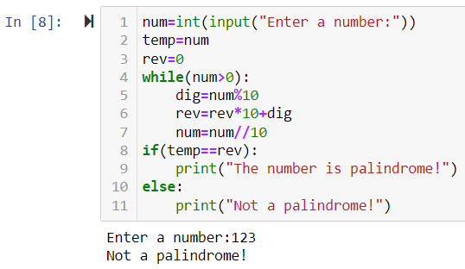

Q2. Python Program to Print all multiples of 3 and 5 in an Interval
A2. 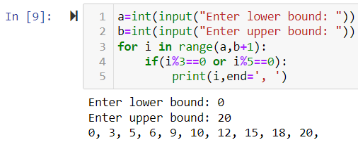

Q3. Python Program to Find the Factorial of a Number
A3. 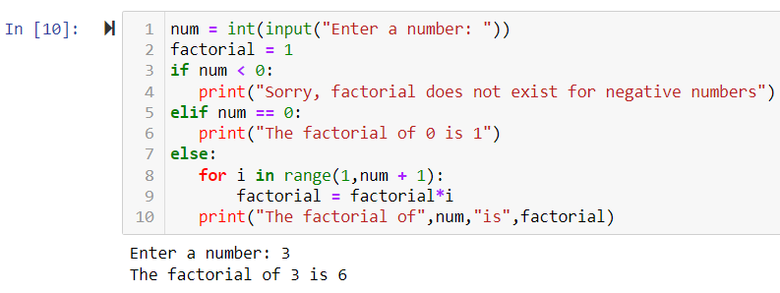

Q4. Python Program to Print the Fibonacci sequence
A4. 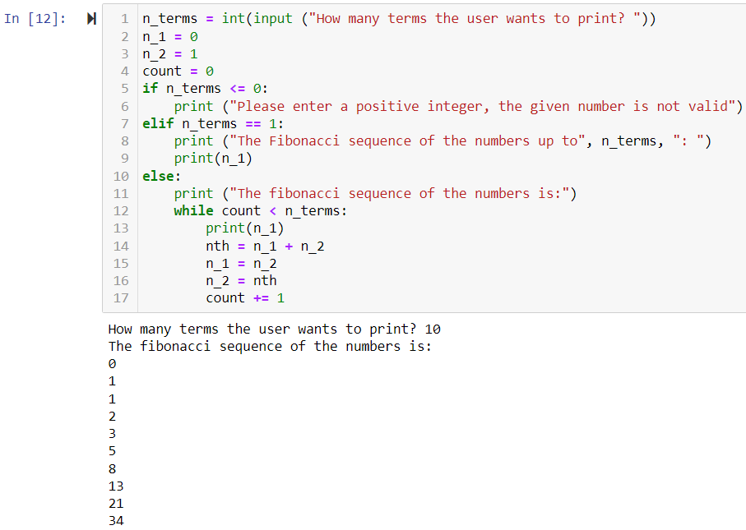

Q5. Python Program to Check Armstrong Number
A5. 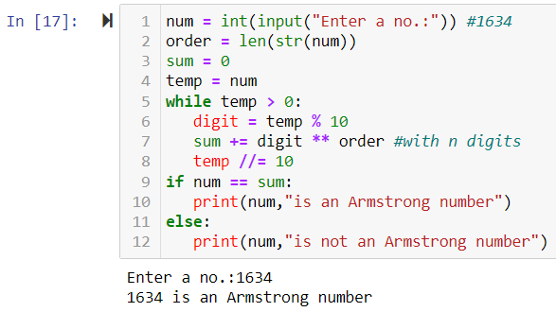

Pattern
Q1. Write Python Code to print these patterns
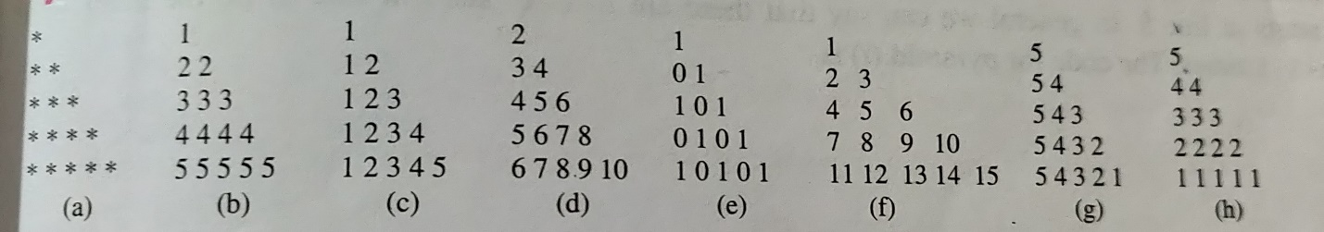

Ans:
a)
n = int(input("Enter the number of rows"))
for i in range(0, n):
for j in range(0, i + 1):
print("* ", end="")
print()

b)
rows = int(input("Enter the number of rows: "))
for i in range(rows+1):
for j in range(i):
print(i, end=" ")
print(" ")

c)
rows = int(input("Enter the number of rows: "))
for i in range(1, rows+1):
for j in range(1, i + 1):
print(j, end=' ')
print("")

d)
n = 2
for i in range(1, 5):
for j in range(1, i+1):
print(n, end="")
n = n * 10 + 2
print()

e)
n = 5
for i in range(1, n+1):
for j in range(i):
if j % 2 == 0:
print("1", end="")
else:
print("0", end="")
print()

f)
n = 5
num = 1
for i in range(1, n+1):
for j in range(i):
print(num, end="")
num += 1
print()

g)
for i in range(5, 0, -1):
for j in range(5, i - 1, -1):
print(j, end='')
print()

h)
for i in range(5, 0, -1):
for j in range(i, 6):
print(i, end='')
print()

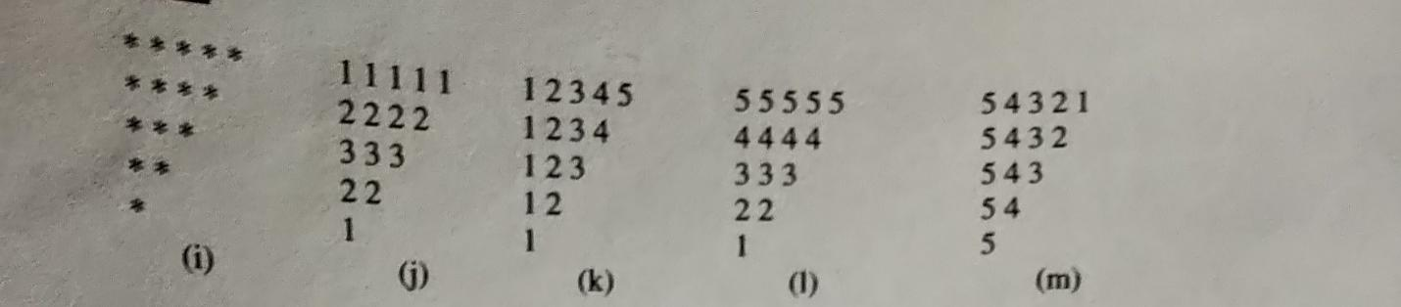

Ans:

i)
rows = int(input("Enter the number of rows: "))
for i in range(rows + 1, 0, -1):
for j in range(0, i - 1):
print("*", end=' ')
print(" ")

j)
for i in range(1, 6):
for j in range(i, 6):
print(i, end='')
print()

k)
for i in range(4, 0, -1):
for j in range(1, i + 1):
print(j, end='')
print()

l)
for i in range(5, 0, -1):
for j in range(i, 0, -1):
print(i, end='')
print()

m)
for i in range(5, 0, -1):
for j in range(5, i-1, -1):
print(j, end='')
print()

- Write Python Code to print these patterns
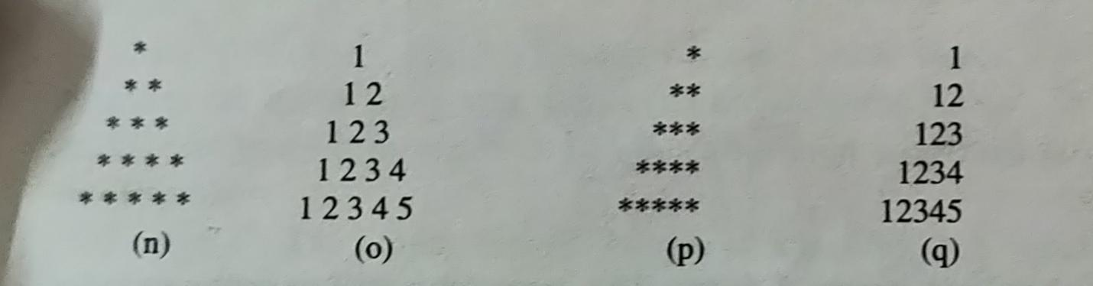

Ans:
n)
rows = int(input("Enter the number of rows:"))
k = 2 * rows - 2 # It is used for number of spaces
for i in range(0, rows):
for j in range(0, k):
print(end=" ")
k = k - 2
for j in range(0, i + 1):
print("* ", end="")
print("")

o)
n = 5
for i in range(1, n + 1):
pattern = ''
for j in range(1, i + 1):
pattern += str(j)
print(pattern.center(2 * n - 1))

p)
rows = int(input("Enter the number of rows: "))
for i in range(rows + 1, 0, -1):
for j in range(0, i - 1):
print("*", end=' ')
print(" ")

Q)
n = 5
for i in range(1, n + 1):
pattern = ''
for j in range(1, i + 1):
pattern += str(j)
print(pattern.rjust(n))

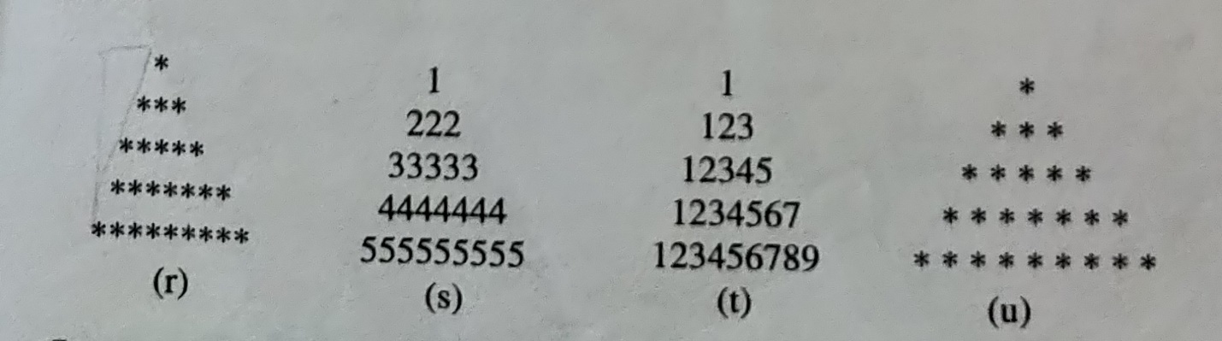

r)
n = int(input("Enter the number of rows: "))
m = (2 * n) - 2
for i in range(0, n):
for j in range(0, m):
print(end=" ")
m = m - 1
for j in range(0, i + 1):
print("* ", end=' ')
print(" ")

s)
rows = [1, 222, 3333, 4444444, 55555555]
for row in rows:
pattern = str(row)
print(pattern.center(len(str(rows[-1]))))

t)
rows = [1, 123, 1234, 12345]
max_width = len(str(rows[-1]))
for row in rows:
pattern = str(row)
print(pattern.center(max_width))

u)
n = int(input("Enter the number of rows: "))
m = (2 * n) - 2
for i in range(0, n):
for j in range(0, m):
print(end=" ")
m = m - 1
for j in range(0, i + 1):
print("* ", end=' ')
print(" ")

- Write Python Code to print these patterns
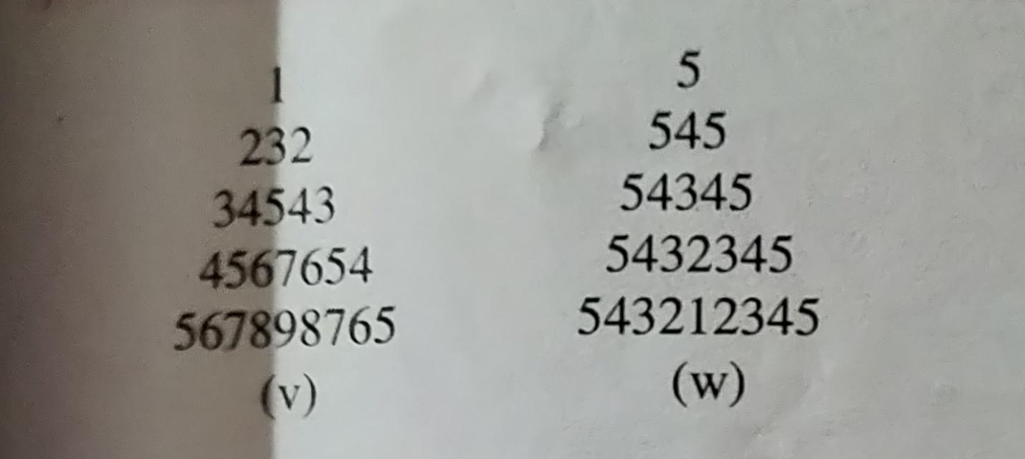

Ans:
v)
rows = [1, 232, 34543, 45676, 567898765]
max_width = len(str(rows[-1]))
for row in rows:
pattern = str(row)
print(pattern.center(max_width))

w)
rows = [5, 545, 54345, 5432345, 543212345]
max_width = len(str(rows[-1]))
for row in rows:
pattern = str(row)
print(pattern.center(max_width))

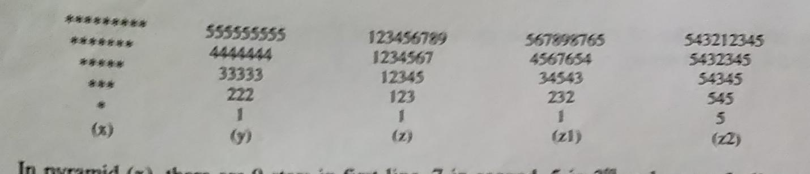

Ans:
x)
rows = int(input("Enter the number of rows: "))
k = 2 * rows - 2
for i in range(rows, -1, -1):
for j in range(k, 0, -1):
print(end=" ")
k = k + 1
for j in range(0, i + 1):
print("*", end=" ")
print("")

y)
rows = [1, 222, 33333, 4444444, 555555555]
for row in reversed(rows):
pattern = str(row)
print(pattern)

z)
rows = [1, 123, 12345, 1234567, 123456789]
for row in reversed(rows):
pattern = ''
for i in range(1, row + 1, 2):
pattern += str(i)
print(pattern)

z1)
rows = [1, 232,34543,4567654,567898765]
for row in reversed(rows):
pattern = ''
for i in range(1, row + 1, 2):
pattern += str(i)
print(pattern)

z2)
rows = [5,545,54345,5432345,543212345]
for row in reversed(rows):
pattern = ''
for i in range(1, row + 1, 2):
pattern += str(i)
print(pattern)

- Write Python Code to print these patterns
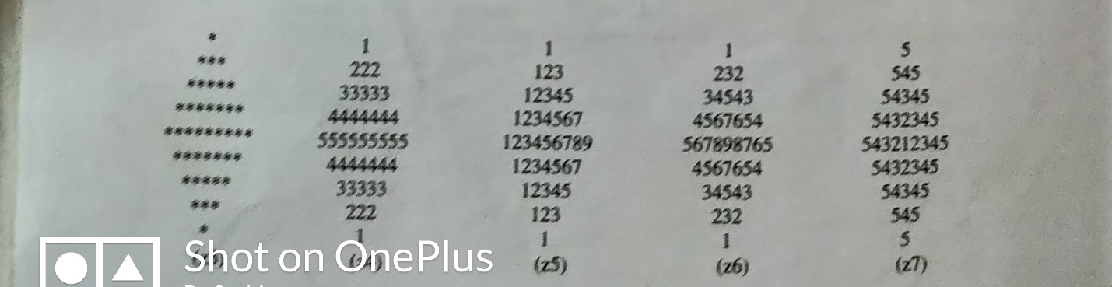

Ans:
Z3)
rows = int(input("Enter the number of rows: "))
k = 2 * rows - 2
for i in range(0, rows):
for j in range(0, k):
print(end=" ")
k = k - 1
for j in range(0, i + 1):
print("* ", end="")
print("")
k = rows - 2
for i in range(rows, -1, -1):
for j in range(k, 0, -1):
print(end=" ")
k = k + 1
for j in range(0, i + 1):
print("* ", end="")
print("")

z4)
def diamondNumber(rows):

k1=1
k2=rows-1

for i in range(0,rows):

for j in range(0,rows):
if j>=k2:
print(i+1,end=” “)

else:
print(” “,end=” “)
k2-=1

print()
for i in range(0,rows):
for j in range(0,rows):
if j>=k1:
print(rows-i-1,end=” “)

else:
print(” “,end=” “)

k1+=1

print()

n=int(input(“Enter the number of Rows : “))

diamondNumber(n)

z5)
rows = [1, 123, 12345, 1234567, 123456789]
for row in rows:
pattern = ''
for i in range(1, row + 1, 2):
pattern += str(i)
print(pattern.center(len(str(rows[-1]))))
for row in reversed(rows[:-1]):
pattern = ''
for i in range(1, row + 1, 2):
pattern += str(i)
print(pattern.center(len(str(rows[-1]))))

z6)
rows = [1,232,34543,4567654,567898765]
for row in rows:
pattern = ''
for i in range(1, row + 1, 2):
pattern += str(i)
print(pattern.center(len(str(rows[-1]))))
for row in reversed(rows[:-1]):
pattern = ''
for i in range(1, row + 1, 2):
pattern += str(i)
print(pattern.center(len(str(rows[-1]))))

z7)
rows = [5,545,54345,543212345]
for row in rows:
pattern = ''
for i in range(1, row + 1, 2):
pattern += str(i)
print(pattern.center(len(str(rows[-1]))))
for row in reversed(rows[:-1]):
pattern = ''
for i in range(1, row + 1, 2):
pattern += str(i)
print(pattern.center(len(str(rows[-1]))))

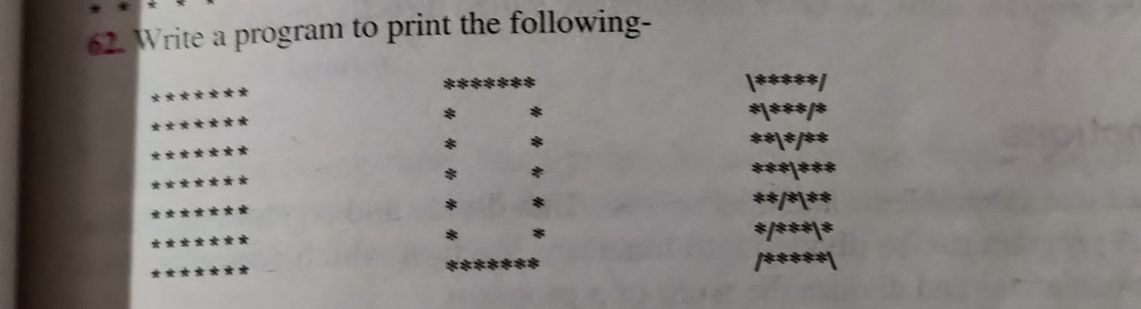

Ans:
a)
size = 5
for i in range(0, size):
# Create a list of columns
for j in range(0, size):
print("*", end="")
print()

b)
size = 5
for i in range(size):
for j in range(size):
# print * completely in first and last row
# print * only in first and last position in other rows
if i == 0 or i == size - 1 or j == 0 or j == size - 1:
print('*', end='')
else:
print(' ', end='')
print()

c)
size = 5
for i in range(size):
for j in range(size):
# print * completely in first and last row
# print * only in first and last position in other rows
if i == 0 or i == size - 1 or j == 0 or j == size - 1:
print('*', end='')
else:
print(' ', end='')
print()

- Write Python Code to print these patterns
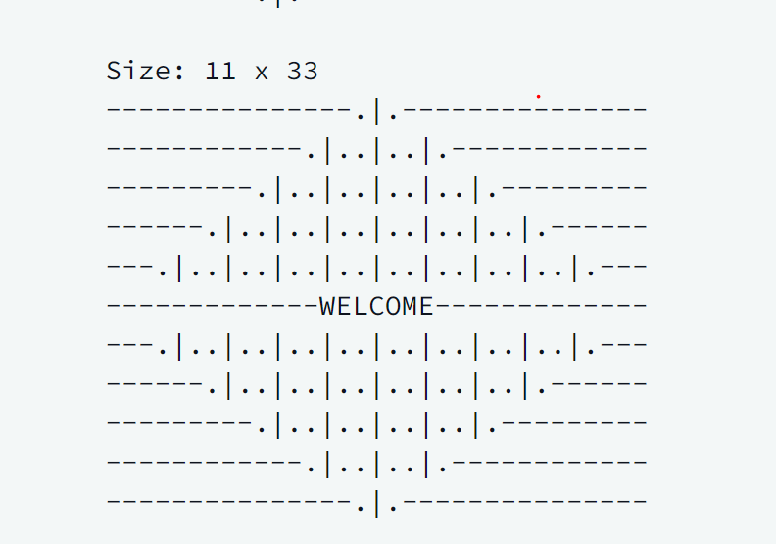
n,m= map(int,input().split())
center = n//2
count = -1
for i in range(0,n):

if i == center:
count += 2
pattern = 'WELCOME'
print(pattern.center(m,'-'))

elif i < center:
count += 2
pattern = '.|.' * count
print(pattern.center(m,'-'))

elif i > center:
count -= 2
pattern = '.|.' * count
print(pattern.center(m,'-'))

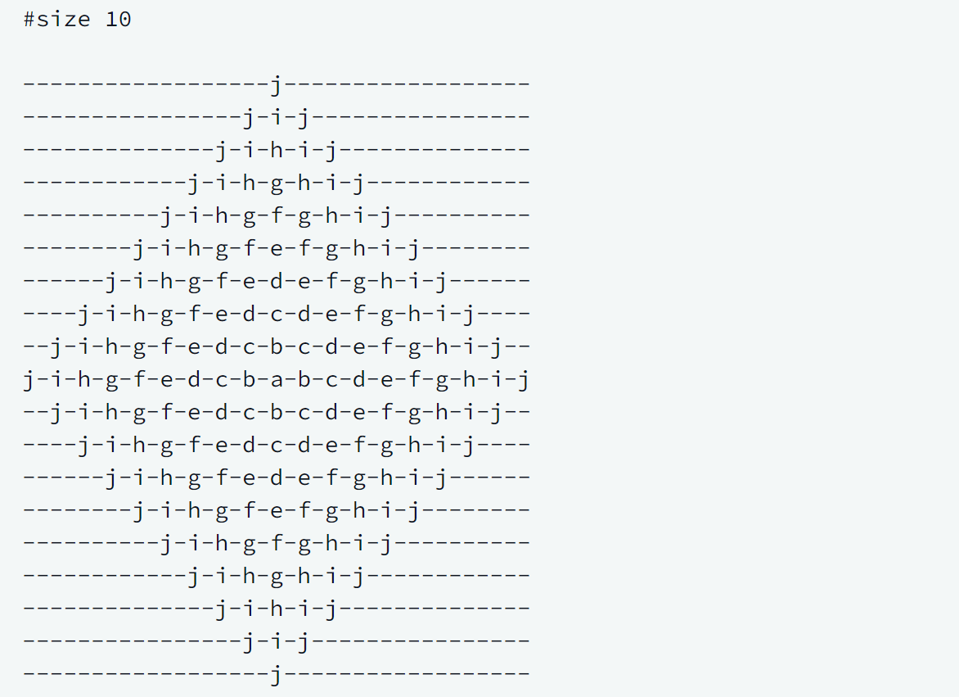

def print_rangoli(size):
# your code goes here
n=size
l1=list(map(chr,range(97,123)))
x=l1[n-1::-1]+l1[1:n]
m=len('-'.join(x))
for i in range(1,n):
print('-'.join(l1[n-1:n-i:-1]+l1[n-i:n]).center(m,'-'))
for i in range(n,0,-1):
print('-'.join(l1[n-1:n-i:-1]+l1[n-i:n]).center(m,'-'))

if __name__ == '__main__':
n = int(input())
print_rangoli(n)

LoopQuestion
- Write a code to implement Guess Game Guess Game
constraints / Rules
you have 5 chance to guess correct number which is choosen by computer / friend
Range which is allowed to select a number 1-50
After each guess you should give some tips / hints to user to improve their chance of winning
for example if user guess a number which is higher than actual number you should say `hint: think a low number!
if user guess a number which is lower than actual number you should say `hint: think a big number!`
if user wins we will show a congrats messege and stop our game
if any time user guess is out of limit than print a warning message saying Think in Limits 1-50 only!
but we do not count this as a chance
A1. import random

number = random.randint(1, 50)
chances = 5

while chances > 0:
guess = int(input("Guess the number (between 1 and 50): "))
if guess < 1 or guess > 50:
print("Think in Limits 1-50 only!")
continue
if guess == number:
print("Congratulations! You won!")
break
elif guess < number:
print("Hint: Think a big number!")
else:
print("Hint: Think a low number!")
chances -= 1

if not chances:
print(f"Sorry, you lost. The number was {number}.")

- Solve this problem https://www.hackerrank.com/challenges/list-comprehensions/problem
A2. if __name__ == '__main__':
x = int(input())
y = int(input())
z = int(input())
n = int(input())
out=[]
for i in range(x + 1):
for j in range(y + 1):
for m in range(z + 1):
if ((i + j + m) != n):
out.append([i,j,m])
print(out)

Output:
[[0, 0, 0], [0, 0, 1], [0, 0, 2], [0, 1, 0], [0, 1, 1], [1, 0, 0], [1, 0, 1], [1, 1, 0], [1, 1, 2]]

- Solve this problem https://www.hackerrank.com/challenges/python-lists/problem
A3. if __name__ == '__main__':
N = int(input())
ls = list()
while N>0:
N -=1
command = input().split()
if command[0] == "insert":
ls.insert(int(command[1]),int(command[2]))
elif command[0] == "remove":
ls.remove(int(command[1]))
elif command[0] == "print":
print(ls)
elif command[0] == "sort":
ls.sort()
elif command[0] == "append":
ls.append(int(command[1]))
elif command[0] == "pop":
ls.pop()
elif command[0] =="reverse":
ls = ls[::-1]
else:
pass
Output:
[0, 6]
[5, 0, 6]

Q4. Solve this problem https://www.hackerrank.com/challenges/finding-the-percentage/problem

A4. if __name__ == '__main__':
n = int(input())
student_marks = {}
for _ in range(n):
name, *line = input().split()
scores = list(map(float, line))
student_marks[name] = scores
query_name = input()
length_of_array = len(student_marks[query_name])
sum = sum(student_marks[query_name])
average = sum / length_of_array
print(f"{average:.2f}")
Output:
26.50
Q5. Write a program to sort a list without using inbuilt functions (list.sort not allowed)
  - Using Bubble Sort Algorithm
  - Using Insertion Sort Algorithm
  - Using Selection Sort Algorithm
A5. a. arr=[8,6,5,7]print('Array before sorting: ',arr)for i in range(0,len(arr)-1):
for j in range(i+1,len(arr)):
if arr[i]>arr[j]:
temp=arr[i]
arr[i]=arr[j]
arr[j]=tempprint('Array after sorting: ',arr)
Output:
Array before sorting: [8, 6, 5, 7]
Array after sorting: [5, 6, 7, 8]

b. arr=[8,6,5,7]print('Array before sorting: ',arr)for i in range(0,len(arr)):
for j in range(0,len(arr)-1-i):
if arr[j]>arr[j+1]:
temp=arr[j]
arr[j]=arr[j+1]
arr[j+1]=tempprint('Array after sorting: ',arr)
Output:
Array before sorting: [8, 6, 5, 7]
Array after sorting: [5, 6, 7, 8]

c.arr=[8,6,5,7]print('Array before sorting: ',arr)for i in range(1,len(arr)):
k=arr[i]
j=i-1
while j>=0 and k<arr[j]:
arr[j+1]=arr[j]
j-=1
arr[j+1]=kprint('Array after sorting: ',arr)

Output:
Array before sorting: [8, 6, 5, 7]
Array after sorting: [5, 6, 7, 8]

Task_NestedLoop
- Write a Python Code to count the Number of Each Vowel in a given string
def operation(s):
l=['a','e','i','o','u']
for i in range(5):
print(f"No of occurences of {l[i]} : {s.count(l[i])}")operation(input("Enter the string : "))

Output:
Enter the string : abceuoaeoooiai'
No of occurences of a : 3
No of occurences of e : 2
No of occurences of i : 2
No of occurences of o : 4
No of occurences of u : 1

- Write a Python Code to count number of words, characters and number of spaces in a given stirng
def operation(s):
print(f"No of Words : {len(s.split())}")
print(f"No of Characters : {len(s)}")
print(f"No of Spaces : {s.count(' ')}")operation(input("Enter the string : "))

Output:
Enter the string : abc def ghi jkl edf
No of Words : 5
No of Characters : 22
No of Spaces : 7

- Write a Python Program to remove punctuation from a given string (using loop)
def operation(s):
l=[',',"'",'-','...','.','!','?']
for c in l:
s=s.replace(c,'')
return s
s=operation(input("Enter the string : "))
print(s)

Output:
Enter the string : abc!...def!=-ghi?>thy-
abcdef=ghi>thy

- Write a Python Program to take a mxn matrix input from user and stored in nested list
matrix=[]
m=int(input('Enter no of columns: '))
n=int(input('Enter no of rows: '))
for i in range(0,n):
a=[]
print('Enter numbers for column ',i+1)
for j in range(0,m):
a.append(int(input()))
matrix.append(a)
print(matrix)

Output:
Enter numbers for column 1
Enter numbers for column 2
Enter numbers for column 3
[[2, 3, 4], [5, 6, 4], [7, 1, 2]]

- Write a Python Program to add, multiply and transpose two matrices given by user
def add(l1,l2,l):
if(len(l1)!=len(l2)):
print("Can't add")
return
for i in range(len(l1)):
t=[]
for j in range(len(l1[0])):
t.append(l1[i][j]+l2[i][j])
l.append(t)
def mul(l1,l2,l):
if(len(l1[0])!=len(l2)):
print("Can't multiply")
return
for i in range(len(l1)):
t=[]
for j in range(len(l2[0])):
s=0
for k in range(len(l2)):
s+=l1[i][k]*l2[k][j]
t.append(s)
l.append(t)
def transpose(l,l1):
for i in range(len(l[0])):
t=[]
for j in range(len(l)):
t.append(l[j][i])
l1.append(t)

def get(l):
m=int(input("Enter number of rows : "))
n=int(input("Enter number of cols : "))
for i in range(m):
l1=[]
for j in range(n):
l1.append(int(input(f"Enter element of row {i+1} and col {j+1} : ")))
l.append(l1)
l1=[]
print("Enter data for list 1")
get(l1)
l2=[]
print("Enter data for list 2")
get(l2)
a=[]
add(l1,l2,a)
print(f"After Addition : \n{a}")
m=[]
mul(l1,l2,m)
print(f"After Multiplication : \n{m}")
t1=[]
transpose(l1,t1)
print(f"Transpose of matrix 1 : \n{t1}")
t2=[]
transpose(l2,t2)
print(f"Transpose of matrix 2 : \n{t2}")

Output:
Enter data for list 1
Enter number of rows : 2
Enter number of cols : 2
Enter element of row 1 and col 1 : 1
Enter element of row 1 and col 2 : 2
Enter element of row 2 and col 1 : 3
Enter element of row 2 and col 2 : 4
Enter data for list 2
Enter number of rows : 2
Enter number of cols : 2
Enter element of row 1 and col 1 : 5
Enter element of row 1 and col 2 : 6
Enter element of row 2 and col 1 : 7
Enter element of row 2 and col 2 : 8
After Addition :
[[6, 8], [10, 12]]
After Multiplication :
[[19, 22], [43, 50]]
Transpose of matrix 1 :
[[1, 3], [2, 4]]
Transpose of matrix 2 :
[[5, 7], [6, 8]]

- Task_LoopGeneral

Q1. Program to find the sum of digits of a number until the sum is reduced to 1 digit
num = input("Enter a number: ")
sum = 0
while len(num) > 1:
for digit in num:
sum += int(digit)
num = str(sum)
sum = 0
print("The sum of digits of the number until it is reduced to 1 digit is:", num)

- Program to find LCM and HCF of two numbers
def gcd(a,b):
if(b==0):
return a
else:
return gcd(b,a%b)

a = int(input("Enter first number: "))
b = int(input("Enter second number: "))

gcd = gcd(a,b)
lcm = (a*b)//gcd

print("The HCF of",a,"and",b,"is",gcd)
print("The LCM of",a,"and",b,"is",lcm)

- Write a program to accept any number n and print the cube of all numbers from 1 to n which are divisible by 3. Rewrite the program using a continue statement.
n = int(input("Enter any number: "))
for i in range(1, n+1):
if i % 3 == 0:
print(i**3)
print("\nRewritten using continue statement:")
for i in range(1, n+1):
if i % 3 != 0:
continue
print(i**3)

- Write a program to read roll number and marks of 10 students in 3 subjects. The valid range for roll number is 1000-9999, if the roll number entered is not in this range, the user should be asked to enter again. Calculate total marks of only those students who get more than or equal to 40 marks in each subject. Count the number of students whose total is more than 200. Print the roll number of the students who gets the highest total.
def main():
students = {}
for i in range(10):
while True:
roll = int(input(f"Enter roll number for student {i+1}: "))
if roll < 1000 or roll > 9999:
print("Invalid roll number. Try again.")
else:
break
marks = []
for j in range(3):
while True:
mark = int(input(f"Enter marks for subject {j+1} of student {i+1}: "))
if mark < 0 or mark > 100:
print("Invalid mark. Try again.")
else:
break
marks.append(mark)
students[roll] = marks
count = 0
highest_total = -1
highest_roll = -1
for roll, marks in students.items():
if all(mark >= 40 for mark in marks):
total = sum(marks)
if total > highest_total:
highest_total = total
highest_roll = roll
if total >= 200:
count += 1
print(f"Number of students with total marks greater than or equal to 200: {count}")
print(f"Roll number of student with highest total marks: {highest_roll}")
if __name__ == '__main__':
main()

- Write a program to input a number and count the digits in it. Use while loop and the program should work correctly for 0 also
num = int(input("Enter a number: "))
count = 0
if num == 0:
count = 1
while num != 0:
count += 1
num //= 10
print("The number of digits in the number are:", count)

- Write a program to enter a number and find the reverse of that number. Also display the double of the reverse number. (don’t use string magic)
num = int(input("Enter a number: "))
reverse_num = 0
while(num > 0):
remainder = num % 10
reverse_num = (reverse_num * 10) + remainder
num = num//10
print("Reverse of the number:", reverse_num)
print("Double of the reverse number:", reverse_num * 2)

