**Introduction**

The Internet has become an indispensable part of our life, However, It also has provided opportunities to anonymously perform malicious activities like Phishing. Phishers try to deceive their victims by social engineering or creating mockup websites to steal information such as account ID, username, password from individuals and organizations. Although many methods have been proposed to detect phishing websites, Phishers have evolved their methods to escape from these detection methods. One of the most successful methods for detecting these malicious activities is Machine Learning. This is because most Phishing attacks have some common characteristics which can be identified by machine learning methods.

**Technologies used**

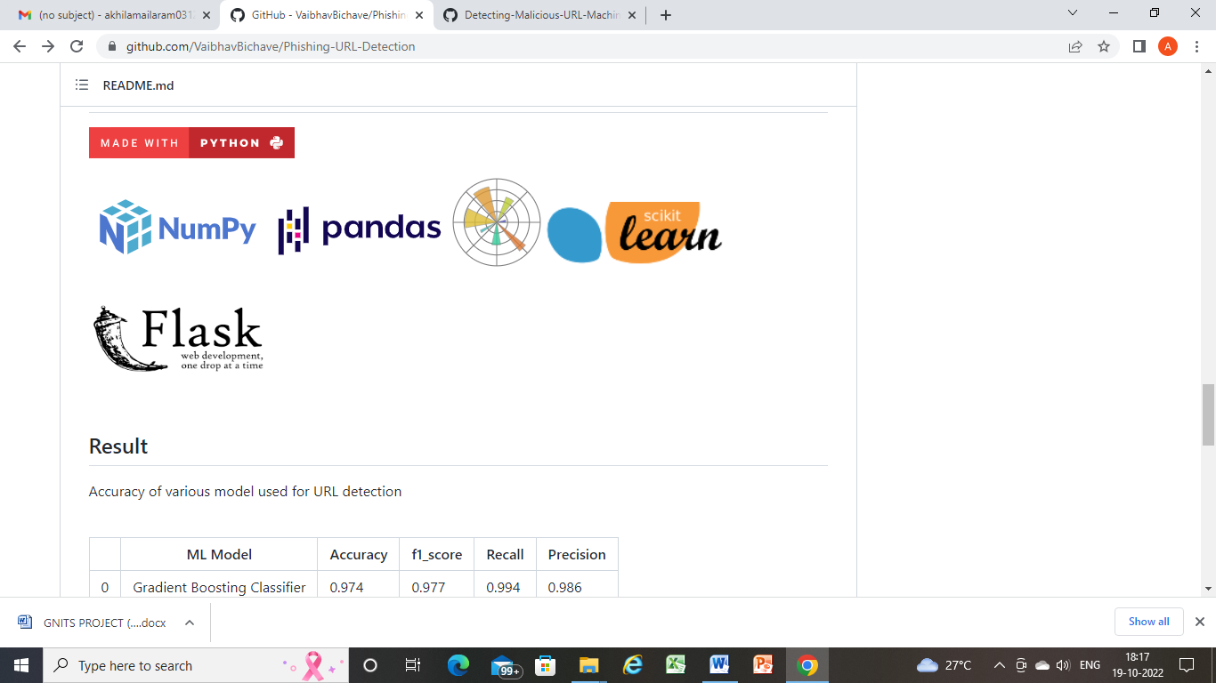

**Datasets used:**

**https://phishtank.org/index.php**

**https://www.kaggle.com/datasets/sid321axn/malicious-urls-dataset**

**Conclusion:**

* The final take away form this project is to explore various machine learning models, perform Exploratory Data Analysis on phishing dataset and understanding their features.
* The project helped us to learn a lot about the features affecting the models to detect whether URL is safe or not, also to know how to tune model and how they affect the model performance.
* The final conclusion on the Phishing dataset is that the some feature like "HTTTPS", "AnchorURL", "WebsiteTraffic" have more importance to classify URL is phishing URL or not.
* Gradient Boosting Classifier currectly classify URL upto 97.4% respective classes and hence reduces the chance of malicious attachments.