A RESEARCH PROJECT SUBMITTED TO THE
CENTRAL BOARD OF SECONDARY EDUCATION
IN PARTIAL FULFILMENT OF THE REQUIREMENTS FOR
THE AISSCE IN ECONOMICS (CODE 030)

IMPACT OF UPI-BASED DIGITAL PAYMENTS ON THE VELOCITY OF MONEY AND ECONOMIC ACTIVITY IN INDIA

An empirical study of the Unified Payments Interface between FY 2016-17 and FY 2025-26, and what it implies for the circulation of money in the Indian economy

Submitted by
ROUNAK ARCHANA KAMESWARAN
Class XII · Commerce
Under the guidance of
_______________________________
Post-Graduate Teacher, Economics
ACADEMIC SESSION 2026-27

Certificate
This is to certify that ROUNAK ARCHANA KAMESWARAN, a student of Class XII, has satisfactorily completed the research project entitled "Impact of UPI-Based Digital Payments on the Velocity of Money and Economic Activity in India" in partial fulfilment of the requirements prescribed by the Central Board of Secondary Education for the All India Senior School Certificate Examination in Economics (Code 030) for the academic session 2026-27.
The work presented in this report is the original effort of the candidate. It has been carried out under my supervision, and to the best of my knowledge it has not been submitted earlier to this or any other Board for the award of any certificate or diploma.

_____________________________  Signature of the Internal Examiner | _____________________________  Signature of the External Examiner

_____________________________  Signature of the Subject Teacher | _____________________________  Signature of the Principal

Date: _______________ Place: _______________

Acknowledgement
A project of this kind is never the work of one person alone, and I am glad to record the debts I have accumulated in writing it.
My first and deepest thanks go to my Economics teacher, whose classes first made me curious about why the same rupee, spent more often, does more work in an economy. That single idea became the spine of this study. I am grateful for the patience with which my drafts were read and for the insistence that every number carry a source.
I thank the Principal and the school for providing the library and internet access without which secondary research of this scale would not have been possible.
This project rests almost entirely on data placed in the public domain by Indian institutions. I acknowledge the Reserve Bank of India, the National Payments Corporation of India, the Press Information Bureau, the Ministry of Statistics and Programme Implementation and the Telecom Regulatory Authority of India, whose published statistics form the evidentiary base of this report. I also acknowledge the International Monetary Fund, the Bank for International Settlements and the World Bank, whose research allowed me to place India’s experience in an international frame.
Finally, I thank my family for their encouragement, and my classmates for arguing with my conclusions — which improved them.

ROUNAK ARCHANA KAMESWARAN
Class XII · Commerce

Declaration
I hereby declare that the project report entitled "Impact of UPI-Based Digital Payments on the Velocity of Money and Economic Activity in India" is a record of independent research work carried out by me during the academic session 2026-27.
The study is based on secondary data. Every statistic reproduced in this report has been drawn from the published releases of official institutions or from peer-reviewed and institutional research, and each has been referenced to its source in the text and in the Bibliography. Where a figure has been derived by me from published data — for example the average value of a transaction, or a ratio to Gross Domestic Product — the method of derivation is stated alongside the table so that it can be independently checked.
No part of this report has been copied from any other project, and it has not been submitted previously for the award of any certificate, diploma or degree.

_____________________________
ROUNAK ARCHANA KAMESWARAN

Table of Contents
Certificate 2
Acknowledgement 3
Declaration 4
List of Exhibits 6
1. Introduction 7
1.1 The meaning of digital payments 7
1.2 The Unified Payments Interface 7
1.3 The growth of digital transactions in India 8
1.4 The role of the National Payments Corporation of India 8
1.5 From a cash economy to a digital economy 9
1.6 The meaning of the velocity of money 9
1.7 Digital payments and economic activity 10
1.8 Financial inclusion and the formalisation of the economy 10
1.9 Relevance in the post-demonetisation and post-pandemic economy 11
1.10 Statement of the problem 11
2. Design of Study 12
2.1 Objectives of the study 12
2.2 Research questions and hypotheses 12
2.3 Data collection methodology 13
2.4 Scope of the study 13
2.5 Limitations of the study 14
3. Review of Literature 15
3.1 Meaning and evolution of digital payments 15
3.2 UPI and its features 16
3.3 The growth of UPI transactions in India 16
3.4 The concept of the velocity of money 16
3.5 Digital payments and the circulation of money 18
3.6 Digital payments and economic activity 18
3.7 Financial inclusion and the digital economy 20
3.8 Government initiatives promoting digital payments 20
3.9 Challenges faced by digital payment systems 21
3.10 Case studies 22
3.11 Analysis of data 24
4. Findings and Suggestions 41
4.1 Findings 41
4.2 Suggestions 42
5. Conclusion 44
Glossary of Key Terms 46
Bibliography 49

List of Exhibits
The eight data sets analysed in Chapter 3 are supported by the following tables and figures. Each data set follows the same four-part structure: the table or graph, an explanation of the data, an analysis, and an interpretation.

Exhibit | Title | Data set
Table 1 | Growth of UPI transactions, FY 2016-17 to FY 2025-26 | Data Set 1
Figure 1 | UPI transaction volume, FY 2016-17 to FY 2025-26 | Data Set 1
Figure 2 | UPI transaction value, FY 2016-17 to FY 2025-26 | Data Set 1
Table 2 | Average value of a single UPI transaction | Data Set 2
Figure 3 | Average value of a single UPI transaction | Data Set 2
Table 3 | UPI and total digital payments compared | Data Set 3
Figure 5 | UPI’s share of retail digital payment volume | Data Set 3
Table 4 | UPI turnover relative to nominal GDP | Data Set 4
Figure 4 | UPI turnover relative to nominal GDP | Data Set 4
Table 5 | Digital payments around demonetisation | Data Set 5
Figure 6 | Digital payments around demonetisation | Data Set 5
Table 6 | UPI growth before, during and after COVID-19 | Data Set 6
Figure 7 | UPI volume before, during and after COVID-19 | Data Set 6
Table 7 | Indicators of financial inclusion and digitalisation | Data Set 7
Figure 8 | Financial inclusion and payment digitalisation indices | Data Set 7
Figure 10 | India’s share of global real-time payment volume | Data Set 7
Table 8 | Internet and telecom penetration, rural and urban | Data Set 8
Figure 9 | The rural–urban digital divide | Data Set 8

1. Introduction

1.1 The meaning of digital payments
A payment is the transfer of purchasing power from one person to another in settlement of an obligation. For most of economic history that transfer required a physical object to change hands — a coin, a note, a cheque. A digital payment removes the object. The money moves as an instruction: a message passes between two accounts held with regulated institutions, the payer’s balance is debited, the payee’s is credited, and no currency is physically handled at any point.
The distinction matters more than it first appears. Cash settles instantly but travels slowly: it must be withdrawn, carried, counted and re-deposited. A digital instruction travels at the speed of a telecommunications network and settles in seconds. What changes, therefore, is not only the convenience of paying but the sheer number of times a given stock of money can be used within a given period. That last observation is the thread this project follows from beginning to end.

1.2 The Unified Payments Interface
The Unified Payments Interface, universally known as UPI, was launched in India in 2016. It is best described not as an application but as a standard — a common set of rules that allows any bank account to be addressed by any application through a single virtual payment address. A user of one provider can pay a merchant who banks elsewhere and who uses an entirely different application, instantly, at no cost to either party, at any hour of any day.
Three features explain why UPI succeeded where earlier systems did not. First, it is interoperable: the payer and payee need not share a provider. Second, it is available without interruption, in contrast to the batch-processed systems it displaced. Third, for the ordinary person-to-person or small merchant transaction it is free — a design choice the Government has reinforced by keeping the Merchant Discount Rate at zero for small-merchant UPI transactions up to ₹2,000 and paying an incentive of 0.15 per cent of transaction value in their place [14].
The International Monetary Fund, in a June 2025 study of retail payment interoperability, identified precisely this architecture as the source of UPI’s adoption. Interoperability, the Fund argued, increases the user’s freedom to choose an application; many users join through a trusted brand and later switch to a better one, and the standing threat of that switch forces incumbents to improve. The result was a market that expanded to more than 200 applications rather than consolidating around the first mover [18].

1.3 The growth of digital transactions in India
The scale of what followed is difficult to convey without figures. In FY 2016-17, its first full year, UPI processed about 2 crore transactions worth ₹0.07 lakh crore. In FY 2025-26 it processed over 24,162 crore transactions worth approximately ₹314 lakh crore — a roughly twelve-thousand-fold increase in volume and a more than four-thousand-fold increase in value over ten years [2].
Nor is this the growth of a niche instrument. UPI accounted for 81 per cent of all retail digital payment transactions in India in FY 2024-25 [14], and the IMF records it as the world’s largest retail fast payment system by transaction volume, handling close to 49 per cent of global real-time payment transactions [3], [18]. As of June 2026, 55.49 crore users had been onboarded [16], and by FY 2025-26 the number of banks live on the platform had risen from 44 to 703 [2].

1.4 The role of the National Payments Corporation of India
None of this was left to the market to organise. UPI was built and is operated by the National Payments Corporation of India (NPCI), an umbrella organisation for retail payments established under the guidance of the Reserve Bank of India and the Indian Banks’ Association. NPCI is constituted as a not-for-profit company, and that legal form is central to the economics of the system: because the operator is not obliged to maximise a return on the switch itself, transactions can be routed at or near cost.
NPCI writes the technical standard, operates the central switch through which every transaction is routed, settles positions between member banks, sets and revises transaction limits, and runs the fraud-monitoring systems that screen traffic in real time. Through its subsidiary NPCI International Payments Limited it has also carried the standard abroad; UPI is now live in eleven foreign jurisdictions for acceptance or cross-border remittances, among them the United Arab Emirates, Singapore, Bhutan, Nepal, Sri Lanka, France, Mauritius and Qatar [17].
The public character of this infrastructure has attracted international attention in its own right. The Bank for International Settlements classes fast payment systems of this kind as digital public infrastructure — open, interoperable systems that support society-wide public and private services — and notes that India’s deployment of Aadhaar and UPI has delivered substantial advances in both financial inclusion and payments efficiency [20].

1.5 From a cash economy to a digital economy
India entered this decade with one of the world’s higher ratios of currency in circulation to GDP, and the Reserve Bank has treated the reduction of that ratio as an explicit objective of policy, naming it in Payments Vision 2025 [26]. Cash is not costless: it must be printed, transported, secured, sorted and destroyed, and every rupee sitting in a pocket or a cash box is a rupee performing no work.
The shift away from cash has therefore been pursued deliberately rather than left to convenience alone. Independent survey evidence commissioned by the Department of Financial Services and released in February 2026 found that 90 per cent of users reported greater confidence in digital payments after using UPI and RuPay, accompanied by a marked decline in cash usage and ATM withdrawals [15]. This is the behavioural counterpart of the aggregate statistics.

1.6 The meaning of the velocity of money
The velocity of money is the average number of times one unit of currency is used to purchase goods and services within a given period. It is not a physical property of money but a behavioural one: it describes how quickly people part with the money they hold.
The idea is formalised in Irving Fisher’s equation of exchange, conventionally written as:
M × V = P × T
where M is the stock of money in circulation, V is the transactions velocity of that money, P is the average price level and T is the volume of transactions. In its more commonly used income form the identity becomes V = (P × Y) ÷ M, where P × Y is nominal national income. Read from left to right, the identity says something simple and important: for a given stock of money, a rise in velocity supports a larger volume of transactions.
It is essential to be precise about which velocity is meant, and this project is careful to distinguish the two. Income velocity relates national output to the money stock, and moves slowly. Transactions velocity relates the total value of all payments — including the many transfers that are not themselves purchases of newly produced output — to the money stock, and can move a great deal faster. Payment systems act on transactions velocity directly and on income velocity only indirectly. Chapter 3 returns to this distinction at length, because conflating the two is the commonest error in popular writing on the subject.

1.7 Digital payments and economic activity
How might a payment system affect real economic activity? Four channels are usually proposed, and each recurs in the literature reviewed in Chapter 3.
- Transaction costs fall. When paying costs nothing in fees and almost nothing in time, exchanges that were previously not worth the friction begin to take place. The margin here is very small payments — the ones cash handled badly and cards never reached.
- Idle balances shrink. A household that can pay instantly from its account has less reason to hold precautionary cash. Money held for transactions purposes falls relative to spending, which is the same statement as a rise in velocity.
- The informal economy becomes visible. A digital payment leaves a record. Records accumulate into a credit history, and a credit history converts an unbanked trader into a borrower — a channel the Reserve Bank has pursued explicitly through the Unified Lending Interface [20].
- Working capital turns over faster. A merchant paid instantly rather than at the end of the day can restock sooner. The same rupee of working capital finances more sales in a year.
These are plausible mechanisms rather than established magnitudes, and this project is careful throughout to treat them as such.

1.8 Financial inclusion and the formalisation of the economy
Financial inclusion means access to useful, affordable financial services. India’s approach has rested on a sequence in which each layer depends on the one before it: universal bank accounts opened under the Pradhan Mantri Jan Dhan Yojana, a digital identity to authenticate the account holder, and a payment rail on which those accounts could actually transact. By 4 August 2025 the Jan Dhan programme had reached over 55.98 crore beneficiaries, more than 55 per cent of them women [7].
The measurable result appears in the Reserve Bank’s Financial Inclusion Index, which rose from 64.2 in March 2024 to 67.0 in March 2025, with growth recorded across all three sub-indices of access, usage and quality [7]. Formalisation follows from usage rather than from access alone: an account that is merely opened changes nothing, while an account that is used generates the transaction record on which credit and insurance can later be built.

1.9 Relevance in the post-demonetisation and post-pandemic economy
Two shocks bracket UPI’s first decade. In November 2016, banknotes of ₹500 and ₹1,000 denominations — ₹15.4 trillion, or 86.9 per cent of the value of notes then in circulation — ceased to be legal tender [23]. Monthly digital transactions rose 56 per cent between October 2016 and May 2017 [24]. UPI, launched only months earlier, was available at exactly the moment a nation was compelled to look for an alternative to cash.
The second shock was the COVID-19 pandemic, which made contactless payment a matter of public health rather than convenience and pushed a generation of small merchants into accepting a QR code. The distinction between the two episodes is instructive and is examined in Data Sets 5 and 6: the first was a sharp compulsion followed by partial reversion, the second a slower change that did not reverse.

1.10 Statement of the problem
That UPI has grown is not in dispute; the figures are published monthly and are not seriously contested. The question this project asks is narrower and harder. Has that growth changed the speed at which money circulates in the Indian economy, and can any effect on real economic activity be identified from publicly available data?
The distinction between the two questions is the substance of this report. A payment system can move an enormous quantity of money without altering national income at all, if what it does is relocate transactions that would have occurred in cash. Establishing whether something more than relocation has occurred requires evidence of a different kind — evidence about transaction sizes, about who is transacting, and about what merchants report. That evidence is assembled in Chapter 3.

2. Design of Study

2.1 Objectives of the study
This study is directed at five objectives.
- To understand the concept, architecture and growth of UPI-based digital payments in India between FY 2016-17 and FY 2025-26.
- To examine the relationship between UPI-based payments and the velocity of money, distinguishing carefully between transactions velocity and income velocity.
- To analyse the impact of digital payments on economic activity, including consumption patterns, small-merchant sales and the formalisation of transactions.
- To examine the role of UPI in promoting financial inclusion and in bringing informal economic activity into the recorded economy.
- To study the challenges and limitations of digital payment systems in India, including cyber fraud, infrastructure dependence and unequal regional adoption.

2.2 Research questions and hypotheses
The objectives above are translated into three testable propositions. They are stated here so that the reader may judge, at the end of Chapter 3, whether the evidence supports them.

 | Hypothesis | Evidence used
H1 | The value of payments settled per rupee of national output has risen substantially since FY 2016-17 — that is, transactions velocity has increased. | Data Sets 1 and 4
H2 | UPI’s growth reflects genuinely new, small-value transactions rather than only the migration of existing large payments from cash. | Data Sets 2 and 3
H3 | The gains in inclusion and usage are not distributed evenly between rural and urban India. | Data Sets 7 and 8

2.3 Data collection methodology
The study is based entirely on secondary data. No primary survey was conducted, for the straightforward reason that the phenomenon under study is national in scale and is already measured, comprehensively and at high frequency, by the institutions that operate and regulate it. A school-level survey could not improve on that measurement, and any sample small enough to be feasible would be too small to be representative.
Sources were selected in the following order of preference:
- Operator and regulator data. Transaction statistics published by the National Payments Corporation of India, and the Annual Report, Payment Systems Report, Digital Payments Index and Financial Inclusion Index of the Reserve Bank of India.
- Government releases. Press Information Bureau releases and factsheets, replies placed before Parliament, and the Economic Survey.
- Official statistics. National income aggregates from the Ministry of Statistics and Programme Implementation; telecom and internet subscription data from the Telecom Regulatory Authority of India.
- International institutional research. Publications of the International Monetary Fund, the Bank for International Settlements and the World Bank, used chiefly for comparison and for methodological guidance.
- Academic literature. Peer-reviewed and pre-print research, used where it supplies micro-level evidence that aggregate statistics cannot.
Commercial and news websites were deliberately avoided as primary sources of numbers. Where a figure is quoted in this report, it is quoted from the institution that produced it, and the reference number in square brackets points to the entry in the Bibliography at which that institution’s release may be found.
Two derived measures are computed by the author from published data rather than taken from any source. The first is the average value of a UPI transaction, obtained by dividing annual transaction value by annual transaction volume. The second is UPI turnover as a multiple of nominal GDP. Both derivations are stated in full beside the relevant tables so that they can be checked.

2.4 Scope of the study
The study is confined to the macroeconomic implications of digital payments in India. Within that field its focus is narrower still: it is a study of UPI, and other instruments — cards, wallets, IMPS, NEFT and RTGS — enter only where they are needed as a comparison. The period examined runs from FY 2016-17, the first full year of UPI’s operation, to FY 2025-26, the most recent year for which complete annual data were available at the time of writing. The conceptual focus is on the velocity of money, consumption and the formalisation of financial activity.
Certain adjacent questions are deliberately excluded. The study does not examine the profitability of payment service providers, the design of central bank digital currency, or the competition-policy question of market concentration among UPI applications. Each is a substantial subject in its own right.

2.5 Limitations of the study
The following limitations are stated plainly, because a study that conceals them invites more confidence than its evidence can bear.
- The study rests on secondary data. Its conclusions can be no more reliable than the published statistics on which they depend.
- Correlation is not causation. UPI expanded during a decade in which smartphone ownership, internet access, bank account ownership and nominal income all rose together. This project can describe association; it cannot isolate UPI’s independent causal contribution, and it does not claim to.
- Velocity cannot be measured directly. It is inferred from the ratio of payment or income aggregates to a money stock, and different choices of numerator and denominator yield materially different numbers. The turnover ratio used in Data Set 4 is a proxy, and its limitations are set out where it is introduced.
- Payment value is not output. A large share of UPI value consists of person-to-person transfers, which are not purchases of newly produced goods and services and therefore do not enter GDP. Any ratio of payment value to GDP must be read with this firmly in mind.
- A revision of the national accounts occurred within the study period. Nominal GDP is now published on a 2022-23 base, having previously used a 2011-12 base; the two series are not perfectly continuous. The break is identified where it affects a calculation.
- The ecosystem changes rapidly. Transaction limits, fee rules and product features were revised repeatedly during the study period, and figures cited here are current only to their stated date.
- Regional variation is understated. National aggregates conceal wide differences between states and between districts, and district-level UPI data are not published.

3. Review of Literature
This chapter has two halves. Sections 3.1 to 3.10 review what is already known: the evolution of digital payments, the theory of the velocity of money, the empirical literature connecting payments to economic activity, the policy framework, and the principal criticisms of the system. Sections 3.11 onward present the eight data sets analysed for this project, each in the same four-part structure of table or graph, explanation, analysis, and interpretation.

3.1 Meaning and evolution of digital payments
India’s retail payment system did not arrive at UPI in a single step. Its evolution can be read as a sequence of attempts to solve one problem after another.
Electronic settlement between banks came first, with the Real Time Gross Settlement and National Electronic Funds Transfer systems. These were reliable but institutional in character: they operated in batches or during banking hours, required the payer to know the payee’s account number and branch code, and were designed for payments of substance. The Immediate Payment Service, introduced by NPCI, removed the constraint of banking hours and made round-the-clock retail transfer possible for the first time.
Card networks solved a different problem — payment at the point of sale — but imposed costs of their own. Acceptance required a terminal, the merchant paid a discount rate on every transaction, and the economics of that arrangement excluded precisely the small traders who constitute the majority of Indian retail. Mobile wallets, which proliferated in the middle of the last decade, lowered the cost of acceptance but reintroduced a worse problem: each wallet was a closed loop. Money inside one provider’s system could not reach a user of another, and the market fragmented into networks that could not talk to each other.
UPI’s contribution was to make the network itself the public good. Rather than build a better wallet, NPCI defined a standard that any wallet, bank or application could adopt, and required that all of them settle against the same rail. The Bank for International Settlements describes systems of this design as digital public infrastructure — interoperable, open and inclusive digital systems supporting society-wide public and private services — and treats fast payment systems as the archetype of the category regardless of whether the operator is public or private [20].

3.2 UPI and its features
Six features distinguish UPI from what preceded it, and together they explain the adoption pattern documented later in this chapter.
- Interoperability. Any application can pay any account at any participating bank. By FY 2025-26 there were 703 banks live on the platform, up from 44 in FY 2016-17 [2].
- Addressability without account details. A virtual payment address or a QR code replaces the account number and branch code, which removes both a memory burden and a common source of error.
- Continuous availability. Settlement is instant and the system operates without interruption, including on holidays.
- Zero cost to the user. There is no charge to the payer for UPI payments, and small merchants face a zero Merchant Discount Rate on transactions up to ₹2,000, supported by a government incentive of 0.15 per cent of transaction value [14].
- Two-factor authentication by design. Every transaction requires a PIN, and the device is bound to the customer’s registered mobile number [28].
- Extensibility. The same rail now carries recurring mandates, credit lines, cross-border acceptance and UPI-linked credit cards, without change to the user-facing model.

3.3 The growth of UPI transactions in India
The growth record is set out in full in Data Set 1. Two features of it are worth stating here because they govern how the rest of the chapter should be read.
The first is that growth has been sustained rather than explosive-then-flat. A system that grows a thousand-fold in three years and then stops has found a niche; a system that compounds for a decade has changed a habit. UPI’s volume rose in every single year of the period studied, including the years after the novelty had plainly worn off.
The second is that volume has consistently grown faster than value. This is not a statistical curiosity but the single most informative fact in the whole data set, and Data Set 2 is devoted to it. It means that the typical UPI transaction has been getting smaller, which in turn tells us something about what kind of spending is moving onto the platform.

3.4 The concept of the velocity of money
The velocity of money is among the oldest concepts in monetary economics and among the most frequently misused. This section sets out the theory with some care, because the empirical claims made later in this chapter depend on getting it right.

3.4.1 The equation of exchange
Irving Fisher’s equation of exchange states that the total value of payments made in an economy over a period must equal the total value of goods and services exchanged:
M × V = P × T
Here M is the money stock, V the transactions velocity, P the average price and T the number of transactions. The relation is an identity — it is true by construction, not by assumption. Its usefulness lies in what it forces us to notice: if the money stock is held constant and the number of transactions rises, then velocity must have risen too.

3.4.2 Income velocity and transactions velocity
Because T is not directly observable, economists ordinarily work with the income form of the identity, in which total transactions are replaced by national income:
V = (P × Y) ÷ M
This is income velocity, and it is a much more conservative measure. It counts only those payments that correspond to newly produced output. Transactions velocity, by contrast, counts every payment — including a transfer of money between two of a person’s own accounts, a repayment to a friend, or a wholesaler paying a distributor for goods that will be counted in GDP only once, at final sale.
The gap between the two measures is large and it is systematic. A payment system that makes transfers frictionless will raise transactions velocity a great deal and income velocity comparatively little, because most of the additional payments it enables are not purchases of final output. Any study claiming that a payment system has raised "the velocity of money" without saying which velocity it means should be treated with caution. This project accordingly reports a transactions-velocity proxy in Data Set 4 and labels it as such.

3.4.3 The Cambridge approach and the demand for money
The Cambridge cash-balance approach expresses the same relationship from the opposite direction. Writing M = k × P × Y, where k is the fraction of nominal income that people choose to hold as money, velocity is simply the reciprocal of k. A rise in velocity is therefore identical to a fall in the proportion of income held idle as money.
This formulation makes the link to payment technology direct and intuitive. Keynes identified a transactions motive for holding money: people hold balances because income and expenditure are not synchronised, and they must bridge the gap. A payment system that permits instant transfer from an interest-bearing account at any hour reduces the size of the bridge required. Held balances fall relative to spending; k falls; V rises. This is the theoretical mechanism by which UPI could plausibly affect velocity, and it is the one this project tests.

3.4.4 What velocity does not tell us
A caution is owed here. A rise in velocity is not by itself a sign of economic health. Velocity rises during hyperinflations, when holding money is punished and people spend immediately. It falls during periods of uncertainty when precautionary saving increases. The claim that faster circulation is beneficial holds only when the increase arises from lower transaction costs rather than from a flight from money. The distinction matters for the interpretation offered in Data Set 4.

3.5 Digital payments and the circulation of money
The Reserve Bank has treated the relationship between payment digitalisation and currency demand as a policy variable rather than an academic curiosity. Payments Vision 2025 named the reduction of cash in circulation as a percentage of GDP among its goals, observing that India’s ratio is high by international standards and that currency demand grows with both output and inflation [26].
The mechanism by which digital payments might reduce currency demand is not that people hold less wealth, but that they hold less of it in the specific form of notes. Money kept in a bank account and spendable instantly through a phone performs the transactions function that cash previously performed, while remaining within the banking system where it can be lent. The Reserve Bank tracks the aggregate progress of this shift through its Digital Payments Index, constructed on a March 2018 base of 100, which stood at 465.33 in September 2024 and 493.22 in March 2025 [6].
Direct evidence on household behaviour points the same way. The Department of Financial Services study of February 2026 found that adoption of UPI and RuPay was accompanied by a marked decline in both cash usage and ATM withdrawals among users, with 74 per cent citing speed of payment as the principal advantage [15].

3.6 Digital payments and economic activity
The international evidence on whether fast payment systems affect real activity is developing, and it is more careful than popular commentary suggests.
The Bank for International Settlements examined 86,163 applications across 95 countries between 2012 and 2022 and found that the launch of a retail fast payment system stimulates the adoption of digital finance applications, with the most pronounced effect in lower-income economies. The effect was strongest for applications built by fintech and big-tech entrants rather than by incumbent financial institutions, and it was amplified where the central bank took an active role, where membership was open, and where settlement was in real time [20]. India’s system has all three characteristics.
The International Monetary Fund’s study of interoperability used the universe of UPI transactions and found that in districts where the payment landscape had been most fragmented before interoperability — and where the gain from unification was therefore largest — digital payments subsequently grew faster [18]. This is closer to a causal identification than most work in the field, because it exploits variation in the size of the shock across districts rather than merely comparing before and after.
Evidence from comparable economies supports the general direction. A panel study of thirty-three Indonesian provinces found that digital payments significantly affected regional income and consumption both before and after an identified structural break associated with COVID-19, with the effect larger after the break [29]. Indonesia is not India, and the finding cannot be transplanted; it is cited here as an indication that the relationship is detectable in data of this kind, not as a measurement of India’s experience.
For India specifically, the most useful micro-evidence is behavioural rather than macroeconomic. A study of 276 survey respondents supported by 20 follow-up interviews found that approximately 75 per cent of participants reported increased spending as a result of UPI, and that many attributed this to the intangibility of digital money, which reduced the reluctance ordinarily associated with parting with cash; 95.2 per cent found UPI convenient and 91.5 per cent were satisfied with it [25]. The sample is small and self-reported, and it cannot be generalised to the population. But it identifies a mechanism that aggregate statistics cannot see, and it carries a warning as well as a finding: a system that makes spending easier makes overspending easier too.
The merchant-side evidence is stronger. The Department of Financial Services study found that 94 per cent of small merchants had adopted UPI, that about 72 per cent were satisfied with digital payments, citing faster transactions and improved record-keeping, and — most significantly for the present question — that 57 per cent reported an increase in sales following digital adoption [15]. Self-reported sales increases are not audited accounts, and a merchant may attribute to a payment method a gain that had other causes. Even so, a majority reporting higher sales is the most direct evidence available that the effect reaches real activity and not merely the composition of payments.

3.7 Financial inclusion and the digital economy
Financial inclusion in India has proceeded in layers, and the payment layer is the one that made the others useful. An account opened under the Pradhan Mantri Jan Dhan Yojana and never transacted upon is an entry in a register. The same account, connected to a payment rail that a vegetable vendor will accept, becomes a functioning financial relationship.
The Reserve Bank’s Financial Inclusion Index registered this progression, rising from 64.2 in March 2024 to 67.0 in March 2025 with improvement in all three sub-indices of access, usage and quality [7]. The improvement in the usage sub-index is the analytically important one, since access had already been substantially achieved through the Jan Dhan programme, which had reached over 55.98 crore beneficiaries by August 2025, more than 55 per cent of them women [7].
The World Bank’s Global Findex 2025, drawing on nationally representative surveys of about 145,000 adults across 141 economies, provides the international benchmark for this kind of measurement and records a related Indian finding: the proportion of women holding inactive accounts fell from a third in 2021 to 18 per cent by 2024 [21]. Dormancy is the precise problem that a usable payment rail addresses.
Beyond payments, the transaction record itself has become an economic asset. The Reserve Bank has built the Unified Lending Interface on this foundation, giving regulated lenders seamless access to verified borrower data and thereby converting a payment history into creditworthiness [20]. For a small trader who has never had audited accounts, this is the route by which digital payment adoption becomes access to capital.

3.8 Government initiatives promoting digital payments
Adoption on this scale was not spontaneous. Four categories of intervention shaped it.
- Pricing. The Government has kept UPI free to the user and has compensated the system for the revenue foregone rather than allowing a merchant fee to be levied. Successive incentive schemes for low-value BHIM-UPI person-to-merchant transactions and RuPay debit cards have paid acquiring banks a percentage of transaction value in place of a Merchant Discount Rate, with a ₹1,500 crore scheme approved for low-value P2M transactions [14], [15].
- Infrastructure. The Payments Infrastructure Development Fund subsidises the deployment of acceptance infrastructure in smaller centres. By 31 October 2025 approximately 5.45 crore digital touch points had been deployed through the Fund in tier-3 to tier-6 centres, and by FY 2024-25 some 56.86 crore QR codes had been deployed to approximately 6.5 crore merchants [14].
- Identity and accounts. The Jan Dhan–Aadhaar–Mobile architecture supplied the preconditions: an account to receive money, an identity to authenticate the holder, and a device on which to transact.
- Internationalisation. Through NPCI International Payments Limited, UPI acceptance and remittance corridors have been extended abroad, reaching eleven foreign jurisdictions, with acceptance launched in Cambodia in June 2026 and a remittance corridor with the Maldives’ instant payment system going live in July 2026 [17].
It is worth recording the fiscal character of this policy honestly. Free payments are not costless payments; the cost has been shifted from the merchant to the exchequer. Whether that transfer is justified depends on whether the resulting gains in formalisation, inclusion and tax visibility exceed the outlay — a question this project raises in Chapter 4 but cannot settle.

3.9 Challenges faced by digital payment systems
Four difficulties recur across the literature and the policy record, and an honest assessment must give them their weight.
Cyber fraud and social engineering.
Cybersecurity incidents in India rose from 10.29 lakh in 2022 to 22.68 lakh in 2024 [28]. The technical security of UPI itself is not the principal vulnerability — device binding and two-factor authentication with a PIN make unauthorised access difficult. The vulnerability is the user, who can be deceived into authorising a payment. NPCI operates a fraud-monitoring solution using machine-learning models to generate alerts and decline suspicious transactions, and the Citizen Financial Cyber Fraud Reporting and Management System has saved more than ₹1,200 crore across more than 4.7 lakh complaints [28]. A system used by over 55 crore people is a target proportionate to its size.
Dependence on infrastructure.
A digital payment requires electricity, a functioning device and network connectivity simultaneously. Cash requires none of these. As UPI displaces cash it concentrates systemic risk: an outage that would once have been an inconvenience becomes an interruption of commerce.
Unequal access.
The digital divide is documented quantitatively in Data Set 8. Rural internet penetration stood at 46.73 subscribers per 100 people against an urban figure of 113.83 in August 2025 [22]. A payment system reachable only through the internet cannot be more inclusive than internet access itself.
Behavioural risk.
The finding that roughly 75 per cent of surveyed users reported spending more because digital money felt less tangible [25] is a genuine cost, particularly for low-income households with little buffer against overspending. The same frictionlessness that raises velocity also removes a restraint that cash imposed without anyone designing it.

3.10 Case studies

3.10.1 Urban and rural India
The rural story is one of rapid catching-up from a low base, achieved through deliberate subsidy of acceptance infrastructure rather than by market forces alone. The Payments Infrastructure Development Fund exists precisely because deploying a QR code in a tier-6 centre is not commercially attractive at the transaction volumes initially available there; 5.45 crore touch points had been deployed under it in tier-3 to tier-6 centres by October 2025 [14]. The gap that remains, however, is not primarily a gap in acceptance infrastructure but in connectivity, and it is documented in Data Set 8.

3.10.2 Small businesses and consumers
For the small merchant, UPI resolved a problem that card acceptance never could. A terminal costs money and a discount rate erodes a thin margin; a printed QR code costs nothing and, below ₹2,000, carries no fee at all [14]. The result is near-universal acceptance: 94 per cent of small merchants surveyed reported adoption, and 57 per cent reported higher sales afterwards [15]. Street vendors under the PM SVANidhi scheme have been brought into the same framework, with cashback on digital transactions and access to UPI-linked RuPay credit cards converting a payment record into a credit line [14].

3.10.3 India in international comparison
India’s position is unusual in two respects. The first is scale: UPI accounted for close to 49 per cent of global real-time payment transaction volume in 2024 and is recognised by the IMF as the world’s largest retail fast payment system by volume [3], [18]. The second is the pricing model. Most comparable systems abroad charge merchants something; the BIS notes that in India there are no charges for UPI-based payments to the user, with an interchange fee applying only to merchant transactions made through prepaid instruments [20]. India has chosen to treat retail payment as a public utility, and the adoption curve documented in this chapter is in part a consequence of that choice.

3.11 Analysis of data
Eight data sets follow. Each is presented in the four-part structure adopted for this project: the table or graph, an explanation of what the data show, an analysis of what they mean, and an interpretation stating what may and may not be concluded.

Data Set 1 · The growth of UPI transactions, FY 2016-17 to FY 2025-26

Financial year | Volume (crore) | Value (₹ lakh crore) | Volume growth | Value growth
2016-17 | 2 | 0.07 | — | —
2017-18 | 92 | 1.10 | 4,500% | 1,471%
2018-19 | 535 | 8.77 | 482% | 697%
2019-20 | 1,252 | 21.32 | 134% | 143%
2020-21 | 2,233 | 41.04 | 78% | 92%
2021-22 | 4,597 | 84.16 | 106% | 105%
2022-23 | 8,375 | 139.00 | 82% | 65%
2023-24 | 13,116 | 199.90 | 57% | 44%
2024-25 | 18,587 | 261.00 | 42% | 31%
2025-26 | 24,162 | 314.00 | 30% | 20%
Table 1. Sources: NPCI UPI product statistics [1], with year-wise figures as reported in Press Information Bureau releases [2], [10], [13], [16]. Growth rates are computed by the author from the volume and value columns. Figures are rounded as published.
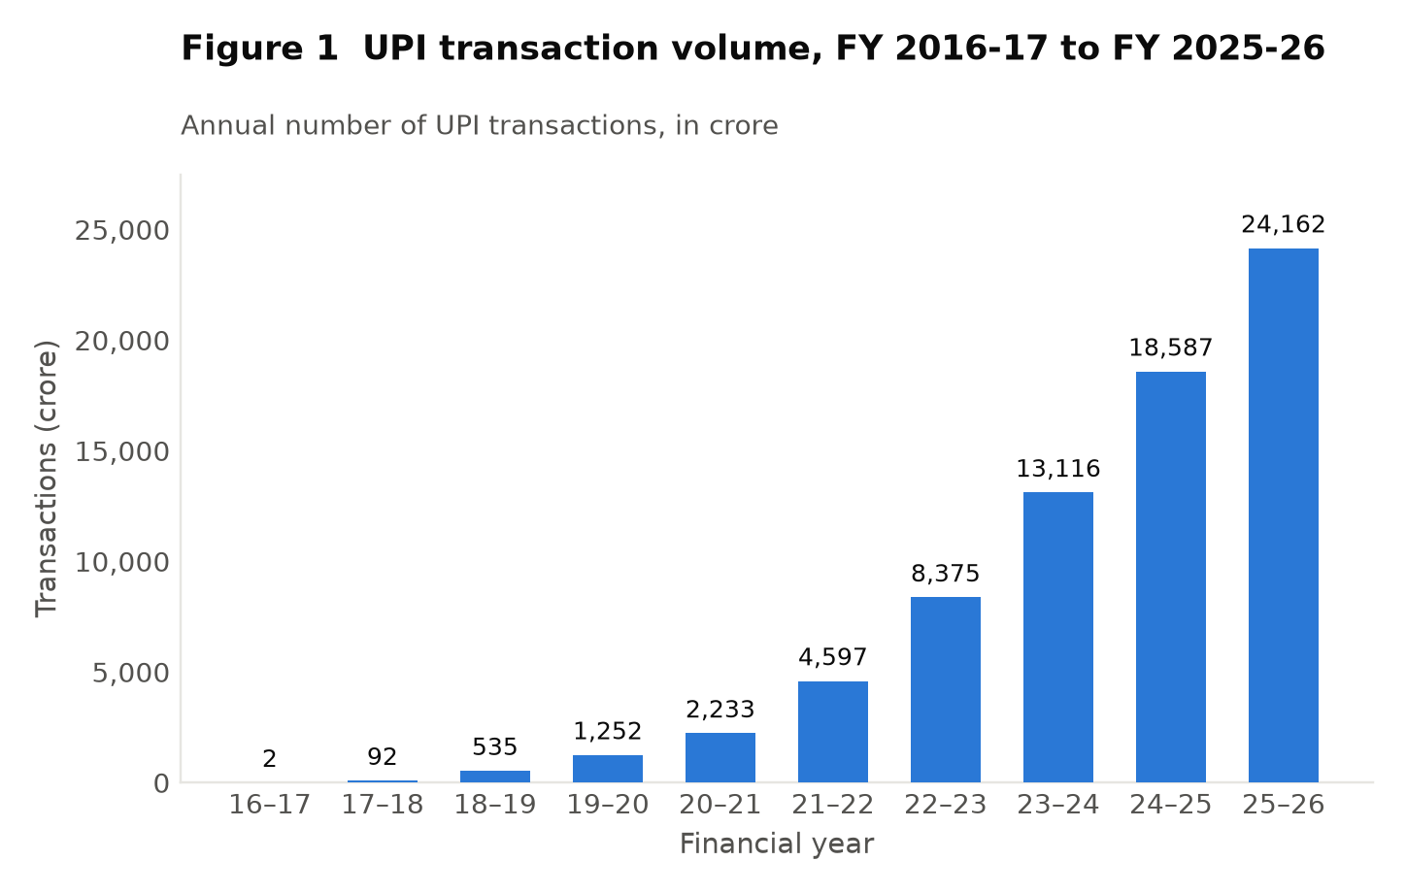
Figure 1. UPI transaction volume, FY 2016-17 to FY 2025-26.
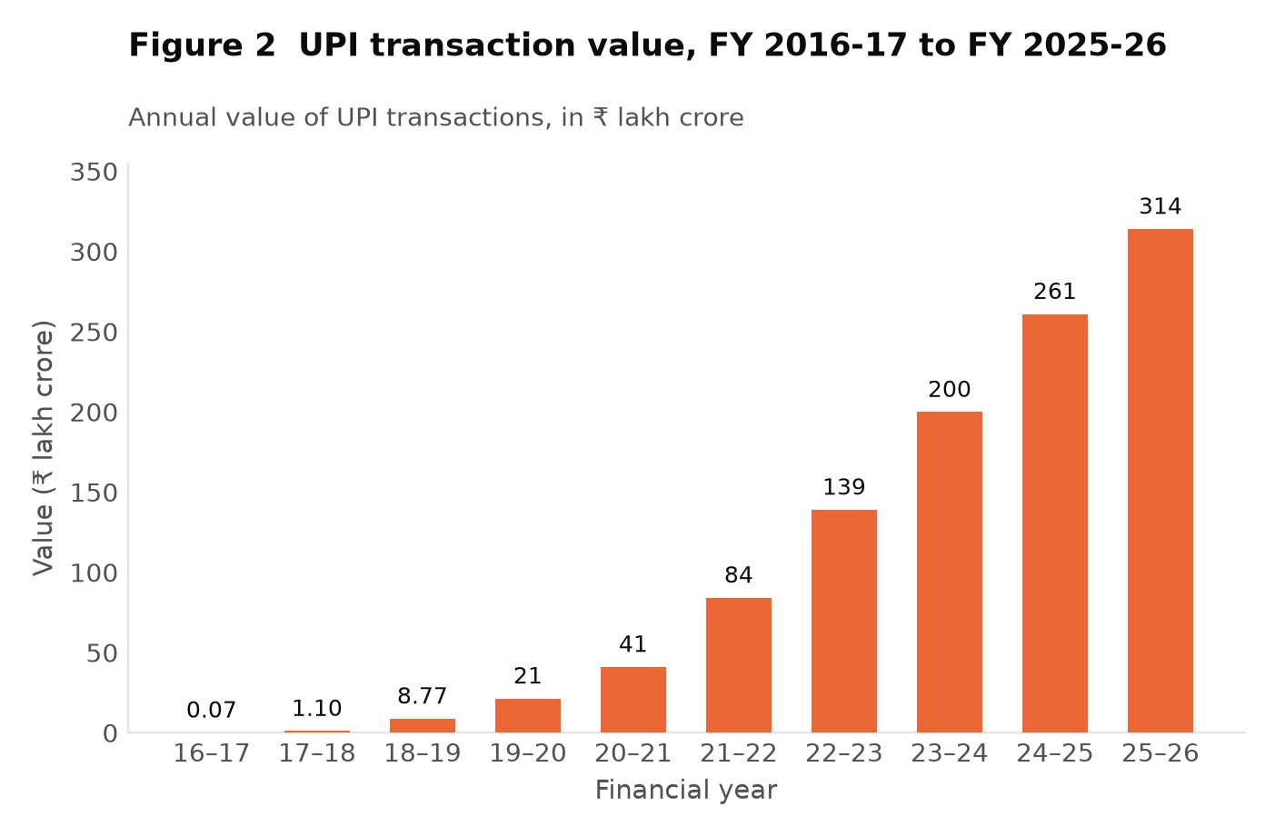
Figure 2. UPI transaction value, FY 2016-17 to FY 2025-26.
Explanation of the data
The table records the number and value of UPI transactions in each financial year since the platform’s launch, together with year-on-year growth rates calculated from those two columns. Volume rose from 2 crore transactions to 24,162 crore, and value from ₹0.07 lakh crore to approximately ₹314 lakh crore, over ten years [2].
Analysis
Three patterns are visible. First, growth rates are decelerating in percentage terms — from 4,500 per cent to 30 per cent — while absolute increments continue to rise. The increase in FY 2025-26 alone, some 5,575 crore transactions, exceeds the entire volume of FY 2021-22. This is the ordinary arithmetic of a maturing base and should not be read as a slowdown in real terms.
Second, the curve has no plateau. Ten consecutive years of growth, through a pandemic and well past the point at which novelty could explain adoption, indicate a durable change in payment behaviour rather than a fashion.
Third, and most importantly, volume growth has outpaced value growth in every year since FY 2021-22. In FY 2025-26 volume grew 30 per cent while value grew 20 per cent. Since the average transaction size is value divided by volume, this divergence necessarily means that the typical UPI payment is shrinking. Data Set 2 pursues this directly.
Interpretation
UPI has moved from an experiment to the default retail payment mechanism of the Indian economy, and it now handles the great majority of retail digital transactions. The divergence between volume and value growth is the first indication, developed further below, that the platform is not merely absorbing payments that already existed in another form but is reaching into a class of very small transactions that were previously settled in cash or not made at all. Hypothesis H1 is supported at this stage in its descriptive form; its velocity implication is tested in Data Set 4.
In one sentence: UPI grew from 2 crore transactions to 24,162 crore in ten years, and because volume grew faster than value in every year from FY 2021-22, the typical payment was getting smaller even as the total kept rising.

Data Set 2 · The average value of a single UPI transaction

Financial year | Value (₹ lakh crore) | Volume (crore) | Average per transaction (₹)
2017-18 | 1.10 | 92 | 1,196
2018-19 | 8.77 | 535 | 1,639
2019-20 | 21.32 | 1,252 | 1,703
2020-21 | 41.04 | 2,233 | 1,838
2021-22 | 84.16 | 4,597 | 1,831
2022-23 | 139.00 | 8,375 | 1,660
2023-24 | 199.90 | 13,116 | 1,524
2024-25 | 261.00 | 18,587 | 1,404
2025-26 | 314.00 | 24,162 | 1,300
Table 2. The average value per transaction is derived by the author as transaction value divided by transaction volume, using the figures in Table 1. FY 2016-17 is omitted because the base is too small for the ratio to be meaningful. Underlying data: [1], [2].
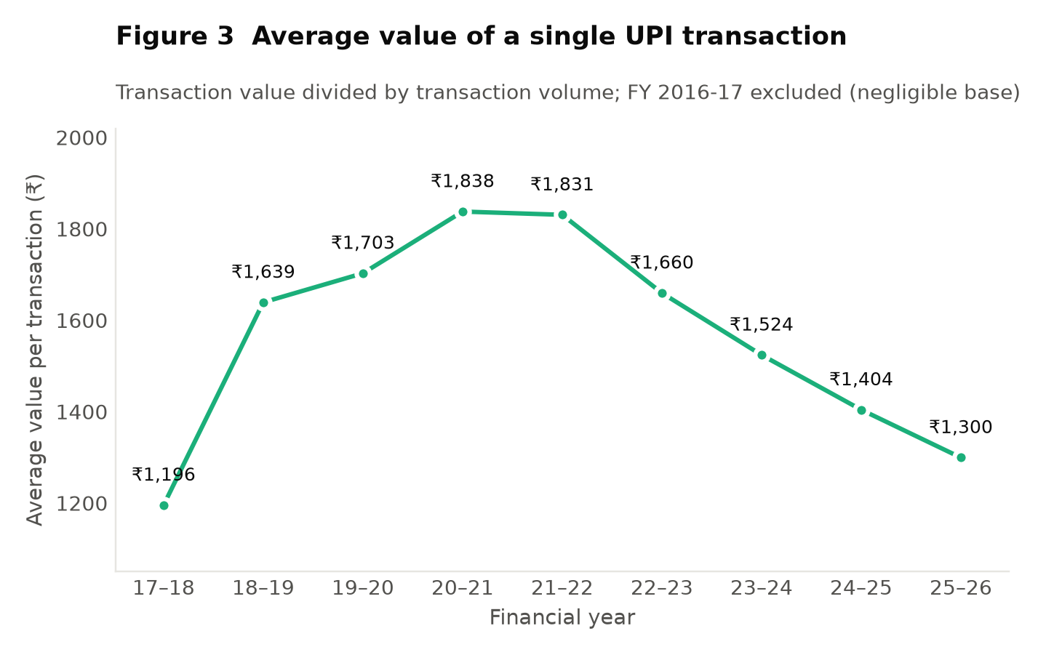
Figure 3. Average value of a single UPI transaction, FY 2017-18 to FY 2025-26.
Explanation of the data
This measure is not published directly; it is derived here by dividing each year’s transaction value by its volume. It answers the question: how large is a typical UPI payment, and is it changing? The series rises from ₹1,196 in FY 2017-18 to a peak of ₹1,838 in FY 2020-21, and then falls steadily to ₹1,300 in FY 2025-26 — a decline of roughly 29 per cent from the peak.
Analysis
The shape of this curve tells the story of UPI’s adoption in two distinct phases.
In the first phase, to FY 2020-21, the average transaction grew. This is what one expects when early adopters are relatively affluent, urban and comfortable with technology, and when the payments migrating to the platform are substantial ones — rent, fees, transfers between family members — that previously moved by cheque or bank transfer.
In the second phase the average falls, continuously, for five years. Since total value continued to rise throughout, this cannot reflect a contraction in what people spend. It can only mean that the transactions being added at the margin are much smaller than the existing average, and are numerous enough to pull the mean down. The composition data confirm this: person-to-merchant transactions now constitute 63 per cent of volume, and 86 per cent of those are below ₹500 [2].
It should be noted that inflation works against this finding rather than producing it. Prices rose over the period, so a constant basket of goods would show a rising average transaction value. The observed decline is therefore an understatement of the shift towards small payments in real terms.
Interpretation
This is the single most important finding in the project, because it distinguishes between the two competing explanations of UPI’s growth. If UPI had merely digitised payments that already existed, the average transaction size would have remained broadly stable while volume rose. Instead it fell by nearly a third while volume multiplied thirteen-fold, which is the signature of a payment system reaching a class of transaction it did not previously serve — the tea, the vegetables, the auto fare.
This bears directly on velocity. Fisher’s identity relates the money stock to the number of transactions it supports. A payment system that adds a very large number of very small transactions increases T substantially while adding relatively little to the value settled, which is precisely a rise in the frequency with which each rupee is used. Hypothesis H2 is supported.
In one sentence: The average UPI payment fell from ₹1,838 to ₹1,300 while volume rose more than ten-fold, which is the signature of a system adding small everyday payments rather than merely digitising ones that already existed.

Data Set 3 · UPI within India’s wider digital payment system

Indicator | Earlier period | Later period
Total digital payment volume (crore) | 2,071 (FY 2017-18) | 18,737 (FY 2023-24)
Total digital payment value (₹ lakh crore) | 1,962 (FY 2017-18) | 3,659 (FY 2023-24)
Volume CAGR over the period | — | 44%
Value CAGR over the period | — | 11%
UPI share of retail digital payment volume | — | 81% (FY 2024-25)
Digital transactions, FY 2019-20 to FY 2024-25 | — | over 65,000 crore, worth over ₹12,000 lakh crore
Table 3. Sources: Press Information Bureau releases [10], [11], [12], [14].
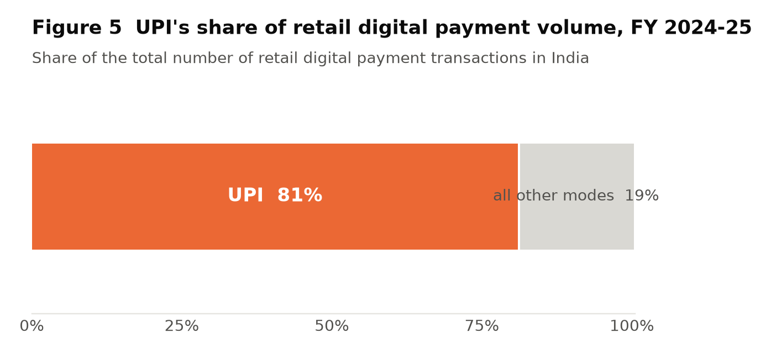
Figure 5. UPI’s share of retail digital payment volume, FY 2024-25.
Explanation of the data
This data set places UPI in the context of all digital payments in India, including cards, wallets, NEFT, IMPS and RTGS. Total digital payment volume rose from 2,071 crore transactions in FY 2017-18 to 18,737 crore in FY 2023-24, a compound annual growth rate of 44 per cent, while value grew from ₹1,962 lakh crore to ₹3,659 lakh crore at a compound rate of 11 per cent [10], [11]. UPI accounted for 81 per cent of retail digital payment volume in FY 2024-25 [14].
Analysis
The contrast between the two growth rates — 44 per cent for volume against 11 per cent for value — repeats at the level of the whole payment system the pattern found for UPI alone. India’s digital payment system as a whole has been growing overwhelmingly through an increase in the number of payments rather than in their size.
The value figures also require careful reading. Total digital payment value of ₹3,659 lakh crore vastly exceeds India’s GDP, because it includes wholesale settlement through RTGS — interbank and large corporate transfers of enormous individual size and modest number. This is a clear illustration of why payment value cannot be equated with economic output, and why the ratio computed in Data Set 4 must be described as a transactions proxy rather than as income velocity.
That UPI carries 81 per cent of retail digital transactions by number while total digital value is dominated by wholesale systems is not a contradiction. It states precisely what UPI is: the instrument of high-frequency, low-value retail payment.
Interpretation
UPI is not one option among several in Indian retail payments; it is the system, with other instruments occupying the remaining fifth. For the purposes of this study, this means that changes in retail payment behaviour in India during the period may reasonably be attributed to UPI, since alternatives are too small a share to drive the aggregate.
In one sentence: UPI carries 81 per cent of India’s retail digital transactions, so changes in retail payment behaviour during this period can reasonably be attributed to it.

Data Set 4 · UPI turnover relative to nominal GDP — a velocity proxy

Financial year | UPI value (₹ lakh crore) | Nominal GDP (₹ lakh crore) | UPI ÷ GDP
2022-23 | 139.00 | 269.50 | 0.52×
2023-24 | 199.90 | 295.36 | 0.68×
2024-25 | 261.00 | 318.07 | 0.82×
2025-26 | 314.00 | 346.36 | 0.91×
Table 4. UPI values from [1], [2]. Nominal GDP at current prices from MoSPI provisional estimates [8], [9]. The ratio is computed by the author. Note a discontinuity: figures for FY 2022-23 and FY 2023-24 are on the 2011-12 base series, while FY 2024-25 and FY 2025-26 are on the revised 2022-23 base series. The break is small relative to the trend but the series is not perfectly continuous.
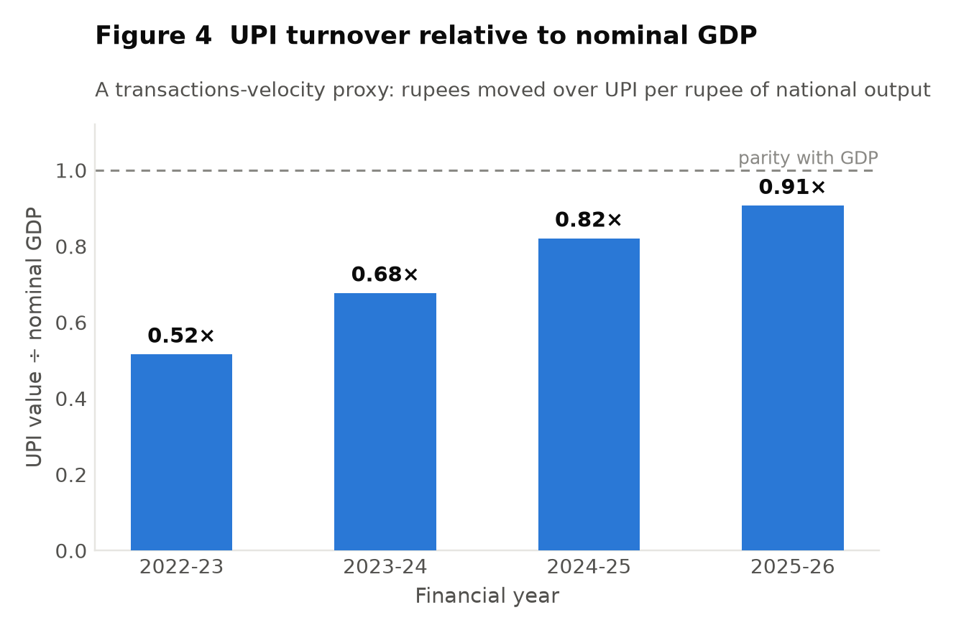
Figure 4. UPI turnover relative to nominal GDP, FY 2022-23 to FY 2025-26.
Explanation of the data
This data set constructs the closest approximation to a velocity measure that publicly available data permit. It expresses the total value settled over UPI in a year as a multiple of nominal GDP in the same year. The ratio rose from 0.52 in FY 2022-23 to 0.91 in FY 2025-26: by the most recent year, the value passing over UPI alone approached the entire annual output of the Indian economy.
Analysis
What this ratio does and does not measure must be stated exactly, since the risk of overstatement here is high.
It is a transactions-turnover ratio, not income velocity. The numerator counts every payment, including person-to-person transfers that are not purchases of output and intermediate payments that GDP counts only once at final sale. The denominator counts final output only. The two are not commensurable in the way the ratio’s simplicity suggests, and the number should not be read as "each rupee now circulates 0.91 times".
What the ratio does measure reliably is the rate of change. Whatever the mismatch between numerator and denominator, that mismatch is broadly consistent from year to year. The ratio therefore rose by roughly 75 per cent in three years, which means the value settled through this one retail instrument grew far faster than national output. Payment activity per unit of output has increased substantially, and this is exactly the direction the Cambridge formulation predicts: as the cost of transacting falls, the money balance held against a given volume of spending falls, and turnover rises.
Two cautions temper the finding. First, some of the rise reflects payments migrating from cash to UPI, which raises measured turnover without any change in underlying behaviour — cash transactions were never counted. Second, as Section 3.4.4 noted, a rise in velocity is favourable only when it arises from lower transaction costs rather than from a flight from money. In this case the mechanism is plainly the former: India experienced no monetary disorder during the period, and the rise coincides with the documented collapse in the cost and friction of paying.
Interpretation
Hypothesis H1 is supported, with the qualification that what has been demonstrated is a rise in measured transactions turnover rather than in income velocity, and that part of the rise reflects the migration of previously invisible cash payments into a measured system. Both effects are real and both matter, but they are not the same thing, and the available data cannot separate them. This is the honest limit of what a study based on published aggregates can establish.
In one sentence: The value settled over UPI rose from 0.52 to 0.91 times India’s GDP in three years — the level of that ratio is not meaningful, but its rapid rise is, and it points to a higher transactions velocity of money.

Data Set 5 · Digital payments around demonetisation

Indicator | Value
Value of specified bank notes demonetised (Nov 2016) | ₹15.4 trillion
Share of total value of notes in circulation | 86.9%
Share of demonetised notes returned to the RBI | approximately 98.96%
Monthly digital transactions, October 2016 | 71.27 crore
Monthly digital transactions, May 2017 | 111.45 crore
Increase over the period | 56%
Table 5. Sources: RBI, Macroeconomic Impact of Demonetisation [23]; PIB [24].
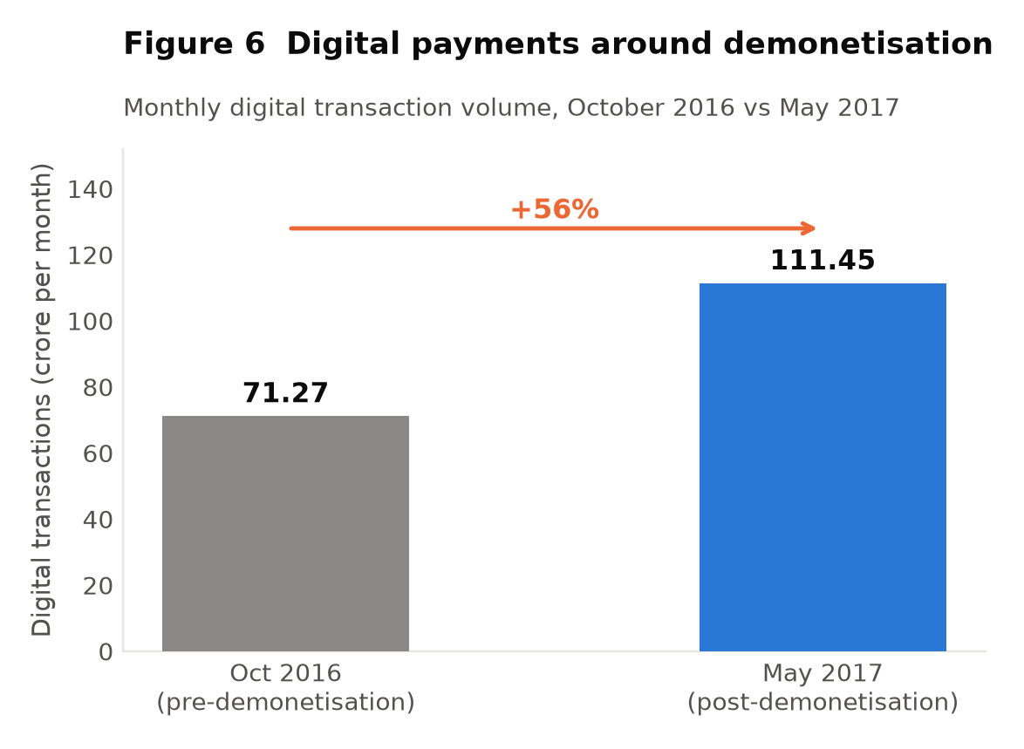
Figure 6. Monthly digital transaction volume before and after demonetisation.
Explanation of the data
On 9 November 2016 banknotes of ₹500 and ₹1,000 denominations, valued at ₹15.4 trillion and constituting 86.9 per cent of the value of notes then in circulation, ceased to be legal tender [23]. Monthly digital transactions rose from 71.27 crore in October 2016 to 111.45 crore by May 2017, an increase of 56 per cent [24].
Analysis
Demonetisation constitutes a natural experiment of unusual severity: the supply of the dominant payment medium was withdrawn almost overnight, and an alternative had been launched only weeks earlier. The 56 per cent increase in digital transactions over seven months is the immediate behavioural response.
The response must not be overstated. Approximately 98.96 per cent of the demonetised notes returned to the banking system [23], indicating that the currency was replaced rather than permanently displaced, and cash usage recovered substantially in the following years. Demonetisation did not by itself convert India into a digital economy.
What it did accomplish is better described as a forced trial. A large number of people who would not otherwise have installed a payment application did so under compulsion, and a large number of merchants who would not otherwise have accepted digital payment learned to. Some of that behaviour persisted after the compulsion was removed. The lasting effect was on familiarity and infrastructure rather than on the immediate composition of payments.
Interpretation
Demonetisation accelerated UPI’s adoption at a formative moment but did not cause its sustained growth, which continued long after cash supply had normalised and at rates far exceeding anything observed in 2016-17. The episode is better understood as having removed an adoption barrier — the effort of learning something new — than as having changed the underlying economics of paying.
In one sentence: Demonetisation produced a 56 per cent jump in digital payments, but about 99 per cent of the currency came back, so it accelerated UPI’s adoption without causing its sustained growth.

Data Set 6 · UPI growth before, during and after COVID-19

Financial year | Volume (crore) | Growth | Period
2019-20 | 1,252 | 134% | Pre-pandemic
2020-21 | 2,233 | 78% | Pandemic
2021-22 | 4,597 | 106% | Pandemic
2022-23 | 8,375 | 82% | Post-pandemic
2023-24 | 13,116 | 57% | Post-pandemic
Table 6. Volumes from [1], [2], [10], [13]. Growth rates computed by the author.
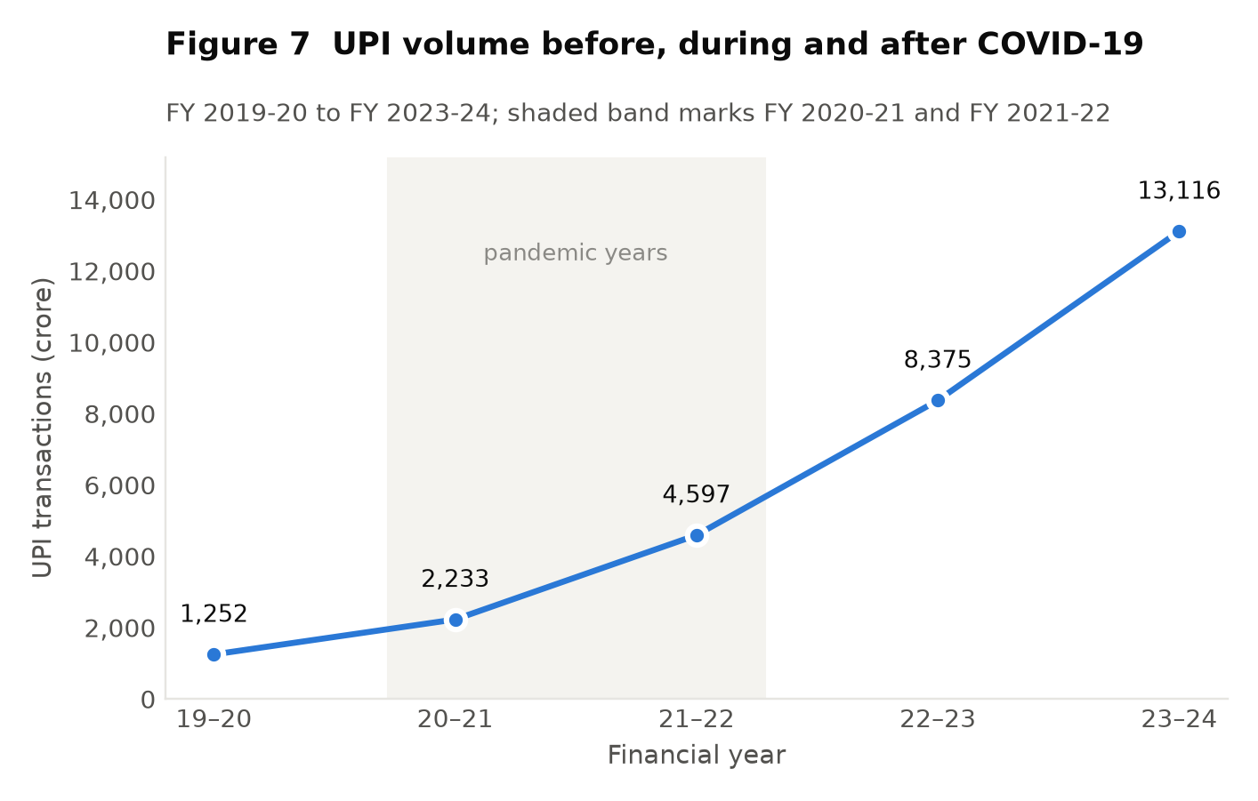
Figure 7. UPI transaction volume before, during and after the COVID-19 pandemic.
Explanation of the data
The table isolates the pandemic years. UPI volume grew 78 per cent in FY 2020-21, the year of the most severe restrictions, and then 106 per cent in FY 2021-22 — a rate higher than the year before it. Volume more than tripled between FY 2019-20 and FY 2021-22.
Analysis
The pattern is initially surprising. FY 2020-21 saw India’s real output contract, and one would expect a payment system to shrink with the economy it serves. UPI volume grew 78 per cent instead. Two forces account for this.
The first is substitution: with movement restricted and physical contact discouraged, payments that would have been made in cash were made digitally instead. This redistributes payments between media without increasing their number.
The second is adoption, and it is the more consequential. Merchants who had resisted digital acceptance adopted it because customers required it, and consumers who had avoided digital payment learned it because the alternative was unavailable. This expanded the addressable base permanently.
The evidence that adoption dominated substitution lies in what happened next. If the pandemic surge had been purely substitution, growth would have reversed once normal commerce resumed. Instead FY 2021-22 grew faster than FY 2020-21, and growth continued at 82 per cent and 57 per cent in the two following years, from a base many times larger. The change did not unwind.
Interpretation
COVID-19 functioned as a second and more durable forcing event than demonetisation. The contrast between the two episodes is instructive: demonetisation removed the alternative for a period of months and adoption partially reverted, while the pandemic lasted long enough for digital payment to become habitual. Habits, unlike compliance, survive the removal of the constraint that formed them.
In one sentence: UPI grew faster after the pandemic (106 per cent) than during its worst year (78 per cent), which shows the change had become a habit rather than reverting once cash was available again.

Data Set 7 · Financial inclusion, digitalisation and global standing

Indicator | Earlier | Later
RBI Financial Inclusion Index | 64.2 (Mar 2024) | 67.0 (Mar 2025)
RBI Digital Payments Index (Mar 2018 = 100) | 465.33 (Sep 2024) | 493.22 (Mar 2025)
PMJDY beneficiaries | — | 55.98 crore (Aug 2025)
Share of PMJDY accounts held by women | — | over 55%
UPI users onboarded | — | 55.49 crore (Jun 2026)
Merchants accepting UPI | — | approx. 6.5 crore (FY 2024-25)
QR codes deployed | — | 56.86 crore (FY 2024-25)
India’s share of global real-time payment volume | — | approx. 49% (2024)
Table 7. Sources: RBI and PIB releases [3], [6], [7], [14], [16]; IMF [18].
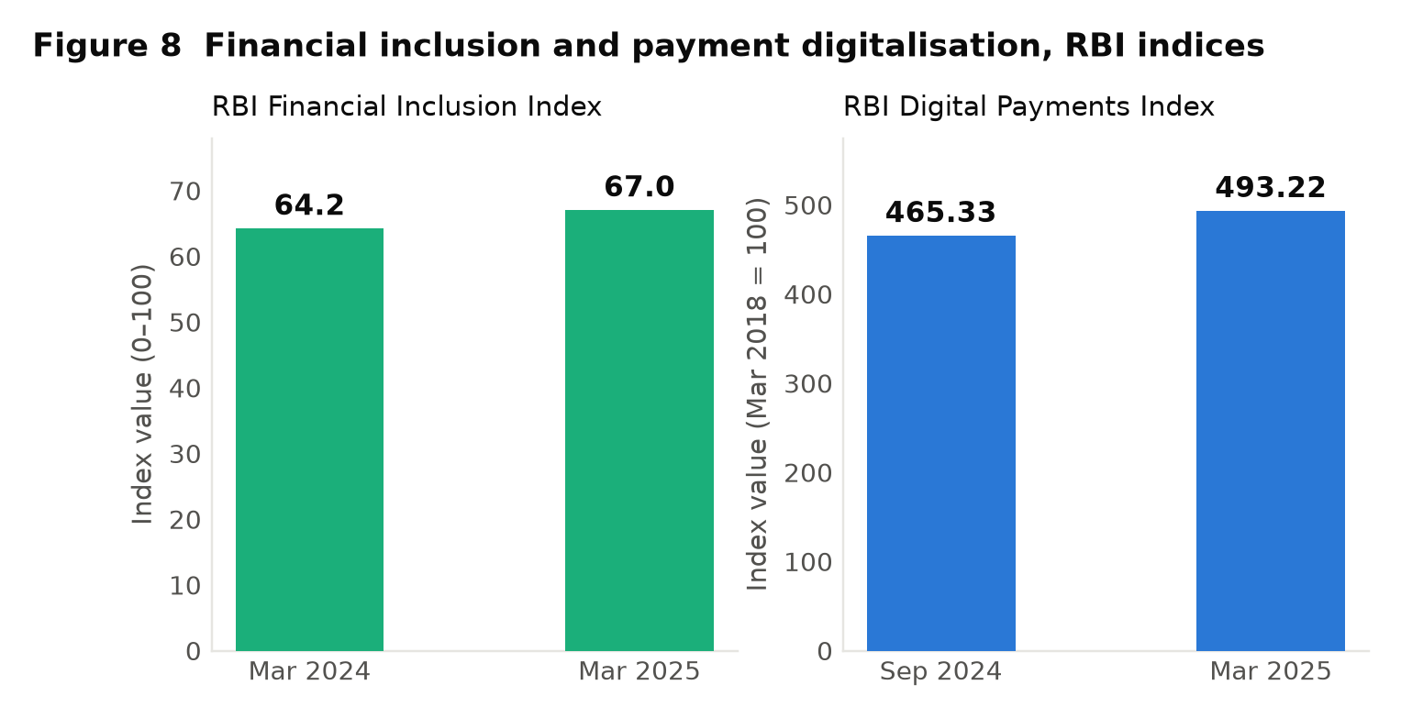
Figure 8. RBI Financial Inclusion Index and RBI Digital Payments Index.
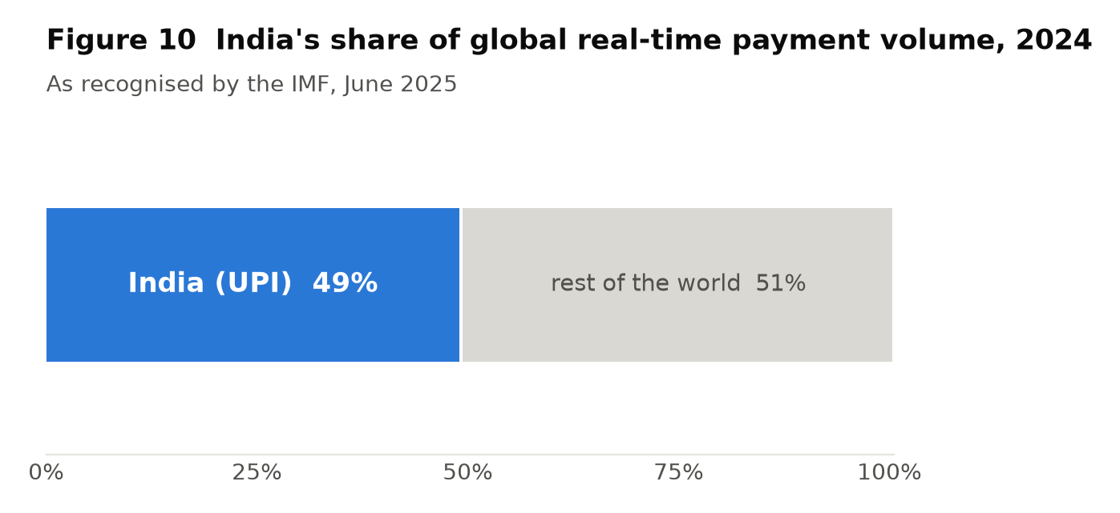
Figure 10. India’s share of global real-time payment volume, 2024.
Explanation of the data
This data set assembles the principal indicators of inclusion and digitalisation. Both RBI composite indices rose over their most recent measurement intervals, and the Financial Inclusion Index improved across all three of its sub-indices — access, usage and quality [7]. The final row records that India accounted for approximately 49 per cent of global real-time payment transaction volume in 2024 [3].
Analysis
The rise in the usage sub-index carries more weight than the headline number. Access had already been largely achieved through the Jan Dhan programme; the binding constraint was dormancy, and the World Bank records that the share of Indian women holding inactive accounts fell from a third in 2021 to 18 per cent by 2024 [21]. A payment rail that a small vendor will accept is what converts an account from a registration into an instrument.
The international comparison must be read with proportion in mind. India’s 49 per cent share of global real-time payment volume partly reflects population, and a share of volume is not a measure of quality. What makes it notable is the underlying policy difference identified by the BIS: most fast payment systems charge merchants, while India’s does not [20]. India has treated retail payment as a public utility, and the adoption curve is in part the consequence of that decision.
The gap between 55.98 crore Jan Dhan beneficiaries and 55.49 crore UPI users is worth a moment’s attention. These are different populations measured at different dates and cannot be netted against one another, but their similar magnitude indicates that account ownership and payment capability now reach comparable shares of the adult population.
Interpretation
The inclusion gains are real and measurable, and the causal chain from accounts through usage to formalisation is visible in the indices rather than merely asserted. India’s international position rests on a deliberate policy choice about pricing, not on scale alone.
In one sentence: The RBI’s Financial Inclusion Index rose from 64.2 to 67.0 with usage improving fastest — the sub-index that matters, because access had already been achieved and dormancy was the real problem.

Data Set 8 · Internet penetration and the rural–urban divide

Indicator | Urban | Rural
Internet subscribers, Aug 2025 (million) | 579.46 | 423.39
Internet subscribers per 100 people, Aug 2025 | 113.83 | 46.73
Tele-density, Dec 2025 | 148.92% | 59.63%
Telecom subscribers, Dec 2025 (million) | 762.44 | 543.70
Table 8. Source: TRAI telecom subscription data and performance indicator reports [22]. Total broadband subscribers stood at 999.81 million as at 31 October 2025, and total telecom subscribers at 1,306.14 million as at 31 December 2025, giving an overall tele-density of 91.74 per cent.
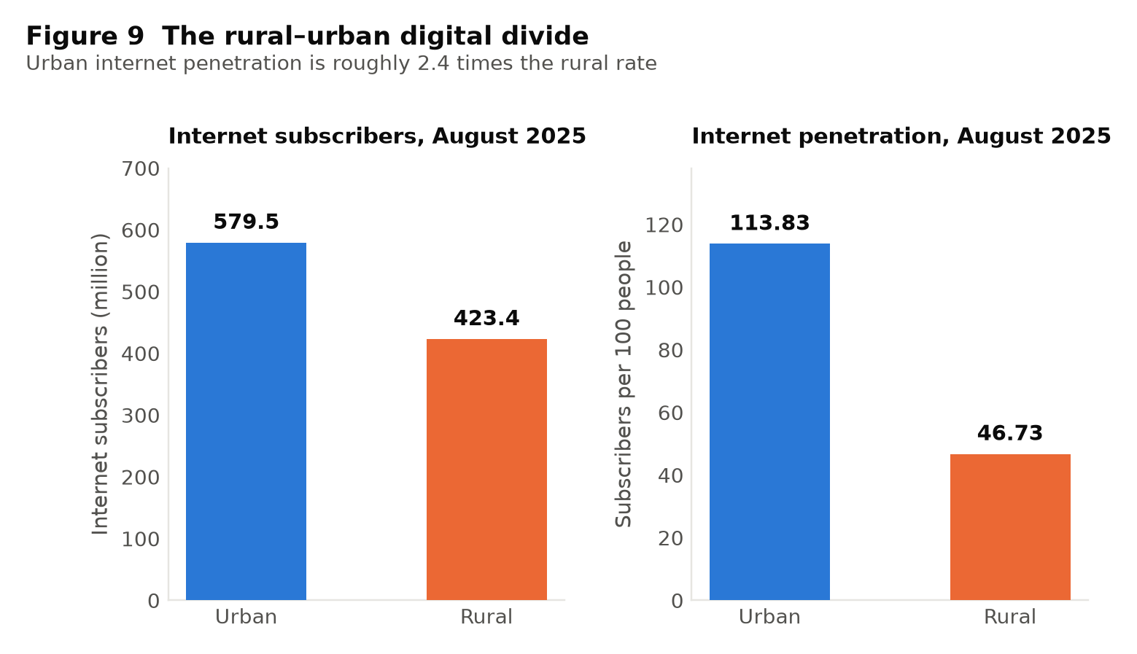
Figure 9. Internet subscribers and internet penetration, rural and urban India.
Explanation of the data
UPI requires a connected device, so internet penetration sets the ceiling on how inclusive it can be. India had 999.81 million broadband subscribers as at 31 October 2025 [22]. Urban internet penetration stood at 113.83 subscribers per 100 people against a rural figure of 46.73 — a ratio of roughly 2.4 to 1.
Analysis
The urban figure exceeds 100 per 100 people because the measure counts subscriptions rather than persons, and many urban users hold more than one. This is a reminder to read the rural number as an upper bound on the share of rural individuals connected: if some rural users hold multiple subscriptions, fewer than 46.73 per cent of rural people are actually online.
In absolute terms the gap is narrower than the penetration ratio implies — 579.46 million urban subscribers against 423.39 million rural — because rural India is more populous. The two panels of Figure 9 therefore tell complementary stories: rural India represents a large and growing absolute market, but a much smaller proportion of rural people are reached.
This constraint is a connectivity constraint rather than an acceptance constraint. The Payments Infrastructure Development Fund has deployed some 5.45 crore digital touch points in tier-3 to tier-6 centres [14], so the difficulty is not that rural merchants lack QR codes. It is that a substantial share of rural residents cannot reliably reach the network on which the codes depend.
Interpretation
Hypothesis H3 is supported. The benefits of UPI documented throughout this chapter accrue unequally, and the inequality is structural rather than behavioural: it follows the distribution of connectivity. Any policy intended to extend the gains of digital payment further into rural India must therefore address the telecommunications constraint, since payment-system measures alone cannot overcome it.
In one sentence: Rural internet penetration is 46.73 per 100 people against an urban 113.83, so what limits UPI’s reach in rural India is connectivity, not merchant acceptance.

4. Findings and Suggestions

4.1 Findings
Seven findings emerge from the analysis in Chapter 3. Each is stated with the evidence that supports it and with the qualification that evidence requires.
Finding 1. UPI has become the default retail payment mechanism of the Indian economy.
Volume rose from 2 crore transactions in FY 2016-17 to 24,162 crore in FY 2025-26, and UPI accounted for 81 per cent of retail digital payment transactions in FY 2024-25 [2], [14]. Growth occurred in every year of the period, and the absolute annual increment continues to rise even as percentage growth moderates.
Finding 2. The growth is composed of small payments, and increasingly so.
The average value of a UPI transaction fell from ₹1,838 in FY 2020-21 to ₹1,300 in FY 2025-26, a decline of roughly 29 per cent, while volume rose more than ten-fold over the same years (Data Set 2). Person-to-merchant transactions now form 63 per cent of volume, of which 86 per cent are below ₹500 [2]. Since prices rose over the period, the shift towards small payments is larger in real terms than the nominal figures show.
Finding 3. Measured transactions turnover per rupee of output has risen substantially.
UPI value as a multiple of nominal GDP rose from 0.52 in FY 2022-23 to 0.91 in FY 2025-26 (Data Set 4). This is consistent with the Cambridge prediction that a fall in the cost of transacting reduces the money balance held against a given volume of spending. It is a transactions measure, not income velocity, and part of the rise reflects the migration of previously unmeasured cash payments into a measured system. The available data cannot separate the two components.
Finding 4. Both external shocks accelerated adoption, but only one produced a durable change.
Digital transactions rose 56 per cent in the seven months after demonetisation [24], but approximately 98.96 per cent of the demonetised currency returned to the banking system [23] and cash usage substantially recovered. The pandemic produced 78 per cent growth in FY 2020-21 followed by 106 per cent in FY 2021-22 — faster after the shock than during it — and growth continued at 82 and 57 per cent in the two subsequent years (Data Set 6). The distinguishing factor appears to be duration: the pandemic lasted long enough for digital payment to become habitual.
Finding 5. UPI has contributed to measurable gains in financial inclusion.
The RBI Financial Inclusion Index rose from 64.2 to 67.0 between March 2024 and March 2025 with improvement across access, usage and quality [7]. The usage gain matters most, since access had already been largely achieved: the share of Indian women holding inactive accounts fell from a third in 2021 to 18 per cent by 2024 [21].
Finding 6. There is credible evidence of an effect on real activity, though it is not conclusive.
Of small merchants surveyed for the Department of Financial Services, 94 per cent had adopted UPI and 57 per cent reported an increase in sales following adoption [15]. This is self-reported and cannot be audited, and a merchant may attribute to a payment method a gain with other causes. It nonetheless constitutes the most direct available evidence that the effect reaches output and not merely the composition of payments. Cross-country work supports the direction: the BIS finds that fast payment system launches stimulate digital finance adoption, most strongly in lower-income economies [20].
Finding 7. The gains are unequally distributed, and two significant risks accompany them.
Rural internet penetration was 46.73 subscribers per 100 people against an urban 113.83 in August 2025 [22], which caps how inclusive a network-dependent payment system can be. Cybersecurity incidents rose from 10.29 lakh in 2022 to 22.68 lakh in 2024 [28]. And roughly 75 per cent of users in one survey reported spending more because digital money felt less tangible [25] — the same frictionlessness that raises velocity also removes a restraint that cash imposed incidentally.

4.2 Suggestions
Six suggestions follow from the findings. They are directed at the constraints the evidence actually identifies rather than at general aspirations.
- Treat rural connectivity as payments policy. Data Set 8 shows the binding constraint on rural digital payment is network access, not merchant acceptance: 5.45 crore touch points have been deployed in tier-3 to tier-6 centres [14], yet fewer than half of rural residents are connected. Extending broadband is therefore a more effective payments intervention at the margin than further acceptance subsidy.
- Invest in fraud awareness at the scale of the system itself. UPI’s technical defences — device binding, two-factor authentication, machine-learning transaction monitoring [28] — are strong; the exploited vulnerability is the user’s judgement. Awareness campaigns should be treated as core infrastructure and delivered in regional languages through the payment applications themselves, at the point of transaction.
- Build spending-awareness features into payment applications. Given the finding that a large majority of surveyed users report spending more because digital money feels less tangible [25], applications could offer opt-in periodic spending summaries and self-imposed limits. This addresses a documented behavioural cost without restricting anyone’s choices.
- Publish disaggregated payment statistics. The most significant analytical limitation encountered in this project was the absence of state- and district-level UPI data, which made it impossible to examine regional variation. Releasing anonymised, disaggregated statistics would enable research that national aggregates cannot support.
- Reduce single points of failure. As cash is displaced, an outage ceases to be an inconvenience and becomes an interruption of commerce. Offline and feature-phone payment modes deserve continued investment specifically as resilience measures, not merely as inclusion measures.
- Evaluate the incentive framework openly. Zero-cost payment is financed by the exchequer rather than by merchants [14], [15]. Whether the gains in formalisation, inclusion and tax visibility exceed that outlay is an empirical question that deserves periodic public evaluation, since the answer determines whether the current pricing model is sustainable.

5. Conclusion
This project set out to ask whether the growth of UPI has changed the speed at which money circulates in the Indian economy, and whether any effect on real economic activity can be identified from published data. The two questions deserve separate answers.
On circulation, the evidence is strong. The value settled over UPI rose from roughly half of nominal GDP in FY 2022-23 to approximately nine-tenths of it in FY 2025-26, and the number of transactions rose thirteen-fold over the decade while the average transaction shrank by nearly a third. Read through Fisher’s identity, this is a large increase in the number of transactions supported by a given money stock; read through the Cambridge formulation, it is a fall in the balance people need to hold against their spending. Both readings describe a rise in the transactions velocity of money. The qualification, stated plainly in Data Set 4 and repeated here, is that some part of the measured increase is the migration of cash payments — real, but previously invisible — into a system that counts them.
On economic activity the evidence is suggestive rather than conclusive, and this project declines to claim more. That 57 per cent of small merchants report higher sales after adopting digital payment [15] is the most direct indication available that the effect reaches output. That the BIS finds fast payment systems stimulate digital finance adoption most strongly in lower-income economies [20], and that the IMF finds faster growth in districts where interoperability delivered the largest gain [18], both point the same way. None of this isolates UPI’s independent causal contribution from the simultaneous expansion of smartphones, internet access, bank accounts and nominal incomes over the same decade. A study based on published aggregates cannot perform that separation, and it would be dishonest to pretend otherwise.
What can be said without qualification is that UPI has transformed payment behaviour. It has done so by solving a problem that cards and wallets could not: making the very small payment worth making. The decline in average transaction size from ₹1,838 to ₹1,300, occurring alongside a ten-fold rise in volume and in the face of inflation, is the signature of a system reaching transactions it did not previously serve. The tea, the vegetables, the auto fare — these are the payments UPI added, and they are the reason the aggregate numbers are what they are.
The efficiency case is therefore genuine. Money that need not be withdrawn, carried and re-deposited is money available for use; a merchant paid instantly restocks sooner; a transaction that leaves a record can become the basis of credit. These are real gains and they are consistent with everything in Chapter 3.
Two problems remain unresolved and neither is incidental. The first is unequal access: with rural internet penetration at less than half the urban rate, a payment system that requires connectivity cannot be more inclusive than the network beneath it, and the people least reached are those for whom inclusion would matter most. The second is security, where the growth in cyber incidents tracks the growth of the system and the weak point is the user rather than the technology.
A closing observation seems warranted. India built this system as public infrastructure and chose to make it free at the point of use, financing the cost from the exchequer rather than from merchants. Almost every comparable system abroad made the opposite choice. The adoption documented in this report is, in significant part, the consequence of that decision — which suggests that the most important thing about UPI may not be its technology at all, but the view of payment as a public good that the technology was built to serve.

Glossary of Key Terms
Every technical term used in this report is defined below, in the sense in which the report uses it. Terms are listed alphabetically.

Term | Meaning as used in this report
Average ticket size | The average value of a single transaction, obtained by dividing total transaction value by total transaction volume. Derived by the author in Table 2; not published by any source.
Base year revision | A periodic updating of the reference year used to compute national income. India moved from a 2011-12 base to a 2022-23 base during the study period, so GDP figures either side of the change are not perfectly comparable.
CAGR | Compound Annual Growth Rate — the constant yearly rate at which a quantity would have to grow to move from its starting value to its ending value over the period.
Cambridge cash-balance approach | The formulation M = k × P × Y, which views money demand as the fraction of income people choose to hold as money. Velocity is the reciprocal of that fraction, so V = 1 ÷ k.
Currency in Circulation (CIC) | The total value of banknotes and coins in the hands of the public and in bank tills. India’s CIC-to-GDP ratio is high by international standards, and reducing it is a stated aim of RBI policy.
Demonetisation | The withdrawal of legal tender status from ₹500 and ₹1,000 banknotes on 9 November 2016, affecting ₹15.4 trillion, or 86.9 per cent of the value of notes then in circulation.
Digital public infrastructure | Open, interoperable digital systems that support society-wide public and private services. The Bank for International Settlements treats fast payment systems such as UPI as the archetype.
Equation of exchange | Fisher’s identity M × V = P × T, relating the money stock and its velocity to the price level and the volume of transactions. It is true by construction rather than by assumption.
Fast payment system | A retail payment system settling in or near real time, available continuously. UPI is the largest such system in the world by transaction volume.
Financial inclusion | Access to useful and affordable financial services. Measured in India by the RBI’s Financial Inclusion Index across three sub-indices: access, usage and quality.
Formalisation | The movement of economic activity from the unrecorded to the recorded economy. A digital payment leaves a record; records accumulate into a credit history.
Income velocity | The number of times a unit of money is used to buy newly produced output, computed as nominal national income divided by the money stock. The conservative measure of velocity, and the one that moves slowly.
Interoperability | The property that a user of one application or bank can transact with a user of any other. This is the design feature the IMF identifies as the source of UPI’s adoption.
k (cash-balance ratio) | The fraction of nominal income that people choose to hold as money. A fall in k is arithmetically the same statement as a rise in velocity.
Merchant Discount Rate (MDR) | The fee a merchant pays on each digital transaction. It is zero for UPI transactions up to ₹2,000 for small merchants, with the Government paying an incentive of 0.15 per cent of transaction value in its place.
Natural experiment | A real-world event that changes conditions sharply and without the researcher’s intervention, allowing before-and-after comparison. Demonetisation is treated as one in Data Set 5.
Nominal GDP | The value of national output measured at current prices, so it rises with both output and inflation. Used as the denominator in Table 4.
NPCI | The National Payments Corporation of India — the not-for-profit umbrella organisation that built and operates UPI, sets its standards and settles positions between member banks.
P2M and P2P | Person-to-merchant and person-to-person transactions. P2M now forms 63 per cent of UPI volume, and 86 per cent of P2M payments are below ₹500.
PIDF | The Payments Infrastructure Development Fund, which subsidises the deployment of acceptance infrastructure — QR codes and terminals — in tier-3 to tier-6 centres.
RBI Digital Payments Index | A composite RBI index measuring the extent of payment digitalisation, with March 2018 set equal to 100. It stood at 493.22 in March 2025.
Real-time settlement | Settlement of a payment within seconds of it being initiated, as against batch processing at fixed intervals.
Secondary data | Data collected and published by someone other than the researcher. This entire study rests on secondary data, which is stated as its first limitation.
Structural break | A point at which the statistical relationship between variables changes, usually because of a shock or a policy change. COVID-19 is identified as one in the literature reviewed in Section 3.6.
Transactions velocity | The number of times a unit of money is used in any payment, including transfers that are not purchases of output. Payment systems act on this measure directly, and it can move much faster than income velocity.
UPI | The Unified Payments Interface — a common standard, launched in 2016, allowing any bank account to be addressed by any application through a single virtual payment address.
Velocity of money | The average number of times one unit of currency is used to purchase goods and services in a given period. A behavioural property, not a physical one.
Virtual Payment Address | A short identifier that stands in for a bank account number and branch code when making a UPI payment.
A note on one ambiguity: the abbreviation DPI is used in two senses in the payments literature — "digital public infrastructure" and the RBI’s "Digital Payments Index". This report spells both out in full wherever they appear.

Bibliography
Entries are numbered as cited in the text. All sources were consulted online and were available at the addresses shown at the time of writing.
[1] National Payments Corporation of India. UPI Product Statistics. https://www.npci.org.in/what-we-do/upi/product-statistics
[2] Press Information Bureau, Government of India. "UPI completes 10 glorious years, Emerges as World’s Largest Real-Time Payments Platform, Anchoring India’s Digital Economy." https://www.pib.gov.in/PressReleasePage.aspx?PRID=2257087
[3] Press Information Bureau, Government of India. "UPI Recognized as World’s Largest Real-Time Payment System by IMF; Accounts for 49% of Global Transactions." https://www.pib.gov.in/PressReleasePage.aspx?PRID=2200569
[4] Reserve Bank of India. Annual Report 2024-25, Chapter on Payment and Settlement Systems. https://www.rbi.org.in/Scripts/AnnualReportMainDisplay.aspx
[5] Reserve Bank of India. Payment Systems Report, Half Year ended December 2024. https://www.rbi.org.in/scripts/PublicationsView.aspx?Id=23127
[6] Reserve Bank of India. Press releases on the RBI Digital Payments Index (RBI-DPI). https://www.rbi.org.in/Scripts/BS_PressReleaseDisplay.aspx?prid=60913
[7] Press Information Bureau, Government of India. "RBI’s Financial Inclusion Index rises to 67 in 2025." https://www.pib.gov.in/PressNoteDetails.aspx?NoteId=154980&ModuleId=3
[8] Ministry of Statistics and Programme Implementation. Press Note on Provisional Estimates of Annual GDP for 2024-25. https://www.mospi.gov.in/sites/default/files/press_release/NAD_PR_30may2025.pdf
[9] Ministry of Statistics and Programme Implementation. Press Note on Provisional Estimates of Annual GDP for 2025-26. https://www.pib.gov.in/PressReleasePage.aspx?PRID=2269286
[10] Press Information Bureau, Government of India. "Total digital payment transactions volume increases from 2,071 crore in FY 2017-18 to 13,462 crore in FY 2022-23 at a CAGR of 45 per cent." https://www.pib.gov.in/PressReleasePage.aspx?PRID=1988370
[11] Press Information Bureau, Government of India. "Total digital payment transactions grow by 46% from 8,839 crore in FY 2021-22 to 18,737 crore in FY 2023-24." https://www.pib.gov.in/PressReleasePage.aspx?PRID=2110407
[12] Press Information Bureau, Government of India. "Indian digital payment landscape witnesses over 65,000 crore digital transactions amounting to more than ₹12,000 lakh crore in last 6 Financial years." https://www.pib.gov.in/PressReleasePage.aspx?PRID=2149372
[13] Press Information Bureau, Government of India. "UPI transactions grew from ₹1 lakh crore in FY 2017-18 to ₹139 lakh crore in FY 2022-23 in value, at a CAGR of 168%." https://www.pib.gov.in/PressReleasePage.aspx?PRID=1987764
[14] Press Information Bureau, Government of India. "Coordinated Efforts of Government, RBI and NPCI Accelerate Growth in Digital Payments." https://www.pib.gov.in/PressReleasePage.aspx?PRID=2240723
[15] Department of Financial Services, Ministry of Finance. "Socio-Economic Impact Analysis of Incentive Scheme for Promotion of RuPay Debit Card and low-value BHIM-UPI Transactions (P2M)", released at Chintan Shivir 2026. https://www.pib.gov.in/PressReleasePage.aspx?PRID=2228651
[16] Press Information Bureau, Government of India. "Nearly 55.49 Crore Users Onboarded on UPI as in June 2026." https://www.pib.gov.in/PressReleasePage.aspx?PRID=2286608
[17] Press Information Bureau, Government of India. "UPI is now live in over eight countries." https://www.pib.gov.in/PressReleasePage.aspx?PRID=2224505
[18] International Monetary Fund. Growing Retail Digital Payments: The Value of Interoperability. FinTech Note 2025/004, June 2025. https://www.imf.org/en/publications/fintech-notes/issues/2025/06/25/growing-retail-digital-payments-the-value-of-interoperability-567814
[19] International Monetary Fund. "India’s Frictionless Payments." Finance & Development, September 2025. https://www.imf.org/en/publications/fandd/issues/2025/09/indias-frictionless-payments-maria-peria
[20] Bank for International Settlements. Retail fast payment systems as a catalyst for digital finance. BIS Working Paper No. 1228, November 2024. https://www.bis.org/publ/work1228.htm
[21] World Bank. The Global Findex Database 2025: Connectivity and Financial Inclusion in the Digital Economy. https://www.worldbank.org/en/publication/globalfindex
[22] Telecom Regulatory Authority of India. Telecom Subscription Data and Indian Telecom Services Performance Indicator Reports, 2025. https://www.trai.gov.in/release-publication/reports/telecom-subscriptions-reports
[23] Reserve Bank of India. Macroeconomic Impact of Demonetisation — A Preliminary Assessment, 2017. https://rbidocs.rbi.org.in/rdocs/Publications/PDFs/MID10031760E85BDAFEFD497193995BB1B6DBE602.PDF
[24] Press Information Bureau, Government of India. "Status of the Return of SBNs — Reserve Bank of India Annual Report 2016-17." https://www.pib.gov.in/newsite/PrintRelease.aspx?relid=170379
[25] Dev, H., Gupta, R., Dharmavaram, S. and Kumar, D. "From Cash to Cashless: UPI’s Impact on Spending Behavior Among Indian Users and Prototyping Financially Responsible Interfaces." ACM CHI 2024 Late Breaking Work; arXiv:2401.09937. https://arxiv.org/abs/2401.09937
[26] Reserve Bank of India. Payments Vision 2025. https://rbidocs.rbi.org.in/rdocs/PublicationReport/Pdfs/PAYMENTSVISION2025844D11300C884DC4ACB8E56B7348F4D4.PDF
[27] Reserve Bank of India. National Strategy for Financial Inclusion 2025-30. https://www.rbi.org.in/commonman/Upload/English/Content/PDFs/English12052026.pdf
[28] Press Information Bureau, Government of India. "Curbing Cyber Frauds in Digital India." https://www.pib.gov.in/PressNoteDetails.aspx?NoteId=155384&ModuleId=3
[29] Badrawani, W. et al. "The Role of Digital Payments in Driving Regional Economic Growth: A Panel Data Analysis with Structural Break." arXiv:2508.02119, August 2025. https://arxiv.org/abs/2508.02119
[30] Ministry of Finance, Government of India. Economic Survey 2025-26, Statistical Appendix. https://www.indiabudget.gov.in/economicsurvey/

