AUTHOR: RASHPINDER KAUR CHAHAL
PROJECT SAS



Objective
The wireless company would like to investigate the customer distribution and
business behaviours, and then gain insightful understanding about the customers, and to
forecast the deactivation trends for the next 6 months.

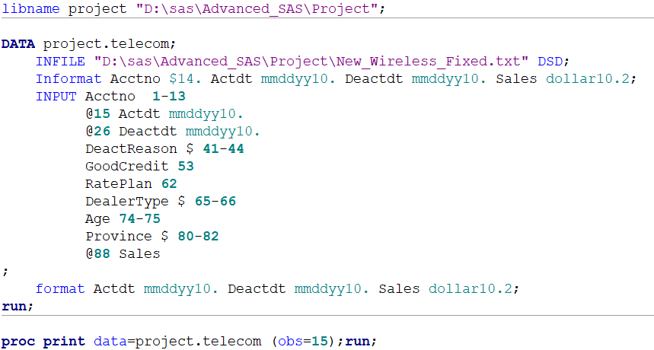

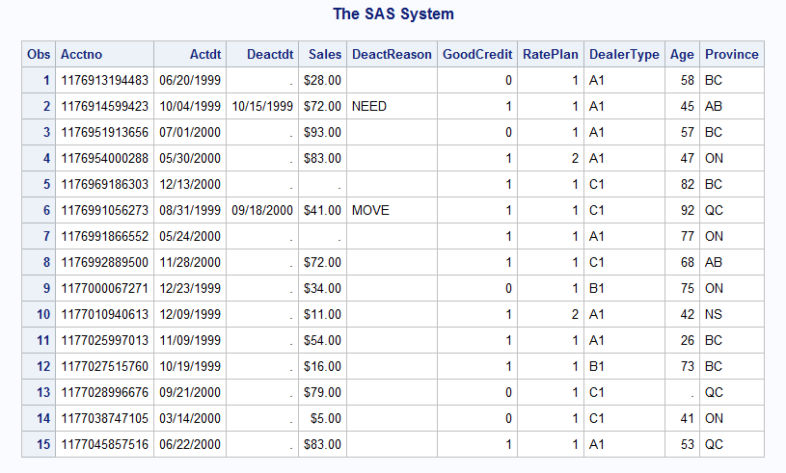
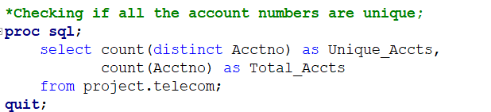

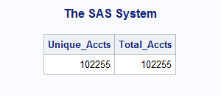
On observation, no of total accounts and unique accounts are same which means Acctno is unique for each row that means account numbers can be primary key for our dataset.

1.1 Explore and describe the dataset briefly. For example, is the acctno unique? What is the number of accounts activated and deactivated? When are the earliest and latest activation/deactivation dates available? And so on….

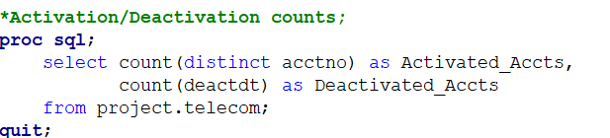

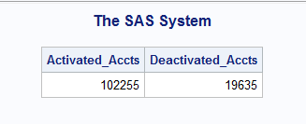
Number of Active accounts are equal to total number of accounts and number of deactivated accounts are 19635.
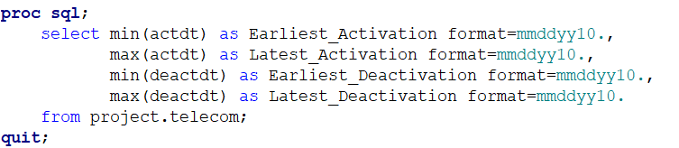
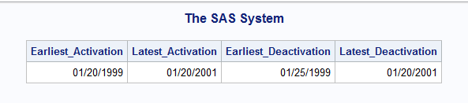

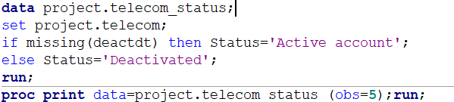
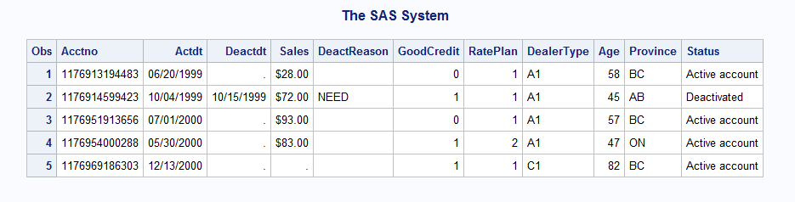

1.2 What are the age and province distributions of active and deactivated customers?
And is there any association between Age and activation, how about between Province and activation.

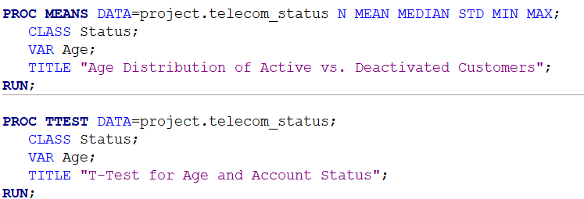

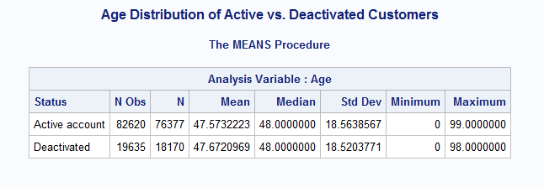
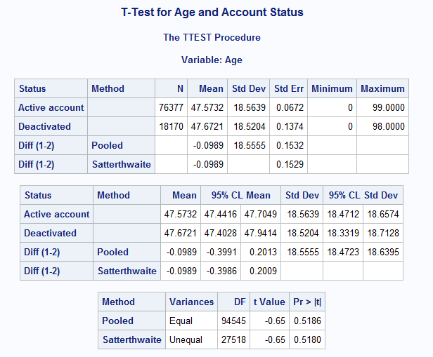
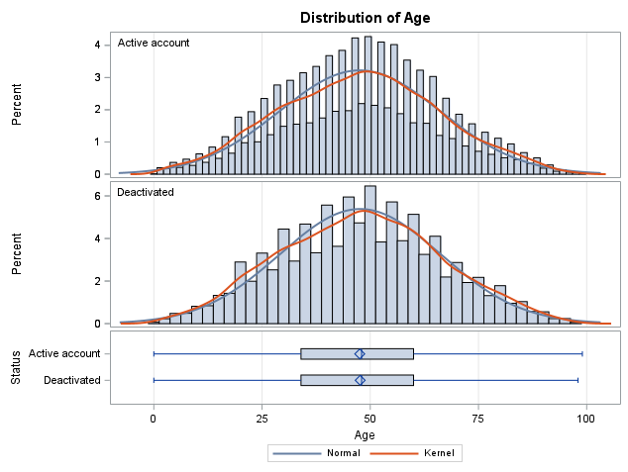
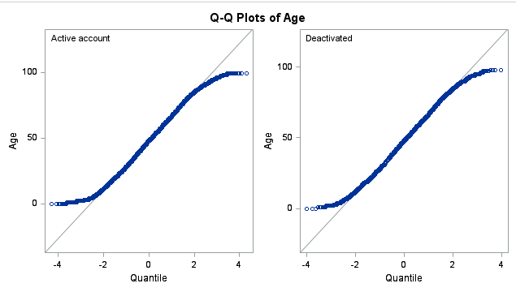
There is no significant difference in the age distribution between active and deactivated customers.
The variances of age are similar for both groups.
Age does not seem to be a strong factor in account deactivation.

Since p > 0.05, the difference in age is not statistically significant.
Age does not appear to be significantly different between active and deactivated customers.
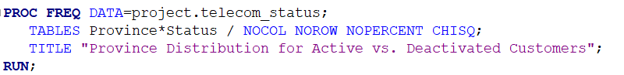
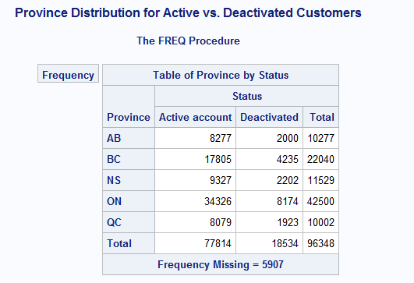
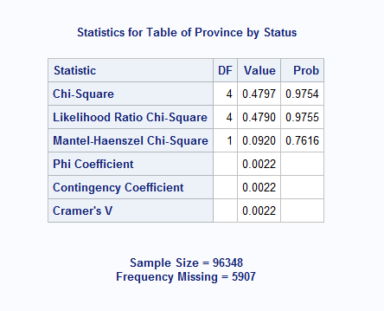

Since p > 0.05 in all tests, Province and Account Status are NOT significantly associated.
This means the province a customer is from does not impact whether their account is
active or deactivated.
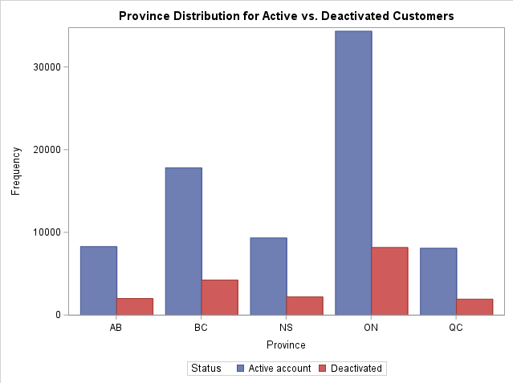

1.3 Customer Segmentation: Segment customers into defined groups for age and sales.
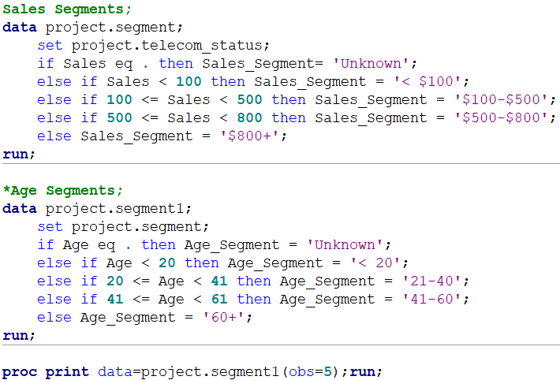

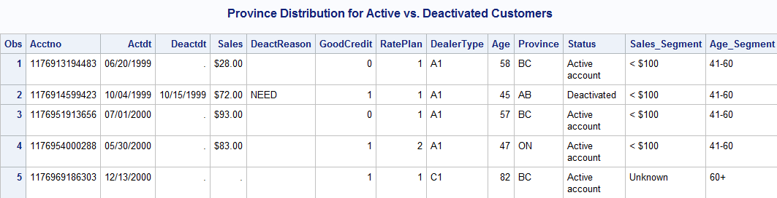

1.4 Statistical Analysis: Tenure Calculation and stats
Date used here is 20 January 2001 because the earliest activation is January 20, 1999 and
the analysis dataset is for two years so the maximum limit of the date will range upto two
years from the earliest activated date.
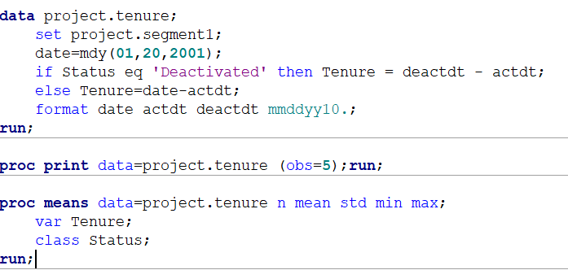
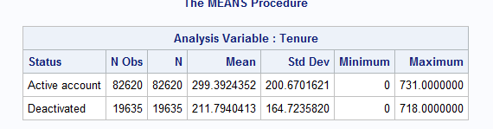

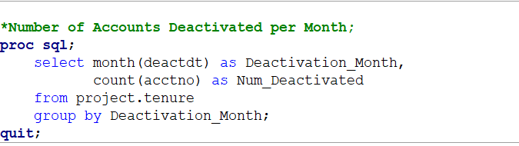

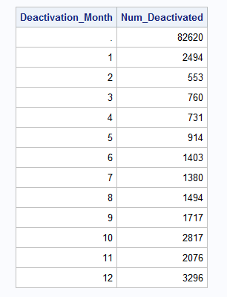
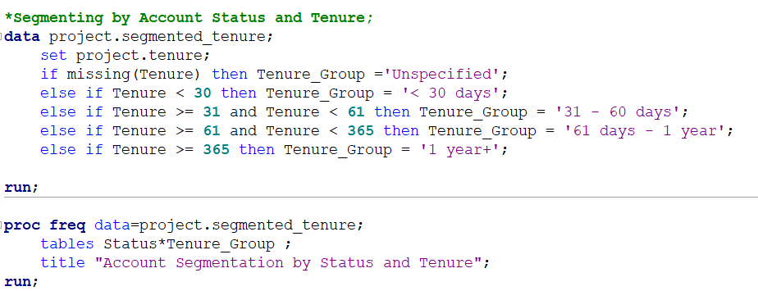

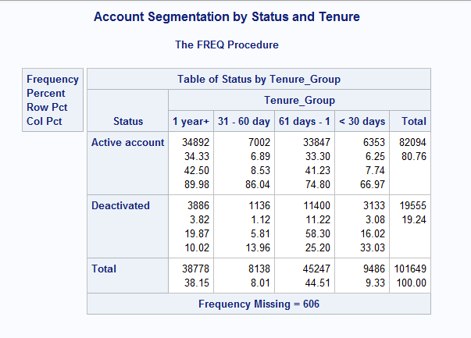

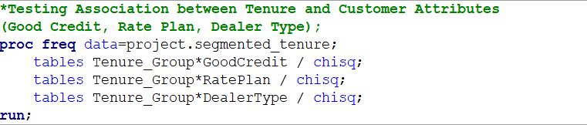

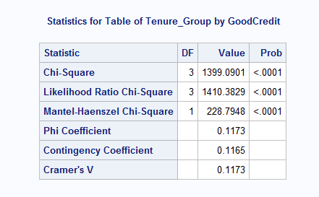
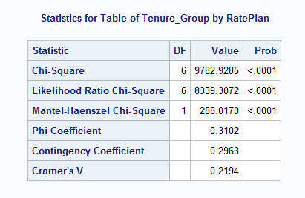
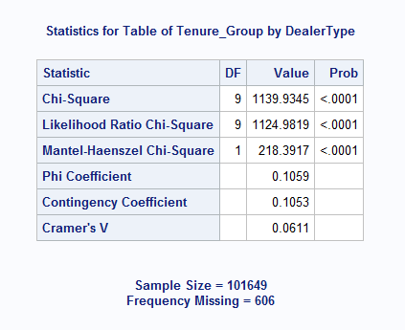

Reject the Null Hypothesis (H₀) – There is a significant association between the categorical variables in all of the above cases, p-values less than 0.005, so we reject null hypothesis and accept that there is significant association between:
Tenure_Group and GoodCredit
Tenure_Group and RatePlan
Tenure_Group and DealerType

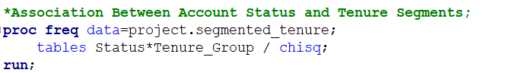
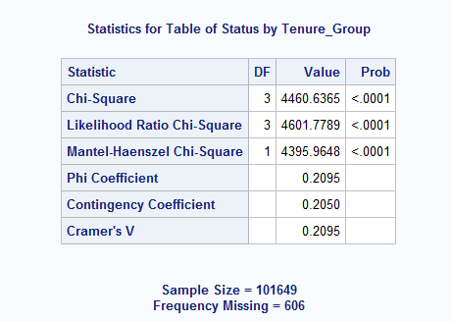

Conclusion:
- Chi-Square Value (χ²) = 4460.6365
- This is a very high chi-square value, suggesting a strong association between account status and tenure group.
- p-value < 0.0001
- Since p < 0.05, the null hypothesis (H₀) is rejected.
- This means account status is significantly associated with tenure group.
- There is a significant and moderate relationship between tenure and account status.
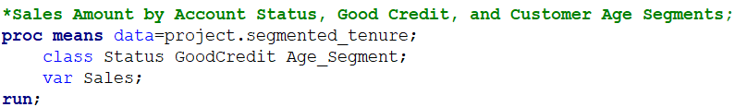
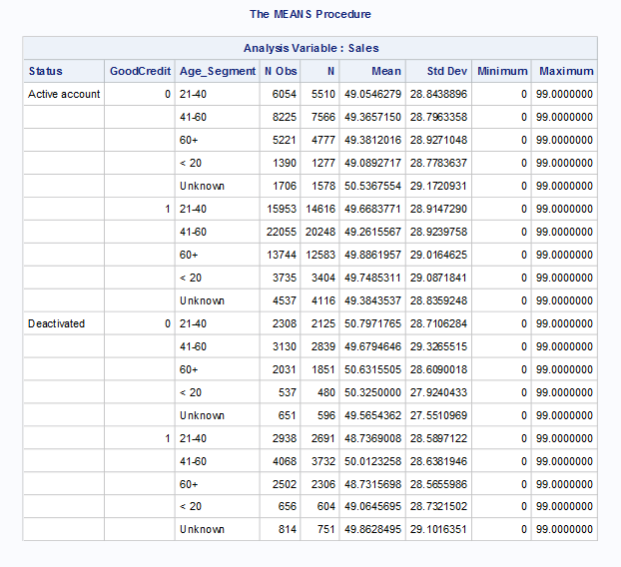

Bivariate Analysis
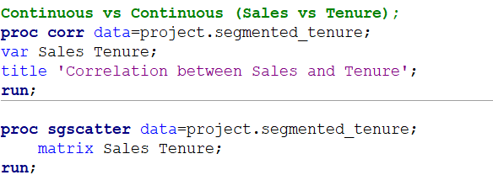
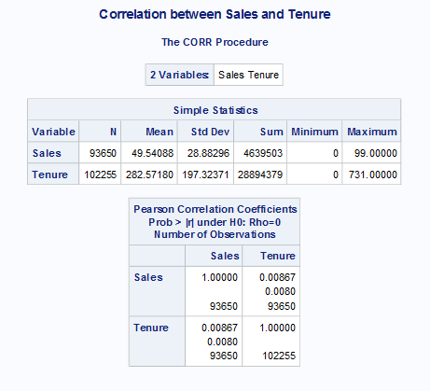
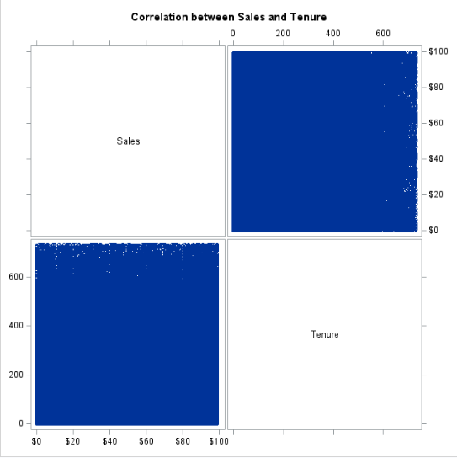
- The correlation coefficient (0.00867) is very close to zero.
- The p-value (0.0080) is below 0.05, meaning the result is statistically significant, reject null hypothesis, there is relationship between Sales and Tenure.

