

NAME: KEERTHANA R
ROLL NO-411625104031
SUB- DBMS
DEP-B.E (COMPUTER SCIENCE)
BATCH-3

SQL(QUERY)

ER DIAGRAM
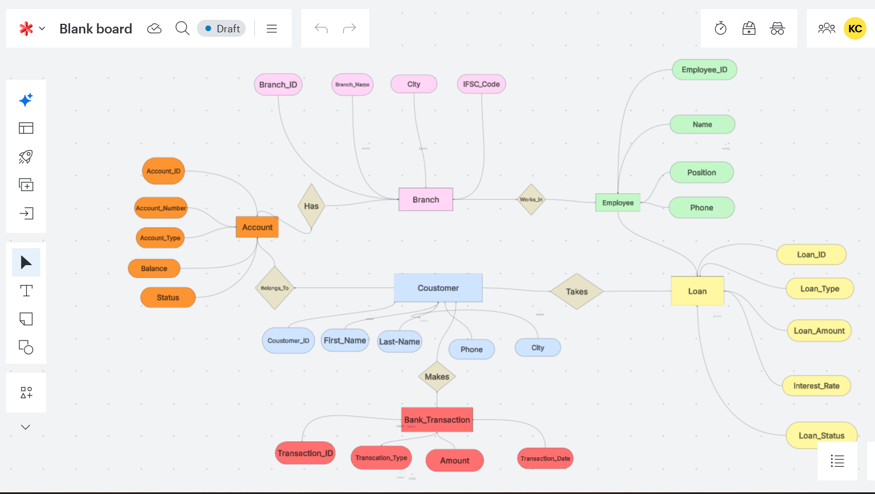

1-CREATE DATABASE Keerthu_BankVault_DB;
USE Keerthu_BankVault_DB;
2-CREATE TABLE Branch (
Branch_ID INT PRIMARY KEY AUTO_INCREMENT,
Branch_Name VARCHAR(50) NOT NULL,
City VARCHAR(40) NOT NULL,
IFSC_Code VARCHAR(20) UNIQUE NOT NULL,
Contact_Number VARCHAR(15) UNIQUE
);
3-CREATE TABLE Customer (
Customer_ID INT PRIMARY KEY AUTO_INCREMENT,
First_Name VARCHAR(30) NOT NULL,
Last_Name VARCHAR(30) NOT NULL,
Gender VARCHAR(10),
DOB DATE NOT NULL,
Phone VARCHAR(15) UNIQUE NOT NULL,
Email VARCHAR(60) UNIQUE NOT NULL,
Address VARCHAR(100),
City VARCHAR(40),
Created_On DATE DEFAULT (CURRENT_DATE)
);
4-CREATE TABLE Account (
Account_ID INT PRIMARY KEY AUTO_INCREMENT,
Customer_ID INT NOT NULL,
Branch_ID INT NOT NULL,

Account_Number BIGINT UNIQUE NOT NULL,

Account_Type VARCHAR(20)
CHECK(Account_Type IN ('Savings','Current')),

Balance DECIMAL(12,2)
CHECK(Balance>=0),

Open_Date DATE DEFAULT (CURRENT_DATE),

Status VARCHAR(20) DEFAULT 'Active'
CHECK(Status IN ('Active','Inactive')),

FOREIGN KEY(Customer_ID)
REFERENCES Customer(Customer_ID),

FOREIGN KEY(Branch_ID)
REFERENCES Branch(Branch_ID)
);
5-CREATE TABLE Employee (
Employee_ID INT PRIMARY KEY AUTO_INCREMENT,
Branch_ID INT NOT NULL,

Employee_Name VARCHAR(50) NOT NULL,

Position VARCHAR(30),

Salary DECIMAL(10,2)
CHECK(Salary>=10000),

Phone VARCHAR(15) UNIQUE,

Hire_Date DATE,

FOREIGN KEY (Branch_ID)
REFERENCES Branch(Branch_ID)
);
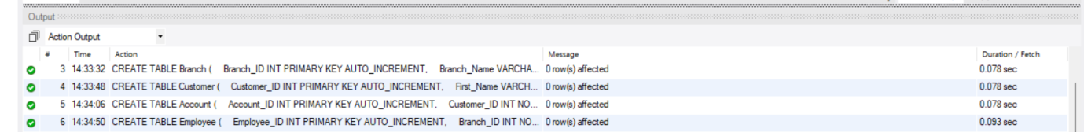

6-CREATE TABLE Loan (
Loan_ID INT PRIMARY KEY AUTO_INCREMENT,

Customer_ID INT NOT NULL,

Loan_Type VARCHAR(30)
CHECK(Loan_Type IN
('Home','Education','Vehicle','Personal')),

Loan_Amount DECIMAL(12,2)
CHECK(Loan_Amount>0),

Interest_Rate DECIMAL(4,2)
CHECK(Interest_Rate BETWEEN 5 AND 20),

Loan_Status VARCHAR(20) DEFAULT 'Pending'
CHECK(Loan_Status IN
('Pending','Approved','Closed')),

FOREIGN KEY(Customer_ID)
REFERENCES Customer(Customer_ID)
);
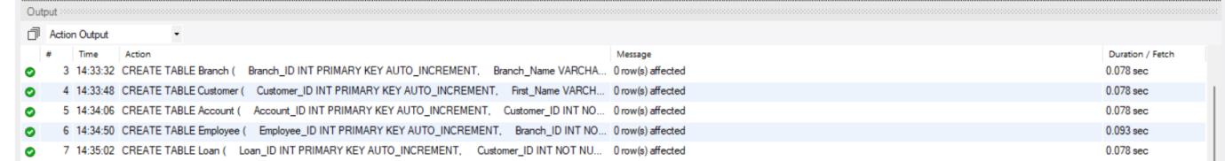
7-CREATE TABLE Bank_Transaction (
Transaction_ID INT PRIMARY KEY AUTO_INCREMENT,

Account_ID INT NOT NULL,

Transaction_Type VARCHAR(20)
CHECK(Transaction_Type IN
('Deposit','Withdrawal','Transfer')),

Amount DECIMAL(12,2)
CHECK(Amount>0),

Transaction_Date DATETIME
DEFAULT CURRENT_TIMESTAMP,

Remarks VARCHAR(100),

FOREIGN KEY(Account_ID)
REFERENCES Account(Account_ID)
);
SELECT DATABASE();
CREATE TABLE Branch (
Branch_ID INT AUTO_INCREMENT PRIMARY KEY,
Branch_Name VARCHAR(50) NOT NULL,
City VARCHAR(40) NOT NULL,
IFSC_Code VARCHAR(20) UNIQUE NOT NULL,
Contact_Number VARCHAR(15) UNIQUE
);
8-DESC Branch;
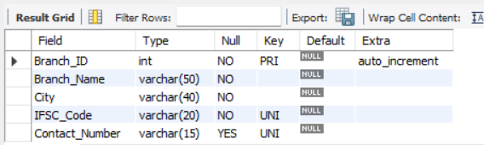
9-CREATE TABLE Customer (
Customer_ID INT AUTO_INCREMENT PRIMARY KEY,
First_Name VARCHAR(30) NOT NULL,
Last_Name VARCHAR(30) NOT NULL,
Gender VARCHAR(10),
DOB DATE NOT NULL,
Phone VARCHAR(15) UNIQUE NOT NULL,
Email VARCHAR(60) UNIQUE NOT NULL,
Address VARCHAR(100),
City VARCHAR(40),
Created_On DATE DEFAULT (CURRENT_DATE)
);
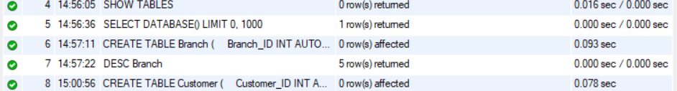
10-DESC Customer;
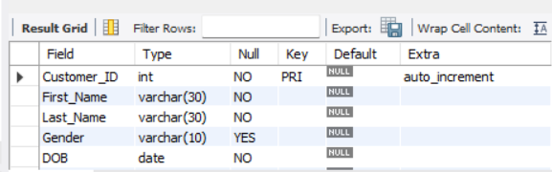
11-CREATE TABLE Account (
Account_ID INT AUTO_INCREMENT PRIMARY KEY,

Customer_ID INT NOT NULL,
Branch_ID INT NOT NULL,

Account_Number BIGINT UNIQUE NOT NULL,

Account_Type ENUM('Savings','Current') NOT NULL,

Balance DECIMAL(12,2) DEFAULT 0.00,

Open_Date DATE DEFAULT (CURRENT_DATE),

Status ENUM('Active','Inactive') DEFAULT 'Active',

FOREIGN KEY (Customer_ID)
REFERENCES Customer(Customer_ID),

FOREIGN KEY (Branch_ID)
REFERENCES Branch(Branch_ID)
);
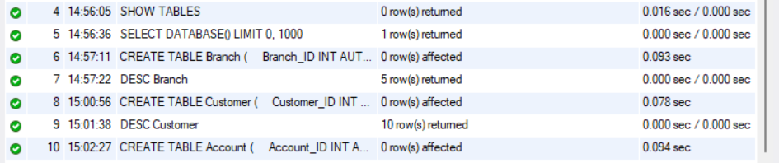
13-
DESC Account;
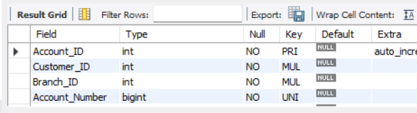
14-CREATE TABLE Employee (
Employee_ID INT AUTO_INCREMENT PRIMARY KEY,

Branch_ID INT NOT NULL,

Employee_Name VARCHAR(50) NOT NULL,

Position VARCHAR(30) NOT NULL,

Salary DECIMAL(10,2) NOT NULL,

Phone VARCHAR(15) UNIQUE,

Hire_Date DATE,

FOREIGN KEY (Branch_ID)
REFERENCES Branch(Branch_ID)
);
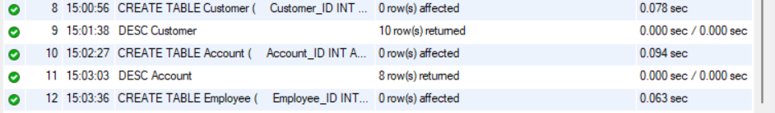
15-DESC Employee;
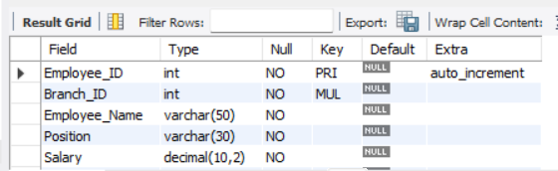
15-
CREATE TABLE Loan (
Loan_ID INT AUTO_INCREMENT PRIMARY KEY,

Customer_ID INT NOT NULL,

Loan_Type ENUM('Home','Education','Vehicle','Personal') NOT NULL,

Loan_Amount DECIMAL(12,2) NOT NULL,

Interest_Rate DECIMAL(4,2) NOT NULL,

Loan_Status ENUM('Pending','Approved','Closed')
DEFAULT 'Pending',

FOREIGN KEY (Customer_ID)
REFERENCES Customer(Customer_ID)
);
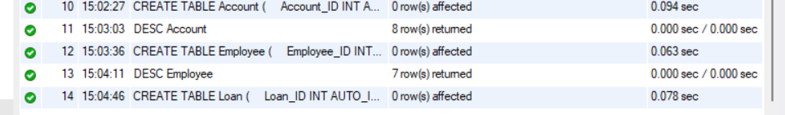
16-DESC Loan;
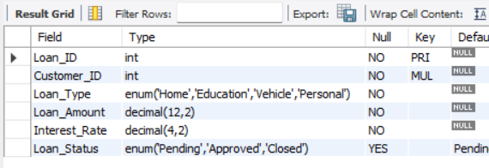
17-CREATE TABLE Bank_Transaction (
Transaction_ID INT AUTO_INCREMENT PRIMARY KEY,

Account_ID INT NOT NULL,

Transaction_Type ENUM('Deposit','Withdrawal','Transfer') NOT NULL,

Amount DECIMAL(12,2) NOT NULL,

Transaction_Date DATETIME DEFAULT CURRENT_TIMESTAMP,

Remarks VARCHAR(100),

FOREIGN KEY (Account_ID)
REFERENCES Account(Account_ID)
);
18-DESC Bank_Transaction;
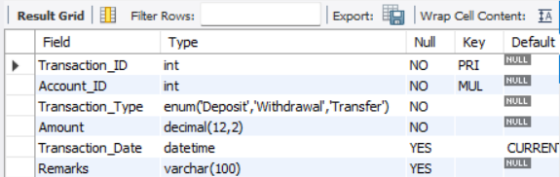
19-SHOW TABLES;
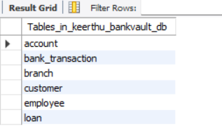
20-INSERT INTO Branch
(Branch_Name, City, IFSC_Code, Contact_Number)
VALUES
('SBI Anna Nagar','Chennai','SBIN0001001','04424560001'),
('SBI T Nagar','Chennai','SBIN0001002','04424560002'),
('SBI RS Puram','Coimbatore','SBIN0001003','04222456003'),
('SBI Gandhipuram','Coimbatore','SBIN0001004','04222456004'),
('SBI Mattuthavani','Madurai','SBIN0001005','04522456005'),
('SBI Peelamedu','Coimbatore','SBIN0001006','04222456006'),
('SBI Velachery','Chennai','SBIN0001007','04424560007'),
('SBI Salem Main','Salem','SBIN0001008','04272456008'),
('SBI Trichy Junction','Trichy','SBIN0001009','04312456009'),
('SBI Tirunelveli','Tirunelveli','SBIN0001010','04622456010');
21-SELECT * FROM Branch;
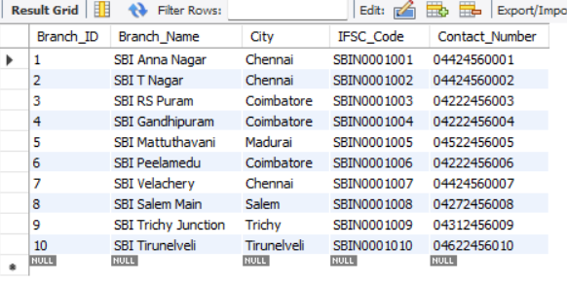
22-INSERT INTO Customer
(First_Name, Last_Name, Gender, DOB, Phone, Email, Address, City)
VALUES
('Keerthana','M','Female','2006-05-15','9876500001','keerthana@gmail.com','Anna Nagar','Chennai'),
('Arun','Kumar','Male','2003-08-20','9876500002','arun@gmail.com','T Nagar','Chennai'),
('Priya','S','Female','2002-11-10','9876500003','priya@gmail.com','RS Puram','Coimbatore'),
('Rahul','R','Male','2001-02-18','9876500004','rahul@gmail.com','Gandhipuram','Coimbatore'),
('Nivetha','P','Female','2004-06-30','9876500005','nivetha@gmail.com','Mattuthavani','Madurai'),
('Vignesh','M','Male','2000-09-14','9876500006','vignesh@gmail.com','Velachery','Chennai'),
('Ananya','R','Female','2005-01-25','9876500007','ananya@gmail.com','Peelamedu','Coimbatore'),
('Karthik','S','Male','1999-12-11','9876500008','karthik@gmail.com','Salem Main','Salem'),
('Deepika','L','Female','2003-03-08','9876500009','deepika@gmail.com','Trichy Junction','Trichy'),
('Harish','B','Male','2002-07-21','9876500010','harish@gmail.com','Tirunelveli Town','Tirunelveli'),
('Sneha','V','Female','2001-10-01','9876500011','sneha@gmail.com','Anna Nagar','Chennai'),
('Gokul','A','Male','2000-04-17','9876500012','gokul@gmail.com','RS Puram','Coimbatore'),
('Meena','T','Female','2004-09-05','9876500013','meena@gmail.com','Madurai East','Madurai'),
('Ajay','D','Male','2003-12-12','9876500014','ajay@gmail.com','Salem West','Salem'),
('Pooja','N','Female','2005-07-09','9876500015','pooja@gmail.com','Velachery','Chennai');
23-SELECT * FROM Customer;
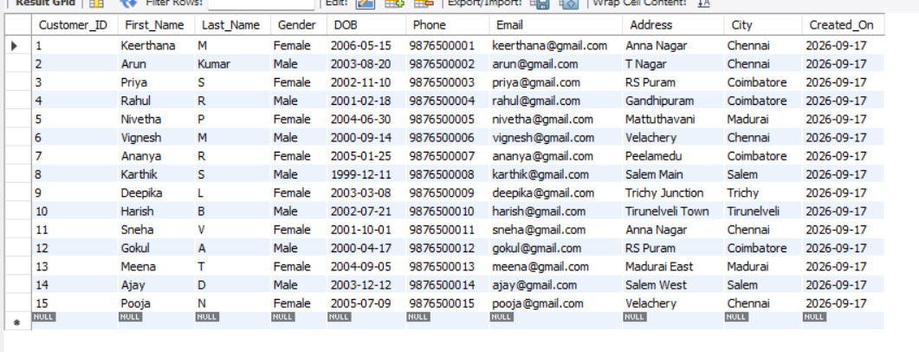
24-INSERT INTO Account
(Customer_ID, Branch_ID, Account_Number, Account_Type, Balance, Open_Date, Status)
VALUES
(1,1,100000001001,'Savings',25000.00,'2024-01-10','Active'),
(2,2,100000001002,'Current',50000.00,'2023-12-05','Active'),
(3,3,100000001003,'Savings',18000.00,'2024-03-18','Active'),
(4,4,100000001004,'Savings',32000.00,'2024-02-12','Active'),
(5,5,100000001005,'Current',75000.00,'2023-09-15','Active'),
(6,7,100000001006,'Savings',15000.00,'2024-04-01','Active'),
(7,6,100000001007,'Savings',29000.00,'2024-05-10','Active'),
(8,8,100000001008,'Current',90000.00,'2023-10-20','Active'),
(9,9,100000001009,'Savings',22000.00,'2024-06-25','Active'),
(10,10,100000001010,'Savings',31000.00,'2024-01-28','Active'),
(11,1,100000001011,'Savings',27000.00,'2024-02-05','Active'),
(12,3,100000001012,'Current',68000.00,'2023-11-18','Active'),
(13,5,100000001013,'Savings',19500.00,'2024-04-22','Active'),
(14,8,100000001014,'Savings',36000.00,'2024-07-01','Active'),
(15,7,100000001015,'Current',82000.00,'2023-08-30','Active'),
(1,2,100000001016,'Current',40000.00,'2024-05-15','Active'),
(2,1,100000001017,'Savings',17000.00,'2024-03-12','Active'),
(5,5,100000001018,'Savings',21000.00,'2024-06-05','Active'),
(8,8,100000001019,'Savings',14500.00,'2024-07-20','Inactive'),
(10,9,100000001020,'Current',95000.00,'2023-12-01','Active');
SELECT Account_ID,
Customer_ID,
Branch_ID,
Account_Number,
Balance
FROM Account;
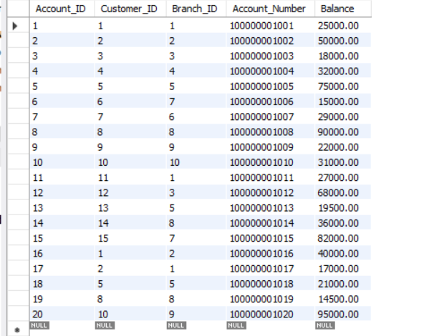
25-INSERT INTO Employee
(Branch_ID, Employee_Name, Position, Salary, Phone, Hire_Date)
VALUES
(1,'Rajesh Kumar','Branch Manager',85000,'9000000001','2020-01-15'),
(2,'Lakshmi Devi','Cashier',35000,'9000000002','2021-06-20'),
(3,'Suresh Babu','Loan Officer',50000,'9000000003','2019-03-10'),
(4,'Divya Priya','Customer Executive',32000,'9000000004','2022-09-05'),
(5,'Karthikeyan','Branch Manager',87000,'9000000005','2018-11-25'),
(6,'Meenakshi','Cashier',34000,'9000000006','2023-02-14'),
(7,'Prakash','Accountant',45000,'9000000007','2021-12-01'),
(8,'Anitha','Customer Executive',33000,'9000000008','2022-04-18'),
(9,'Ramesh','Loan Officer',52000,'9000000009','2020-07-09'),
(10,'Saranya','Cashier',36000,'9000000010','2023-01-12');
SELECT Employee_ID,
Employee_Name,
Position,
Salary
FROM Employee;
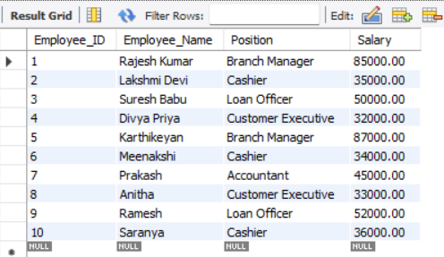
26-INSERT INTO Loan
(Customer_ID, Loan_Type, Loan_Amount, Interest_Rate, Loan_Status)
VALUES
(1,'Education',350000,8.50,'Approved'),
(2,'Vehicle',600000,9.20,'Approved'),
(3,'Home',2500000,7.90,'Pending'),
(4,'Personal',150000,11.50,'Approved'),
(5,'Education',500000,8.10,'Closed'),
(6,'Vehicle',800000,9.50,'Approved'),
(7,'Home',1800000,7.75,'Pending'),
(10,'Personal',200000,12.00,'Approved'),
(12,'Education',450000,8.20,'Approved'),
(15,'Vehicle',700000,9.00,'Closed');
SELECT Loan_ID,
Customer_ID,
Loan_Type,
Loan_Status
FROM Loan;
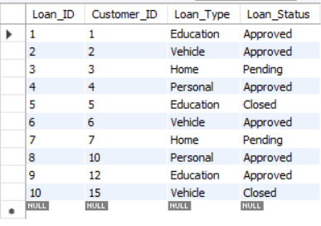
27-INSERT INTO Bank_Transaction
(Account_ID, Transaction_Type, Amount, Transaction_Date, Remarks)
VALUES
(1,'Deposit',5000,'2026-08-01 09:15:00','Salary Credit'),
(1,'Withdrawal',1500,'2026-08-02 10:20:00','ATM Withdrawal'),
(2,'Deposit',12000,'2026-08-03 11:30:00','Business Deposit'),
(3,'Deposit',3000,'2026-08-04 12:10:00','Cash Deposit'),
(4,'Transfer',4500,'2026-08-05 13:00:00','Transfer to Friend'),
(5,'Withdrawal',10000,'2026-08-06 14:15:00','ATM Withdrawal'),
(6,'Deposit',2500,'2026-08-07 09:45:00','UPI Credit'),
(7,'Deposit',6000,'2026-08-08 10:00:00','Salary Credit'),
(8,'Transfer',7000,'2026-08-09 15:25:00','Online Transfer'),
(9,'Withdrawal',2000,'2026-08-10 16:30:00','ATM Withdrawal'),
(10,'Deposit',8000,'2026-08-11 09:10:00','Cash Deposit'),
(11,'Transfer',3500,'2026-08-12 11:45:00','UPI Payment'),
(12,'Deposit',15000,'2026-08-13 12:30:00','Business Income'),
(13,'Withdrawal',500,'2026-08-14 13:50:00','ATM Withdrawal'),
(14,'Deposit',4200,'2026-08-15 15:20:00','Salary Credit'),
(15,'Transfer',9000,'2026-08-16 16:10:00','Rent Payment'),
(16,'Deposit',10000,'2026-08-17 09:25:00','Cash Deposit'),
(17,'Withdrawal',1200,'2026-08-18 10:40:00','ATM Withdrawal'),
(18,'Deposit',4500,'2026-08-19 11:30:00','UPI Credit'),
(19,'Deposit',2500,'2026-08-20 12:45:00','Refund'),
(20,'Transfer',6500,'2026-08-21 14:10:00','Online Shopping'),
(3,'Withdrawal',1800,'2026-08-22 15:05:00','ATM Withdrawal'),
(5,'Deposit',7000,'2026-08-23 09:40:00','Cash Deposit'),
(7,'Transfer',2000,'2026-08-24 10:50:00','Electricity Bill'),
(8,'Withdrawal',5000,'2026-08-25 12:15:00','ATM Withdrawal'),
(9,'Deposit',9000,'2026-08-26 13:35:00','Salary Credit'),
(10,'Transfer',2500,'2026-08-27 15:00:00','Mobile Recharge'),
(12,'Withdrawal',3000,'2026-08-28 16:20:00','ATM Withdrawal'),
(14,'Deposit',5200,'2026-08-29 09:30:00','UPI Credit'),
(16,'Transfer',4500,'2026-08-30 11:00:00','Transfer to Savings');
SELECT Transaction_ID,
Account_ID,
Transaction_Type,
Amount
FROM Bank_Transaction
LIMIT 10;
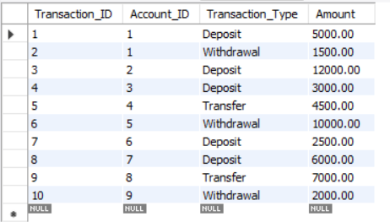
28-SELECT COUNT(*) AS Total_Branches FROM Branch;
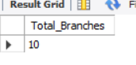
29-SELECT COUNT(*) AS Total_Customers FROM Customer;
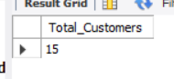
30-SELECT COUNT(*) AS Total_Accounts FROM Account;
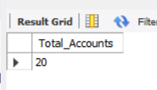
31-SELECT COUNT(*) AS Total_Employees FROM Employee;
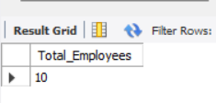
32-SELECT COUNT(*) AS Total_Loans FROM Loan;
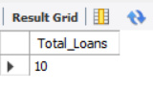
33-3SELECT * FROM Branch;
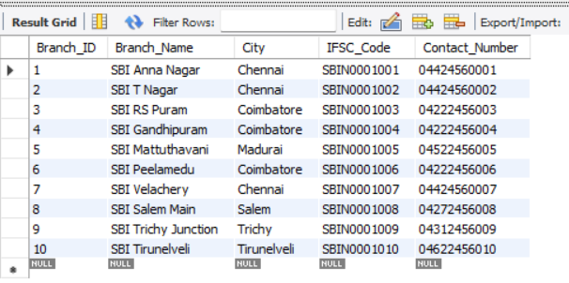
34-SELECT * FROM Customer;
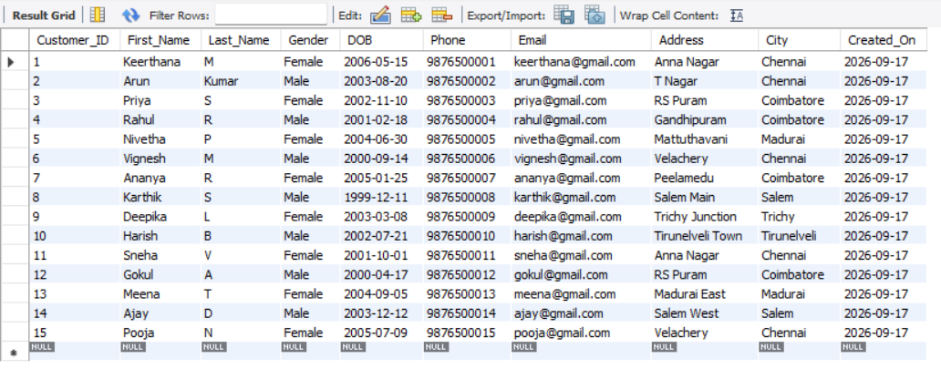
35-SELECT Customer_ID,
First_Name,
Last_Name,
City
FROM Customer;
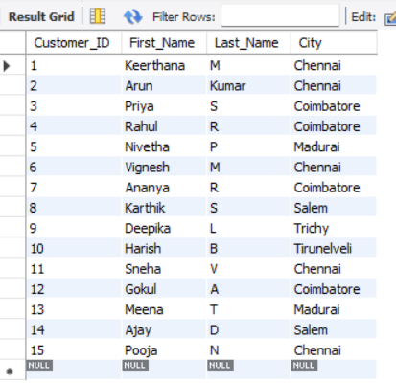
36-SELECT Account_Number,
Account_Type,
Balance
FROM Account;
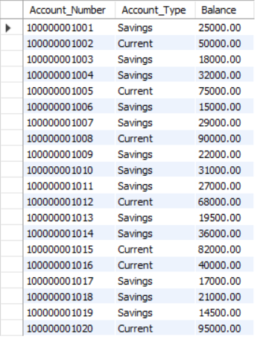
37-SELECT *
FROM Account
WHERE Status = 'Active';
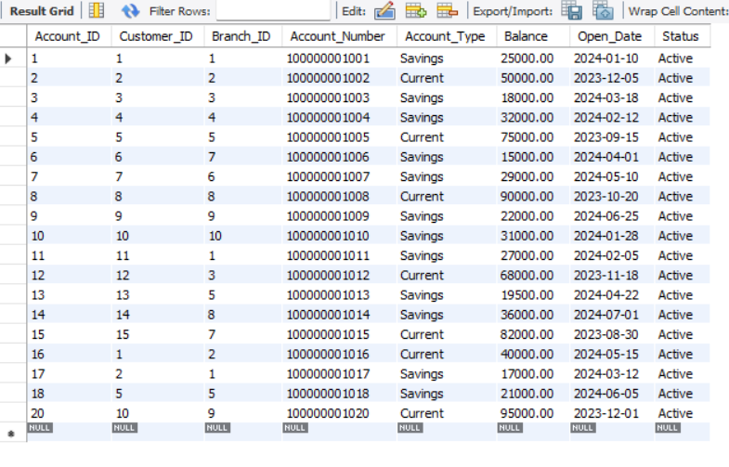
38-SELECT DISTINCT City
FROM Customer;
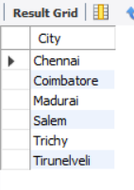
39-SELECT *
FROM Customer
LIMIT 5;
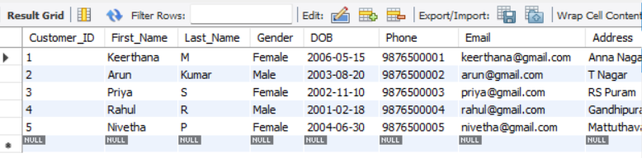
40-SELECT *
FROM Customer
LIMIT 5 OFFSET 5;
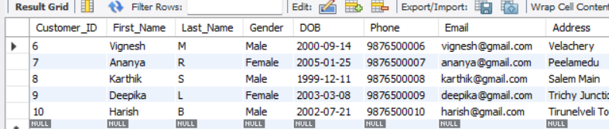
41-SELECT Account_Number,
Balance
FROM Account
ORDER BY Balance DESC;
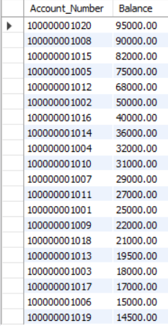
42-SELECT First_Name AS Customer_Name,
Phone AS Mobile_Number,
City AS Customer_City
FROM Customer;
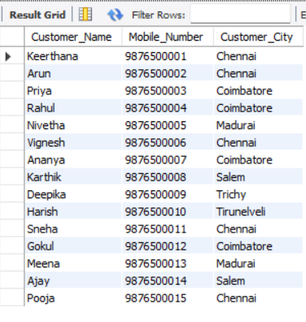
43-SELECT *
FROM Account
WHERE NOT Status = 'Inactive';
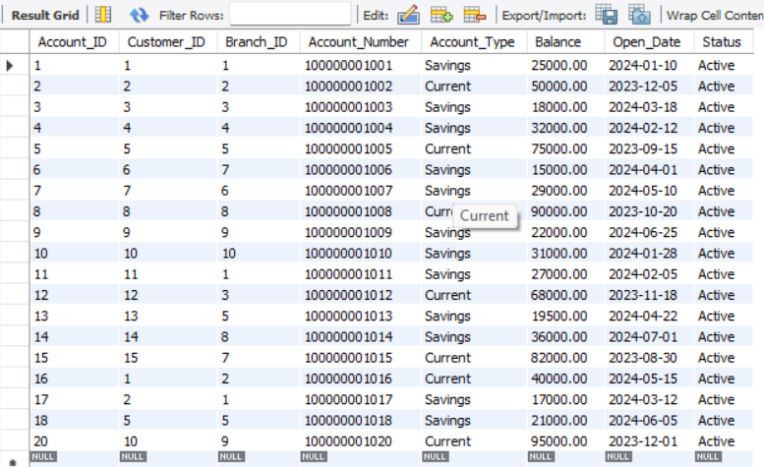
44-SELECT Customer_ID,
First_Name,
City
FROM Customer
WHERE City IN ('Chennai','Salem','Trichy');
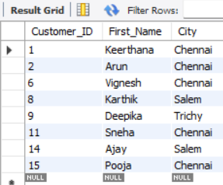
45-SELECT Customer_ID,
First_Name,
City
FROM Customer
WHERE City NOT IN ('Chennai','Coimbatore');
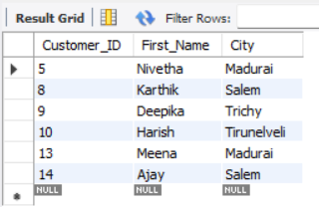
46-SELECT Account_Number,
Balance
FROM Account
WHERE Balance > 50000;
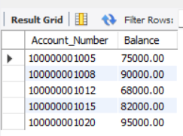
47-SELECT Loan_ID,
Loan_Type,
Interest_Rate
FROM Loan
WHERE Interest_Rate >= 9;
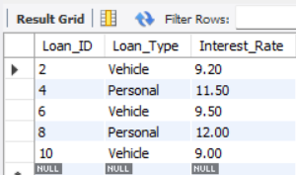
48-SELECT Account_Number,
Account_Type
FROM Account
WHERE Account_Type <> 'Current';
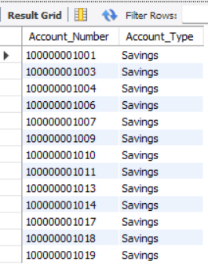
49-SELECT Account_Number,
Balance
FROM Account
WHERE Balance BETWEEN 20000 AND 50000;
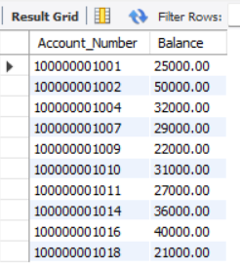
50-SELECT Branch_Name,
City
FROM Branch
WHERE Branch_Name LIKE 'SBI%';
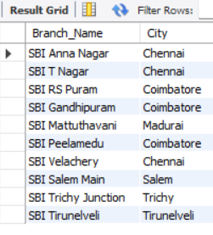
51-SELECT Branch_Name
FROM Branch
WHERE Branch_Name LIKE '%Main';
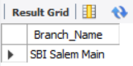
52-SELECT First_Name,
Last_Name
FROM Customer
WHERE First_Name LIKE '%a%';
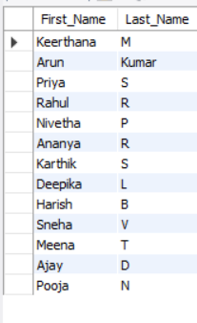
53-SELECT Account_Number,
Balance
FROM Account
ORDER BY Balance ASC;
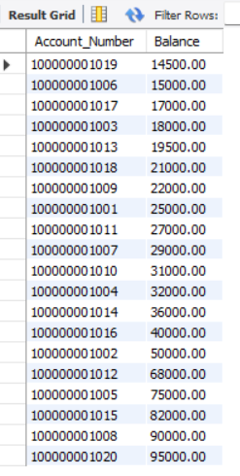
54-SELECT Account_Number,
Balance
FROM Account
ORDER BY Balance DESC;
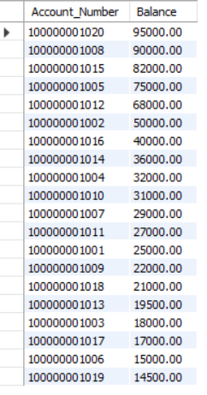
55-SELECT *
FROM Bank_Transaction
LIMIT 3;
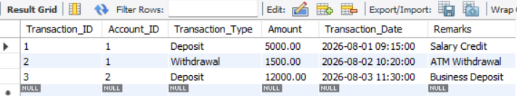
56-SELECT *
FROM Bank_Transaction
LIMIT 3 OFFSET 3;
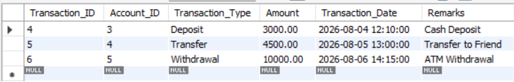
57-SELECT DISTINCT Account_Type
FROM Account;
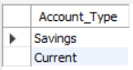
58-SELECT First_Name AS Customer_Name,
Phone AS Mobile_Number,
City AS Customer_City
FROM Customer;
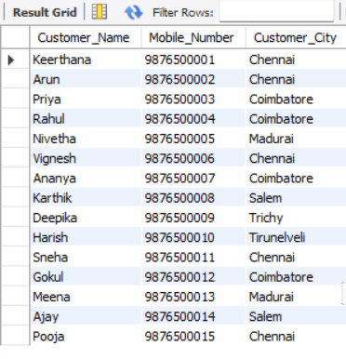
59-SELECT COUNT(*) AS Total_Customers
FROM Customer;
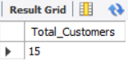
60-SELECT SUM(Balance) AS Total_Balance
FROM Account;
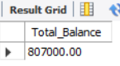
61-SELECT AVG(Balance) AS Average_Balance
FROM Account;
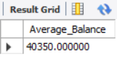
62-SELECT MIN(Balance) AS Minimum_Balance
FROM Account;
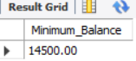
63-SELECT MAX(Balance) AS Maximum_Balance
FROM Account;
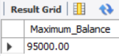
64-SELECT Account_Type,
COUNT(*) AS Total_Accounts
FROM Account
GROUP BY Account_Type;
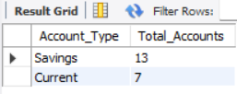
65-SELECT Branch_ID,
COUNT(*) AS Number_of_Accounts
FROM Account
GROUP BY Branch_ID;
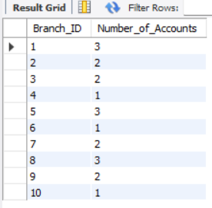
66-SELECT Loan_Status,
COUNT(*) AS Total_Loans
FROM Loan
GROUP BY Loan_Status;
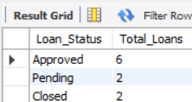
67-SELECT Transaction_Type,
SUM(Amount) AS Total_Amount
FROM Bank_Transaction
GROUP BY Transaction_Type;
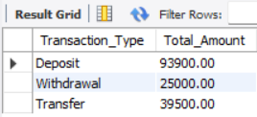
68-SELECT Account_Type,
COUNT(*) AS Total_Accounts
FROM Account
GROUP BY Account_Type
HAVING COUNT(*) > 5;
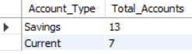
69-SELECT C.Customer_ID,
C.First_Name,
C.Last_Name,
A.Account_Number,
A.Account_Type,
A.Balance
FROM Customer C
INNER JOIN Account A
ON C.Customer_ID = A.Customer_ID;
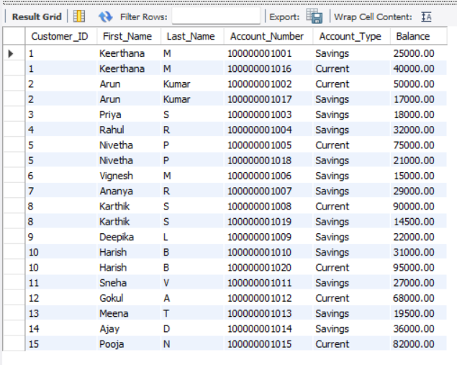
70-SELECT C.Customer_ID,
C.First_Name,
C.City,
L.Loan_Type,
L.Loan_Status
FROM Customer C
LEFT JOIN Loan L
ON C.Customer_ID = L.Customer_ID;
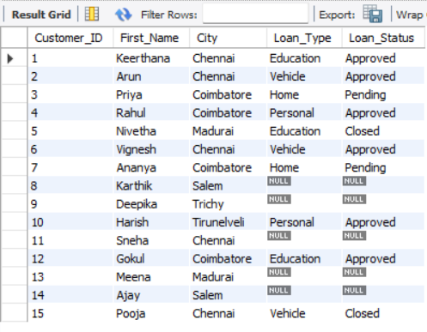
71-SELECT E.Employee_Name,
E.Position,
B.Branch_Name,
B.City
FROM Employee E
RIGHT JOIN Branch B
ON E.Branch_ID = B.Branch_ID;
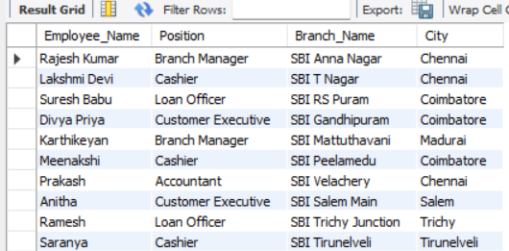
72-SELECT C.Customer_ID,
C.First_Name,
L.Loan_Type
FROM Customer C
LEFT JOIN Loan L
ON C.Customer_ID = L.Customer_ID

UNION

SELECT C.Customer_ID,
C.First_Name,
L.Loan_Type
FROM Customer C
RIGHT JOIN Loan L
ON C.Customer_ID = L.Customer_ID;

73-SELECT C.Customer_ID,
C.First_Name,
C.Last_Name,
A.Balance
FROM Customer C
INNER JOIN Account A
ON C.Customer_ID = A.Customer_ID
WHERE A.Balance >
(SELECT AVG(Balance)
FROM Account);
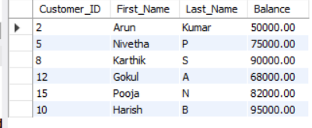
74-SELECT Customer_ID,
First_Name,
Last_Name
FROM Customer
WHERE Customer_ID IN
(SELECT Customer_ID
FROM Loan);
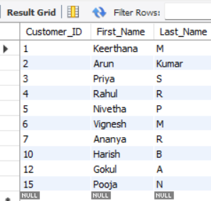
75-CREATE VIEW Customer_Account_View AS
SELECT C.Customer_ID,
C.First_Name,
C.Last_Name,
A.Account_Number,
A.Account_Type,
A.Balance
FROM Customer C
INNER JOIN Account A
ON C.Customer_ID = A.Customer_ID;
76-SELECT * FROM Customer_Account_View;
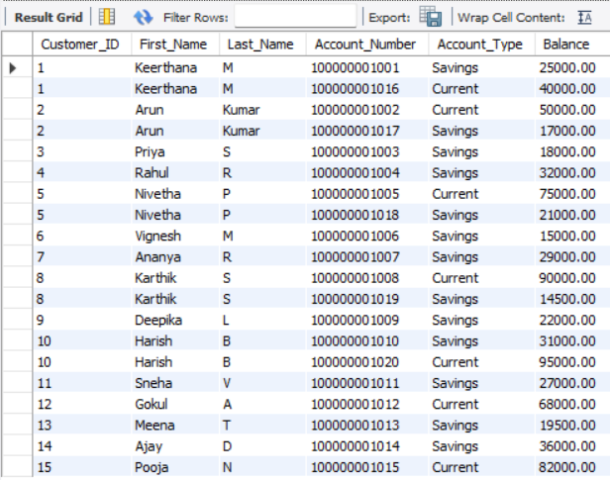
77-DROP VIEW Customer_Account_View;
ALTER TABLE Customer
ADD Aadhaar_Number VARCHAR(20);
ALTER TABLE Customer
DROP COLUMN Aadhaar_Number;
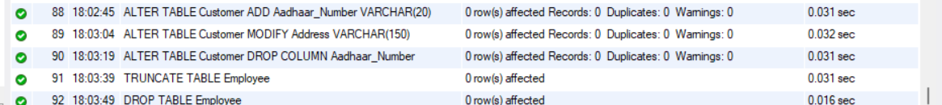

78-CREATE INDEX idx_account_customer_id
ON Account(Customer_ID);
SHOW INDEX FROM Account;

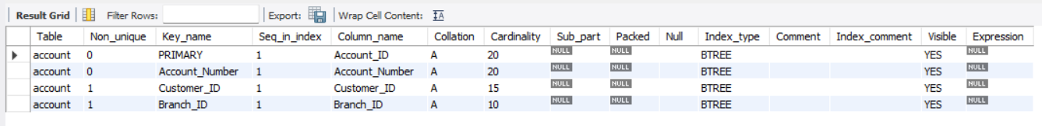

80-USE Keerthu_BankVault_DB;

SELECT Customer_ID, First_Name, Last_Name
FROM Customer
WHERE Customer_ID IN
(
SELECT Customer_ID
FROM Account
WHERE Balance >
(
SELECT AVG(Balance)
FROM Account
)
);

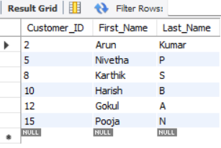

CONCLUSION

As all the sql query are performed for the BankManagement System all the operators ,joins,subqueries,aggregate functions,clauses are performed and the system is successfully created

