Name : KEERTHANA R
Reg No : 411625104031
Department : CSE
Subject : Fundamentals of Programming
Batch : 3
Title : Flower Garden Management System using Python

Aim:
To design and implement a Python program for managing a Flower Garden System that demonstrates the basic programming concepts such as operators, decision making, looping, lists, tuples, sets, dictionaries, strings, functions, and recursion.

Procedure
Step 1: Creating Tuple for Garden Information
A tuple named garden_info was created to store fixed information such as the garden name and section. Tuples are used because their values cannot be changed.

Step 2: Creating List for Flowers
A list named flowers was created to store the names of flowers planted in the garden. Lists allow storing multiple values and can be modified easily.

Step 3: Creating Set for Fertilizers
A set named fertilizers was used to store the fertilizers used in the garden. Sets help avoid duplicate fertilizer entries.

Step 4: Creating Dictionary for Plant Count
A dictionary named flower_count was created to store the flower name as the key and number of plants as the value.

Step 5: Implementing Recursion
A recursive function named total_plants() was created to calculate the total number of plants in the garden by repeatedly adding the values in the list.

Step 6: Adding Flower Records
A function named add_record() was created to allow the user to enter:
• Flower name
• Number of plants
• Fertilizer used
The entered values are stored in the list, set, and dictionary.

Step 7: Displaying Garden Records
The display_records() function displays:
• Garden name and section
• Flowers planted
• Number of plants for each flower
• Fertilizers used

Step 8: Checking Garden Target
The check_target() function calculates the total number of plants using recursion and checks whether the total plants are greater than or equal to 20 to achieve the garden target.

Step 9: Using Loop for Menu System
A while loop was used to repeatedly display a menu that allows the user to:
- Add flower records
- Display records
- Check plant target
- Exit the program

Code:
garden_info=("Keerthana Garden","Flower Section")
flowers=[]
fertilizers=set()
flower_count={}
def total_plants(plant_list):
if len(plant_list)==0:
return 0
return plant_list[0]+total_plants(plant_list[1:])
def add_record():
flower=input("Enter flower name: ")
count=int(input("Enter number of plants: "))
fertilizer=input("Enter fertilizer used: ")
flowers.append(flower)
fertilizers.add(fertilizer)
flower_count[flower]=count
print("Flower record added successfully.")
def display_records():
print("\nGarden Name:",garden_info[0])
print("Section:",garden_info[1])
print("\nFlowers Planted:")
for f in flowers:
print(f)
print("\nFlower Plant Count:")
for f,c in flower_count.items():
print(f,":",c)
print("\nFertilizers Used:",fertilizers)
def check_target():
plant_list=list(flower_count.values())
total=total_plants(plant_list)
print("Total Plants:",total)
if total>=20:
print("Garden Target Achieved!")
else:
print("Target Not Achieved. Plant more flowers!")
while True:
print("\n===== FLOWER GARDEN MENU =====")
print("1. Add Flower Record")
print("2. Display Records")
print("3. Check Plant Target")
print("4. Exit")
choice=int(input("Enter choice: "))
if choice==1:
add_record()
elif choice==2:
display_records()
elif choice==3:
check_target()
elif choice==4:
print("Exiting program.")
break
else:
print("Invalid choice")
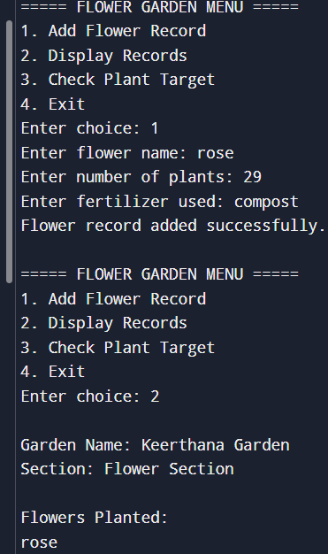
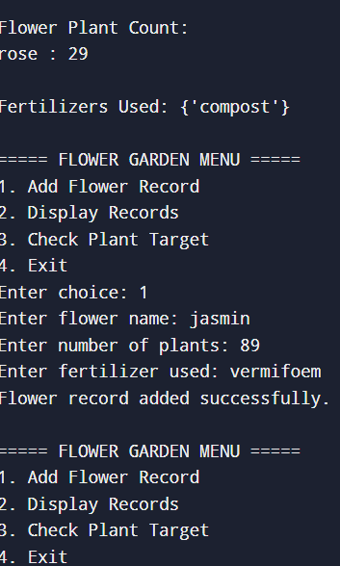

Result:
The Flower Garden Management System program was successfully executed. The program demonstrated fundamental programming concepts including tuples, lists, sets, dictionaries, decision making, looping, functions, and recursion in Python. The system allowed the user to add flower records, display garden details, and check whether the planting target was achieved.

