Name : KEERTHANA R
Reg No : 411625104031
Department : CSE
Subject : JAVA(OOPS)
Batch : 3
Title : Seed Bank Management System using HashMap in Java

Aim:
To design and implement a Java program for a Seed Bank Management System using HashMap to store and manage different seed types and their quantities.

Procedure
Step 1: Importing Required Packages
The java.util package was imported to use classes such as Scanner and HashMap.

Step 2: Creating HashMap for Seed Storage
A HashMap named seedStock was created to store seed names as keys and their quantities as values.
Initial seed types such as Wheat, Rice, and Corn were added to the HashMap.

Step 3: Creating Menu Driven System
A do-while loop was used to create a menu-driven system that allows the user to perform different operations until the exit option is selected.

Step 4: Adding New Seed Type
The user can enter a new seed name and quantity.
The put() method of HashMap is used to add the seed to the inventory.

Step 5: Distributing Seeds
The user can distribute seeds from the stock.
The program checks whether the seed type exists using containsKey().
If sufficient quantity is available, the seeds are distributed and the stock is updated.

Step 6: Restocking Seeds
The user can add more quantity to an existing seed type.
The current stock is retrieved using get(), and the new quantity is updated using put().

Step 7: Displaying All Seed Inventory
All seed types and their quantities are displayed using a for-each loop by iterating through the keys of the HashMap.

Step 8: Showing Low Stock Seeds
The program checks for seeds with quantity less than 50 and displays them as low stock seeds.
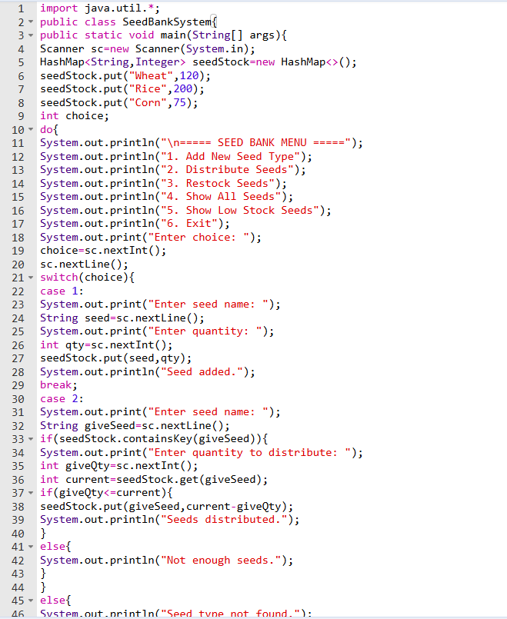
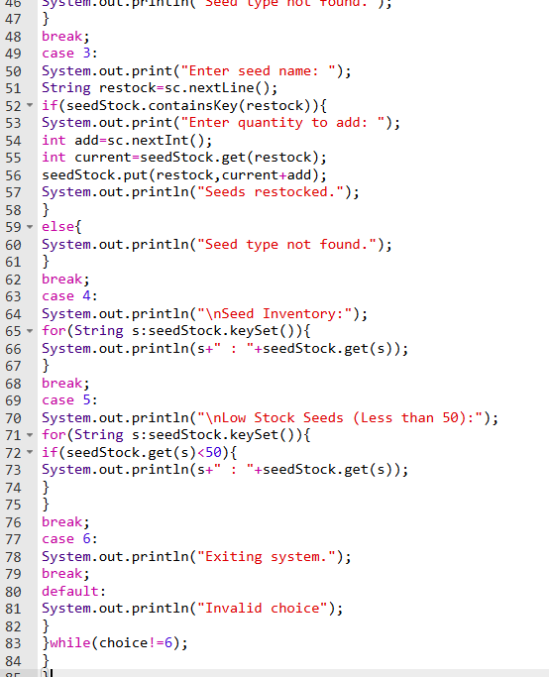
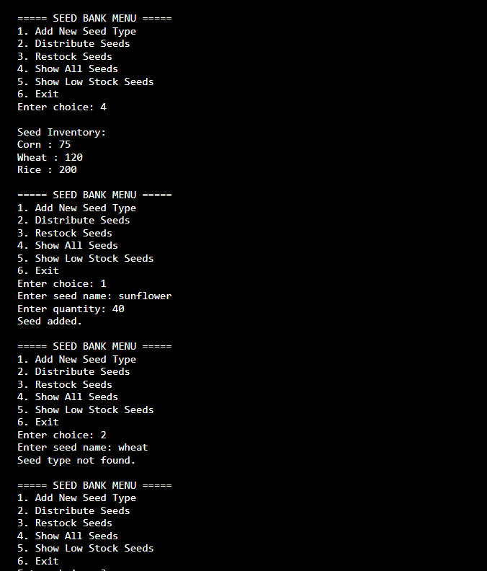
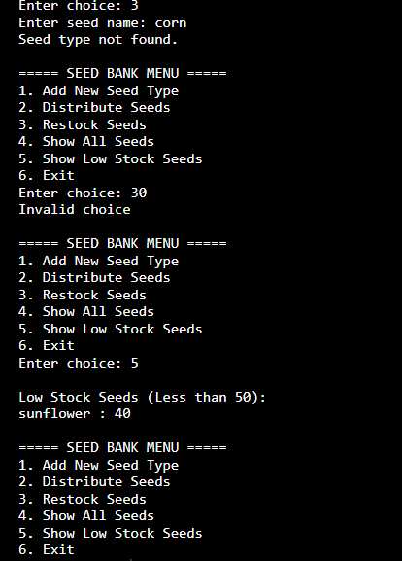

Result:
The Seed Bank Management System using HashMap was successfully implemented and executed. The program allowed users to add new seeds, distribute seeds, restock inventory, view all seeds, and identify low stock seeds. This program demonstrates the practical use of HashMap for efficient data storage and management in Java.

